Create a class rectangle with data member length,breath and area.member function calculate area to calculate area of rectangle,display to show information ,setData to set data by passing parameters and getdata to take input by users.

#include<iostream>

using namespace std;

class rectangle

{

private:

float length;

float breath;

float area_rect;

public:

void setData(float l,float b);

void getData();

float area();

void show();

};

void rectangle::setData(float l,float b)

{

length=l;

breath=b;

}

void rectangle::getData()

{

cout<<"enter length";

cin>>length>>breath;

}

void rectangle::show()

{

cout<<"length"<<length<<"breath"<<breath<<endl;

}

float rectangle::area()

{

area_rect=length*breath;

return area_rect;

}

int main()

{

rectangle a1,a2;

a1.setData(3,4);

a1.show();

cout<<"area1="<<a1.area();

a2.getData();

a2.show();

cout<<"area2="<<a2.area();

return 0;

}

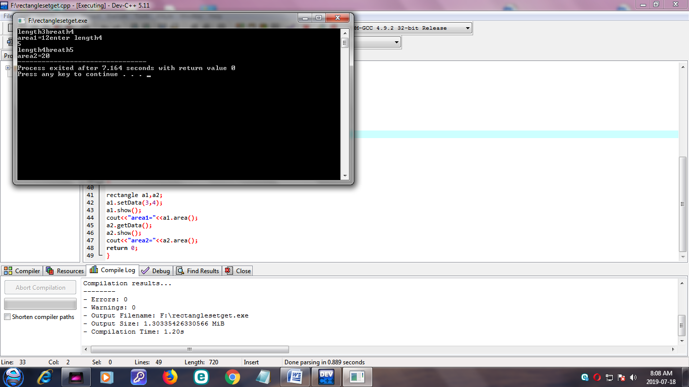

CREATE A CLASS NAMED TIME WITH DATA MEMBER HOURS,MINUTE,AND SECOND.

USE MEMBER FUNCTION SETTIME TO SET TIME BY PASSING PARAMETERS GETTIME TO READ TIME FROM USERS,ADDTIME TO ADD TWO TIME,AND SHOWTIME TO DISPLAY TIME IN HH:MM:SS FORMAT

#include<iostream>

using namespace std;

class time

{

private:

int hr,min,sec;

public:

void setTime(int x,int y,int z)

{

hr=x;

min=y;

sec=z;

}

void showTime()

{

cout<<endl<<hr<<":"<<min<<":"<<sec;

}

void normalize()

{

min=min+sec/60;

sec=sec%60;

hr=hr+min/60;

min=min%60;

}

time operator +(time t)

{

time temp;

temp.sec=sec+t.sec;

temp.min=min+t.min;

temp.hr=hr+t.hr;

temp. normalize();

return (temp);

}

};

int main()

{

time t1,t2,t3;

t1.setTime(4,35,26);

t2.setTime(3,50,45);

t3=t1+t2;

t1.showTime();

t2.showTime();

t3.showTime();

return 0;

}

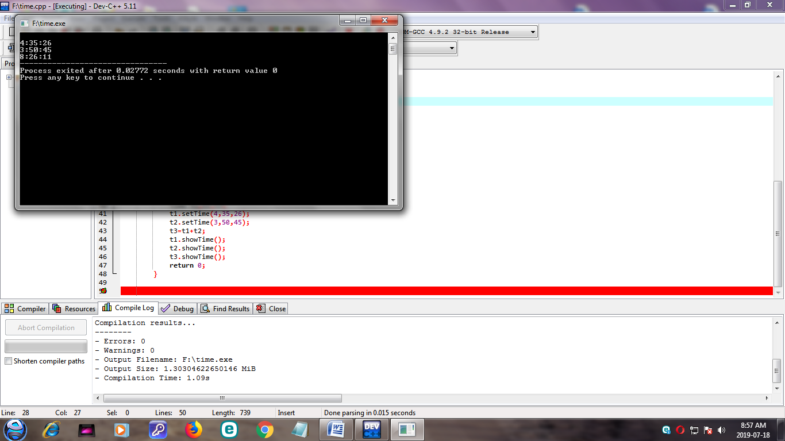

DEFINE A CLASS DISTANCE WITH DATA MEMBERS:

-FEET IN INCH

-INCHES IN FLOAT

MEMBER FUNCTIONS:

-TO READ DATA MEMBER

-TO DISPLAY DISTANCE IN FORMAT

FEET’-INCHES”

-TO ADD TWO DISTANCE OBJECT AND RETURNING DISTANCE OBJECT

#include<iostream>

using namespace std;

class height

{

private:

int feet;

int inches;

public:

void getData()

{

cout<<"enter height in feet and inches";

cin>>feet>>inches;

}

void show()

{

cout<<"feet"<<feet<<"inches"<<inches<<endl;

}

void sum(height,height);

};

void height::sum(height h1,height h2)

{

inches=h1.inches+h2.inches;

feet=inches/12;

inches=inches%12;

feet=feet+h1.feet+h2.feet;

}

int main()

{

height h1,h2,h3;

h1.getData();

h2.getData();

h3.sum(h1,h2);

cout<<"height h1:"<<endl;

h1.show();

cout<<"height h2:"<<endl;

h2.show();

cout<<"height h3"<<endl;

h3.show();

}

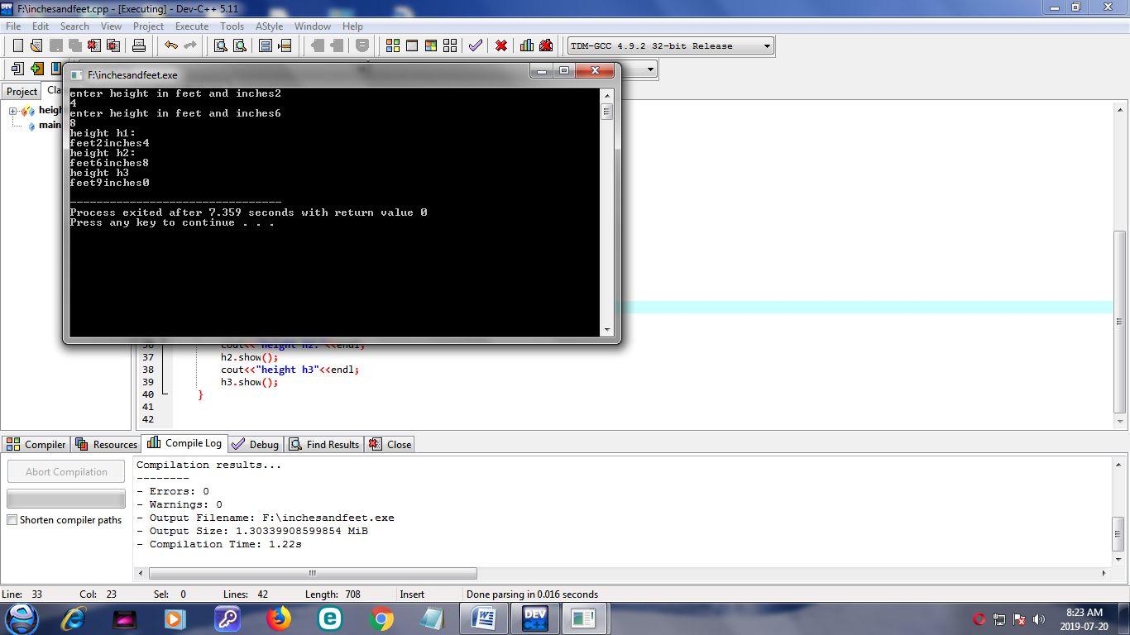

DEFINE CLASS AMOUNT WITH DATA MEMBER:

-RUPEES

-PAISA

MEMBER FUNCTION:

-TO READ DATA MEMBER

-TO DISPLAY AMOUNT IN APPROPRIATE FORMAT

-TO ADD TWO AMOUNTS

#include<iostream>

using namespace std;

class amount

{

private:

int rupees;

int paisa;

public:

void getData()

{

cout<<"enter the amount in rupees and paisa";

cin>>rupees>>paisa;

}

void show()

{

cout<<"rupees"<<rupees<<"paisa"<<paisa;

}

void sum(amount ,amount);

};

void amount::sum(amount a,amount b)

{

paisa=a.paisa+b.paisa;

rupees=paisa/100;

paisa=paisa%100;

rupees=rupees+a.rupees+b.rupees ;

}

int main()

{

amount a,b,c;

a.getData();

b.getData();

c.sum(a,b);

cout<<"amount a:"<<endl;

a.show();

cout<<"amount b"<<endl;

b.show();

cout<<"amount c"<<endl;

c.show();

}

