/*define a class distance with Data members:

-feet in inch

-inches in float

member function:

-to read data member

friend function:

-to display distance in feet-inches format

-to add two distance object and returning diatance object*/

#include<iostream>

using namespace std;

class height

{

int feet,inch;

public:

void set()

{

cout<<"Enter the height in feet and inch ";

cin>>feet>>inch;

}

friend height sum(height,height);

friend height display(height);

};

height display(height h1)

{

cout<<"The sum of height is "<<h1.feet<<" feet "<<h1.inch<<" inch ";

return h1;

}

height sum(height a,height b)

{

height h;

h.inch=a.inch+b.inch;

h.feet=h.inch/12;

h.inch=h.inch%12;

h.feet=h.feet+a.feet+b.feet;

return h;

}

int main()

{

height a,b,c;

a.set();

b.set();

c=sum(a,b);

display(c);

return 0;

}

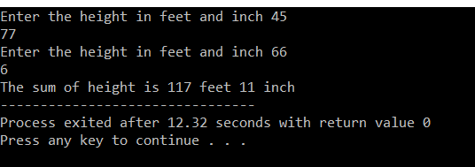

/*declare the class student with

data member

-rollno

-name

-marks in 5 subject

-total

-percentage

member function:

-input()to input data

-display() to display data

-calavg() to calculate average

enter the data for five students.

*/

#include<iostream>

#include<iomanip>

using namespace std;

class student

{

private:

int roll;

float marks[10],total=0,percent;

char name[20];

public:

void input();

void display();

void calAvg();

};

void student::input(){

cout<<"enter roll:";

cin>>roll;

cout<<"enter name:";

cin>>name;

cout<<"enter marks of 5 subject:";

for(int i=0;i<5;i++)

{

cin>>marks[i];

total+=marks[i];

}

percent=total/5;

}

void student::display(){

cout<<"roll:"<<setw(8)<<roll<<endl;

cout<<"name:"<<setw(8)<<name<<endl;

cout<<"marks of 5 subjects are :"<<endl;

for(int i=0;i<5;i++)

{

cout<<marks[i]<<"";

}

cout<<"\ntotal="<<setw(8)<<total<<endl;

cout<<"\npercentage="<<setw(8)<<percent<<"%"<<endl;

}

void student::calAvg(){

float avg;

avg=total/5;

cout<<"Average="<<setw(8)<<avg;

}

int main(){

student s1[5],s2;

for(int i=0;i<2;i++)

{

cout<<"\nenter data of student"<<i+1<<endl;

s1[i].input();

}

cout<<endl;

for(int i=0;i<2;i++)

{

cout<<"\nData of student"<<i+1<<endl;

s1[i].display();

s1[i].calAvg();

cout<<endl;

}

return 0;

}

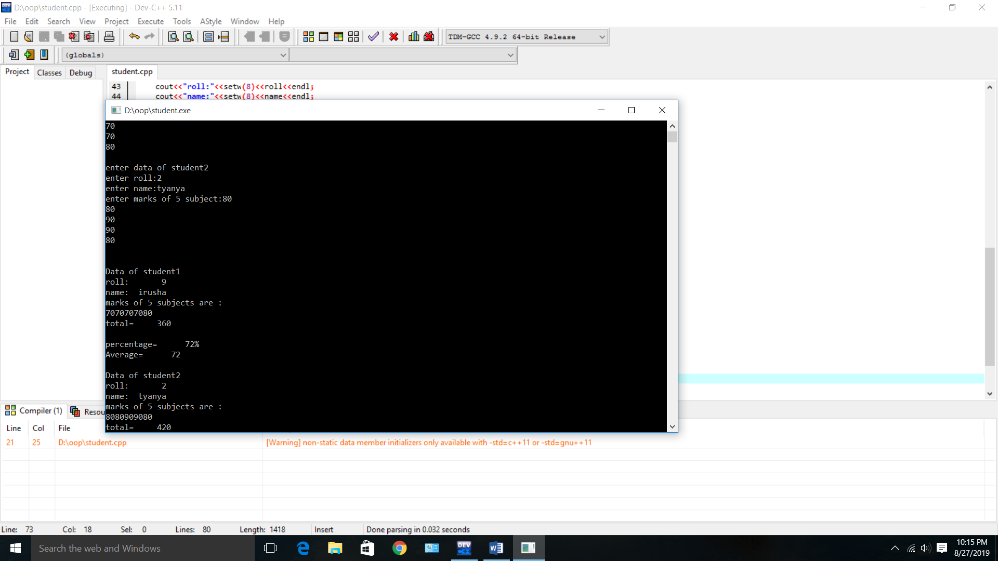

/*write a menu driven program to calculate the area ,rectangle,triangle and circle using the concept of function overloading*/

#include<iostream>

using namespace std;

int area(int);

int area(int,int);

float area(float);

float area(float,float);

int main()

{

int s,l,b;

float r,bs,ht;

cout<<"Enter side of a square:";

cin>>s;

cout<<"Enter length and breadth of rectangle:";

cin>>l>>b;

cout<<"Enter radius of circle:";

cin>>r;

cout<<"Enter base and height of triangle:";

cin>>bs>>ht;

cout<<"Area of square is"<<area(s);

cout<<"\nArea of rectangle is "<<area(l,b);

cout<<"\nArea of circle is "<<area(r);

cout<<"\nArea of triangle is "<<area(bs,ht);

}

int area(int s)

{

return(s*s);

}

int area(int l,int b)

{

return(l*b);

}

float area(float r)

{

return(3.14*r*r);

}

float area(float bs,float ht)

{

return((bs*ht)/2);

}

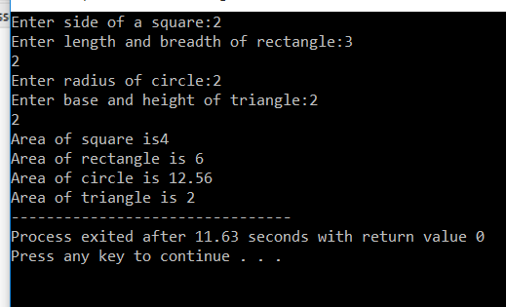

/*2. Define a class matrix with

Data member:

- Two dimensional array for 3*3 matrix

Member functions:

- To read matrix

- To display matrix in matrix format*/

#include<iostream>

using namespace std;

#include<conio.h>

class matrix

{

int a[10][10];

int m,n;

public:

void input();

void output();

void multiply(matrix,matrix);

};

void matrix::input()

{

cout<<"Enter the number of row and columns: ";

cin>>m>>n;

cout<<"Matrix"<<"\n";

for(int i=0;i<m;i++) {

for(int j=0;j<n;j++) {

cin>>a[i][j];

}

}

}

void matrix :: output() {

for(int i=0;i<m;i++) {

cout<<"\n";

for(int j=0;j<n;j++) {

cout<<a[i][j]<<"\t";

}

}

}

void matrix :: multiply(matrix m1, matrix m2)

{

if(m1.n!=m2.m){

cout<<"matrix multiplication is not possible";

}

else

{

for(int i=0;i<m1.m;i++){

for(int j=0;j<m2.n;j++) {

a[i][j]=0;

for(int k=0;k<m1.n;k++) {

a[i][j]=a[i][j] +( m1.a[i][k]*m2.a[k][j]);

m=m1.m;

n=m2.n;

}

}

}

}

}

int main()

{

matrix m1,m2,m3;

m1.input();

m2.input();

m3.multiply(m1,m2);

m3.output();

getch();

}

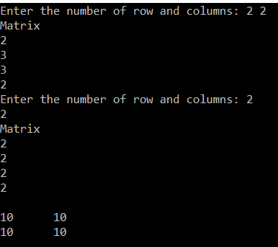

//PRINTING PATTERN

#include<iostream>

using namespace std;

int main()

{

int i,j,row;

for(i=1;i<=5;i++)

{

for(j=1;j<=5;j++)

{

if(j>=i)

cout<<"*";

else

cout<<" ";

}

cout<<endl;

}

return 0;

}

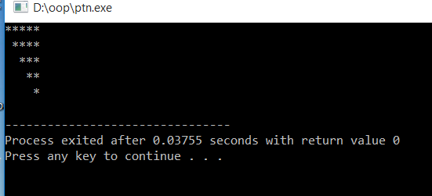

//palindrome or not

#include <iostream>

using namespace std;

int main()

{

int n, num, digit, rev = 0;

cout << "Enter a positive number: ";

cin >> num;

n = num;

do

{

digit = num % 10;

rev = (rev * 10) + digit;

num = num / 10;

} while (num != 0);

cout << " The reverse of the number is: " << rev << endl;

if (n == rev)

cout << " The number is a palindrome.";

else

cout << " The number is not a palindrome.";

return 0;

}

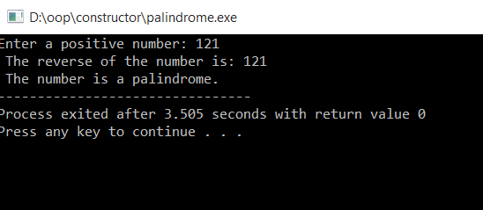

/*write aprogram to input the salary of person and calculate the HRA and DA according to the following condditions.

salary HRA DA

<5000 5% 2%

5000-10,000 10% 5%

10001-15000 15% 8%

>15000 17% 10%

*/

#include<iostream>

using namespace std;

int main(){

float salary;

float hra,da;

cout<<"enter the salary:";

cin>>salary;

if(salary<5000){

hra=0.05*salary;

da=0.02*salary;

}

else if(salary>5000&&salary<=10000){

hra=0.1*salary;

da=0.05*salary;

}

else if(salary>=10001&&salary<15000){

hra=0.15*salary;

da=0.08*salary;

}

else{

hra=0.17*salary;

da=0.10*salary;

}

cout<<"HRA="<<hra<<"\n"<<"DA="<<da;

}

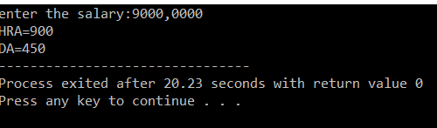

/*write a program to create a class account with data members account no,account holder's name and balance.add member function

create an object of the account class and show all operation with this

*/

#include<iostream>

using namespace std;

class account{

private:

int account_no;

char name[20];

float balance;

public:

void createAccount();

void deposite();

void withdraw();

void balanceEnquiry();

};

void account::createAccount(){

cout<<"enter your name";

cin>>name;

cout<<"enter account_no";

cin>>account_no;

cout<<"enter the balance";

cin>> balance;

}

void account::deposite(){

float depositeamt;

cout<<"enter the balance to deposite";

cin>>depositeamt;

balance=balance+depositeamt;

}

void account::withdraw(){

float withdrawamt;

cout<<"enter the amount to withdraw";

cin>>withdrawamt;

if(withdrawamt>balance){

cout<<"balance cannot be withdrawn";

}

else{

balance=balance-withdrawamt;

}

}

void account::balanceEnquiry(){

cout<<"the balance in your account_no"<<account_no<<"is"<<balance<<"\n";

}

int main(){

account b1;

b1.createAccount();

int choice=1;

while(choice!=0){

cout<<"1.deposite"<<"\n"<<"2.withdraw"<<"\n"<<"3.balanceenquiry"<<"\n";

cout<<"enter your choice(1-3):";

cin>>choice;

switch(choice){

case 1:

b1.deposite();

break;

case 2:

b1.withdraw();

break;

case 3:

b1.balanceEnquiry();

break;

case 4:

cout<<"exiting..";

}

}

}

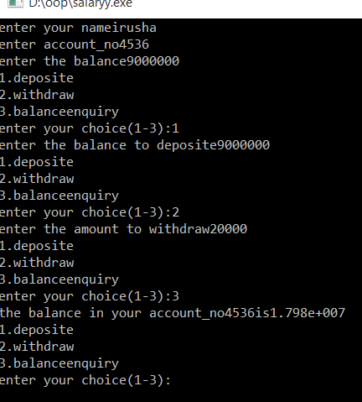

Samriddhi college

Assignment (lab3 and 4a)

Lokanthali,bhaktapur

Submitted by:irusha

basukala

Roll:9

Sub:oop(lan 3and 4)

Submitted to:jeevan sir

(department of 00p)