**Author: Marcel Boxberger, 188571**

○ **Implementation of the world and its visualisation**

The program is asking if we want to start a new simulation [N] or load state from a save [L].

When N is pressed, it asks about the size of the board. I entered the size 15x15.

Then we have a brief instruction about movement, special ability.

After proceeding, the simulation is launching:

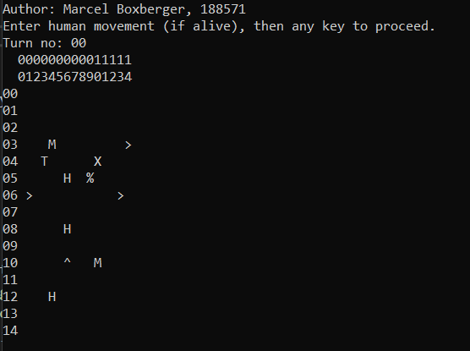

The simulation is randomly generating from 10 available species (every cell of the board has 5% chance to create an organism)

Class “God” is creating the world, and in class “World" we have all functions that are drawing the board.

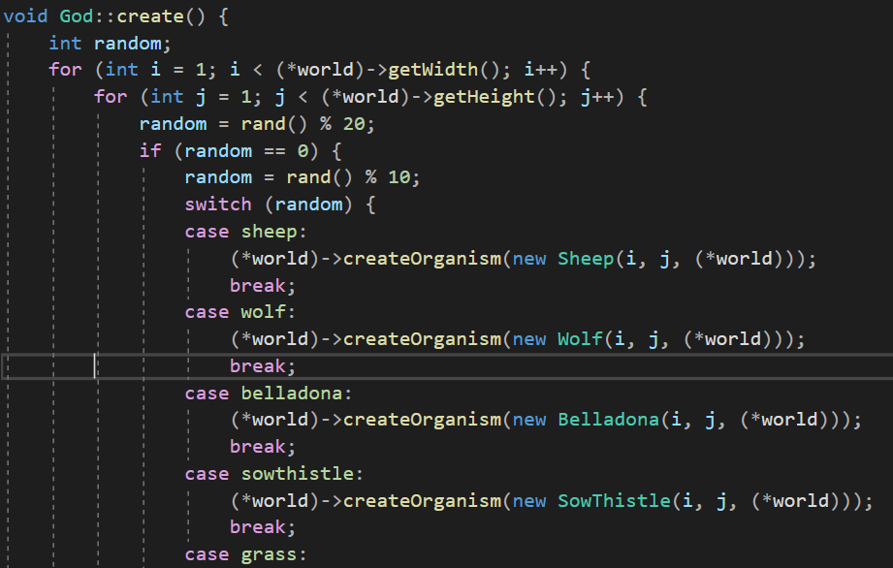

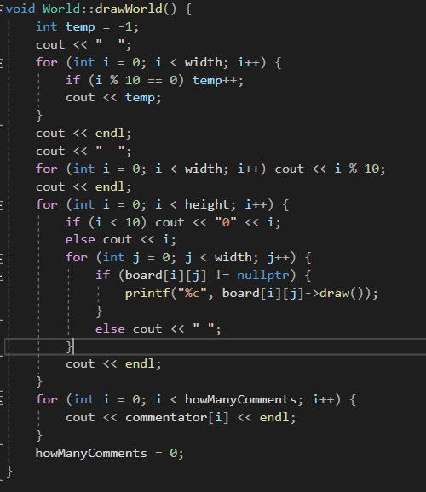

Organism.h :

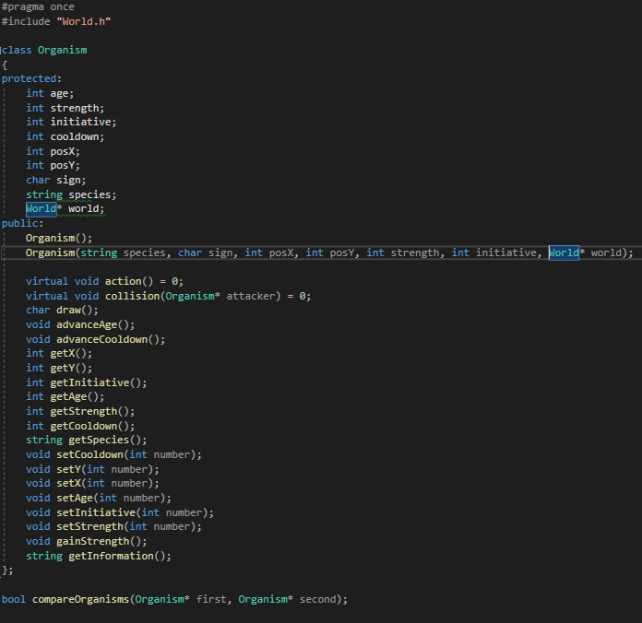

World.h :

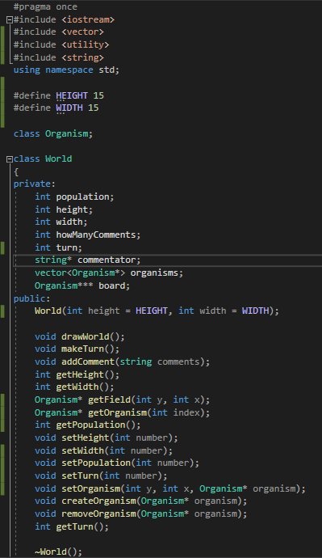

**○ Implementation of all required animals without breeding**

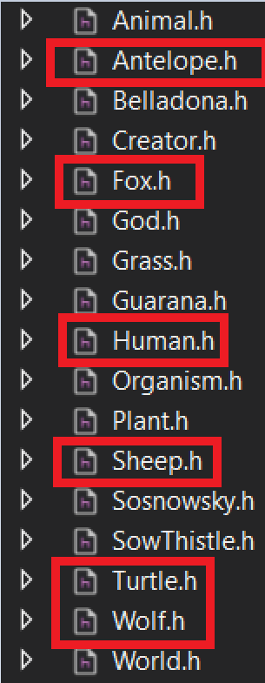

Every animal is working correctly (Turtle’s, Antelope’s, Fox’s actions are also implemented and are overriding default functions. Everything is in the files.)

○ **Implementation of all plants without sawing**

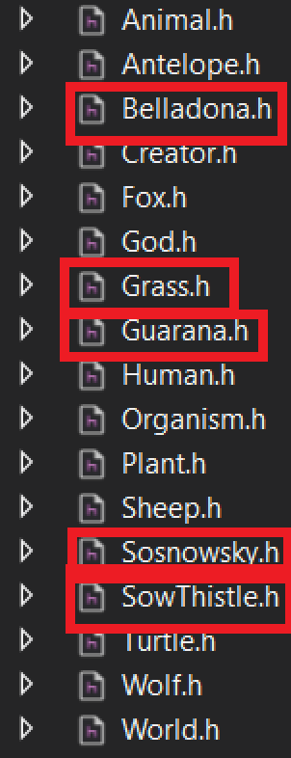

The same with plants. Everything is correctly implemented and special properties of sosnowsky, guarana and sow thistle are also correctly implemented, overriding basic functions with their own. For more details about special abilities/actions, check the files please.

○ **Implementation of a Human which can controlled by arrow keys**

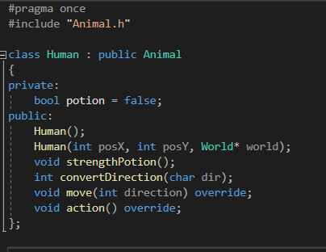

The human moves by using W/S/A/D keys. His sign is ‘T’, like a t-pose.

His special ability is the strength potion. It is increasing his strength to 10, then the strength is decreasing by one each turn till it is again normal. The potion has a cooldown equal to 5 turns.

**○ breeding of animals and sawing of plants**

**Breeding:**

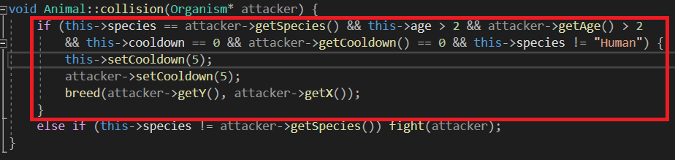

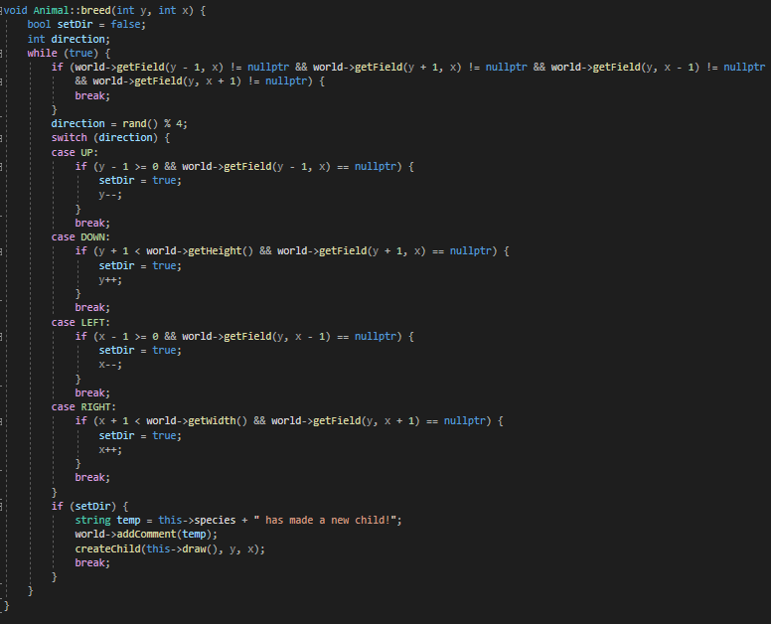

When two animals that have the same species meet, they are creating a new child. The breed method is searching for an available place next to the breeding couple. When there is no place. The child is not born due to overpopulation.

**Sowing:**

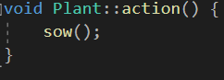

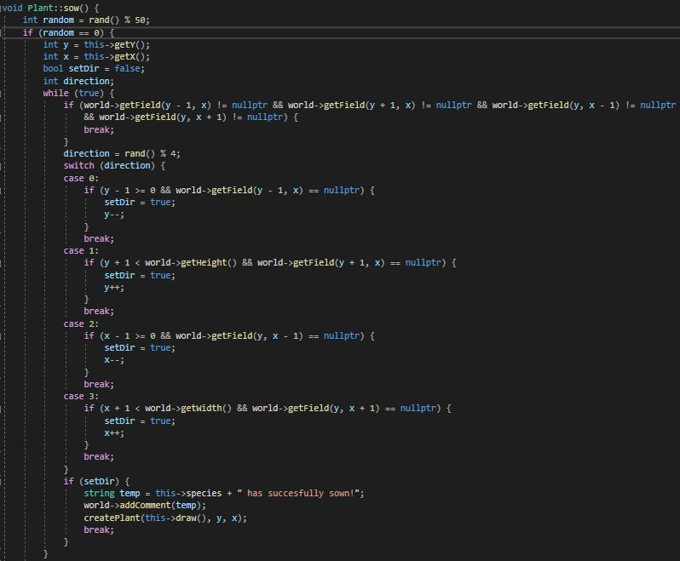

The same as breeding. Searching for a place next to the plant that is sowing, when there is no place, it is not doing anything.

**○ implementation of Human's special ability.**

His special ability is the strength potion. It is increasing his strength to 10, then the strength is decreasing by one each turn till it is again normal. The potion after worn off has a cooldown equal to 5 turns. It is activating when pressing P.

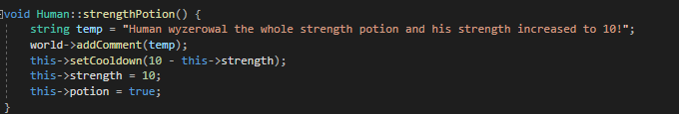

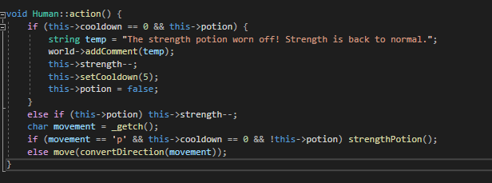

**○ Implementation of saving and loading state of the world to file and from file.**

Saving/loading is located in class “God”.

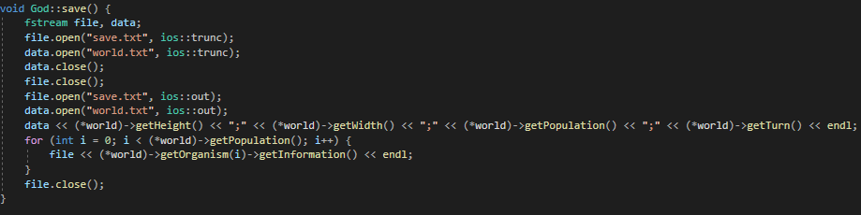

I am creating two .txt files: world.txt and save.txt

In world.txt I have the size and turn of the world.

In save.txt all organisms.

Loading world.txt :

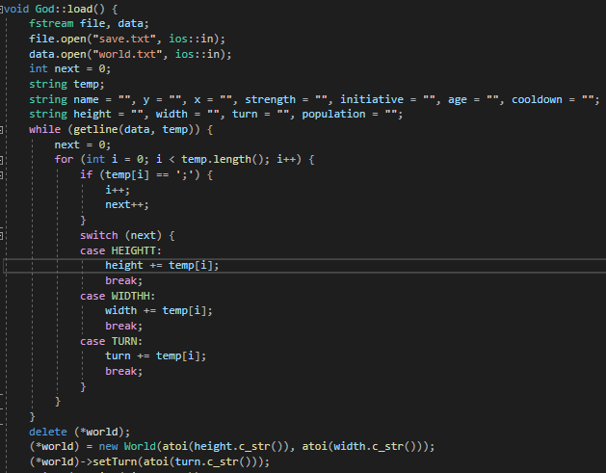

Loading save.txt :

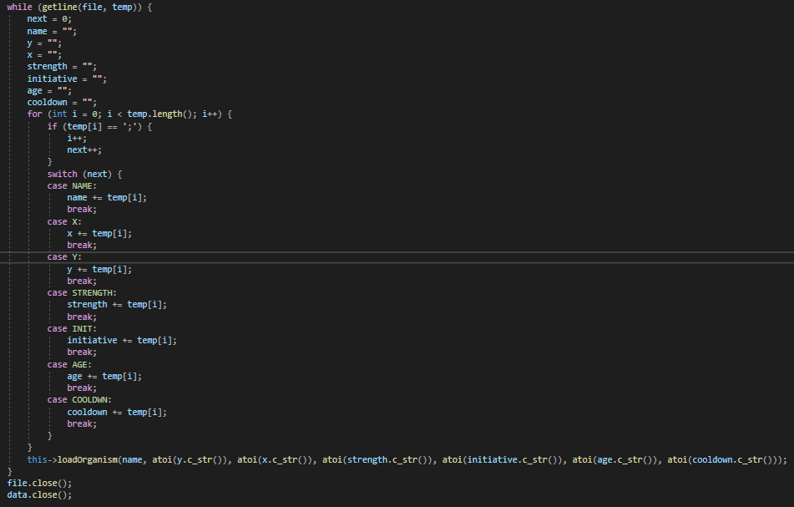

Example:

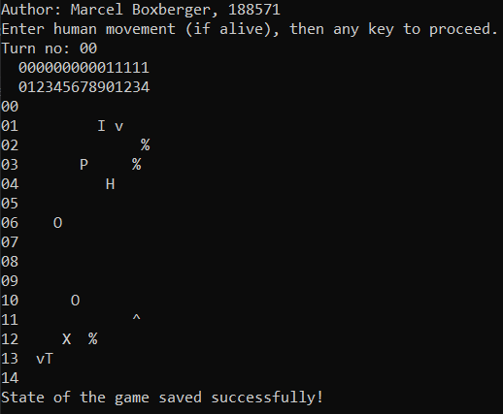

I created a new game and pressed [K] to save the state.

world.txt and save.txt :

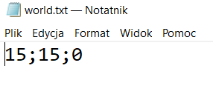 <- height ; width ; turn

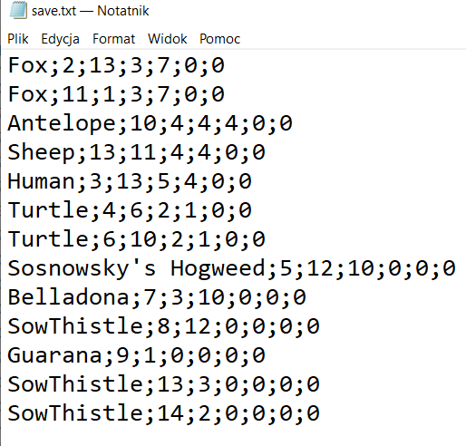

^ species ; position X ; position Y; strength ; initiative; age ; cooldown

After launching and pressing [L] to load, this is the result:

