**Author: Marcel Boxberger, 188571**

**3 points:**

* **Implementation of the world and its visualization**

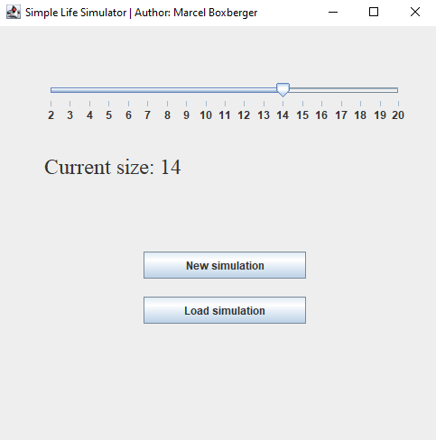

This is the menu where you can choose *New Simulation* or *Load simulation* of an earlier saved state.

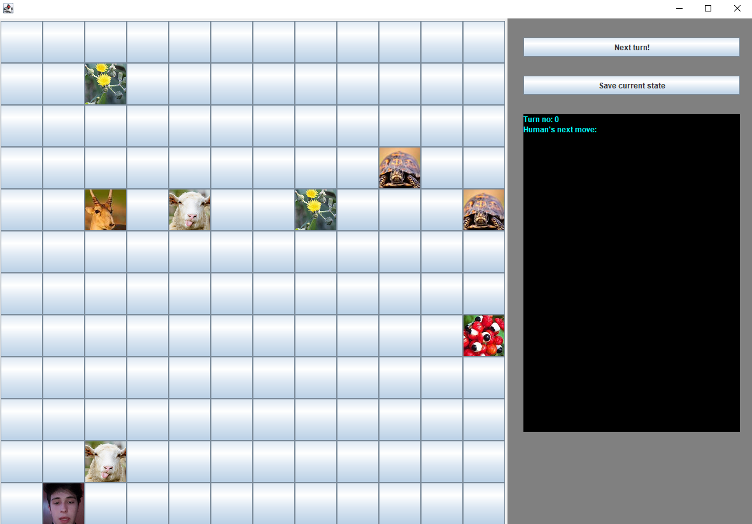

After choosing *New Simulation*, my program is randomly generating organisms (10% for each cell to create an organism, I can easily change the odds).

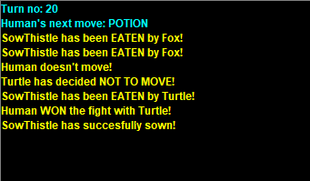

There is also a text box that comments updates after advancing to the next turn. It shows also *Human’s next move*, which is informing about the move we set for the next turn by using arrow keys.

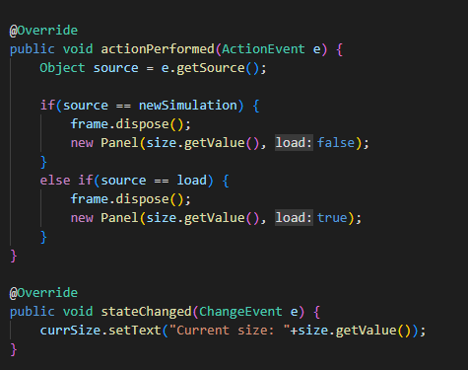

^ Actionlistener for menu

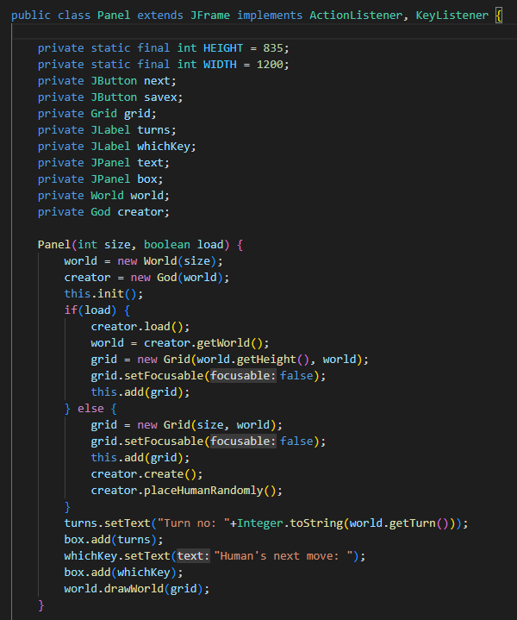

^ The Panel of the program

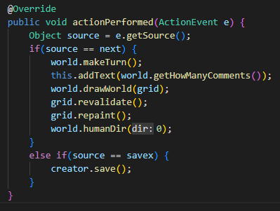

^ Panel’s action listener

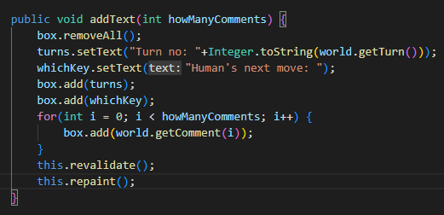

^ Text box refresher

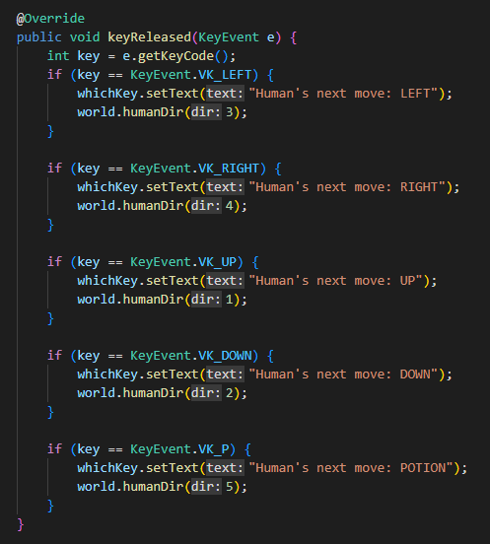

^ Text box’s key listener

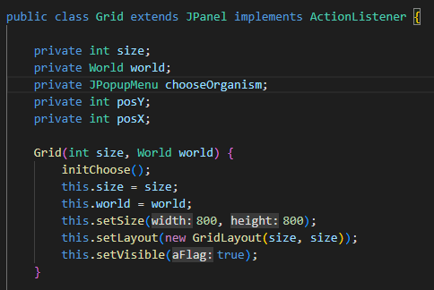

^ Grid of buttons constructor

**○ Implementation of all required animals**

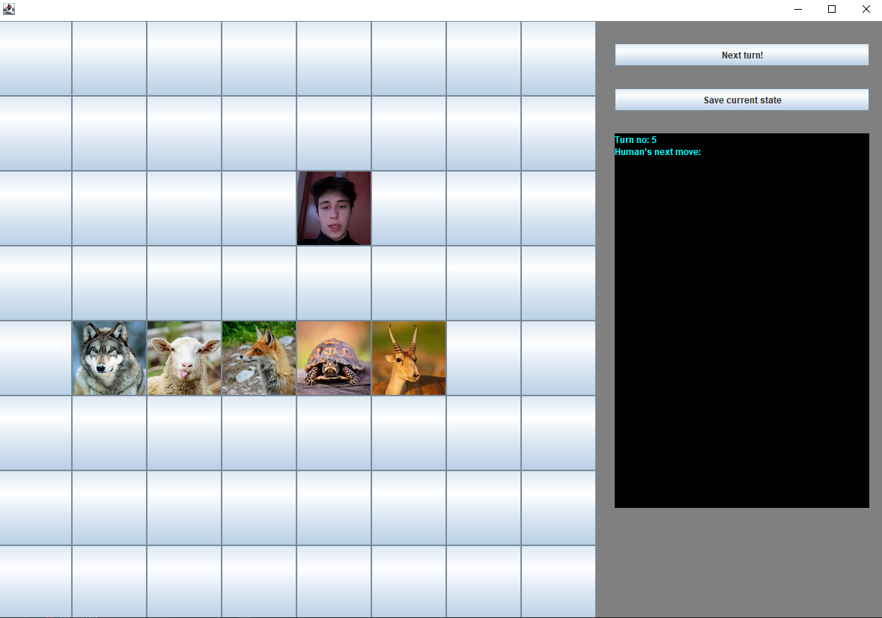

Here are my animals. Human above them is the author of the program (me).

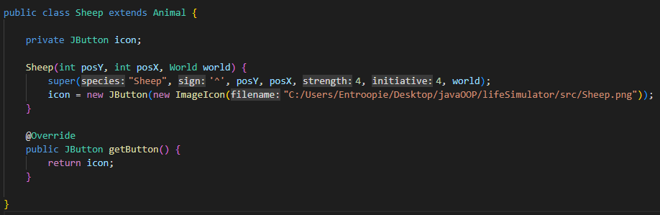

^ Example of an animal in the code

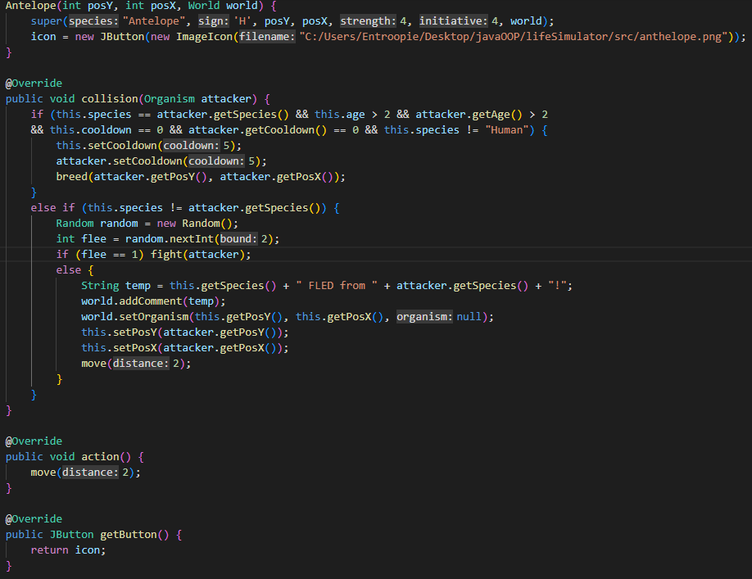

^ Example of an animal that is overriding some functions

**○ Implementation of all plants**

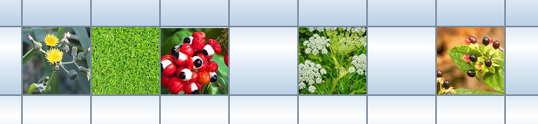

And here are the plants.

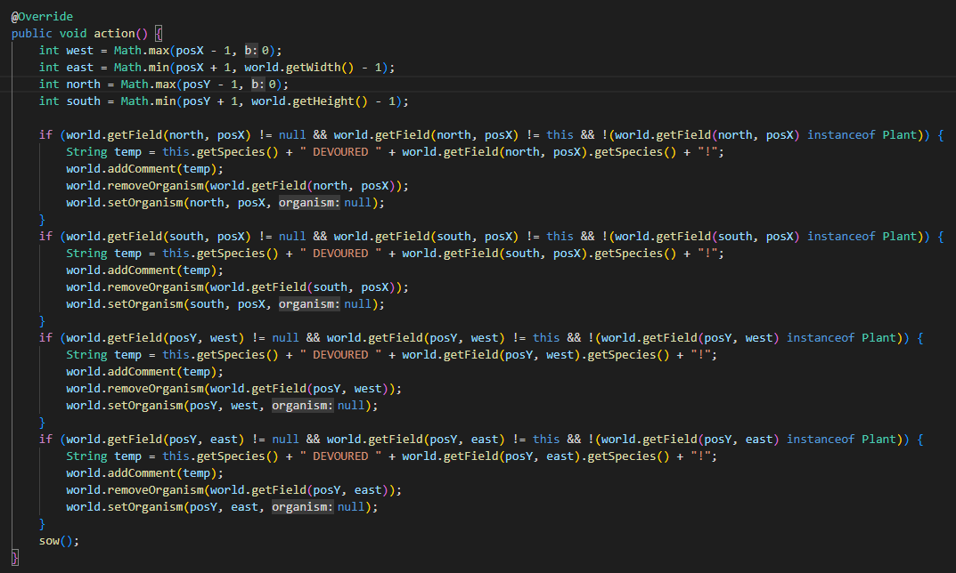

^ Sosnowsky’s function that is capable of killing neighboring animals.

**○ Implementation of a Human which can controlled by arrow keys.**

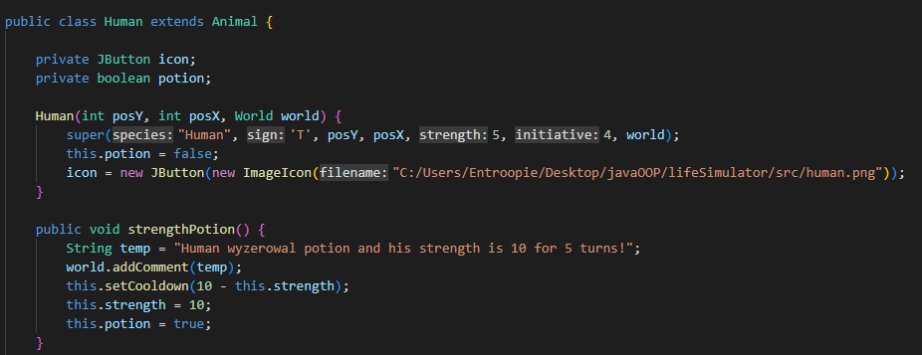

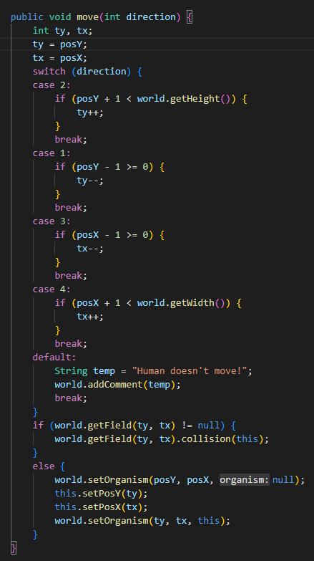

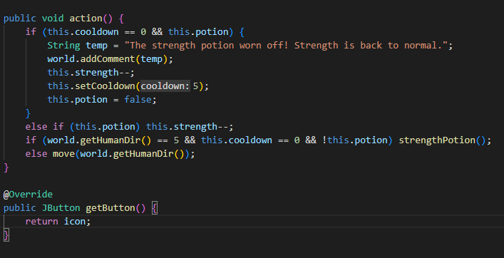

Here is the code of my human. Everything is working fine.

**○ Implementation of Human's special ability**

This is how potion is working in text box:

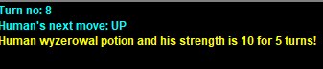

After 5 turns:

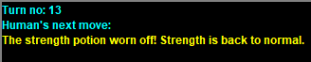

*The code of the potion is above, the strength potion is increasing human’s strength to 10 and is decreasing (by one per turn) till the strength is back to 5.

**○ Implementation of saving and loading state of the world to file and from file**

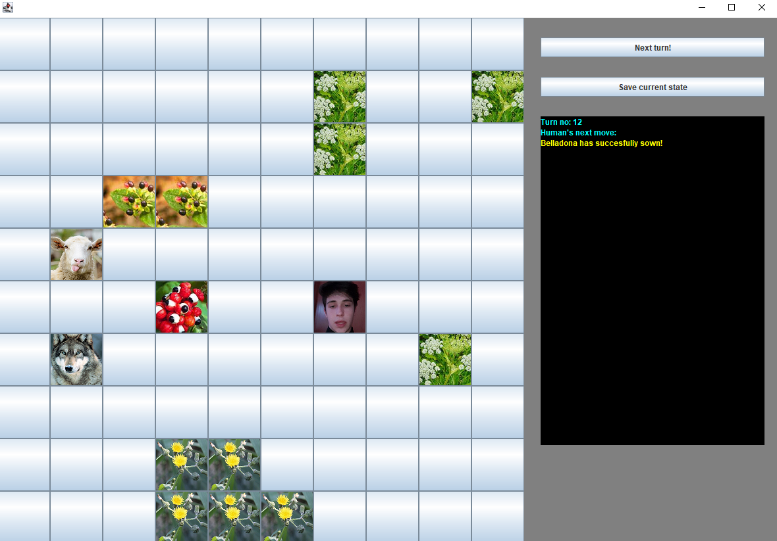

I have saved this state of the simulation.



The file after saving :

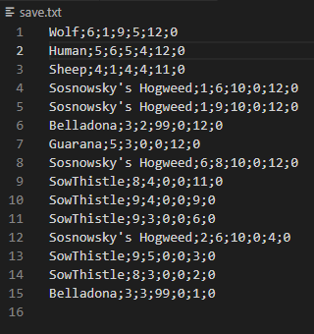

^ Save of the organism’s state (y, x, strength, initiative, age, cooldown)



^ Save of the world (size Y, size X, Current turn)

After loading:

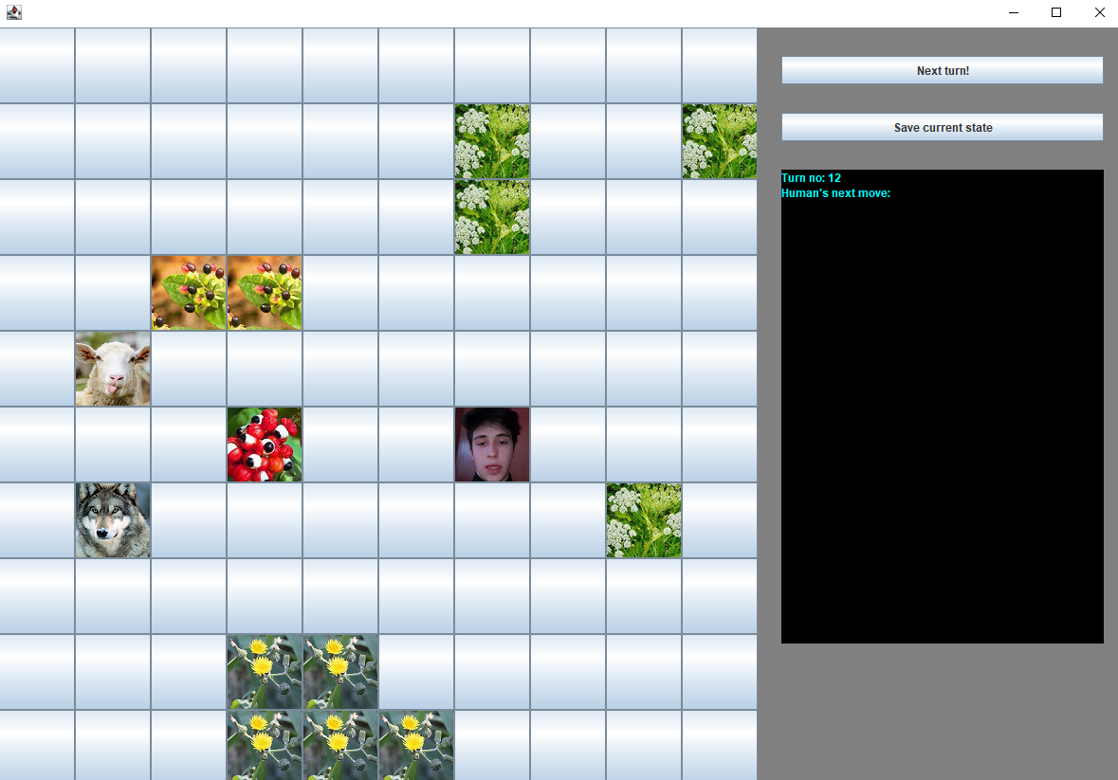



**4 points:**

**○ Implementation of adding a new organism to the word by clicking on a free map cell. It should be possible to add organisms of any kind.**

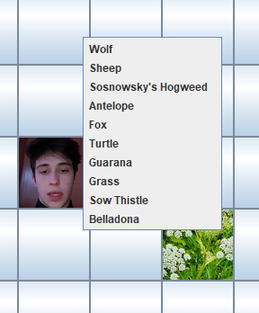 After clicking on a cell, a menu appears.

After choosing, the organism is being added. I have chosen the turtle.

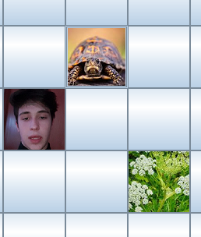

Here is the code:

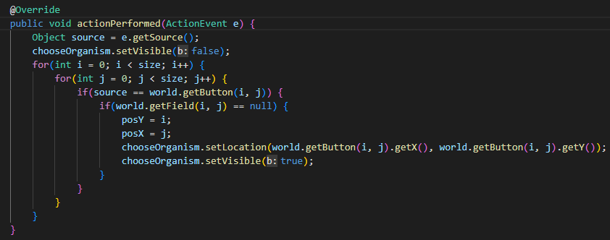

^ when clicking on a button on the grid (chooseOrganism is an instance of JPopupMenu)

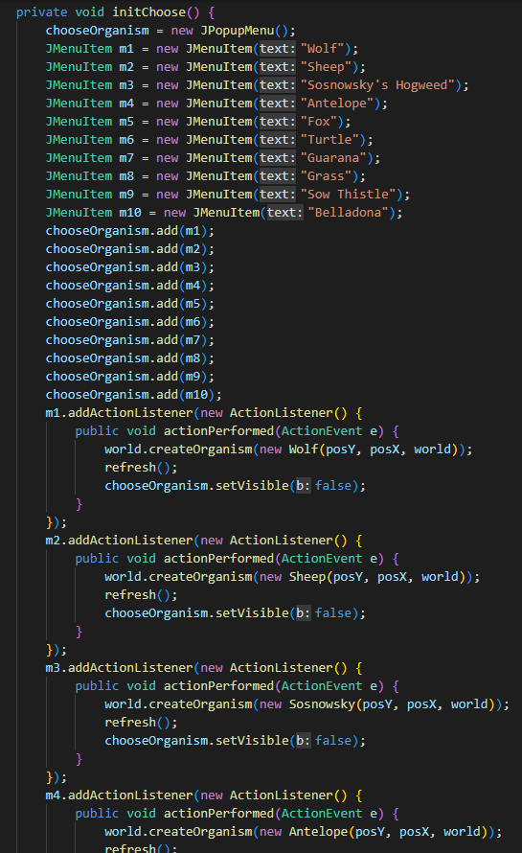

^ here is the popup menu initialization