* BASIC SETUP
- Sit or stand within reach of forge, soulforge, trashcan, and 2 secured bags.
- 1 bag should be empty, and used for the script to store elemental weapons
- 1 bag should have resources, such as ingots or boards, runic tools, and regular tools. It is used by the script to replenish resources to craft.
- Trashcan is to throw bows that are either not exceptional or not 100% elemental, script tries to burn using imbuing for magical residue before throwing them away.
- Metal weapons that are not exceptional or 100% elemental are instead burn in the forge for ingots.

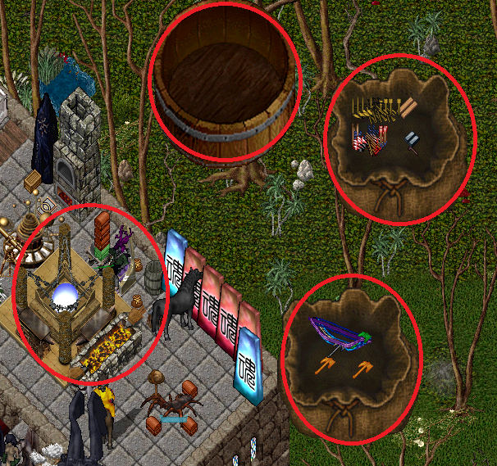

1) Add script to your enhanced scripting tab by:
- Copy script to your scripts folder (located in razor install)
- in razor go to enhanced scripting tab and click add
- Navigate and add script

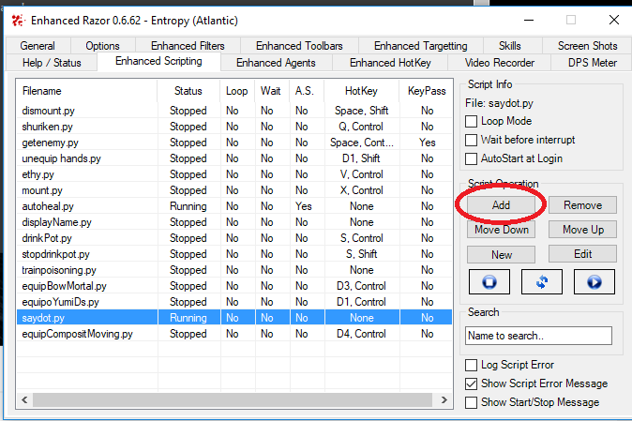

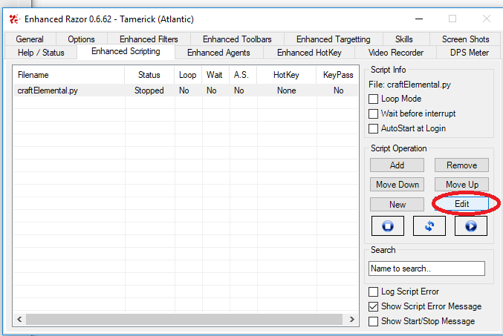

2) Setup script for crafting
- Click Edit an a window with the script will pop
- Scroll to the end of the script to edit

- On the screenshot below line 128 to line 141 are only comments, and provide useful ID’s
- You should only need to edit the following variables:
a) resourceBag : Serial
b) shadowToolColor :Color
c) toolID: ID
d) ingotID :ID
e)dAxeID :ID
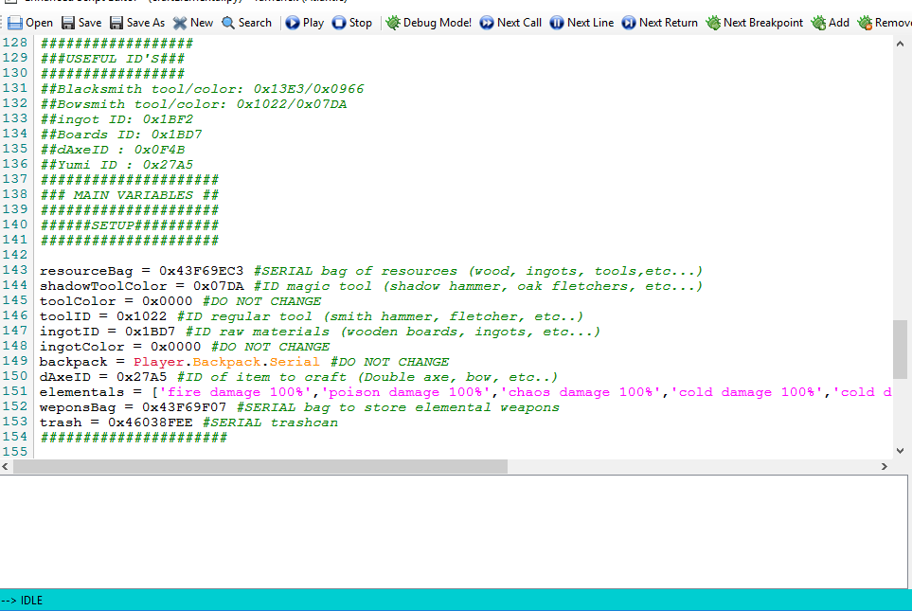
f) weponsBag: Serial
g) trash: Serial
- Most ID’s and colors are offered in the comments above, all you need to do is take the ID and replace it.
- To obtain an ID and/or Serial in game: On the script window click on “Inspect Entities” and target the object in game. A window pops up with information containing itemID, Serial, and color. Simply copy the ID and/or serial and/or color and replace with the variable in game.
- ItemID’s are general to an item (all items of same type have same ID). Regular tools and runic tools have the same ID’s, that’s why a color needs to be defined, so that the script can differentiate from both.
- Serials are UNIQUE to an item, that’s why you need to set up your resource bags and trashcan as serials.

3) Click play on script window.

