ITU - Telecommunications Standardization Sector  STUDY GROUP 16 Question 6  Video Coding Experts Group (VCEG)  31st Meeting: Marrakech, MA, 15-16 January, 2007 | Document VCEG-AE07  Filename: VCEG-AE07.doc

Question: | Q.6/SG16 (VCEG)
Source: | Stéphane Pateux  Orange – France Telecom R&D  4, rue du Clos Courtel – BP 91226  35512 Cesson Sévigné Cedex, France  Joel Jung  Orange - France Telecom R&D  38, rue du Général Leclerc  92794 Issy les Moulineaux, France | Tel:  Fax:  Email:  Tel:  Fax:  Email: | +(33)299124177  stephane.pateux@orange-ftgroup.com  +(33)145295366  joelb.jung@orange-ftgroup.com
Title: | An excel add-in for computing Bjontegaard metric and its evolution
Purpose: | Information
_____________________________

Introduction

The VCEG test conditions detailed in [1] recommend using the Bjontegaard metric described in [2] to provide relative gain between two methods, by measuring average difference between the two RD-curves.
We propose to make available to VCEG an Excel add-in that computes this metric. As an additional feature, this add-in allows to provide the bitrate saving between two methods, for a given objective quality and the PSNR-Y delta for a given bitrate which allows drawing the evolution of the metric.
This contribution explains the installation and usage of these macros and provides examples on real data given by the H.264 reference software [3].

BJM: Excel macro for computing the Bjontegaard metric

The Excel macro, named BJM() provides identical results as the software avsnr4 already available on the ftp site ftp://ftp3.itu.int/video-site/H26L/avsnr4.zip. The macro is enclosed in the file BJM.xla. An additional sample excel file VCEG-AE07.xls provides a showcase of the functionalities offered by this macro.

Syntax
BJM(data1, data2, output)

Input arguments:
- data1: 4 pairs of bitrate/PSNR for data set 1 (anchor).
- data2: 4 pairs of bitrate/PSNR for data set 2.
- output: select the type of the output.

Output:
- If output=1: percentage of bitrate saving between data set 1 and data set 2.
- If output=0: difference of PSNR between data set 1 and data set 2.
- #VALUE if an error in input arguments is found.

#VALUE! is returned to signal an error in the following cases:
- PSNR-Y input values are not in the range [0,99]
- Data sets have less or more than 4 bitrate/PSNR pairs.

Example

Table 1 gives the result of the encoding of the Foreman sequence (CIF resolution) for the Baseline and the High profiles configured as in the VCEG common conditions [1].

Sequence | QP | data1 |  | data2
Sequence | QP | H.264 High Profile |  | H.264 Baseline Profile
Sequence | QP | Bitrate | PSNR | Bitrate | PSNR
Foreman CIF | 22 | 686.76 | 40.28 | 893.34 | 40.39
Foreman CIF | 27 | 309.58 | 37.18 | 407.8 | 37.21
Foreman CIF | 32 | 157.11 | 34.24 | 204.93 | 34.17
Foreman CIF | 37 | 85.95 | 31.42 | 112.75 | 31.24

Table 1: Bitrates and PSNR for Baseline and High profiles for the Foreman CIF sequence.

With the values and the data set given in Table 1, the results of BJM are:

BJM (data1, data2, 0) = -1.18489792dB
BJM (data1, data2, 1) = 31.397426%

For comparison the results for avsnr are:

avsnr(data1, data2, 0) = -1.184900dB
avsnr(data1, data2, 1) =31.397429%

Note that following formatting are also possible for the set of data:

- rates are decreasing downward
85.95 | 31.42
157.11 | 34.24
309.58 | 37.18
686.76 | 40.28

- data are formatted in rows, rates are increasing from left to right or right to left

686.76 | 309.58 | 157.11 | 85.95
40.28 | 37.18 | 34.24 | 31.42

- data are in row and in column

  686.76 | 309.58 | 157.11 | 85.95
  40.28 | 37.18 | 34.24 | 31.42
  893.34 | 40.39
  407.8 | 37.21
  204.93 | 34.17
  112.75 | 31.24
- data are unsorted
85.95 | 31.42
309.58 | 37.18
686.76 | 40.28
157.11 | 34.24

Installation

The add-in is installed in the menu Tools / Add-Ins / Browse by selecting the file BJM.xla.

It may happen when opening an Excel file that the links to the macro are not correct. In that case, update the links at the opening of the file, or replace all occurrences of the old path (full path) by the new path. This can be done using the Edit/Replace function, and selecting “Within Workbook” in the Options.

In order to uninstall this excel add-in, you should perform the following steps:
- Close excel program.
- Locate the file "BJM.xla" and remove it from your computer
- Launch Excel.
- A error message occurs; ignore it by pressing OK button.
- Go to "Tools / Add-ins"
- Click on the "BJM" item, it will then ask you whether you would like to remove this add-in. Click Yes.

BJM_e: Excel macro for computing BJM evolution

Goal
The result provided by the BJM metric gives an average gain on 4 quantization parameters. The metric does not provide any information on:
- the evolution of the gain as the quantization parameters evolves,
- the gain at a given objective quality.

The first point can be of interest for algorithms that are more powerful on a particular range of QP (for instance at high bitrates). Having this information available can be useful to study the compatibility of tools such as those currently integrated in the KTA software [4][5].

The second point is useful for someone having a particular application in mind, to check if some tools are more adapted for his own application.

The proposed macro provides this new feature. This feature is based on the same cubic interpolation used for computing the Bjontegaard metric.

Syntax

BJM_e(data1, data2, xt, rateMode)

Input arguments:
- data1: 4 pairs of bitrate/PSNR for data set 1 (anchor).
- data2: 4 pairs of bitrate/PSNR for data set 2.
- xt: PSNR value for which the bit-rate gain is computed if rateMode=TRUE, otherwise
rate value for which the PSNR gain is computed.
- rateMode: select the type of the output:
  - bit-rate gain in % if rateMode = TRUE
  - PSNR gain in dB if rateMode = FALSE

Output:
- If rateMode=1: percentage of bitrate saving between data set 1 and data set 2 (for a given PSNR).
- If rateMode=0: difference of PSNR between data set 1 and data set 2 (for a given rate).
- #VALUE if an error in input arguments is found.

#VALUE! is returned to signal an error in the following cases:
- PSNR-Y input values are not in the range [0,99]
- Data sets have less or more than 4 bitrate/PSNR pairs.
- Psnr (or rate) is not in the intersection range of the provided data sets, to avoid drifts due to extrapolation of the RD-curves.

Example

If data1 and data2 are defined like in Table 2 and Table 3, the following values are obtained:
BJM_e(data1, data2, 31, 1) = #VALUE!
BJM_e(data1, data2, 32, 1) = 34.76
BJM_e(data1, data2, 33, 1) = 33.44
…
BJM_e(data1, data2, 40, 1) = 27.09

The graphs given in Figure 1 can be derived from these data. It shows the evolution of the bitrate saving relatively to the PSNR evolution (purple bars), and the results of the BJM metric (blue line).

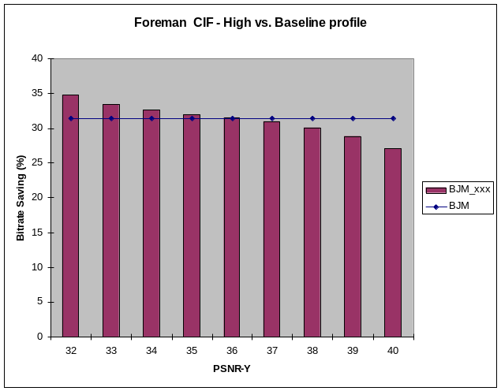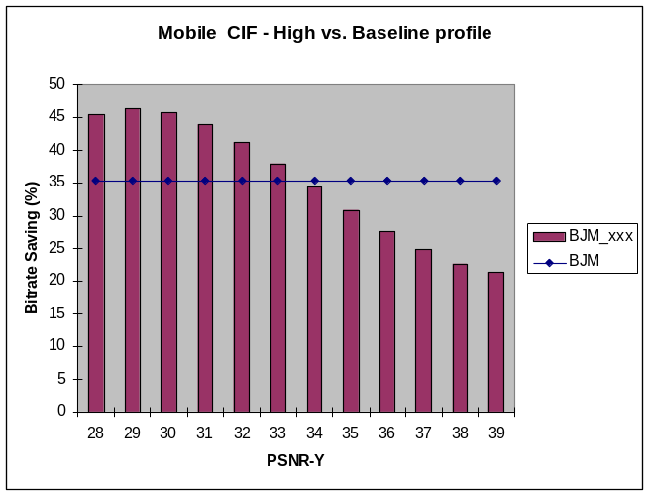

Figure 1: Bitrate saving relatively to PSNR-Y for Foreman and Mobile sequences.

Computing the gain for a set of sequences

In order to produce a graph for a set of sequences, it is recommended to compute first the gain for each PSNR-Y and each sequence, using BJM_e and make the average afterwards. Note that this result is different than the result obtained by averaging the bitrates and PSNR-Y for each QP first, and then apply the BJM once. An example of correct and wrong way to produce this kind of graph is given the VCEG-AE07.xls document (BJM evolution section).

IPR statement
Orange France Telecom R&D has no IPR connected to this contribution.

References
[1] TK Tan, G. Sullivan, T. Wedi, “Recommended Simulation Conditions for Coding Efficiency Experiments”, VCEG Contribution VCEG-AA10, Nice, October 2005.
[2] G. Bjontegaard, “Calculation of average PSNR differences between RD-curves”, VCEG Contribution VCEG-M33, Austin, April 2001.
[3] ITU-T. Recommendation H.264 and ISO/IEC 14496-10 AVC, “Advanced video coding for generic audiovisual services,” version 3: 2005.
[4] KTA software coordination, K. Suehring, http://iphome.hhi.de/suehring/tml/download/KTA/
[5] KTA software coordination, Y. Vatis, http://www.tnt.uni-hannover.de/~vatis/kta/

