To Hop Or Not To Hop

# Average 100m time and pulse on a marathon run!

# Introduction

## Scenario introduction

|  |  |
| --- | --- |
| A marathon runner is racing a track shaped as shown in figure 1, while equipped with sensor node A. The sensor node is broadcasting four packages per second tracking the runner’s pulse history. The level of details in the tracking package defines the number of marathons possible for the runner to run before a new battery is required. At one time the track was closed, resulting in the runner racing around the building of her workplace.  Protocol introduction “To hop or not to hop”  Node A will be broadcasting with a packet size of 128 Bytes. The base station will collect the data from node A when in range and save the data. The North station will, when in range and the base station is out of range, receive and relay the message to the base station. The same scenario will happen at the south station. Time Synchronization, Localization and Scalability will be considered regarding the protocol design. Each and combined scenarios will be evaluated in relation to signal strength relative to power consumption and data reliability. |  |

Figure 1: A marathon runner "node A" is racing around a track, while transmitting pulse information to the base station. In the red northern territory, node A transmits to the north station which relays the message to the base station. Likewise, at the southern station.

## Power consumption

### Source: Node A

Source node A will be transmitting at a periodic transmission rate. Different levels of power consumption will be determined by the chosen protocol, but, in any case, the power consumption will be considered, over a period of one second, constant. The less power consumption of node A will give longer individual lifetime and runtime for the runner, but low signal strength of node A might not give a lowest possible system power consumption. Depending on the needed quality of the received package, e.g. -84dBm, a cut of distance will be calculated and measured. Distance measuring will be limited by interference providing a need for a scalable transfer function estimate and an average over multiple measurements. Life time of node A will be considered when half of the battery capacity is used.

### Sink and Source: North and South Station

Idle time, receiving and transmitting power consumption will be calculated and measure. When out of range the “pole” stations will in theory go to an idle state to save power. When in transmitting mode different measurements will be conducted depending on the chosen protocol. E.g. firm or no handshakes between pole station and base station will be measured leading to different possible distances between jumps.

## Sink: Base Station

The required detail of information needed to give a good user estimate will raise the question of acceptable package loss. Signal strength, package frequency, package loss vs reliability from both pole stations and source will determine the power consumption of the base station and the system. The base station will never be in idle state and it must be able to reach pole station resulting in the highest cost function of the system.

# Theory

## Path Loss “Free Space Loss vs engineering building space loss”

|  |  |
| --- | --- |
| To be able to understand the need for relaying, one must first understand the boundaries of the chosen working environment. The range equation gives a nice theoretical reference point to how a far a certain quality signal can be transmitted in optimal conditions. The range equation is dependent on transmission frequency and characteristics of the transmitting and receiving antenna. The frequency dependency comes from the range equation calculation of the far field distance from the antenna pair. The far field distance is when the magnetic and electric part of the signal has a steady state phase relation. Also, the far field distance is dependent on the size and type of the antenna, while the Telosb has a 2.7cm inverted f-antenna and it is transmitting at 2.408GHz centre frequency. 2.408GHz transmission frequency is chosen from the standard IEEE_802.15.4, making 2.401GHz a ‘1’ and 2.408 a ‘0’. Trying to keep the frequency as low as possible gives longer transmit range. The radiation pattern, -3dB power line, of a Ferrite-based inverted F-antenna can be seen in figure 2 [6]. Focusing on protocol and power consumption the range equation will be visualized based on an omnidirectional antennas with same polarization, isotropic. | Figure 2:Estimation of an inverted F-Antenna radiation pattern |

Telosb software specifies transmission power in dBm and the receiving and transmitting antenna have same characterises, so the need to understand the antenna characteristics beyond the far field distance estimation is not needed for this project. Since the main scope of the project is package control protocol, each antenna is treated as an isotropic antenna being able to broadcast up to 100m in each direction as specified in the datasheet. To simulate a real scenario the transmitting antenna could be mounted on a rotational motor following the runner through computer vision hence the main beam, e.g. 153deg, of the antenna pattern would always point towards the runner verifying our calculation approach. Giving a far field distance of 0.01167m and optimal conditions in air, figure 3 shows the expected received signal strength indication, RSSI, based on the range equation, equation 1 and presumed assumptions.

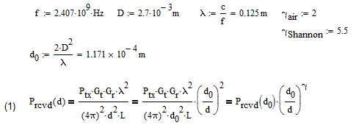

Equation 1: Range equation based on a 2.7cm wide inverted f-antenna and a 2.408GHz centre frequency

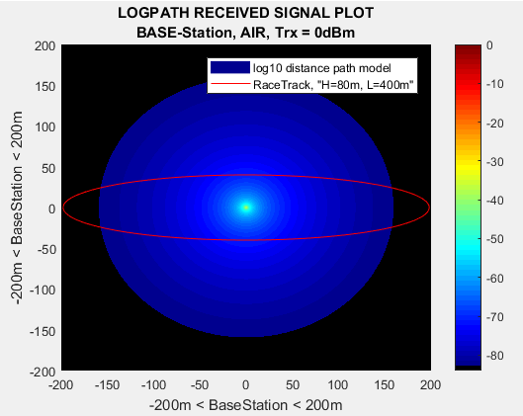

Figure 3:-84dBm received signal area of the race track. The antenna cannot cover the entirety of the racetrack.

Given a racetrack of 400m in width, under optimal conditions, as shown in figure 3, a telosb will not be able to cover the entirety of the race track and two additional relay “hop” stations must be applied to give sufficient cover. The antenna dimension and transmission power gives a natural boundary to which relaying will be the only option. Figure 4 (left) show the RSSI of the two relay stations in comparison to the base station, while figure 4 (right) shows the combined RSSI of the runner node.

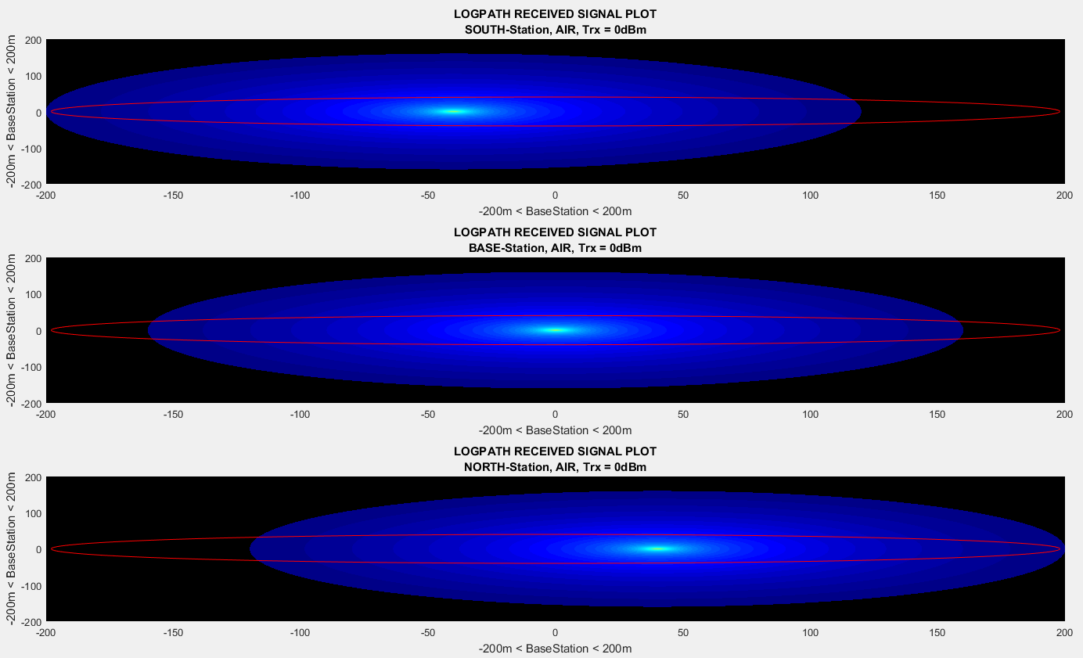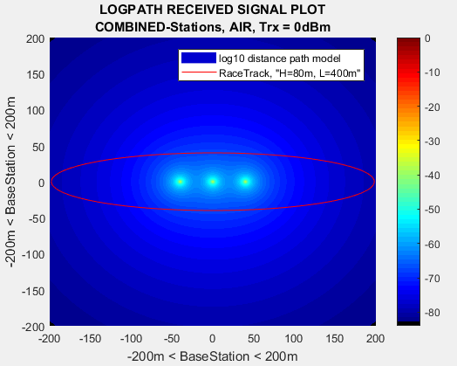

Figure 4: three stations covering the entirety of the racetrack and combined RSSI

Minimizing the transmission power can lead to extended life time of the individual nodes and the system all together, but at the cost of less coverage area. Figure 5 shows the single and combined RSSI of the runner node with all nodes using transmission power of -24dBm. The size of the race track now is only 7.5% of the full power track.

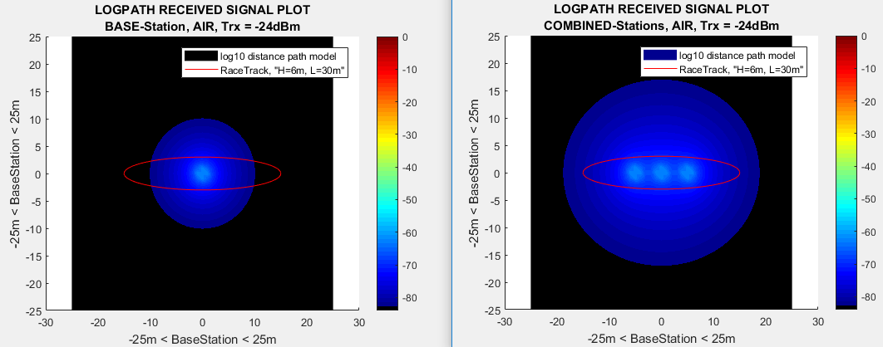

Figure 5: Three stations covering the entirety of the racetrack and combined RSSI

Further reduction in RSSI can happen for multiple reasons, e.g. reflection, diffraction, scattering and doppler fading. An easy noise model can be to change gamma_air in equation 1 to gamma_shannon, with values taken from page 93 [REF 1]. Figure 6 shows the distance at minimum Ptr and inside Shannon providing a stunning 0.035% of the coverage related to full power in open AIR.

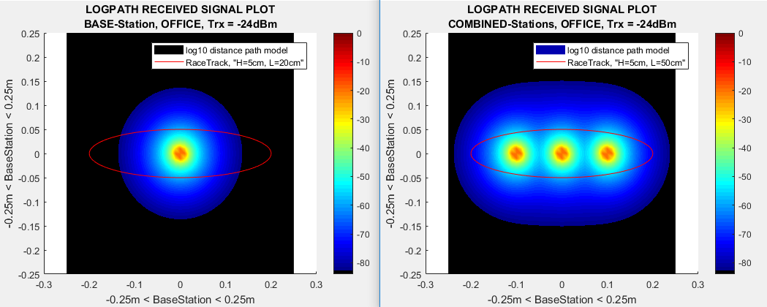

Figure 6: Three stations covering the entirety of the racetrack and combined RSSI

## Fading

The above plots all give a good estimate of the RSSI in a stationary clean environment with stationary nodes, but in case of a dynamic environment with obstacles, concepts like fading must be considered. Intrinsic and extrinsic electronic noise set the signal to noise ratio floor of the received signal, but more expensive electronics can compensate for the former noise source, and say no mobile phones at the racetrack can lead to less of the latter noise source, however the RSSI still will experience signal strength drops at times in a dynamic environment. The broadcasting behaviour of the wireless sensor network causes constructive and destructive interference at the receiver, which can lead to deep fading. Deep fading is the scenario in which two or more, out of phase, adequate signals arrive at the receiver simultaneously, leading to a critical destructive interference. The deep fading interferences causes the signal strength to fall below the established noise floor, deeming the signal unreliable or unmeasurable. In the scenario a receiver has experienced a deep fade, depending on the time length, or number of lost packages, the scenario is characterised as a fast fade or a slow fade. This is typically cause by reflection, diffraction or scattering of the signal, causing in line of sight (LOS) signal interfering with a none line of sight (NLOS) signals. The moving of the nodes relative to each other not only has interference, but they have a change in behaviour also. An example of behaviour changing fading is the doppler fading, in which the signal tends to shift in frequency relative to the movement of the sink and the source node.

### Doppler fading

Following the standard IEEE_802.15.4, it permits the Telosb to transmit in the ISM[1] band at frequencies between 2.4 and 2.4835 GHz. Having 12 channels, 2 MHz wide and separated by 5 MHz, the TelosB allows a centre frequency signal to shift +-1 MHz while still being acknowledged by the receiving channel. Does the signal shift the frequency more than 1 MHz, the receiving node will simply filter out the signal and the package will be lost. The sign of the shift in frequency depends on the distance between the source and the sink increasing or decreasing. The running node will be changing position relative to the base station at different speeds due to the shape of the track, so an investigation of the effect to the case was made. Firstly, the distance between a package, every quarter of a second, covered by a runner, running at 12kph, was calculated closest and furthest on the track relative to the base station. The runner is running circular, but the change in distance experienced by the base station will by a straight line leading to doppler frequency found at different speeds relative to track position. The results showed a 29.698Hz frequency shift at the end of the track, while the at the top of the track a 26.773Hz shift happened. The buffer of 1MHz was far beyond the results needed for danger of lost packages due to doppler fading. Just for scalability and flexibility the extreme case was also calculated for the system. Had the runner been running the package distance at approximately 50000kph doppler fading would have been an issue. Given the calculated results the project is focusing on fast and slow fading as a simulated instead. See appendix 2 for doppler calculations.

### Fast fading and slow fading

## Busty bit errors at the receiver is often measured in clusters with different duration or length. Fast fading clusters are typically in the range of tens to hundreds of milliseconds, before the received signal again is adequate, while slow fading clusters are in the range of tens of seconds to minutes. Fast fading and slow fading are both biproducts of the broadcasting behaviour of the nodes, while no clean separation can be made between the two, slow fading is referred to as a shadowing effect and fast fading can be simplified to reflection. E.g. a signal at 2.4GHz will have a wavelength of 12.5cm, given an opposite phased signal every 12.5cm. If the 2.4GHz LOS signal travels 1m to the sink and the NLOS signal travels 1.125m to the sink, they would cancel each other out. Unfortunately, the calculations of the reflected fading also must consider the directivity of the antenna, since the signal strength also varies at different angles from the source. An antenna with high directivity will since not have a full cancelation at the sink, since the LOS signal will have a higher amplitude than the NLOS signal. From [1, page 92] the drop-in signal strength can be estimated to be around 30-40dB (60-70dBm), and this is the values for both slow and fast fading chosen for the simulations in this project. Slow fading can represent diffraction and scattering of the signal from objects in between source and sink, e.g. more runners on the track or the photographer taking images along the route. The slow fading since is modelled as a random stochastic variable with a showing variance visualized through a lognormal fading plot. Given a shadowing variance of 2.22dBm and probability of occurrence at 10% for both fast and slow fading, fast fading effect is simulated to last 333 milliseconds while slow fading is simulated to last 14seconds. Figure 7a plots the base station RSSI including fading, while figure 7b plot the binary, received or lost package, output of the base station. Figure 8a plots the combined stations RSSI including fading, while figure 8b plot the binary output of the combined stations and figure 9 shows a combined stations plot, but with all three station signals being victims of individual fading patterns.

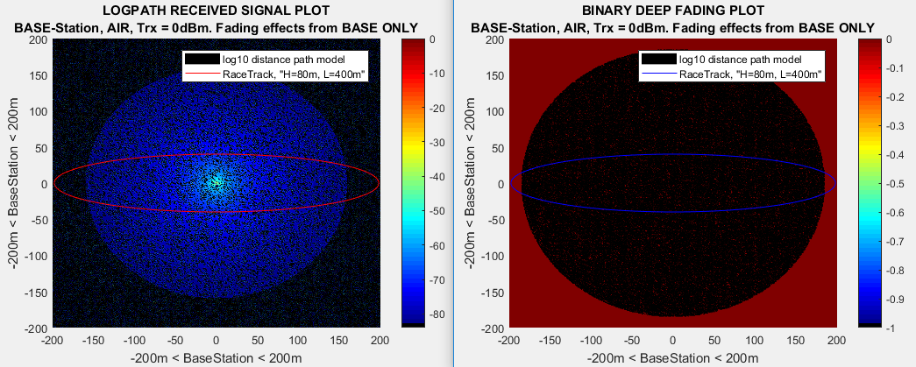

Figure 7: Base Station RSSI plot after base station experiencing fading (Left), Deep fading plot (Right)

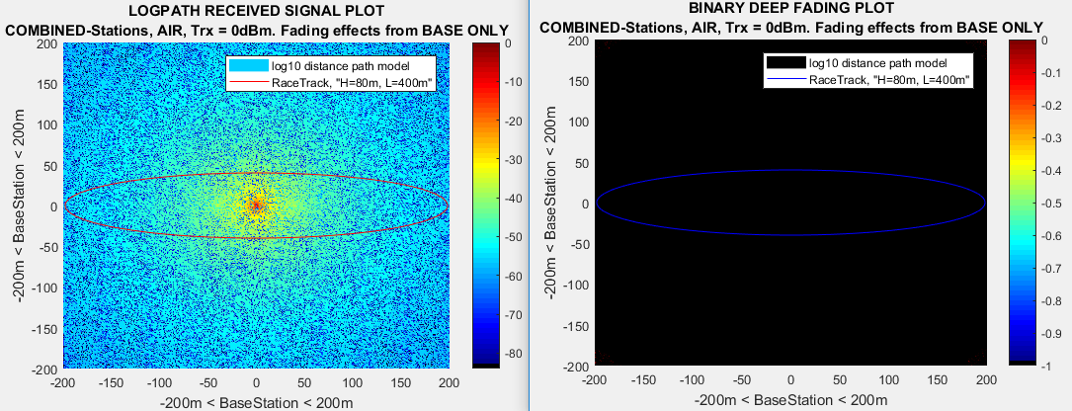

Figure 8: Combined Station RSSI plot after base station experiencing fading (Left), Deep fading plot (Right)

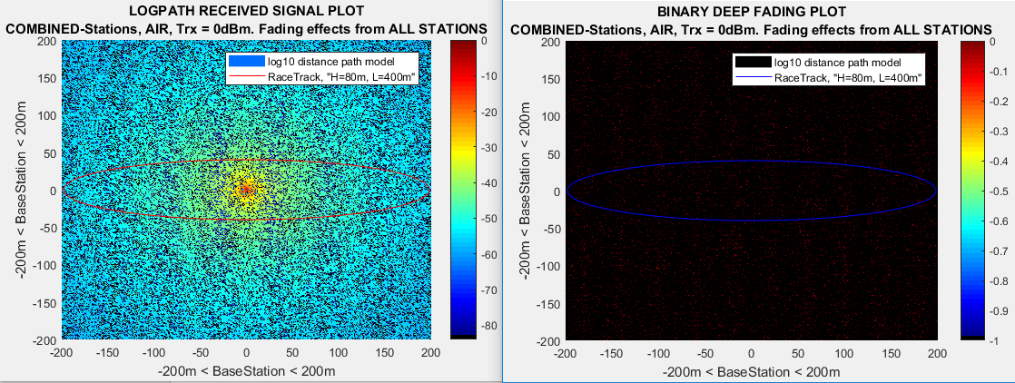

Figure 9: Combined Station RSSI plot after ALL stations experiencing fading (Left), Deep fading plot (Right)

## Protocol Decision Example

Figure 10 (left) shows the base station RSSI of a run around the track from start to finish, while figure 10 (right) shows the base station RSSI for 47 rounds, which equals to a marathon, and each round has different fadings. Figure 11 shows the in range of the base station packages which needs to be relayed or not.

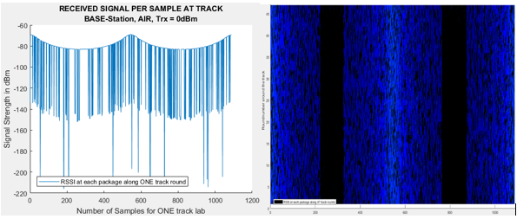

Figure 10: (Left) RSSI plot of a single run around the track, (Right) RSSI plot of 47 runs (marathon) around the track

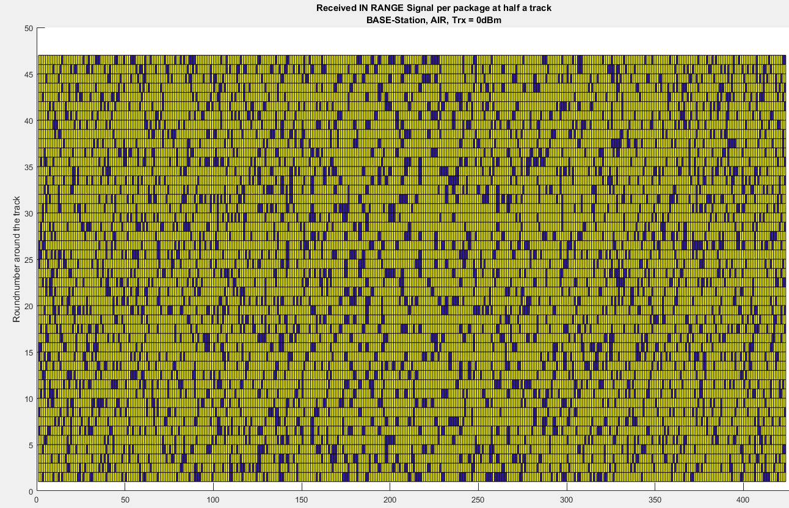

Figure 11: In, half a track, base station RSSI transmitting range ToHopOrNot plot. Blue is relayed packages while yellow is direct package.

A multi-linear regression line estimation was process on the simulated data based on distance, signal strength and package status, relayed or not, trying to determine whether to relay or not the next package. Since in our simulation signal strength and distance are strongly correlated, due to antenna approximation and the binary behaviour of the fading, they cancel each other out, while the previous package status shows a 10% likelihood of the next package needing to be relayed. Again, it is also expected since the simulations have fading behaviour added as a random variable appearing randomly at a 10% likelihood. A real-life excursion of the case would be interesting to see the analysis on, but it, unfortunately, is a bit out of scope for the project. Figure 12 show the regression plot with the equation added as a legend box.

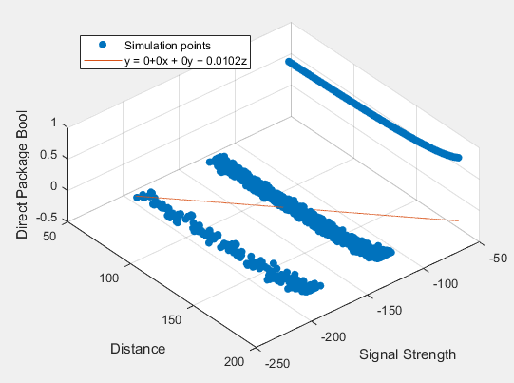

Figure 12: Regression plot of the three variables, distance, RSSI and Relayed or not packages. The regression line is representing a change from direct transmission to relaying.

## Power Calculations

In every wireless network system power consumption is a must to evaluate. Based on measurement, see section ???, some calculations were made. Since power consumption is not the main investigation of the project, only lifetime for the base station is done in theory. An assumption of every package is send directly to the sink successfully and immediately a respond is send also successfully. Total latency between the two nodes is set as constant to 12 milliseconds and an overshoot time at powerup from sleep mode is also constant at 50 milliseconds and 40% extra power related to receiving power. Overshoot after wakeup is modelled as a gaussian function as shown in figure 13 for max power wakeup. Table 1 shows the lifetime of the base station at six different scenarios all assuming two full AA-batteries[2].

Scenario 1: Full power at transmission and otherwise always listening for packages

Scenario 2: Min power at transmission and otherwise always listening for packages

Scenario 3: Full power at transmission, only listening for packages when receiving and no overshoot.

Scenario 4: Min power at transmission, only listening for packages when receiving and no overshoot.

Scenario 5: Full power at transmission, only listening for packages when receiving and overshoot at power up.

Scenario 6: Min power at transmission, only listening for packages when receiving and overshoot at power up.

Calculations are in appendix ?? and even though it cost to power up from sleep mode, it is still gives longer life time to put the nodes to sleep.

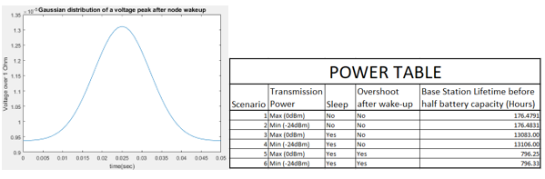

Figure 13: (Left) Start up power peak after sleep mode, (Right) Half capacity battery lifetime table for the base station!

1. Industrial, Scientific, and Medical Band 
2. AA Battery https://en.wikipedia.org/wiki/AA_battery "RAM"