CCMX FORM 5 - INTERIM SCIENTIFIC report

**Analytical Platform Project**

This report should be sent by e-mail in both Word and pdf fomats to [reporting@ccmx.ch](mailto:reporting@ccmx.ch)

Scientific reporting questions may be addressed to: nathalie.jongen@epfl.ch

|  |  |
| --- | --- |
| Platform | [X] NMMC |
| **Project title** | **Gantry-based X-ray Phase Contrast Scanner for MicroCT Applications** |
| **Principal investigator (PI)** | **Prof. Dr. Marco Stampanoni**  **ETH Zürich and Paul Scherrer Institut** |
| **Co-applicant(s)** | Christian Kottler, Senior R&D Engineer, CSEM Zürich, |
| **Industrial partner(s)** | Bruno Koller, CEO SCANCO Medical AG |
| **Reporting period** | **01.01.2013 to 31.12.2013** |

I, Prof. Dr. Marco Stampanoni, hereby declare that the information in this report is complete and true.

The report has been approved by all the project partners.

|  |  |  |
| --- | --- | --- |
| Signature | Date | Location |

# CCMX FORM 5 – INTERIM SCIENTIFIC SUMMARY

# FOR THE PERIOD COVERING 01.01.2013 TO 31.12.2013

**1. Executive Summary (max. 10 lines)**

The project foresees the development of a high-energy, gantry-based phase contrast system based on grating interferometry. This approach allows recording absorption, differential phase and dark-field signals simultaneously, returning information about sample attenuation, electron density and small-angle scattering power. In 2013 we manufactured and commissioned a gantry system using a novel grating frame architecture and developed all necessary software tools.

The edge-on illumination of the gratings allows to overcome the limitations in the fabrication process. In the new design, the gratings are illuminated from the side, so that an arbitrary aspect ratio can be achieved with the current technology. Interferometers with energies of 100 keV and 120 keV were designed and operated on a lab source at PSI.

**2. Project goals.**

The goal of the project is to develop a table-top, gantry-based X-ray phase contrast microCT scanner. It will be dedicated to a broad field of applications, such as biomedical imaging, inspection and non-destructive testing. Its specific strength resides in high sensitivity for weakly absorbing materials with a resolution down to a few micrometers. At the end of the project, the system will be available in the framework of the CCMX analytical platform.

The two main goals are:

1. Development of a gantry system (accommodating the X-ray source, image detector and interferometer), to enable the measurement of realistic samples, in the best case in-vivo samples, including dedicated acquisition protocols to allow efficient and fast measurements.
2. Access to high-energy applications with demanding geometries (compact setups and fan beam illuminations), requiring the design of innovative grating solutions.

**3. Summary of milestones and achievements during the reporting period (max ½ page).**

The project essentially poses two main challenges. These are, on the one hand, the development and realization of a new grating-based imaging concept to access high X-ray energy and, on the other hand, the implementation of a compact grating interferometer on a gantry system for fast and high resolution data acquisition. The first challenge will be addressed by introducing a novel illumination scheme dubbed “edge-on grating illumination”, the second will be realized with the use of conventional, planar gratings. The project has been designed in such a way that – at the end – both approaches could be combined. Due to the significant cut to the budget, however, we expect this last step not to be realized within the context of the present project.

In 2013 the compact gantry system containing source and detector, a novel, robust design of a grating interferometer and a sample manipulation stage was constructed and put into operation. The system is made such that it rotates horizontally around the sample, but could in principle also be mounted on a vertical rotation stage. To reduce image degradations due to thermal expansion of the interferometer the whole grating holder and adjustment structure was made of Invar, which has a very low expansion coefficient. The grating alignment in four axes is fully motorised and can be controlled on a computer. The grating manufacturing was unfortunately a bit delayed and therefore we first had to use preliminary gratings containing many defects. For the final setup new gratings with a low defect density will be available.

Two high-energy edge-illuminated systems have been built in 2013 at the Paul Scherrer Institute. The designs were optimized for an energy of 100 keV and 120 keV respectively. Both setups can now be reliably aligned with six degrees of freedom on every grating holder. A stable operation was therefore achieved, although with a reduced visibility around 6%. Scanning electron microscope inspections of the gratings manufactured by Microworks GmbH (Germany) highlighted many imperfections and inconsistencies in the structures, leading to a reduction in the visibility and sensitivity of the system. The source of these defects was later identified in the mask used for the lithography and a new mask and gratings are currently being designed at the Karlsruhe Institute of Technology (Germany).

The first images on a conventional X-ray source at 100 and 120 keV were recorded with a grating interferometer, and complementarity of the phase and dark-field contrasts was shown.

**4. Description of the achieved results (max. 4 pages).**

**5. Assessment of project progress.**

Did the project run as planned? [ ] Yes [X] No

# Were the project goals reached? [X] Yes [] No

If no to either question, please describe why.

The project had a very slow start due to the significant budget cut to one of the project partners. Because of this, we had to revise our plans and adapt the strategy to the reduced resources, which resulted in a delayed start.

The company in charge of manufacturing the edge-on gratings experienced unexpected, severe, difficulties in fabricating our structures, resulting in a 6 months delay in the delivery of the first bunch of gratings, which, as described in the report, was not satisfying.

As a consequence, we reached our milestones, but not on time. We also had to ask for a project prolongation until end of February 2014.

# If PhD theses were being financed, did they progress as planned? [ ] Yes [ ] No

If no, please describe why.

# Please indicate the anticipated date of the thesis defence of the PhD candidate(s). When available, please submit a copy of the thesis.

If the thesis has already been defended, please indicate the title and submit a copy of the thesis.

**6. Have publications/presentations of the project results been made?** [ X] Yes [ ] No

If yes, please list the publications in the following order (please ensure to adhere to the formatting of bold, italics etc.):

First name initials Author 1, Last Name Author 1, First name initials Author 2, Last Name Author 2, etc, **Title**, *Journal*, volume (year), 1st page-last page.

Please organize the publications/presentations into the following categories:

1) reviewed ISI-publications,

2) non ISI-publications,

3) theses,

4) posters and talks at conferences,

M. Abis, T. Thuering, Z. Wang, C. David, M. Stampanoni, “Phase-contrast imaging at 100 keV”, poster at the JUMPSI meeting, 14th September 2013.

**7. Have inventions been made and/or patents filed?** [ ] Yes [X ] No

If yes, please describe / if no, are any envisaged?

**8. Description of industrial interest and involvement.**

a) Describe the technical contribution to the project by the industrial partner(s)

b) Is a commercialization strategy in place?

**9. Tell us about any success stories in your research projects: key scientific findings, interactions between research groups, prizes won such as best talk or poster… (10 lines max. per success story)**

**10. Please send electronically up to 5 pictures including a relevant caption (scientific topic or people) which may be used in CCMX publications (printed & website).**

\\strzh01-a-248\proj-p\743-FP.0235_CCMX_GANTRY\4_PROJECT_EXECUTION\INFORMATION\IMG_7515.JPG

The gantry-ready system at CSEM, with X-ray source (left), interferometer and detector (right).

\\strzh01-a-248\proj-p\743-FP.0235_CCMX_GANTRY\4_PROJECT_EXECUTION\INFORMATION\IMG_7513.JPG

A close-up view of the interferometer containing two gratings and pico-motors for their alignment (in red).



Moiré-fringes from a slight misalignment of the two gratings prove that the interferometer is working. The white spots are due to defects in the preliminary gratings. The final version will contain gratings of higher quality.

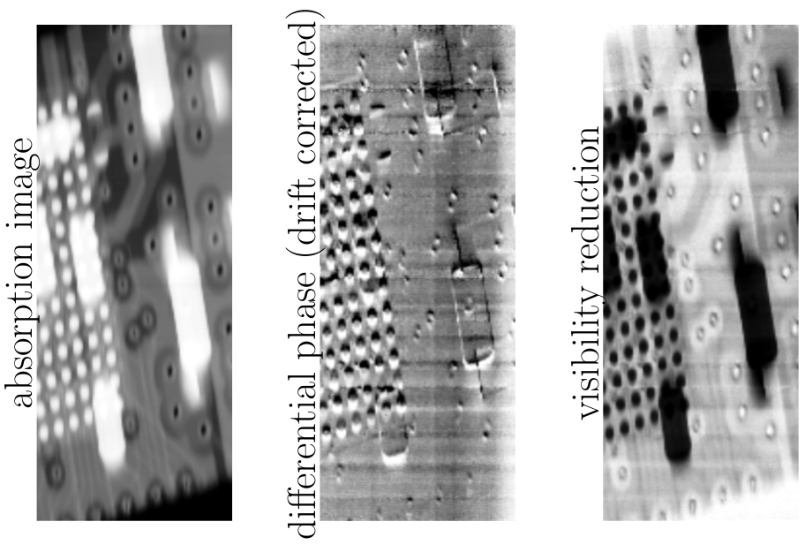

One of the first images taken with the 100 keV grating interferometer. An electronic chip is scanned in 100 micrometer steps, a phase and dark-field signal are obtained. We can see that the multilayer structure with the soldering joints is better revealed in the differential phase image, even under the strongly absorbing resistors.

**11. Remarks.**