# CCMX FORM 7 - FINAL SCIENTIFIC report

# Anayltical Platform project

This report should be sent by e-mail in both Word and pdf fomats to [reporting@ccmx.ch](mailto:reporting@ccmx.ch)

**within 60 days of the project end date.**

Scientific reporting questions may be addressed to: nathalie.jongen@epfl.ch

|  |  |
| --- | --- |
| Platform | [X] NMMC |
| **Project title** | **Gantry-based X-ray Phase Contrast Scanner for MicroCT Applications** |
| **Principal investigator (PI)** | **Prof. Dr. Marco Stampanoni**  **ETH Zürich and Paul Scherrer Institut** |
| **Co-applicant(s)** | Christian Kottler, Senior R&D Engineer, CSEM Zürich, |
| **Industrial partner(s)** | Bruno Koller, CEO SCANCO Medical AG |
| **Reporting period** | **1. 10. 2011 to 28. 2. 2014 (enter contract start to end date)** |

I, ______________________, _________________hereby declare that the information in this report is

“Name” “Title”

complete and true. The report has been approved by all the project partners.

|  |  |  |
| --- | --- | --- |
| Signature | Date | Location |

# CCMX FORM 7 – FINAL SCIENTIFIC SUMMARY

# 1. 10. 2011 to 28. 2. 2014 (ENTER IN THE ENTIRE PERIOD OF THE PROJECT)

**1. Executive Summary (max. 10 lines)**

In this project we developed a high X-ray energy grating technology and a gantry-phase contrast system based on grating interferometry, which will be combined in the future. This approach allows recording absorption, differential phase and dark-field signals of relevant samples like e.g. lab animals simultaneously, returning information about sample attenuation, electron density and small-angle scattering power.

**2. Project goals.**

The goal of the project was to develop a table-top, gantry-based X-ray phase contrast microCT scanner. It is dedicated to a broad field of applications, such as biomedical imaging, inspection and non-destructive testing. Its specific strength resides in high sensitivity for weakly absorbing materials with a resolution down to a few micrometers. The two main goals are:

1. Development of a gantry system (accommodating the X-ray source, image detector and interferometer), to enable the measurement of realistic samples, in the best case in-vivo samples, including dedicated acquisition protocols to allow efficient and fast measurements.
2. Access to high-energy applications with demanding geometries (compact setups and fan beam illuminations), requiring the design of innovative grating solutions.

**3. Summary of milestones and achievements during the reporting period (max ½ page).**

Gantry-setup:

The compact gantry system containing source and detector, a novel, robust design of a grating interferometer and a sample manipulation stage was constructed and put into operation. The system is made such that it rotates horizontally around the sample, but could in principle also be mounted on a vertical rotation stage. To reduce image degradations due to thermal expansion of the interferometer the whole grating holder and adjustment structure was made of Invar, which has a very low expansion coefficient. The grating alignment in four axes is fully motorised and can be controlled on a computer.

At CSEM a “gantry-ready” system was constructed and commissioned. It can take projection images with a field of view of 50x70 mm2. Also the sample positioning is fully motorised. This system design together with a reconstruction software was also transferred to PSI where a fully rotating gantry was implemented. …

A compact Talbot-Lau interferometer for high-energy applications was designed and two prototypes with a design energy of 100 keV and 120 keV were realized at PSI. Higher energies require gratings with a large thickness, in order to achieve an efficient absorption, and a small period, in order to have a high sensitivity. The ratio between thickness and period, known as the aspect ratio, becomes very large, and the current fabrication technology for the gratings do not allow build such structures with X-ray lithography and electroplating.

For this reason, a new design was used, where the gratings are laid on the beam plane. They are illuminated from the edge, so that the X-rays go through the total length of the structures. On the other hand, only one line at a time can be imaged with this system, so that a scanning procedure is implemented to perform a radiography.

**4. Description of the achieved results (max. 4 pages).**

Gantry-System:

A gantry approach, where the source and the detector rotate around the object under investigation, is necessary for human or animal CT imaging, since the organs would move when the body would be rotated. The implementation of this project’s XPCI gantry is intended for small animal imaging, like e.g. laboratory mice. The project partner Scanco produces such CT equipment and considers implementing this new technology once into his systems.

The technical challenge was mainly to keep the system compact and mechanically robust. Compared to the already existing XPCI systems at PSI and at CSEM we introduced two novelties. 1) the interferometer gratings were not put on individual goniometers, but they were mounted together in a solid block and can be adjusted with 4 or 5 motors within this block. The block is entirely made of Invar to avoid any thermal expansions of contraction.

Figure gives an overview of the gantry system with the source, the interferometer block and the detector. The samples are placed in front of the interferometer block. Figure shows the Invar interferometer system in more detail.

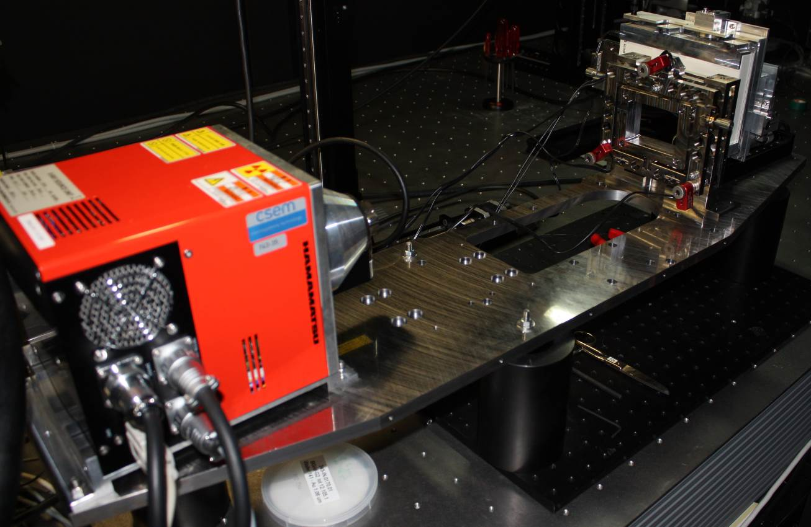

Figure : The gantry-ready setup at CSEM Zurich

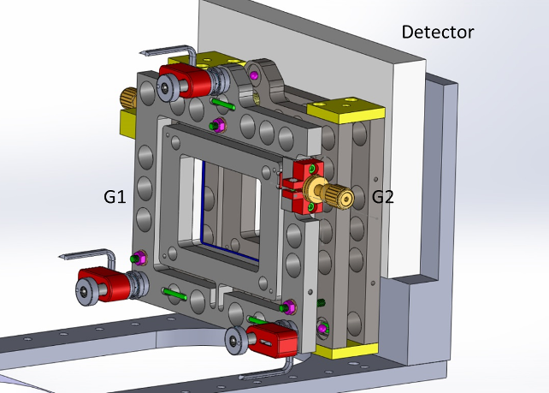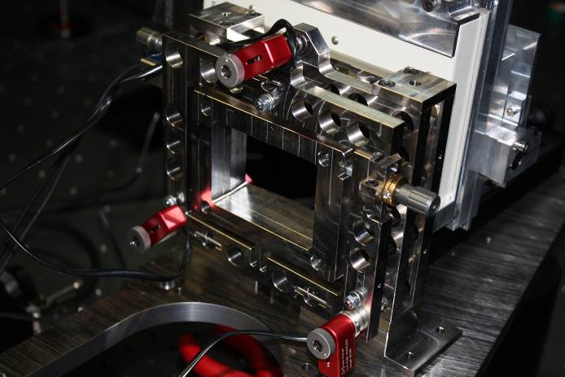

Figure : Mechanical drawing of the interferometer block (left) and its implementation (right).

The interferometer block was planeed and commissioned at CSEM. It works with a interfermoeter desing nergy of 30 keV which is adpated to small animal imaging. The grating alignment is fully motorised and can be controlled by LabView (Figure ). The reconstruction algorithm had to be adapted to the special form of phase stepping with Moiré stripes. Figure shows the reconstructed absorption, differential phase shift and dark field image of a small plastic rabbit, which was used to demonstrate the functionality of the system.

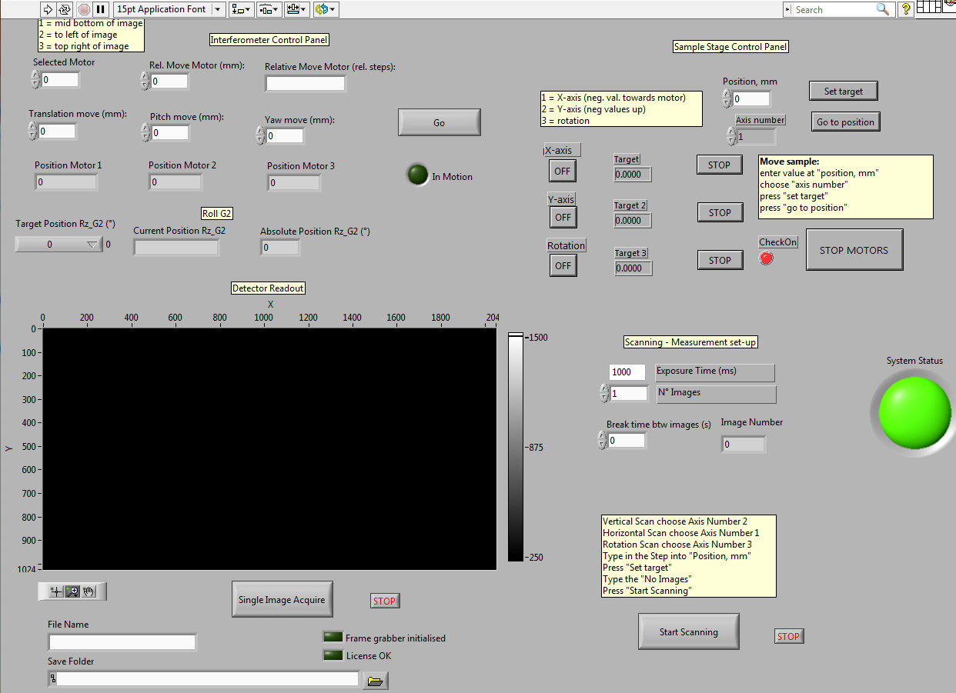

Figure : LabView control panel (at CSEM).

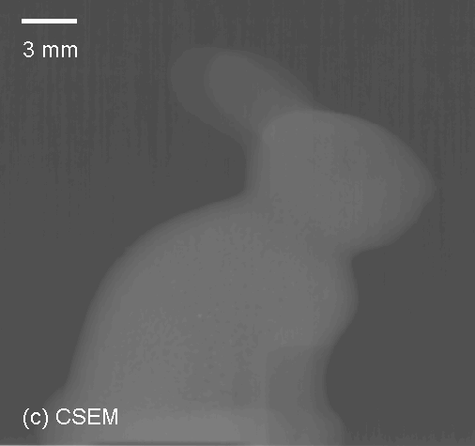 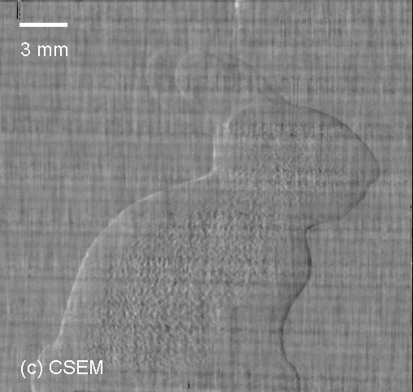 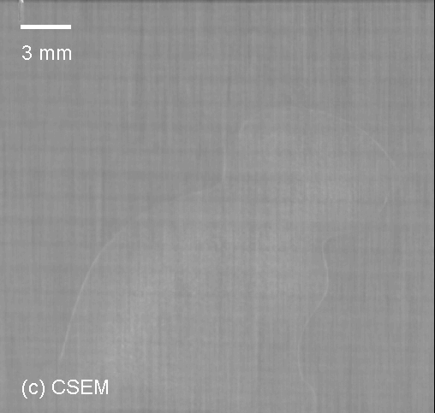

Figure : first reconstruced single projections of a very low absorbing plastic rabbit, left: absorption image,   
middle: differential phase contrast image, right: scattering image.

Much effort went into designing a mechanically stable and compact system which is much less prone to temperature variations than e.g. the existing CCMX XPCI system at CSEM. With its compact total length of about 50 cm it is basically ready to be added to an existing Scanco CT system for small animals, of course with some modifications of the electronics and the data acquisition system.

High-energy interferometer

The high-energy system aims to bring grating interferometry into the range of mainstream medical and security machines. These operate at voltages above 100 kV in order to get sufficient penetration through large thicknesses or heavy materials. While lower energy applications, e.g. mammography and cartilage imaging, are successfully being developed, the unavailability of the optical elements is a limiting factor in the deployment of the technique to other areas.

Two setups with a design energy of 100 keV and 120 keV were built at PSI, with gratings manufactured by Microworks GmbH. The gratings involve a circular alignment of the structures that matches the beam divergence. The interferometers are quite compact, with a total length of 54 cm and 60 cm respectively.

The grating holders are fully motorized with six degrees of freedom in order to achieve the necessary alignment on the beam plane, which is only 100 µm wide.

Figure : radiography of an electronic chip with the 100 keV interferometer. Top: absorption image, with differential absorption on the right,  
middle: differential phase contrast image, bottom: scattering image.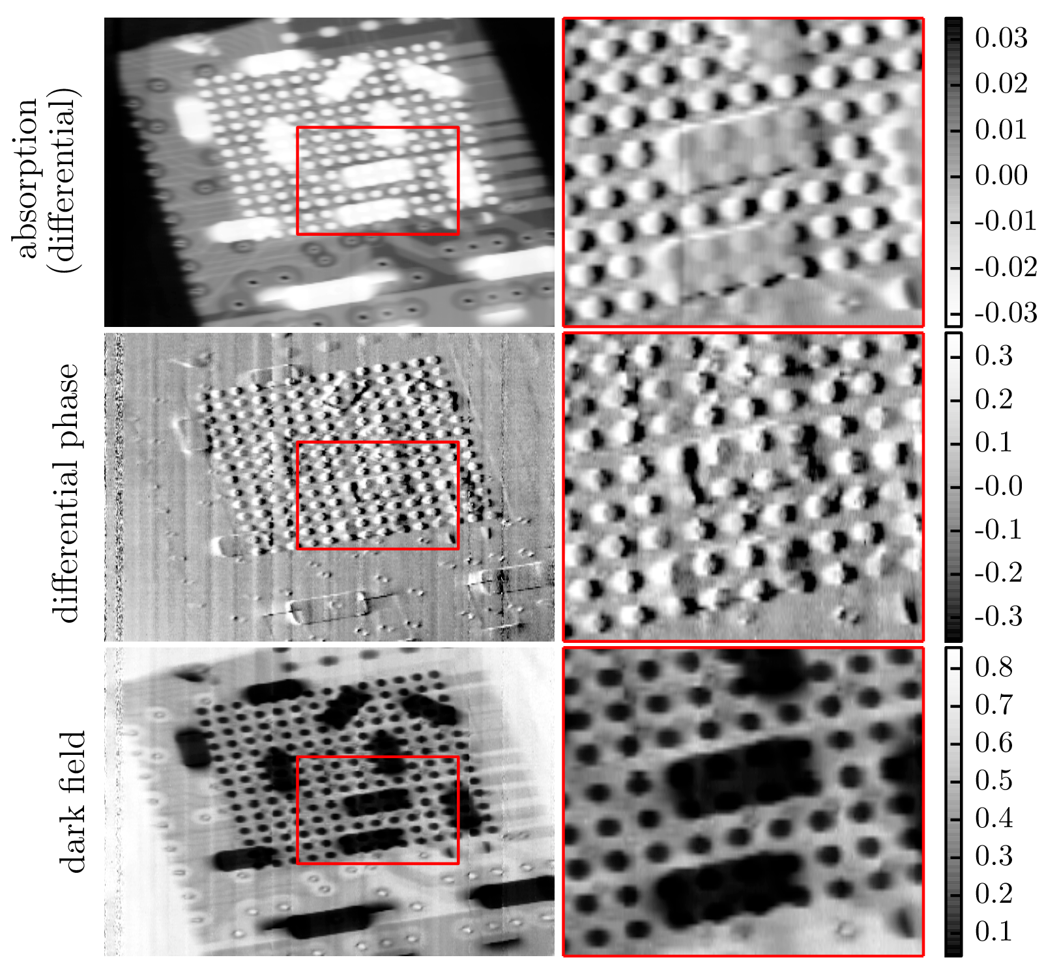

Although the visibility of the interferometers is still low with this first generation of gratings, averaging between 5% and 6%, first images could be acquired with the usual Fourier component analysis of the phase stepping curves.

They show the complementarity of the three signals of Talbot interferometry at unprecedented energy levels.

The results have been presented at international conferences in San Diego (SPIE 2014) and Garmisch-Partenkirchen (XNPIG and IMXP 2014) and published in the journal Scientific Reports 4/5198.

**5. Assessment of project progress.**

Did the project run as planned? [x] Yes [ ] No

# Were the project goals reached? [x] Yes [ ] No

If no to either question, please describe why.

# If PhD theses were being financed, did they progress as planned? [ ] Yes [ ] No

If no, please describe why.

# Please indicate the anticipated date of the thesis defence of the PhD candidate(s). When available, please submit a copy of the thesis.

If the thesis has already been defended, please indicate the title and submit a copy of the thesis.

**6. Have publications/presentations of the project results been made?** [x] Yes [ ] No

If yes, please list the publications in the following order (please ensure to adhere to the formatting of bold, italics etc.):

First name initials Author 1, Last Name Author 1, First name initials Author 2, Last Name Author 2, etc, **Title**, *Journal*, volume (year), 1st page-last page.

Please organize the publications/presentations into the following categories:

1) reviewed ISI-publications:

Thomas Thüring, Matteo Abis, Zhentian Wang, Christian David, Marco Stampanoni,

**X-ray phase-contrast imaging at 100 keV on a conventional source**,

*Scientific Reports (2014) 4/5198*

2) non ISI-publications,

3) theses,

4) posters and talks at conferences:

M. Abis, T. Thüring, Z. Wang, C. David, and M. Stampanoni

**Phase-contrast imaging above 100 keV, grating interferometry on a conventional X-ray tube**  
*Prize for best poster at XNPIG 2014*

T. Thüring , M. Abis , and M. Stampanoni  
**Optimization of X-ray grating interferometry and results on a 160 kVp lab source***Poster at the SPIE 2014 conference*

**7. Have inventions been made and/or patents filed?** [ ] Yes [ ] No

If yes, please describe / if no, are any envisaged?

**8. Description of industrial interest and involvement.**

a) Describe the technical contribution to the project by the industrial partner(s)

b) Is a commercialization strategy in place?

**9. Tell us about any success stories in your research projects: key scientific findings, interactions between research groups, prizes won such as best talk or poster… (10 lines max. per success story)**

* A mechanically stable interferometer block, which is much less prone to temperature variations than previous interferometer implementations.

**10. Please send electronically up to 5 pictures including a relevant caption (scientific topic or people) which may be used in CCMX publications (printed & website).**

**11. Remarks.**