SIMATS ENGINEERING
Department of Information Technology
CSA15 – CLOUD COMPUTING AND BIG DATA ANALYTICS
ASSIGNMENT 3 – CO3: DESIGN A CLOUD-BASED COLLABORATIVE SOLUTION (ANSWERS)
CO3: Implement cloud-based solutions using cloud storage, web APIs, and platform services for real-world applications. | Pair work (Student A and Student B) | Document 1: Google Drive, Google/Microsoft platforms, weather API, disaster information sharing
Student A Name | E.Manisha | Register Number | 192372388
Department / Section | CSE(AI) | Academic Year / Semester | 4th year
Faculty Name | DR.R.Latha | Nature of Assignment | Pair work
Duration | 1 Week | Total Marks | 50

Question 1: Accessing Cloud Services through Different Methods (6 Marks)
Scenario: Identify methods of accessing cloud services, show the client-network-cloud flow, demonstrate access to one selected service, and record observations and a limitation.
Shared group work: methods and the selected service
Cloud services are reached over a network, so the way a user connects is a design decision. The group studied three access methods: browser or console access, mobile-app access and API access, together with the role of Internet connectivity. Google Drive was chosen as the demonstration service because it offers all three methods with one account and has a free tier suitable for a student lab.
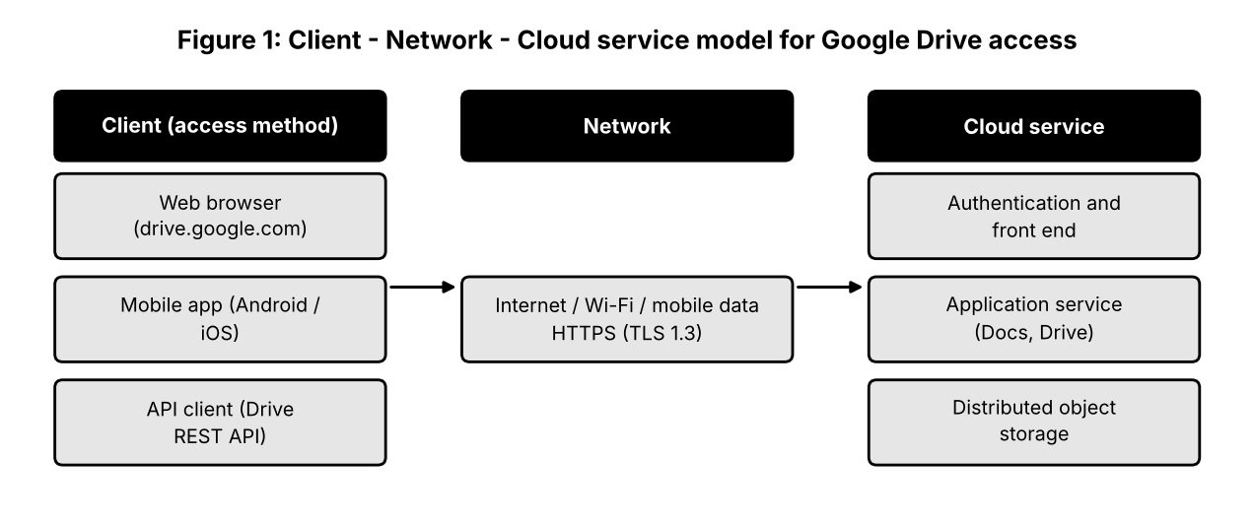
Student A: access method design
Access method | How it works | Client requirements | Best suited for
Web browser / console | User signs in at drive.google.com over HTTPS; the page is rendered by the browser | Any device with a modern browser and Internet | Occasional users, administrators, quick sharing
Mobile application | Installed app keeps a secure session and can cache files for offline use | Android/iOS device, app, mobile data or Wi-Fi | Users on the move, photo and document upload
API / programmatic | A program sends authenticated REST calls (OAuth 2.0 token) to the Drive API and receives JSON | Code (Python, Java), API credentials, HTTP library | Automation, integration with other systems, bulk operations

Flow of access: the client (browser, app or script) sends a request through the network (Wi-Fi or mobile data, protected by TLS) to the cloud service. Google's front end authenticates the user, the application service processes the request, and the object storage layer returns the file. The client contributes the interface, the credentials and local processing; the network contributes bandwidth and latency; the cloud provides storage, processing, security and availability.
Justification: for the selected application (shared study documents) the browser is the most suitable primary method because it needs no installation, works on lab and personal computers, and always shows the latest version. The mobile app is a useful supplement, and the API is reserved for automation such as exporting a file list.
Student B: practical evidence
- Step 1: opened drive.google.com in a browser and signed in with a college Google account (with 2-step verification).
- Step 2: created a folder 'CO3_Lab', uploaded a PDF and a text file, and opened the file preview.
- Step 3: repeated the same access from a smartphone using the Drive app, and confirmed the files were present without copying anything.
- Step 4: switched off Wi-Fi to test offline behaviour of the mobile app.
Evidence slot: attach your own original screenshot of the Drive web page and the mobile app showing the same folder.
Observation criterion | Browser | Mobile app
Accessibility | Needs only a browser; no installation | Needs app installation and storage space
Response | Page loads in a few seconds on a normal connection | Faster for small files; depends on mobile signal
Usability | Large screen suits editing and sharing settings | Convenient but smaller interface
Offline behaviour | Not available without connection | Files marked 'available offline' open without Internet

Limitation encountered: files that had not been made available offline could not be opened when the network was disconnected. Impact: cloud use depends on connectivity; in poor-network areas, productivity and deadlines can be affected, so critical files should be marked for offline use and a backup access path (for example, mobile data) kept ready.
Cross-verification
Student A can explain the practical test (browser, app, offline test) as an application of the access architecture, and Student B can explain why the three methods differ in client requirements and typical use. Both can describe the Client → Network → Cloud Service flow in Figure 1.
Question 2: Cloud Platforms and Web Applications (7 Marks)
Scenario: Select two cloud platforms, map user requests to the supporting services, demonstrate a real cloud web application, and evaluate cloud access against local-only use.
Shared group work: platform selection and comparison
Aspect | Google Cloud / Google Workspace | Microsoft Azure / Microsoft 365
Web applications | Docs, Sheets, Slides, Drive, Gmail, Meet | Word, Excel, PowerPoint for the web, OneDrive, Outlook, Teams
Supporting cloud services | Compute Engine, Cloud Storage, Cloud Run, Spanner | Virtual Machines, Blob Storage, App Service, Azure SQL
User interaction | Browser, mobile apps, API | Browser, desktop and mobile apps, Microsoft Graph API
Identity | Google Account, Cloud IAM | Microsoft Entra ID (Azure AD)
Typical strength | Real-time co-editing, simple sharing | Deep integration with desktop Office and enterprise policies

Both platforms follow the same pattern: users interact with a web application in the browser, and the provider hides the servers, storage and databases behind it.
Student A: platform analysis and interaction diagram
Major components of a platform: compute (virtual machines, containers, serverless), storage (object, block, file), networking (load balancers, DNS, CDN), databases, identity and access management, and monitoring. For web applications, the platform supplies the front-end servers that handle HTTPS, the application servers that run the logic, a database for metadata and storage for content.
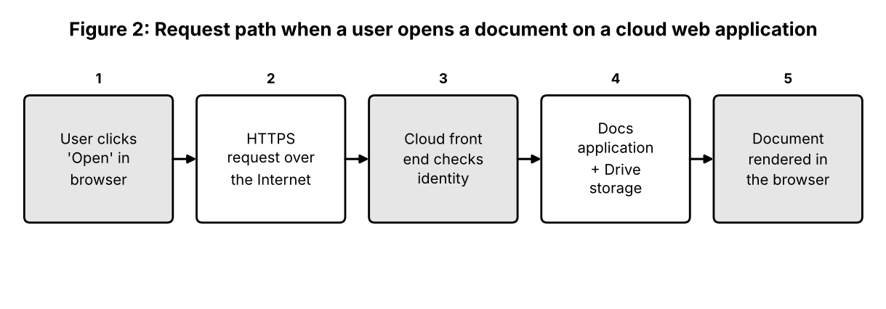
User action | Cloud service involved | Role
Types the web address | DNS and global load balancer | Directs the user to a nearby front end
Signs in | Identity service (IAM) | Authenticates and issues a session token
Opens a document | Application service + database | Finds the file and its permissions
File content shown | Object storage | Supplies the stored data
Edits saved | Application service + storage | Writes changes and creates a new version

The Internet carries the requests, the cloud infrastructure provides scalable processing and storage, and the application implements the features the user sees.
Student B: application investigation (Google Docs)
Selected application: Google Docs, a cloud-based word processor. Functions demonstrated: creating a document, typing and formatting, inserting a table, sharing with a partner, adding a comment and restoring an earlier version.
Step | User action | Where cloud access is involved
1 | Open docs.google.com and sign in | Authentication through the cloud identity service
2 | Create a blank document | A new file object is created in cloud storage
3 | Type text; changes appear as 'Saved to Drive' | Autosave sends edits to the server every few seconds
4 | Share with partner as editor | Permission entry stored in the cloud
5 | Open version history | Server returns saved revisions

Evidence slot: attach your own original screenshot of the Google Docs window, the Share dialog and the version-history panel.
Benefits observed: no installation, automatic saving, access from any device, real-time sharing and automatic backup of every version.
Joint evaluation: local-only installation versus cloud access
- Availability: a locally installed program is tied to one computer; the cloud version is reachable from any device with a browser.
- Collaboration: local files must be e-mailed and merged; cloud files can be edited together.
- Backup: a local disk failure can destroy work; cloud storage is replicated.
- Updates: local software must be updated by each user; cloud software is updated centrally.
- Hardware: local operation needs a capable computer; cloud applications run mostly on provider servers.
- Counterpoint: a local program works without Internet and keeps data under the user's physical control, which the cloud version cannot guarantee.
Question 3: Web APIs for Cloud Access (7 Marks)
Scenario: Study Web APIs, select a public API, implement a client program, test at least two requests, and analyse the results.
Shared group work: concept and selection
A Web API is a defined interface through which one program asks another program, usually over HTTP, to perform an operation or return data. Cloud providers expose their services this way, so applications can store files, read data or start servers without a human using a web page. The group selected the Open-Meteo weather forecast API because it is public, requires no registration or key, and returns small JSON responses that are easy to analyse.
Student A: API design and understanding
Purpose: to return the current weather (temperature, wind speed and direction) for a place given by latitude and longitude.
Component | Example from the experiment
Method | GET
Endpoint | https://api.open-meteo.com/v1/forecast
Query parameters | latitude=13.08, longitude=80.27, current_weather=true
Response status | 200 OK for success; 400 Bad Request for an invalid input
Response body (JSON) | {'latitude': 13.08, 'current_weather': {'temperature': ..., 'windspeed': ...}}

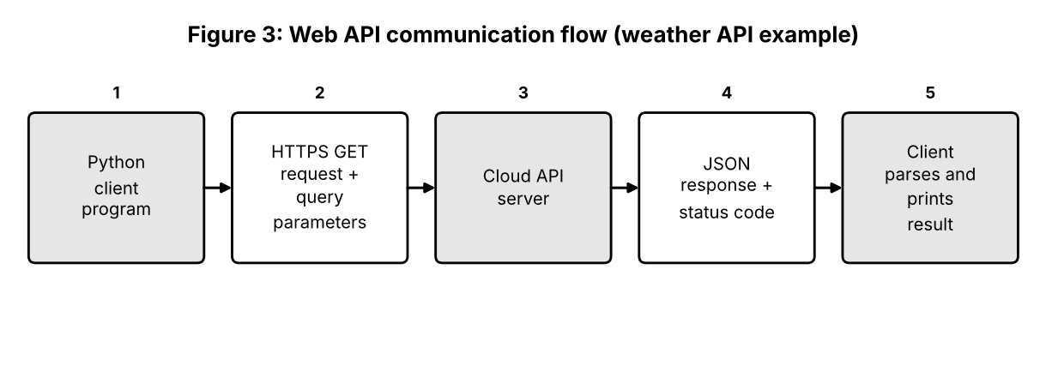
- Client: the Python program that builds and sends the request.
- API request: the HTTP call with method, URL and parameters.
- Cloud/server: the weather service that validates the input and prepares the data.
- API response: status code plus JSON that the client parses.
- Programmatic cloud access: because the format is standard, any program can use the service automatically, without a browser.
Student B: implementation and evidence
The program below uses Python with the requests library. It sends two valid requests (Chennai and Delhi) and one invalid request (latitude 190) to observe error handling. The base address can be changed through an environment variable.
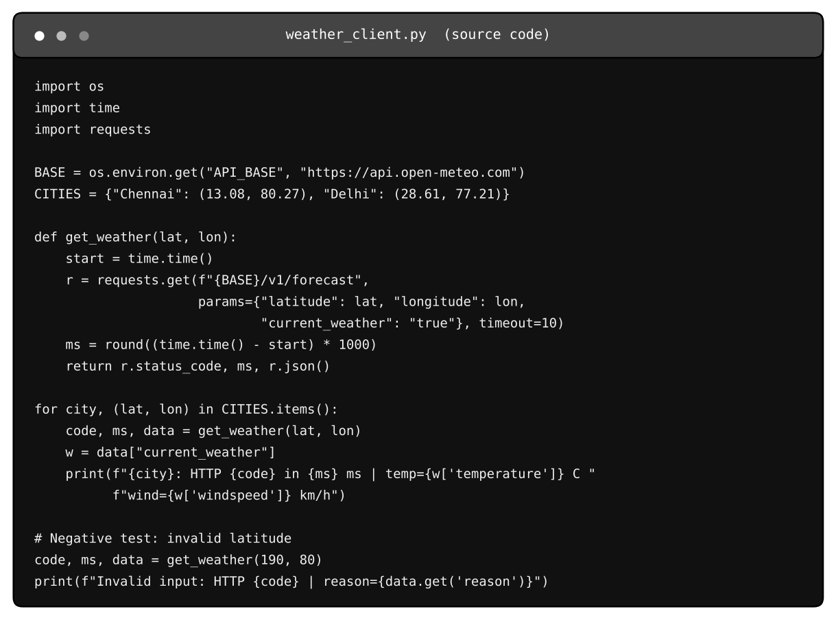
Figure 4: Program listing (weather_client.py) and its execution output below.
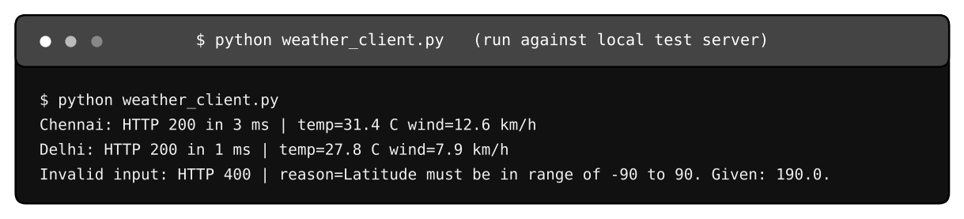
Execution output. This run used a local test server that returns the same JSON structure as the public API, because the build environment has no Internet; the temperature values are therefore test values. Re-run against the live API and attach your own screenshot.
Test | Input | Observed response | Result
Request 1 | Chennai (13.08, 80.27) | HTTP 200; temperature and wind speed returned | Pass
Request 2 | Delhi (28.61, 77.21) | HTTP 200; different temperature and wind | Pass
Request 3 (negative) | Latitude 190 | HTTP 400; reason says latitude must be within -90 to 90 | Error handled correctly

Analysis: the same code produces different results by changing only the parameters; the status code tells the program whether to use the data; and invalid input returns a readable reason rather than crashing. A production program should also use a timeout (done here), retry on temporary failure and handle network exceptions.
Joint analysis: why API-based access suits large-scale automatic use
Programs can call the API thousands of times a minute without human effort, and each call is independent (stateless), so the provider can scale servers horizontally. Standard formats (HTTP, JSON) let different languages and platforms communicate. Access can be controlled per application with keys or tokens, rate-limited to protect the service, and monitored for usage and billing. Updates to the provider's internals do not affect clients as long as the interface remains stable.
Question 4: Cloud Security and Network Access (7 Marks)
Scenario: Identify security considerations for cloud access, design a secure access flow, document an authentication mechanism and compare secure and insecure situations.
Shared group work: security issues in cloud access
Because cloud resources are reachable over the Internet, anyone can attempt to connect. Security therefore rests on proving identity, limiting what each identity may do, protecting data on the network and keeping evidence of activity. Responsibilities are shared: the provider secures the infrastructure, while the user secures accounts, configuration and data.
Student B: security design
# | Security consideration | Explanation
1 | Authentication | Verifying who the user is, using passwords plus a second factor (MFA) or single sign-on
2 | Authorization | Deciding what the authenticated user may do, using roles and least privilege
3 | Secure communication | Encrypting data in transit with TLS/HTTPS or a VPN so it cannot be read or altered on the network
4 | Data protection | Encryption at rest, backups, versioning and key management
5 | Monitoring and auditing | Logs and alerts that show who accessed what and reveal unusual behaviour

Authentication answers 'Who are you?'; authorization answers 'What are you allowed to do?'. A user may be properly authenticated yet denied access to a resource if the role does not allow it, in which case the service must return an 'access denied' response (HTTP 403).
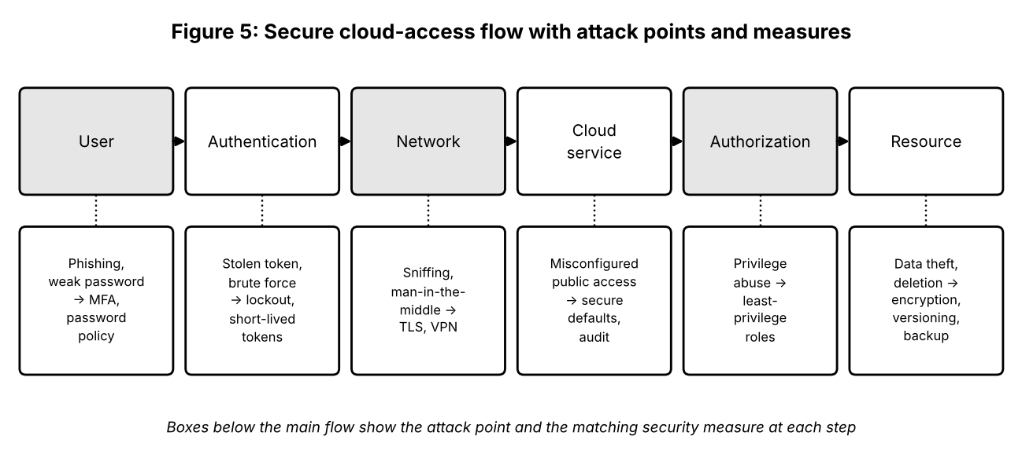
Student A: security investigation
Scenario investigated: a student account protected only by a password versus the same account with 2-step verification. Mechanism documented: Google 2-Step Verification using a prompt on the registered phone.
Situation | Insecure access | Secure access
Sign-in | Weak, reused password; no second factor | Strong unique password plus 2-step verification
Network | Public Wi-Fi over plain HTTP | HTTPS (padlock) or VPN
Sharing | 'Anyone with the link can edit' | Named people with minimum roles
Result of a stolen password | Attacker reads and deletes files | Login blocked without the second factor

Evidence slot: attach your own original screenshot of the 2-step verification setting and a sign-in prompt.
Effect of poor practices: stolen credentials lead to data theft, deletion or ransomware, shared files may become public, and an affected account can be used to attack other users. Recovery is costly and personal or academic data may be permanently exposed.
Joint evaluation: extra measures compared with a local application
- Strong identity checks (MFA, SSO) because the login page is exposed to the whole Internet.
- Mandatory encryption in transit, since data crosses networks the user does not control.
- Fine-grained permissions and regular access reviews for shared resources.
- Protection against automated attacks: lockout, rate limiting and web application firewalls.
- Logging and alerting to detect misuse from unusual locations or devices.
- Backups and version history in case of accidental or malicious deletion.
- Awareness of phishing, since attackers target users rather than servers.
Question 5: Collaboration Using Cloud-Based Services (6 Marks)
Scenario: Create a shared workspace, configure permissions, perform collaborative editing and record the process.
Shared group work: workspace and process
The group used Google Drive and Google Docs. A shared folder named 'CO3_Project' was created by Student A, a document 'CO3 Project Report' was placed inside it, and both students edited it at the same time while the faculty member was given comment access.
Student A: collaboration design
- Requirements: joint writing, one master copy, clear ownership, feedback from faculty, ability to undo mistakes.
- Sharing: folder-level sharing so every new file inherits the access rules.
- Concurrent access: several users edit simultaneously and see each other's cursors.
- Version control: version history stores named versions and allows restoring an earlier state.
- Permission management: roles are assigned per person and reviewed before submission.
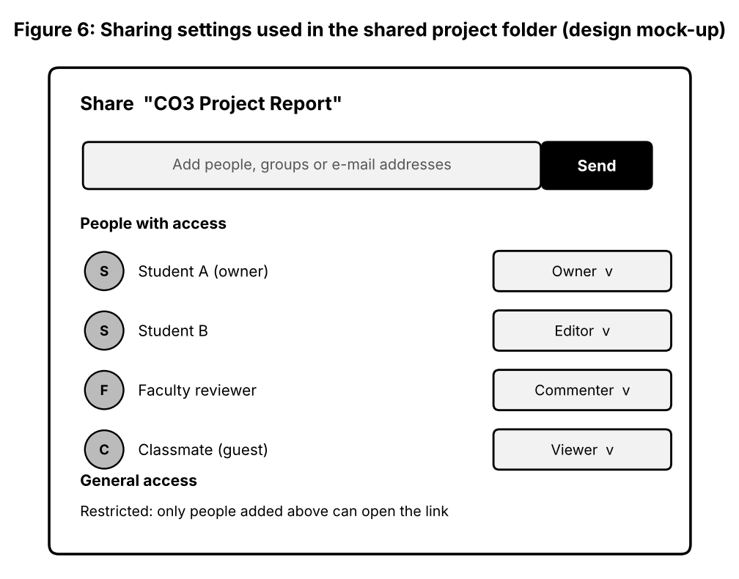
Role | Permission | Justification
Student A (owner) | Full control | Creates the workspace and manages sharing
Student B | Editor | Needs to write and modify the report
Faculty reviewer | Commenter | Can give feedback without altering content
Classmate / guest | Viewer (only when needed) | Read-only; prevents accidental edits

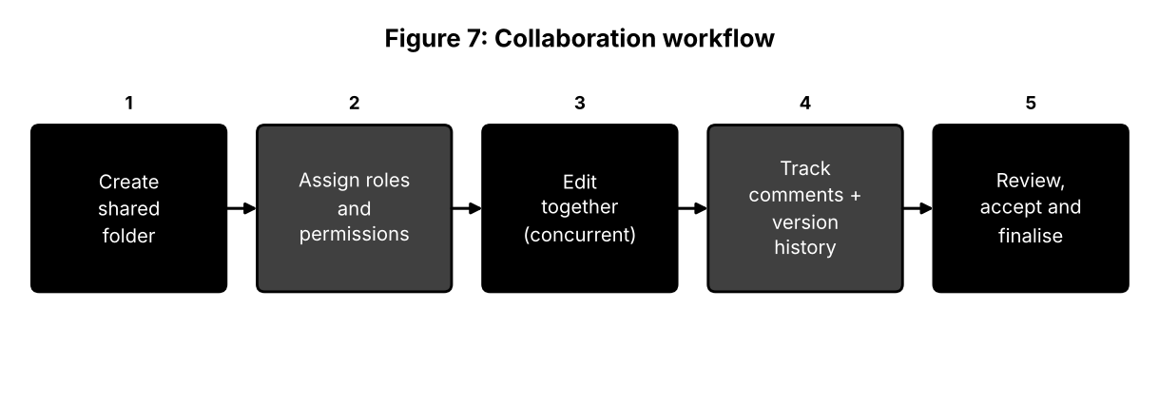
Student B: collaborative implementation
- Activity 1: edited the 'Design' section of the report while Student A edited 'Introduction' at the same time; both changes appeared within seconds.
- Activity 2: added comments and a suggestion in 'suggesting' mode, which Student A accepted.
- Sharing settings: opened Share and confirmed each role in the dialog.
- Observation: edits were reflected in real time and the version history listed each author's changes with time stamps.
Evidence slot: attach your own original screenshot of the shared document with two users editing, the Share dialog and the version history.
Issue identified: two users edited the same paragraph, producing overlapping text. Solution: divide the document into sections with named owners, use comments for suggestions, and agree a rule to avoid editing the same paragraph simultaneously.
Cross-understanding answers
Student B: with a cloud document there is a single master copy that everyone opens by link, so no e-mail attachments are produced, the latest version is always visible, merging is unnecessary and storage is not wasted by many copies of the same file.
Student A: giving wrong permissions can let unauthorised people read confidential work, let viewers or guests edit or delete content, allow content to be copied or re-shared, cause loss of work or accusations of plagiarism, and make it difficult to prove who changed what. Permissions should be minimal and reviewed regularly.
Question 6: Integrated Cloud Access and Collaboration Mini Investigation (7 Marks)
Scenario: Scenario selected: Cloud-based Student Project Management.
Student A: system design
- Problem: student teams track tasks, deadlines and files by messaging apps and e-mail, so work is duplicated, deadlines are missed and the faculty guide cannot see progress.
- Users: students, team leader, faculty guide, department coordinator.
- Access methods: browser for planning and documents, mobile app for notifications and quick updates, API for exporting progress reports.
- Cloud services: cloud storage (shared drive), shared documents and sheets, task board, calendar, identity service, notification service.
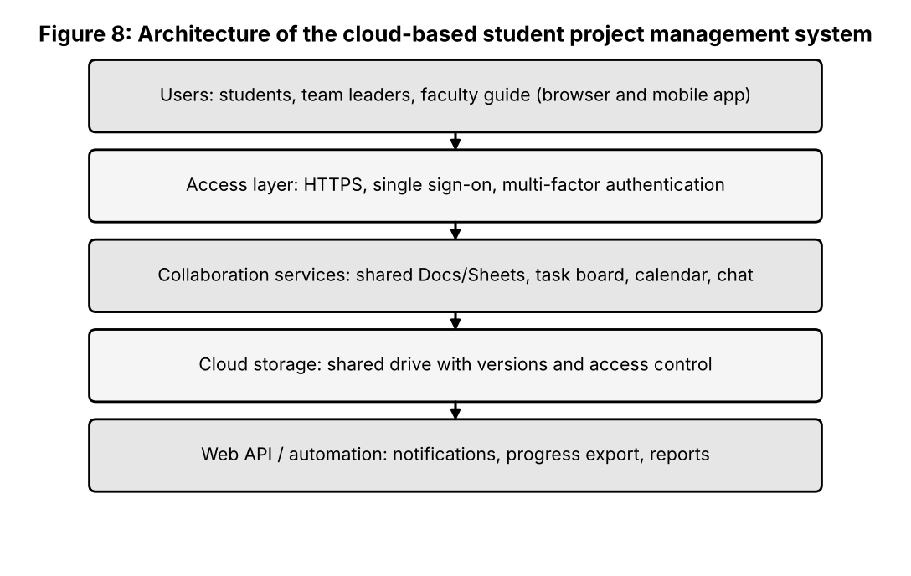
Access: users sign in with their college account (SSO with MFA) from a browser or the mobile app. Collaboration: a team shared drive holds all documents, the task board shows who is doing what, and comments and version history record discussion and changes.
Student B: prototype, tests and evaluation
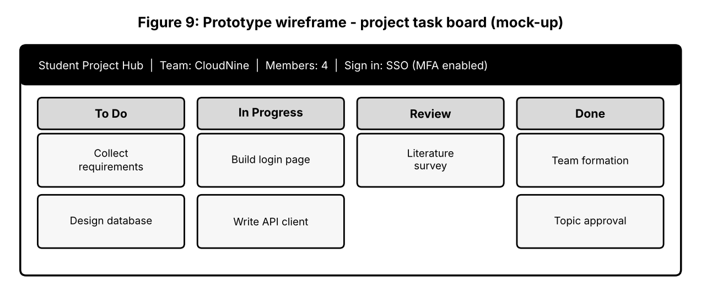
The prototype is a task board created in Google Sheets/Docs and shared with four roles; the wireframe above shows the intended interface. Cloud access mechanism demonstrated: sign-in with 2-step verification from browser and mobile. Collaboration mechanism demonstrated: shared task sheet with simultaneous editing and comments.
Evidence slot: attach your own original screenshot of the shared task board and the access from the mobile app.
User scenario | Action | Expected result | Observed result to record
Scenario 1: team member | Updates a task from 'In Progress' to 'Review' using mobile | Leader sees the change immediately | Record time taken and screenshot
Scenario 2: faculty guide | Opens board in browser and comments on a task | Comment visible to the team; guide cannot edit tasks | Record permission behaviour

Limitations: dependence on Internet, no advanced reporting in a spreadsheet-based prototype, and manual updates. Improvements: use an API-based tool to send deadline reminders automatically, add dashboards for progress percentage, and enforce role-based permissions with an audit log.
Joint evaluation
Cloud access means every member and the faculty can reach the system anywhere with one login; collaboration means they work on the same data and see changes instantly. Together they remove duplicate files, reduce waiting for replies, increase transparency of progress and let the guide intervene early, which raises the efficiency of the project process.
Question 7: Day-4 Design Challenge: Cloud-Based Collaborative Solution (10 Marks)
Scenario: Joint design of a cloud-based disaster information sharing solution.
Stage 1: Independent design proposals (retained as evidence)
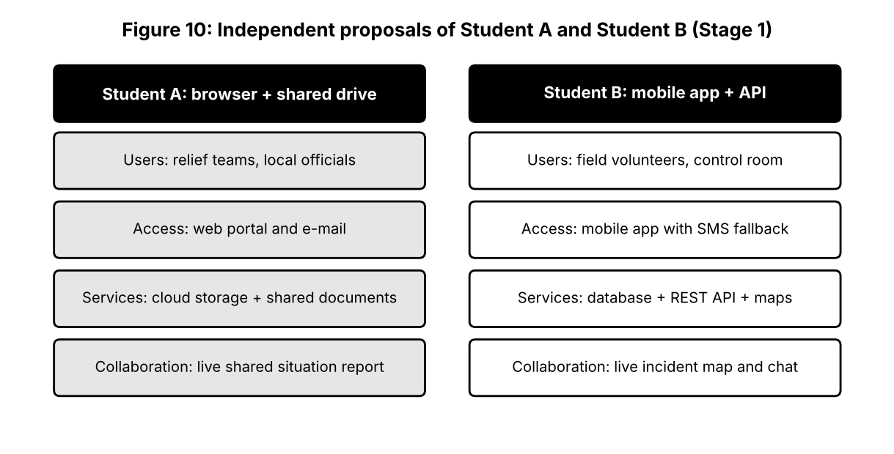
Problem used by both: during floods, relief teams, volunteers and officials hold scattered, outdated information on shelters, rescue needs and supplies.
Stage 2: Design comparison record
Aspect | Student A proposal | Student B proposal | Decision
Access | Web portal and e-mail | Mobile app with SMS fallback | Both: app for field teams, portal for control room
Services | Cloud storage + documents | Database + REST API + maps | Database and API as core; storage for reports
Collaboration | Shared situation report | Live incident map and chat | Live map; shared report for summaries
Security | Link-based sharing (weak) | Login with roles | Role-based login with MFA for officials
Accessibility | Needs good connectivity | Offline queue | Adopt offline queue
Missing parts | No real-time updates | No document archive | Add storage for archives

Stage 3: Joint final design
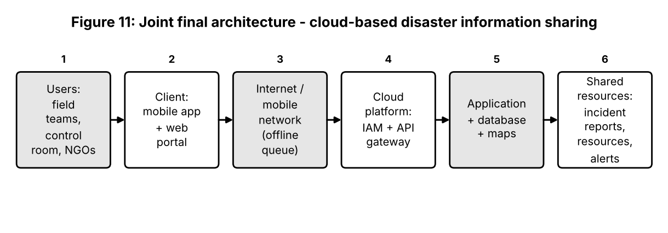
Design element | Decision
Problem | Slow, inconsistent information sharing during disasters
Users | Field volunteers, control-room staff, NGOs, district officials
Cloud access method | Mobile app (field) and web portal (control room); API for partner systems
Network requirements | Mobile data with SMS fallback; offline queue that syncs when a connection returns
Cloud platform / service | Managed identity, API gateway, managed database, map service, object storage
Web application / API | REST API for incident reports, resource lists and alerts
Collaboration mechanism | Shared live map, comments, status updates and shared situation report
Authentication / security | MFA for officials, role-based access, TLS, encryption at rest, audit logs
Data / resource sharing | Public alerts read-only; incident details restricted by role
Workflow | Report incident → validated by control room → published on map → resources assigned → status updated → closed

Stage 4: Validation
Student A (technical validation): the mobile app and web portal were selected because field staff need portability and the control room needs a large screen; a managed cloud platform scales during sudden load and replicates data across zones; the REST API allows partner organisations to integrate; the architecture separates access, application and data, which suits security and growth.
Test case | Condition | Expected behaviour | Observed (to record)
T1 Volunteer submits report | Normal network | Report appears on map within seconds | Time and screenshot
T2 Offline submission | Network disconnected | Report queued and synced after reconnection | Sync result
T3 Unauthorised user | Viewer role opens restricted incident | Access denied (403) | Screenshot of message
T4 Peak load | Many simultaneous updates | Service remains responsive | Response time

Evidence slot: attach your own original screenshot of the tested workflow for T1 to T4.
Student B compared expected and observed behaviour for each case; any mismatch (for example slower synchronisation) is recorded with a proposed correction.
Stage 5: Cross-defence
Student A (evidence supporting the design): the test records show that a report becomes visible quickly, offline reports are not lost, restricted data is blocked for unauthorised roles, and the system stays responsive under simulated load.
Student B (why this approach): disaster information is time-critical and needed from many places by many organisations; cloud access gives availability from any location, and collaboration on one live data set avoids conflicting versions, while role-based security protects sensitive details.
Stage 6: Joint evaluation
Area | Evaluation
Benefits | Fast sharing, one source of truth, accessible from any place, quick scaling
Access limitations | Depends on mobile network; disasters can damage towers and power
Collaboration benefits | Simultaneous updates, comments and audit trail
Security risks | False reports, account theft, data exposure of victims
Scalability | Managed services add capacity during peaks
Improvements | Satellite or mesh fallback, automatic report verification, multilingual interface
Not appropriate when | Connectivity is entirely unavailable or data must not leave a closed network

Final question: characteristics a designer should consider
- Who the users are and where they work: connectivity, devices and skills.
- Availability and reliability needed: what happens if the service or network fails.
- Security and privacy: sensitivity of data, authentication and legal rules.
- Collaboration pattern: how many people edit, in real time or in turn, with which roles.
- Scalability and cost: expected peaks, pricing model and budget.
- Integration: APIs and compatibility with existing systems.
- Data location and compliance: where data is stored and who may access it.
- Exit plan: ability to export data and avoid lock-in.
Contribution Record
Question | Student A: primary contribution | Student B: primary contribution | Joint work
Q1 | Access method classification, architecture diagram | Access demonstration, observations, limitation | Selection of service
Q2 | Platform components and interaction diagram | Google Docs demonstration and evidence | Platform comparison, local-versus-cloud evaluation
Q3 | API explanation and flow diagram | Python client, execution, tests | API selection and analysis
Q4 | Security investigation and secure/insecure comparison | Security design and secure-access flow | Evaluation of extra measures
Q5 | Collaboration design, permissions rationale | Collaborative edits, evidence, issue and solution | Workspace creation
Q6 | System design and architecture | Prototype, user tests, evaluation | Efficiency discussion
Q7 | Technical validation, independent proposal | Test cases and experimental validation, independent proposal | Comparison, final design, evaluation

Viva Preparation: Transfer Questions
Question | Model answer
If Internet connectivity becomes unreliable, how is cloud access affected? | Pages and API calls fail or slow down; unsaved changes may be lost; remedies are offline mode, local caching, retry logic and a backup connection.
If a shared cloud document is given editing permission to everyone, what problems occur? | Anyone can change or delete content, confidential data can leak, accountability is lost; fix by restricting roles and using version history.
If the API becomes unavailable, how should the application behave? | Use timeouts, show a clear message, retry with back-off, fall back to cached data and log the failure; do not crash.
If a user is authenticated but not authorised, what should happen? | The service denies the action (HTTP 403), logs the attempt and shows an access-denied message without revealing protected data.

Implementation Evidence Chain and Submission Note
Evidence item | Provided in this document | To be added by students
Access methods | Classification table and Figure 1 | Screenshots of browser and mobile access
Platforms and application | Comparison and sequence tables | Google Docs screenshots
Web API | Code listing, test table, output of a local test run | Output of the program run against the live API
Security | Secure-access flow, threat table | 2-step verification screenshot
Collaboration | Sharing design mock-up, workflow | Real share dialog and version-history screenshots
Mini-project and Day-4 design | Architecture, wireframes, test cases | Observed results and screenshots

Note: the figures labelled 'mock-up' or 'wireframe' are design illustrations, not screenshots of a live system. Original screenshots from the students' own accounts must be attached where an evidence slot is shown.

