SIMATS ENGINEERING
Department of Information Technology
CSA15 – CLOUD COMPUTING AND BIG DATA ANALYTICS
ASSESSMENT TOOL 3 – APPLICATION BASED QUESTIONS (ANSWERS)
CO2: Analyze virtualization architectures to identify performance and security issues in cloud computing environments. | Document 2: Microsoft Azure view with fashion retail, healthcare, gaming and ride-hailing cases
Student Name | E.Manisha | Register Number | 192372388
Department / Section | CSE(AI) | Academic Year / Semester | 4TH YEAR
Course Outcome | CO2 (BL3) | Total Marks | 25

Question 1: Handling Unpredictable Seasonal Traffic in the Cloud
Scenario: A company experiences unpredictable traffic spikes during seasonal sales. Explain how cloud auto-scaling and load balancing handle the demand, how they reduce downtime and improve user experience, the role of monitoring tools, and relate it to a real-world e-commerce scenario.
A. The core idea: elastic capacity matched to demand
Seasonal demand is hard to predict: a social-media post by an influencer can multiply traffic in minutes. The cloud responds with elasticity, meaning that capacity follows demand automatically. In Microsoft Azure this is delivered by Virtual Machine Scale Sets (or App Service autoscale) for the compute and by Azure Application Gateway or Front Door for load balancing. Instead of predicting the peak, the company defines rules and limits, and the platform does the rest.
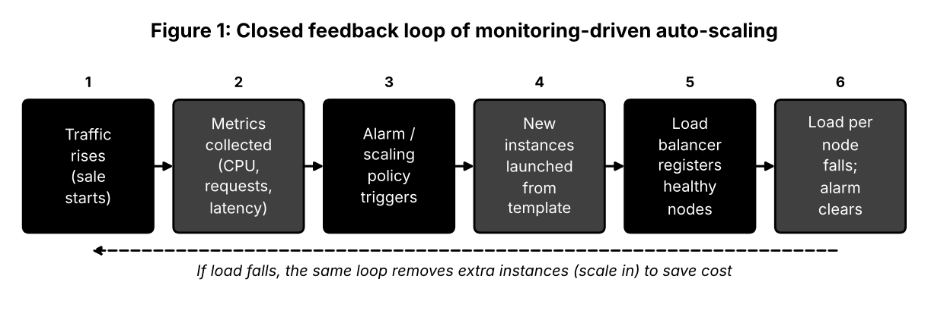
The figure shows that auto-scaling is a closed loop: measurement, decision, action, and check. The same loop that adds servers at the peak removes them when traffic falls, which controls the cost.
B. Components and their contribution
Component | Function | Effect on the sale
Load balancer | Distributes requests; health probes; SSL offload | No server is overloaded; failed servers bypassed
Scale set / autoscale rules | Adds or removes identical instances using CPU, queue length or schedule | Capacity grows before queues build up
In-memory cache (Redis) | Serves popular product data and sessions | Database protected; faster pages
Content delivery network | Serves images and scripts from edge | Less origin traffic; faster loading
Queue for orders | Absorbs bursts of checkout requests | Orders processed steadily; none lost

C. Reduction of downtime and improvement of user experience
- No single point of failure: instances are spread over availability zones; if one zone fails, the rest continue.
- Instant recovery: health probes remove unhealthy instances, and the scale set creates replacements.
- Fast response: cache and CDN shorten page-load time; scaling keeps response time flat as traffic rises.
- Graceful degradation: when the system is stressed, non-essential features (recommendations) can be switched off while search, cart and payment remain available.
- Zero-downtime releases: rolling or blue-green deployments behind the load balancer allow changes during the sale.
D. Role of monitoring tools
Azure Monitor and Application Insights collect infrastructure metrics, application traces and logs. They provide three services. First, they feed the autoscale rules with live data. Second, they send alerts to the on-call team by SMS or chat when error rates or latency exceed limits. Third, they show where time is being lost (slow database query, overloaded cache), so engineers can fix root causes. Load testing before the season, using the same dashboards, shows whether the rules react quickly enough.
E. Real-world scenario
A fashion retailer running an end-of-season sale (similar to Myntra's End of Reason Sale or a Black Friday sale for a global brand) announces the start time to millions of app users. The team schedules extra capacity 20 minutes earlier, keeps autoscale rules for unexpected jumps, and puts product images on a CDN. During the first hour, orders come in at many times the normal rate; the queue smooths checkout traffic and monitoring shows the cart service as the bottleneck, which is scaled to more instances. After the sale, instance counts return to normal automatically, and the retailer pays only for the hours actually used.
Question 2: Cloud Backup Storage: Durability, Security and Cost
Scenario: An organisation wants to store large volumes of backup data securely in the cloud. Discuss durability and redundancy, encryption and access control, cost advantages compared to traditional storage, and an example of a disaster recovery use case.
A. How the cloud achieves durability and redundancy
Durability means that data is not lost or corrupted over time. Cloud storage achieves it through replication or erasure coding, where data is divided into fragments with extra parity fragments and spread across many disks, racks and buildings. If a disk fails, missing data is rebuilt from the remaining fragments without user action. Azure Blob Storage, for instance, offers redundancy options that grow in protection and cost:
Redundancy option | How data is kept | Protects against
Locally redundant (LRS) | 3 copies in one data centre | Disk and rack failure
Zone redundant (ZRS) | 3 copies across availability zones in one region | Data-centre failure
Geo-redundant (GRS) | LRS in primary region plus copy in a paired region hundreds of kilometres away | Regional disaster
Geo-zone redundant (GZRS) | ZRS in primary region plus copy in paired region | Zone and regional failures

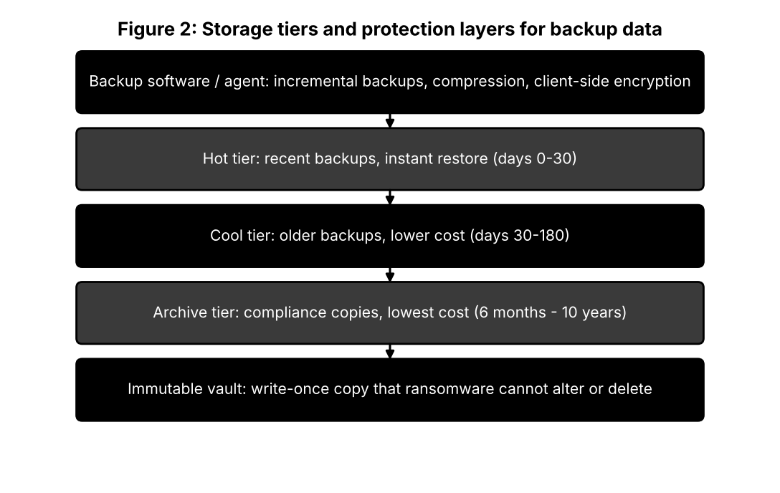
B. Encryption and access control
Backups often contain the organisation's most complete copy of sensitive data, so they must be protected as carefully as live systems.
- Encrypt before and during transfer: TLS in transit and optional client-side encryption so that the provider never sees plaintext.
- Encrypt at rest: AES-256 by default; keys stored in Azure Key Vault with rotation and separate administrators.
- Role-based access control: backup operators can create backups but cannot delete them; restore rights go to a different role.
- Network restrictions: private endpoints and firewall rules, so storage accounts are not reachable from the public internet.
- Immutability and soft delete: retention locks mean that even a stolen administrator password cannot erase backups.
- Multi-person approval: deleting a vault or reducing retention needs a second authorised approver.
C. Cost advantages over traditional storage
- Pay-as-you-go instead of buying arrays and tapes for the largest forecast size.
- Tiering: older backups cost much less in cool and archive tiers than on primary disks.
- No second site to build, power or staff; geo-replication is a setting, not a project.
- Reduced administration, since hardware refresh, tape handling and capacity planning shift to the provider.
- Predictable per-GB pricing and cost-management reports for budgeting.
Limits to remember: egress and retrieval fees can be significant during a large restore, and archive tiers can take hours to rehydrate, so frequently needed backups belong in the hot or cool tier.
D. Disaster recovery use case: ransomware at a hospital
A hospital's file servers are encrypted by ransomware. Because nightly backups are stored in an immutable vault with 30-day retention, the attackers cannot delete or alter them. The IT team isolates the infected network, creates clean virtual machines in a recovery environment, and restores the patient-records database from the last verified backup. Clinical systems resume the next morning with the loss of less than a day of data. The hospital also runs a quarterly restore drill, which shows that recovery works and how long it takes.
Question 3: Global Deployment of a Mobile App using CDNs
Scenario: A mobile app company plans to deploy its application globally. Explain how CDNs improve performance and reduce latency, how edge servers enhance user experience, how providers support global availability, and relate this to a real-time streaming or gaming application.
A. Why distance matters and what a CDN changes
Data travels at about two-thirds the speed of light in fibre, and every router adds delay, so a round trip from India to a US data centre costs roughly 200-250 ms before the server does any work. A CDN solves this by caching content in many points of presence (PoPs) close to users. The first request to a PoP fetches content from the origin; all later requests are served locally. Latency falls, origin load falls, and the app handles much larger audiences with the same back end.
Without CDN | With CDN
Every request travels to the origin region | Most requests are answered by a nearby PoP
High latency for distant users | Low latency everywhere
Origin must size for global peak | Origin sees only cache misses
Bandwidth bill grows with users | Lower origin egress cost
Origin is exposed to attacks | PoPs absorb and filter attacks

B. Edge servers and user experience
- Faster first load: static files, app updates and images arrive from a nearby server.
- Smoother media: video segments are cached at the edge, reducing buffering and start-up time.
- Edge compute: small functions run at the PoP to authenticate requests, choose language or route users by country.
- Reliability: if one PoP fails, requests are routed to the next nearest.
- Mobile friendliness: compressed images and modern protocols (HTTP/3) improve performance on weak networks.
C. Global availability supported by cloud providers
Providers run dozens of regions with multiple availability zones, joined by private high-capacity networks. Services such as Azure Front Door, AWS Global Accelerator or Google Cloud Load Balancing give an app one global address; anycast routing sends each user to the closest healthy deployment, and health probes redirect traffic automatically if a region fails. Multi-region databases (Cosmos DB, Spanner, DynamoDB Global Tables) keep data close to users, and managed DNS offers latency-based or geography-based routing. Compliance needs may require a user's data to stay inside certain regions, which geo-routing can enforce.
D. Example: real-time multiplayer game
In a fast-paced multiplayer game, a delay above about 100 ms is noticeable and above 150 ms spoils the experience. The game keeps its game servers in several regions and uses anycast to bring players into the nearest edge node, where the connection is secured and filtered for DDoS attacks. Players are matched to a regional server with low delay for all participants, while static assets such as maps, skins and patches come from the CDN. Session and leaderboard data are replicated across regions. The result is lower ping, fewer disconnects and quick patch downloads at game launch.
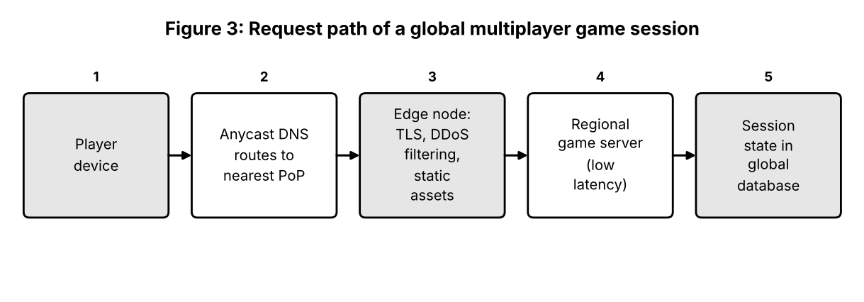
Question 4: Compliance, Auditing and Data Sovereignty in Financial Cloud Use
Scenario: A financial institution requires strict compliance and data security in cloud usage. Explain how providers support compliance and auditing, the role of logging, monitoring and encryption, how data sovereignty is ensured, and give an example with sensitive financial transactions.
A. How cloud providers support regulatory compliance
Large providers undergo regular independent audits and publish the results. Examples include ISO/IEC 27001 and 27018, SOC reports, PCI DSS for card data, and region-specific financial-sector requirements. Customers can download these reports (for example from the Azure Service Trust Portal) and use them as evidence. Providers also offer policy engines that apply rules across all resources (Azure Policy, AWS Config), blueprints that deploy pre-approved secure designs, and compliance scorecards that show which controls pass or fail. Responsibility is shared: the provider is accountable for the infrastructure, while the bank remains responsible for identities, configuration and data.
Requirement | Cloud capability that helps
Evidence for auditors | Audit reports, configuration history, exportable logs
Consistent configuration | Policy-as-code that blocks non-compliant resources
Access governance | Role-based access, just-in-time privileges, access reviews
Incident response | Security centre alerts, playbooks, forensic snapshots
Contractual assurance | Data processing agreements and breach-notification clauses

B. Roles of logging, monitoring and encryption
Logging answers who did what and when. Activity logs, sign-in logs and data-access logs are streamed to a central workspace and stored in immutable form for the retention period required by law. Monitoring turns these logs into alerts: a SIEM such as Microsoft Sentinel correlates events and flags unusual patterns, for example a login from two countries within an hour or a large export of account data. Encryption reduces the damage of any breach, as stolen disks, backups or network captures cannot be read without the keys. For regulated data, keys are kept in a hardware security module under the bank's control, with rotation and strict separation of duties.
C. Ensuring data sovereignty
- Pin resources to permitted regions with deny policies on other locations.
- Keep backups, logs and disaster-recovery copies inside the same jurisdiction (for example, two regions in the same country).
- Use sovereign or government cloud offerings where the law demands them.
- Hold encryption keys in the home country, so data is useless without local approval.
- Restrict support access: require approval for provider staff and review the access logs.
- Review sub-processors and data flows during vendor due diligence.
D. Example: card payment processing
A bank's mobile app sends a card payment through an API gateway and web application firewall. The card number is replaced by a token, so downstream systems never store it. The payment service runs in the bank's home-country region, and the transaction record is encrypted and appended to an immutable audit log. Fraud rules flag unusual amounts or locations in real time. Quarterly, the bank produces PCI DSS evidence from these logs and policy reports, which shortens the audit.
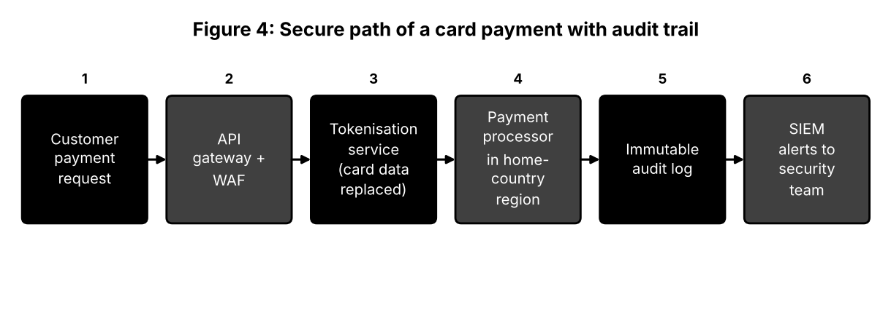
Question 5: Containers, Kubernetes and Microservices
Scenario: A development team wants to adopt containerization for application deployment. Explain how containers differ from virtual machines in performance and resource usage, how orchestration such as Kubernetes simplifies deployment and scaling, the portability benefits, and give an example of a microservices-based application.
A. Containers compared with virtual machines
A hypervisor divides one physical server into several complete virtual computers, each with its own operating system. Containers divide a single operating system into several isolated processes (using namespaces and cgroups). This difference determines performance and resource use.
Aspect | Virtual machines | Containers
Operating system | One full guest OS per VM | Shared host kernel
Image size | GBs | 10-500 MB
Boot time | 30 s to several minutes | Under a second to a few seconds
Memory and CPU overhead | High; every OS uses resources | Low; only the application process
Density | Fewer per host | Many more per host
Performance | Slight virtualisation overhead | Near native
Isolation | Hardware-level | Kernel-level; needs hardening and policies
Typical use | Legacy apps, mixed OS, strict isolation | Cloud-native apps, CI/CD pipelines

In practice they are often combined: containers run inside VMs, which gives the speed of containers with the isolation of VMs, as on managed Kubernetes services.
B. How orchestration simplifies deployment and scaling
Kubernetes is a declarative system. A manifest states how many replicas of a service should run, which image to use and what resources it needs. The control plane compares this with reality, and its controllers continuously correct differences.
- Scheduling: places each pod on a node with enough free CPU and memory.
- Service discovery and load balancing: services get a stable name and spread traffic over healthy pods.
- Rolling updates and rollback: new versions replace old ones gradually; a faulty release is reverted with one command.
- Autoscaling: pods and nodes scale with load.
- Self-healing: failed pods are restarted or rescheduled to other nodes.
- Storage and secrets: volumes and secret objects are attached without altering the image.
C. Portability across cloud environments
Because the image includes the application and dependencies, 'it works on my machine' becomes 'it works everywhere'. The same container passes through development, test and production without rebuilding. Kubernetes APIs are the same on Azure (AKS), AWS (EKS), Google (GKE) and on-premises, so a company can move a workload, run it in two clouds for resilience, or burst to the cloud during peaks. Tools like Helm charts and infrastructure-as-code make the environment itself reproducible. Care should be taken with provider-specific services (managed databases, proprietary queues) that reduce portability.
D. Example: ride-hailing app built from microservices
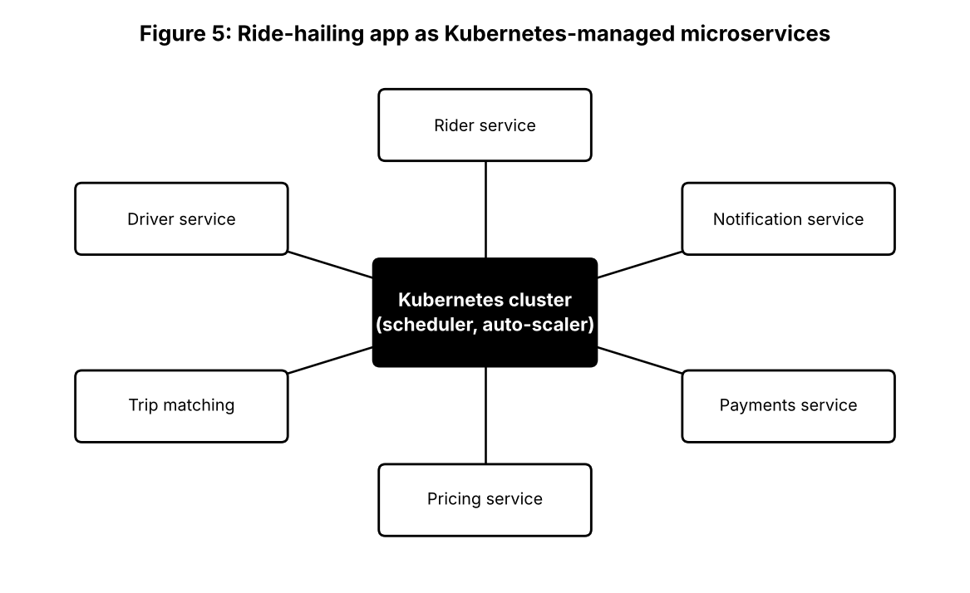
Service | Task | Scaling trigger
Rider | Sign-up, profile, trip requests | User requests
Driver | Availability, location updates | Number of active drivers
Trip matching | Finds the nearest driver | Requests per minute; scaled up at rush hour
Pricing | Fare and surge calculation | CPU use during peaks
Payments | Charges and receipts | Separate, security-hardened pods
Notification | Push messages and SMS | Message queue length

Each service can be written in a different language, released independently, and scaled on its own. During rainy-evening peaks, only matching and pricing scale up; payments remain stable. A fault in notifications does not stop trips.

