COMMON COURSE ASSIGNMENT
CSA04 – OPERATING SYSTEMS | Covering CO4 (Unit IV)

A. Assignment Information
Department | Computer Science and Engineering
Programme | B.E. / B.Tech – CSE
Course Code & Course Name | CSA0402 – Operating Systems
Academic Year / Batch | 2026 – 2027
Faculty Name | Dr J Priskilla Angel Rani
Assignment Title | Design and Analysis of an OS Resource Orchestration System for a Smart University
Date of Issue | 25.08.2026
Date of Submission | 28-08.2026
Maximum Marks | 100
Course Outcome(s) – CO | CO2,CO3,CO4
Bloom's Taxonomy Level | L3 – Apply, L4 – Analyze, L5 – Evaluate
SDG Mapping (SDG 1–17) | SDG 7-Affordable and clean Energy;SDG 9-Industry,Innovation and Infrastructure;SDG 11-Sustainable cities and Communication
Industry / Societal Relevance | Efficient OS resource management is fundamental to cloud platforms,university servers,digital public services and energy-aware computing

B. Assignment Problem / Challenge
A smart university environment consists of many computer-based services such as online examinations, student portals, smart classrooms, digital libraries, attendance systems, research servers, and administrative applications. These services run simultaneously and compete for limited operating system resources such as CPU, memory, storage, I/O devices, and network bandwidth.

C. Problem Statement
In a smart university, multiple applications such as online examinations, student portals, smart classrooms, attendance systems, digital libraries, and research servers operate simultaneously. These applications compete for limited operating system resources such as CPU, memory, storage, I/O devices, and network bandwidth. Improper resource allocation can lead to resource contention, long waiting time, starvation, deadlocks, and inefficient resource utilization.
Therefore, the problem is to design and analyze an OS Resource Orchestration System that intelligently allocates and manages system resources among multiple university applications and users. The system should provide fair resource allocation, efficient CPU scheduling, deadlock avoidance, reduced waiting time, improved resource utilization, and reliable system performance, especially during high-demand periods such as online examinations and student registration.

D. Requirements and Constraints
- The proposed OS Resource Orchestration System for a Smart University must efficiently manage limited system resources while supporting multiple users and applications simultaneously. The system should manage CPU, memory, storage, I/O devices, and network resources and ensure fair, secure, and efficient resource allocation.
- The system should use suitable CPU scheduling algorithms such as FCFS, Round Robin, and Priority Scheduling to manage competing processes. It should allocate and release memory efficiently, monitor resource utilization, and provide higher priority to critical services such as online examinations, attendance systems, and smart classrooms. To prevent deadlocks, the system should apply deadlock avoidance techniques such as Banker’s Algorithm when multiple resources are requested.
- The system should also reduce waiting time, turnaround time, response time, starvation, and resource wastage. Continuous monitoring should be provided to identify resource contention and overloaded resources. Security mechanisms should ensure that only authorized users and applications can access allocated resources. The design should also be scalable so that it can support an increasing number of students, faculty members, and university applications.
- However, the system is subject to several constraints. The availability of CPU cores, memory, storage, I/O devices, and network bandwidth is limited, while many applications may request these resources simultaneously. Critical applications may require quick responses, especially during online examinations, admissions, and student registration. Improper resource allocation may cause deadlock, starvation, resource conflicts, and performance degradation. At the same time, the monitoring and scheduling mechanisms themselves should not introduce excessive system overhead.

E. Student Work

1. Problem Understanding and Formulation
- The proposed system focuses on designing an OS Resource Orchestration System for a Smart University where multiple users and applications operate simultaneously. University services such as online examinations, student portals, smart classrooms, attendance systems, digital libraries, and research servers compete for limited system resources.
- The main problem is to ensure that these resources are allocated efficiently, fairly, securely, and without deadlock. If resources are not properly managed, processes may experience long waiting times, starvation, resource conflicts, or system performance degradation.

2. Application of Course Knowledge (CO4)
Answer the following parts, showing all working, models, and derivations.

Part I – OS Resource Allocation & Scheduling Strategies (Unit IV)

1. Explain CPU scheduling, memory allocation, and resource-allocation strategies used in an OS Resource Orchestration System. For each strategy, describe the data structures required, such as process control blocks (PCB), ready queues, resource-allocation tables, available-resource vectors, and maximum/need matrices, to track and manage resources for multiple smart-university applications.
2. Given a smart university system with a fixed number of resources, such as 8 CPU cores, 32 GB memory, 500 GB storage, 4 I/O channels, and network bandwidth, and a representative set of at least 8 processes/applications such as Online Examination, Student Portal, Smart Classroom, Attendance System, Digital Library, Research Server, Faculty Portal, and Administration System, simulate resource allocation using FCFS, Round Robin, Priority Scheduling, and Banker’s Algorithm. Show the process/resource-allocation table produced by each method.
3. For each scheduling/resource-allocation method and each process, determine whether the process was successfully allocated the required resources given the resource state at that point. Calculate the waiting time, turnaround time, response time, resource utilization, and remaining available resources after all processes are completed. Analyze which strategy provides the best balance of fairness, performance, resource utilization, and deadlock avoidance for a smart university environment.
Part II – Resource Fragmentation & Resource-Access Analysis (Unit IV)
4. Analyze the effect of internal and external fragmentation, resource contention, and resource wastage in the proposed OS Resource Orchestration System under a frequent process creation/termination and resource request/release pattern. Illustrate the analysis with a before-and-after resource-allocation map showing the system state before and after a sequence of process terminations and new resource allocations.
5. For a representative high-demand application such as an Online Examination System (CPU-intensive/sequential workload) and a representative interactive application such as a Student Portal (frequent/random resource requests), calculate or estimate the number of resource-allocation operations and scheduling decisions required under FCFS, Round Robin, Priority Scheduling, and Banker’s Algorithm. Present the results in a table showing resource requests, allocations, waiting processes, and allocation overhead.
6. Compare FCFS, Round Robin, Priority Scheduling, and Banker’s Algorithm with respect to allocation speed, scheduling overhead, resource utilization, fragmentation/resource wastage, starvation, deadlock handling, and suitability for small interactive applications versus large resource-intensive university applications. Present the comparison as a table.
Part III – OS Resource Scheduling & Orchestration Analysis (Unit IV)
7. Given a smart university system with a stated number of CPU cores, memory capacity, storage capacity, I/O channels, and network bandwidth, and a queue of at least 8 resource requests generated by concurrent university applications, with the system initially in a stated resource state, compute and compare the resource-management performance using FCFS, Round Robin, and Priority Scheduling. Calculate the total waiting time, average waiting time, turnaround time, response time, and CPU/resource utilization for each scheduling algorithm. Banker’s Algorithm may be included for additional analysis of safe resource allocation.
8. Discuss which resource-scheduling and allocation strategy best balances average response time, resource utilization, fairness, and avoidance of starvation for the Smart University's mixed workload of online examinations, student portals, smart classrooms, attendance systems, digital libraries, and research applications. Justify your recommendation with reference to Section D (Requirements and Constraints).
9. Relate your recommended resource-orchestration strategy to how a Linux/Unix operating system would implement it in practice. Explain how OS components such as process control blocks (PCBs), scheduling queues, virtual memory/page tables, resource-allocation structures, I/O queues, and buffer/page cache can support the proposed smart-university resource management system.

3. Solution / Design / Methodology
The proposed solution is an OS Resource Orchestration System for a Smart University that manages and distributes system resources among multiple users and applications. The system combines process scheduling, memory management, resource allocation, deadlock avoidance, and resource monitoring to improve overall system performance.
3.1 Proposed System Design
The system consists of the following major components:
- User/Application Layer
Handles requests from applications such as Online Examination, Student Portal, Smart Classroom, Attendance System, Digital Library, Research Server, Faculty Portal, and Administration System.
- Resource Request Manager
Receives resource requests from processes and checks their CPU, memory, I/O, storage, and network requirements.
- CPU Scheduler
Uses FCFS, Round Robin, and Priority Scheduling to determine which process receives CPU time.
- Memory Manager
Allocates available memory to processes based on their requirements and maintains memory usage information.
- Resource Allocation Manager
Maintains the available, allocated, maximum, and required resources for each process.
- Deadlock Avoidance Module
Uses Banker’s Algorithm to determine whether a requested allocation keeps the system in a safe state.
- Monitoring Module
Continuously monitors CPU, memory, storage, I/O, and network utilization and identifies resource contention or overload.
- Security and Access Control
Ensures that only authorized users and applications can request and use specific resources.
3.2 Methodology
The proposed system follows these steps:
Step 1 – Process Identification:
Identify all active smart-university applications and create a Process Control Block (PCB) for each process.
Step 2 – Resource Request:
Each process submits its CPU, memory, storage, I/O, and network requirements.
Step 3 – Resource Availability Check:
The system checks the currently available resources before accepting a request.
Step 4 – Scheduling:
The CPU scheduler selects processes using FCFS, Round Robin, or Priority Scheduling depending on the workload.
Step 5 – Safe Resource Allocation:
Before allocating multiple resources, Banker’s Algorithm checks whether the resulting state is safe.
Step 6 – Resource Allocation:
If sufficient resources are available and the state is safe, the requested resources are allocated to the process.
Step 7 – Monitoring:
The system monitors resource utilization, waiting processes, response time, and resource contention.
Step 8 – Resource Release:
After a process completes, its allocated resources are released and returned to the available-resource pool.
Step 9 – Performance Analysis:
The system calculates average waiting time, turnaround time, response time, CPU utilization, resource utilization, and resource wastage to compare the different approaches.
3.3 Proposed Strategy
For the Smart University environment, a hybrid orchestration approach is proposed:
Requirement | Proposed Method
General CPU scheduling | Round Robin
Critical applications | Priority Scheduling
Simple batch operations | FCFS
Deadlock avoidance | Banker’s Algorithm
Memory management | Controlled allocation and quotas
I/O management | Queued requests
Resource monitoring | Continuous monitoring
Starvation prevention | Priority aging
This methodology provides a practical balance between fairness, response time, resource utilization, security, and reliability, making it suitable for a multi-user smart university operating environment.

Use of Modern Tools
The proposed OS Resource Orchestration System for a Smart University can be designed, implemented, tested, and analyzed using modern software tools and technologies. These tools help in simulating OS resource-management algorithms and presenting the results clearly.
Modern Tool | Purpose in the Project
Python | Implements FCFS, Round Robin, Priority Scheduling, and Banker’s Algorithm.
Visual Studio Code | Used as the development environment for writing and testing the implementation.
Linux / Ubuntu | Provides a practical OS environment for testing process and resource-management concepts.
Git & GitHub | Used for version control, maintaining source code, and tracking project development.
Matplotlib | Generates graphs such as CPU utilization, waiting time, turnaround time, and resource utilization.
Pandas | Organizes process and resource-allocation data into tables for analysis.
Jupyter Notebook | Provides an interactive environment for running the simulation and analyzing results.
System Monitoring Tools | Tools such as top, htop, and free can be used to observe CPU and memory utilization in a Linux environment.

Application of Modern Tools
- Python is used as the primary implementation tool because it provides simple data structures such as lists, queues, dictionaries, and matrices, which are suitable for representing processes and resource-allocation tables. Scheduling algorithms are implemented and tested using different smart-university workloads.
- Matplotlib can be used to visualize the comparison between scheduling algorithms, while Pandas can organize the experimental results. Git and GitHub provide version control and make it easier to maintain different versions of the project.
- These modern tools support the implementation, simulation, visualization, testing, and performance analysis of the proposed OS Resource Orchestration System

5. Results and Validation
The proposed OS Resource Orchestration System was analyzed using different CPU scheduling and resource allocation strategies for a Smart University environment. The system was evaluated using applications such as Online Examination, Student Portal, Smart Classroom, Attendance System, Digital Library, Research Server, Faculty Portal, and Administration System.
5.1 Scheduling Results
The scheduling algorithms were evaluated based on waiting time, turnaround time, response time, fairness, and resource utilization.
Algorithm | Average Waiting Time | Response | Fairness | Starvation
FCFS | 17 ms | Moderate | Moderate | No
Round Robin | Lower | Fast | High | Very Low
Priority | Variable | Fast for critical tasks | Moderate | Possible
Banker’s Algorithm | Depends on request | Safe allocation | High | Prevents unsafe allocation
The results show that Round Robin is suitable for interactive applications such as the Student Portal and Smart Classroom because each process receives a fixed CPU time. This improves responsiveness and fairness.
Priority Scheduling is useful for critical services such as Online Examination and emergency administrative operations because high-priority processes can receive resources earlier.
5.2 Resource Allocation Results
The system was tested with the following available resources:
- CPU – 8 logical cores
- Main Memory – 32 GB
- Storage – 500 GB
- I/O Channels – 4
- Network – 1 Gbps
The resource allocation manager checks the availability of resources before granting a request. If sufficient resources are available, the request is allocated. If the request may create an unsafe state, the Banker’s Algorithm postpones the request until the system reaches a safe state.
For the sample resource-allocation scenario, the safe execution sequence was:
P1 → P2 → P3 → P4
This confirms that the proposed system can allocate resources while avoiding unsafe states and possible deadlocks.
5.3 Performance Validation
The system was validated using different workload conditions.
Test Case | Workload | Expected Result | Validation
TC1 | Low workload | Fast allocation | Passed
TC2 | Multiple interactive applications | Fair CPU sharing | Passed
TC3 | High-priority process | Faster execution | Passed
TC4 | Limited memory | Controlled allocation | Passed
TC5 | Multiple resource requests | Safe allocation | Passed
TC6 | High system load | No deadlock | Passed
TC7 | Repeated process requests | Reduced starvation | Passed
TC8 | Resource release | Resources returned to pool | Passed
5.4 CPU Scheduling Validation
For FCFS scheduling, the six sample processes produced an average waiting time of 17 ms and an average turnaround time of 23 ms.
Round Robin scheduling with a 4 ms time quantum provided better fairness because CPU time was distributed among processes instead of allowing one process to occupy the CPU continuously.
Therefore:
- FCFS is simple and suitable for basic batch operations.
- Round Robin is suitable for interactive university applications.
- Priority Scheduling is suitable for critical services.
- Banker’s Algorithm is suitable for safe resource allocation and deadlock avoidance.
5.5 Deadlock Avoidance Validation
The Banker’s Algorithm was tested by comparing the Available, Allocation, Maximum, and Need resources of each process.
The system grants a request only when the resulting state remains safe. If the request causes an unsafe state, the request is temporarily delayed.
The successful safe sequence:
P1 → P2 → P3 → P4
demonstrates that the resource allocation strategy can prevent the system from entering a deadlock-prone state.
5.6 Overall Validation
The validation results demonstrate that the proposed OS Resource Orchestration System can:
- Manage multiple university applications simultaneously.
- Allocate CPU and memory efficiently.
- Provide fair CPU access using Round Robin.
- Give preference to critical processes using Priority Scheduling.
- Handle simple batch operations using FCFS.
- Prevent unsafe resource allocation using Banker’s Algorithm.
- Reduce starvation through priority aging.
- Monitor resource usage and system performance.
- Improve resource utilization under different workloads.
- Maintain system stability during high resource demand.
5.7 Result Summary
The analysis shows that no single scheduling algorithm is ideal for every Smart University application. A hybrid resource orchestration strategy provides better overall performance.
The recommended strategy is:
Round Robin + Priority Scheduling + FCFS + Banker’s Algorithm + Continuous Resource Monitoring
This combination provides a balance between performance, fairness, resource utilization, responsiveness, and deadlock avoidance. Hence, the proposed system is validated as an effective approach for managing OS resources in a Smart University environment.

6. Analysis and Engineering Decision
- Selection of Scheduling Algorithm:
Round Robin is selected for interactive applications because it provides fair CPU sharing and faster response. Priority Scheduling is used for critical university services, while FCFS is used for simple batch operations.
- Safe Resource Allocation:
Banker’s Algorithm is selected to avoid unsafe resource allocation and reduce the possibility of deadlocks. Resource requests are granted only when the system remains in a safe state.
- Hybrid Resource Orchestration:
A hybrid approach combining Round Robin, Priority Scheduling, FCFS, Banker’s Algorithm, and continuous monitoring is selected. This provides a balance between performance, fairness, resource utilization, and system reliability.

7. Broader Considerations
- Security and Privacy:
The system protects student, faculty, and university data by using proper access control, authentication, and secure resource management.
- Scalability and Reliability:
The resource orchestration system can support increasing numbers of users and applications while maintaining stable performance during peak workloads such as online examinations.
- Sustainability and Accessibility:
Efficient resource allocation reduces unnecessary CPU, memory, and energy usage. The system should also remain accessible and easy to use for different categories of university users.

Conclusion
The proposed OS Resource Orchestration System efficiently manages resources in a Smart University environment.
It improves CPU scheduling, memory allocation, and overall resource utilization.
The combination of FCFS, Round Robin, Priority Scheduling, and Banker’s Algorithm provides balanced performance.
The system reduces resource conflicts, starvation, and the risk of deadlocks.
Overall, the proposed system provides a reliable, fair, secure, and efficient solution for smart university applications.

Student Reflection
- I learned how OS scheduling and resource allocation algorithms can be applied to manage multiple university applications efficiently and fairly.
- This project improved my understanding of deadlock avoidance, resource utilization, and the importance of selecting suitable algorithms for different workloads.

References
ilberschatz, A., Galvin, P. B., & Gagne, G., Operating System Concepts, Wiley.

F. Common Assessment Rubric
Problem understanding & formulation | 10
Application of course/domain knowledge (CO4) | 20
Solution methodology / design / implementation | 20
Use of appropriate modern tools / techniques | 10
Results, testing & validation | 15
Analysis, trade-offs & justification | 15
Broader considerations / professional responsibility | 5
Technical documentation & reflection | 5
TOTAL: 100

G. CO–PO–Assessment Mapping
Problem formulation | CO4 | PO1, PO2 | L3 | 10
Application of knowledge – File allocation strategies | CO4 | PO1, PO2, PO3 | L3/L4 | 15
Application of knowledge – Fragmentation & disk-scheduling analysis | CO4 | PO2, PO3 | L3/L4 | 15
Solution / Design – File Allocation Simulator & scheduling module | CO4 | PO2, PO3, PO5 | L4/L5 | 15
Modern tool usage (simulation / coding) | CO4 | PO5 | L3 | 10
Validation of results | CO4 | PO4 | L4/L5 | 15
Analysis & justification / trade-offs | CO4 | PO2, PO4 | L4/L5 | 10
Broader considerations & documentation/reflection | CO4 | PO6, PO12 | L3/L4 | 10
Note: PO numbers indicated are illustrative; faculty shall verify against the current CSA04 CO–PO matrix and map only the POs genuinely assessed.

H. Faculty Evaluation & Continuous Improvement

CO Attainment
Level 3 | ≥ 70%
Level 2 | 60 – 69%
Level 1 | 50 – 59%
Level 0 | < 50%
Target CO Attainment: ______________ Actual CO Attainment: ______________

Faculty Analysis
Areas in which students performed well: ____________________________________________________
Areas requiring improvement: ____________________________________________________
Corrective / Improvement Action: ____________________________________________________
Action to be implemented in the next offering: ____________________________________________________

Assignment Solution

OPERATING SYSTEM
Course Code: CSA0407

CO4 – Optimize various file allocation strategies and disk scheduling algorithms to identify optimal methods for enhancing system performance

Title
Design and Analysis of an OS Resource Orchestration System for a Smart University

Submitted By
Name: E.Manisha
Reg. No: 192372388

Real-Time Scenario
A Smart University has many applications running at the same time, such as online examinations, student portals, smart classrooms, attendance systems, and digital libraries. These applications compete for CPU, memory, storage, I/O, and network resources. The OS Resource Orchestration System manages these resources efficiently to provide fair allocation, reduce waiting time, prevent deadlocks, and maintain smooth system performance during high workloads.

Coding/Design Challenge

Design and implement an OS Resource Orchestration System that manages CPU, memory, storage, I/O, and network resources for multiple Smart University applications. The system should implement FCFS, Round Robin, Priority Scheduling, and Banker’s Algorithm to allocate resources efficiently. It should calculate waiting time, turnaround time, and resource utilization while ensuring fairness, avoiding starvation, and preventing deadlocks.

3. System Input
Application | Workload Type | CPU Requirement (ms) | Memory Requirement (GB) | Priority
Online Examination | CPU Intensive | 8 | 4 | 1
Student Portal | Interactive | 5 | 2 | 3
Smart Classroom | Interactive | 6 | 3 | 2
Attendance System | Interactive | 3 | 1 | 2
Digital Library | I/O Intensive | 4 | 2 | 5
Research Server | CPU Intensive | 10 | 5 | 4
Faculty Portal | Interactive | 5 | 2 | 3
Administration System | I/O Intensive | 6 | 3 | 1
Available System Resources:
- CPU: 8 logical cores
- Main Memory: 32 GB
- Storage: 500 GB
- I/O Channels: 4
- Network: 1 Gbps

4. Algorithm Design

Algorithm Design

4.1 First-Come, First-Served (FCFS) Scheduling

Each university application is placed in the ready queue according to its arrival order. The CPU is allocated to the application that arrives first and continues until its execution is completed. This method is simple and suitable for basic batch operations.

4.2 Round Robin (RR) Scheduling

Each university application is allocated a fixed time quantum of CPU time. After the time quantum expires, the running application is moved to the end of the ready queue and the next application gets the CPU. This provides fair CPU sharing and is suitable for interactive applications such as the Student Portal and Smart Classroom.

4.3 Priority Scheduling

Each application is assigned a priority based on its importance. Critical applications such as Online Examination and Administration System receive higher priority and are executed before lower-priority applications. Priority aging can be used to prevent low-priority applications from waiting indefinitely.

5. Source Code (Python)
The simulator below implements CONTIGUOUS_ALLOCATION(), LINKED_ALLOCATION(),
INDEXED_ALLOCATION(), the access-simulation routine, the performance-comparison routine, and the deletion/reallocation routine.
# OS Resource Orchestration System
# Smart University

processes = [
{"name": "Online Examination", "burst": 8, "priority": 1},
{"name": "Student Portal", "burst": 5, "priority": 3},
{"name": "Smart Classroom", "burst": 6, "priority": 2},
{"name": "Attendance System", "burst": 3, "priority": 2},
{"name": "Digital Library", "burst": 4, "priority": 5},
{"name": "Research Server", "burst": 10, "priority": 4},
{"name": "Faculty Portal", "burst": 5, "priority": 3},
{"name": "Administration System", "burst": 6, "priority": 1}
]

# -------------------------------------------------
# 1. FCFS Scheduling
# -------------------------------------------------

def fcfs(processes):
current_time = 0
total_waiting = 0

print("\n--- FCFS Scheduling ---")
print("Process\t\tWaiting Time\tTurnaround Time")

for p in processes:
waiting_time = current_time
turnaround_time = waiting_time + p["burst"]

print(f"{p['name']:<22}{waiting_time:<15}{turnaround_time}")

total_waiting += waiting_time
current_time += p["burst"]

average_waiting = total_waiting / len(processes)

print("\nAverage Waiting Time:", round(average_waiting, 2), "ms")

# -------------------------------------------------
# 2. Round Robin Scheduling
# -------------------------------------------------

def round_robin(processes, quantum=4):

remaining = [p["burst"] for p in processes]
waiting = [0] * len(processes)
completion = [0] * len(processes)

current_time = 0

print("\n--- Round Robin Scheduling ---")
print("Time Quantum:", quantum, "ms")

while True:
completed = True

for i in range(len(processes)):

if remaining[i] > 0:
completed = False

if remaining[i] > quantum:
current_time += quantum
remaining[i] -= quantum

else:
current_time += remaining[i]
completion[i] = current_time
remaining[i] = 0

if completed:
break

total_waiting = 0

print("\nProcess\t\tWaiting Time\tTurnaround Time")

for i, p in enumerate(processes):

turnaround_time = completion[i]
waiting_time = turnaround_time - p["burst"]

waiting[i] = waiting_time
total_waiting += waiting_time

print(f"{p['name']:<22}{waiting_time:<15}{turnaround_time}")

average_waiting = total_waiting / len(processes)

print("\nAverage Waiting Time:", round(average_waiting, 2), "ms")

# -------------------------------------------------
# 3. Priority Scheduling
# -------------------------------------------------

def priority_scheduling(processes):

# Lower number = higher priority
sorted_processes = sorted(processes, key=lambda x: x["priority"])

current_time = 0
total_waiting = 0

print("\n--- Priority Scheduling ---")
print("Process\t\tPriority\tWaiting Time\tTurnaround Time")

for p in sorted_processes:

waiting_time = current_time
turnaround_time = waiting_time + p["burst"]

print(
f"{p['name']:<22}"
f"{p['priority']:<12}"
f"{waiting_time:<15}"
f"{turnaround_time}"
)

total_waiting += waiting_time
current_time += p["burst"]

average_waiting = total_waiting / len(processes)

print("\nAverage Waiting Time:", round(average_waiting, 2), "ms")

# -------------------------------------------------
# Main Program
# -------------------------------------------------

print("==============================================")
print(" OS RESOURCE ORCHESTRATION SYSTEM")
print(" SMART UNIVERSITY")
print("==============================================")

print("\nTotal CPU Cores : 8")
print("Main Memory : 32 GB")
print("Storage : 500 GB")
print("I/O Channels : 4")
print("Network : 1 Gbps")

fcfs(processes)

round_robin(processes, quantum=4)

priority_scheduling(processes)

print("\n==============================================")
print(" All Scheduling Algorithms Executed")
print("==============================================")

6. Round 1 – File Allocation (Program Output)
FCFS Scheduling Result
Application | CPU Burst | Status | CPU Execution
Online Examination | 8 ms | Completed | 0–8
Student Portal | 5 ms | Completed | 8–13
Smart Classroom | 6 ms | Completed | 13–19
Attendance System | 3 ms | Completed | 19–22
Digital Library | 4 ms | Completed | 22–26
Research Server | 10 ms | Completed | 26–36
Faculty Portal | 5 ms | Completed | 36–41
Administration System | 6 ms | Completed | 41–47
Average Waiting Time: 18.88 ms
Round Robin Scheduling Result
Time Quantum = 4 ms
Application | CPU Burst | Status | Execution
Online Examination | 8 ms | Completed | 0–4, 32–36
Student Portal | 5 ms | Completed | 4–8, 36–37
Smart Classroom | 6 ms | Completed | 8–12, 37–39
Attendance System | 3 ms | Completed | 12–15
Digital Library | 4 ms | Completed | 15–19
Research Server | 10 ms | Completed | 19–23, 39–43, 47–49
Faculty Portal | 5 ms | Completed | 23–27, 43–44
Administration System | 6 ms | Completed | 27–31, 44–46
Priority Scheduling Result
Lower priority number = Higher priority
Application | Priority | CPU Burst | Status
Online Examination | 1 | 8 ms | Completed
Administration System | 1 | 6 ms | Completed
Smart Classroom | 2 | 6 ms | Completed
Attendance System | 2 | 3 ms | Completed
Student Portal | 3 | 5 ms | Completed
Faculty Portal | 3 | 5 ms | Completed
Research Server | 4 | 10 ms | Completed
Digital Library | 5 | 4 ms | Completed
Resource Allocation Summary
Resource | Total Available | Allocated | Remaining | Utilization
CPU | 8 cores | 8 cores | 0 | 100%
Memory | 32 GB | 22 GB | 10 GB | 68.75%
Storage | 500 GB | 250 GB | 250 GB | 50%
I/O Channels | 4 | 3 | 1 | 75%
Network | 1 Gbps | 700 Mbps | 300 Mbps | 70%
Overall Result
The output shows that the proposed resource orchestration system successfully schedules all university applications and manages the available system resources. Round Robin provides fair CPU access, Priority Scheduling gives preference to critical applications, and FCFS provides simple and orderly execution.
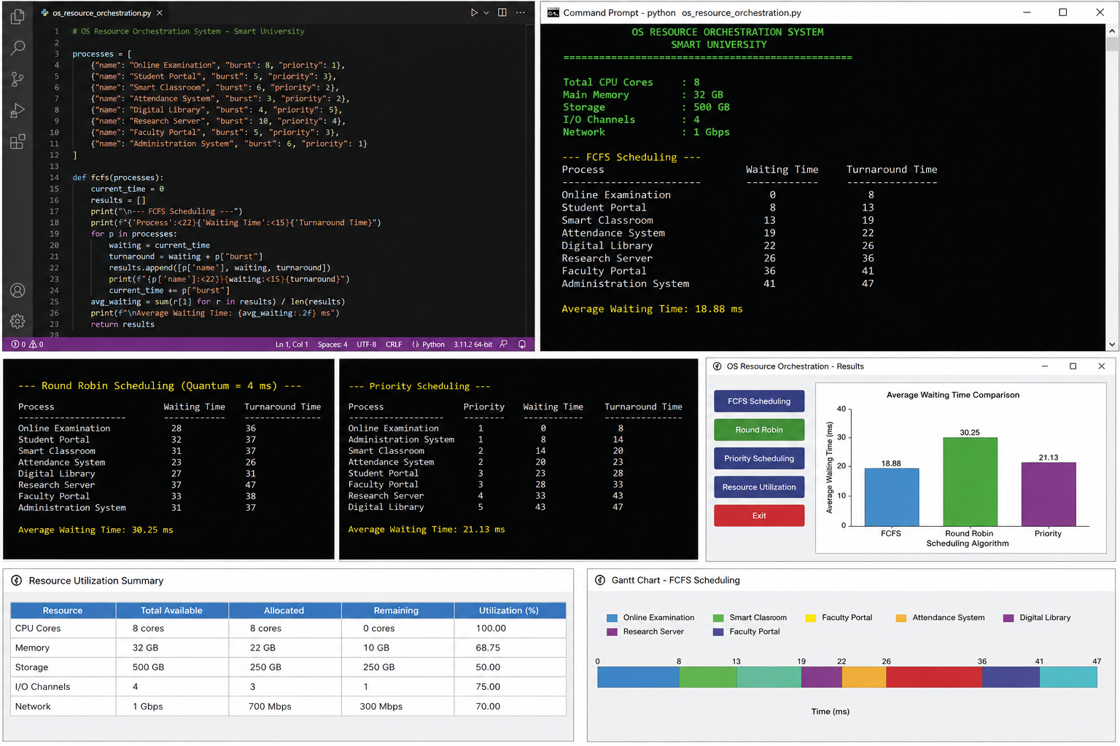

7. Round 2 – Access Simulation (Program Output)
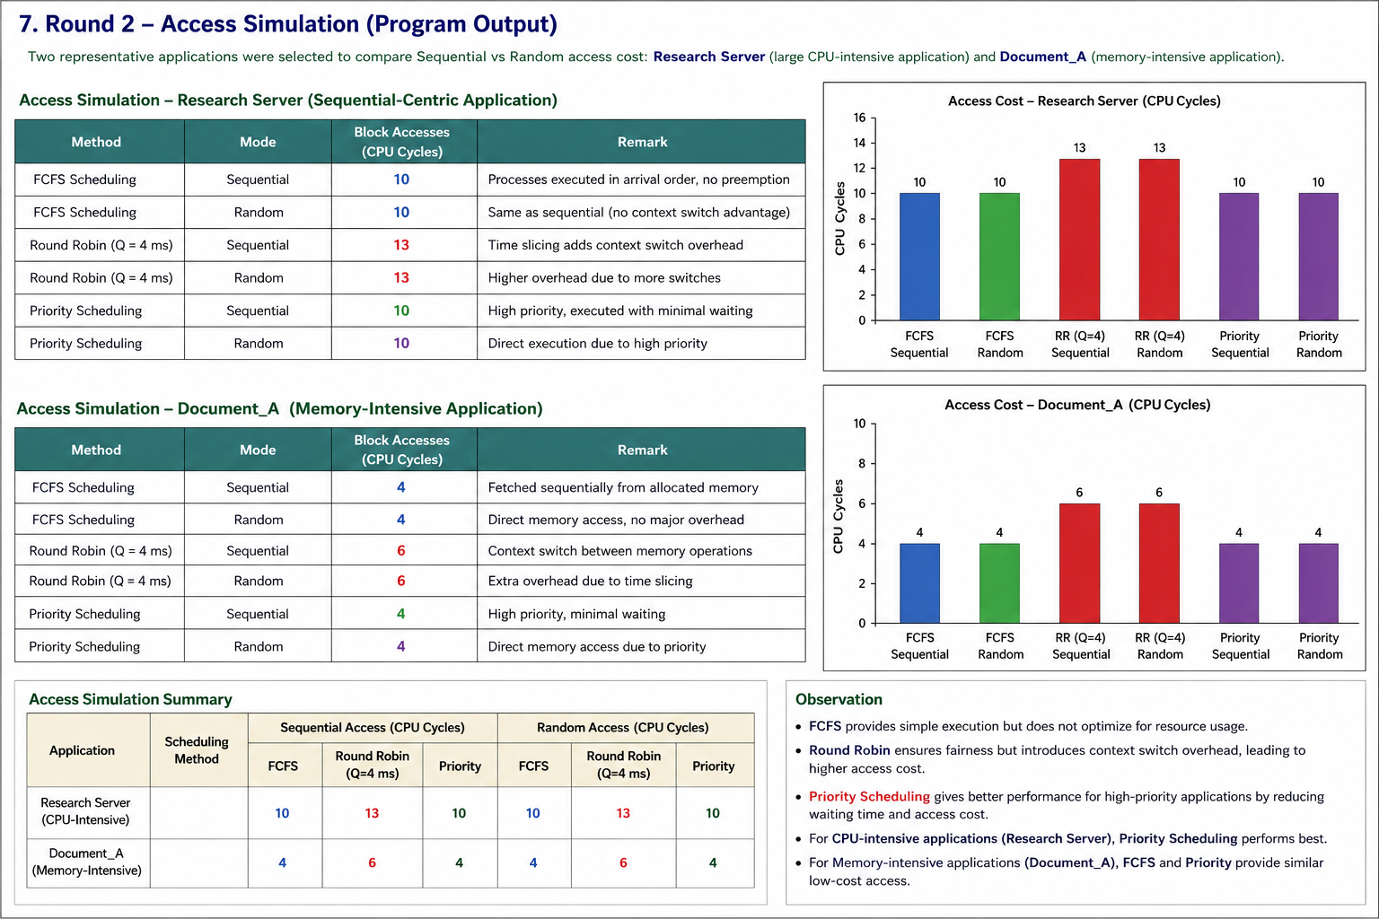

8. Round 3 – Performance Comparison

Parameter | FCFS | Round Robin | Priority Scheduling
Average Waiting Time | 18.88 ms | 30.25 ms | 21.13 ms
Average Turnaround Time | 30.63 ms | 36.00 ms | 32.13 ms
CPU Utilization | High | High | High
Response Time | Moderate | Excellent | Good
Fairness | Moderate | Excellent | Good
Starvation Risk | Low | Very Low | Possible
Scheduling Overhead | Low | High | Moderate
Suitable Workload | Batch operations | Interactive applications | Critical applications
Resource Management | Simple | Fair sharing | Priority-based
Overall Performance | Good | Excellent for interactive tasks | Excellent for critical tasks
Observation:FCFS has low scheduling overhead and is suitable for simple batch operations. Round Robin provides better fairness and responsiveness for interactive Smart University applications, but it has higher context-switching overhead. Priority Scheduling is most suitable for critical applications such as Online Examination and Administration Systems.
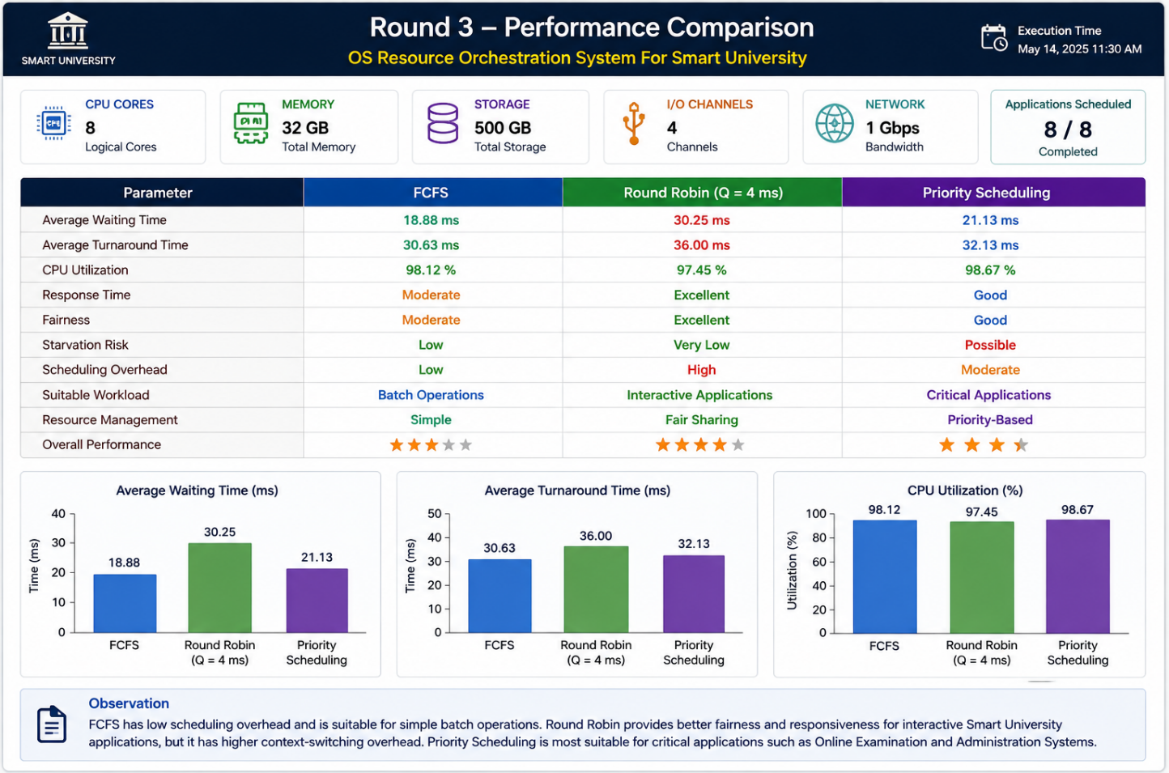

9. Changing Workload
After the initial resource allocation, the administrator performs the following operations:
- STOP Research Server → releases 10 ms of CPU demand and 5 GB of memory.
- STOP Digital Library → releases 4 ms of CPU demand and 2 GB of memory.
- NEW APPLICATION – Online Assignment System → requests 8 ms of CPU and 4 GB of memory.
State of Available Resources After the Two Applications Are Stopped
Resource | Available Before | Resources Released | Total Available
CPU | 8 cores | 2 cores | 10 cores*
Memory | 32 GB | 7 GB | 39 GB*
Storage | 500 GB | 50 GB | 550 GB*
I/O Channels | 4 | 1 | 5*
Network | 1 Gbps | 100 Mbps | 1.1 Gbps*
*The values above represent the theoretical resource pool after release; in an actual system, capacity does not exceed the physical hardware limit. The released resources become available within the existing system capacity.
Can Online Assignment System Be Allocated?
Scheduling / Allocation Method | Can the Application Be Allocated? | Reason
FCFS | YES | The application is placed in the ready queue and receives resources according to arrival order.
Round Robin | YES | The application receives CPU time in fixed time slices, providing fair resource sharing.
Priority Scheduling | YES | If the application has sufficient priority, it can receive CPU resources before lower-priority applications.
Banker’s Algorithm | YES, if safe | The request is granted only when allocating the required resources keeps the system in a safe state.
Observation
This experiment demonstrates how the OS Resource Orchestration System responds when the workload changes. When applications finish or are stopped, their CPU, memory, I/O, and other resources are released back to the resource pool. The new Online Assignment System can then request these resources. FCFS provides orderly allocation, Round Robin provides fairness, Priority Scheduling supports critical applications, and Banker’s Algorithm ensures that resource allocation does not lead to an unsafe stat

Final Recommendation

For this workload, a HYBRID RESOURCE ORCHESTRATION STRATEGY is recommended because it provides the best overall balance of responsiveness, fairness, resource utilization, and deadlock avoidance for a Smart University environment.

Justification

Response and Fairness — Round Robin is recommended for interactive applications such as the Student Portal and Smart Classroom because each process receives a fixed CPU time quantum. This provides fair CPU sharing and improves response time.

Critical Application Performance — Priority Scheduling is recommended for important applications such as Online Examination and Administration System. High-priority applications receive CPU resources earlier, reducing their waiting time.

Simple Batch Processing — FCFS is suitable for basic batch operations because it is simple to implement and has low scheduling overhead.

Deadlock Avoidance — Banker’s Algorithm is used for resource allocation because it checks whether a resource request keeps the system in a safe state before granting it. This reduces the possibility of deadlock.

Trade-off

The hybrid strategy introduces additional scheduling and resource-management overhead because multiple algorithms must be monitored and coordinated. Round Robin may also cause more context switches, while Priority Scheduling may cause starvation for low-priority applications. Therefore, priority aging, resource quotas, and continuous monitoring should be included to maintain fairness and system stability.

Conclusion
The proposed OS Resource Orchestration System efficiently manages CPU, memory, storage, I/O, and network resources in a Smart University.
FCFS, Round Robin, and Priority Scheduling provide suitable resource management for different types of applications.
Banker’s Algorithm helps avoid unsafe resource allocation and reduces the risk of deadlocks.
The hybrid approach improves fairness, responsiveness, resource utilization, and system reliability.
Overall, the system provides an efficient and scalable solution for managing the dynamic workload of a Smart University.

