UNIVERSITY OF NORTH TEXAS

Final Report
ON
“ E – Commerce System ”
Submitted partial fulfillment of the requirements for the award of degree of
Master of Science
in
Information Systems and Technology

Course Name : Information Systems Development
Course Code : BCIS 5120
Group Number : 8
Data of submission : 12/01/2024

NAME Student ID
- Rohan Chowdary Pusala 11802322

- Yaswanth Reddy Chittem 11761770

- Harini Gaurishankar 11808659

- Gilbert Vijayan 11821825

- Bhavitha Enuganti 11794159

TABLE OF CONTENTS

S.NO. | NAME OF CONTENTS | Pg. No.
1 | Brief Project Description | 3
2 | Rationale for the project | 4
3 | Analysis of the Requirement Gathering Process | 6
4 | Use case diagram | 9
5 | Object Diagram | 12
6 | Class Diagram | 13
7 | Windows Navigation Diagram | 14
8 | Conclusion | 14
9 | Technical Recommendations | 14
10 | AI tool used by the group | 16

BRIEF PROJECT DESCRIPTION:
Objective: Creating a fully functional e-commerce store for Orion Retail Management focused on improving the customer experience and business process as well as broadening potentials for business growth by offering an easy to use online shopping interface.
Scope:
The system will encompass the following core features
1. Online Storefront:
- An interactive e-commerce website for showcasing Orion Retail Management's products.
- Users interact with the websites and can view all items in stock, prices, pictures and descriptions.
2. User Accounts and Profiles:
- Allows clients to register, sign in and manage accounts.
- There are features like order history, wishlists and recommend products.
3. Shopping Cart and Checkout System:
- Adding and updating items and removing items from the shopping cart is easy as pie.
- Integrated and secured checkout system with comprehensive payment processing (credit/debit cards, digital wallets, etc)
4. Inventory Management:
- Automatically update and keep track of inventory when orders are made.
- Manage product inventories and provide low stock alerts.
5.Order Management:
- Enable employees to manage and follow through with customer orders from when it's placed to delivery.
- Give customers information on their order's shipping status and updates.
6.Customer Support Features:
- Contact form, live chat integration, and customer service to assist in solving all inquiries made by customers.
- A return and refund handling system to manage customers grievances after purchase.
7. Analytics and Reporting:
- The platform will also have reports and analytics tools covered where users will be able to measure sales and analyze their customers and the products sold.
- Information belonging to Orion Retail will thus enable the company to rearrange its
promotion policy and stock control system in order to increase the efficiency of operations.

Target Audience:
1.Customers:
- People who are interested in going through the inventory and ordering any item at the Orion Retail Management Centre from any place in the world through the Internet.
2.Internal Staff:
- Employees who update the orders, manage the existing items and deal with the customers regarding their orders.
Problem Statement: The Orion Retail Management Company has an opportunity but does have an appropriate online platform to facilitate its customers to shop online. Customers are unable to access products as there is no central site available and also, the work such as inventory control and order placement is very paper based and so very slow and unwieldy.
Solution overcome:
The e-commerce system will entail:
- An attractive and modern site which is responsive and will encourage customers to shop there and come back.
- Tools of inventory together with order processing in order to reduce operational headaches.
- Analytical tools for Orion Retail Management to keep track of trends that assist in determining client’s needs and enhancing the products offered.
Expected Outcomes:
- Enhanced customer satisfaction due to the fact that the clients are going to enjoy an improved online shopping experience that is friendly and rich in content.
- Improved operational efficiency and therefore, useful time and resources are saved for the Orion Retail Management workers.
- User expectations and satisfaction is anticipated to increase tremendously as the company will grow its scale of operations online through rising traffic to the business.
- Data likely provides a guide on enabling improvement of marketing and distribution of stocks.
RATIONALE FOR THE PROJECT:
1. Expanding Market Access and Approachability:
- The dependency on physical stores has confined the customer approach for Orion Retail within the limited radius of its outlet location. To date, an e-commerce launch by the company can eradicate these obstacles and make them a global entity. This very phenomenon transcends market outreach from being a limited location-based sales model to an indefinite online market. The products will be accessible from anywhere and be bought by customers, therefore increasing the propensity of sales, and enhance brand awareness, enabling Orion Retail to establish a stronger presence in the wider market.
2. Meeting Consumer Expectation:
- In today's digital era, consumers expect an easy, accessible, and comparative online shopping experience, available 24/7, with the convenience of home delivery. An e-commerce system will meet such expectations through a friendly, flexible shopping platform that meets the needs of the modern consumer. In embracing this shift, Orion Retail will ensure that it remains competitive since companies without an online presence stand to lose customers to competitors offering better and more convenient digital services.
3. Business Process Reengineering and Business Process Efficiency:
- E-commerce platform integration will enable Orion Retail to automate and streamline most of the business processes in inventory management, order processing, payment, and customer interaction. Automation reduces the need for manual input, cuts down on errors, and increases speed, hence increasing efficiency. Besides, such automation cuts labor costs and saves lots of time spent on mundane tasks by employees, which is instead utilized for more strategic work. Therefore, it enables the company to support larger volumes of transactions at lesser overheads and helps to achieve higher operational efficiencies and cost savings.
4. Customer Engagement and Personalization:
- E-commerce has the added advantage of integrated CRM systems for personalization of customer experiences.
- Through the collection of data regarding customer preferences, Orion Retail will be able to create and deliver customized recommendations, special offers, and loyalty programs aimed at increasing customer retention and encouraging repeat business. These targeted campaigns raise the level of customer interaction, satisfaction, and overall brand loyalty. The personalization of the customer journey promotes better customer engagement and finally boosts sales.
5. Data Analytics to Enhance Decision-Making:
- E-commerce systems offer real-time data insight into consumer behavior, sales trends, and product performance. Orion Retail can thus make informed decisions that improve business operations and marketing strategies through the analysis of such data. For instance, the company could better its product offerings, understand the peak periods of sales, adjust inventory levels, and adjust pricing accordingly. Data analytics gives the company an edge to act swiftly on market fluctuations so that it can sustain competitiveness and profitability in the fast-paced environment.
6. Business Value: Growing Competitiveness and Growth:
- The implementation of the e-commerce system will raise Orion Retail's edge over competitors in the competitive retail industry. As more and more customers shift to online purchases, a strong presence through an online platform becomes crucial. The digital transformation not only enhances the company's present competitiveness but also positions it for future growth as the sector of e-commerce continues to grow.
- Thus, the Orion Retail Group would better be able to face consumers' preferences for the development of operational efficiencies and prosper in a digitized marketplace.
7. Overall Impact on Business:
- At Orion Retail, the implementation of an e-commerce system modernizes core business processes by the automation of key business processes, thus forcing the level of operational efficiency higher. This will also expand the company's reach to more customers and allow for deeper engagement through personalized experiences with customers.
ANALYSIS OF THE REQUIREMENT GATHERING PROCESS:
Understanding the Business Context:
1.Problem: Orion Retail Management needs an online interface where customers can shop and view products, and all functional procedures (inventory and order management) are done on paper and are tedious and slow.
2.Impact of the Problem:
- This means that customers do not make online purchases and the business loses revenues that could have come from such sales.
- The company’s staff are forced to perform heavy workloads through manual processes for the purposes of scaling.
3.Business Goals:
- Develop a convenient and encouraging interface, aimed at increasing reach to the customers.
- Cut down internal functional processes to eliminate wastage.
4.Design Principles Extracted:
- Working Principle: The design of the system should be aimed at using less manual work.
- Growth Principle: It has to be a system which supports the growth of the organization.
- User Principle: The users of the system have to use it because its design is inviting Engaging the Stakeholders of Orion.
Stakeholder Engagement:
1.Identifying Stakeholders:
- External Stakeholders: Consumers who are likely to access the site for browsing and purchasing purposes
- Internal Stakeholders: Employees in charge of managing stock levels, order processing and responding to customer queries
- Business Owners: The management team responsible for business strategy and seeking to benefit from Analytics

2.Capturing Stakeholder Needs:
- Customer Needs:
- Provision of a unified platform for easy navigation and purchase.
- Allow order tracking, have wish lists, and facilitate an easy checkout process.
- Employee Needs:
- Managers and employees need easy inventory and order management with lots of automations.
- Tools that enable users to quickly respond to customer inquiries.
- Management Needs:
- To acquire comprehensive insights that will enable effective decision making regarding stock, marketing and customer trends.
3.Design Principles Extracted:
- Inclusivity: Differentiate between the requirements of various stakeholders and meet them.
- Data-Driven Design: Data from analytics should be used in coming up with solutions or design
Functional Requirements:
The functional requirements correspond to the pain points and objectives that have been highlighted as follows:
1.Online Storefront:
- An interactive and responsive interface designed to showcase the different products with their descriptions, prices, as well as images.
- Has a navigation search and a filter system.
- A responsive interface that encourages usability across devices.
Design Principle: Ensure that the customers enjoy a smooth experience by making the interactions more responsive and user friendly as possible.
2.User Accounts and Profiles:
- The features consist of registration and login, order history, and wishlist features.
- User traces (i.e. view history to suggest particular items).
Design Principle: The rationale of the design should be to encourage user-friendly features and as much customization as possible.
3.Shopping Cart and Checkout:
- Ability to manage the items by adding new items or removing the current ones without difficulty.
- Multiple gateways to facilitate payments: credit or debit cards, mobile wallets.
- Supports multiple currencies in order to serve customers around the world.
Design Principle: To facilitate smooth and safe transactions which build confidence. 4.Inventory Management
- Order placements trigger automatic replenishment of stock.
- Order stock alerts to indicate when fresh stock needs to be ordered.
- Live updates to reduce any discrepancies and mistakes made.
Design Principle: Automation should be used to improve productivity.
5.Order Management.
- The order placement to delivery time span for the staff and shipping updates for customers are relevant to the status tracking system.
- The scope of delivery services is provided within the order management system.
Design Principle: Bring more clarity into the order lifecycle and eliminate its pressure points.
6.Customer Support Features.
- Live chat and contact forms for fast response to user requests.
- Customers need to be satisfied with return/control of return/refund.
Design Principle: Customer support must be both proactive and reactive.
7.Analytics and Reporting.
- Metrics of sales and client structure, range of goods in demand.
- Business operation insights dashboard.
Design Principle: Help users tolerate information overload by audience-friendly data presentation.
Technical and Non-Functional Requirements:
1.Technical Requirements:
- Scalability: The site must support larger user base and a growing database of products
- Integration: Payment processing systems, external delivery organizations, and analysis systems
- Performance: The users can be able to load pages quickly even if there are many people online.
- Security: Information about a person and transactions need to be secure as well as comply with data policies.
2. Non-Functional Requirements:
- Usability: This is a system designed for people with various levels of technical skills.
- Reliability: The system downtime is to be least and the error handling should be efficient.
- Maintainability: New features such as products or designs must be easy to add.
Design Principle: Reliability of the system and enhancement should be its core foundation.
Outcomes and Validation Mechanisms:
1.Expected Results
- A system that is easy to use with appealing user interface thus enhanced customer satisfaction.
- Internal operations enhanced, resulting in efficient use of time and resources by operations staff.
- Improved sales due to enhanced online presence and increased sales.
- Marketing and inventory decisions based on facts.
2.Validation Methods
- Usability Testing: the platform must satisfy the needs of customers and staff.
- Beta Phase: limit the number of people to a certain level so as to make use of feedback received to improve these features.
- Analytics: Monitor performance indicators owing to site t such as the KPI targets.
USE CASE DIAGRAM:

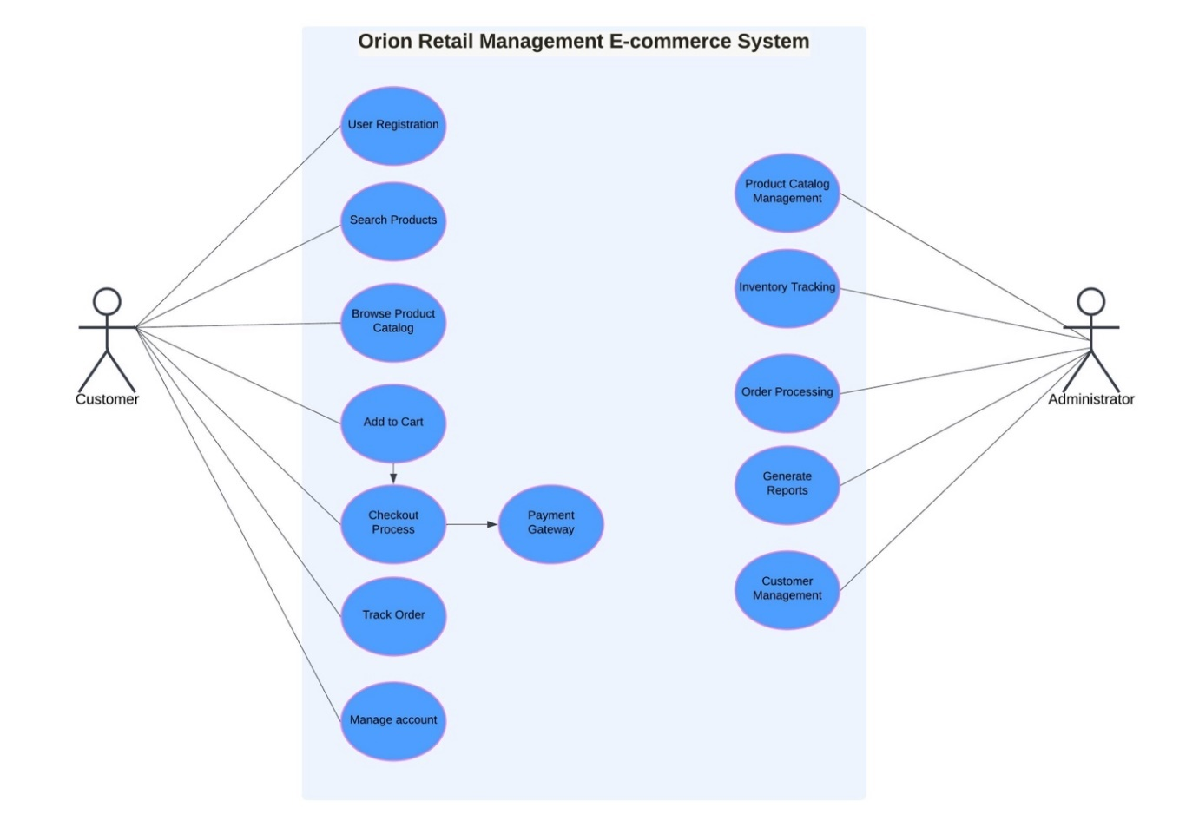
Use cases:
Actors:
1.Customer: customer witnesses the products and end up buying some after logging onto the e-commerce site. Customers use the facility either by logging into a registered account or as a guest.
Responsibilities:
- Look up the product catalog.
- Put items in a shopping basket.
- Check-out and pay.
- Monitor the order status and delivery details.
- See history of orders and other account details if logged in.
Goal: To find and purchase products efficiently, either as a guest or through an account
2.Administrator: The second end-user is a registered internal user able to operate the e-commerce website’s backend. Some of the tasks the administrators perform include product sanctions, product catalogue maintenance, order handling, etc.
Responsibilities:
- Catalogues management- add new catalogue items, modify or remove existing ones.
- Control the stock balance and ration stock.
- Fulfill consumers’ orders, Prepare documents concerning sale and customer activities.
- Maintain system reliability and safety.
Goal: To maintain and update the product catalog, manage orders, and ensure smooth functioning of the e-commerce platform.
Flow of events:
Use case 1:
1. Browse and Purchase Products:
- Use Case ID: UC1
- Primary Actor: Customer
- Goal: To allow customers to search for, review, and purchase products from the catalog.
- Preconditions:
- The system is operational and the product catalog is populated with products.
- The customer has internet access.
- Main flow:
- Product Search: The user logs in (if applicable) or continues as a guest. They browse through the product categories or manually enter keywords in the search box trying to locate products.
- Searching for product specifics: The customer proceeds to click on a product so as to check its particulars such as price, brief detail about the product, the features and specifications of the product as well as the availability of that item.
- Shopping cart: The rest of the found products are then placed in the shopping basket. The icon, which shows the current cart status is automatically updated following the movement of these items to their new position.
- Review cart: The user has the option to check what items are in the online shopping cart and if it is satisfactory they are now able to finish editing all the details concerning their purchase.
- Proceed for checkout: In case users wish to place their items into their shopping carts they are able to checkout. However, the big green button triggering the action states this clearly says.
- Enter shipping and billing details: Facilitated by credit and debit cards and selected during registration Paypal or an ApplePay set up, its account for example the system may be stored in one of these stores types. Inaddition it may include payment for goods that are being shipped.
- Payment: The customer submits payment information, and the payment gateway processes the transaction.
- Confirmation: The system receives payment confirmation and generates an order receipt. The customer receives an email with the order details and estimated delivery time.
Postconditions:
- The customer receives a confirmation email.
- The inventory is updated based on the order.
- The order is saved in the system for further processing.
Exception:
- If payment fails, the system prompts the customer to retry.
- If the product is out of stock, the system informs the customer before they proceed with the purchase.
Use case :2
- Use Case ID: UC2
- Primary Actor: Administrator
- Goal: To allow the administrator to manage the inventory, including updating product details, quantities, and pricing.
• Preconditions:
- The administrator has valid login credentials and access to the admin dashboard.
- The product catalog is already created and stored in the system.
- Main Flow:
- Login: The system provides the administrator with a secure area by password protection that will prevent unauthorized usage and allows only legitimate users.
- View inventory: The administrator goes to the inventory management section and views a record of the available products and stock amounts.
- Search for products: The administrator uses predefined filters like category or SKU or name and examines the searched products to any changes in product usages or only for its stock.
- Updating product’s information: The administrator changes particular aspects of the product like description, price, images, available stock, and stock.
- Save changes: The administrator implements the changes and they become effective immediately in the system.
- Monitor stock levels: If stock is low for any product, the system alerts the administrator. The administrator can then restock or remove the product from the catalog if necessary.
Postconditions:
- The administrator is responsible for the entry of any updates to the goods in question in the system.
- Stock levels are automatic only depending on numerous factors courtesy of the administrator's input.
Exceptions:
- If an administrator conducts a search for updating any product in the catalogue, the system shall issue an informational prompt to help him avoid that action.
- If stocks balance is possible through various mean entered negative to the greatest extent amount of stock balance the system automatically puts that particular entry on hold.
UML DIAGRAMS:
Object diagram:
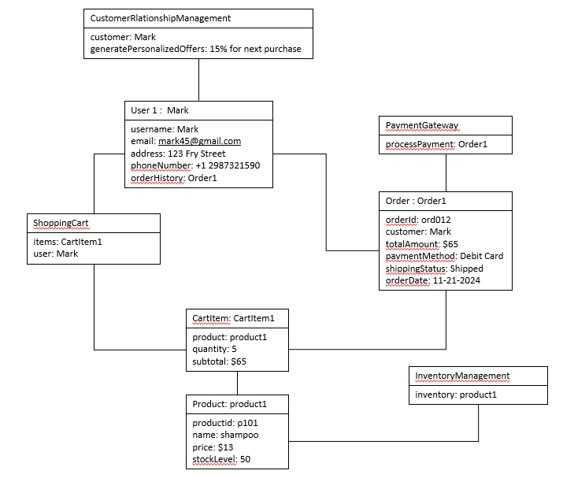
Class diagram: 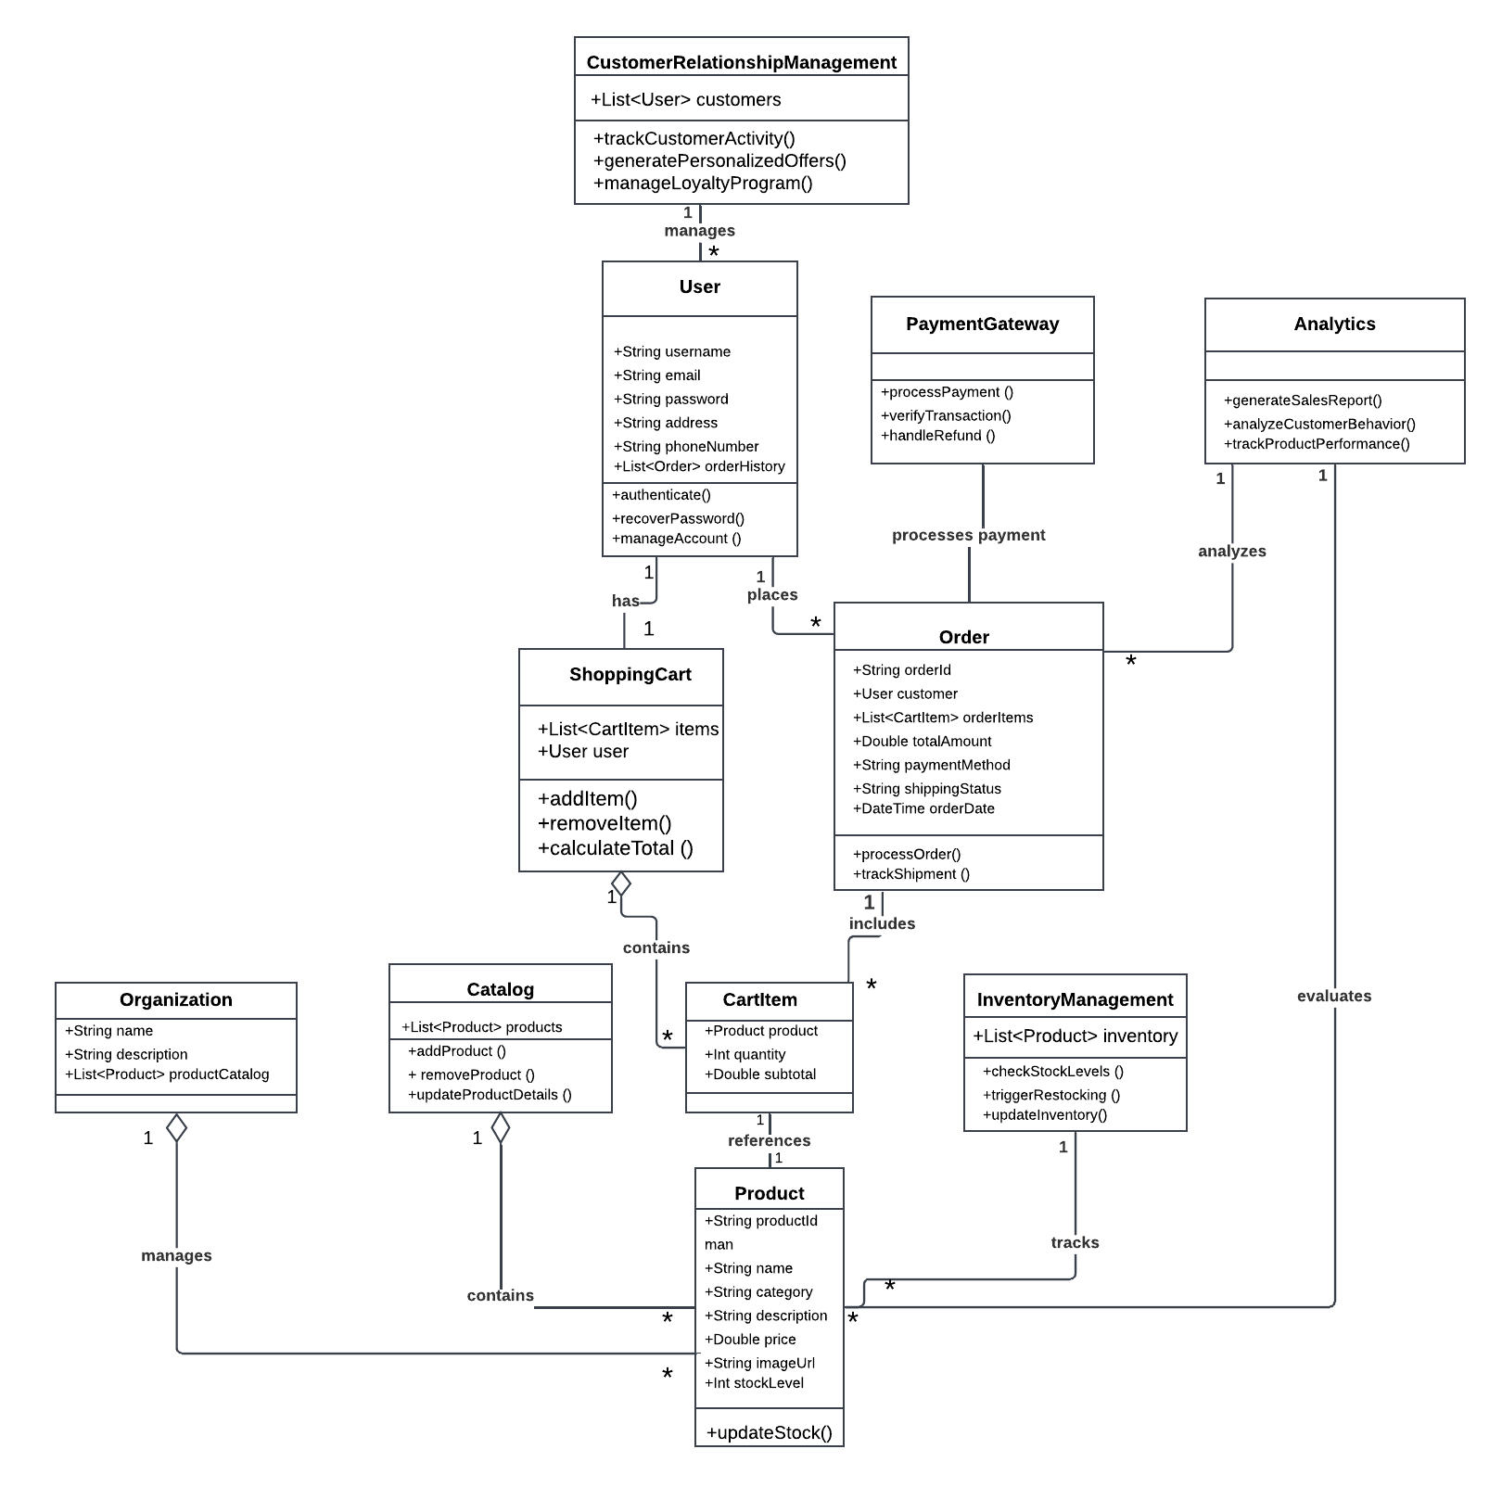
INTERFACE DESIGN – Windows Navigation Diagram: 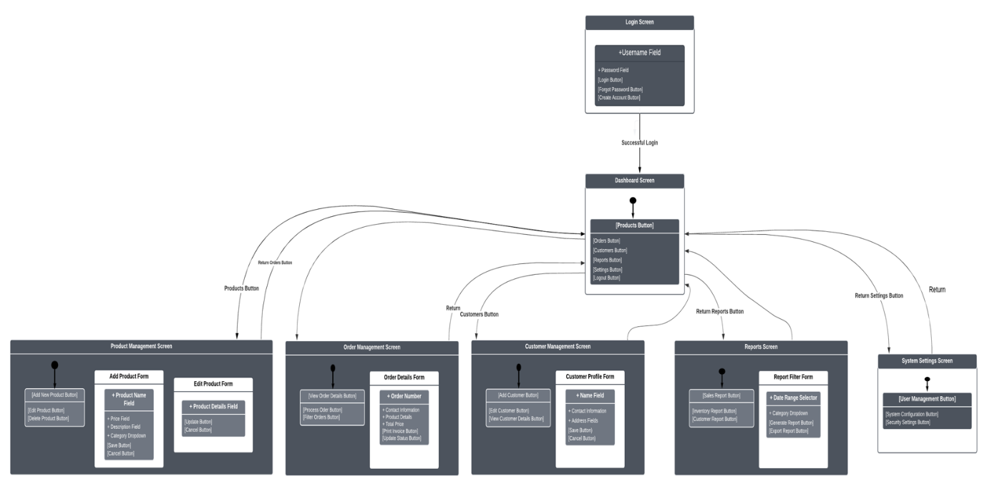

CONCLUSION:
The platform’s functional features –– such as satisfactory performance, efficient checkout and sophisticated stock management, inventory and analytics ––are suitable for addressing Orion’s current concerns. The system’s purpose is to:
- Guide users with seamless ordering, safe transactions and competent customer care, which will increase customers’ satisfaction.
- Minimize operational costs by providing management system that will handle the periodic changes in stock levels or the progress of customer orders.
- Aid in the formulation of strategies by providing significant statistics and content management.
By the technology applied in a way that is consistent with the goals of the business, this initiative provides a good baseline for future growth and competitiveness in the retail industry.
TECHNICAL RECOMMENDATIONS:
To ensure the platform meets Orion’s objectives, we recommend:
1.Technology stack:
- The use of modern frameworks such as a React or Angular at the frontend will assist in making an appealing and functional user interface.
- Adopt back-end options such as Node.js or Django together with well-designed database systems like PostgreSQL and/or MongoDB for transaction recording and data processing.
2.Security measures:
- Secure Sockets Layer encryption should be applied to ensure data security during its transfer.
- Access tokens (OAuth 2.0) will be specified to the accounts of users.
- Every activity will be within the confines established by the data privacy policies like GDPR or CCPA.
3.Scalability and performance:
- At present and in the future the architecture could cope with the increased traffic through cloud server facilities including AWS and Azure.
- Employ a Content Delivery Network (CDN) to speed up the time required for content load across various regions.
4.Third-Party Integrations:
- It is smooth and easy work to implement the payment methods like Stripe or Shopify.
- This postage and tracking can be handled with promise by partnering with logistics providers.
5.Testing and Feedback:
- Management should perform very rigorous tests in terms of use, speed, and security.
- After creating the basic and web pages design company should introduce beta version for the employees and few clients in order to receive valuable recommendations.
6. Maintenance and Updates:
- It's also crucial to set up technical support management in order to rapidly fix any problems that arise.
- Set up periodic updates in order to improve the capability on the basis of the analysis and the customer complaints.

AI tool used by the group: CHAT GPT
Screenshots of the obtained responses: