**Example: What algorithms need feature scaling?**

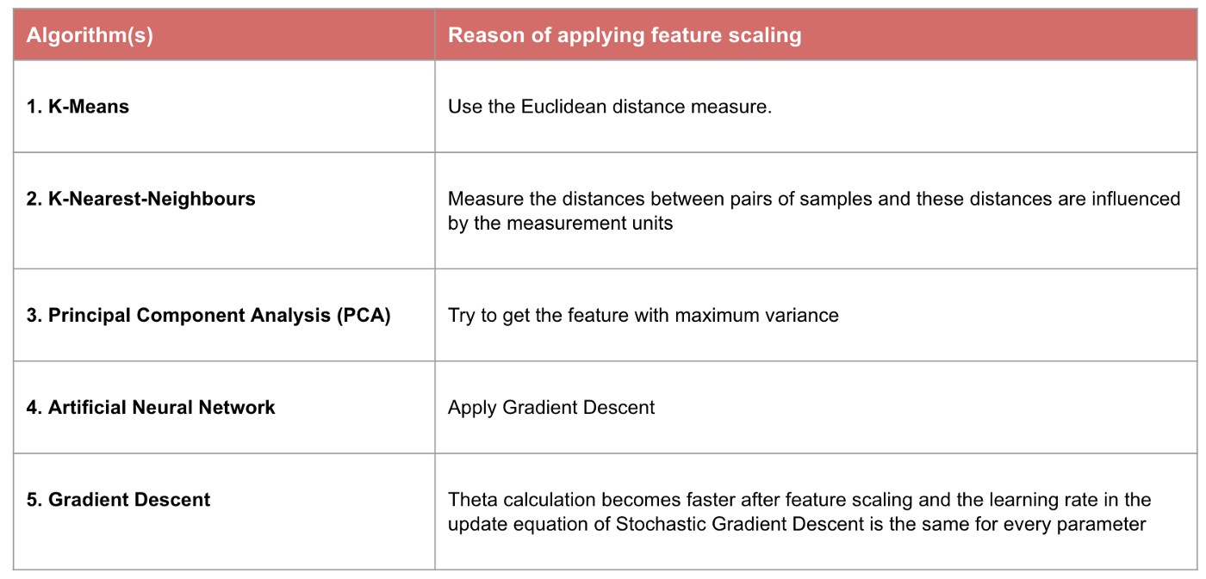

If an algorithm is not distance-based, feature scaling is unimportant, including Naive Bayes, Linear Discriminant Analysis, and Tree-Based models (gradient boosting, random forest, etc.).