ls – List directory contents

1. What is the difference between ls, ls -l , and ls -a? Provide examples.

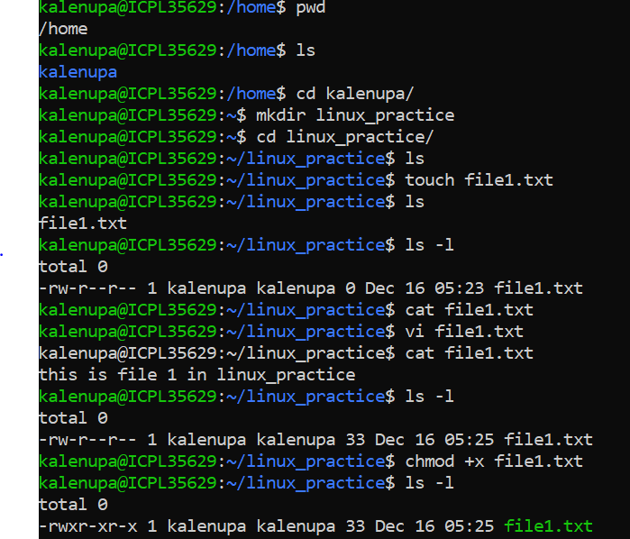



2. How can you display the contents of a directory sorted by file size using ls ?

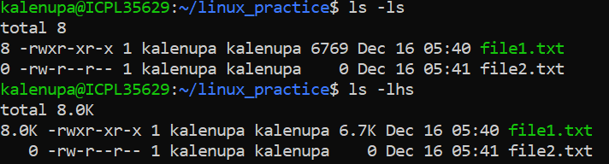

3. Explain the purpose of the ls -i option and its practical use.

4. How can you use ls to only list files with a specific extension (e.g., .txt )?

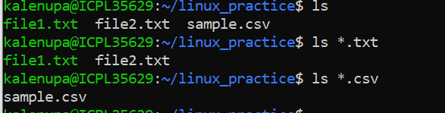

5. How do you display the human-readable file sizes in the output of ls ?

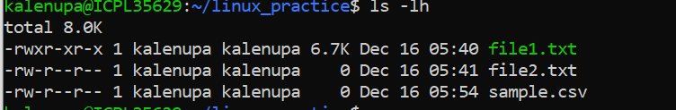

7. What is the difference between ls -R and ls -d \*/ ?

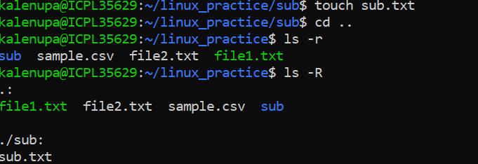



8. How would you use ls to display file types (e.g., directories, regular files, symbolic

links)?



9. What does cd .. do? How is it different from cd ../.. ?

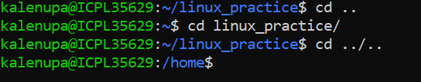

10. Explain the behavior of cd - . Why is it useful?



11. What happens when you run cd without any arguments?

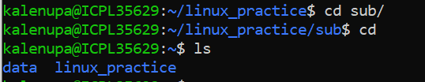

12. How can you navigate to a directory with spaces in its name using cd ?

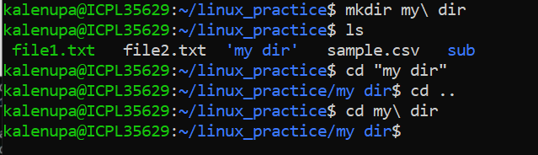

14. What is the difference between cd ~ and cd $HOME ? Are they always equivalent?

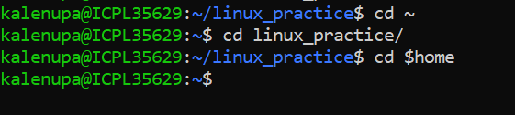

16. What is the significance of pwd in shell scripting?

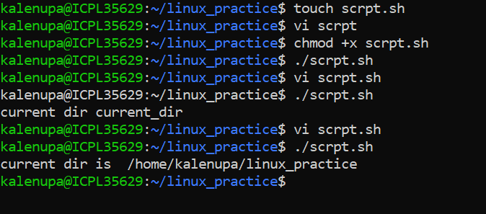

19. How can you create a directory along with its parent directories in one command?

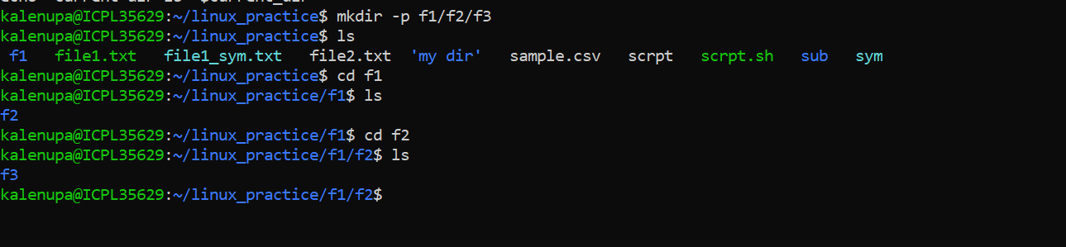

20. What happens if you try to create a directory that already exists using mkdir ? How

can you suppress the error message?

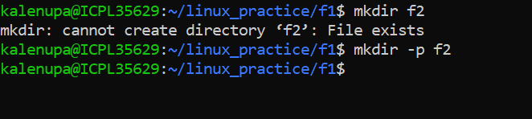

21. Explain the purpose of the -m option in mkdir . How would you use it to set specific

permissions on a directory during creation?

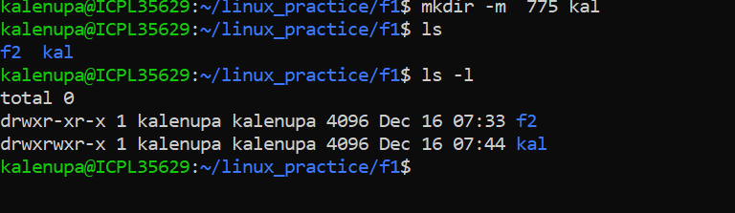

22. How can you use mkdir to create multiple directories at once (e.g., dir1, dir2, dir3)?

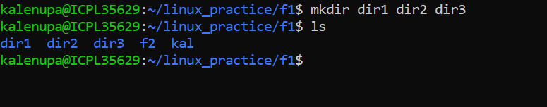

23. Explain the difference between rm filename , rm -r directory , and rm –rf?

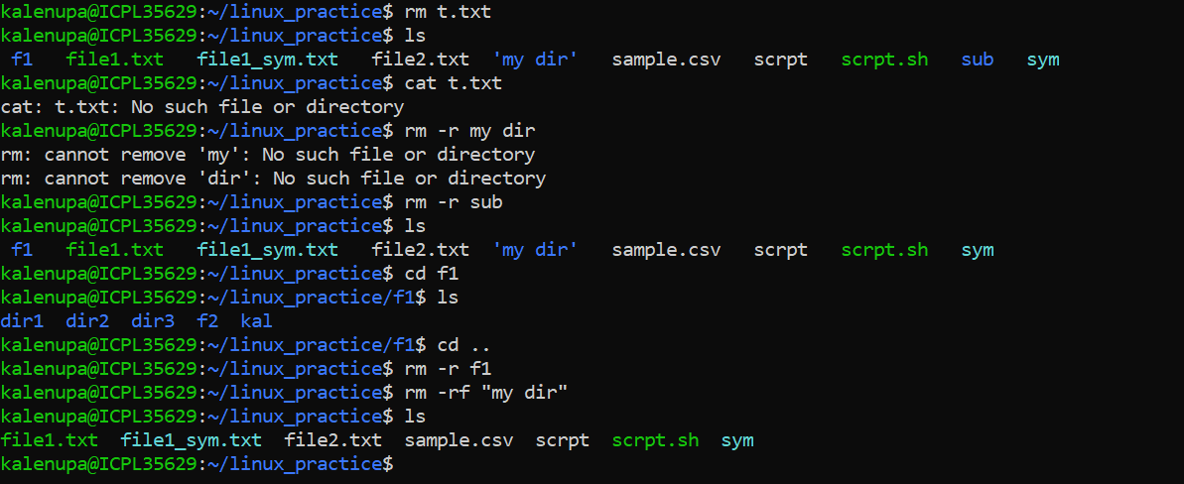

25. How can you use rm interactively to confirm file deletion?

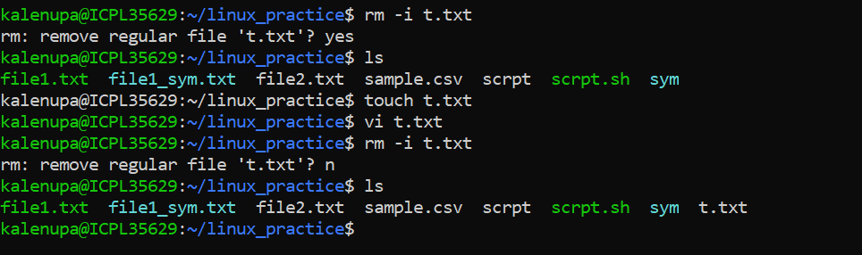26. How would you remove all files with a specific extension (e.g., .log ) in the current

directory using rm ?

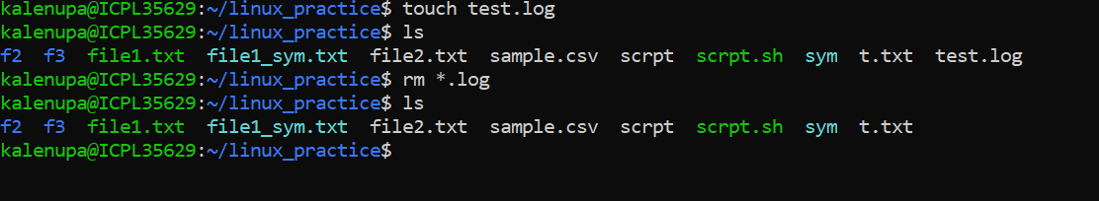

28. How can you ensure that rm does not accidentally delete files by enabling a safety

mechanism?

