[CUKUROVA UNIVERSITY LOGO] | [FACULTY OF ENGINEERING LOGO]

CUKUROVA UNIVERSITY
FACULTY OF ENGINEERING
COMPUTER ENGINEERING DEPARTMENT
GRADUATION THESIS
DESIGN AND IMPLEMENTATION OF A CONTAINER-BASED VIRTUAL TACTICAL FIELD NETWORK SIMULATOR WITH REAL-TIME PERFORMANCE MONITORING

[STUDENT NUMBER] - [STUDENT NAME]
[STUDENT NUMBER] - [STUDENT NAME]
ADVISORS
[ADVISOR NAME / TITLE]
[CO-ADVISOR NAME / TITLE]

[MONTH]
2026
ADANA

ABSTRACT
Tactical field networks connect command posts, unmanned aerial vehicles and ground units over bandwidth-limited, high-latency and lossy radio links. Testing measurement and monitoring software on real radio hardware is costly and difficult to reproduce. This thesis presents the design and implementation of a container-based virtual tactical field network simulator that reproduces such link conditions on a single host and visualises link quality in real time. Four isolated Docker nodes - a headquarters, two unmanned aerial vehicles and a ground unit - communicate over a private bridge network with fixed addresses. Each node runs an iperf3 server, and the Linux tc/netem queueing discipline is applied to every node's egress interface to impose realistic bandwidth caps, propagation delay, jitter and packet loss. A Python measurement engine periodically measures every directed link using iperf3 (TCP throughput and UDP jitter and loss) and ping (round-trip latency), appending each result to a JSON Lines time series. A Streamlit dashboard reads this log and renders live node status and streaming performance charts. The system was evaluated by collecting 27 measurement cycles over the five configured links under the emulated field profiles. The measured metrics tracked the imposed netem profiles closely: links emulating weaker radios showed lower throughput and higher latency, and links whose traffic crossed two constrained egress interfaces accumulated the delay and loss of both. The results show that inexpensive container and kernel-level emulation can reproduce the qualitative behaviour of tactical links closely enough to develop, demonstrate and teach network performance monitoring without physical radios. The modular design allows new nodes, links and field profiles to be added through a single configuration file.
Keywords: network emulation, tactical communications, Docker containers, tc/netem, real-time performance monitoring

CONTENTS
Page

ABBREVIATIONS AND SYMBOLS
API | Application Programming Interface
CLI | Command-Line Interface
CSV | Comma-Separated Values
HQ | Headquarters (command post node)
IP | Internet Protocol
JSON | JavaScript Object Notation
JSONL | JSON Lines (newline-delimited JSON)
MANET | Mobile Ad hoc Network
netem | Network Emulator (Linux queueing discipline)
QoS | Quality of Service
RTT | Round-Trip Time
TCP | Transmission Control Protocol
tc | Traffic Control (Linux iproute2 utility)
UAV | Unmanned Aerial Vehicle
UDP | User Datagram Protocol

LIST OF TABLES
Table Page

LIST OF FIGURES
Figure Page

1. INTRODUCTION
Modern military operations depend on networked command and control systems that connect a command post with mobile platforms such as unmanned aerial vehicles (UAVs) and ground vehicles. Unlike the wired or fibre links of civilian data centres, the radio links that join these platforms are severely constrained: usable bandwidth is limited, propagation and queueing introduce significant latency, the delay varies from packet to packet (jitter), and a non-negligible fraction of packets is lost (Burbank, Chimento, Haberman, & Kasch, 2006; Elmasry, 2010). Software that measures, reports and visualises the quality of these links must therefore be developed and validated under conditions that resemble the field rather than the laboratory.
Validating such software on real radio equipment is expensive, logistically demanding and hard to reproduce: the same experiment rarely yields the same channel twice. Network emulation offers an attractive alternative. Tools such as ns-3 (Riley & Henderson, 2010), Mininet (Lantz, Heller, & McKeown, 2010) and CORE (Ahrenholz, Danilov, Henderson, & Kim, 2008) let researchers reproduce network behaviour in software, while the Linux tc/netem queueing discipline (Hemminger, 2005) can impose controlled delay, jitter, loss and rate limits on real traffic at the kernel level. Lightweight operating-system containers (Merkel, 2014) make it possible to run many isolated network endpoints on a single host with little overhead.
This thesis brings these ideas together in a single, modular system: a container-based virtual tactical field network simulator with real-time performance monitoring. Four Docker containers represent a headquarters node, two UAV nodes and a ground (tank) node, connected by a private bridge network with fixed addresses. Each node runs an iperf3 server so that any node can measure a link to any other. A tc/netem profile is applied to every node's egress interface to emulate the bandwidth, delay, jitter and loss of a particular radio class. A Python measurement engine periodically measures every configured link with iperf3 and ping, logs the results as a JSON Lines time series, and a Streamlit dashboard renders the live status and streaming charts.
The objectives of the project are: (i) to build a reproducible, isolated multi-node network topology that can stand in for a small tactical field network; (ii) to impose configurable, realistic link conditions on that topology using kernel-level emulation; (iii) to measure the standard link-quality metrics - throughput, latency, jitter and packet loss - automatically and continuously; and (iv) to present these metrics in a live monitoring dashboard. A further objective is that the whole system be driven from a single configuration file so that nodes, links and field profiles can be changed without touching the measurement or visualisation code.
The remainder of this report is organised as follows. The Literature Review surveys network simulation and emulation tools, container based testbeds and tactical networking. The Material and Method section describes the system architecture, the emulation profiles, the measurement core, the measurement engine and the monitoring dashboard, together with the experimental setup. The Result and Discussion section reports the metrics measured under the emulated profiles and interprets them. The Conclusion summarises the contributions, the limitations and possible directions for future work.

2. LITERATURE REVIEW
Research on reproducing network behaviour in software spans discrete event simulators, emulators and, more recently, container-based testbeds. Discrete-event simulators model a network as a sequence of events without running real protocol stacks. The ns-3 simulator (Riley & Henderson, 2010) is the most widely used representative of this class and offers detailed models of wireless channels and routing protocols. Such simulators are accurate and fully controllable, but the software under test must be written against the simulator's models rather than against the real operating-system network stack.
Emulators take the complementary approach of running real software over an artificially shaped network. Mininet (Lantz, Heller, & McKeown, 2010) uses Linux network namespaces to create many virtual hosts and switches on one machine for rapid prototyping of software-defined networks, and the Common Open Research Emulator (CORE) extends this idea with a graphical topology editor and support for mobile and wireless scenarios (Ahrenholz, Danilov, Henderson, & Kim, 2008). Both rely on the Linux kernel to carry real packets, which means that unmodified application software - such as iperf3 or a monitoring tool - can run inside the emulated topology exactly as it would on a physical network.
The mechanism that gives these emulators their realism is the Linux traffic-control subsystem. The netem queueing discipline (Hemminger, 2005), configured through the tc utility of the iproute2 package (Hubert, 2002), can add fixed and random delay, reorder and duplicate packets, drop a configurable fraction of traffic and cap the egress rate. Because netem operates on a real interface, it shapes genuine TCP and UDP flows, including their reaction to loss and delay, rather than a model of them. This makes it the standard tool for introducing controlled impairments in Linux-based experiments.
Operating-system-level containers have made multi-node testbeds lighter and more portable. Docker (Merkel, 2014) packages an application and its dependencies into an image that starts in milliseconds and runs in an isolated namespace, sharing the host kernel. Compared with full virtual machines, containers allow many more network endpoints to run on a single host, which is convenient for emulating a topology of several communicating nodes. Docker's user-defined bridge networks provide isolated subnets with assignable fixed addresses, and the NET_ADMIN capability lets a container apply its own tc/netem rules.
The application domain of this work is tactical networking. Burbank, Chimento, Haberman and Kasch (2006) describe the defining characteristics of military tactical networks - intermittent, low-bandwidth, high-latency and lossy links with mobile nodes - and the challenges these pose to mobile ad hoc network (MANET) technology. Elmasry (2010) contrasts tactical wireless networks with commercial ones and stresses the importance of quality of service under constrained capacity. These characteristics motivate the specific netem profiles used in this project, in which different nodes are given distinct bandwidth, delay, jitter and loss parameters to represent different radio classes.
Measurement methodology builds on established, widely used tools. iperf3 (ESnet, 2016) is the de facto standard for active throughput measurement and reports TCP throughput and retransmissions as well as UDP jitter and loss, while the ping utility measures round-trip time. The contribution of this thesis is not a new emulator or metric, but the integration of these established components - Docker isolation, tc/netem impairment, iperf3/ping measurement and a Streamlit dashboard - into a single, configuration-driven system aimed specifically at demonstrating and monitoring tactical-style link quality.

3. MATERIAL AND METHOD
This section describes the materials and methods used to build and evaluate the simulator: the system architecture and network topology, the node containers and their measurement infrastructure, the tc/netem field profiles, the measurement core, the measurement engine with its logging format, the real-time dashboard, and the experimental setup under which the results in the next section were obtained. The complete software stack is written in Python 3.14 and orchestrated with Docker Compose; key source files are listed in the Appendix.

3.1. System Architecture and Network Topology
The simulated field consists of four nodes connected by a single private bridge network named tactical_net on the subnet 172.30.0.0/24. Each node is a Docker container with a fixed IP address, which keeps measurement targets stable across restarts. The headquarters (HQ) node represents the command post; two nodes represent unmanned aerial vehicles (UAV-1 and UAV-2); and one node represents a ground unit (Tank-1). Table 3.1 lists the nodes and their addresses, and Figure 3.1 shows the topology and the directed links that are measured.

Table 3.1. Nodes of the simulated tactical field network.
Node | Container | IP address | Role
Headquarters | karargah | 172.30.0.10 | Command post
UAV-1 | iha1 | 172.30.0.11 | Unmanned aerial vehicle
UAV-2 | iha2 | 172.30.0.12 | Unmanned aerial vehicle
Tank-1 | tank1 | 172.30.0.13 | Ground unit

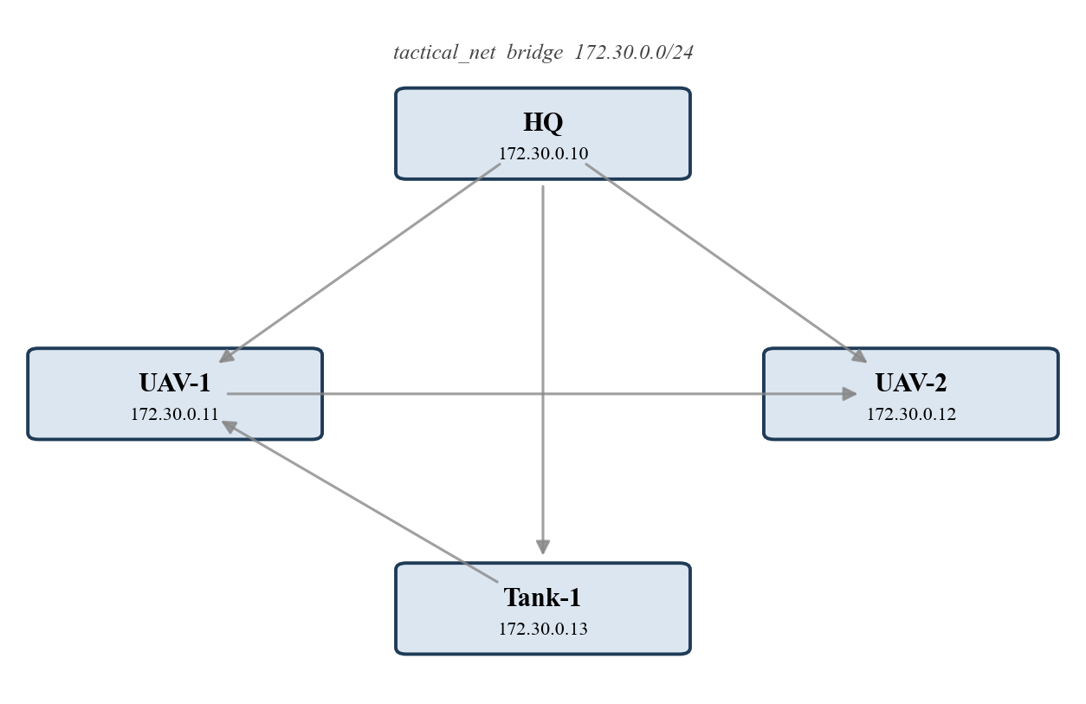
Figure 3.1. Network topology: four nodes on the tactical_net bridge and the five directed links measured by the engine.

3.2. Node Containers and Measurement Infrastructure
All nodes share a single container image built from Alpine Linux 3.20, chosen for its small size and multi-architecture support so that the system runs natively on both x86-64 and Apple Silicon (arm64) hosts. The image installs iperf3 for bandwidth, jitter and loss measurement, the iputils ping utility for latency, and the iproute2 package, which provides the tc command used for emulation. Each container's entry point starts an iperf3 server listening on TCP and UDP port 5201, so that any node can act as a measurement client against any other. The containers are granted the NET_ADMIN capability so that tc/netem rules can be applied to their own interfaces. The topology is declared once in a Docker Compose file using a shared base definition, which removes repetition and makes adding a node a few lines of configuration.

3.3. Emulated Field Conditions (tc/netem)
Because all containers run on one host, raw inter-container throughput is unrealistically high (on the order of 100 Gbit/s) and latency is negligible. To make the measured metrics resemble real radio links, a netem queueing discipline is attached to the egress (eth0) interface of every node. Each profile sets a mean one-way delay, a random jitter around that delay, a packet-loss percentage and a rate cap that emulates the radio's bandwidth. The profiles, summarised in Table 3.2, deliberately differ between nodes to represent different radio classes: the HQ has the best link, the UAVs the weakest and most variable links, and the ground unit an intermediate link. Because netem shapes egress traffic, a measured link is affected by the profile of the source node, and traffic between two impaired nodes experiences the combined effect of both egress queues.

Table 3.2. tc/netem profiles applied to each node's egress interface.
Node | Rate | Delay (ms) | Jitter (ms) | Loss (%)
Headquarters | 100 Mbit/s | 5 | 1 | 0.1
UAV-1 | 50 Mbit/s | 25 | 5 | 1.0
UAV-2 | 20 Mbit/s | 40 | 10 | 2.0
Tank-1 | 30 Mbit/s | 15 | 3 | 0.5

3.4. Measurement Core
The measurement core measures one directed link at a time by running commands inside the source container with docker exec. Round-trip latency is obtained from ping by sending a small number of packets and parsing the average round-trip time. TCP throughput and retransmissions are obtained from a short iperf3 TCP test in JSON mode, reading the received bit rate from the test summary. Jitter and packet loss are obtained from a separate iperf3 UDP test at a fixed target rate. Every function is written defensively: any failure (an unreachable node, a parsing error, a timeout) results in a null value for the affected metric rather than an exception, so a single failed link never interrupts a measurement cycle. A link is marked as up if at least one of its metrics was obtained.

3.5. Measurement Engine and Logging
The measurement engine drives the experiment. On start-up it optionally applies the netem profiles to all nodes, then repeatedly executes measurement cycles. In each cycle it measures every directed link defined in the configuration, stamps every record with a single UTC timestamp for that cycle, appends the records to an append-only JSON Lines file (one JSON object per line), and writes a separate snapshot of current node status. The append-only log makes the data a time series that can be read concurrently by the dashboard while the engine is still writing. Five directed links are measured per cycle: HQ to each of the three other nodes, UAV-1 to UAV-2, and Tank-1 to UAV-1. The engine can also run a single cycle for testing or run without emulation to confirm the unshaped baseline.

3.6. Real-Time Monitoring Dashboard
The monitoring dashboard is a Streamlit web application. It can start and stop the measurement engine as a background process from a sidebar control, and it reads the JSON Lines log on a fixed refresh interval to display live information. The dashboard shows a status card for each node (active or passive, with its address), summary cards with the latest average throughput, latency, jitter and loss across the selected links, and four streaming line charts - one per metric - in which each line is a link. The user can choose which links to display and how many recent samples to keep in view. Because the dashboard only reads the shared log, it imposes no load on the measurement path.

3.7. Experimental Setup
The experiment reported in the next section was run on a single host with the four containers active and all four netem profiles applied. In each measurement cycle every iperf3 test ran for a short fixed duration, the UDP test used a fixed target rate to probe jitter and loss, and latency was averaged over several ping packets; a short pause separated successive cycles. The engine was left running until 27 complete cycles had been collected for each of the five links, and the resulting JSON Lines log was analysed to produce the tables and figures that follow. Because the impairments are random within the configured bounds, metrics are reported as means over all cycles together with their variation.

4. RESULT AND DISCUSSION
This section reports the link-quality metrics measured under the emulated field profiles and interprets them. Results are aggregated over 27 measurement cycles per link. Table 4.1 gives, for each directed link, the mean and standard deviation of TCP throughput and round-trip latency together with the mean jitter and packet loss. Figure 4.1 shows the throughput of every link over the course of the experiment, Figure 4.2 and Figure 4.3 compare the mean throughput and mean latency across links, and Figure 4.4 compares jitter and packet loss.

Table 4.1. Measured link metrics aggregated over 27 cycles (mean ± standard deviation where shown).
Link | Throughput (Mbit/s) | Latency (ms) | Jitter (ms) | Loss (%)
HQ -> UAV-1 | 46.9 ± 24.2 | 35.2 ± 2.1 | 0.45 | 0.10
HQ -> UAV-2 | 34.3 ± 23.5 | 50.2 ± 2.8 | 0.46 | 0.11
HQ -> Tank-1 | 81.5 ± 20.6 | 24.2 ± 1.3 | 0.47 | 0.10
UAV-1 -> UAV-2 | 8.6 ± 8.1 | 73.2 ± 2.9 | 0.78 | 0.97
Tank-1 -> UAV-1 | 12.3 ± 6.5 | 46.4 ± 2.4 | 0.61 | 0.50

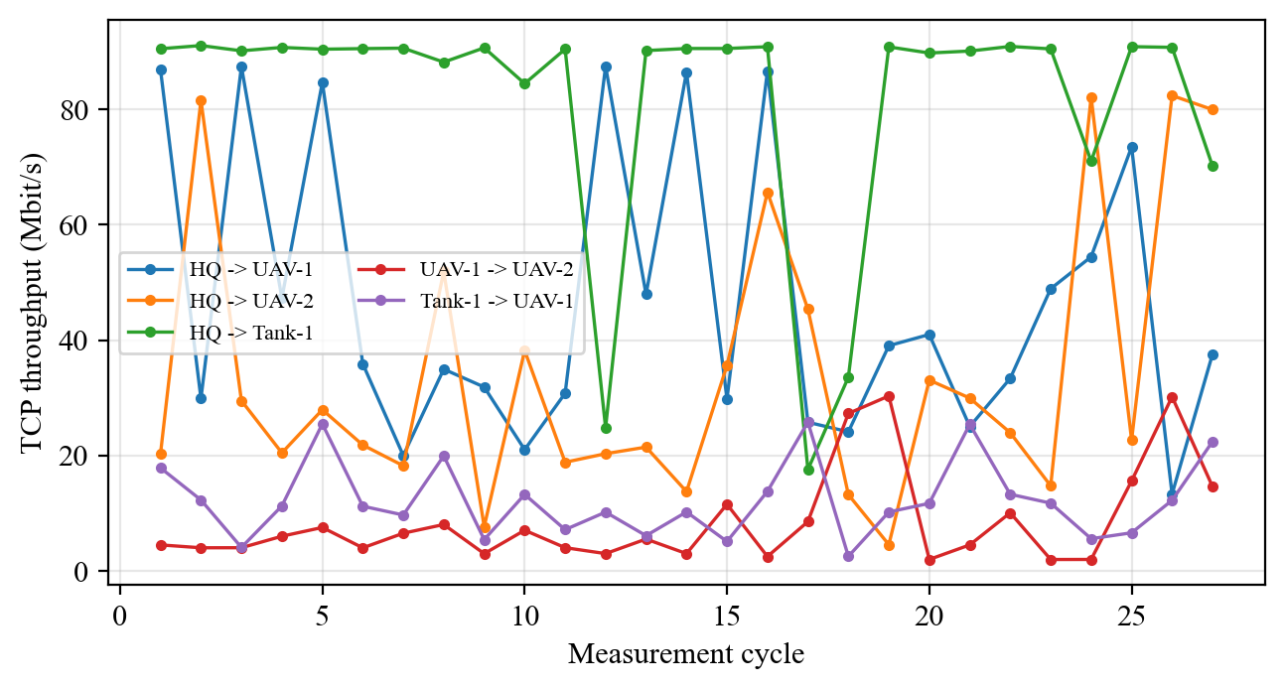
Figure 4.1. TCP throughput of each directed link across the measurement cycles.

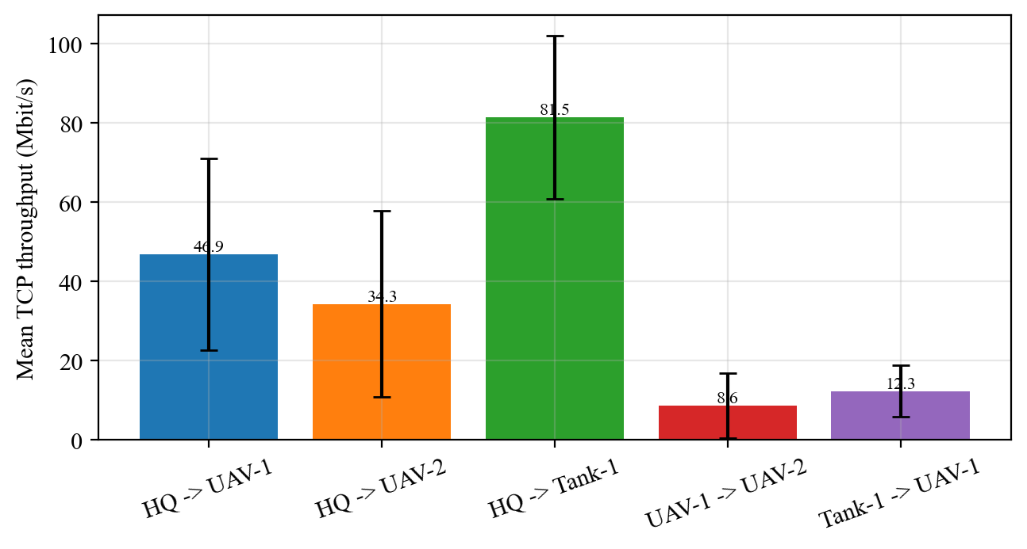
Figure 4.2. Mean TCP throughput per link (error bars show one standard deviation).

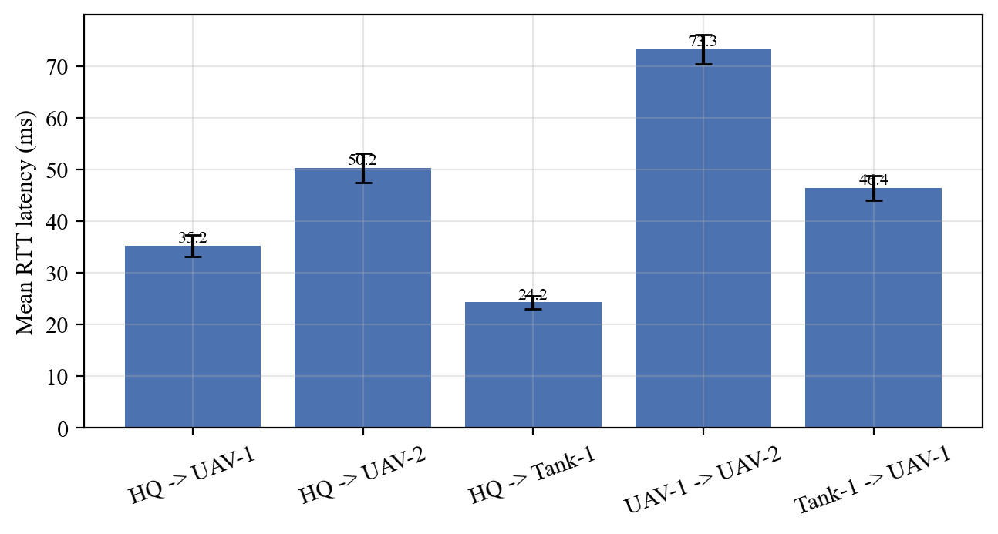
Figure 4.3. Mean round-trip latency per link (error bars show one standard deviation).

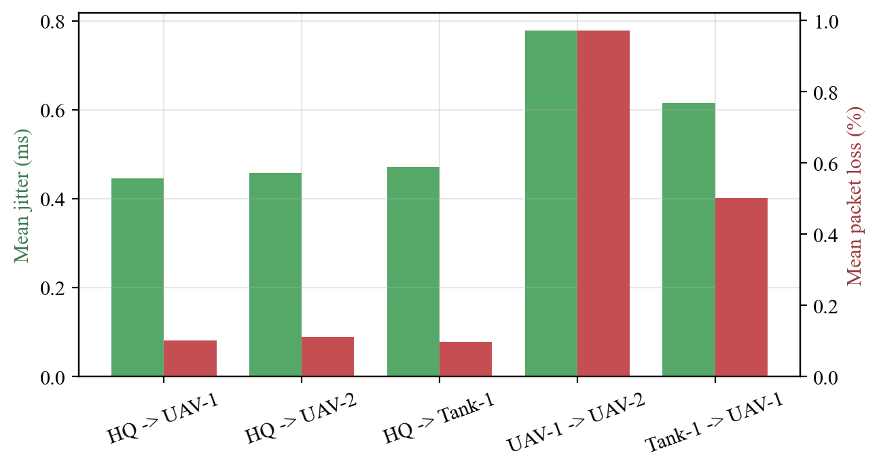
Figure 4.4. Mean jitter and mean packet loss per link.

The measured metrics follow the imposed netem profiles closely. The highest mean throughput was observed on the HQ -> Tank-1 link (81.5 Mbit/s) and the lowest on the UAV-1 -> UAV-2 link (8.6 Mbit/s), which is consistent with the rate caps in Table 3.2: links whose source node has a higher rate cap and whose path crosses fewer constrained egress queues achieve higher throughput. Because netem shapes egress traffic, the throughput of a link is bounded primarily by the rate cap of its source node, while the destination node's profile contributes additional delay and loss on the return path.
Latency behaves analogously. The largest mean round-trip time was measured on the UAV-1 -> UAV-2 link (73.2 ms). Round-trip latency reflects the sum of the one-way delays of the queues traversed in both directions plus queueing under load, so links between two delayed nodes show the highest round-trip times, whereas links originating at the low-delay HQ node show the lowest. The standard deviations in Table 4.1 are produced by the configured jitter together with TCP's own rate adaptation and are larger on the links emulating weaker, more variable radios.
Jitter and packet loss, shown in Figure 4.4, are likewise ordered by the severity of the profiles on the path: links involving the UAV nodes, which carry the highest configured jitter and loss, show the largest measured jitter and loss, while links originating at the HQ node remain low. The accumulation effect is clearest on the UAV-1 to UAV-2 link, whose traffic crosses two of the most constrained egress interfaces and which therefore combines a low rate cap with high latency, jitter and loss. This is exactly the qualitative behaviour expected of a link between two weak radios in the field.
Two points qualify these results. First, the absolute values depend on the chosen profiles and on the fact that all nodes share one host; the contribution of the work is the faithful reproduction of the relative ordering and qualitative behaviour of tactical links, not the prediction of any specific radio's absolute performance. Second, because the impairments are random within their configured bounds, individual cycles vary; reporting means over many cycles, as in Table 4.1, gives a stable picture, and the live dashboard makes this variation visible in real time. Overall, the system reproduces the intended field conditions and measures them consistently, meeting the objectives set out in the Introduction.

5. CONCLUSION
This thesis presented the design and implementation of a container-based virtual tactical field network simulator with real-time performance monitoring. Four isolated Docker nodes - a headquarters, two UAVs and a ground unit - communicate over a private bridge network; tc/netem profiles emulate the bandwidth, delay, jitter and loss of different radio classes; a Python engine measures every link with iperf3 and ping and logs the results as a time series; and a Streamlit dashboard visualises the link quality live.
All four objectives stated in the Introduction were met. A reproducible, isolated multi-node topology was built; configurable and realistic link conditions were imposed with kernel-level emulation; throughput, latency, jitter and packet loss were measured automatically and continuously; and the metrics were presented in a live dashboard. The evaluation showed that the measured metrics track the imposed profiles closely and reproduce the expected ordering and accumulation effects of constrained radio links. The single-configuration-file design met the further objective of extensibility.
The study has limitations. All nodes run on one host, so the emulation captures the qualitative behaviour of radio links rather than the physical-layer behaviour of any specific radio; netem shapes only egress traffic and does not model node mobility, fading or contention for a shared medium; and the topology and traffic patterns are deliberately small.
Future work could address these limitations by modelling mobility and time-varying profiles, adding a shared-medium wireless model, introducing routing so that multi-hop paths can be studied, scaling the topology to more nodes across multiple hosts, and recording long-term measurements for statistical analysis and alerting in the dashboard. These extensions would build naturally on the modular, configuration-driven architecture presented here.

ACKNOWLEDGEMENT
The authors would like to thank their advisor, [ADVISOR NAME / TITLE], and co-advisor, [CO-ADVISOR NAME / TITLE], of the Department of Computer Engineering at Cukurova University for their guidance and support throughout this project. [Add any further acknowledgements here. If the project received financial or institutional support from programmes such as BAP or TUBITAK, state it clearly in this section.]

REFERENCES
Ahrenholz, J., Danilov, C., Henderson, T. R., & Kim, J. H. (2008). CORE: A real-time network emulator. In MILCOM 2008 - IEEE Military Communications Conference (pp. 1-7). IEEE. https://doi.org/10.1109/MILCOM.2008.4753614
Burbank, J. L., Chimento, P. F., Haberman, B. K., & Kasch, W. T. (2006). Key challenges of military tactical networking and the elusive promise of MANET technology. IEEE Communications Magazine, 44(11), 39-45. https://doi.org/10.1109/COM-M.2006.248164
Elmasry, G. F. (2010). A comparative review of commercial vs. tactical wireless networks. IEEE Communications Magazine, 48(10), 54-59. https://doi.org/10.1109/MCOM.2010.5594678
ESnet. (2016). iPerf3: A TCP, UDP and SCTP network bandwidth measurement tool [Computer software]. Lawrence Berkeley National Laboratory. https://software.es.net/iperf/
Hemminger, S. (2005). Network emulation with NetEm. In Proceedings of the Australian National Linux Conference (linux.conf.au) (pp. 18-23). Linux Australia.
Hubert, B. (2002). Linux advanced routing & traffic control HOWTO. The Linux Documentation Project. https://lartc.org/
Lantz, B., Heller, B., & McKeown, N. (2010). A network in a laptop: Rapid prototyping for software-defined networks. In Proceedings of the 9th ACM SIGCOMM Workshop on Hot Topics in Networks (HotNets-IX) (pp. 1-6). ACM. https://doi.org/10.1145/1868447.1868466
Merkel, D. (2014). Docker: Lightweight Linux containers for consistent development and deployment. Linux Journal, 2014(239), Article 2.
Riley, G. F., & Henderson, T. R. (2010). The ns-3 network simulator. In K. Wehrle, M. Gunes, & J. Gross (Eds.), Modeling and tools for network simulation (pp. 15-34). Springer. https://doi.org/10.1007/978-3-642-12331-3_2

ABOUT THE AUTHORS AND AUTHOR CONTRIBUTION
[STUDENT NAME] is an undergraduate student in the Department of Computer Engineering at Cukurova University. [Add a short description of academic background and interests.] In this project the author was responsible for [describe contribution, e.g. the Docker topology and netem emulation, the Python measurement engine, the Streamlit dashboard, the experiments and the writing of this report].
[SECOND STUDENT NAME, if applicable] is an undergraduate student in the Department of Computer Engineering at Cukurova University. [Add a short description of academic background and interests.] In this project the author was responsible for [describe contribution]. (Delete this paragraph if the thesis has a single author.)

APPENDIX
This appendix contains supporting material that is too detailed for the main text: the central configuration file that defines the nodes, links and field profiles, and the structure of the measurement log used for the results.

Appendix A: System Configuration
The entire topology - nodes, the directed links to measure, the tc/netem field profiles and the measurement parameters - is defined in a single Python configuration module, reproduced below.
NODES = {
"karargah": {"display": "HQ", "ip": "172.30.0.10"},
"iha1": {"display": "UAV-1", "ip": "172.30.0.11"},
"iha2": {"display": "UAV-2", "ip": "172.30.0.12"},
"tank1": {"display": "Tank-1", "ip": "172.30.0.13"},
}

LINKS = [
("karargah", "iha1"), ("karargah", "iha2"), ("karargah", "tank1"),
("iha1", "iha2"), ("tank1", "iha1"),
]

NETEM_PROFILES = {
"karargah": {"delay_ms": 5, "jitter_ms": 1, "loss_pct": 0.1, "rate": "100mbit"},
"iha1": {"delay_ms": 25, "jitter_ms": 5, "loss_pct": 1.0, "rate": "50mbit"},
"iha2": {"delay_ms": 40, "jitter_ms": 10, "loss_pct": 2.0, "rate": "20mbit"},
"tank1": {"delay_ms": 15, "jitter_ms": 3, "loss_pct": 0.5, "rate": "30mbit"},
}

INTERVAL_SEC = 3 # wait between full cycles
IPERF_DURATION = 2 # seconds per iperf3 test
UDP_BANDWIDTH = "20M" # UDP probe target rate
PING_COUNT = 4 # ping packets per latency measurement

Appendix B: Measurement Log Format
Each measurement cycle appends one JSON object per directed link to the append-only log file (JSON Lines). A representative record is shown below; all reported tables and figures were computed from these records.
{
"src": "karargah", "src_display": "HQ",
"dst": "iha1", "dst_display": "UAV-1",
"latency_ms": 37.49, "throughput_mbps": 87.08,
"retransmits": 10, "jitter_ms": 0.516,
"loss_pct": 0.23, "up": true,
"ts": "2026-05-29T16:33:44.381034+00:00"
}

