**Proposed Initial “Proof of Concept” Inversion**

The real World picture looks like this:

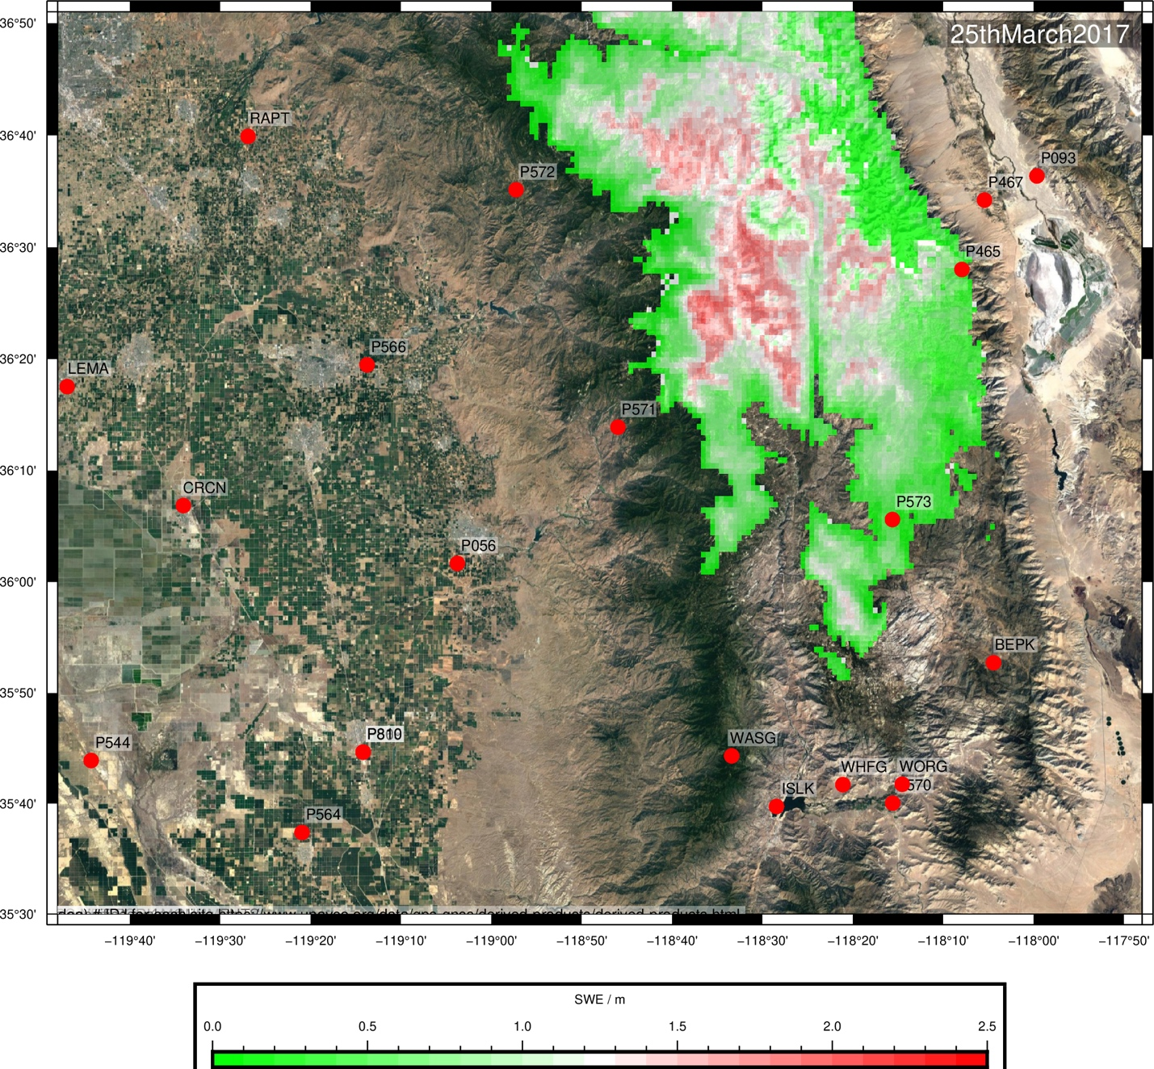

Red circles are GPS stations. The green-red coloured grid are ‘truth’ from the SNODAS SWE model.

Inversion

Restrict ourselves to January through March 2017 for simplicity. **DATA** will be vertical displacement time series from GPS stations P572, P571, P573 and P465. The **MODEL** will be thickness time series for two disks of snow, one centred at approx (-118.30,36.4) and the other at approx (-118.30, 36.30). The disks will have fixed radii.