DATA SCIENCE MINOR PROJECT REPORT

CONTENTS OF THE REPORT
- Cover page
- Declaration
- Certificate
- Acknowledgement
- Table of Content

1. Introduction
2. Source of dataset
3. EDA process
4. Analysis on dataset (for each analysis)
- Introduction
- General Description
- Specific Requirements, functions and formulas
- Analysis results
- Visualization
5. Conclusion
6. Future scope
7. References

COVER PAGE
Python: INT375
PROJECT REPORT
(Project Semester January-April 2025)

Harvest Insights: Yearly Crop Production

Submitted by

Ramya Sharma

Registration No: 12323097

Programme and Section: CSE K23KM
Course Code INT375

Under the Guidance of

Mr. Aanchal

Discipline of CSE/IT

Lovely School of _____CSE_____________

Lovely Professional University, Phagwara

CERTIFICATE

This is to certify that Ramya Sharma bearing Registration no. ....12323097... has completed ........... INT375 project titled, “.......Harvest Insights: Yearly Crop Production...........” under my guidance and supervision. To the best of my knowledge, the present work is the result of his/her original development, effort and study.

Signature and Name of the Supervisor
Designation of the Supervisor
School of …………CSE…………………………….
Lovely Professional University
Phagwara, Punjab.

Date: 12.04.2025

DECLARATION

I, .........RAMYA.........., student of .........Btech CSE.............. (Program name) under CSE/IT Discipline at, Lovely Professional University, Punjab, hereby declare that all the information furnished in this project report is based on my own intensive work and is genuine.

Date: 12.04.25 RAMYA SHARMA
Registration No. ........12323097..........

Harvest Insights: Yearly Crop Production

The "Harvest Insights: Yearly Crop Production" dataset provides a comprehensive overview of agricultural production across different states and seasons in India. This dataset includes data on the production of various crops over the course of the year, segmented by seasons such as Autumn, Kharif, Rabi, and Whole Year, for each state and union territory.

Key Insights:
- Top 10 States by Agricultural Production: The states with the highest agricultural production are identified, offering a glimpse into the key contributors to India's agricultural output. This information helps in understanding the regions with the highest yield and potential for agricultural growth.

- Seasonal Distribution: Seasonal trends in agricultural production are analyzed to understand which seasons contribute the most to the overall production across India. The dataset reveals patterns in production across different times of the year, offering insights into the impact of seasons on agricultural yields.

- State-wise and Seasonal Heatmap: A heatmap visualizes the production distribution across various states and seasons, normalizing the data for better comparison. This offers an intuitive way to explore how different states perform in each season.

- Top States' Contribution to Total Production: A pie chart highlights the share of the top 5 states in total agricultural production. This shows the dominance of certain states in contributing to the country's agricultural output.

- Seasonal Distribution in Top States: The seasonal distribution of agricultural production for the top 5 states provides an in-depth look at how these states perform across various

seasons. This information is valuable for understanding the agricultural dynamics in these regions.

- Stacked Bar Chart for Seasonal Production: A stacked bar chart offers a breakdown of the seasonal production in the top 10 states, allowing for a deeper understanding of how different seasons contribute to the overall production in these states.

- Whole Year vs Seasonal Production: A comparison of production categories—Whole Year vs Seasonal—shows how much of the total agricultural production is accounted for by crops harvested throughout the year as opposed to those harvested in specific seasons.

Through various visualizations such as bar charts, pie charts, and heatmaps, the "Harvest Insights: Yearly Crop Production" provides valuable insights into India's agricultural landscape, highlighting key trends, top contributors, and seasonal variations in crop yields.

Data Source: Empowering Insights with Data.gov.in

The dataset titled "Daily FCI Stock Position by Commodity" is sourced from the official platform data.gov.in, which serves as the Open Government Data (OGD) Platform of India. It is maintained by the Government of India to provide public access to a wide range of datasets spanning various sectors. This specific dataset is contributed by the Food Corporation of India (FCI), which is responsible for ensuring the food security of India by maintaining buffer stocks of essential commodities such as rice, wheat, and coarse grains. The dataset provides daily records of the stock positions for various commodities held in FCI warehouses across different states and regions of India. It includes detailed metrics like the quantity of stocks (in metric tons), the storage location, and the corresponding date of the record. The data is crucial for analyzing trends in food stock management, monitoring supply chains, and ensuring the equitable distribution of essential food grains.
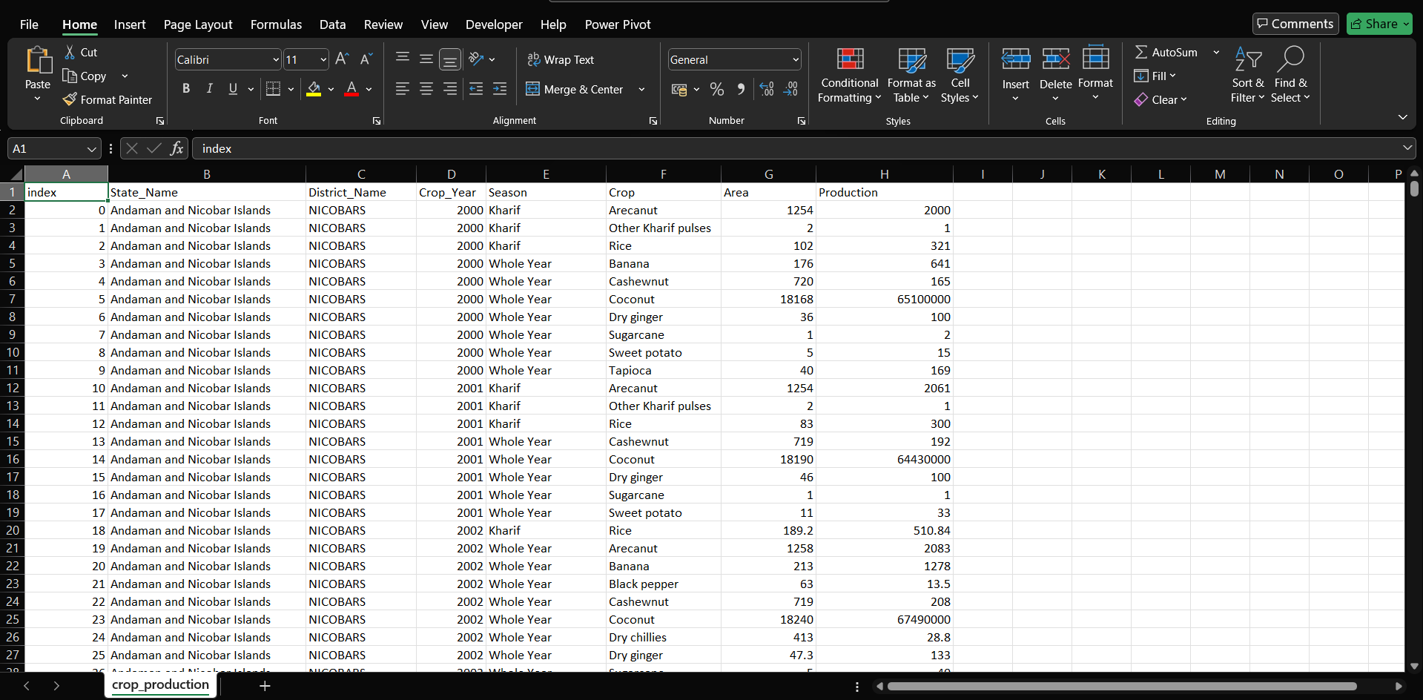

EDA (Exploratory Data Analysis) Process

1. Bar Chart of Top 10 States by Production:
i. Introduction
This analysis identifies the top 10 states contributing to agricultural production to highlight the regions with the highest output.
ii. General Description
The dataset contains agricultural production data for various states across seasons. This chart provides an overview of the leading states based on total production.
iii. Specific Requirements, Functions, and Formulas
- Data Aggregation: Grouped data by State and summed up production values.
- Visualization: Bar chart using Seaborn's barplot function.
- Formula: df.groupby('State')['Production'].sum()
iv. Analysis Results
The top 10 states (e.g., Maharashtra, Uttar Pradesh, etc.) dominate agricultural production. Maharashtra alone accounts for a significant share, followed by other high-yielding states.

2. Agricultural Production by Season
i. Introduction
This analysis evaluates seasonal variations in agricultural production to understand the influence of different seasons.
ii. General Description
The dataset categorizes production data into seasons such as Kharif, Rabi, and Whole Year, showing their contribution to the overall production.
iii. Specific Requirements, Functions, and Formulas
- Data Aggregation: Grouped by Season and summed up production values.
- Visualization: Bar chart using Seaborn's barplot.
- Formula: df.groupby('Season')['Production'].sum()

iv. Analysis Results
The Whole Year season has the highest production, indicating crops harvested throughout the year contribute significantly. Kharif and Rabi follow as key seasonal contributors.

3. Heatmap of Agricultural Production by State and Season
i. Introduction
This analysis uses a heatmap to reveal patterns in agricultural production across states and seasons.
ii. General Description
The heatmap visualizes production data as a matrix, highlighting regions and seasons with varying production intensities.
iii. Specific Requirements, Functions, and Formulas
- Pivot Table: Created a pivot table of Production with State as rows and Season as columns.
- Normalization: Log scale applied for better contrast using np.log10().
- Visualization: Heatmap using Seaborn's heatmap.
iv. Analysis Results
The heatmap shows high production in states like Maharashtra and Uttar Pradesh across multiple seasons. Certain states have production concentrated in specific seasons.

4. Pie Chart of Top 5 States' Contribution
i. Introduction
This analysis quantifies the contribution of the top 5 states to total agricultural production.
ii. General Description

A pie chart provides a proportional comparison, emphasizing the dominance of leading states.
iii. Specific Requirements, Functions, and Formulas
- Data Aggregation: Summed production values for the top 5 states and compared them to the rest.
- Visualization: Pie chart using Matplotlib's pie function.
iv. Analysis Results
The top 5 states contribute over 60% to total production, with Maharashtra and Uttar Pradesh being the largest contributors.

5. Seasonal Production Distribution for Top 5 States
i. Introduction
This analysis focuses on the seasonal distribution of production for the top 5 states.
ii. General Description
The analysis identifies how seasonal production varies among the top 5 states, offering insights into their agricultural patterns.
iii. Specific Requirements, Functions, and Formulas
- Filter Data: Filtered the dataset for the top 5 states.
- Visualization: Bar chart with Season as the hue using Seaborn's catplot.
iv. Analysis Results
Most top states have balanced contributions across seasons, with some states like Uttar Pradesh showing high production during specific seasons.

6. Stacked Bar Chart of Production by Season for Top 10 States
i. Introduction
This analysis examines seasonal contributions to production for the top 10 states.
ii. General Description
A stacked bar chart provides a breakdown of each state's production across seasons.

iii. Specific Requirements, Functions, and Formulas
- Pivot Table: Created a pivot table with State as rows and Season as columns.
- Visualization: Stacked bar chart using Pandas' plot(kind='bar', stacked=True).
iv. Analysis Results
The chart highlights the diversity in seasonal production across states, with states like Maharashtra and Uttar Pradesh exhibiting substantial Whole Year production.

Summary of EDA
The EDA process has uncovered critical insights into the dataset:
- Maharashtra and Uttar Pradesh are leading contributors to agricultural production.
- The Whole Year season dominates overall production.
- States show unique seasonal patterns, which are visually distinguishable through heatmaps and bar charts.
- The top states significantly influence national agricultural trends, as evident from pie and stacked bar charts.

DATA VISUALIZATION

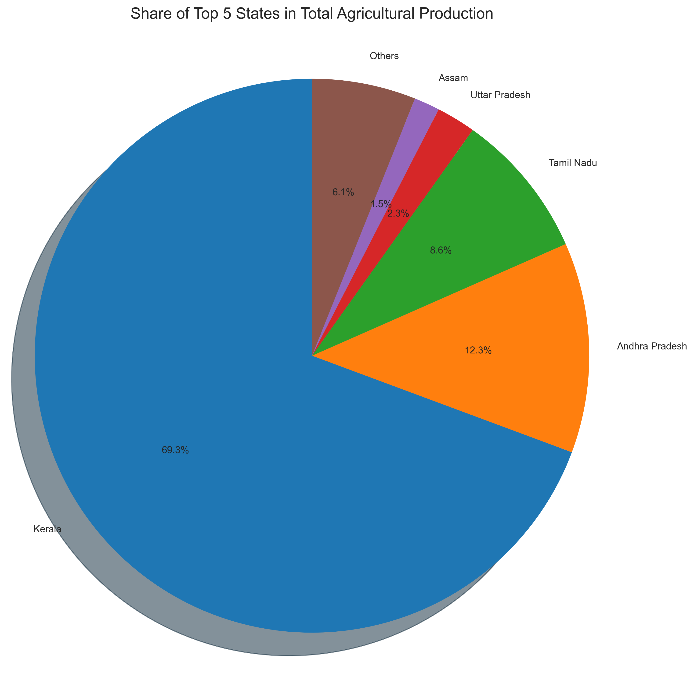
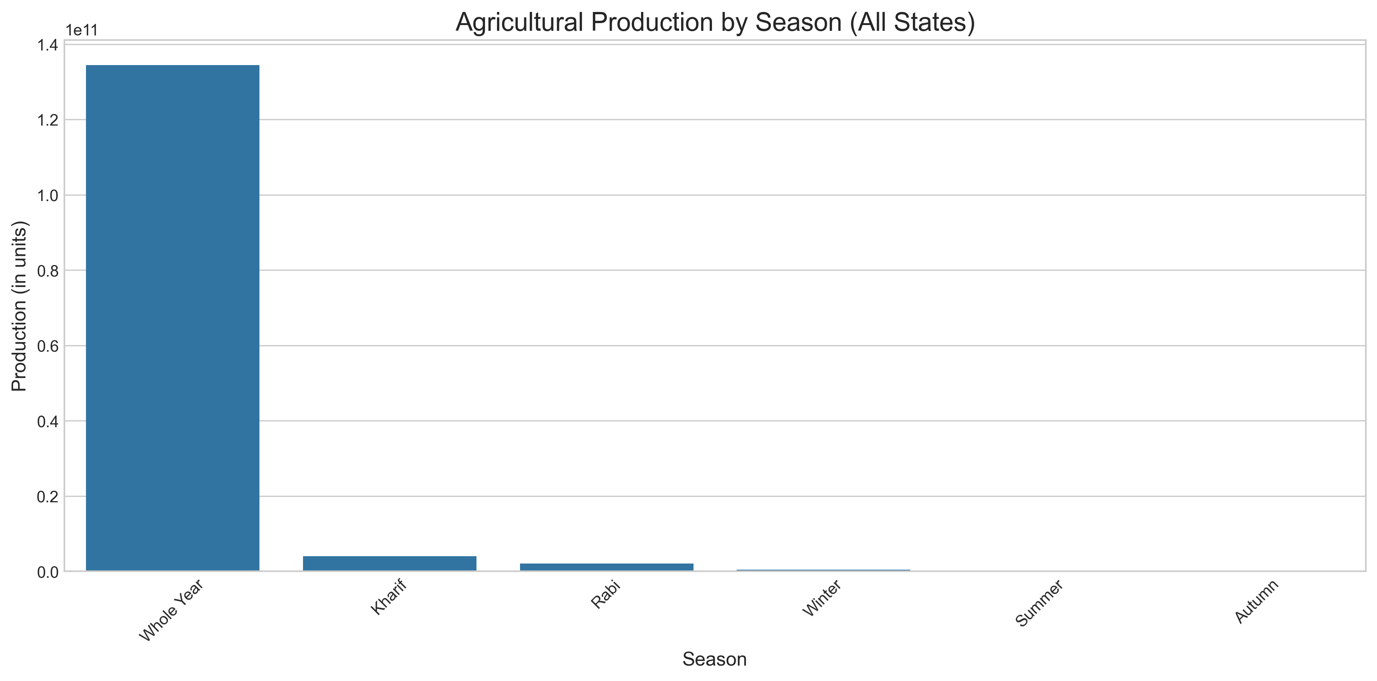
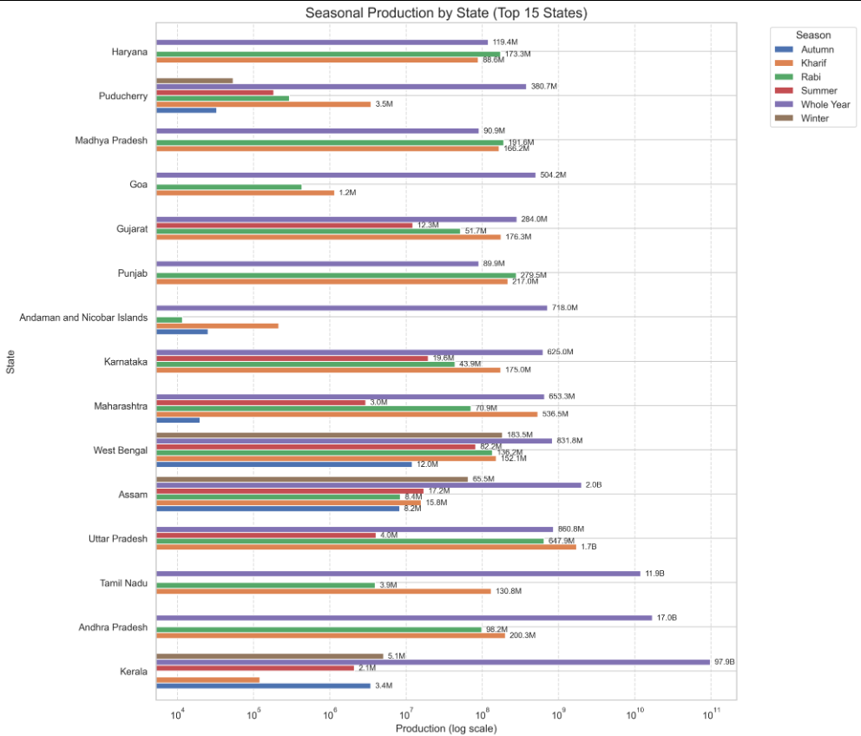

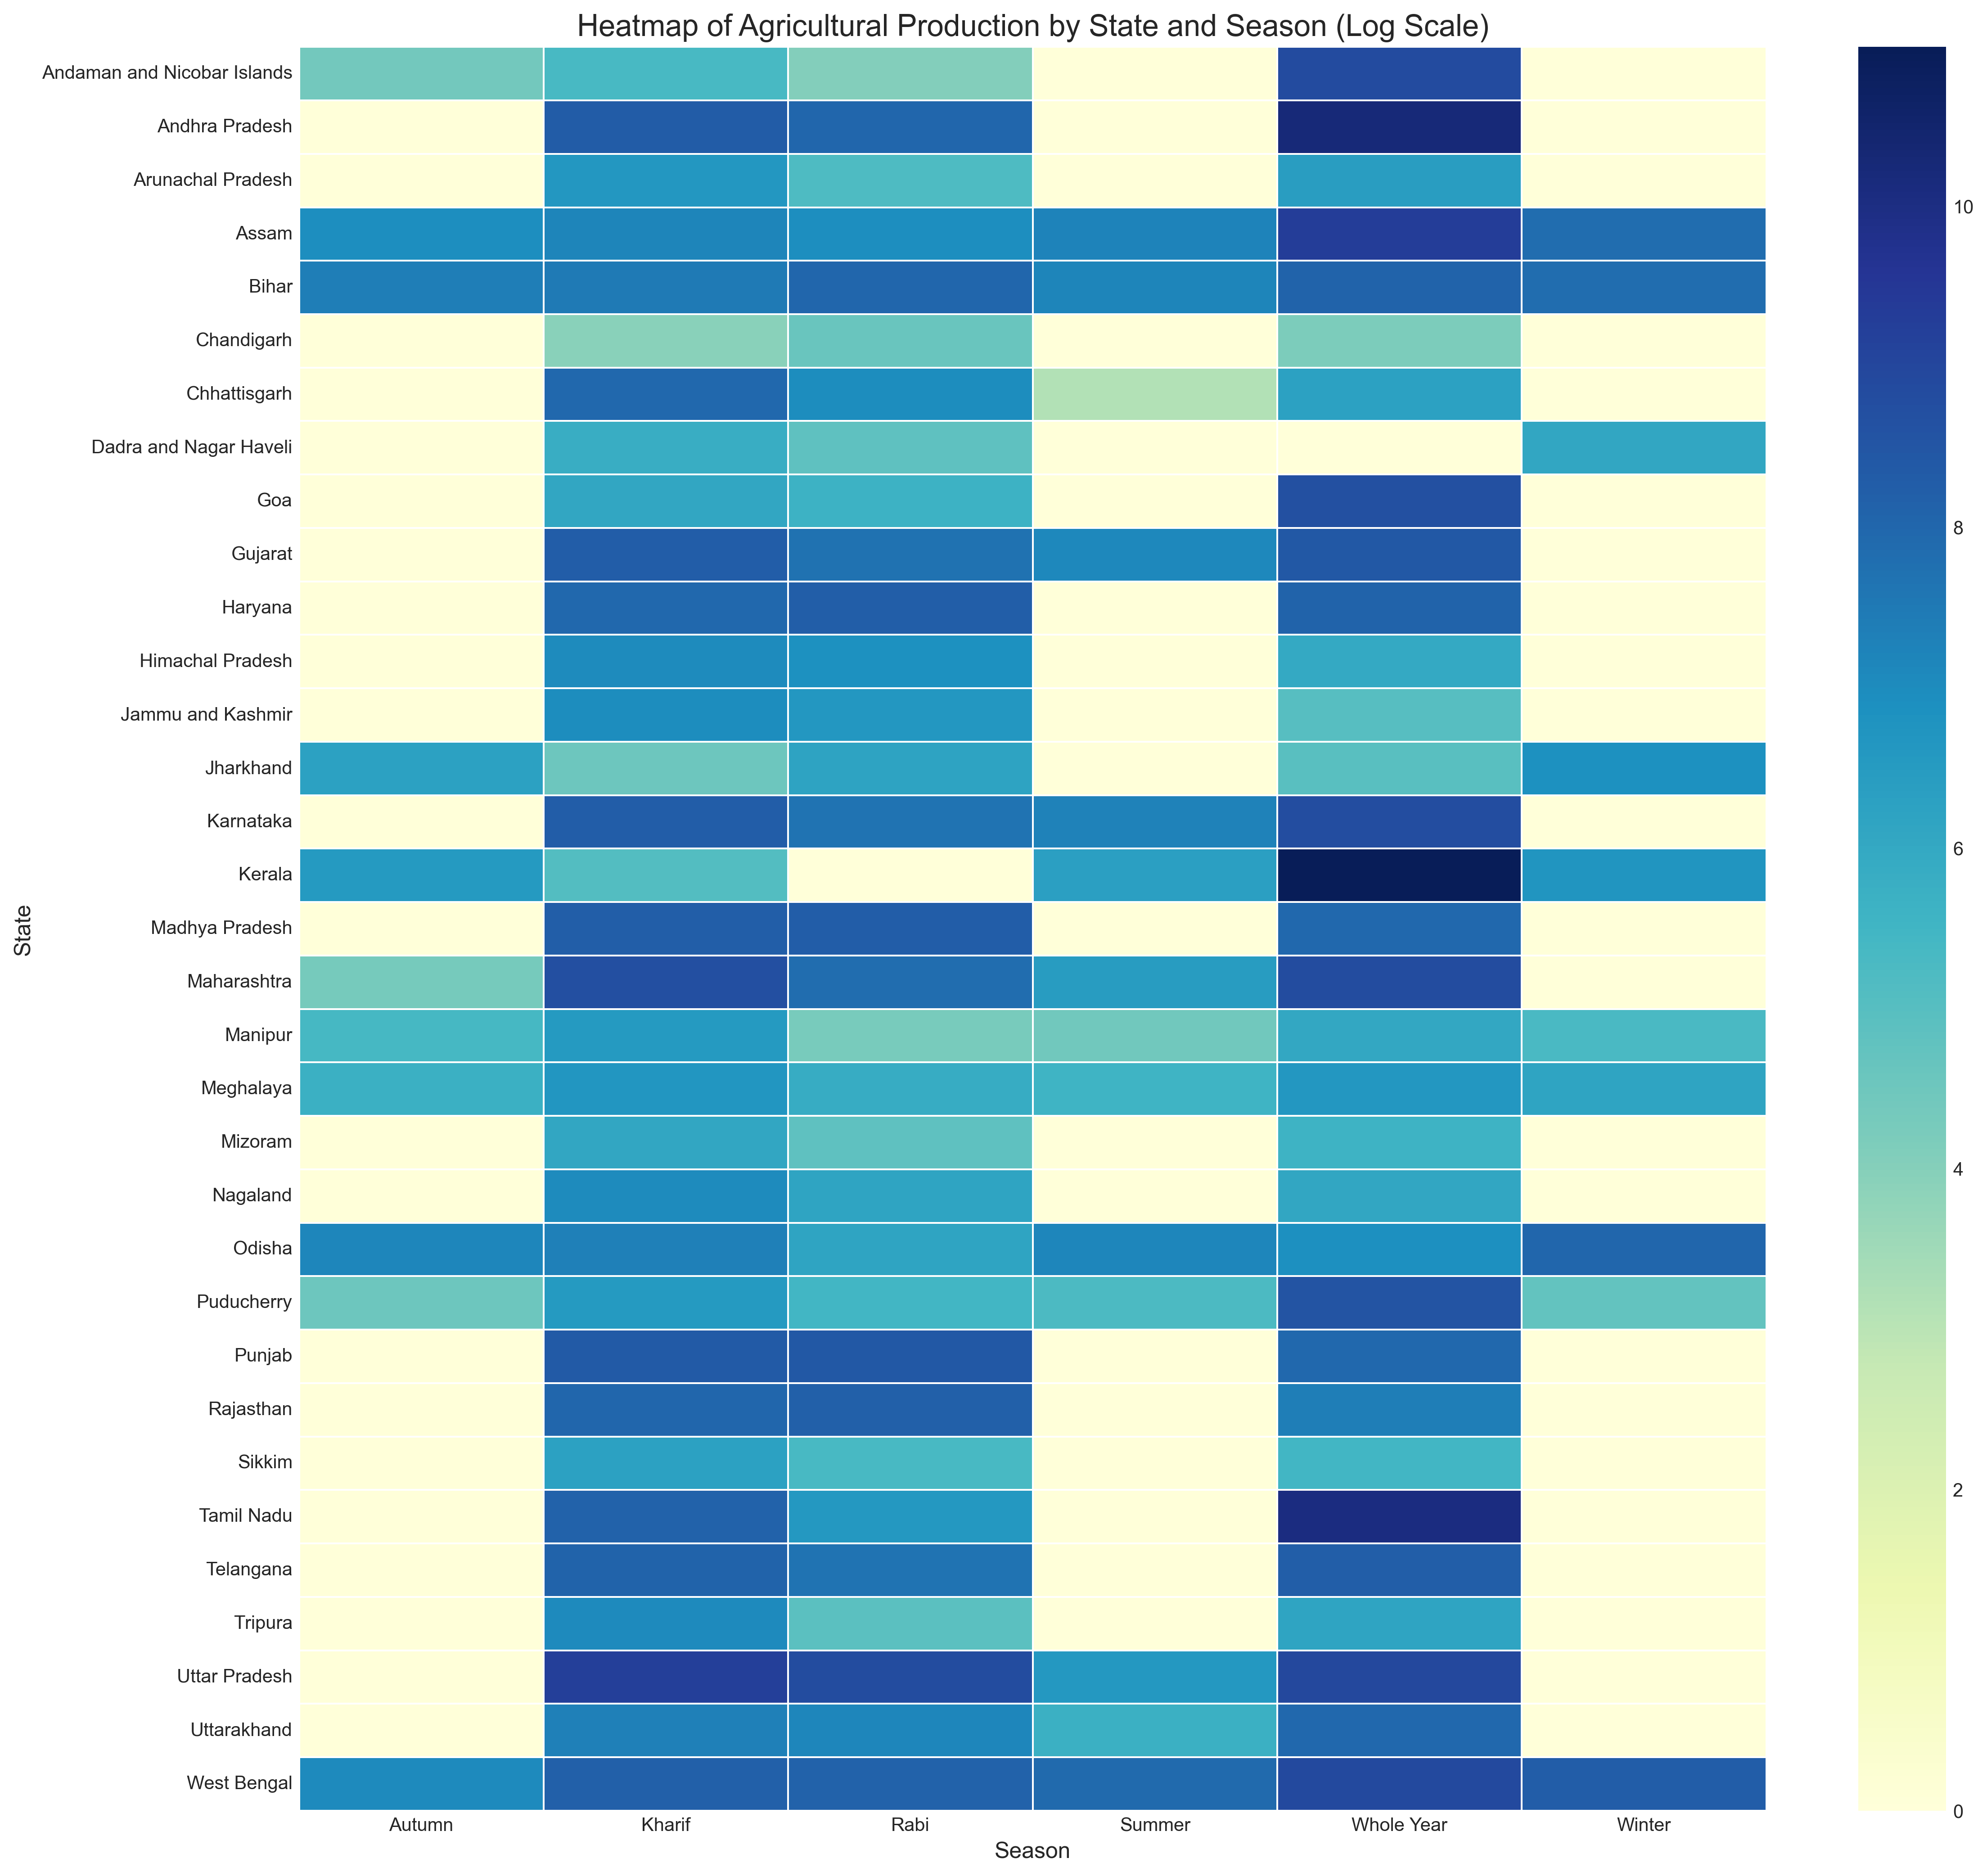

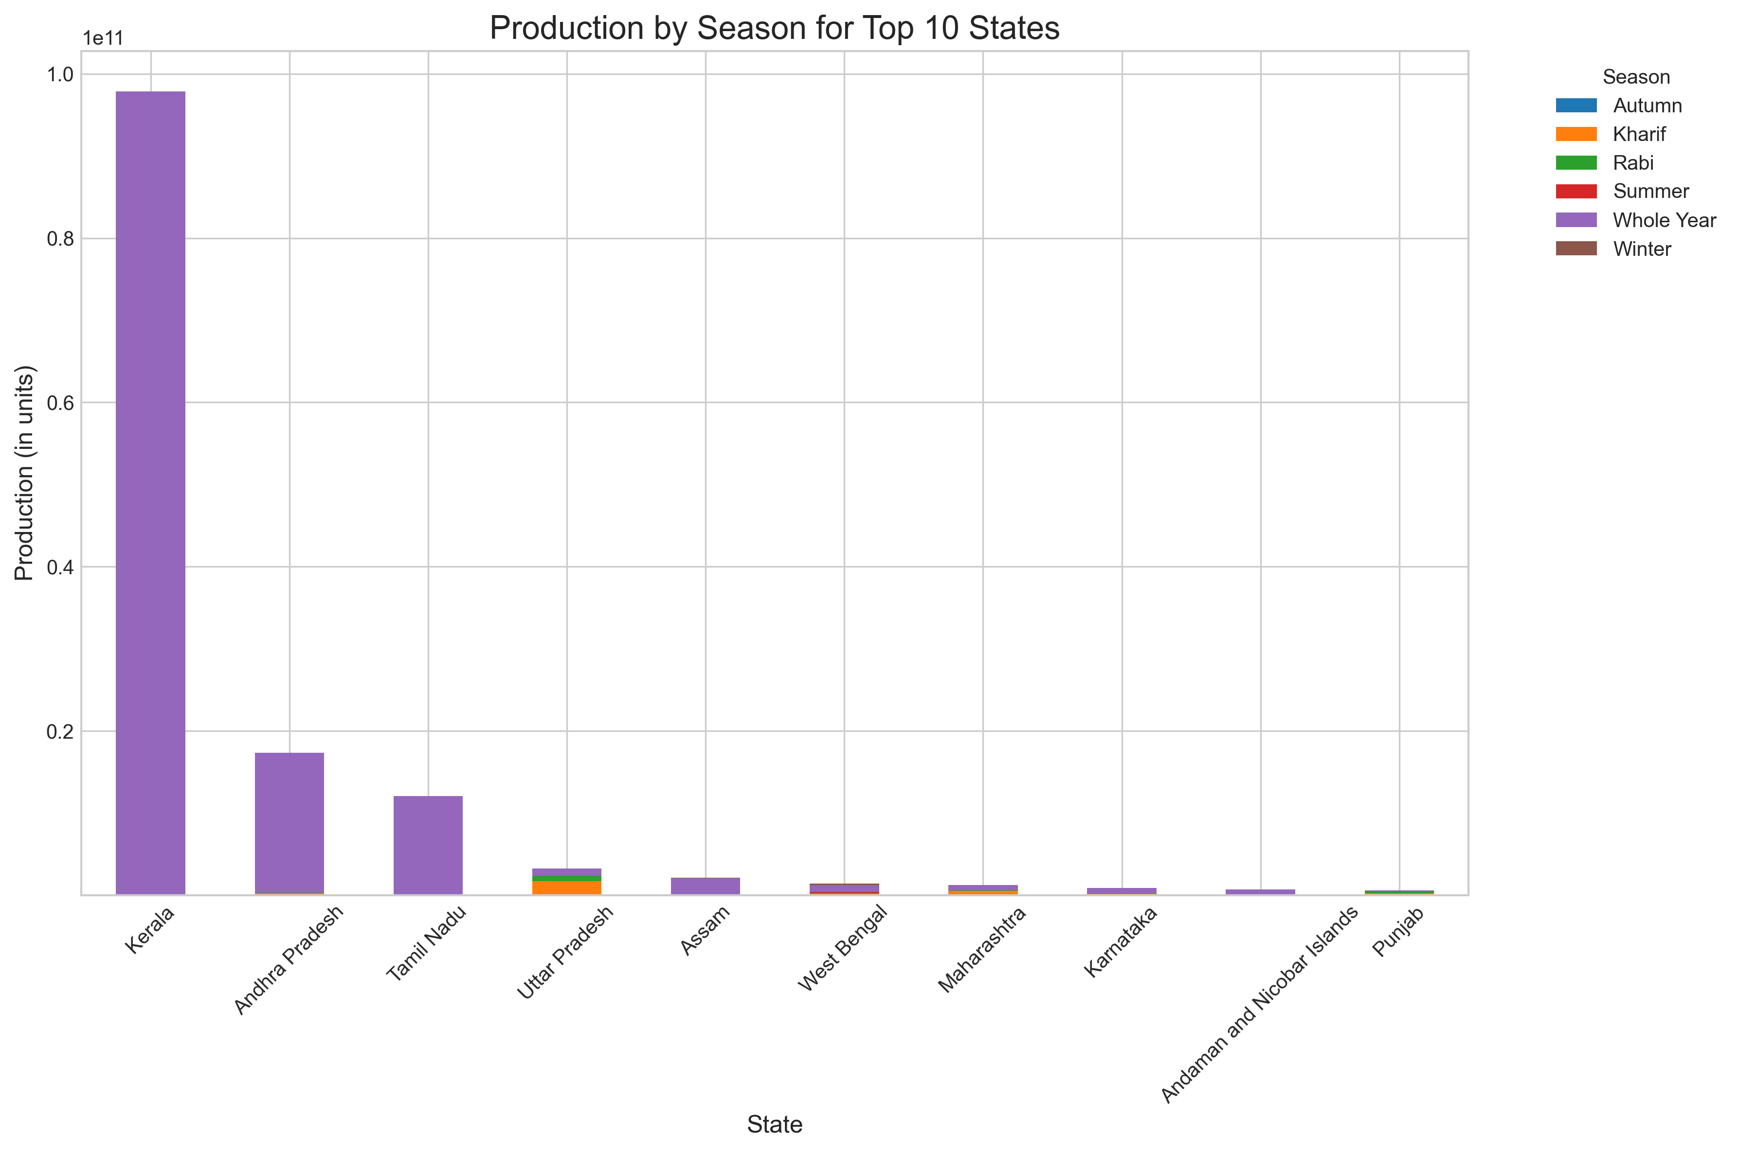
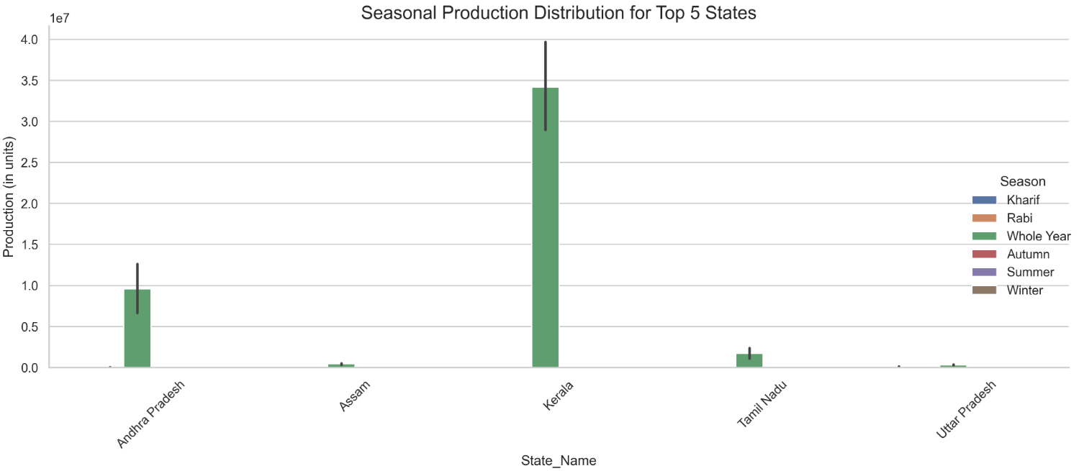

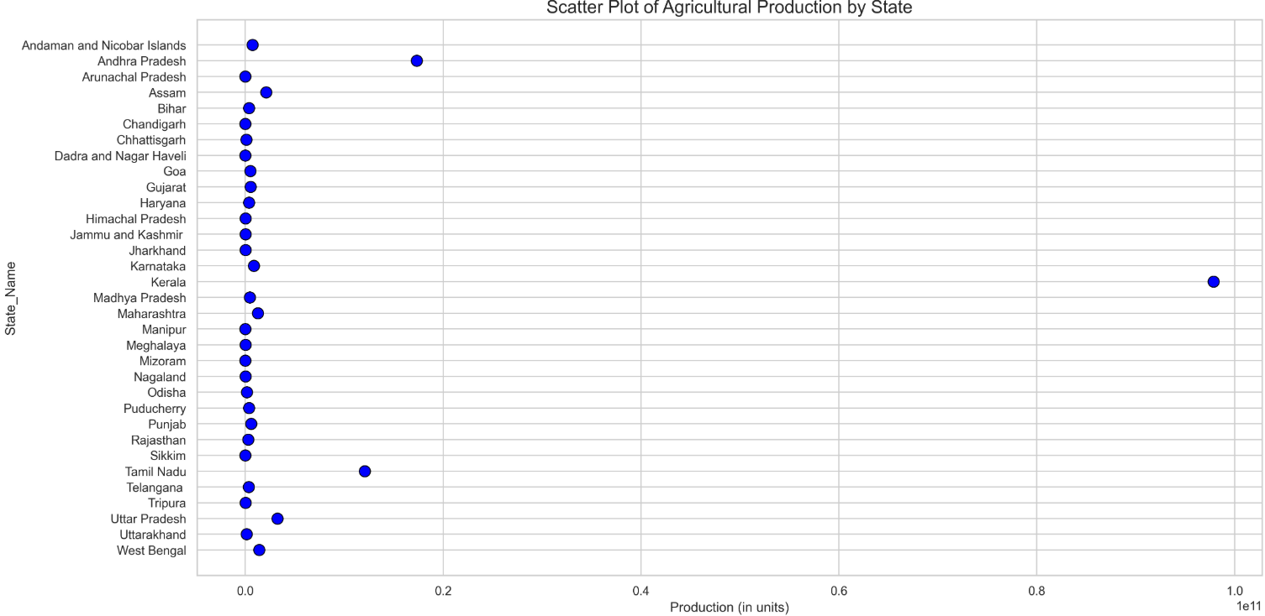
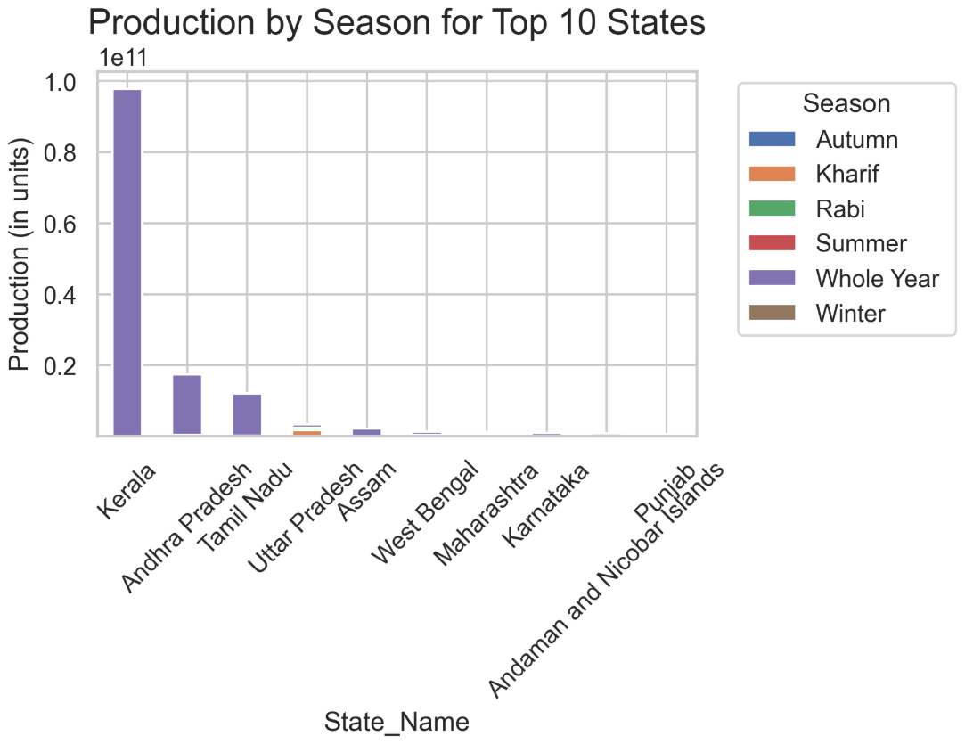
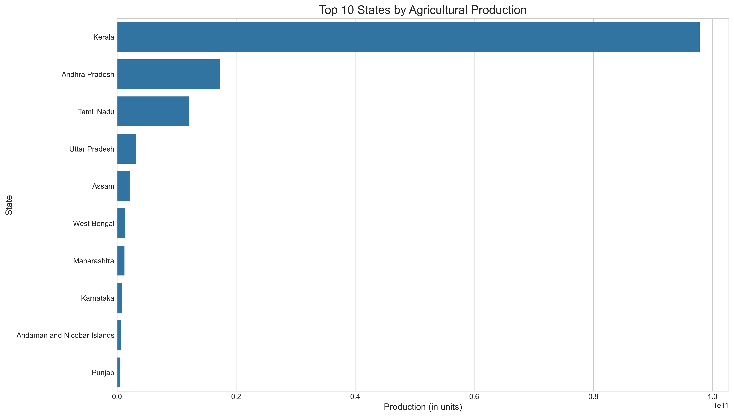

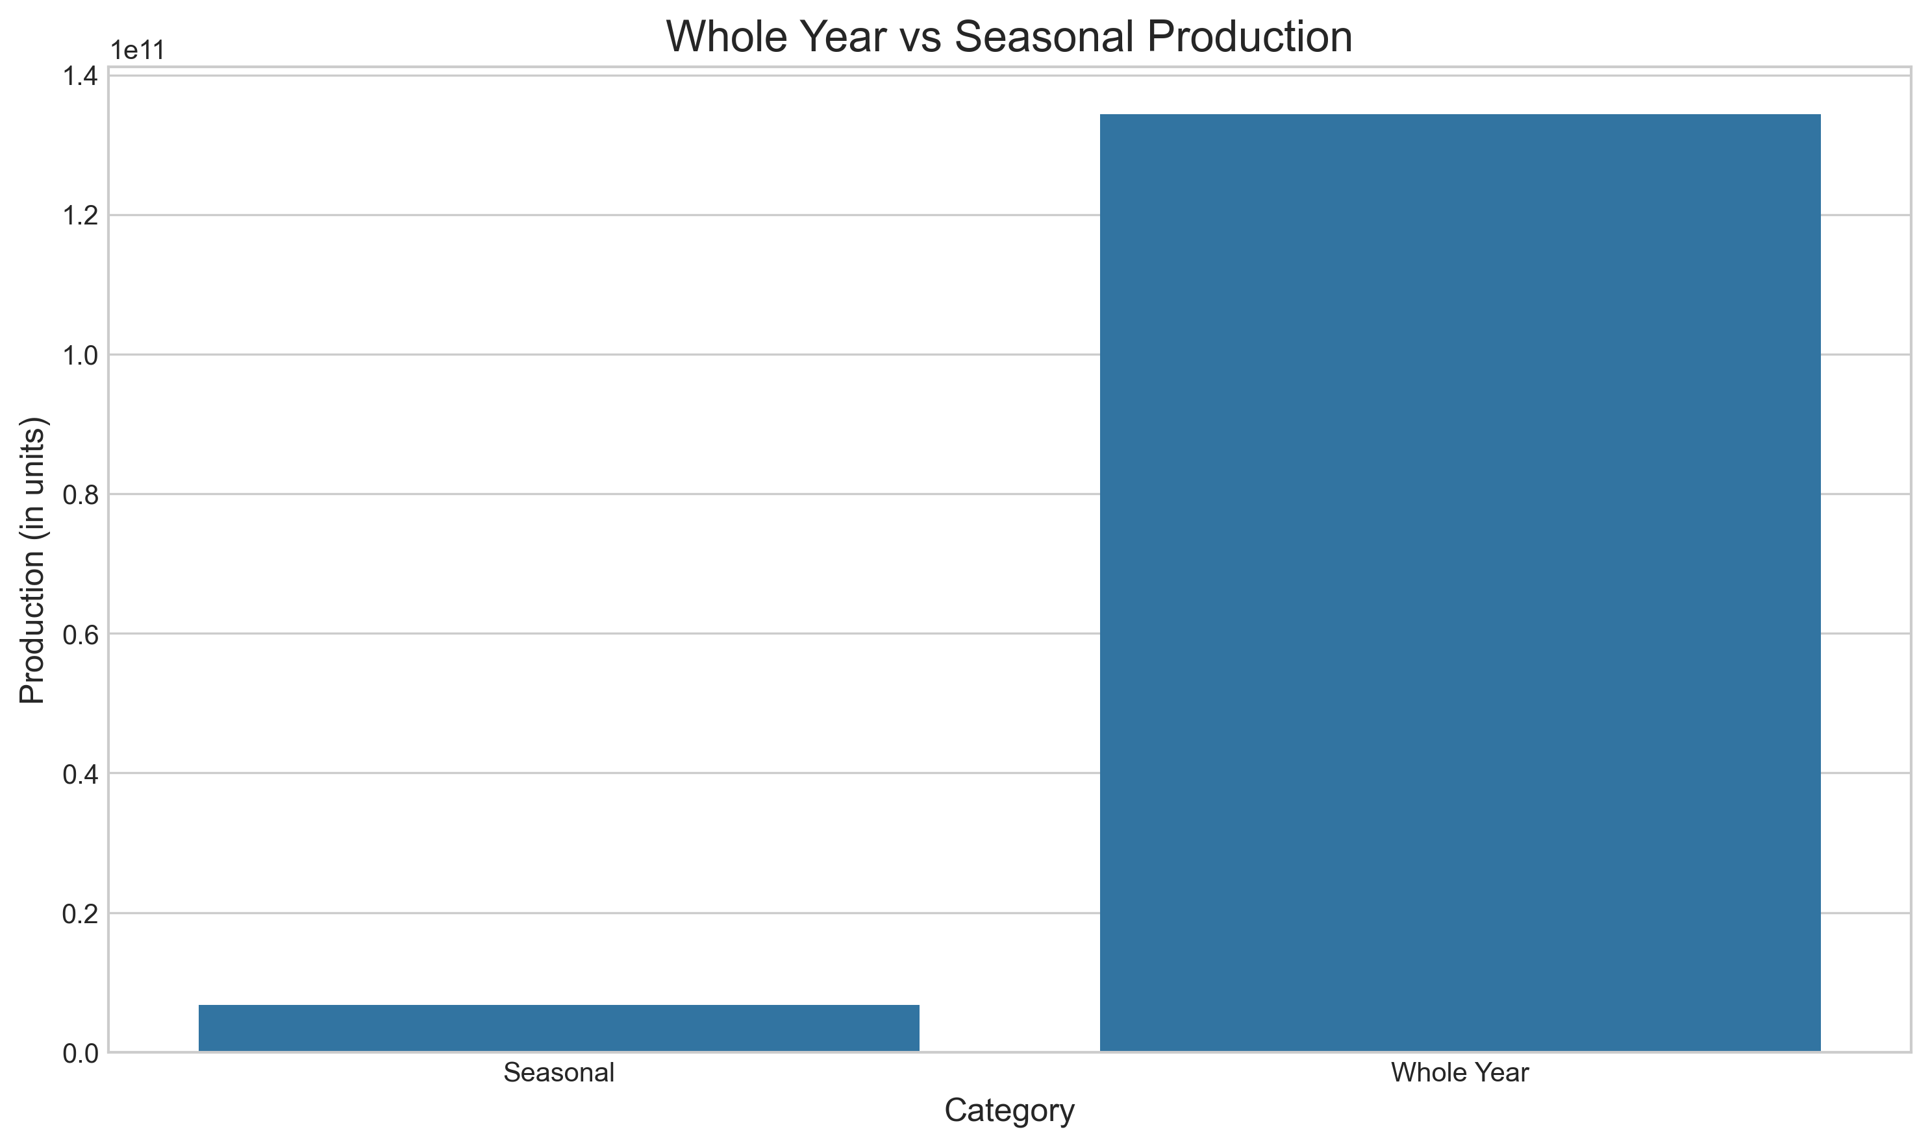

Conclusion
The exploratory data analysis of the agricultural production dataset has provided valuable insights into the production patterns across different states and seasons in India. Key findings include:
- The top 10 states contribute significantly to agricultural production, with a steep drop-off in production for other states.
- Seasonal variations highlight the dominance of specific seasons, such as Kharif and Whole Year, in overall production trends.
- The state-season heatmap reveals nuanced distribution patterns, indicating that certain states excel in specific seasons.
- The top 5 states account for a majority share of production, emphasizing the disparity in agricultural contributions across states.
This analysis enables policymakers, researchers, and agricultural planners to make informed decisions to optimize resources and address disparities in agricultural practices.

Future Scope
- Granular Analysis
  - Include data for crop-specific analysis to identify which crops dominate production in each state and season.
  - Investigate regional dependencies on certain crops and seasons for livelihood and economy.
- Temporal Trends
  - Extend the dataset to include historical data to analyze temporal trends and forecast future production patterns.
  - Incorporate climatic and economic factors to study their influence on agricultural output.
- Advanced Models
  - Apply machine learning models for predictive analytics and anomaly detection in production patterns.
  - Explore deep learning techniques for crop yield prediction and season optimization.

- Policy Recommendations
  - Use insights to design policies that encourage balanced agricultural growth.
  - Support underperforming states with tailored interventions, such as irrigation systems, subsidies, and training programs.
- Integration of Remote Sensing Data
  - Include satellite imagery and geospatial data to improve accuracy in analyzing agricultural trends.
  - Combine remote sensing data with production statistics to monitor and manage agricultural land more effectively.

References
- Government of India, Data Portal. “Daily FCI Stock Position Dataset.” Retrieved from: https://www.data.gov.in/resource/daily-fci-stock-position-commodity
- Seaborn Documentation. Available at: https://seaborn.pydata.org/
- Matplotlib Documentation. Available at: https://matplotlib.org/stable/index.html
- Pandas Documentation. Available at: https://pandas.pydata.org/
- NumPy Documentation. Available at: https://numpy.org/doc/stable/
- Additional insights derived from the analysis and visualizations presented in this report.

