
Inspection & Testing Services

FINAL REPORT
DEMO-PC0001 – Demo boiler shutdown inspection
Client
DEMO – Sample Process Plant (not a real client)
Demo Utilities Area

Document control
Document number | ES/DEMO-FR-2026-01
Revision | Rev. 00
Date | 10 Oct 2026
Status | Issued
Prepared by | Demo Inspector
Reviewed by | Demo Office Lead
Approved by | General Manager
This document is confidential and is intended only for DEMO – Sample Process Plant (not a real client). It shall not be reproduced except in full without the written approval of EnvironmSafe.

1. DOCUMENT CONTROL
Rev. | Date | Description | Prepared | Reviewed | Approved
00 | 10 Oct 2026 | First issue | Demo Inspector | Demo Office Lead | General Manager

CONTENTS
1. DOCUMENT CONTROL
2. EXECUTIVE SUMMARY
3. SCOPE
4. EQUIPMENT INSPECTED
5. INSPECTION RESULTS
6. FINDINGS AND PRIORITIES
7. DAILY PROGRESS SUMMARY
8. HOLDS AND OBSERVATIONS
9. CERTIFICATES ISSUED
10. LIMITATIONS
11. SIGN-OFF
12. ANNEX – PHOTOGRAPHS
2. EXECUTIVE SUMMARY
We carried out 3 inspections on 2 items under DEMO-PC0001. 4 findings remain open (2 at priority P1) and 1 was closed. 2 certificate(s) were issued.
3. SCOPE
The scope of work covered the inspection of the equipment listed in this report in accordance with the referenced codes and the client's requirements.
Internal and external inspection of B-101, PSV overhaul and UT survey of V-201 / V-202 and P-301.
4. EQUIPMENT INSPECTED
Tag | Description | Service | Location | Status
V-201 | Air receiver / pressure vessel | Compressed air | Compressor house | In service
PSV-101A | Steam drum safety valve A | Steam | Compressor house | In service

5. INSPECTION RESULTS
Tag | Inspection | Date | Report no. | Conclusion | Next due
V-201 | External visual inspection | 10 Oct 2026 | ES/DEMO-EXT-2026-001 | Fit for continued service with conditions | 10 Oct 2027
PSV-101A | PSV set pressure test and overhaul | 09 Oct 2026 | — | Fit for continued service | 09 Oct 2027
V-201 | Hydrostatic / pressure test | 09 Oct 2026 | — | Fit for continued service | —

V-201 – External visual inspection (10 Oct 2026)
We carried out an external visual inspection and an ultrasonic thickness survey of the air receiver. External corrosion at the bottom head has progressed since the previous inspection. The drain valve has been replaced. The origin of the pitting at the north support leg could not be established from the as-found condition.
Point | Location | Nominal (mm) | t-min (mm) | Previous (mm) | Measured (mm) | ST rate (mm/y) | LT rate (mm/y) | Rem. life (y)
CML-01 | Top head | 12 | 8.2 | 11.6 (2025) | 11.5 | 0.100 | 0.060 | 33.0
CML-04 | Bottom head | 12 | 8.2 | 10.6 (2025) | 10.1 | 0.500 | 0.219 | 3.8
CML-05 | Drain nozzle | 7.1 | 4 | 6 (2025) | 5.8 | 0.200 | 0.139 | 9.0

6. FINDINGS AND PRIORITIES
Asset | Ref. | Finding | Pri. | Raised | Status | Latest note | Due
V-201 | F-001 | External corrosion at bottom head | P1 | 10 Oct 2025 | Open – deteriorated | 10 Oct 2026: Pitting deeper; coating breakdown now approx. 45 % of the head. | —
V-201 | F-002 | Drain valve passing | P2 | 10 Oct 2025 | Closed | 10 Oct 2026: Valve replaced by client in March 2026. | —
V-201 | F-003 | Nameplate partly illegible | P3 | 10 Oct 2025 | Open – unchanged | 10 Oct 2026: No change. | —
V-201 | F-004 | Pitting at north support leg | P1 | 10 Oct 2026 | Open |  | 10 Apr 2027
V-201 | F-005 | Earthing strap loose | P3 | 10 Oct 2026 | Open |  | —

P1: Action within 6 months. P2: Action at the next shutdown and not later than the set due date. P3: Continuous or routine attention.
7. DAILY PROGRESS SUMMARY
Report | Date | Staff | Hours | Actual % | Main activities
ES/DEMO-PC0001-DPR-003 | 09 Oct 2026 | 4 | 20 | 45 | As-found tests of PSV-101A, 21-PSV-003-2, PSV 18 111-1; UT survey of V-201 completed (5 CMLs)

8. HOLDS AND OBSERVATIONS
Ref. | Type | Description | Raised | Closed
H-01 | Hold | Boiler internal access | 08 Oct 2026 | Open
O-01 | Observation | Scaffold tag missing at drum level | 08 Oct 2026 | 09 Oct 2026

9. CERTIFICATES ISSUED
Certificate | Tag | Type | Issued | Issued by
ES-R-12-001 | PSV-101A | PSV | 10 Oct 2026 | Demo Office Lead
ES-H-2026-001 | V-201 | HYDRO | 10 Oct 2026 | Demo Office Lead

10. LIMITATIONS
This report records the condition of the equipment as found on the date of inspection, within the scope and access available. Areas that were insulated, buried, inaccessible or not prepared were not examined unless stated. Where the origin of a condition cannot be established from the as-found condition, this is stated.
11. SIGN-OFF
Prepared by | Reviewed by | Approved by
Demo Inspector  Date: 10 Oct 2026 | Demo Office Lead  Date: | General Manager  Date:

12. ANNEX – PHOTOGRAPHS
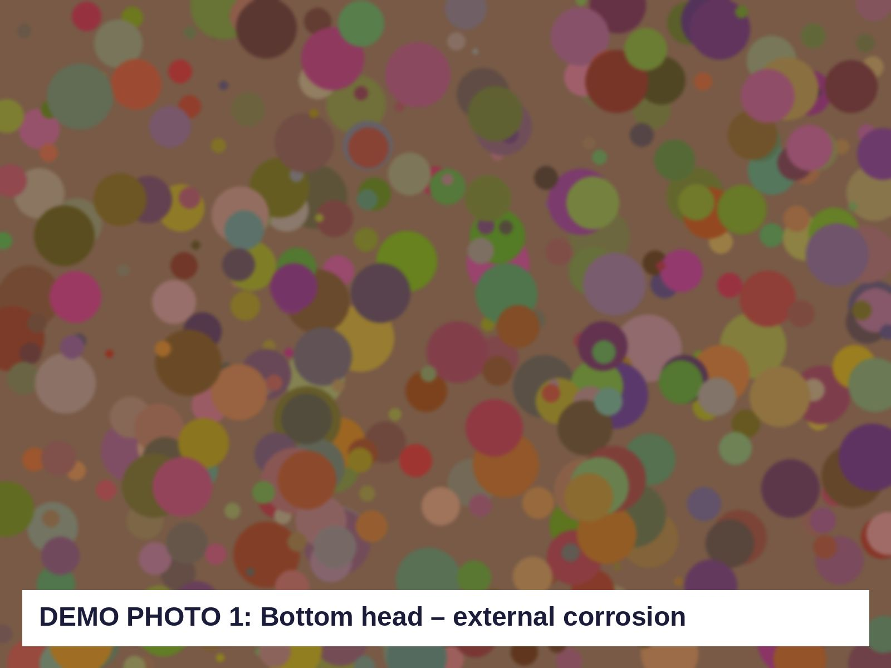  Figure 1 – Bottom head – external corrosion (F-001) |   Figure 2 – Drain nozzle N5 with new valve (F-002)

