
Inspection & Testing Services

INSPECTION REPORT
External visual inspection – V-201 Air receiver / pressure vessel
Client
DEMO – Sample Process Plant (not a real client)
Demo Utilities Area

Document control
Document number | ES/DEMO-EXT-2026-001
Revision | Rev. 00
Date | 10 Oct 2026
Status | Issued
Inspection date | 10 Oct 2026
Prepared by | Demo Inspector
Reviewed by | Demo Office Lead
Approved by | General Manager
This document is confidential and is intended only for DEMO – Sample Process Plant (not a real client). It shall not be reproduced except in full without the written approval of EnvironmSafe.

1. DOCUMENT CONTROL
Rev. | Date | Description | Prepared | Reviewed | Approved
00 | 11 Oct 2026 | First issue | Demo Inspector | Demo Office Lead | General Manager

CONTENTS
1. DOCUMENT CONTROL
2. SCOPE
3. EQUIPMENT DETAILS
4. METHOD
5. RESULTS
6. THICKNESS READINGS
7. STATUS OF PREVIOUS FINDINGS
8. FINDINGS AND PRIORITIES
9. RECOMMENDATIONS
10. CONCLUSION
11. LIMITATIONS
12. CERTIFICATES
13. SIGN-OFF
14. ANNEX – PHOTOGRAPHS
2. SCOPE
The scope of work covered the inspection of the equipment listed in this report in accordance with the referenced codes and the client's requirements.
This report records the external visual inspection of V-201 (Air receiver / pressure vessel) at Demo Utilities Area, which we carried out on 10 Oct 2026 with reference to API 510 (2022 edition). The inspection was witnessed by Demo Plant Engineer.
3. EQUIPMENT DETAILS
Tag number | V-201 | Description | Air receiver / pressure vessel
Equipment type | Pressure vessel | Site / location | Demo Utilities Area – Compressor house
Manufacturer | Demo Fabricators | Model | AR-10
Serial number | DF-5521 | Year built | 2012
Service | Compressed air | Code of construction | ASME VIII-1
Material | SA-516 Gr 70 | Capacity | 10 m³
Design pressure | 12 bar | MAWP | 12 bar
Design temperature | 80 °C | Orientation | Vertical
Corrosion allowance (mm) | 3

4. METHOD
We carried out a close visual examination of the accessible external surfaces, welds, nozzles, supports and attachments, using hand lamps, mirrors and gauges where needed. Conditions found were recorded and photographed.
Checklist
No. | Item | Result | Note
1 | Nameplate present and legible | Yes
2 | Shell / body free of visible corrosion, dents or bulges | No | Corrosion at bottom head
3 | Supports, saddles, foundations and anchor bolts in good condition | No | Pitting at north leg
4 | No leaks observed | Yes

5. RESULTS
We carried out an external visual inspection and an ultrasonic thickness survey of the air receiver. External corrosion at the bottom head has progressed since the previous inspection. The drain valve has been replaced. The origin of the pitting at the north support leg could not be established from the as-found condition.
6. THICKNESS READINGS
Point | Location | Nominal (mm) | t-min (mm) | Previous (mm) | Measured (mm) | ST rate (mm/y) | LT rate (mm/y) | Rem. life (y)
CML-01 | Top head | 12 | 8.2 | 11.6 (2025) | 11.5 | 0.100 | 0.060 | 33.0
CML-04 | Bottom head | 12 | 8.2 | 10.6 (2025) | 10.1 | 0.500 | 0.219 | 3.8
CML-05 | Drain nozzle | 7.1 | 4 | 6 (2025) | 5.8 | 0.200 | 0.139 | 9.0

ST = short-term rate (last two readings); LT = long-term rate (first and last readings). Remaining life uses the higher of the two rates.
7. STATUS OF PREVIOUS FINDINGS
Ref. | Finding | Raised | Previous status | Status now | Our note
F-001 | External corrosion at bottom head | 10 Oct 2025 | Open | Open – deteriorated | Pitting deeper; coating breakdown now approx. 45 % of the head.
F-002 | Drain valve passing | 10 Oct 2025 | Open | Closed | Valve replaced by client in March 2026.
F-003 | Nameplate partly illegible | 10 Oct 2025 | Open | Open – unchanged | No change.

8. FINDINGS AND PRIORITIES
Ref. | Finding and location | Severity | Priority | Recommendation | Due
F-004 | Pitting at north support leg – North leg, 300 mm above base plate  Scattered pitting up to an estimated 1.5 mm deep over an area of approx. 150 × 200 mm. | High | P1 | Clean to bare metal, measure pit depth and assess against API 579-1 Part 6; restore coating. | 10 Apr 2027
F-005 | Earthing strap loose | Low | P3 | Re-tighten and test the earthing connection. | —

P1: Action within 6 months. P2: Action at the next shutdown and not later than the set due date. P3: Continuous or routine attention.
9. RECOMMENDATIONS
Restore the coating system on the bottom head and support legs before the next inspection.
- F-004 (P1): Clean to bare metal, measure pit depth and assess against API 579-1 Part 6; restore coating.
- F-005 (P3): Re-tighten and test the earthing connection.
10. CONCLUSION
Fit for continued service with conditions
The equipment is considered fit for continued service subject to the conditions and recommendations stated in this report being completed by the dates given.
Next inspection due | 10 Oct 2027
Interval | 12 months

11. LIMITATIONS
The internal surfaces were not examined within the scope of this inspection.
This report records the condition of the equipment as found on the date of inspection, within the scope and access available. Areas that were insulated, buried, inaccessible or not prepared were not examined unless stated. Where the origin of a condition cannot be established from the as-found condition, this is stated.
12. CERTIFICATES
Certificate | Type | Issued | Issued by
ES-H-2026-001 | HYDRO | 10 Oct 2026 | Demo Office Lead

13. SIGN-OFF
Inspected by | Reviewed and issued by
  Demo Inspector  Senior Inspector · Cert. API 510 #00000  Date: 10 Oct 2026 | Demo Office Lead  Date: 11 Oct 2026

14. ANNEX – PHOTOGRAPHS
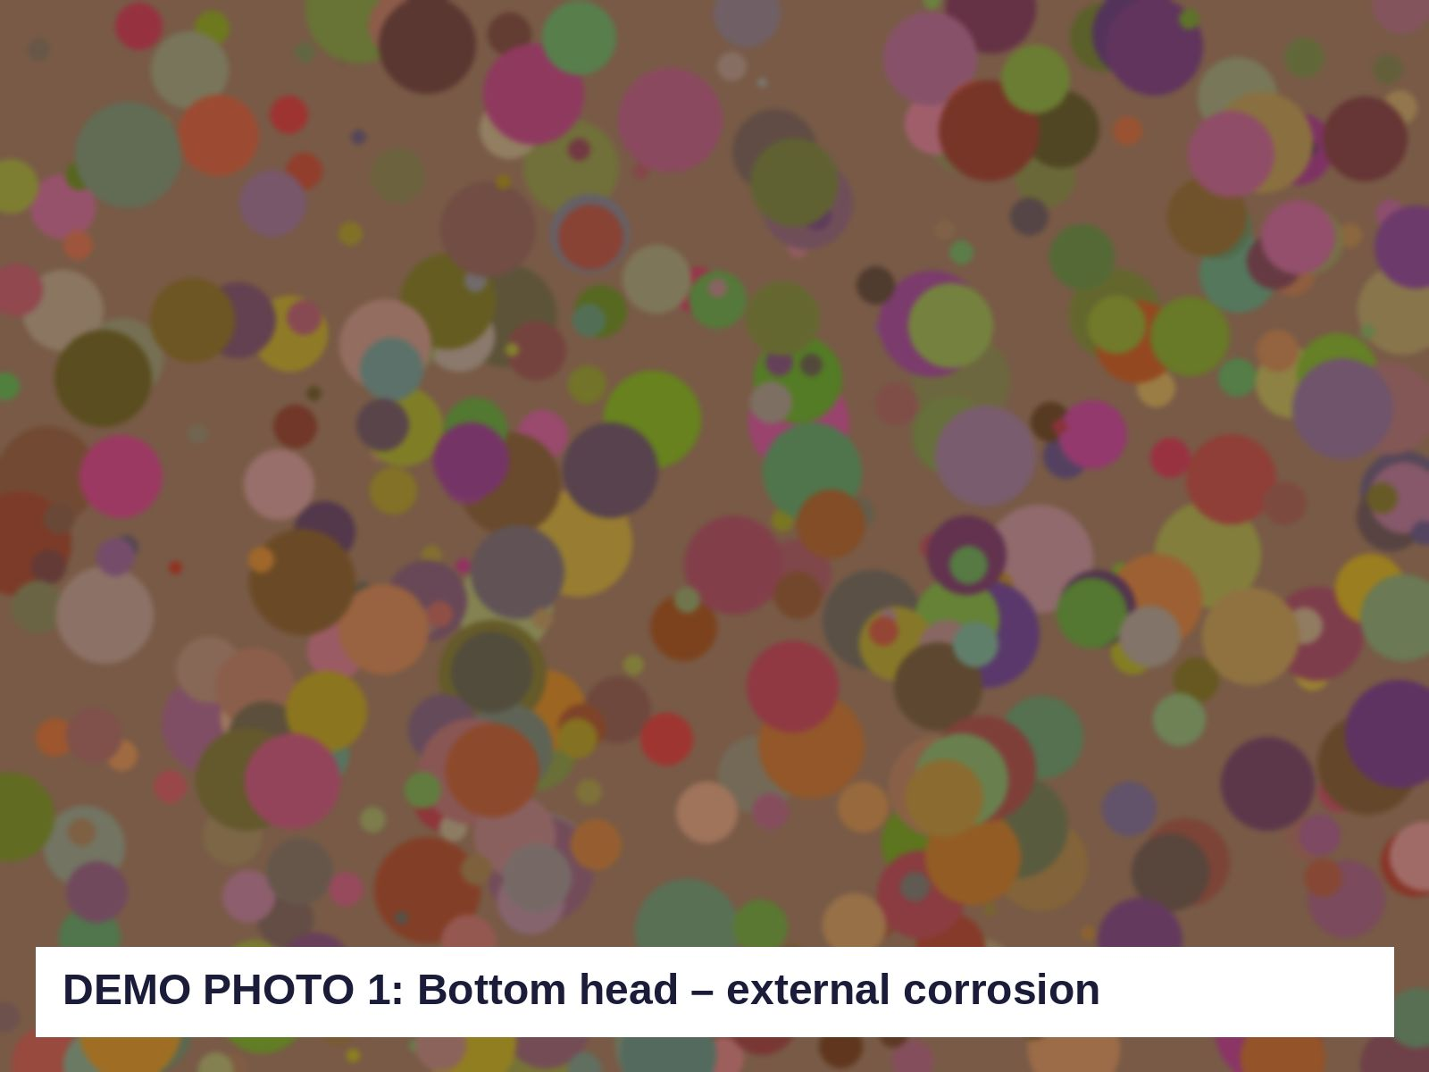  Figure 1 – Bottom head – external corrosion (F-001) |   Figure 2 – Drain nozzle N5 with new valve (F-002)
  Figure 3 – Nameplate (F-003) |   Figure 4 – Pitting at north support leg (F-004)

