Step 1:

create a folder and open terminal from that folder
(by opening the folder, right click and then open in terminal)

Step 2: Sql

- open mysql with root

sudo mysql -u root -p

- create database and table

CREATE DATABASE test_db;
USE test_db;

CREATE TABLE employees (
id INT AUTO_INCREMENT PRIMARY KEY,
name VARCHAR(50),
position VARCHAR(50)
);

- Change password and flush previlliges

ALTER USER 'root'@'localhost' IDENTIFIED WITH mysql_native_password BY 'ubuntu';
FLUSH PRIVILEGES;

- Exit mysql

EXIT; or \q

Step 3: Python and Tkinter

- python3 –version

- pip install mysql-connector-python
(if pip is not installed it will command to install pip first install pip then connector)

- sudo apt install python3-tk
(install tkinter library)

Step 4: Create app.py file and add Code in it

- gedit app.py
(python file backend)

- Now add the code in it with user and password as follows

user="root"
password="ubuntu"

- Main code:

import tkinter as tk
from tkinter import messagebox
import mysql.connector

# Connect to MySQL database
db = mysql.connector.connect(
host="localhost",
user="root", # Replace with your MySQL username
password="ubuntu", # Replace with your MySQL password
database="test_db"
)

# Set up the cursor
cursor = db.cursor()

# Functions for CRUD operations
def add_employee():
name = entry_name.get()
position = entry_position.get()

if name and position:
cursor.execute("INSERT INTO employees (name, position) VALUES (%s, %s)", (name, position))
db.commit()
messagebox.showinfo("Success", "Employee added successfully")
entry_name.delete(0, tk.END)
entry_position.delete(0, tk.END)
display_employees()
else:
messagebox.showwarning("Input Error", "Please fill all fields")

def delete_employee():
employee_id = entry_id.get()

if employee_id:
cursor.execute("DELETE FROM employees WHERE id = %s", (employee_id,))
db.commit()
messagebox.showinfo("Success", "Employee deleted successfully")
entry_id.delete(0, tk.END)
display_employees()
else:
messagebox.showwarning("Input Error", "Please enter an ID")

def edit_employee():
employee_id = entry_id.get()
name = entry_name.get()
position = entry_position.get()

if employee_id and name and position:
cursor.execute("UPDATE employees SET name = %s, position = %s WHERE id = %s", (name, position, employee_id))
db.commit()
messagebox.showinfo("Success", "Employee updated successfully")
entry_id.delete(0, tk.END)
entry_name.delete(0, tk.END)
entry_position.delete(0, tk.END)
display_employees()
else:
messagebox.showwarning("Input Error", "Please fill all fields")

def display_employees():
cursor.execute("SELECT * FROM employees")
records = cursor.fetchall()

listbox.delete(0, tk.END)
for row in records:
listbox.insert(tk.END, f"ID: {row[0]}, Name: {row[1]}, Position: {row[2]}")

# Setting up the GUI window
root = tk.Tk()
root.title("Employee Database")

tk.Label(root, text="Employee ID:").grid(row=0, column=0, padx=10, pady=10)
entry_id = tk.Entry(root)
entry_id.grid(row=0, column=1)

tk.Label(root, text="Name:").grid(row=1, column=0, padx=10, pady=10)
entry_name = tk.Entry(root)
entry_name.grid(row=1, column=1)

tk.Label(root, text="Position:").grid(row=2, column=0, padx=10, pady=10)
entry_position = tk.Entry(root)
entry_position.grid(row=2, column=1)

tk.Button(root, text="Add", command=add_employee).grid(row=3, column=0, padx=10, pady=10)
tk.Button(root, text="Edit", command=edit_employee).grid(row=3, column=1, padx=10, pady=10)
tk.Button(root, text="Delete", command=delete_employee).grid(row=3, column=2, padx=10, pady=10)

# Display listbox for records
listbox = tk.Listbox(root, width=50)
listbox.grid(row=4, column=0, columnspan=3, padx=10, pady=10)

# Display initial data
display_employees()

# Run the application
root.mainloop()

# Close the database connection when done
db.close()
- Run the python file:
pytho3 app.py

Step 5:
Perform CRUD operations

Done...!!!

ScreenShots:
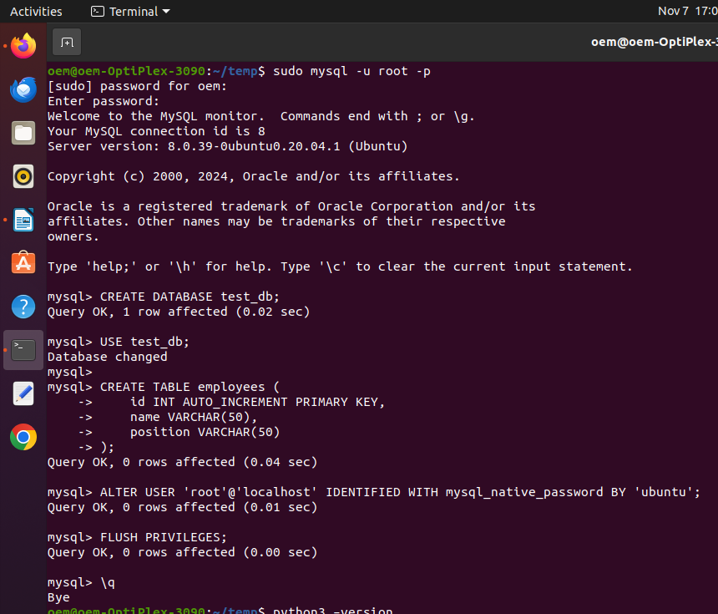

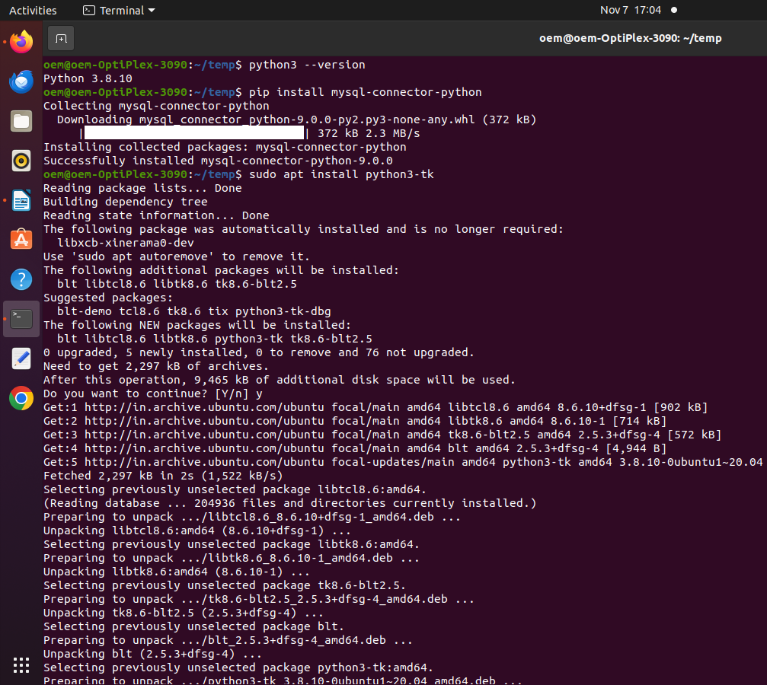

- In this PC pip was installed so directly installed connector

