Chapter 26-2

quick sort

- The core of the quickSort algorithm works as follows:
  - Choose an element of the array as the pivot (we will simply choose the middle element as the pivot).
  - Rearrange the array so that the pivot is in its final position, while the lower sublist has elements that are <= to the pivot, and the upper sublist has elements that are >= to the pivot.
  - Recursively calls quickSort to sort the lower sublist and the upper sublist

Method quickSort

//Example 26-2-1
public class QuickSort
{
/**
Sorts an int array into ascending order<p>
<b>Post:</b><br>Elements in arr sorted in ascending order <p>
*/
public static void quickSort(int[] arr)
{
quickSort(arr, 0, arr.length); //line 5
}
//Desc: Sorts an int array into ascending order
//Pre: arr[first]..arr[last-1] contain integers to be sorted
//Post: arr[first]..arr[last-1] sorted in ascending order
public static void quickSort(int[] arr, int first, int last)
{
if (last - first <= 1) return; //no element or 1 element in array
else if (last - first == 2) //2 elements in array
{
if (arr [last-1] < arr [first])
{
int temp = arr [last-1];
arr [last-1] = arr [first];
arr [first] = temp;
}
return;
}
else
{
int pivotLoc = rearrange(arr, first, last); //line 24
quickSort(arr, first, pivotLoc); //line 25
quickSort(arr, pivotLoc +1, last); //line 26
}
}
//Pre :arr [first]..arr [last-1] contain integers
//Post :arr [first]..arr [pivotLoc-1] <= arr[pivotLoc] <= arr[pivotLoc+1]..arr [last-1]
//Return: pivotLoc
private static int rearrange (int[] arr, int first, int last)
{
int mid = (last + first)/2;
int pivot = arr [mid];
arr [mid] = arr [first];
arr [first] = pivot;
int scanUp = first + 1;
int scanDown = last - 1;
while (true)
{
while ((scanUp <= scanDown) && (arr [scanUp] <= pivot))
scanUp++;
while ((scanDown >= scanUp) && (arr [scanDown] >= pivot))
scanDown--;
if (scanUp > scanDown) break;
int temp = arr [scanUp];
arr [scanUp] = arr [scanDown];
arr [scanDown] = temp;
scanUp++;
scanDown--;
}
arr [first] = arr [scanDown];
arr [scanDown] = pivot;
return scanDown;
}
}

//Example 26-2-2
public class Demo
{
public static void main(String[] args)
{
int[] arr={800, 150, 300, 650, 550, 500, 400, 350, 450, 900};
QuickSort.quickSort (arr); //line 66
for (int i=0; i< arr.length; ++i)
System.out.print(arr[i]+" ");
}
}
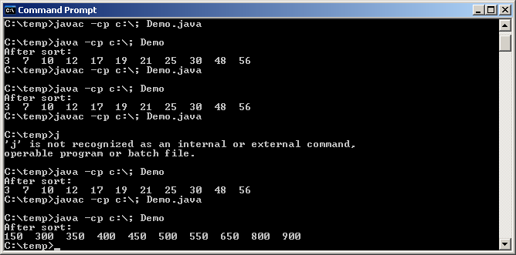

- Time complexity:
- Space efficiency:

Comparing the computational complexity of sorting algorithms

Best worst average in-place (does not require a temp array)
quicksort
mergesort
insertionSort
selectionSort
bubbleSort

Finding the kth-largest element

- An application might need to find the median value in an array. The median is a value M such that half the array elements are <=M and the remaining values are >=M. Finding a median is a special case of a more general problem that locates the kth largest element of an array. Note that the 0th largest element is the smallest element.
- We can solve the problem of finding the kth largest element by partitioning the elements into 2 disjoint sublists as follows:
<=kthLargest kthLargest >=kthLargest

0..k-1 k k+1..n-1
- Add the following method findKth to class QuickSort. In particular, method findKth finds the kth largest element by calling method rearrange.
/**
Find the kth largest element in an int array <p>
<b>Post:</b><br>The elements in arr has been rearranged in such a way that arr[k]
now contains the kth largest element.
*/
public static void findKth(int[] arr, int k)
{
findKth(arr, 0, arr.length, k); //line 5
} //line 6
//Pre: arr[first]..arr[last-1] contain integers
// k must be in [first..last-1]
//Post: The elements in arr has been rearranged in such a way that arr[k] now contains the kth
// largest element
public static void findKth(int[] arr, int first, int last, int k)
{
int pivotLoc = rearrange(arr, first, last);
if (pivotLoc==k) return;
else if (pivotLoc>k) findKth(arr, first, pivotLoc, k); //line 25
else findKth (arr, pivotLoc +1, last, k); //line 26
}

//Example 26-2-3
public class Demo
{
public static void main(String[] args)
{
int[] arr={1,2,3,4,5,6,7,8,9,10,11};
int highest=arr.length-1;
int lowest=0;
int ninetyPercent= arr.length*9/10;
int median= arr.length/2;
QuickSort.findKth (arr, highest);
System.out.println("Largest:"+arr[highest]);
QuickSort.findKth (arr, lowest);
System.out.println("Smallest:"+arr[lowest]);
QuickSort.findKth (arr, median);
System.out.println("Median:"+arr[median]);
QuickSort.findKth (arr, ninetyPercent);
System.out.println("The 90% largest:"+arr[ninetyPercent]);
}
}
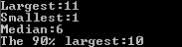

- Time complexity:
- Space efficiency:

Programming Assignment

- a. Add the following methods to class QuickSort:
    - A generic quickSort using Object.
    - A parameterized quickSort.
    - A generic findKth using Object.
    - A parameterized findKth.
- Write ONE test driver to test the newly added quickSort methods and findKth methods.

Hand in/email:
    - QuickSort.java and Driver.java

- Write a program to read in a sequence of test scores, and print the average score, median score, the highest score, and the lowest score.
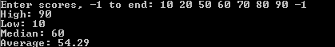

Note:
    - You must make use of method findKth instead of sorting the array.
    - You do not know how many input numbers there are.

Hand in/email:
    - Statistics.java

