**Function Library for Algorithm**

α＝α×Δα （７）

其中：Δα为步长衰减系数，在（０．９５，１）内取值。

F1:



F2:



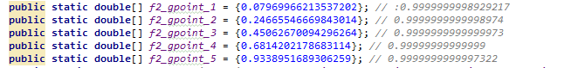

F3:

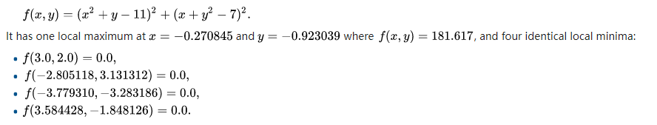

F4:

**Branin Function**

fBran(x1,x2)=a·(x2-b·x1^2+c·x1-d)^2+e·(1-f)·cos(x1)+e;   
a=1, b=5.1/(4·pi^2), c=5/pi, d=6, e=10, f=1/(8·pi);   
-5<=x1<=10, 0<=x2<=15.

global minimum

f(x1,x2)=0.397887; (x1,x2)=(-pi,12.275), (pi,2.275), (9.42478,2.475).

F5:

**Shubert Function**

function y = shub(x)

%

% Shubert function

% Matlab Code by A. Hedar (Nov. 23, 2005).

% The number of variables n =2.

%

s1 = 0;

s2 = 0;

for i = 1:5;

s1 = s1+i*cos((i+1)*x(1)+i);

s2 = s2+i*cos((i+1)*x(2)+i);

end

y = s1*s2;

F6:

F7: F7: 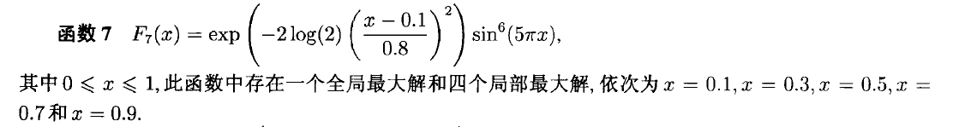

F8:

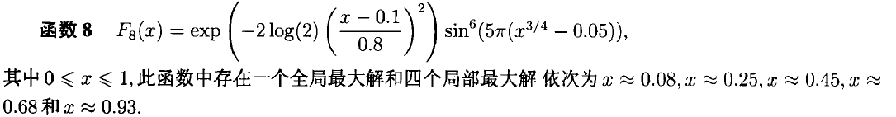

F9:

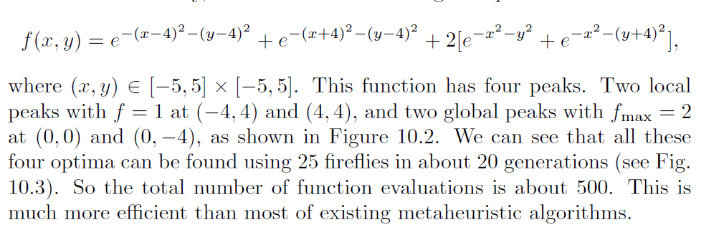

F10:



F11:

