**Flowcharts & Pseudocodes**

A **Flowchart** is a type of diagram that is characterized by various shapes and symbols with corresponding meanings and values that are connected and directed with arrows. A flowchart is used to represent algorithms, workflow or process, and presentation of steps. Attached below are examples of a flowchart about solving a problem and the different flow-charting symbols.

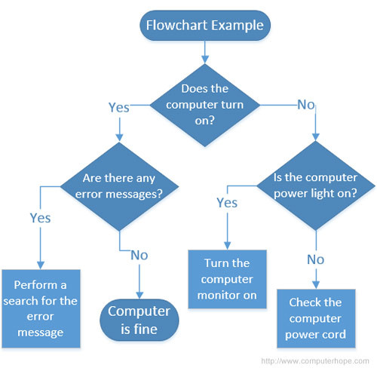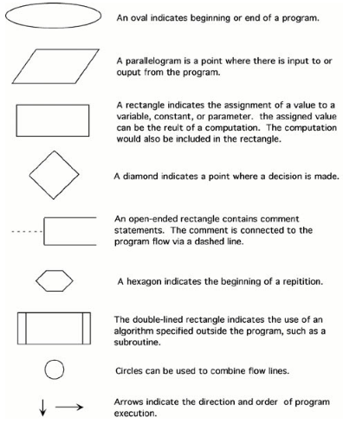

*Example of a Flowchart; Different Flow-charting Symbols and their function*

**Pseudocodes**, however, are methods that define computer algorithms with mixtures of natural and programming language. It is fundamentally meant as an initial phase before proceeding to creating an actual code. According to Codeinminutes. (2017, January 25), in writing a pseudocode, there are no strict rules however there are some common terms and notations that are standardly used. These are:

* **INPUT** – indicates a user will be inputting something
* **OUTPUT** – indicates that an output will appear on the screen
* **WHILE** – a loop (an iteration that has a condition at the beginning)
* **FOR** – a counting loop (iteration)
* **REPEAT – UNTIL** – a loop (iteration) that has a condition at the end
* **IF – THEN – ELSE** – a decision (selection) in which a choice is made
* any instructions that occur inside a selection or iteration are usually indented

Flowchart and Pseudocode are both used before doing an actual code because they help the programmer to have a framework and idea of some sort. Flowcharts can easily let the programmer and readers understand about the main concept of the whole program at one glance. Pseudocodes, though, can also be advantageous because the structure of it is very similar to the actual code and would also easily let the programmer edit. Both have their own strengths and weaknesses, and it is only up to the programmer on which should he use depending on the situation.

**References:**

* Codeinminutes. (2017, January 25). FLOWCHART VS PSEUDOCODE. Retrieved from <https://codeinminutes.wordpress.com/2016/04/04/flowchart-vs-pseudocode/>.
* (n.d.). Retrieved from <http://www.owlnet.rice.edu/~ceng303/manuals/fortran/FOR3_3.html>.