Class Number: 33

Name: Yap Seng, Envy

Activity 4

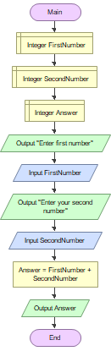

Adding two numbers in flowgorithm

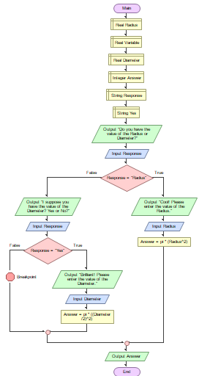

Getting the area of the circle using diameter or radius