11/20/19

Reflection Paper 2

Throughout my academic life, I have always encountered flowcharts in different kinds. When we were tasked to do a flowchart in the context of programming. When I first did my flowchart, everything was all over the place. Different shapes for random reasons, arrows going to wrong directions, captions indicating wrong meanings – in short, chaos.

I have quite a few knowledges about flowchart-making but after a few tries, I finally got the hang of it. At first, we learned the different types of shapes to use and their own functionalities. After some lectures by Ms. Jen and some random guy’s video tutorial on YouTube, I can finally come up with a somehow decent flowchart. I now understand what squares are for, even diamonds, ovals, and arrows.

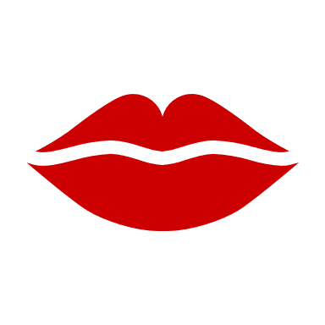

xoxo,

Envy <3