**This assignment contains five pages;**

1. Home (homepage);
2. Rainbow Flag (introduce rainbow flag);
3. History in Ireland;
4. Pride News;
5. Gallery

**General requirement:**

1. Links to both your own pages and external webpages.

The navigation bar can link to every page of my pages, the images in gallery page can link to external pages.

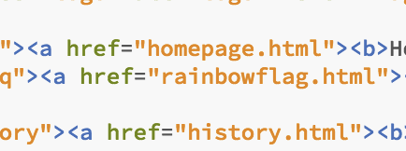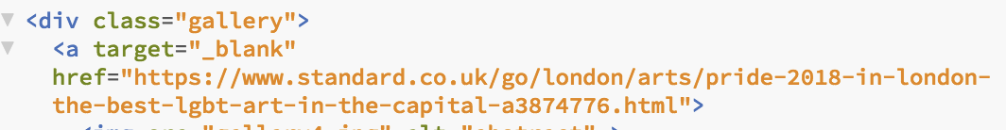

1. A navigation bar

The five pages

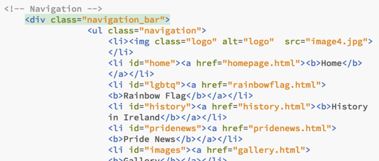

1. At least one table

Pride news page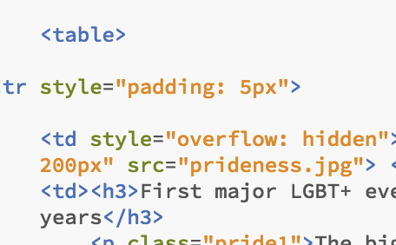

1. At least one list (ordered or unordered)

Rainbow flag page, list different colors have different meanings.

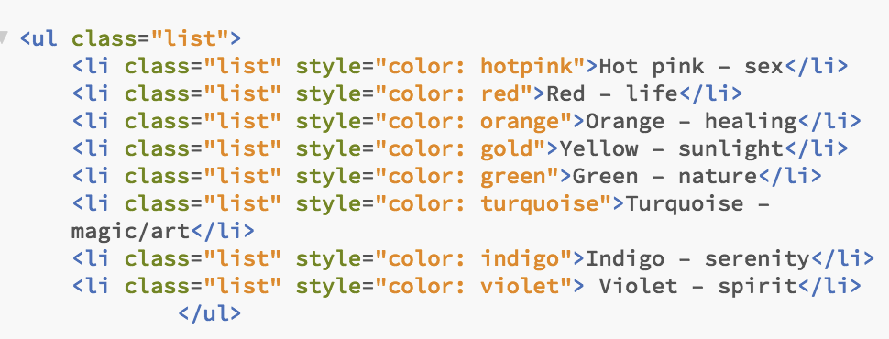

1. At least one local or embedded video

History in Ireland page, Youtube video

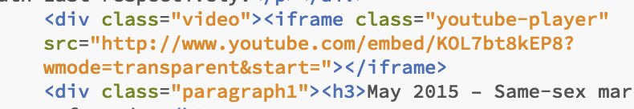

1. At least four CSS3 and four HTML5 elements

CSS3 elements:

margin, paddding font, background-color, display, color and so on.

HTML elements:

<span><header>, <footer>, <link>, <ul>, <div>, <img>, <video>, <h1>, <p> and so on.

1. Make use of the CSS positional properties (e.g. position, float)

every page: position: fixed

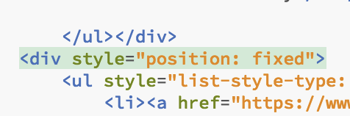

float: left or right

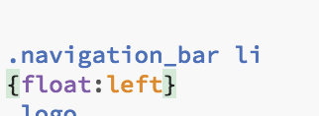

8. Make use of both inline and block elements

Every page navigation bar: block;

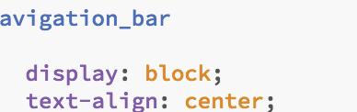

Rainbow flag page: topic

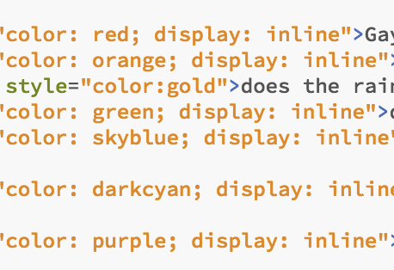

**How to explored additional features of HTML and CSS:**

I learned Javascript animation from the W3school, and use three images to achieve this transformation effect in my home page, and I explored how to use background image as background. I designed four small logos, such as Instagram, that float on every page. I learned the usage of span through practice to change the color of the topic and how to set the background color’s transparency. In addition, When moving the mouse over a frame, which can animate that frame. The web page’s color scheme from a website, a good web page is designed not only to look good, it has an interface that makes the user look comfortable, it also has to be easy to use, so all my web pages has the same navigation bar for users looking for applications.

**Reference:**

Javascript:

https://www.w3schools.com/howto/howto_website.asp

Text:

<https://en.wikipedia.org/wiki/LGBT_community>

<https://www.thesun.co.uk/news/3959656/pride-flag-gay-rainbow-design-lgbt/>

<http://www.thejournal.ie/history-lgbt-rights-ireland-4078424-Jun2018/>

<https://www.pressandjournal.co.uk/category/news/inverness/>

<https://www.bbc.com/news/world-asia-india-45429664>

<https://www.bbc.com/news/world-latin-america-45546645>

<https://www.sexualwellbeing.ie/sexual-health/sexually-transmitted-infections/types-of-stis/hiv.html?gclid=EAIaIQobChMIk7OtmbH03QIVA5ztCh3RsA1pEAAYASAAEgIipfD_BwE>

Images:

<https://www.google.ie/url?sa=i&rct=j&q=&esrc=s&source=images&cd=&cad=rja&uact=8&ved=2ahUKEwjit_DLsfTdAhWkKcAKHShwC6IQjRx6BAgBEAU&url=https%3A%2F%2Fwww.vectorstock.com%2Froyalty-free-vector%2Fbrush-stroke-rainbow-flag-lgbt-movement-vector-17222986&psig=AOvVaw2wo5_8bYbosUw6b5liUgBe&ust=1539003666138632>

<https://en.wikipedia.org/wiki/Rainbow_flag_(LGBT_movement)>

<https://www.pinknews.co.uk/2018/03/15/what-is-lgbtq-what-does-the-plus-stand-for-and-is-anyone-left-out/>

<https://www.lgbtqnation.com/>

<https://www.thesun.co.uk/news/3959656/pride-flag-gay-rainbow-design-lgbt/>

<https://www.independent.co.uk/topic/gay-pride>

<https://www.google.ie/imgres?imgurl=https%3A%2F%2Fwww.mercurynews.com%2Fwp-content%2Fuploads%2F2016%2F08%2F20160626__SJM-PRIDE-0627-021.jpg%3Fw%3D620&imgrefurl=https%3A%2F%2Fwww.mercurynews.com%2F2016%2F06%2F26%2Fsan-francisco-pride-parade-takes-a-moment-to-mourn-amid-revelry%2F&docid=7l6V7LrNRjOGTM&tbnid=VZoQxpvJ1TMKpM%3A&vet=10ahUKEwjC7978sfTdAhWsK8AKHXZ6BIYQMwhdKBswGw..i&w=620&h=431&bih=687&biw=1440&q=pride%20news&ved=0ahUKEwjC7978sfTdAhWsK8AKHXZ6BIYQMwhdKBswGw&iact=mrc&uact=8>

https://www.google.ie/imgres?imgurl=https%3A%2F%2Fwww.iu.edu%2F~images%2Fdams%2F6xcx6i3hgn_w1024.jpg&imgrefurl=https%3A%2F%2Fnews.iu.edu%2Fstories%2F2018%2F05%2Fiupui%2Finside%2F17-iupui-to-show-its-pride.html&docid=kasnCx7ZxDFtSM&tbnid=bHcWPWZa10DKUM%3A&vet=10ahUKEwjC7978sfTdAhWsK8AKHXZ6BIYQMwhhKB8wHw..i&w=1024&h=683&bih=687&biw=1440&q=pride%20news&ved=0ahUKEwjC7978sfTdAhWsK8AKHXZ6BIYQMwhhKB8wHw&iact=mrc&uact=8

Video: http://www.youtube.com/embed/KOL7bt8kEP8?wmode=transparent&start=