Department of Computer Science
The College at Brockport

Connecting to csdb.brockport.edu from off-campus
Tim Mullins/Sandeep Mitra/T.M. Rao

There are two ways you can connect to csdb from off-campus:
- Using VMware or
- port forwarding.
The two methods are described below. You can use any one of them.

- Using VMware Client to obtain on-campus lab environment from off-campus computers

Download the VMware Client software from https://software.brockport.edu/. You will need a valid Brockport net-id and password to login. This software will simulate the on-campus lab environment on your own computer. After the VMware client is installed on your computer you will have to login again with your net-id and password.

When you launch the software the opening screen will look like this:

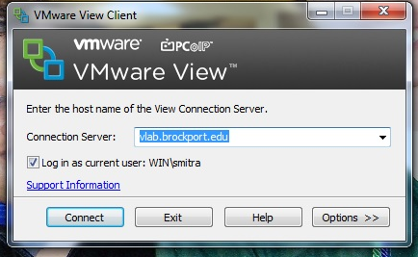

- Remember: the connection server is vlab.brockport.edu
- You should login as WIN\<your netid> For example: WIN\ab123
- Click on Connect. You will be prompted for net-id and password. Once you enter these your screen will become the screen in on-campus lab computers.
- Click on the x on the top right to go back to your original desktop.

- Using port-forwarding to connect to phpMyAdmin on csdb from off campus.

This requires port forwarding. It is a good idea to forward ports 80, 443 and 3306.

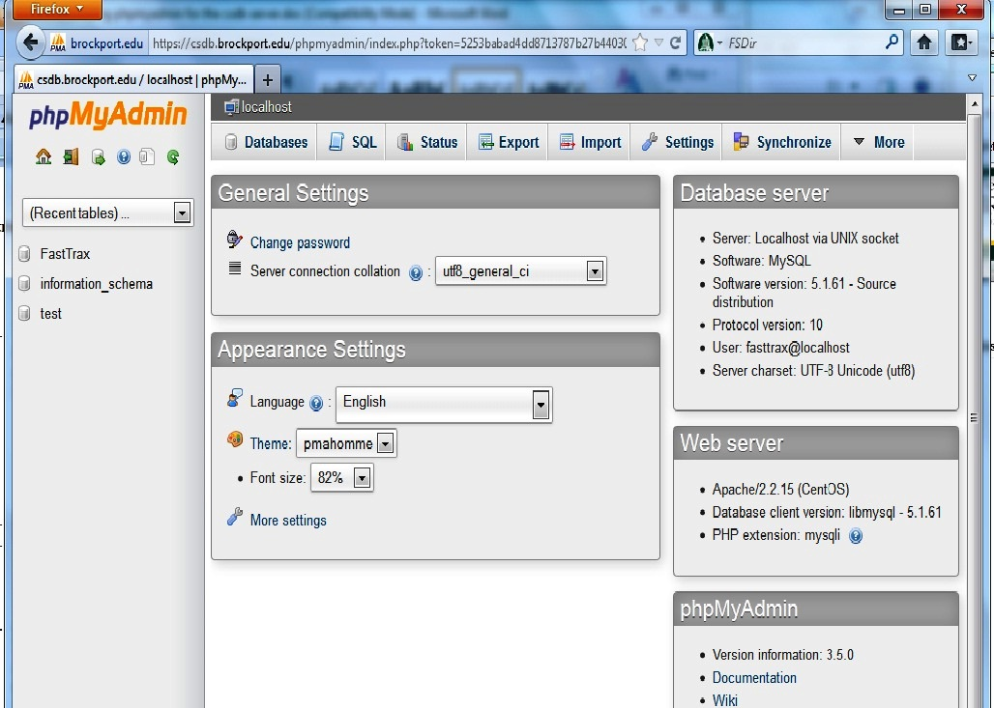

From on campus to access phpMyAdmin all you need to do is enter the URL https://csdb.brockport.edu/phpmyadmin in your browser (as shown above).

But from off campus, you need to do the following:

Set up Port Forwarding session.
1. Open up PuTTY (yes, you need this program on your computer. You can download it from http://www.chiark.greenend.org.uk/~sgtatham/putty/download.html and download putty.exe ). You see the following ‘opening screen’:
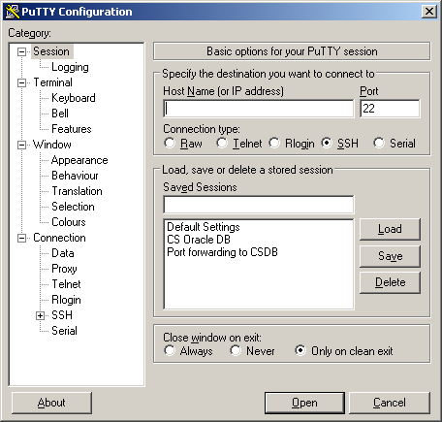

Enter the following:

2. Host name: holly2.brockport.edu
3. Then, from the SSH menu (along left panel, with higher level title ‘Connection:’), highlight the ‘Tunnels’ sub-menu (obtained after clicking the ‘+’ sign to the left of the selection ‘SSH’). This is what you get:

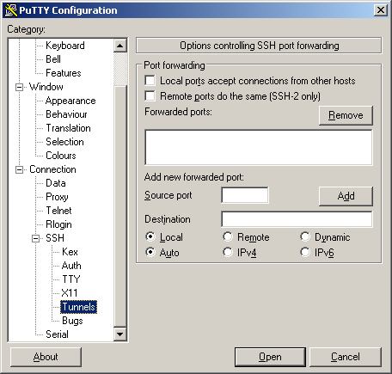

Here, fill in the following options:
Source port: 80
Destination: csdb.brockport.edu:80
4. Click the ‘Add’ button
5. Repeat steps 3 and 4 to add port 22 (if you want to do this), port 443 and port 3306 (the last two MUST be forwarded)

This is the resulting screen:

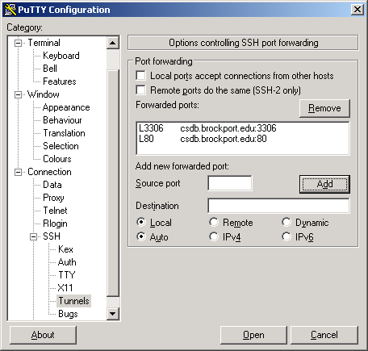

6. Click Session menu (also along left panel, see first screen shot of PuTTY above), give session a name (in the Saved Sessions box) and then click ‘Save’.
7. Log into holly2.brockport.edu (double click Session name) with NetID and Password

That enables port forwarding. Note that the ‘PuTTY’ session must stay open for the full duration of the session for which you want the port forwarding to be there.

While port forwarding is on,

phpMyAdmin:
In your web browser, use the URL of https://127.0.0.1/phpmyadmin (NOTE: You must say ‘https’, not ‘http’ – it won’t work with just ‘http’)
Enter your MySQL username (NetID probably) and MySQL password

Configuration Files:
Edit the value associated with the key ‘server’ in the ‘dbConfig.ini’ file to have value ‘127.0.0.1’ instead of ‘csdb.brockport.edu’.

