Table of Contents

**Introduction 1**

Wind Tunnel **2**

Objectives**2**

Wind Tunnel Experiment **2**

Sources of errors **2**

Conclusion**2**

Reference **2**

**Introduction**

In this report we will demonstrate various types of wind tunnels showcasing their advantages and disadvantages, and the type we chose to support the upcoming research. We have conducted experiments to examine the wind tunnel capabilities, benefits and possible errors that might occur. We have also employed graphs to support the experiments. In addition, this report will explain objectives of using wind tunnel in experiments. And how can we benefit from these experiments.

* **Objectives**.
* Wind tunnel definition, purpose, components and operation.
* Different types of wind tunnel.
* Advantages and disadvantages of wind tunnel types.
* Criteria for choosing wind tunnel for the upcoming research.
* Experiments and graphs.
* Errors analysis.

* **Wind Tunnel.**

Wind Tunnel is a machine that is used to understand the forces of Aerodynamics around solid objects. An object can be an aircraft module, spaceship module, air foil or even a tennis ball. The movement of air around a still object is the same as if the air was still and the object was moving. The wind tunnel is a controlled environment were scientists can pre-set conditions required for experiments. Wind tunnels can simulate conditions of flight by varying temperature, pressure and airspeed. It is a simple, safe and cost efficient to test flight conditions around a flying module for a better understanding and improving airplane design and calibrate aviation instruments, ex: pitot tubes and static ports*.("Wind Tunnels: How they Work & Types", 2019)*

The first wind tunnel ever was developed by the Wright brothers to design the shape of the wing for their airplane.

* **Benefits of Wind Tunnels.**

1. Measure Aerodynamic forces, moments, pressure and shear stress.
2. Measure parameters of velocity, lift and drag.
3. Study the laminar airflow and boundary layer.
4. Obtain values of the test Reynolds numbers.

* **Types of Wind Tunnels.**

Wind tunnels are designed based on the specific [speed range](https://www.grc.nasa.gov/WWW/K-12/airplane/mach.html) required to be tested. There is a wide variety of [wind tunnel types](https://www.grc.nasa.gov/WWW/K-12/airplane/tuntype.html) and model instrumentation. *("Wind Tunnel Parts", 2019)*

1. Subsonic: range of speed within airflow over a body is less than 0.8 Mach, used to test subsonic speed aircraft performance.
2. Transonic: range of speed 0.8 to 1.3 Mach, within which the airflow over different parts of a body is between subsonic and supersonic.
3. Supersonic: range of speed within airflow over a body is from 1.3 to 5.0 Mach.
4. Hypersonic.range of speed within airflow over a body is from 5.0 to 10.0 Mach.
5. Hypervelocity (over 12 times the speed of sound).

**(1)**

* **Wind Tunnels Layouts:**

1. Open-circuit, where air is directed to the outlet fan to exit the tunnel.
2. Closed-circuit, where the air return to the closed tunnel.

* **Advantages and Disadvantages of Wind Tunnels Layouts (Open Vs Closed).**

1. Advantages of closed-circuit tunnels:

* Lower power requirement for a speed.
* Lower noise.
* Surrounding air movement and dust doesn’t affect wind tunnel flow, because it’s a controlled environment.
* Damage due to model failure doesn’t affect fan blades.
* Higher air flow quality due to the utilization of corner turning vanes and screens

1. Disadvantages of closed-circuit tunnels:

* Higher cost than open wind tunnels, for a given test section size.
* Air supply is recycled, that is not desired when working with combustion engines.
* Larger footprint that requires more overall space.
* Increasing air temperature during prolonged use can become an issue. *(Almeida et al.,2018)*

1. Advantages of open-circuit wind tunnels:

* Less construction cost.
* Possibility to run internal combustion engines.
* Possibility to extensive use of smoke for flow visualization without purging the tunnel.

1. The disadvantages of open-circuit wind tunnels:

* Harder to obtain high-quality air flow.
* Wind and changing temperatures surrounding the wind tunnel can affect operation
* Higher power requirement in case of high utilization rate.
* Higher noise.
* Damage due to model failure can damage fan blades.*(*[*Barlow et al., 1999*](http://www.scielo.br/scielo.php?script=sci_arttext&pid=S2175-91462018000100200#B2)*;*[*Mehta and Bradshaw, 1979*](http://www.scielo.br/scielo.php?script=sci_arttext&pid=S2175-91462018000100200#B12)*).*

*("Closed Return Wind Tunnel", 2019)*

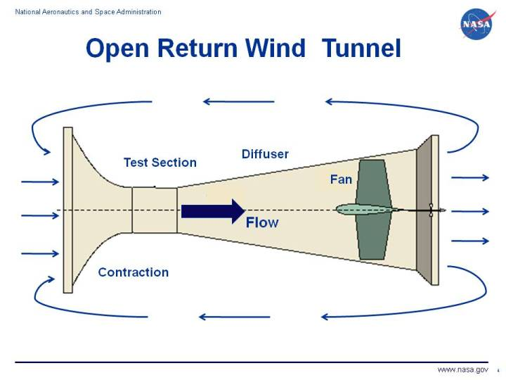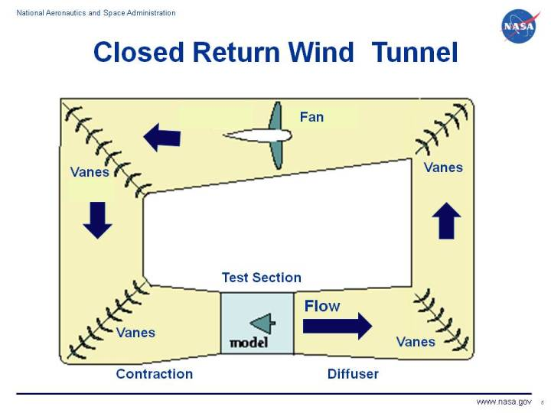*)*

*("Open Return Wind Tunnel", 2019)*

* **Components of Wind Tunnel.**

Components of open and closed-circuit tunnels are similar with slight differences.

* Drive section: comprises of fans that are used to generate airflow and control its’ velocity.
* Vanes: placed at corners of closed-circuit wind tunnel for a smooth high quality are flow with minimal loss of pressure and velocity.
* The settling chamber: consists of either screens or honeycomb that are employed to uniform the air flow before entering the test section.
* Test section: the section where a model or a body is mounted on sensors for testing.
* Diffuser: Placed at the end of the test section to keeps the air running smoothly as it’s exiting. *(Science Buddies, 2017)*

**Experiment: NACA 2412 Airfoil with variable flap.**

In this experiment we have employed an airfoil model with variable flap to determine the effect of flap deflection angle to the aerodynamic characteristics of airfoil.

The three main aerodynamic forces on the airfoil are:

* 1. Lift.
  2. Drag.
  3. Pitch moment.

Where they vary as the angle of attack, air velocity, air density, temperature, pressure and airfoil area vary.

In this experiment the pressure, temperature and air density are set, we have varied the angle of attack, air velocity and flap angle.

**Apparatus**

* AF100 Subsonic wind tunnel.
* Digital manometer.
* AF103 airfoil with variable flap.
* AFA3 Three component balance.

**Specification of AF103 airfoil**

* Dimension: 300 mm span and 150 mm chord.
* Airfoil: NACA 2412.
* Weight: 2 kg.
* Notch increment: 2.5 degrees.
* Flap deflection angle: + and – 2.5 degrees.

**Precautions**

For SHUTDOWN:

* Press the red STOP button.
* Slowly turn the speed control fully anti- clockwise.

For EMERGENCY STOP:

* Press the red STOP button.
* Turn the speed control fully anti- clockwise.

Here are the reading we got for different angles of attack at different velocities.

velocity used: 10 ms.

Angle of attack used: from 0 degree to stalling angle.

Flap Angles: 0, 22.5 and 45 degrees.

|  |  |  |  |  |  |  |  |  |  |
| --- | --- | --- | --- | --- | --- | --- | --- | --- | --- |
| **Manual Angle** | **Coefficient of Lift, CL** | | | **Coefficient of Drag, CD** | | | **Pitching Moment Coefficient, CM** | | |
| **AoA** | **Flap Angle 0  CL** | **Flap Angle 22.5  CL** | **Flap Angle 45 CL** | **Flap Angle 0  CD** | **Flap Angle 22.5  CD** | **Flap Angle 45 CD** | **Flap Angle 0  CM** | **Flap Angle 22.5 CM** | **Flap Angle 45  CM** |
| 0 | 0.05 | -0.01 | 0 | 0.29 | 0.02 | -0.01 | 0 | 0 | 0 |
| 0 | 0.03 | -0.01 | 0 | 0.3 | 0.03 | -0.01 | 0 | 0 | 0 |
| 0 | 0.03 | -0.01 | 0 | 0.3 | 0.03 | 0 | 0 | 0 | 0 |
| 3 | 0.06 | 0.48 | 1.22 | 1.21 | 0.37 | -0.92 | 0.02 | -0.1 | -0.43 |
| 3 | 0.07 | 0.48 | 1.25 | 1.19 | 0.37 | -0.93 | 0.02 | -0.1 | -0.44 |
| 3 | 0.08 | 0.48 | 1.24 | 1.21 | 0.38 | -0.93 | 0.02 | -0.1 | -0.44 |
| 6 | 0.21 | 2.12 | 0.38 | 1.37 | 0.34 | -0.63 | 0.02 | -0.86 | 0.07 |
| 6 | 0.21 | 2.11 | 0.36 | 1.37 | 0.34 | -0.63 | 0.02 | -0.86 | 0.05 |
| 6 | 0.2 | 2.1 | 0.37 | 1.36 | 0.34 | -0.63 | 0.02 | -0.86 | 0.05 |
| 9 | 0.62 | 1.73 |  | 1.38 | 0.6 |  | -0.19 | -0.8 |  |
| 9 | 0.62 | 1.75 |  | 1.38 | 0.59 |  | -0.19 | -0.8 |  |
| 9 | 0.62 | 1.79 |  | 1.38 | 0.58 |  | -0.19 | -0.73 |  |
| 12 | 0.68 |  |  | 1.33 |  |  | -0.24 |  |  |
| 12 | 0.67 |  |  | 1.28 |  |  | -0.23 |  |  |
| 12 | 0.69 |  |  | 1.3 |  |  | -0.24 |  |  |
| 15 | 0.59 |  |  | 1.18 |  |  | -0.21 |  |  |
| 15 | 0.59 |  |  | 1.18 |  |  | -0.21 |  |  |
| 15 | 0.62 |  |  | 1.22 |  |  | -0.19 |  |  |
| 18 | 0.58 |  |  | 1.07 |  |  | -0.16 |  |  |
| 18 | 0.59 |  |  | 1.09 |  |  | -0.17 |  |  |
| 18 | 0.58 |  |  | 1.05 |  |  | -0.19 |  |  |

**Analysis:**

As the angle of attack increases the lift increases as well as the drag until the stall angle is reached then drag increases and lift goes to 0. Utilizing the variable flap helps to increase the lift without having to increase the angle of attack, thus delaying the stall angle. Flaps increase the length of the airfoil and enhances the airfoil characteristics. Flaps are considered to be a high lift device. High left devices like flaps and slats are used to delay the airflow separation point and stall angle by increasing the length the airfoil or wing length and varying its’ angle without changing the airfoil or wing angle of attack.

**Sources of Errors**

* Scale effect: less accurate when there is a great difference in size between the model and the full scale.
* Interference from Wind Tunnel Walls: due to the wind tunnel the air stream is confined to the limits of the tunnel.
* Parallax error where values are not read correctly.
* Air stream from surroundings affecting air speed of wind tunnel.

**References**

Almeida, Odenir de, Miranda, Frederico Carnevalli de, Ferreira Neto, Olivio, & Saad, Fernanda Guimarães. (2018). Low Subsonic Wind Tunnel - Design and Construction. *Journal of Aerospace Technology and Management*, *10*, e1018. Epub February 26, 2018. <https://dx.doi.org/10.5028/jatm.v10.716>

Author: Schoolworkhelper Editorial Team https://schoolworkhelper.net/Article last reviewed: 2018 | St. Rosemary Institution © 2010-2019 | Creative Commons 4.0, Author: & Article last reviewed: 2018 | St. Rosemary Institution © 2010-2019 | Creative Commons 4.0. (n.d.). Wind Tunnels: How they Work & Types. Retrieved December 14, 2019, from <https://schoolworkhelper.net/wind-tunnels-how-they-work-types/>.

Barlow JB, Rae Jr WH, Pope A (1999) Low-speed wind tunnel testing. 3rd edition. New York: John Wiley and Sons.

Closed Return Wind Tunnel. (n.d.). Retrieved December 12, 2019, from <https://www.grc.nasa.gov/www/k-12/airplane/tuncret.html>.

Open Return Wind Tunnel. (n.d.). Retrieved December 10, 2019, from <https://www.grc.nasa.gov/www/k-12/airplane/tunoret.html>.

Mehta RD, Bradshaw P (1979) Design rules for small low speed wind tunnels. Aeronaut J 83(827):443-453. doi: 10.1017/S0001924000031985

Science Buddies. (2017, August 9). How to Build and Use a Subsonic Wind Tunnel. Retrieved December 20, 2019, from <https://www.sciencebuddies.org/science-fair-projects/references/how-to-build-a-wind-tunnel>.

Wind Tunnel Parts. (n.d.). Retrieved December 17, 2019, from <https://www.grc.nasa.gov/WWW/K-12/airplane/tunpart.html>.