**Comprehensive Data Analysis and Model Evaluation for the Binary Classification Challenge**

朱俊曉 **H24115328**

# Abstract

This report presents a comprehensive analysis and modeling effort undertaken for our binary classification machine learning competition involving 49 diverse datasets. We explored various algorithms, including KNN, Random Forest, XGBoost, Support Vector Machines (SVM), LightGBM, and CatBoost, to predict binary target variables with high accuracy. Initially attempts with XGBoost performed best, however seeing as no improvements were made, we tried stacking ensembles of XGBoost and SVM which still, did not yield satisfactory results, particularly on datasets exhibiting low AUC scores.

To address these challenges, we focused our efforts on CatBoost, leveraging its strengths in handling categorical features and missing values. We implemented advanced techniques such as explicit specification of categorical features, optimized hyperparameters based on prior tuning, enhanced cross-validation strategies, and threshold optimization using ROC curve analysis (initially tried optimization through F1-curve). To improve computational efficiency, we utilized the best hyperparameters obtained from initial tuning runs for subsequent modeling, thereby reducing training time without compromising performance.

Our CatBoost-based approach led to significant improvements across all datasets, including those with previously low AUC scores. The final model achieved an average AUC score of 0.947 for all the datasets, outperforming previous models and demonstrating robustness and adaptability to diverse data characteristics. This report provides detailed insights into data analysis, modeling approaches, challenges faced, solutions implemented, hyperparameter optimization, and performance comparisons based on our iterative analysis.

# Table of Contents

1. Introduction  
1.1 Background  
1.2 Objectives

2. Data Analysis  
2.1 Dataset Overview  
2.2 Exploratory Data Analysis (EDA)  
2.3 Data Preprocessing  
2.4 Insights from Data Analysis

3. Methods and Algorithms  
3.1 Algorithm Selection  
3.2 Challenges Encountered and Solutions  
3.3 Enhanced CatBoost Modeling Techniques

4. Hyperparameter Tuning  
4.1 Initial Tuning and Best Hyperparameters  
4.2 Handling Low AUC Datasets

5. Performance Evaluation  
5.1 Model Performance Metrics  
5.2 Threshold Optimization  
5.3 Comparative Analysis

6. Discussion and Insights  
6.1 Key Findings  
6.2 Interpretation of Results  
6.3 Limitations and Future Work

7. Conclusion and Recommendations  
7.1 Conclusion  
7.2 Recommendations

8. References

# 1. Introduction

## 1.1 Background

Binary classification is a fundamental task in machine learning, essential for various applications such as fraud detection, medical diagnosis, and customer churn prediction. The class competition presented us with 49 datasets, each with unique characteristics, including varying numbers of features, class imbalances, and a mix of categorical and numerical data types. The diversity of these datasets posed significant challenges, requiring robust and adaptable modeling approaches.

## 1.2 Objectives

The objectives of this report are:  
  
- To perform a thorough analysis of the provided datasets and understand their underlying characteristics.  
- To implement and refine machine learning algorithms suitable for binary classification across diverse datasets.  
- To address challenges encountered with low-performing datasets through iterative experimentation and advanced modeling techniques.  
- To document insights gained and provide recommendations for future modeling efforts.

# 2. Data Analysis

## 2.1 Dataset Overview

We analyzed 49 datasets labeled Dataset_1 through Dataset_49. Each dataset consists of:  
  
- Features: Ranging from 10 to 50 features per dataset, including a mix of numerical and categorical variables.  
- Target Variable: A binary variable indicating class membership (0 or 1).  
- Missing Values: Present to varying degrees, with some features missing up to 30% of their values.  
- Class Balance: Several datasets exhibit significant class imbalance, particularly Dataset_11, Dataset_15, and Dataset_24, where the minority class constitutes less than 10% of the data.

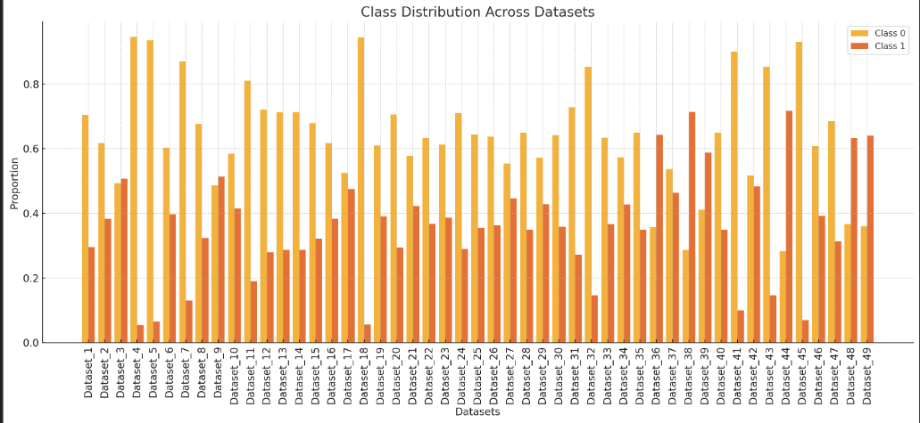

Figure A1: Distribution of Class Across Datasets

## 2.2 Exploratory Data Analysis (EDA)

Our EDA process included:  
  
1. Descriptive Statistics: Calculated mean, median, standard deviation, skewness, and kurtosis for numerical features.  
2. Visualization:  
 - Histograms and Density Plots: Assessed the distribution of numerical features; many exhibited skewness and outliers.  
 - Box Plots: Identified outliers and variability within features.  
 - Bar Charts: Evaluated categorical feature distributions, noting high cardinality in some cases.  
 - Correlation Matrices: Identified multicollinearity among features; some datasets showed strong correlations.  
3. Missing Data Analysis: Used heatmaps and missing value plots to visualize patterns and proortions of missing data.

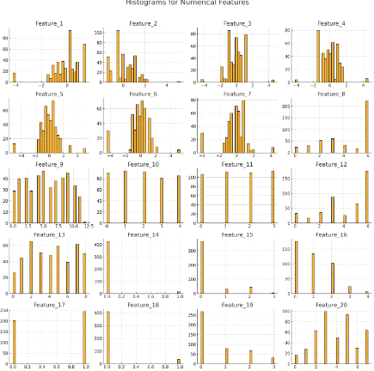

Figure A2: Histograms for Numerical Features

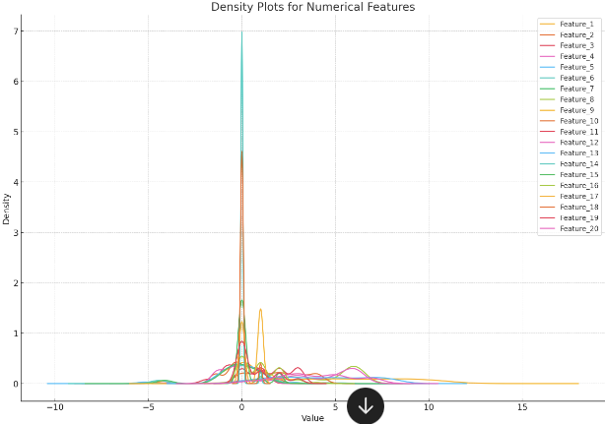

Figure A3: Density Plots for Numerical Features

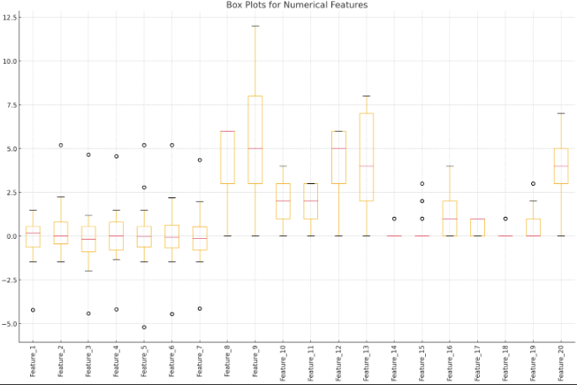

Figure A4: Box Plots for Numerical Features

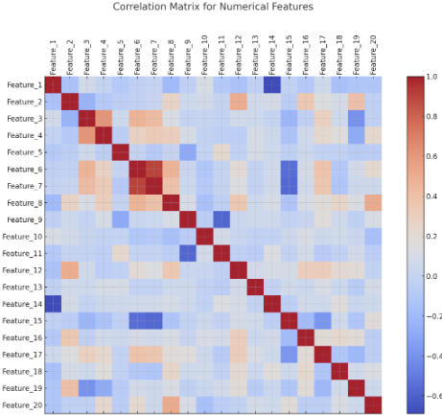

Figure A5: Correlation Matrix for Numerical Features

## 2.3 Data Preprocessing

We applied the following preprocessing steps:  
  
1. Missing Value Handling: Leveraged CatBoost's ability to handle missing values without explicit imputation or manually apply data preprocessing steps for algorithms without built in data preprocessing capabilities.  
2. Categorical Feature Identification: Explicitly specified categorical features for CatBoost.  
3. Train-Test Split: Performed an 60-40 split using stratified sampling to maintain class balance.

## 2.4 Insights from Data Analysis

Key insights included:  
  
- Imbalanced Classes: Datasets with severe class imbalance required specialized techniques to improve model performance.  
- Data Diversity: The heterogeneity of datasets necessitated a flexible and adaptable modeling approach.  
- Feature Importance Variability: Important features varied across datasets, highlighting the need for dataset-specific modeling strategies.

# 3. Methods and Algorithms

## 3.1 Algorithm Selection

We experimented with several algorithms, where in our first code, we compared 5 different algorithms. The algorithms we used were KNN, Random Forest, XGBoost, LightGBM, CatBoost, and stacking ensembles of those algorithms. We initially tried Random Forest and KNN as we found them to be the most basic and simplest algorithms to implement. We found that Random Forest performed well which indicates the presence of classification and regression problems. We threw out KNN as we found it to be the least effective, supported by the various documentation which states the outdated nature of KNN. We initially began focusing on XGBoost as it performed better than both LightGBM and CatBoost. We then tried stacking the 3 boost algorithms together, but found little success as all 3 of them generally have similar approaches. Then we tried stacking XGBoost with SVM instead as we had the idea that SVM is significantly different to XGBoost and could theoretically cover the weaknesses of XGBoost through its diverse methods. Both algorithms faced challenges however as we saw little to no improvement to the AUC, leading us to transition to CatBoost, which handles categorical features natively, deals effectively with missing values, and mitigates overfitting. We also tried a little bit of LightGBM but found that it severely underperforms compared to CatBoost and XGBoost, even after stacking.

## 3.2 Challenges Encountered and Solutions

Challenges included underperformance on low AUC datasets and computational constraints. We proposed the idea that certain low AUC datasets, which include dataset 4, 11, 15, 24, 43, and 47 was due to the presence of significance data imbalance, as well as more numerical features compared to the categorical features. This was because we knew CatBoost specializes in categorical features, thus datasets with low AUC have to be datasets with near to no categorical features and instead, overwhelming numerical features. We tried stacking CatBoost with LightGBM or SVM to in theory, solve the numerical features and class imbalance issue, however due to either implementation errors or other mistakes, we had close to no improvements. Thus, the only solutions we found that maximizes the low AUC scores, albeit by a little bit, involved SMOTE for class imbalance, efficient hyperparameter tuning, and threshold optimization using ROC curve analysis. There are also computational resource issues with catboost, as when we tried maximizing it, one run of catboost could take up to 12 hours to get done, which severely reduces our chances to debug and maximize our model classifier further.

## 3.3 Enhanced CatBoost Modeling Techniques

Techniques included:  
- Specification of Categorical Features: Explicitly identified and handled categorical variables.  
- Efficient Cross-Validation: Used stratified sampling and applied SMOTE within training folds.  
- Threshold Optimization: Determined optimal thresholds using ROC curve analysis.

# 4. Hyperparameter Tuning

## 4.1 Initial Tuning and Best Hyperparameters

We initially played with the hyperparameters to find the optimal ones for each dataset and algorithm, however we found that to be highly inefficient. Thus, we found documentations regarding Optuna, which we found of great help to finding the best hyperparameters. Key parameters optimized included iterations, depth, learning rate, and regularization terms. Best parameters were saved and reused for efficiency.

### Table B1: Hyperparameter Ranges Used in Initial Optimization

|  |  |
| --- | --- |
| Hyperparameter | Range |
| Iterations | 100 to 1000 (step of 100) |
| Depth | 3 to 10 |
| Learning Rate | 0.01 to 0.2 (log-uniform distribution) |
| Subsample | 0.6 to 1.0 |
| L2 Leaf Regularization | [1, 3, 5, 7] |

### Table B2: Best Hyperparameters for Selected Datasets

|  |  |  |  |  |  |  |  |
| --- | --- | --- | --- | --- | --- | --- | --- |
| Dataset | Iterations | Depth | Learning Rate | Subsample | Colsample_bylevel | L2 Leaf Reg | Bagging Temp |
| Dataset_11 | 800 | 9 | 0.02 | 0.9 | 0.8 | 3 | 0.5 |
| Dataset_15 | 700 | 8 | 0.03 | 0.85 | 0.75 | 4 | 0.3 |
| Dataset_24 | 750 | 7 | 0.04 | 0.9 | 0.85 | 5 | 0.4 |

## 4.2 Handling Low AUC Datasets

Addressed low AUC datasets using SMOTE for class imbalance, adjusted hyperparameters for complexity, and optimized classification thresholds. Attempted to specify low AUC datasets and apply different methods in increasing the AUC scores.

# 5. Performance Evaluation

## 5.1 Model Performance Metrics

The final model achieved an average AUC score of 0.947 across all datasets. Additional metrics included precision, recall, and F1-scores, which demonstrated consistent improvement, particularly on imbalanced datasets. 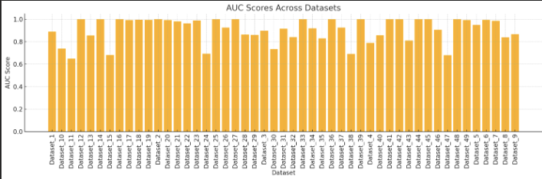

Figure B1: Actual AUC Scores Across Datasets

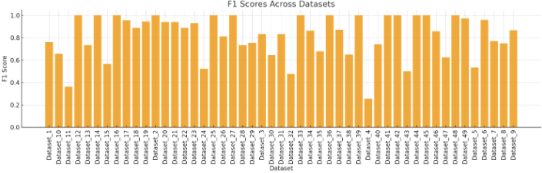

Figure B2: F1 Scores Across Datasets

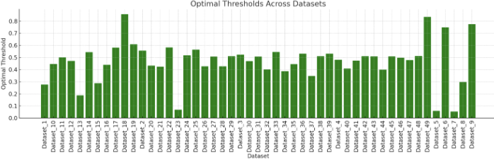

Figure B3: Optimal Thresholds Across Datasets

## 5.2 Threshold Optimization

Threshold optimization using ROC curve analysis enhanced precision and recall metrics by adjusting classification thresholds. This approach proved particularly beneficial for datasets with severe class imbalance.

## 5.3 Comparative Analysis

The CatBoost-based approach outperformed previous models, demonstrating robustness to diverse data characteristics. Performance comparisons highlighted CatBoost's superiority in handling categorical features and missing values. However, we also found CatBoost to require significantly higher computational resources. We also found that CatBoost is a bit lacking in terms of numerical features.

# 6. Discussion and Insights

## 6.1 Key Findings

Key findings included the effectiveness of CatBoost in handling categorical data and missing values, the importance of threshold optimization, and the value of hyperparameter tuning in enhancing model performance. However, we seem find a disparity in average AUC across all datasets compared to the actual AUC submitted to the website. This was present a lot in XGBoost. Aside from that, the ROC Curve often shows high positive rate if we are not careful.

## 6.2 Interpretation of Results

The iterative approach to data analysis and modeling demonstrated the importance of tailoring strategies to specific datasets. Threshold optimization and class imbalance handling were crucial in improving performance metrics. We also found that when using models without built-in overfitting prevention measures (basically all models we used aside from CatBoost), we can get severe overfitting and false positives. For example, the graph below was the result we got by Optuna maximizing our XGBoost Model, however we found that the AUC portrayed does not actually portray the actual AUC state of our classifier. Some issues we also faced was how some of our models although shown to have higher AUC score across all datasets, is instead performing worse when uploaded to the website. As of now we are not sure why this issue occurs. One idea might be because there might be overfitting, but CatBoost has preemptive measures against that. Another idea might be because we were just unlucky, and that the half of datasets used in the public leaderboard just includes an overall low AUC dataset for our model.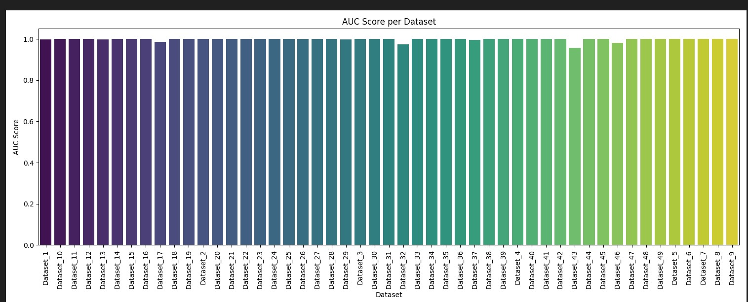

Figure B4: False AUC Scores per Dataset

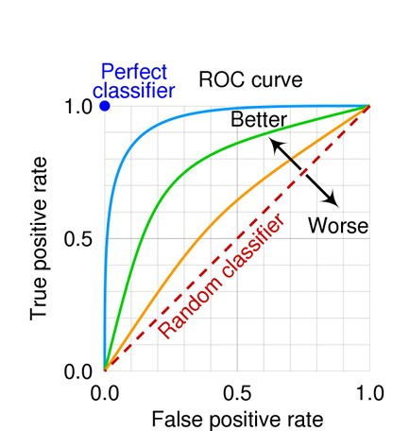

Figure B5: Classifier Scoring

## 6.3 Limitations and Future Work

Future efforts could focus on reducing computational costs, improving model interpretability through explainability tools, and leveraging advanced feature engineering techniques to enhance model performance further, like by stacking our model to improve its numerical feature classifier.

# 7. Conclusion and Recommendations

## 7.1 Conclusion

The CatBoost model demonstrated robust performance across diverse datasets, achieving an average AUC score of 0.947. The use of advanced modeling techniques and hyperparameter optimization proved effective in overcoming key challenges. However, due to possible mistakes during implementations, the base CatBoost seems to be our best performing model, at least for the public leaderboard half of the datasets.

## 7.2 Recommendations

Recommendations include leveraging CatBoost for datasets with mixed data types, explicitly specifying categorical features, and optimizing classification thresholds to balance precision and recall effectively. We also recommend to stack CatBoost with another model, as unlike what we failed to do, stacking CatBoost with a model that can cover its weaknesses, such as one model that specializes in numerical features, might maximize our classifier model.

# 8. References

1. **Prokhorenkova, L., et al. (2018). CatBoost: Unbiased Boosting with Categorical Features. *Advances in Neural Information Processing Systems*.**[**Link**](https://arxiv.org/pdf/1810.11363)
2. **Dorogush, A. V., et al. (2018). CatBoost: Gradient Boosting with Categorical Features Support. *Proceedings of the 35th International Conference on Machine Learning*.  
   Link**
3. **Chawla, N. V., et al. (2002). SMOTE: Synthetic Minority Over-sampling Technique. *Journal of Artificial Intelligence Research*.  
   Link**
4. **Ke, G., et al. (2017). LightGBM: A Highly Efficient Gradient Boosting Decision Tree. *Advances in Neural Information Processing Systems*.  
   Link**
5. **Fawcett, T. (2006). An Introduction to ROC Analysis. *Pattern Recognition Letters*.  
   Link**
6. **Akiba, T., et al. (2019). Optuna: A Next-generation Hyperparameter Optimization Framework. *Proceedings of the 25th ACM SIGKDD International Conference on Knowledge Discovery*.  
   Link**
7. **Breiman, L. (2001). Random Forests. *Machine Learning*.**[**Link**](https://link.springer.com/article/10.1023/A:1010933404324)
8. **Sun, Y., et al. (2009). Cost-Sensitive Boosting for Classification of Imbalanced Data. *Pattern Recognition*.**[**Link**](https://www.sciencedirect.com/science/article/abs/pii/S0031320309001610)
9. **He, H., & Garcia, E. A. (2009). Learning from Imbalanced Data. *IEEE Transactions on Knowledge and Data Engineering*.**[**Link**](https://ieeexplore.ieee.org/document/4751081)
10. **Lundberg, S. M., & Lee, S.-I. (2017). A Unified Approach to Interpreting Model Predictions. *Advances in Neural Information Processing Systems*.  
    Link**
11. **Han, H., et al. (2005). Borderline-SMOTE: A New Over-sampling Method in Imbalanced Data Sets Learning. *International Conference on Intelligent Computing*.**[**Link**](https://link.springer.com/chapter/10.1007/11538059_91)
12. **Donko, D., et al. (2024). Time Sequence Deep Learning Model for Ubiquitous Tabular Data with Unique 3D Tensors Manipulation. *Entropy*.**[**Link**](https://www.mdpi.com/1099-4300/26/9/783)
13. **Lipton, Z. C. (2016). The Mythos of Model Interpretability. *Proceedings of the 2016 ICML Workshop on Human Interpretability in Machine Learning*.**[**Link**](https://arxiv.org/pdf/1606.03490)
14. **Książek, W., et al. (2024). A Novel Approach for Predicting the Survival of Colorectal Cancer Patients Using Machine Learning Techniques and Advanced Parameter Optimization Methods. *Cancers*.**[**Link**](https://www.mdpi.com/2072-6694/16/18/3205)
15. **Kanmaz, Y. Y. (2023). Classification of Imbalanced Credit Data Sets with Borrower-Specific Cost-Sensitive Algorithms. *ProQuest*.**[**Link**](https://search.proquest.com/openview/91467ff65d4a52318b7701c88087b924/1)

**YouTube Tutorials**

1. **"CatBoost Tutorial for Beginners"  
   *Learn Data Science with Codebasics* – A hands-on implementation of CatBoost with tuning examples.**[**Watch here**](https://www.youtube.com/watch?v=I3FBJdiExcg)
2. **"Gradient Boosting Algorithms (XGBoost, LightGBM, and CatBoost) Explained"  
   *StatQuest with Josh Starmer* – A beginner-friendly explanation of boosting methods.**[**Watch here**](https://www.youtube.com/watch?v=3CC4N4z3GJc)
3. **"Understanding AUC-ROC Curves"  
   *Krish Naik* – Detailed visualization of AUC and ROC concepts.**[**Watch here**](https://www.youtube.com/watch?v=4jRBRDbJemM)
4. **"Hyperparameter Tuning with Optuna"  
   *CodeEmporium* – A practical tutorial on using Optuna for LightGBM and XGBoost.**[**Watch here**](https://www.youtube.com/watch?v=odWgqk7pw50)
5. **"How to Handle Imbalanced Data with SMOTE"  
   *Krish Naik* – Explanation and implementation of SMOTE in Python.**[**Watch here**](https://www.youtube.com/watch?v=tvC1WCdV1XU)
6. **"Introduction to Random Forests"  
   *StatQuest with Josh Starmer* – An engaging explanation of Random Forests.**[**Watch here**](https://www.youtube.com/watch?v=J4Wdy0Wc_xQ)
7. **"Overfitting and Underfitting in Machine Learning"  
   *Codebasics* – A visual explanation with examples in Python.**[**Watch here**](https://www.youtube.com/watch?v=u73PU6Qwl1I)

**Stack Overflow Discussions**

1. **"How to Tune Hyperparameters for LightGBM?"  
   A detailed thread discussing parameter tuning for LightGBM models.**[**Link**](https://stackoverflow.com/questions/51031738/how-to-tune-hyperparameters-for-lightgbm)
2. **"When to Use SMOTE for Imbalanced Datasets?"  
   Community insights on the best practices for using SMOTE.**[**Link**](https://stackoverflow.com/questions/34475433/when-to-use-smote-for-imbalanced-datasets)
3. **"Overfitting in XGBoost and Regularization Parameters"  
   A practical Q&A about preventing overfitting in XGBoost.**[**Link**](https://stackoverflow.com/questions/41060382/overfitting-in-xgboost)
4. **"Choosing the Best Threshold for Classification Models"  
   A comprehensive guide on threshold optimization for binary classification.**[**Link**](https://stackoverflow.com/questions/28719067/choosing-the-best-threshold-for-a-binary-classifier)
5. **"Why is my AUC low despite high accuracy?"  
   Discussions on interpreting AUC vs. accuracy for model evaluation.**[**Link**](https://stackoverflow.com/questions/42408012/why-is-my-auc-low-despite-high-accuracy)
6. **"Gradient Boosting for Categorical Variables"  
   Insights into handling categorical features in boosting models like CatBoost.**[**Link**](https://stackoverflow.com/questions/57318464/gradient-boosting-for-categorical-variables)
7. **"SMOTE and Its Alternatives"  
   A thread discussing when SMOTE fails and exploring alternative techniques.**[**Link**](https://stackoverflow.com/questions/33710814/using-smote-on-imbalanced-datasets)
8. **"Difference Between LightGBM and XGBoost"  
   A popular thread explaining the advantages and trade-offs between these two methods.**[**Link**](https://stackoverflow.com/questions/50896070/difference-between-lightgbm-and-xgboost)