PRD - Smart Compliance Office (GRC Task Tracker)
Launch Date : [ESTIMASI] about 10 weeks after IT completes the Google Cloud setup
Link to Project Management : GRC Tracker Google Sheet [link to be added]
Document owner : Enzo Taslim (builder) · Business owner : Head of GRC · Version : draft 0.1, 26 October 2026

Background
The GRC department of BRI Global Financial Services (BGF) receives requests from BRI Indonesia (BRI Pusat), regulators such as the Companies Registry, auditors and internal teams. They arrive at the GRC manager by WhatsApp, email and formal letters (surat), often with an Excel form and a PPT attached. Today the manager reads each one, decides who should do it, and the team tracks the work by hand across four Google Sheet tabs (Reporting, Tasks, Project Intern, PRD). There is no single place to see who is doing what, who is overloaded, or what is about to be late.
Primary JTBD (GRC Manager):
When I receive a request from BRI Pusat or a regulator, I want it logged and a suitable person proposed automatically, so that I only need to approve or adjust the assignment and can see every deadline and workload in one place.
Secondary JTBD (GRC staff and interns):
When a task is assigned to me, I want the original message, the attached files and the deadline in one email, and a reminder before it is due, so that I do not have to dig through WhatsApp or the manager's inbox and nothing is missed.

Problem Statment
- Requests arrive through three channels (WhatsApp, email, letters) and are logged by hand, if at all.
- Work is concentrated: one person led 49 of the 130 reporting tasks with a named lead in 2026 (38%).
- Deadlines slip unseen: 42 open items were past their due date on 26 October 2026.
- Records are inconsistent: the same person appears under up to three spellings, and about 55 tasks were marked done with no submission date.
- Forwarded messages are hard to act on: they mix a greeting, the real request, a deadline (sometimes with a wrong weekday, e.g. "Rabu 06 November 2026" is a Friday) and attachments.

Objective
- Log every request in one Google Sheet within one working day of arrival, with its original message and attachments.
- Propose an owner automatically using fixed, explainable rules; the manager approves or overrides.
- Send the assigned person the full original message and files when the task is assigned.
- Remind people before deadlines and show the manager overdue work and overloaded people every day.
- Record every assignment and change for audit.

Proposed Solution
The manager forwards each request to the system in one of two ways: by applying the Gmail label GRC/To log to the email, or by pasting the WhatsApp text into a Google Chat bot. A small service running on BRI HK's Google Cloud reads the message, saves the attachments to a Drive folder for the task, and writes a new row to the Master tab of the GRC Google Sheet, which is the single data store.
The service extracts the deadline, letter number and sender unit code by fixed rules. An AI model (BRI's existing AI agent if its API can be used, otherwise Gemini on Vertex AI) adds an English title, a two-line summary and the list of deliverables. The AI never chooses who does the work.
The service then proposes an owner from the Catalog of known report types (e.g. the Risk Profile report goes to its usual owner), falls back to a backup when that person is overloaded or leaving, then to the least-busy person in the division indicated by the letter code. The task starts in status Proposed. When the manager approves it, the assigned person (the Doer) receives an email with the task, the deadline, the full original message and the file links. Daily emails remind everyone of what is due, and every change is written to an audit log.
Note :
- 6 Official Statuses: Proposed → Not Started → In Progress → On Hold → Done, plus Cancelled (dropped on purpose).
- Owner vs Doer: the Owner is accountable for the submission and is changed only by the manager; the Doer does the work and can be handed off (e.g. to an intern). Workload is counted against the Doer.
- Done needs proof: a task cannot be marked Done without a submission date and a link to what was sent.
- Routing order: (1) Catalog keyword or known contact → default owner; (2) owner overloaded or leaving → backup; (3) letter code or contact → division → least-busy person; (4) AI suggestion from the Catalog list, labelled as such; (5) nothing matched → "Needs review" for the manager.
- Start fresh: the 2026 tabs stay as a read-only archive; Master starts empty. The Catalog of report owners was learned from that history.
- WhatsApp: no WhatsApp bot in phase 1; WhatsApp text is pasted into the Google Chat bot.

Success Metrics
Metric | Baseline | Target | Description
Open tasks past due date | 42 on 26 Oct 2026 | [ESTIMASI] Under 5 at any time | Deadlines are visible and reminded
Done tasks with no submission proof | About 55 of 222 in 2026 | 0 | Blocked by the Done rule
Share of led work on the busiest person | 38% | [ESTIMASI] Under 30% | Work is spread using the workload score
Requests logged within 1 working day | Not tracked | [ESTIMASI] 95% | Every request enters the system quickly
Proposed owners accepted without change | N/A — feature does not exist yet | [ESTIMASI] 80% or more | Shows the routing rules work
Tasks flagged "Needs review" | N/A | [ESTIMASI] Under 15% | Shows the Catalog is complete

User Stories

Area: Intake

Story 1 — Email intake from the manager's Gmail
As the GRC Manager, I want to label a request email so that it becomes a task without retyping anything.
Acceptance Criteria:
- An email thread labelled GRC/To log becomes one row in Master within 10 minutes.
- The full email body is stored in the Original message column; attachments are saved to a new Drive folder for the task, linked in the Files column.
- After logging, the label changes to GRC/Logged; an email already logged (same Gmail message ID) is never logged twice.
- If logging fails, the label stays so the next run retries it.

Story 2 — Google Chat bot for WhatsApp text
As the GRC Manager, I want to paste a WhatsApp message into a chat with the bot, so that WhatsApp requests are logged the same way as emails.
Acceptance Criteria:
- Any message sent to the bot (other than "help" and "my tasks") becomes one task.
- The bot replies with the task ID, proposed owner, due date, any flags, and the Drive folder link where the manager can drop the attachments.
- Only users with the BRI email domain can use the bot.
- Typing "my tasks" lists the sender's open tasks.

Area: Reading the request

Story 3 — Rule-based extraction
As the system, I want to pull out the deadline, letter number and contacts by fixed rules, so that the key facts are reliable even without AI.
Acceptance Criteria:
- Greetings and sign-offs (Selamat siang/pagi, Yth, Dear, Terima kasih) are ignored for matching and titles.
- The deadline is the date after words such as deadline, paling lambat, batas waktu, by; Indonesian and English month names and dd/mm/yyyy are read.
- A weekday that does not match its date is flagged (e.g. "Rabu 06 November 2026").
- Letter numbers such as B.91.e-EMR/IRM/10/2026 give the letter code EMR/IRM.
- If no deadline is found, a default of 7 days is used and flagged.

Story 4 — AI extraction
As the Doer, I want a clear English title, summary and list of deliverables, so that I understand the request at a glance.
Acceptance Criteria:
- The AI returns a fixed JSON: title, summary, deliverables, deadline with the exact quote, requester, contacts, and a Catalog ID chosen only from the Catalog list.
- Phone, account and ID numbers are masked before the text is sent; only file names, never file contents, are sent.
- If the AI deadline differs from the rule deadline, both are shown and the task is flagged.
- AI can be switched off in the Config tab; if it fails or times out, the task is still created with rules only.

Area: Assignment

Story 5 — Proposed owner with a reason
As the GRC Manager, I want the system to propose who should do each task and say why, so that I only approve or adjust.
Acceptance Criteria:
- The five routing rules in the Note above are applied in order.
- The task is created with status Proposed, Owner and Doer filled, and the rule used written in the Routing note column.
- An intern whose end date is before the deadline is never proposed.

Story 6 — Approval and handoff
As the GRC Manager or an Owner, I want to approve, reassign or hand off a task, so that the right person does it and the change is recorded.
Acceptance Criteria:
- Changing Status from Proposed to Not Started counts as approval.
- Only the manager changes the Owner; the Owner can change the Doer.
- Every change to Owner, Doer, Status, Due date or Division is written to the AuditLog tab with who and when.

Area: Notification

Story 7 — Assignment email with the original message
As the Doer, I want to receive the full request when a task is assigned to me, so that I can start without asking the manager to forward it.
Acceptance Criteria:
- When a task is approved, or its Doer changes, the Doer receives one email with the task ID, title, deadline, routing note, the full original message and the Drive folder link.
- The email is sent once per assignment (tracked in a hidden state tab).

Story 8 — Daily reminders
As a team member, I want a daily list of what is due, and as the manager a daily summary, so that nothing is late unnoticed.
Acceptance Criteria:
- Weekdays at 09:00 HKT, each person receives their overdue tasks, tasks due within 7 days, and In Progress tasks not updated for 5 days.
- The manager receives: tasks awaiting approval, all overdue tasks, people over the load limit, and interns leaving within 30 days who still own Catalog reports.

Area: Tracker

Story 9 — Proof before Done
As the Head of GRC, I want every completed task to show what was submitted and when, so that we have an audit trail.
Acceptance Criteria:
- Setting Status to Done without a Submitted date and Link is rejected with a message.

Story 10 — Recurring reports
As the GRC Manager, I want recurring reports created automatically, so that monthly and quarterly reports are never forgotten.
Acceptance Criteria:
- Catalog rows marked Confirmed = Yes create a task 14 days before their typical due day, once per period.

Story 11 — Dashboard tab
As the GRC Manager, I want one view of load and deadlines, so that I can balance work.
Acceptance Criteria:
- A Dashboard tab shows weighted open load per person, open and overdue per division, and the next 30 days of deadlines, using formulas only.
Phase 2 out of scope :
- WhatsApp bot (direct intake from WhatsApp).
- Separate web dashboard with Claim / Hand off / Start / Done buttons.
- Automatic assignment without manager approval.
- Migration of the 2026 history into Master.

User Flow
1. Request intake flow
- Request arrives (email, WhatsApp, letter).
- Manager labels the email GRC/To log or pastes the text to the Chat bot.
- System cleans the text, extracts deadline, letter code, contacts; AI adds title, summary, deliverables.
- System saves files to the task folder and writes the task to Master as Proposed with an owner and reason.
- Manager approves or changes the owner in the Sheet.
- Doer receives the assignment email with the original message and files.
- Doer works the task and marks Done with submission date and link.
2. Task status lifecycle
Proposed → Not Started (approved) → In Progress → Done. Any open task can move to On Hold or Cancelled. Done requires a Submitted date and Link.
3. Owner routing and change
Catalog match → default owner; if overloaded or leaving → backup; else letter code → division → least-busy; else AI suggestion; else Needs review. The manager can change the Owner at any time; the Owner can hand the work to another Doer; both are logged.

High Level Requirement
No | Area | JTBD | High Level Function Requirements | Priority
1 | Intake | As the manager, I want requests logged from email without retyping. | Gmail label intake; original message and attachments stored per task. | P1
2 | Intake | As the manager, I want WhatsApp requests logged too. | Google Chat bot that logs pasted text and returns the task ID, owner, due date and folder link. | P1
3 | Reading | As the system, I want reliable key facts. | Rule-based deadline, letter code, contacts; weekday check; greetings ignored. | P1
4 | Assignment | As the manager, I want an owner proposed with a reason. | Five routing rules; status Proposed; Routing note. | P1
5 | Notification | As a Doer, I want the full request when assigned. | Assignment email with original message and file links, once per assignment. | P1
6 | Tracker | As the Head of GRC, I want an audit trail. | AuditLog of every change; Done requires proof. | P1
7 | Notification | As the team, I want reminders. | Daily digests per person and for the manager. | P1
8 | Reading | As a Doer, I want a clear summary. | AI title, summary, deliverables with guardrails and an off switch. | P2
9 | Tracker | As the manager, I want recurring reports created. | Recurring task creation from confirmed Catalog rows. | P2
10 | Tracker | As the manager, I want one view of load. | Dashboard tab with formulas. | P2
11 | Intake | As the manager, I want WhatsApp intake without pasting. | WhatsApp Business API bot. | Phase 2

Design
No user interface is designed in phase 1: people work in the existing Google Sheet (Master, Staff, Catalog, LetterCodes, AuditLog, Config tabs) and in Google Chat. The technical design is in Appendix A.

Supporting Data & Insight
- Analysis of the 2026 GRC tabs (280 tasks, January to October 2026): 140 reporting tasks, 89 projects, 44 intern project tasks, 7 PRD risk assessments.
- About 45% of reporting tasks are recurring (monthly, quarterly, semester), which is why the Catalog can propose owners reliably.
- Letter numbers carry the sender unit (EMR/IRM → Policy and Risk, DIR/ASQ → Audit, KEP → Compliance), seen in all 17 letters with a number.
- Testing the rules on 2026 titles: 113 of 115 recurring report titles matched the right Catalog entry (keywords were tuned on the same titles, so real accuracy will be lower).
- Example request (26 Oct 2026, Manpower Planning form and PPT) and the expected result are in Appendix B.

Question and Decision
Open questions that need a decision or clarification.
ID | Question | Owner | Status
Q1 | BRI AI agent: is it reachable as an API endpoint outside Google Chat, and how does a service authenticate (service account preferred over a shared API key)? | Agent owner | Open
Q2 | BRI AI agent: which Google Cloud project and country does it run in? If BRI Indo, requests with staff names, emails and phone numbers move from Hong Kong to Indonesia, which needs IT and Compliance approval. | Agent owner / Compliance | Open
Q3 | BRI AI agent: which model, and is it on Vertex AI or an AI Studio key? On AI Studio's free tier, prompts may be used by Google. | Agent owner | Open
Q4 | BRI AI agent: can it follow our extraction prompt and return strict JSON (Appendix A.5), or is it fixed to its own chat instructions? | Agent owner | Open
Q5 | BRI AI agent: rate limits, expected uptime, and support contact when it fails? | Agent owner | Open
Q6 | BRI AI agent: will we be told before its prompt or model changes? | Agent owner | Open
Q7 | Gmail access: option A (manager consents once), B (forward to an intake mailbox) or C (domain-wide delegation)? See Appendix A.6. | IT / Head of GRC | Open
Q8 | Sender of assignment and digest emails: the manager's address or a dedicated mailbox (needs a licence)? | IT | Open
Q9 | May contact email addresses be sent to the AI, or must they be masked too? | Compliance | Open
Q10 | Retention period for task rows and attachment folders. | Compliance | Open
Q11 | Workload policy: keep reports with their expert owner, or spread them to build backups? Sets the overload limit. | Head of GRC | Open
Q12 | When a message's weekday and date disagree, does the team assume the earlier date? | Head of GRC | Open

Question | Answered
Where is the data stored? | The existing GRC Google Sheet is the single data store.
Migrate the 2026 history? | No. Master starts empty; the old tabs stay as an archive. The Catalog keeps what was learned.
WhatsApp bot in phase 1? | No. WhatsApp text is pasted into a Google Chat bot instead.
Which mailbox receives requests? | The manager's own Gmail.
Who builds and who hosts? | Enzo writes the code; IT owns the Google Cloud project, repository and hosting.
Can the AI assign tasks? | No. AI only reads the message; fixed rules propose the owner and the manager approves.

Known Issues, Limitations, and Workarounds
Issues | Workaround
Workload scores start at zero because Master starts empty. | Keep manager approval on; everyone logs current work in week 1.
People can still type directly in the Sheet (typos in names or status). | Dropdowns on key columns; audit log; web app with buttons in phase 2.
New kinds of request land as "Needs review" until the Catalog has keywords for them. | Builder adds keywords weekly during the pilot.
Chat bot cannot easily take file attachments. | Bot replies with the task folder link; or the manager forwards the email instead.
Gmail permission covers the whole mailbox even though only one label is read. | Option B in Appendix A.6 (forward to an intake mailbox) if IT wants a hard boundary.
Titles from rules alone can be clumsy. | AI title when enabled; manager edits the title when approving.

Security Requirements/Risks
Risk Type | Risk Description | Mitigation Plan | Relevant Stakeholders | Approval Status
Legal | Personal data (staff names, emails, phone numbers) in requests is sent to an AI service, possibly across borders (HK → Indonesia). | Mask phone/account/ID numbers; send file names only; use BRI-controlled AI only; Compliance approves the provider and data flow (Q2, Q9). | Compliance, IT | Pending
Legal | Use of consumer AI (AI Studio free tier) may let Google use prompts. | Only Vertex AI or BRI's agent under enterprise terms; no personal API keys, VPNs or resellers. | IT, Compliance | Pending
Technological | Access to the manager's Gmail by a service. | Least-privilege option chosen by IT; token in Secret Manager; revocable. | IT, Head of GRC | Pending
Technological | Wrong assignment or missed deadline caused by a parsing error. | Manager approval required; deadline quote check; weekday check; flags; rules fallback. | Head of GRC | Pending
Technological | The external AI agent changes or goes down. | Provider switch in Config (BRI agent / Vertex / Off); task always created with rules. | Agent owner, Builder | Pending
Financial | Cloud and AI running costs. | Low volume (about 300 requests a year); budget alert set by IT. | IT | Pending

Planning & Timeline
Weeks counted from IT starting the setup; estimates.
Items | PIC | Date | Status
Requirement Gathering | Enzo + Head of GRC | 26 Oct 2026 | Done
Data foundation (Sheet tabs, Catalog) | Enzo | 26 Oct 2026 | Done
Apps Script pilot | Enzo | Week 1 | In Progress
Answers from AI agent owner (Q1–Q6) | Agent owner | Week 1 | Not Started
Google Cloud project, repository, accounts | IT | Weeks 1–2 | Not Started
Core build: intake, rules, routing, Sheet + Drive | Enzo | Weeks 3–5 | Not Started
Notifications: Chat bot, assignment email, digests, recurring | Enzo | Weeks 6–7 | Not Started
UAT / pilot with GRC team | Head of GRC + team | Weeks 8–10 | Not Started
Go-live sign-off | Head of GRC | End of week 10 | Not Started
AI switched on | Enzo + IT | After approval | Not Started

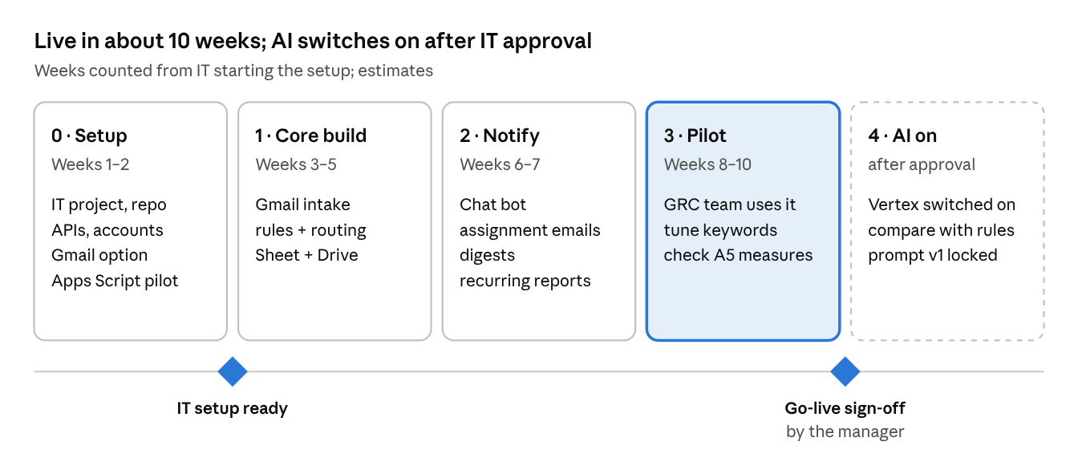

Daily Operation (RACI)
Role | PIC | RACI
Business (Head of GRC) | Pak Dicki | A — approves assignments, Catalog owners, go-live
Product Manager | Enzo Taslim | R — requirements, Catalog rules, acceptance tests
Product Designer | — | N/A in phase 1 (Sheet and Chat only)
Engineering | Enzo Taslim | R — code, prompt, fixes
Ops (GRC staff and interns) | GRC team | R — work the tasks, keep status current
Data | Enzo Taslim | R — success metrics, monthly review
Tech Support / IT | [to be named] | R — Cloud project, identities, secrets, hosting
Compliance Officer | [to be named] | C — data flow and AI provider approval

Approval
Approved by | Title | Date
[Approval Name] | Head of GRC
[Approval Name] | Head of IT / Engineering
[Approval Name] | Head of Compliance

Appendix

Appendix A — Technical Design (TRD)
One Python service on Google Cloud Run does all the work; the Google Sheet stays the system of record that people read and edit. Everything sits in one Google Cloud project owned by IT. Enzo writes the code; IT owns the project, repository, identities and hosting.

A.1 Architecture
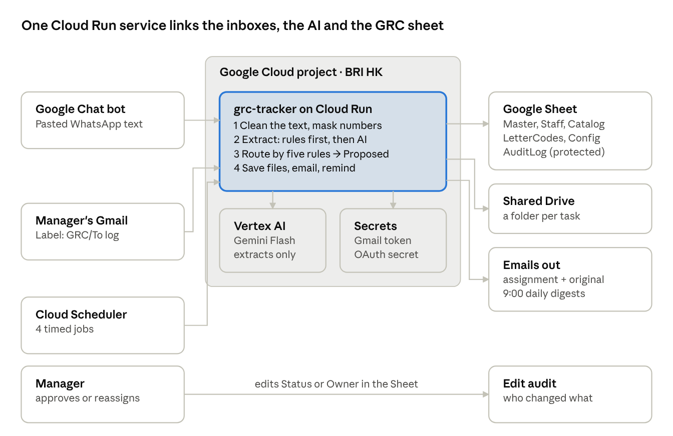
Requests enter from Gmail, the Chat bot or the scheduler; the service reads them, asks the AI for the text fields, proposes an owner and writes to the Sheet. People approve and edit in the Sheet, where a small Apps Script trigger records who changed what.

A.2 Components and Google Cloud services
Component | Google service | Purpose | Notes
grc-tracker service | Cloud Run (Python 3.12, FastAPI) | Intake, extraction, routing, notifications, jobs | Max instances 1 so ID numbering and sheet writes never race
Scheduled jobs | Cloud Scheduler | Calls job endpoints on a timetable | 4 jobs (A.4)
Data store | Google Sheets API | Master, Staff, Catalog, LetterCodes, AuditLog, Config, Dashboard | The existing GRC sheet
Files | Google Drive API | One folder per task for attachments | Shared Drive "GRC Tracker", owned by the team
Email in / out | Gmail API | Read the GRC/To log label; send assignment emails and digests | Access option: A.6
Chat bot | Google Chat API | HTTP endpoint on the service | Visible to GRC staff only
AI extraction | BRI AI agent API, or Vertex AI Gemini Flash | Title, summary, deliverables, deadline, contacts | Provider switch in Config
Secrets | Secret Manager | OAuth client secret, Gmail token, agent credentials | Never in the repo
Build and deploy | Cloud Build + Artifact Registry | Build and deploy on merge to main | Repo host chosen by IT
Logs and alerts | Cloud Logging, Error Reporting, Monitoring | Errors, job failures, alert email

A.3 Data model (Google Sheet tabs)
The service reads columns by header name, never by position, so people can reorder or add columns.
Tab | One row per | Key columns | Written by
Master | Task | ID, Type, Title, Catalog ID, Division, Owner, Doer, Support, Due date, Status, Weight, Last updated, Routing note, Flag, Original message, Files, AI summary, Deliverables, Contacts, Source ID | Service creates; people edit status, owner, doer
Staff | Person | Name, Email, Main division, Role, Internship end date, Capacity, Weighted open load (formula) | Manager
Catalog | Recurring report type | Catalog ID, Report type, Division, Default owner, Backup, Recurrence, Typical due day, Match keywords, Known contacts, Confirmed | Manager + builder
LetterCodes | Sender unit code | Letter code, Route to division | Manager + builder
AuditLog | Change | Timestamp, User, Task ID, Action, Field, Old value, New value, Reason | Service and edit trigger only (protected)
Config | Setting | Load weights, thresholds, labels, AI provider, AI region | Manager
Dashboard | View | Formulas only | Nobody

A.4 Processing flow and scheduled jobs
- Receive: Gmail job or Chat message; skip if its Source ID is already in Master.
- Clean: strip greetings, sign-offs, WhatsApp bold marks and quoted replies; keep the untouched original.
- Extract by rules: deadline, letter number and code, contacts, weekday check.
- Extract by AI (if on): title, summary, deliverables, deadline quote, Catalog guess; rule results win where both exist.
- Store files in the task's Drive folder.
- Route with the five rules; write Owner, Doer, Division, Routing note; Status = Proposed.
- Notify the manager (Chat reply or email). After approval, email the Doer.
Job | Trigger | Schedule (HKT) | Endpoint
Poll Gmail label | Cloud Scheduler | Every 10 min | POST /jobs/gmail
Detect approvals and handoffs | Cloud Scheduler | Every 5 min, 08:00–20:00 | POST /jobs/changes
Create recurring reports | Cloud Scheduler | Daily 07:00 | POST /jobs/recurring
Daily digests | Cloud Scheduler | Weekdays 09:00 | POST /jobs/digest
Chat messages | Google Chat | On message | POST /chat
Edit audit | Apps Script edit trigger on the sheet | On edit | Writes AuditLog directly (keeps the editor's identity)

A.5 AI extraction
AI reads the message; it never decides who does the work. The code has one function, extract(text) → fields, with interchangeable providers set in Config: BRI AI agent (preferred, pending Q1–Q6), Vertex AI Gemini Flash in BRI HK's Cloud project (fallback), or Off (rules only). Consumer Google AI Studio keys are not used: AI Studio is not offered in Hong Kong and free-tier prompts may be used by Google.
Input
- Cleaned text, max 8,000 characters; phone, account and ID numbers masked as [phone], [account], [id].
- The Catalog IDs and report names, so the model can only pick from that list.
- Attachment file names only, never file contents.
Output schema (anything else is rejected)
{
"title_en": "string, max 90 chars",
"summary_en": "string, max 2 sentences",
"deliverables": ["string"],
"deadline": "YYYY-MM-DD or null",
"deadline_quote": "exact words in the message stating the deadline",
"requester_org": "string or null",
"contacts": [{"name": "string", "email": "string or null"}],
"catalog_id": "one ID from the list, or NONE",
"language": "id | en | mixed"
}
Guardrails
- deadline_quote must appear word for word in the message, or the AI deadline is dropped.
- If AI and rule deadlines differ, both are shown and the task is flagged.
- catalog_id must exist in the Catalog; used only when routing rules 1–3 find nothing.
- Timeout 20 seconds, one retry, then rules only; the task is always created.
- Each call logs provider, model, prompt version and latency (not the message text).
- The prompt is versioned in the repo (prompts/extract_v1.md); changes go through code review.

A.6 Integrations, identities and permissions
Integration | Runs as | Permission | Set up by
Sheets | grc-tracker-run service account | GRC sheet shared as Editor | Manager
Drive | grc-tracker-run | Content manager on Shared Drive "GRC Tracker" | IT
Vertex AI | grc-tracker-run | roles/aiplatform.user | IT
BRI AI agent | grc-tracker-run (preferred) | As defined by the agent owner (Q1) | Agent owner + IT
Secret Manager | grc-tracker-run | roles/secretmanager.secretAccessor on its secrets | IT
Scheduled jobs | grc-scheduler service account | roles/run.invoker; service checks the signed token | IT
Chat bot | Google Chat | Chat app pointed at /chat; service checks Google's signed token | IT
Gmail in | See options below | gmail.modify | IT + manager
Gmail out | Sender mailbox (Q8) | gmail.send | IT
Edit audit | Apps Script, as the installer | The sheet only | Builder

Gmail option | How it works | For | Against
A. Manager's one-time consent (recommended) | Internal OAuth app; manager signs in once; refresh token in Secret Manager | Simple; only his mailbox; revocable | Stops if revoked or he leaves; permission covers the whole mailbox
B. Forward to an intake mailbox | Manager forwards (or a Gmail filter forwards) to e.g. grc-intake@ | Service never sees his inbox; survives staff changes | One extra click; needs a mailbox licence
C. Domain-wide delegation | Service account impersonates the manager | No consent step | Can act as any user for that scope; usually refused by security

A.7 Security controls
Area | Control
Data location | BRI HK's Google Workspace and Cloud project; Vertex region set by IT (asia-east2 Hong Kong or asia-southeast1 Singapore).
AI data use | BRI agent or Vertex AI under enterprise terms only; no consumer keys, VPNs or resellers.
Personal data | Phone, account and ID numbers masked before AI; file contents never sent.
Access | Sheet shared with named GRC staff and the service account; AuditLog and state tabs protected.
Secrets | Secret Manager only; none in code, sheet or repo.
Endpoints | Every endpoint checks a Google-signed token (Scheduler or Chat).
Least privilege | Separate runtime and scheduler service accounts with only the roles in A.6.
Human control | No assignment without manager approval in phase 1.

A.8 Repository and deployment
grc-tracker/
├── app/
│ ├── main.py # FastAPI: /chat, /jobs/*, /healthz
│ ├── config.py # Config tab + environment variables
│ ├── sheets.py # read/write tabs by header name
│ ├── intake/gmail.py # label poll, attachments → Drive
│ ├── intake/chat.py # Chat events and replies
│ ├── extract/clean.py # strip greetings, mask numbers
│ ├── extract/rules.py # deadline, letter code, weekday, contacts
│ ├── extract/ai.py # provider adapter: BRI agent / Vertex / off
│ ├── route.py # the five routing rules
│ ├── notify.py # assignment emails, digests
│ ├── jobs.py # recurring, change detection
│ └── auth.py # verify Scheduler and Chat tokens
├── prompts/extract_v1.md
├── apps_script/audit.gs
├── tests/ # incl. the 26 Oct 2026 example
├── Dockerfile
├── cloudbuild.yaml
└── README.md

Environment | Sheet | Mailbox | Deployed from
Dev | Copy of the GRC sheet with test data | Builder's Gmail, test label | Branch dev, by hand
Prod | Live GRC sheet | Manager's Gmail (A.6) | Merge to main → Cloud Build → Cloud Run
- Tests must pass before merge; the 26 Oct 2026 example is a permanent test case.
- Settings that change often (thresholds, labels, AI provider) live in the Config tab, not in code.
- Environment variables hold only IDs: project, region, sheet ID, Shared Drive ID, secret names.

A.9 Monitoring, errors and cost
What can fail | What happens | Who is told
Gmail token revoked or expired | Gmail job stops; labels stay on emails for retry | Alert to builder and manager within 1 hour
AI call fails or times out | Task created with rules only, flagged | Logged; daily count in the manager digest
Sheet column renamed or tab deleted | Job stops before writing | Alert naming the missing column or tab
Job fails 3 times in a row | Cloud Monitoring alert | Builder
Chat bot error | Bot asks the manager to forward by email | Logged
[ESTIMASI] Running cost at about 300 requests a year: Cloud Run likely within the free allowance; Cloud Scheduler a few cents a month; Vertex AI Gemini Flash a few US dollars a month at most. IT to confirm with Google's pricing calculator.

A.10 Requests to IT
- Google Cloud project for BRI HK with billing; builder with deploy rights in dev, read rights in prod.
- Repository with Cloud Build connected.
- APIs enabled: Cloud Run, Cloud Scheduler, Sheets, Drive, Gmail, Google Chat, Vertex AI, Secret Manager, Artifact Registry.
- Two service accounts with the roles in A.6.
- Shared Drive "GRC Tracker".
- Internal OAuth consent screen and client for the Gmail option chosen.
- Workspace admin approval for an internal Google Chat app visible to the GRC team.
- Decision on AI provider and region; Compliance approval of the data flow.

Appendix B — Example request and expected result
Message forwarded by the manager on 26 October 2026, with one Excel form and one PPT attached:
Selamat siang Bapak dan Ibu Anggota Konglomerasi Keuangan Level 1 dan Level 2,
Dalam rangka telah disosialisasikannya pada 23 Oktober 2026 dengan format form dan PPT
Joint Planning Session Manpower Planning Terintegrasi BRI Group, berikut kami lampirkan
format form dan PPT yang perlu diisi oleh masing-masing perusahaan anak, adapun deadline
pengumpulan pada Rabu 06 November 2026.
Terkait mekanisme pengumpulan agar mengirimkan email ke [email] dan/atau menghubungi PIC
terkait a.n. Fadhil Athallah Sakti ([phone]) dan Hirza Sitaningtyas ([phone])
Terima kasih atas perhatiannya Bapak dan Ibu

Field | Expected result | Phase-0 script result
Title | Joint Planning Session – Integrated Manpower Planning (form + PPT) | Greeting line (wrong)
Division / Catalog | HR (contact Hirza Sitaningtyas was the HR contact in 2026) | Shareholding data (wrong: matched "Anggota Konglomerasi" in the greeting)
Deadline | 6 Nov 2026, flagged: "Rabu" is 4 Nov; 6 Nov is a Friday | 6 Nov 2026 (correct, no weekday flag)
Deliverables | Fill in the Excel form; fill in the PPT | Not extracted
Files | Excel and PPT in the task folder, linked in the assignment email | Not stored
These gaps are why the cleaning step, contact matching, weekday check and file storage are P1 requirements.

