IntelHub: The Web Based Research Repository for
Polytechnic University of the Philippines Biñan Campus
A Capstone Project Presented to the Faculty of the College of Information Technology and
Engineering Polytechnic University of the Philippines-Biñan Campus Biñan City, Laguna

In Partial Fulfillment of the Requirements for the Degree Bachelor of Science in Information Technology
By:
Caballero Bryan H.
Cardeño Raven S.
Mendoza Enzo Charles G.
Ibarbia Christian Nel A.

Chapter 1
THE PROBLEM AND ITS SETTING

Introduction
In the 21st century, where digital transformation continuously reshapes the fabric of global education, academic institutions are increasingly embracing technological solutions to improve accessibility, knowledge dissemination, and resource efficiency. The emergence of digital platforms has not only enhanced the way information is stored but has also revolutionized how it is retrieved and utilized by students, faculty, and researchers. According to Gonzales and Santos (2021), the Philippine educational sector must accelerate the adoption of digital infrastructures to remain competitive and responsive to the needs of modern learners.

In particular, research plays a crucial role in the academic landscape. It serves as a fundamental pillar in curriculum development, problem-solving, policy formulation, and the overall intellectual growth of institutions. Unfortunately, many colleges and universities in the Philippines, including satellite campuses, still rely on traditional, paper-based archiving methods for storing academic research. These practices pose significant challenges in terms of accessibility, preservation, and scalability. As David and Mendoza (2022) explain, manual storage systems limit the reach of scholarly output and hinder the development of a collaborative research culture.
The Polytechnic University of the Philippines (PUP) Biñan Campus, recognized for its commitment to public education and research, produces a substantial volume of academic work annually. However, the absence of a centralized and easily navigable digital repository leads to underutilization and, at times, complete neglect of potentially impactful student and faculty research. Bautista et al. (2023) emphasize that universities must transition toward centralized digital repositories to maximize their research assets and institutional visibility.
IntelHub is proposed as a strategic response to this challenge. It is envisioned as a user- centric research repository tailored to the unique needs of PUP Biñan Campus. The platform will serve as a secure, well-organized, and accessible archive of academic outputs, including undergraduate theses, faculty research, and institutional studies. According to Cruz and Velasco (2021), institutional repositories play a critical role in fostering open access, improving citation rates, and supporting institutional accreditation and academic recognition.
The development of IntelHub aligns with international trends toward digital knowledge management. Globally, academic institutions have been investing in digital libraries and repositories as part of their digital transformation strategies. Ortega and Ramos (2020) assert that repositories are more than just digital archives; they are knowledge infrastructures that facilitate innovation, collaboration, and long-term academic growth. IntelHub adopts this philosophy by not only housing digital documents but by also implementing advanced search, tagging, and categorization features that enhance the usability and discoverability of stored materials.

From a technological perspective, IntelHub will utilize modern web development frameworks and database management systems to ensure functionality, security, and scalability. The system will include features such as metadata tagging, access controls, user authentication, and version tracking. Salazar and Lim (2024) suggest that repositories should prioritize not only content but also user experience, ensuring that even first-time users can navigate and utilize the system effectively. IntelHub's intuitive interface and user-centered design will be critical in ensuring widespread adoption.
The platform also promotes inclusivity by granting access to various users, including students conducting literature reviews, faculty revisiting old studies, administrators managing research data, and alumni exploring past academic works. This wide-ranging accessibility supports the democratization of knowledge, which Cruz and Velasco (2021) identify as a cornerstone of educational equity in the digital age. Moreover, by enabling public or limited access to certain documents, IntelHub ensures that institutional intellectual property is protected while promoting academic transparency.

Like any technological innovation, the implementation of IntelHub comes with its own set of advantages and disadvantages. On the positive side, IntelHub enhances accessibility to research materials, reduces the risk of physical loss or damage, and improves the visibility of the university’s academic output. Students and faculty can benefit from faster literature reviews, more organized archives, and access to legacy studies that may inform future research directions. As Villanueva and Reyes (2025) note, repositories help motivate students by preserving their work and positioning it within a broader academic context.
Another major advantage is the system’s scalability and sustainability. Digital storage allows for the continual addition of new research without the space limitations of physical archives. The use of metadata tagging and search functions also dramatically improves retrieval efficiency compared to traditional filing systems. Furthermore, IntelHub contributes to environmental sustainability by minimizing paper use and promoting digital workflows.
However, IntelHub also presents challenges. One disadvantage is the need for reliable IT infrastructure and consistent maintenance. Without proper data backup and cybersecurity protocols, the system may be vulnerable to data breaches or loss. As Salazar and Lim (2024) warn, digital repositories must be designed with security and redundancy in mind to protect sensitive academic information.
Additionally, user training and system familiarization are necessary to ensure smooth adoption. Some users may struggle with navigating the platform initially, especially those unfamiliar with digital systems. Moreover, the cost of developing and maintaining such a platform can be significant, particularly for public institutions operating under constrained budgets. These concerns must be addressed through strategic planning and stakeholder support.

IntelHub is also designed to foster a strong research culture within the PUP Biñan community. By offering a platform where academic work is preserved and showcased, students and faculty are encouraged to contribute meaningful research, knowing that their outputs are not merely submitted and graded, but also stored and valued as part of the university's academic legacy. Villanueva and Reyes (2025) argue that repositories act as motivational tools by highlighting the significance and visibility of student research.
In alignment with the Commission on Higher Education (CHED)'s strategic goals for modernizing academic infrastructure, IntelHub supports institutional efforts to digitize research documentation and performance indicators. CHED (2023) underscores the need for data-driven academic systems to improve quality assurance, streamline administrative reporting, and support evidence-based policy-making. IntelHub can contribute directly to these initiatives by offering structured, exportable, and analyzable research data.
The long-term impact of IntelHub extends beyond campus borders. By showcasing research contributions from a provincial campus like PUP Biñan, the platform positions the institution on a national and potentially international academic map. Regional research, often overlooked in national discourse, finds a voice and a platform through IntelHub. As Bautista et al. (2023) highlight, localized research repositories promote regional development by linking academic insights with community challenges and initiatives.

In its essences, IntelHub stands as a transformative tool for the Polytechnic University of the Philippines Biñan Campus. It merges digital innovation with academic purpose, addressing existing challenges while unlocking new opportunities for research dissemination, student engagement, and institutional growth. With its focus on accessibility, organization, and security, IntelHub not only modernizes research storage but also redefines how knowledge is preserved, shared, and valued within and beyond the university community.
This capstone project is developed in collaboration with the official client, Director Sevilla, the Campus Director of the Polytechnic University of the Philippines (Biñan Campus). Her administrative leadership and institutional oversight have been instrumental in guiding the project toward alignment with the university's research and digital transformation initiatives.

Conceptual Framework
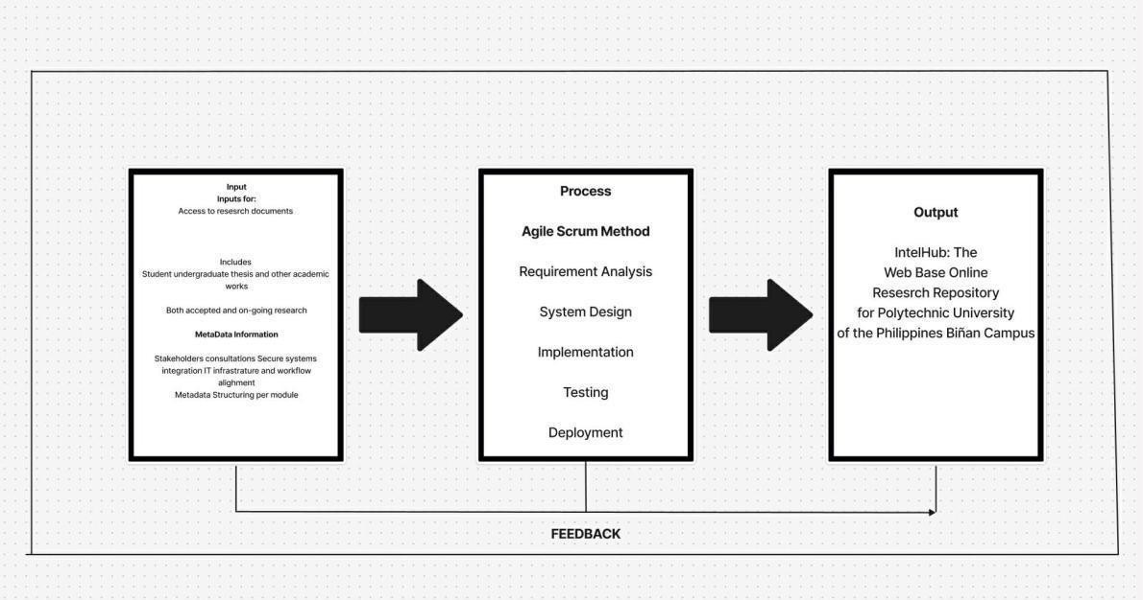

Figure1.1

Conceptual Framework showing input, process, and output of the system

The conceptual framework of IntelHub: The Research Repository for Polytechnic University of the Philippines (Biñan Campus) is structured around three core components: input, process, and output. The input includes the primary need for centralized access to academic documents, including undergraduate theses, completed and ongoing research, and institutional academic outputs. It also incorporates metadata structuring requirements and consultations with stakeholders to align repository features with institutional goals. The technical prerequisites involve a secure IT infrastructure, integration with existing systems, and proper metadata formatting for streamlined data retrieval and indexing.
The process adheres to the Agile Scrum Development Model, encompassing five
sequential stages: Product Backlog, sprint planning, sprint, sprint review, retrospective.
Each phase is completed before moving on to the next, ensuring that all technical and functional requirements are met systematically. This linear methodology supports clarity in development, particularly in academic institutions where standardization and approval stages are critical.
The output is IntelHub, a web-based research repository that provides organized, searchable, and secure access to the academic outputs of PUP Biñan Campus. The platform improves visibility and accessibility of research documents while ensuring long-term preservation and academic integrity. A feedback mechanism is embedded in the system to enable iterative enhancements based on user experience, institutional policies, and evolving academic needs.

Statement of the Problem
The Polytechnic University of the Philippines (PUP) Biñan Campus currently lacks a centralized digital repository to store, manage, and disseminate the academic research outputs produced by students, faculty, and departments. As a result, many valuable research documents remain underutilized, are difficult to access, or are at risk of being lost due to the reliance on traditional paper-based archiving methods. This gap poses significant challenges in terms of research visibility, knowledge preservation, institutional reporting, and academic collaboration.
As the client of this project, Ma’am Sevilla, the Campus Director of PUP Biñan, has expressed a need for a secure, accessible, and sustainable solution to modernize the university's research storage and access system. Based on her insights and the project team's assessment, the following critical questions need to be addressed:
- What are the implications of not having a centralized and digitized repository for storing academic research at PUP Biñan Campus?
- How does the lack of a digital research archive affect the accessibility, recognition, and long-term preservation of student and faculty outputs?
- What are the current limitations and inefficiencies in the existing research documentation and archiving process?
- How can the development of a platform like IntelHub support the university’s goals in research transparency, data management, and academic excellence?
- What are the potential challenges—technical, organizational, or behavioral—that may arise during the implementation and adoption of the proposed research repository?

This capstone project aims to respond to these concerns through the development of IntelHub, a comprehensive digital research repository tailored to the specific needs and goals of PUP Biñan Campus. The project is driven by the vision of improving institutional knowledge management, fostering a stronger research culture, and enabling greater access to academic resources for students, faculty, and administrators.

Statement of Objectives
This study aims to address the absence of a centralized and accessible research repository at the Polytechnic University of the Philippines (Biñan Campus) through the development of a digital platform named IntelHub. This project is developed in collaboration with Ma’am Sevilla, the Campus Director of PUP Biñan, who serves as the official client and key stakeholder. IntelHub is intended to modernize the storage, retrieval, and management of research outputs while supporting the university’s goals in academic excellence, data accessibility, and institutional innovation.
Specifically, the objectives of the study are:
- To design a centralized, client-aligned, and user-friendly research repository system called IntelHub that enables organized, secure, and accessible archiving of research outputs produced by students within PUP Biñan Campus.
- To develop the platform using appropriate web technologies, database management systems, and metadata standards, ensuring system reliability, search efficiency, and long-term digital preservation based on the institution’s research requirements.

- To implement and integrate the IntelHub system within the university’s operational framework, guided by the directives and feedback of the client, Ma’am Sevilla, and ensuring role-based access control for different user types (e.g., students, faculty, administrators).
- To evaluate the system’s performance, usability, and effectiveness through systematic testing, user feedback collection, and measurable indicators such as retrieval time, storage capacity, system responsiveness, and stakeholder satisfaction.
Hypothesis
The theoretical framework of this study, grounded in principles of digital transformation, knowledge management, and system usability, leads to the formulation of the following hypotheses. These hypotheses reflect the expectations of the project team and align with the goals set forth by the client, Margarita T. Sevilla, Campus Director of PUP Biñan:
- H1: The implementation of IntelHub will have a positive impact on the accessibility, preservation, and institutional visibility of academic research outputs at the Polytechnic University of the Philippines (Biñan Campus).
- H2: The features and system design of IntelHub will meet user experience standards and align with the university's operational needs, ensuring high usability for students, faculty, and administrative users.

- H3: The integration of a centralized digital repository system, guided by the client’s directives, will reduce the time and effort required by users to retrieve and manage research documents, leading to improved academic efficiency and data organization.

Scope and Limitations of the Study
This study focuses on the design, development, and deployment of IntelHub, a centralized digital research repository created to organize, preserve, and provide accessible academic outputs within the Polytechnic University of the Philippines (Biñan Campus). Developed in collaboration with the client, Ma’am Sevilla, Campus Director of PUP Biñan, the platform aims to support students, faculty, and administrative personnel by offering a secure and user- friendly system to archive and retrieve research documents. IntelHub is designed as a web- based platform equipped with features such as research categorization, metadata tagging, document uploading, search functionality, and download access, aligned with institutional policies and user requirements.
The study is limited to the implementation of a web-based digital repository system and does not include mobile application development or real-time collaboration tools. The system focuses on storing general research outputs such as undergraduate theses and faculty-led studies and does not handle confidential student records or non-research administrative files. Uploads to the repository are manually curated and require approval from designated academic personnel, ensuring content accuracy but limiting real-time updates. Furthermore, IntelHub requires stable internet connectivity and is optimized for modern desktop browsers. Institutional changes in research submission workflows or repository policies must be manually reflected in the system by administrators. The platform’s effectiveness also depends on the quality of uploaded metadata and the compliance of users with formatting and document submission guidelines.

While IntelHub significantly improves access to research outputs, it is not intended to replace existing student or faculty portals but rather to complement academic transparency and knowledge sharing within the PUP Biñan academic community.

Significance of the Study
This project focuses on the development of IntelHub, a centralized digital research repository designed to support the academic, operational, and knowledge management needs of the Polytechnic University of the Philippines (Biñan Campus). Initiated under the guidance of Ma’am Sevilla, the Campus Director and official client of this project, the study aims to create a lasting impact across multiple sectors of the university community. The significance of this project is outlined below:
PUP Students. IntelHub will provide students with immediate, organized access to existing academic research outputs such as theses and institutional papers. This access will support students in conducting literature reviews, aligning their research with institutional priorities, and gaining inspiration from prior academic work. The platform encourages academic excellence by promoting self-guided learning and reducing dependence on fragmented or outdated research sources.

Faculty and Research Advisers. Faculty members will benefit from streamlined access to previously approved research, enabling better guidance for current student projects and promoting continuity in institutional knowledge. IntelHub also assists in faculty-led research by offering a structured archive of references, institutional studies, and project outcomes. This will reduce redundancy and promote collaborative scholarship.
University Management. For the Campus Director and other senior administrators, IntelHub will serve as a strategic tool to monitor research trends, improve transparency, and support quality assurance. It can also assist in decision-making regarding curriculum development, research funding, and institutional policy based on accessible, data-driven insights.
External Stakeholders and Visitors. Visitors such as alumni, prospective students, researchers, or accreditation bodies will find the repository a credible and convenient source of institutional research outputs. By showcasing the academic productivity of PUP Biñan, IntelHub enhances the university’s reputation, fosters external collaborations, and supports transparency in higher education.

Definition of Terms
Academic Repository – A digital storage space for academic outputs like theses, dissertations, and research papers.
Accessibility – The ease of access to digital content by all users, including those with disabilities.

Administrator – A person managing the platform's backend, user permissions, and content validation.
AI (Artificial Intelligence) – Technology that mimics human intelligence to perform tasks. Approval Workflow – A system process that reviews and validates submissions before publishing.
Archive – A long-term storage area for academic documents.
Authentication – The process of verifying a user’s identity before granting system access.
Authorization – Permission granted to users to access or modify certain parts of the system.
Backup – A duplicate copy of data stored to prevent data loss.
Bandwidth – The data transfer capacity of an internet connection.
Bibliographic Data – Information such as title, author, and publication date for research.
Campus Director – The official head of the campus and client of the IntelHub project.
Client – The person or institution requesting the development of a system.
Cloud Storage – Internet-based storage services.
Confidentiality – Ensuring that private academic data is not accessed without permission.
Content Management – Organizing, editing, and publishing digital content.

Credential – Login information like usernames and passwords.
CSV Format – A common file format for uploading structured data.
Cybersecurity – Protective measures against digital threats.
Dashboard – A graphical interface showing real-time system metrics.
Database – An organized collection of data for quick access and management.
Data Integrity – Accuracy and consistency of stored data.
Data Privacy – Protecting users’ personal and academic data.
Data Retrieval – The process of accessing stored information.
Deployment – The process of releasing the system for public or internal use.
Digital Literacy – The ability to effectively use digital tools.
Digital Repository – An online system that stores and manages digital files.
Document Upload – Submitting digital files to the system.
Downtime – A period when the system is not operational.
Encryption – Converting data into a secure format.
End-User – The final user who interacts with the system.

Evaluation Metrics – Measures used to assess system performance.
Faculty – Academic staff involved in teaching and research.
Feedback System – A feature that collects user suggestions and issues.
File Format – The type of document uploaded (PDF, DOCX, etc.).
Firewall – A security system that controls incoming and outgoing traffic.
Front-End – The visible part of the application the user interacts with.
FTP (File Transfer Protocol) – A standard for transferring files between systems.
Functionality – The range of operations the system can perform.
GUI (Graphical User Interface) – The design and layout of the system.
Hosting Server – A server where the system is stored and made accessible.
HTML – The markup language used to structure web content.
Indexing – Organizing content to make it easily searchable.
Institutional Knowledge – Information generated and stored by the university.
Intellectual Property – Legal rights to academic outputs.
Interface – The point where users interact with the software.

JavaScript – A scripting language used to build interactive web pages.
Landing Page – The homepage of the repository platform.
Latency – Delay in data processing or response.
Login System – The interface and backend that handles user authentication.
Machine Learning – A subset of AI where the system learns from data patterns.
Maintenance – Activities performed to keep the system functional.
Metadata – Descriptive data about a research document.
Mobile Responsiveness – System compatibility with mobile devices.
Module – A functional component of the system (e.g., upload module).
Navigation Bar – A user interface component to browse different pages.
Network – Interconnected systems allowing communication and data exchange.
Open Access – Public availability of academic resources.
PDF (Portable Document Format) – A widely used file format for documents.
PEZA – Philippine Economic Zone Authority, often referenced in academic settings.
Performance Testing – Testing the speed, scalability, and stability of the system.

PHP – A programming language used for web development.
Pilot Testing – Trial use of the system before official deployment.
Plagiarism Check – Verifying originality of research content.
Portal – A digital entry point for users to access system features.
Programming Language – Languages like PHP, HTML, JavaScript used in development.
Publication Date – Date when research is officially added to the system.
Query – A request to retrieve specific data from the system.
Real-Time Access – Immediate availability of system features.
Record Management – Systematic handling of research files.
Repository – A central place for storage and retrieval of research data.
Research Adviser – A faculty member guiding research projects.
Research Output – Any document resulting from academic research.
Responsive Design – Ensures compatibility with different screen sizes.
Role-Based Access – Assigning system permissions based on user roles.
Routing – Directing user actions within the system.

Scalability – The system’s ability to grow with increased users or data.
Search Filter – A tool to narrow search results based on criteria.
Secure Login – A protected method of user authentication.
Server – A computer system hosting the digital repository.
Session Timeout – Automatic log-out after a period of inactivity.
Software Development – The process of creating digital applications.
SQL (Structured Query Language) – Language for managing databases.
Storage Limit – Maximum space allowed for file uploads.
Student Portal – An existing platform for student academic records.
Submission Guidelines – Rules for uploading research documents.
System Administrator – A person who oversees the technical aspects of the platform.
System Architecture – The structure and design of the digital system.
System Downtime – Periods when the system is unavailable.
Tagging System – Assigning labels to documents for better categorization.
Testing Phase – A development stage where features are verified.

Thesis – A major academic research paper submitted by a student.
UI/UX – User Interface and User Experience design practices. Upload Module – A component that handles file submissions.
User Authentication – Process to verify and validate users.
User Experience – The quality of interaction between the user and the system.
User Feedback – Input from users about their experience with the platform.
Version Control – Managing changes to documents over time.
Chapter 2
REVIEW OF LITERATURE AND STUDIES
Foreign Literature

Digital Repositories in Higher Education
According to Zhang and Li (2022), digital repositories play a vital role in enhancing postgraduate research by providing institutional access to a wide array of academic works. Their longitudinal study at Tsinghua University revealed that digital repositories improved the academic performance of students by increasing access to quality resources. Students were more likely to cite credible references and avoid plagiarism because of the easy availability of full-text documents. Furthermore, the authors noted that institutional repositories promote global visibility for university research, allowing scholars from other countries to access and reference work published locally.

Similarly, Hassan and Ahmed (2021) conducted a comparative study between universities that use open-access repositories and those still relying on traditional archives. They found that digital repositories encouraged students to become more independent and active in their research. Full-text access reduced students’ dependence on physical libraries and enabled them to retrieve sources anytime. The study also reported improved feedback cycles between students and thesis advisers, as documents could be submitted and reviewed digitally, speeding up the research process.
In relation to this study, IntelHub serves as a comprehensive repository platform at the Polytechnic University of the Philippines (PUP) Biñan Campus. It aims to improve access to undergraduate and faculty research outputs, enhance academic engagement, promote responsible citation practices, and increase the global visibility of the institution’s academic contributions.

Usability and Accessibility of Repository Platforms
Thompson and Miller (2021) examined usability factors of institutional repositories across major universities in the UK. Their research emphasized that responsive design, clear navigation structures, and customizable user interfaces significantly influenced adoption and sustained use. A repository’s ease of use directly correlated with student satisfaction and frequency of usage. Their study found that students abandoned digital platforms with outdated interfaces and poor search functions, indicating the need for constant updates and user-centered design.

Alvarez and Brooks (2020) supported these conclusions through a case study at a Canadian university where repository use increased by 64% after the system’s interface was redesigned to include easier navigation, role-based access, and improved security protocols. The researchers stressed the value of clear file categorization, keyword optimization, and integration with campus learning systems to encourage consistent usage by both faculty and students.
In relation to this study, IntelHub is designed with a user-friendly interface, secure login mechanisms, and permission-based access for students, faculty, and administrators. These features ensure that research materials are easy to find, safely stored, appropriately accessed, and updated to align with evolving user needs.
Local Literature

Digital Transformation in Academic Repositories
Cruz (2021) examined the digitalization of academic repositories in Philippine state universities and emphasized the significant shift from traditional paper-based filing systems to cloud-based platforms. Her study showed that digital platforms using metadata tagging and automated classification significantly increased retrieval speed and user satisfaction. However, Cruz also pointed out challenges such as limited staff training and poor metadata quality that hindered full optimization of these platforms.

Reyes (2022) reinforced these findings through a study on the research access habits of college students in Manila-based universities. She found that disorganized and poorly indexed archives discouraged students from engaging in deeper research. Her study called for improved classification systems and regular content auditing to maintain relevance and usability.
IntelHub addresses these concerns by offering categorized, metadata-driven search tools and regularly updated indexing systems to enhance the visibility and retrievability of research works at PUP Biñan Campus.

Centralized Repository Systems
Santos and Villanueva (2020) highlighted the benefits of centralizing research archives within academic institutions. Their research found that centralized repositories encouraged interdisciplinary collaboration, simplified document tracking, and improved the efficiency of institutional knowledge-sharing. The centralized model also reduced confusion among students and faculty regarding the location of specific resources, improving overall access and engagement.
Mercado (2021) added that standardizing digital formatting and submission guidelines for research documents reduced the burden on administrative staff and helped maintain a consistent quality of archived works. He also noted that centralized repositories serve as useful resources during accreditation and institutional audits.

IntelHub integrates these findings by centralizing the repository for the entire PUP Biñan campus. It promotes campus-wide collaboration, reduces document duplication, ensures consistency in file formatting, and facilitates faster response during audits and accreditation processes.

Local Studies

Repository Implementation in Regional Universities
De Guzman et al. (2021) assessed the deployment of a digital thesis repository in a state university in Northern Luzon. The study reported a significant decrease in paper-based processes, cutting down printing costs and administrative workloads. The repository improved student access by providing downloadable copies of theses and dissertations, which were previously stored only in physical libraries.
Flores and Javier (2022) conducted a follow-up evaluation, discovering that access to completed academic research gave students greater confidence in starting their own theses. It also minimized topic redundancy and encouraged academic originality by providing examples of previous methodologies and findings.
IntelHub draws from these experiences by offering digital access to a rich archive of past research outputs. The platform aims to reduce redundancy in research topics and boost academic confidence among current students.

Faculty Workflow and Research Archiving
Del Rosario (2020) documented the implementation of a digital archive at the University of the East, where faculty were able to streamline the thesis review and grading process. With digital access to documents, faculty reduced administrative bottlenecks and were able to provide feedback faster and more efficiently.
Mendoza (2021) highlighted how digital archives became a foundational resource for new research projects. Archived student work helped guide new proposals, avoiding repetition and improving research quality. Moreover, the presence of a digital record allowed faculty to assess the evolution of research within departments.
IntelHub mirrors these objectives by integrating features that support thesis tracking, evaluation, and referencing. It helps faculty manage their workload, monitor research trends, and provide better guidance to students at PUP Biñan Campus.
Foreign Studies

International Best Practices in Repository Deployment
Knight and Watson (2020) conducted a global survey involving 50 universities across Asia, Europe, and North America. Their study highlighted that effective repository systems must support interoperability standards such as OAI-PMH and Dublin Core for metadata exchange. Institutions with these standards experienced higher data-sharing rates and greater international collaboration. The study emphasized the role of repositories in promoting institutional reputation and improving knowledge exchange between universities.

A study by Müller and Schneider (2020) in Germany observed that institutional repositories that integrated plagiarism detection tools and ORCID ID systems improved the quality and accountability of submissions. The researchers argued that the presence of validation features encouraged students to produce more original work and provided faculty with enhanced tools to monitor research ethics.
IntelHub considers these insights by planning future integration with plagiarism-checking systems and standardized metadata protocols. By doing so, the platform aligns with international best practices and ensures academic integrity while fostering a research-driven academic environment.

Student Usage Behavior and Repository Efficiency
According to a study by Yamamoto and Saito (2018) in Japan, repository usage among students increased when research guides, tutorial videos, and sample templates were provided. The authors emphasized that repository usage is not merely a technical issue but also a matter of user support and academic culture. The presence of research templates and video tutorials resulted in a 45% increase in repository log-ins and higher submission rates within academic deadlines.
IntelHub integrates similar features by offering tutorial content, structured templates, and guide documentation to help both students and faculty navigate the repository effectively. This ensures a more inclusive and empowering experience for users at all levels of research proficiency.

Synthesis of the Reviewed Literature and Studies
The literature and studies reviewed reveal the pivotal role of digital repositories in improving research access, academic documentation, and institutional efficiency. Foreign literature underscores the global trend of repository development as a response to growing research demands and the need for quality academic references. Studies by Zhang and Li (2022) and Hassan and Ahmed (2021) highlight how digital repositories contribute to student engagement and research authenticity by providing full-text access and enabling independent inquiry.
Usability, accessibility, and centralized access are consistently emphasized in international research, as seen in the work of Thompson and Miller (2021), and Alvarez and Brooks (2020), all of which validate the essential features included in IntelHub. These features ensure a positive user experience and encourage consistent platform use.
Locally, research by Cruz (2021), Reyes (2022), and Santos and Villanueva (2020) affirms the benefits of structured, centralized digital repositories in improving academic access and collaboration. Case studies from Philippine universities demonstrate practical advantages such as improved document tracking (De Guzman et al., 2021), research inspiration (Flores & Javier, 2022), and enhanced faculty workflows (Del Rosario, 2020; Mendoza, 2021).

Overall, the review of literature and studies provides strong support for the implementation of a centralized, user-friendly, and digitally accessible repository system like IntelHub. Drawing from global best practices and localized experiences, the project is designed to meet the academic needs of students and faculty while promoting a culture of research excellence and innovation at PUP Biñan Campus. IntelHub does not only store research outputs but also fosters a research-oriented academic environment that aligns with the university’s vision of inclusive, efficient, and modern education delivery.

Chapter 3
Methodology

Research Design
This study employed a descriptive-developmental research design to guide the formulation, development, and implementation of IntelHub, the research repository system for the Polytechnic University of the Philippines (PUP) Biñan Campus. This dual approach offered a comprehensive framework: descriptive research was used to identify current research documentation challenges, user needs, and expectations; developmental research guided the systematic creation, refinement, and deployment of the IntelHub system in response to those findings.

The descriptive research component enabled the researchers to analyze and understand the real-world academic environment, including how students, faculty, and administrators interact with existing research archives. Descriptive research, as defined by Voxco (2021), helps portray the current state of affairs and address key questions such as “What problems do users face in accessing previous research?” and “How can digital repositories improve user experience?” Data were gathered through surveys, interviews, and focused group discussions, which revealed the gaps and inefficiencies of current systems, particularly in terms of accessibility, user experience, and document organization.
This methodology allowed the study to produce a clear picture of users’ behaviors, pain points, and expectations. According to QuestionPro (2022), descriptive research is ideal for collecting rich and representative data from large populations within a short timeframe, especially when surveys and structured observations are employed. By applying this approach, the research team successfully gathered essential feedback about common difficulties such as limited remote access to physical libraries, disorganized records, and lack of standardized digital documentation processes.
Complementing the descriptive phase, the developmental research design focused on the iterative development and validation of IntelHub. As noted by Claudia F. (2021), developmental research is especially suitable for designing educational and technological tools, where refinement through real-world testing is integral to effectiveness. This aspect of the study emphasized prototype creation, system testing, evaluation by end-users, and implementation based on continuous feedback loops.

This combination of methodologies allowed for an evidence-based, user-centered approach in building IntelHub. The descriptive findings were translated into technical requirements, while developmental methods ensured the system's design and functionalities directly responded to the identified needs. The integration of both research designs resulted in a platform that is context-sensitive, scalable, and aligned with the institutional objectives of the university.

Software Development Methodology
To ensure effective and user-focused system development, this study followed the Agile-
Scrum methodology in creating the IntelHub research repository. Agile software development involves iterative processes, collaborative teamwork, and flexibility in adapting to evolving user requirements (CPrime, 2020). Given the goal of delivering a functional and user-validated repository system, Agile was chosen for its capacity to produce working software in short cycles while gathering user input after each iteration.
The Scrum framework under Agile was used to structure the team’s work into time-boxed sprints. Each sprint included planning, design, coding, testing, and evaluation phases. Regular sprint reviews and retrospectives were conducted with student testers, faculty members, and IT advisors, ensuring each development phase was guided by constructive feedback. This iterative model supported fast adaptation to suggestions and seamless integration of new features such as metadata tagging, category-based browsing, and secure user authentication.

Scrum also fostered accountability and collaborative ownership among the development team. Its principles of transparency and responsiveness helped maintain alignment with project goals, such as user accessibility, data security, and repository reliability. By involving the university stakeholders in various sprints, the system evolved organically to reflect actual academic workflows and digital requirements.
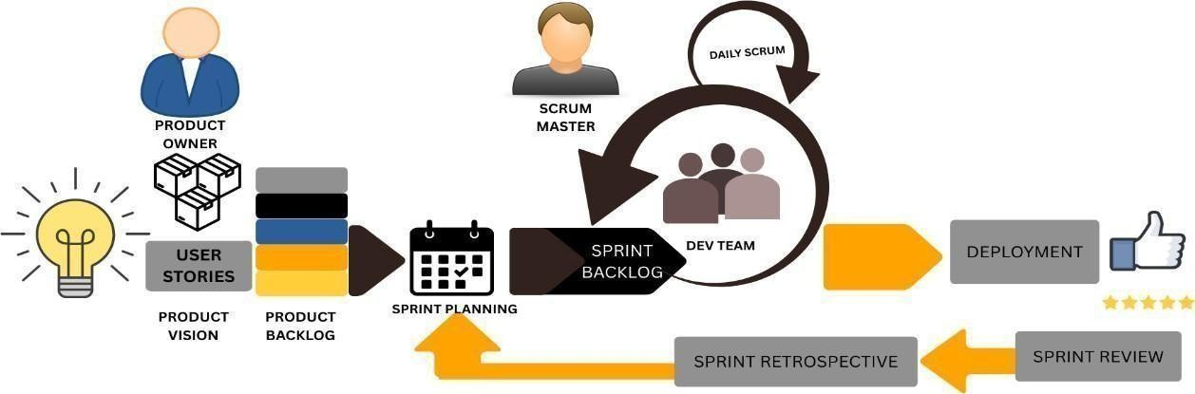
Figure 3.1.

Agile Software Development Cycle with Scrum Framework
In the development of IntelHub, the team implemented the phases of the Agile-Scrum methodology as illustrated in Figure 3.1. This approach comprised essential stages such as product vision, product backlog, sprint planning meeting, sprint backlog, sprint execution, daily stand-up, sprint review, sprint retrospective, and deployment.

Product Vision
The product vision for IntelHub focused on addressing the lack of centralized access to academic outputs and modernizing the research archiving process within PUP Biñan Campus. Inspired by Boiser (2021) and Salimi (n.d.), the vision unified stakeholders around the goal of developing a user-centric, secure, and searchable platform for students, faculty, and staff to upload, access, and manage research outputs efficiently.

Product Backlog
The product backlog served as a dynamic list of system features, improvements, and bug fixes prioritized based on stakeholder input. Tasks included the creation of user roles, metadata tagging, full-text search capabilities, upload validations, and feedback forms. The backlog was continuously updated as user testing and stakeholder feedback surfaced new requirements.

Sprint Planning
Sprint planning meetings allowed the development team to identify the most valuable features to build within a 2–3 week sprint cycle. Tasks were broken down into manageable units, discussed for complexity, and assigned accordingly. These planning sessions ensured clear goals, anticipated risks, and well-aligned responsibilities for each sprint.

Daily Scrum
Daily stand-up meetings kept the team synchronized by discussing progress, goals, and blockers. This enabled faster issue resolution and allowed rapid iterations, such as fixing UI bugs or optimizing search functionality based on immediate user testing results.

Sprint Review
Sprint reviews were held at the end of each sprint to demonstrate completed features to stakeholders. Faculty and student testers gave feedback on new functionalities such as document search filters, user dashboards, or file submission flows. Their feedback helped refine the next set of tasks in the product backlog.

Sprint Retrospective
Sprint retrospectives encouraged team members to reflect on what went well and what could be improved in the sprint cycle. Adjustments were made to improve team productivity, such as refining task estimation methods or updating code review practices.

Deployment
Each sprint concluded with the deployment of a functional version of IntelHub to a test environment. Final deployments involved testing under real-world conditions and collecting user feedback via surveys and usage logs, which informed adjustments in subsequent sprints.

Instrumentation and Data Collection

A multifaceted data collection approach was used to guide the development and evaluation of IntelHub. Methods included:
- Survey: A custom-designed Likert-type survey assessed the usability, performance, and satisfaction of IntelHub. Aligned with the ISO 25010 software quality model, the survey provided quantifiable insights from students, faculty, and IT staff.
- Interview: Structured interviews were conducted with institutional stakeholders to gather detailed feedback about their expectations, concerns, and ideas related to research documentation. These insights revealed both technical and cultural factors influencing system adoption.
- Internet and Internet Research: Online resources such as software documentation, academic publications, developer forums, and comparative studies of other university repositories informed system design, architecture, and feature selection.
In the case of Intelhub the Likert scale was employed to assess user satisfaction with the, accuracy, and overall functionality. By analyzing the responses, the researchers were able to identify areas where the chatbot excelled and areas where improvements were needed. This feedback served as the basis for subsequent iterations of the chatbot, allowing the development team to make data-driven decisions about design enhancements and features.
SCALE | VALUE | RESULT | INTERPRETATION
1.00-1.80 | 1 | Strongly Disagree | Very Uninfluential
1.81-2.60 | 2 | Disagree | Uninfluential
2.61-3.40 | 3 | Neutral | Neutral
3.41-4.20 | 4 | Agree | Influential
4.21-5.00 | 5 | Strongly Agree | Very Influential

Table 3.1

Five-point Likert Scale Rating
A Likert scale posits that an attitude's intensity is linear, i.e., on a scale ranging from strongly agree to strongly disagree, and that attitudes can be quantified. Likert Scales have the advantage of not requiring a simple yes/no response from the respondent, but rather allowing for a range of opinions, including no opinion at all. As a result, the data acquired may be evaluated very quickly.

Weighted Mean
The weighted mean is a type of average that accounts for the relative importance of each data point (CFI Team, 2022). In contrast to the simple arithmetic mean, the weighted mean assigns different weights to responses based on their significance, ensuring that more important responses have a greater impact on the overall result. For Intelhub, the weighted mean was used to analyze survey results and determine the overall sentiment of participants regarding the repositories features and performance.

The formula for the weighted mean is:
Weighted Mean p = ∑x / N
Where:
- p represents the population mean • ∑x represents the sum of all numbers.
- N Number of respondents.
The weighted mean formula was applied to calculate the average score for each question, with responses given a specific weight based on their relevance. This method enabled the researchers to prioritize key areas for improvement by focusing on the most significant aspects of user feedback.

Context Diagram
A context diagram serves as a crucial tool in the initial stages of system design by providing a high-level visual overview of how a system interacts with external entities such as users, devices, and other systems (Podriquez, 2022). It simplifies complex processes by representing the system as a single unit and mapping the flow of information between the system and its environment. In the development of IntelHub, the context diagram was instrumental in defining how the repository interacts with various stakeholders at the Polytechnic University of the Philippines (PUP) Biñan Campus.

The diagram identified external entities such as students, faculty members, administrators, and accreditation bodies, each of whom interacts with IntelHub in distinct ways. For example, students upload, download, and search research materials; faculty members review submissions and provide feedback; administrators manage access permissions and verify data integrity; while external auditors may require access for quality assurance purposes. These data flows—such as research submissions, system-generated feedback, and metadata retrieval— were visualized clearly to establish system boundaries and ensure that all external interactions were properly integrated. By employing the context diagram, the developers ensured a comprehensive understanding of IntelHub’s ecosystem and minimized the risk of functional gaps or miscommunications between system components.

Use Case Diagram
A use case diagram is a visual modeling tool that illustrates how different user roles interact with a system to perform specific functions (Creately, 2022). In the context of IntelHub, use case diagrams were developed to represent the primary users—students, faculty, research coordinators, IT administrators, and auditors—and to outline the major functionalities each user role can perform within the repository system.
For instance, students are able to submit theses, search archived documents, and generate citation information. Faculty users are granted roles to review and approve research submissions, provide comments, and track student submissions. Administrators manage repository access levels, system backups, and indexing, while auditors or external verifiers may be allowed restricted viewing access for quality assurance. These diagrams not only clarified role-specific functionalities but also ensured that IntelHub’s design was aligned with institutional workflows. Furthermore, identifying these use cases supported the development of a user-centric interface and guided the prioritization of features during each Agile sprint cycle.

Process Flow Diagram
A process flow diagram (PFD) is a schematic tool that represents the steps involved in a workflow or system process to achieve a specific outcome (Elahi, 2022). For IntelHub, the process flow diagram was designed to map the entire lifecycle of a research document—from submission to review, approval, storage, and eventual access by future users.
The diagram begins with the student user logging into the IntelHub system, where authentication ensures that only authorized individuals can access the research submission module. After successful login, the student uploads a research document and completes the required metadata fields, such as the research title, authors, abstract, keywords, department, and academic year. This step is essential to ensure proper classification, organization, and retrieval of research outputs within the system.

Once the submission is completed, the system automatically routes the research document to the assigned faculty members or designated evaluators for review. Faculty evaluators assess the submission based on established academic and institutional criteria, including completeness, relevance, formatting, and compliance with research standards. During this stage, the system supports the review process by tracking submission status and enabling efficient communication between students and faculty.

After evaluation, the research follows one of two possible paths. If the document meets the required standards, it is approved and forwarded to the archiving process. If revisions are necessary, the research is returned to the student, along with feedback or recommendations for improvement. The student may then revise and resubmit the document, ensuring a continuous and structured review cycle that promotes research quality and academic
integrity.

Chapter 4
PRESENTATION, ANALYSIS, AND INTERPRETATION
OF DATA
The present chapter was concerned with the analysis and interpretation of results from data collected through online surveys and focus group discussions (FGDs) within the processes of IntelHub development. The analysis and interpretations of the data directed the design and development of the system.
Design and Development of the System


Requirements Specification

The Design and Development of the IntelHub system began with an in-depth examination of the existing research repository practices at PUP Biñan to accurately determine the specific needs of its users. As part of this process, the developers and researchers conducted online surveys and organized Focus Group Discussions (FGDs) involving students, faculty members, and administrative staff.

Analysis
During Analysis phase, the developers and researchers conducted a comprehensive assessment of the existing communication and research management processes within the institution. Through this evaluation, they identified several key issues, including workflow inefficiencies, inconsistent documentation procedures, and the lack of a unified platform for organizing academic research outputs.

Design
This phase was characterized by the creation of models that represent the functionality and data flow of the system, including a prototype that embodied all the use case diagrams and data flow diagrams. To have a tangible representation of the system in user testing and feedback, a prototype was also developed.

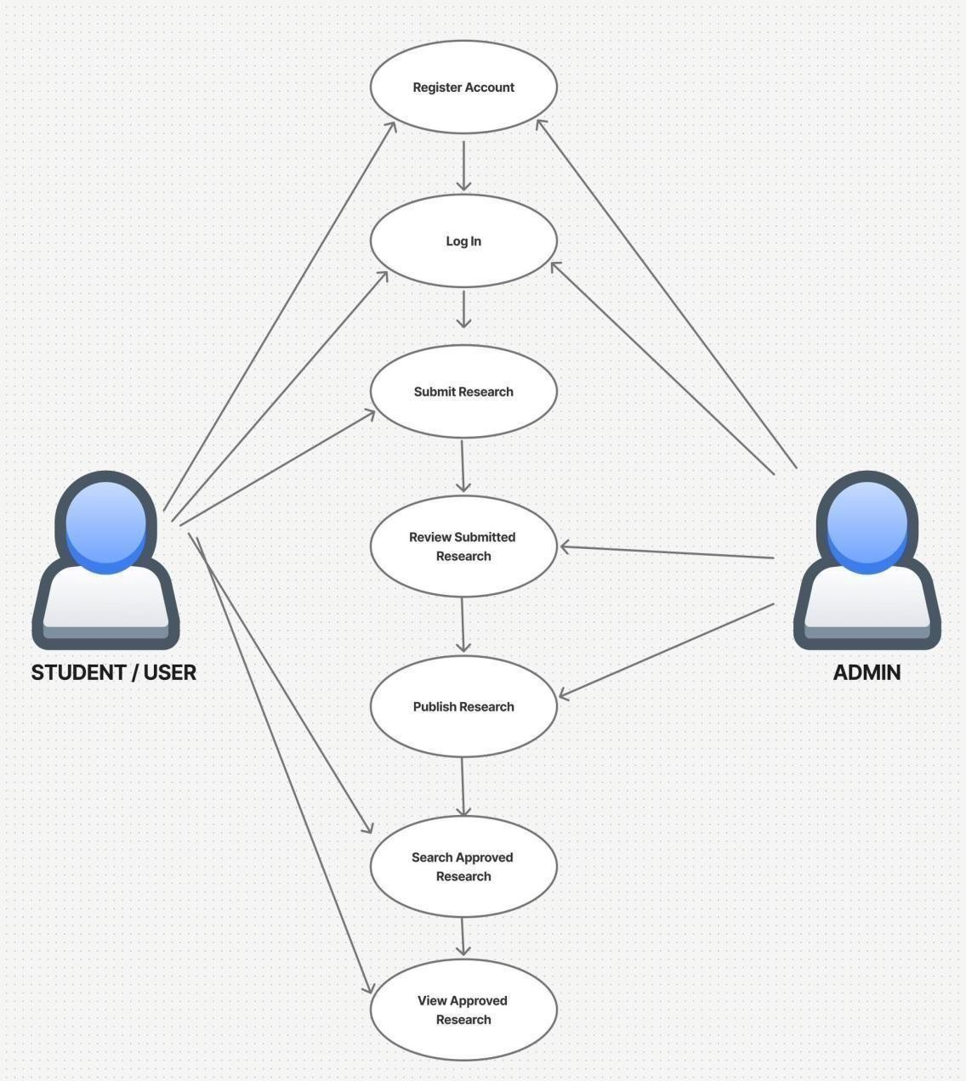

Figure 4.1
Use Case Diagrams of Developed System
Figure 4.1 illustrates a representation of the interactions between the users and the IntelHub system. The use case diagram contains the primary functionalities of the platform and their connections to the two identified actors: the Student/User and the Administrator. New users are linked to the Register Account use case, which enables them to create an account before accessing any system feature, while returning users may proceed directly to the Log In use case.
Once logged in, student users can perform several actions such as Submitting Research, Searching Approved Research, and Viewing Approved Research, which allow them to upload academic outputs and access published studies within the repository. On the other hand, administrators are connected to system-level functions such as Reviewing Submitted Research and Publishing Research, enabling them to evaluate, approve, and make uploaded documents available in the system.

The use case diagram for IntelHub captures the key feature sets of the platform and clearly defines the interactions of both actors with the system. Through these use cases, new users are able to register and gain access, while authenticated users—including both students and administrators—can perform actions appropriate to their roles within the repository.
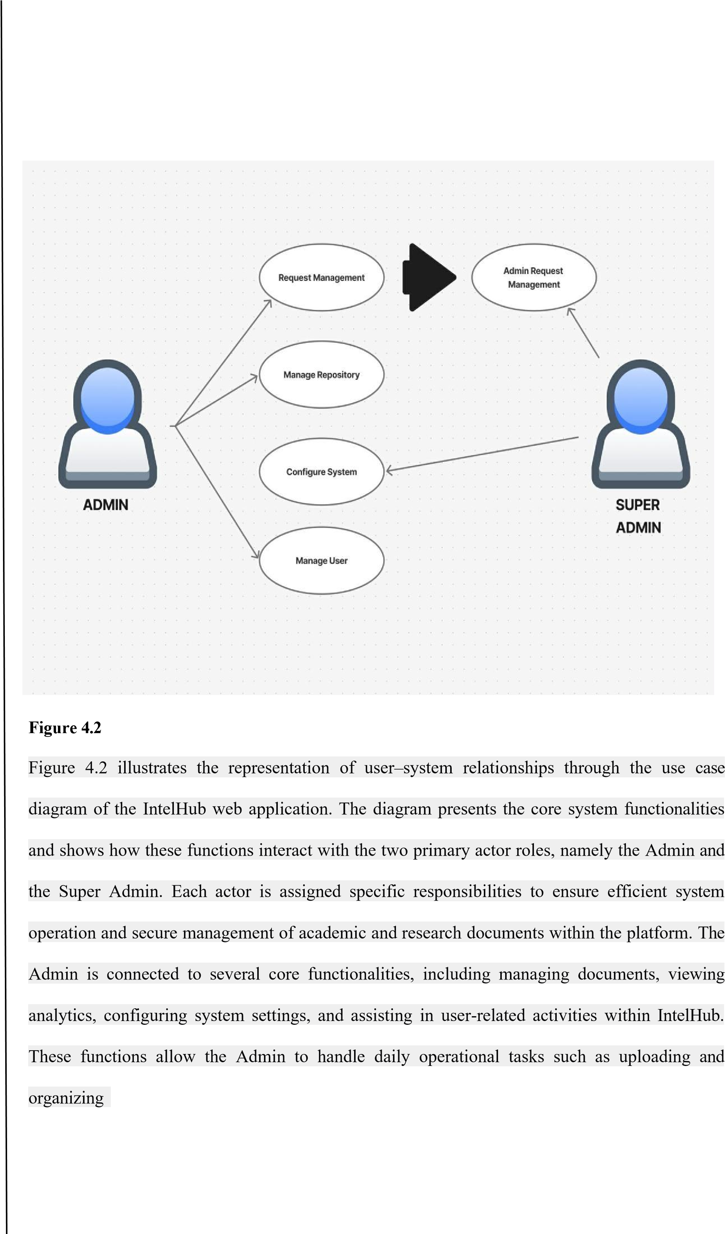
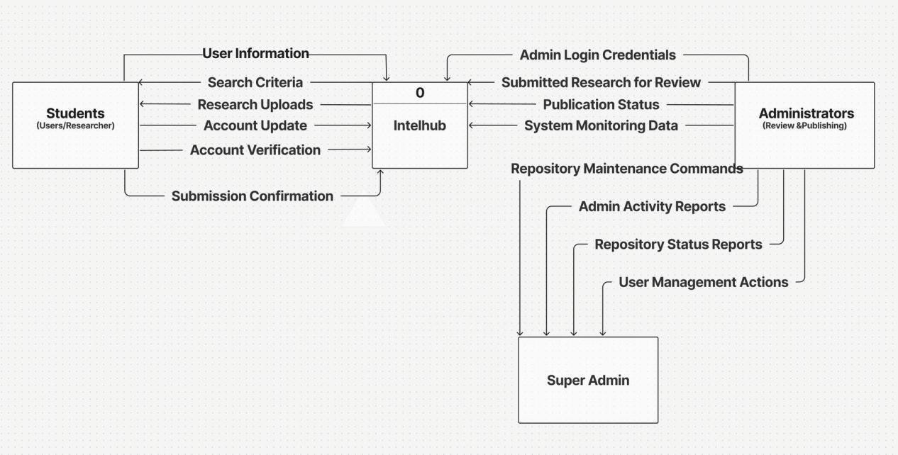

research

files,

monitoring

document

usage,

and

ensuring

that

system

configurations

align

with

institutional

requirements.

On

the

other

hand,

the

Super

Admin

is

linked

to

admin

request

management,

which

serves

as a

centralized

control

function

for handling

critical

system

requests.

This

includes

managing

account
-
related

requests,

approving

document

archiving

or

deletion

actions,

and

overseeing

sensitive

operations

that

require

higher
-
level

authorization.

Through

this

role

separation,

IntelHub

ensures

proper

access

control,

accountability,

and

secure

handling

of

system

resources.

Figure

4.3

Context

Diagram

of

the

Developed

System

A context diagram for IntelHub Research Repository System, illustrating the high
-
level data
flows and interactions among the system and its three main external entities: Students,
Administrators, and the Super Admin. The diagram highlights how each group

communicates with IntelHub by sending inputs and receiving corresponding system
-

generated outputs.

Student users interact with the system by providing inputs such as user information, search criteria, research uploads, account updates, and verification requests. IntelHub processes these inputs and returns outputs including submission confirmations, search results, and access to approved research. This enables students to upload, manage, and search research studies within the platform.
Administrators interact with IntelHub through essential management operations such as submitting login credentials, reviewing submitted research, and issuing publication actions. In return, IntelHub sends outputs such as publication statuses, system monitoring data, and submitted research files for evaluation. These interactions support the administrator’s role in overseeing research approval, publication, and repository quality assurance.

The Super Admin oversees the entire system through higher-level control and monitoring functions. Inputs from the Super Admin include repository maintenance commands, user management actions, and administrative oversight tasks.
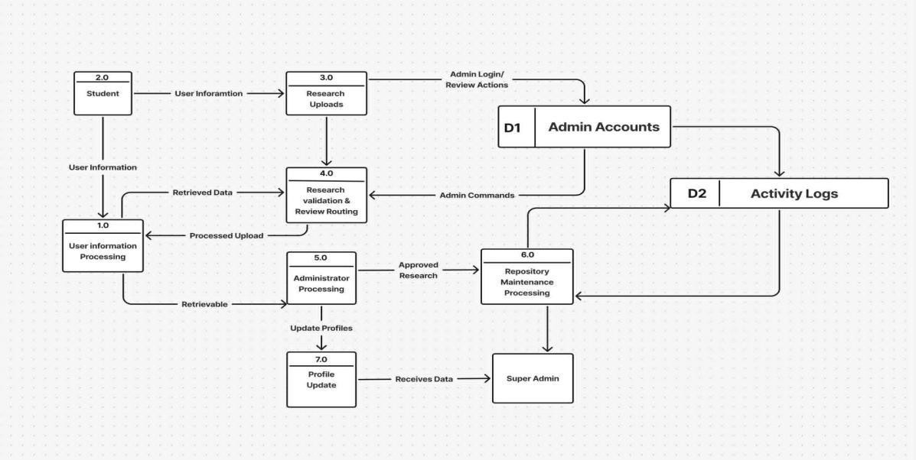

Figure 4.3
Data Flow Diagram of Developed System
The developed IntelHub system streamlined the submission, validation, and publication of research outputs within an academic repository. 1.) First, the user created an account through the system’s registration feature. Once the account was successfully created, the user could log in and gain access to all available functionalities. 2.) After signing in, the user could upload their research files through the Research Uploads sub-process, which processed the input and routed the data for validation. 3.) The uploaded research was then forwarded to the Research Validation and Review Routing sub-process, which checked the completeness, correctness, and formatting of the file. This process coordinated with the Admin Accounts sub-process to retrieve necessary administrator credentials and review actions 4.) Next, the Administrator Processing sub-process handled the actual evaluation of research submissions. Administrators were able to approve, request revisions, or decline entries. 5.) Once a research submission was approved, the system proceeded to the Repository Maintenance Processing sub- process. This component stored validated research outputs, managed metadata, and ensured proper organization of published entries within the repository. 6.) The Super Admin entity received system monitoring data, repository status updates, and administrator activity reports through the same repository maintenance and administrative channels. 7.) Profile- related changes from users and administrators were handled by the Profile Update sub- process. This module updated stored user information and returned confirmation to the requester, ensuring data integrity and allowing both users and administrators to maintain accurate profile details.

8.) Throughout the entire workflow, the User Information Processing sub-process supported all modules by managing stored user data, providing retrieval operations, and ensuring that both user and administrator actions had the required data available. All activities within the IntelHub system revolved around maintaining the integrity of research submissions, ensuring efficient review cycles, and providing administrators and super administrators with the tools needed for repository governance.

The system centralized user data, research uploads, administrative actions, and monitoring components, allowing smooth and coordinated data flow throughout all system processes. The developed IntelHub system was designed to streamline the submission, validation, and publication of research outputs within an academic digital repository. The system integrates multiple processes and user roles to ensure that research materials are handled efficiently, securely, and systematically from submission to publication.
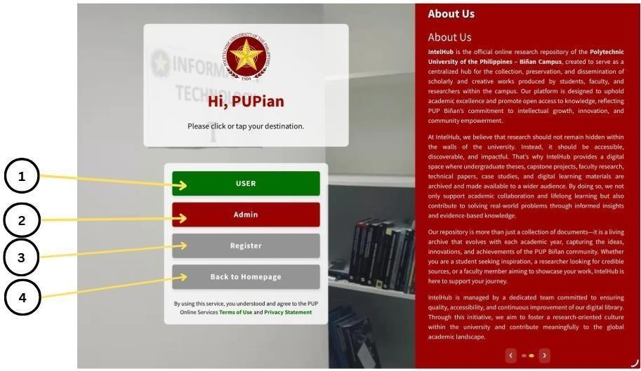
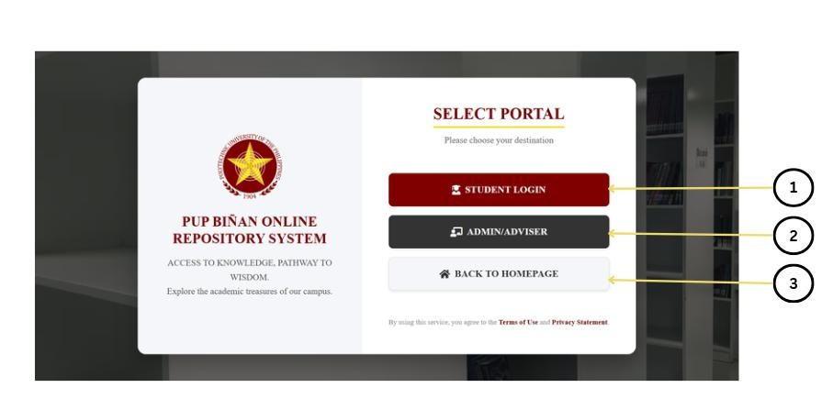

The

following

illustrations

demonstrated

the

user

interfaces

of

the

system:

Figure
4.
4

Portal Selection Interface

This figure presents the
portal selection interface

of the PUP Biñan Online Repository
System, which allows users to choose the appropriate access point based on their role.
(1)

This
button directs student users to the Student Login portal, enabling them to access the system
using their registered student credentials.
(2)

This option is intended for administrators and
advisers, allowing authorized personnel to log in and manage research submissions, approvals,
and system
-
related tasks.
(3)

This button allows users to return to the homepage of the system
if they choose not to proceed with any login option or wish to navigate back to the main
interface.

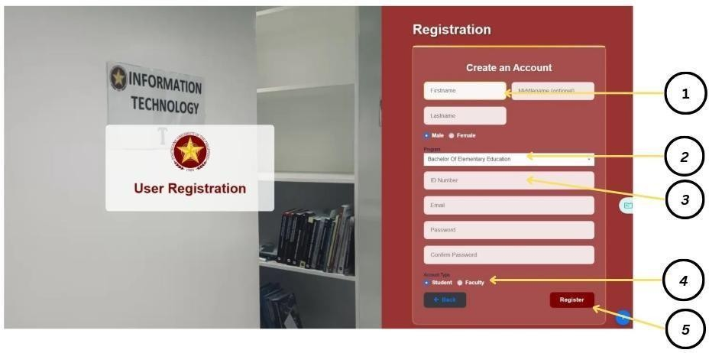
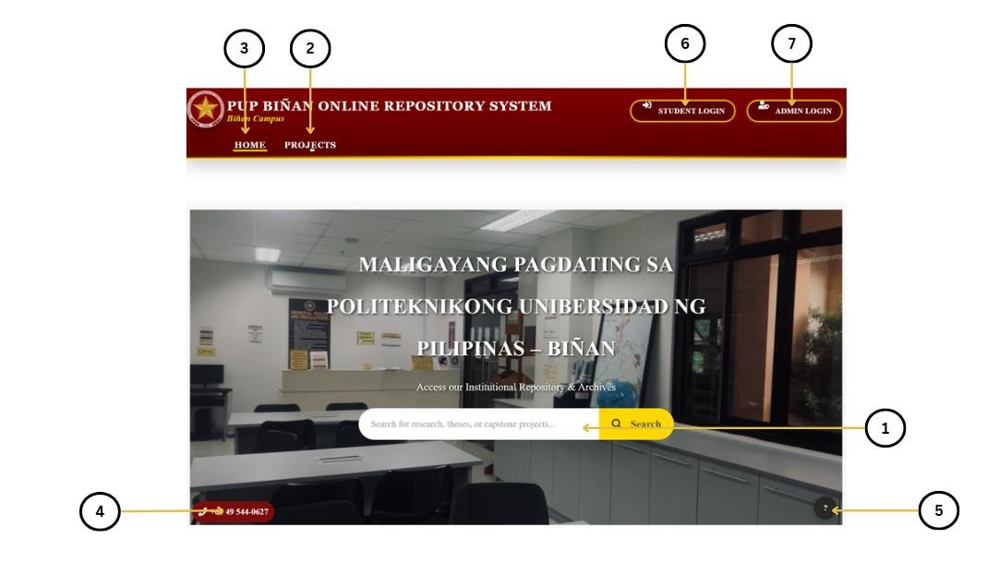

Figure
4.
5

Homepage Interface of the PUP Biñan Online Repository System

This figure shows the
homepage interface

of the PUP Biñan Online Repository System,
highlighting the main navigation and access features.
(1)

The search bar allows users to search
for research papers, theses, and capstone projects using keywords.
(2)

The
Projects

navigation
option directs users to the section containing archived academic outputs, while
(3)

the
Home

option allows users to return to the main homepage.

(4)

This section displays the institution’s
contact information for user reference.
(5)

The help icon provides access to system assistance
and support features.
(6)

The Student Login button allows students to access personalized
system functions, while
(7)

the Admin Login button enables authorized personnel to manage
research content, approvals, and user roles.

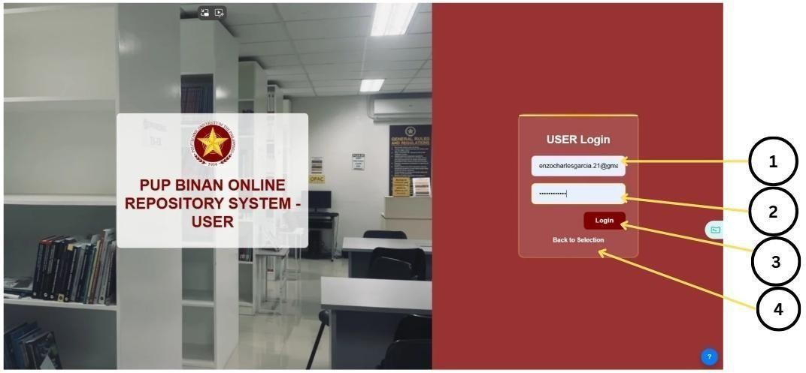
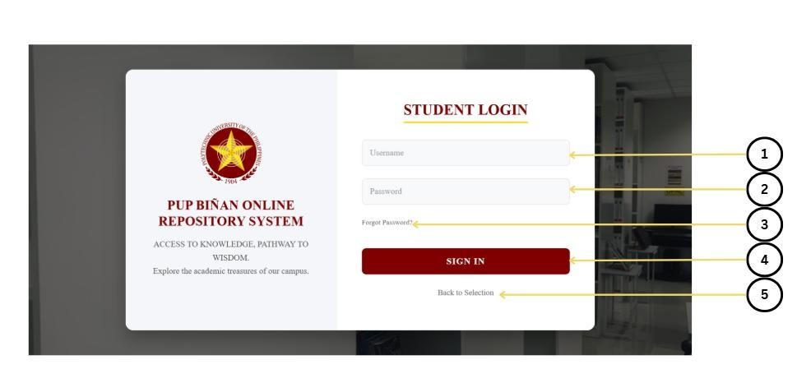

Figu
r
e
4.
6

Student Login Interface

This figure presents the
student login interface

of the PUP Biñan Online Repository
System.
(1)

This field requires the student to enter the registered username to allow the system
to identify the user account.
(2)

This field is used to input the password associated with the
account to authenticate login credentials securely.
(3)

This option allows the student to recover
or reset the password in case it has been forgotten.
(4)

The
Sign In

button enables the student to
proceed with the login process and access the system dashboard.
(5)

This option allows the user
to return to the portal selection page.

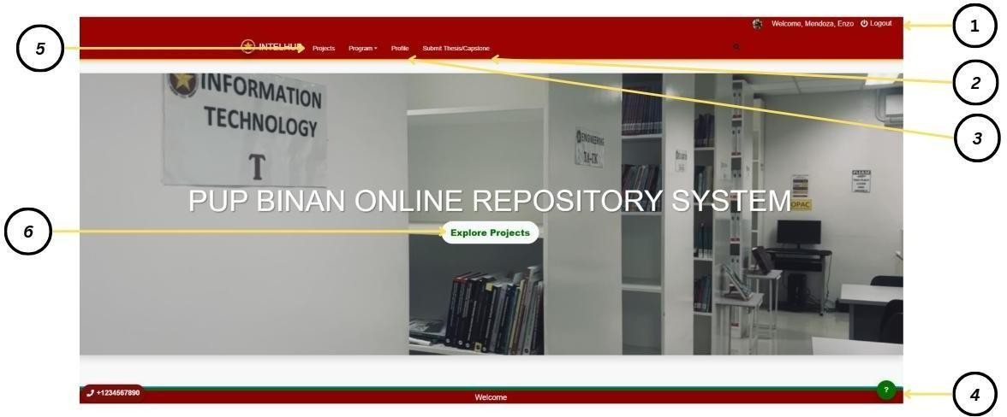
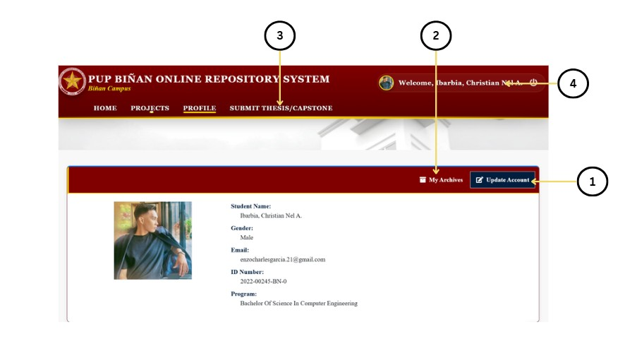

Figure
4.
7

User Profile Interface

This figure shows the
user profile interface

of the PUP Biñan Online Repository System.
(1)

This button allows the user to update account information and manage personal details
associated with the profile.
(2)

This section displays the logged
-
in user’s name and account
status, confirming successful authentication.
(3)

This navigation option directs the user to the
thesis or capstone submission page, enabling the uploading of academic requirements.
(4)

This
option allows the user to log out of the system, ensuring secure termination of the active
session.

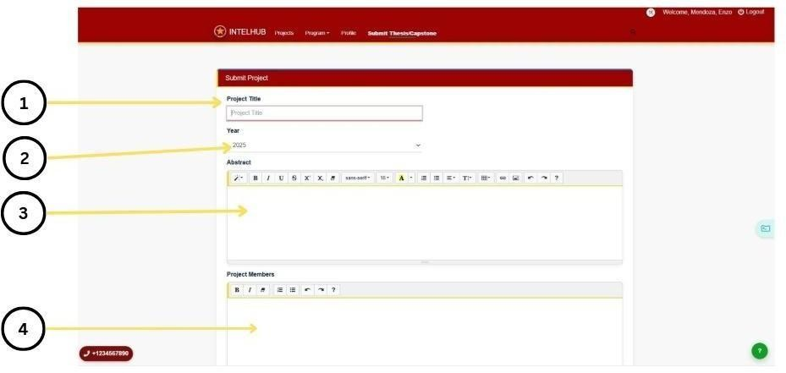

Figure 4.8

User Submit Project Interface
This interface shows how the user will submit research: 1.) In this field, the user must enter the complete and official title of their research, ensuring it accurately represents the focus and scope of their study. 2.) the user needs to specify the year the research was conducted or completed, helping the system categorize and organize submissions based on their publication timeline.3.) This area is intended for the user to provide the abstract, which includes a summary of the research objectives, methodology, key findings, and overall significance of the study. 4.) Indicate here you complete list of your research members.

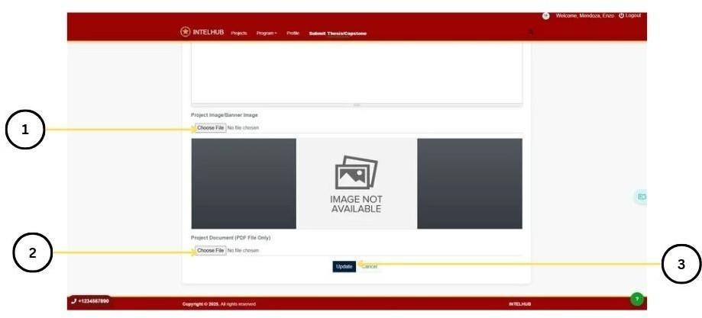

Figure 4.9.1

User Submit Project Interface
This interface shows how the user will submit research: 1.) Select an image file from your device that will be used as the visual banner or header for your research submission, ensuring it represents your work clearly and professionally. 2.) Browse your device and select the PDF version of your research paper, making sure it is complete, properly formatted, and ready for official submission. (PDF). 3.) After selecting both the banner and your research document, click this button to begin the upload process, which will securely submit your research to the system for review and storage.

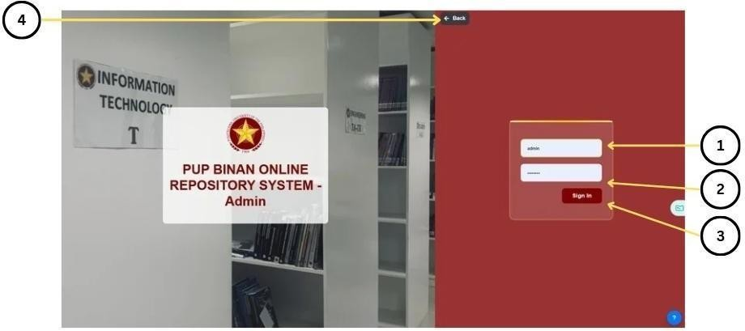
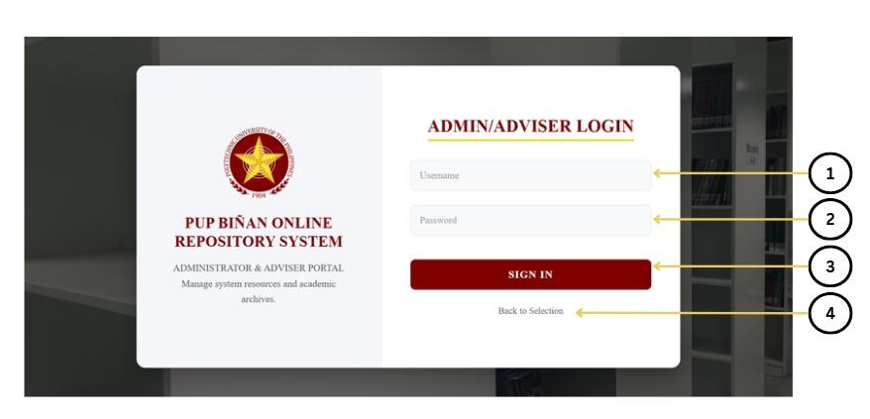

Figure

4.10

Admin

Login

Interface

Figure 4.10 shows the Admin Login Interface of the IntelHub Online Repository System,
which was specifically designed for system administrators to securely access administrative
features of the platform. 1.) This field was where the administrator entered their registered
username to gain access to the system. 2.) This field was where the administrator typed in
their corresponding password to authenticate their login credentials. 3.) Clicking this button
initiated the login process and allowed the administrator to proceed to the admin dashboard
upon successful verification. 4.) This button redirected the user back to the previous page,
providing an easy way to return to the main interface if the administrator chose not to log in.

.

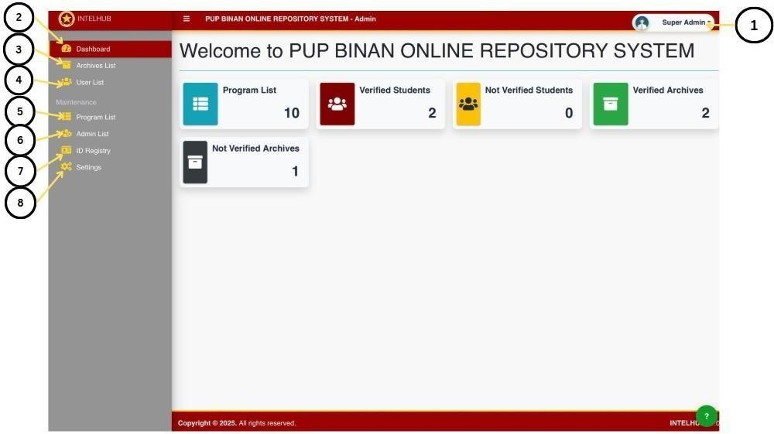

Figure

4.11

Dashboard

This interface shows how the administrator navigates and manages different sections of
the PUP Binan Online Repository System. 1.) Click super admin if you want to Logout, or
see Account. 2.) The overview page. 3.) Navigation link to the list of thesis archives where
the admin can view, approve, or reject submitted projects. 4.) Navigation link to the list of
registered users where the admin can view and manage user accounts. 5.) Navigation link to
manage academic programs (add, edit, remove programs that projects are assigned to). 6.)
Shows existing administrator accounts; the super admin can add, edit, or remove admin users
from this section.

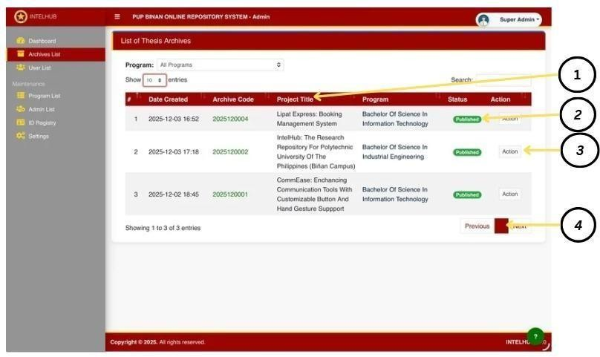
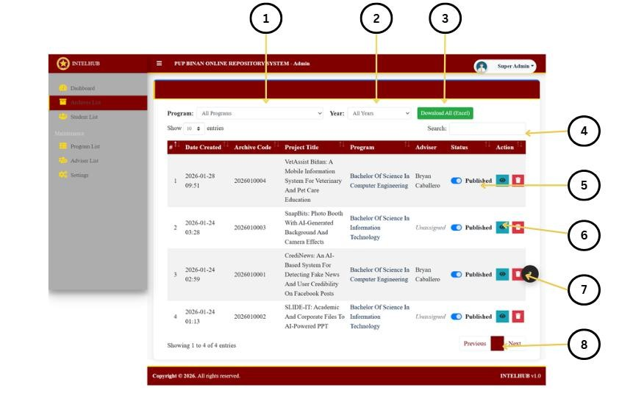

7.)
A module that displays student ID numbers and related registry details for verification

and record
-
keeping. 8.) System settings area where the admin can configure system options,
edit site preferences, and adjust account settings.

Figu
r
e
4.
12

Admin Archive Management Interface

This figure shows the
admin archive management interface

of the IntelHub (PUP Biñan
Online Repository System).
(1)

This dropdown allows the administrator to filter archived
projects by program.
(2)

This dropdown enables filtering of records by year.
(3)

This button
allows the administrator to download archived records in Excel format.
(4)

The search bar
enables quick retrieval of archived projects using keywords.

(5) This control allows the administrator to change the publication status of a project. (6) This button allows the administrator to edit project details. (7) This button enables the deletion of selected archive records. (8) The pagination controls allow navigation through multiple pages of archived project entries.
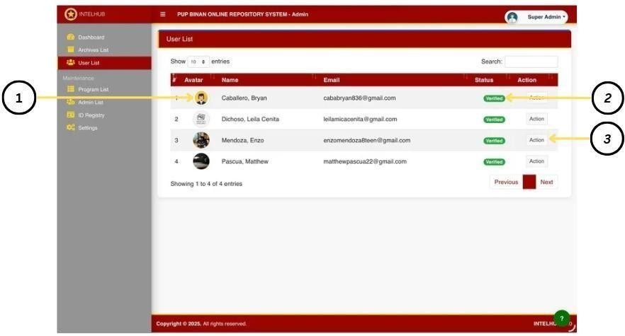

Figure4.13

Student List Management Interface
This figure presents the student list management interface of the IntelHub admin module. (1) This button allows the administrator to create a new student account. (2) The search bar enables quick filtering of student records using keywords. (3) This column displays the current verification status of each student account. (4) The action button provides options to manage individual student records. (5) The pagination controls allow navigation through multiple pages of student entries.
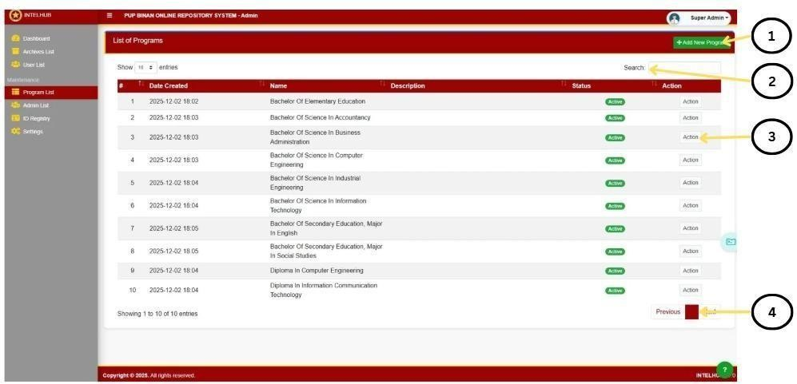

Figure

4.14

Program

List

Figure 4.14 presents the Program List. 1.) This section contains the Add New Program
button used to register a new academic program. It also includes display controls for

selecting how many entries appear per page. 2.) This area contains the search box, which
allows administrators to quickly filter and locate program records by typing keywords such

as program name or description. 3.) Each program row includes an Action button that
expands to management options typically View, Edit, and Delete enabling administrators to
inspect details, update program information, or remove a program from the system. 4.) These
buttons (Previous / Next) allow the administrator to navigate between pages of program
records when the total number of entries exceeds the rows shown on a single page.

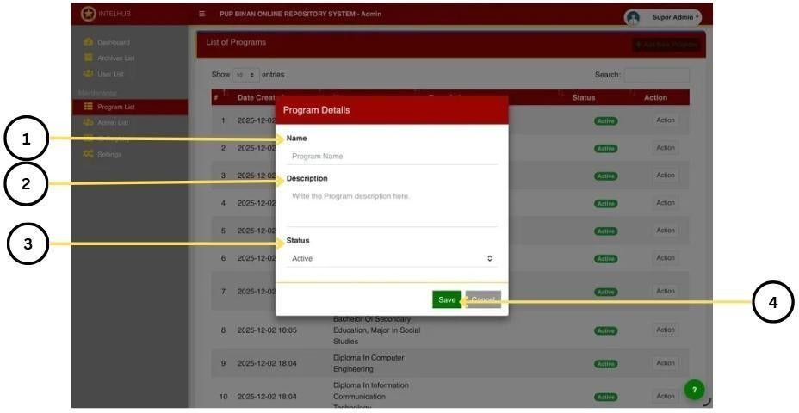

Figure

4.14.1

Program

List

Figure 4.14 illustrates the User List Interface of the IntelHub system, which allows
administrators and super admins to monitor and manage registered users. 1.) This input box
allows the administrator to enter or update the official name of the academic program.

It
ensures that each program is properly labeled before being saved into the system. 2.) This
section provides a text area where the administrator can write a brief description of the
program. It helps identify the program’s purpose or scope for easier reference.

3.) This component determines whether the program is Active or Inactive. Setting the correct status ensures that only valid and currently offered programs appear in other parts of the system. 4.) These buttons allow the administrator to either save the entered information or cancel the operation. Selecting “Save” updates the program list, while “Cancel” closes the modal without making any changes.

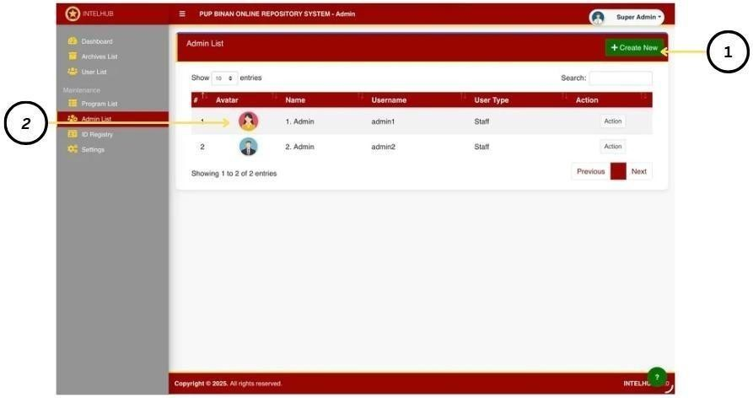

Figure 4.15
Admin List
Figure 4.15 This interface displays the section where the super admin manages all administrator accounts in the system. 1). Allows the super admin to add a new administrator account to the system by opening the admin creation form. 2.) Displays the list of existing admin accounts, including their avatar, name, username, and user type. The action column allows the super admin to edit or remove admin accounts when necessary
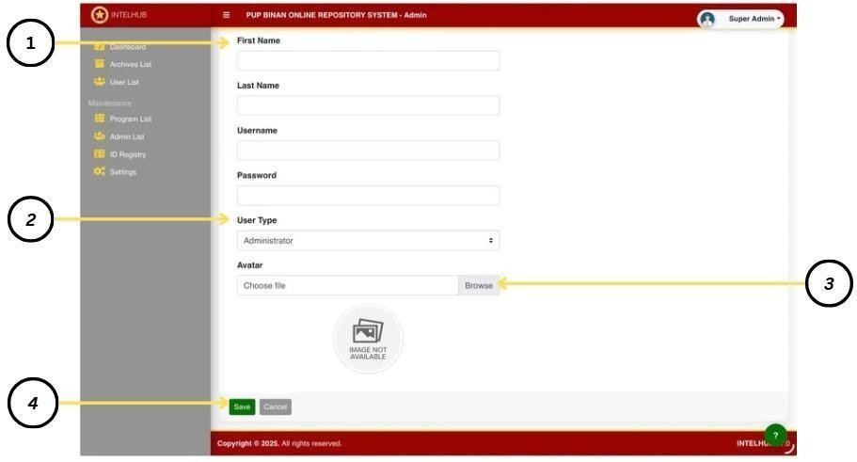

Figure

4.15.1

Admin

List

Figure 4.15 displays the Admin Account Creation Form, which appears when the Super
Admin selects the “Create New Admin” button from the Admin Management Interface.1.)
This section collects the First Name, Middle Name, and Last Name of the person being
registered as an administrator. 2.) This is User Type (Administrator only). 3.) This section
provides the option to upload an avatar image for the new admin account.4.)

T
he Save and
Cancel buttons, allowing the Super Admin to either finalize the account creation or discard
the

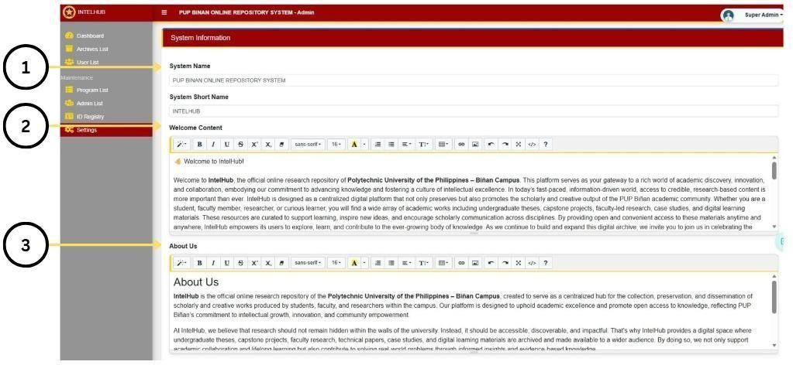

Figure

4.17

Settings

Figure 4.17 presents Settings. 1.) This section displays the System Name and System
Short Name fields, which allow administrators to configure or update the official name and
abbreviate label of the repository system. These fields ensure proper branding across the
platform. 2.) This area contains the Welcome Content editor. It provides a rich
-
text interface
where administrators can create or modify the welcome message shown to users on the main
page. Formatting tools such as bold, italics, alignment, lists, and font sizing are available to
customize the message’s appearance. 3.) This section features the About Us editor, which
functions similarly to the Welcome Content editor. Administrators use this space to write or
update the platform’s background information, mission, and purpose.

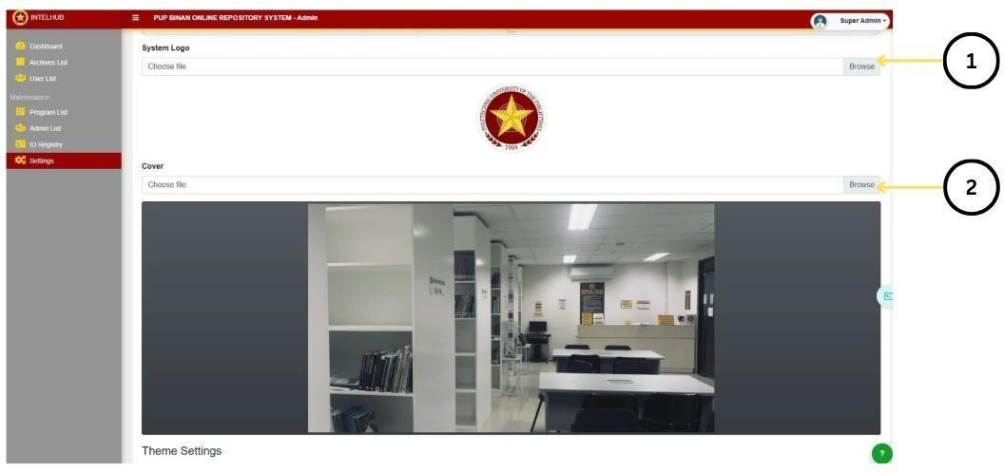

Figure

4.17.1

Settings

Figure 4.17.1 presents Settings. 1.) This part contains the Choose File button used to
upload the system logo. Administrators can select an image file that represents the official
branding icon displayed throughout the system interface. 2.) This area provides the Choose
File option for uploading the system’s cover image. The cover photo enhances the system’s
visual identity and typically appears on the homepage or login page, allowing administrators
to customize the platform’s overall appearance.

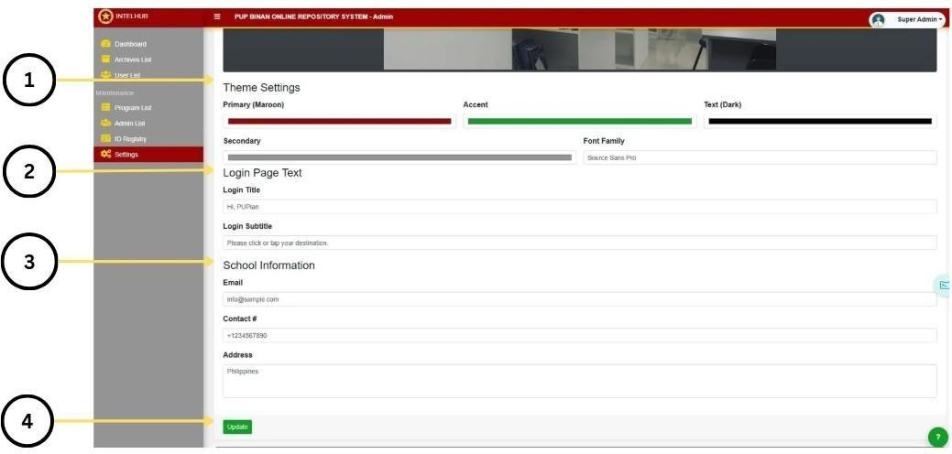

Figure

4.17.2

Settings

Figure 4.17.2 presents Settings 1.) The Themes Settings area allows administrators to
select from the available theme options to customize the system’s overall appearance,
including interface colors and layout style. 2.) The Login Page Text section contains
dedicated input fields for the Login Title and Login Subtitle. These fields allow
administrators to personalize the text displayed on the login page, ensuring that the welcome
message and supporting description clearly communicate the system’s purpose. 3.) The
School Information section includes input fields for the institution’s Email, Contact Number,
and Address. Administrators use these fields to maintain accurate and up
-
to
-
date school
details, which may be displayed across various areas of the system.

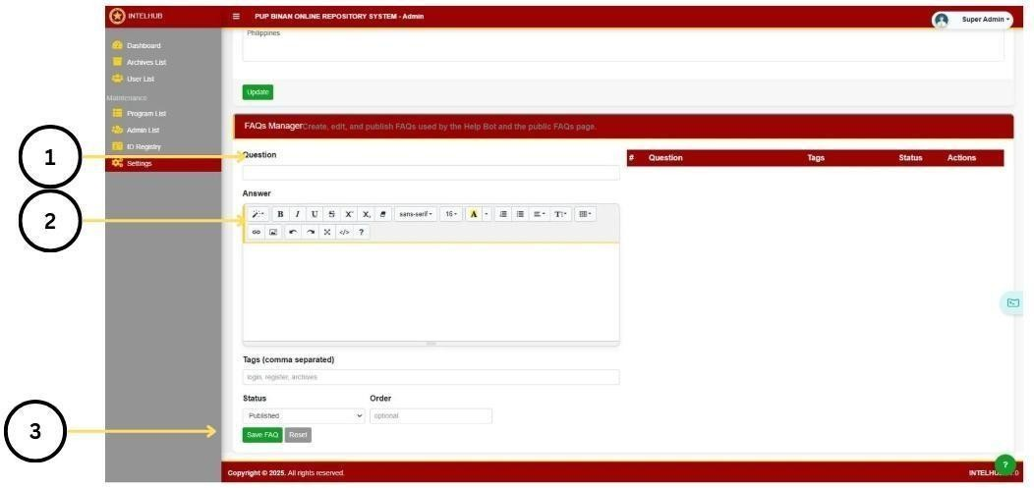

Figure

4.17.3

Settings

Figure 4.17.3 presents Settings. 1.) This section contains the input field for entering a new
FAQ
Question
. Administrators type the inquiry here, which will appear on the Help Bot and
public FAQs page once published. 2.) This area provides the rich
-
text editor for composing
the

Answer
.

The editor

includes

formatting

tools

such

as bold, italic,

lists,

alignment, and

font
size options, enabling administrators to write clear and well
-
formatted responses. 3.) This

part includes the FAQ management controls, such as selecting the
Status
(
Published or

Draft), defining
Tags
, setting the
Order
, and saving or resetting the entry. The
Save FAQ
button finalizes the creation or update of the FAQ item, while
Reset
clears the fields for new
input.

Implementation
The Implementation phase of IntelHub represents the transformation of its conceptual system design into a fully functional academic repository specifically tailored to the needs of PUP Biñan Campus. At this stage, all technical components—backend logic, user flows, database structures, and cloud integration—are developed to bring the system into operational form. IntelHub is built to serve as the official platform where students submit their research papers as part of their graduation clearance requirement, ensuring a more efficient, centralized, and secure method for the campus to manage research output.

The system focuses primarily on student-driven submission. Only graduating students are required to upload their research paper through IntelHub before the librarian signs their clearance. This digital process replaces the previous manual system, ensuring that research papers are properly archived, easily verifiable, and securely stored for institutional reference. Faculty users may access or review submissions, but research uploading is exclusively for students using their Student ID Number as the primary login credential. This safeguards authenticity while preventing unauthorized submissions.

IntelHub was developed using a hybrid backend architecture. PHP manages the server-side functions such as authentication, form handling, data validation, and database transactions for student submissions. For background operations such as file processing, notifications, or assisting with automated repository tasks, Node.js is integrated into the workflow. This dual- backend setup ensures system efficiency and flexibility for potential future enhancements.
The platform initially uses MySQL as its primary database to store user information, research metadata, submission records, and system logs. Recognizing the need for scalability, real-time monitoring, and smoother administrative workflows, IntelHub is progressively migrating to Firebase, which will later support activity logs, document tracking, and cloud- based data operations. This hybrid approach ensures both stability and scalability during and after deployment.
To ensure secure and long-term storage of academic papers, IntelHub utilizes AWS Cloud Storage. All uploaded research files—restricted to PDF and DOCX formats—are stored within AWS buckets, providing durability, redundancy, and efficient retrieval. AWS also ensures that research archives remain protected from data loss and accessible for future institutional needs.

Hosting and deployment are handled through Hostinger, providing a stable execution environment for the PHP backend and public system access. Hostinger’s infrastructure supports domain configuration, automated backups, and optimized performance for student uploads and admin review processes.
The front-end interface is developed using HTML, CSS, and JavaScript, ensuring accessibility, usability, and intuitive navigation. Students can easily upload research documents, view submission status, and monitor their compliance with graduation requirements using any device. Public-facing modules support both desktop and mobile browsing to maximize accessibility.
However, the Admin Panel is restricted to desktop-only use. This is intentional because reviewing submissions, managing metadata, validating research authorship, and monitoring repository status require detailed views, tables, and structured forms that are unsuitable for mobile screens. Limiting admin access to desktop interfaces maintains accuracy, reduces user errors, and preserves institutional data integrity.
The implementation phase successfully unifies all essential elements—student submission workflows, cloud-based storage, administrative review logic, user interface design, and backend operations—into a cohesive system. IntelHub now stands as a secure, structured, and scalable digital repository that supports the campus’ academic documentation needs while ensuring a smooth and trackable clearance process for graduating students.

Acceptance
The acceptance phase marked the point where stakeholders confirmed that IntelHub met all required functionalities and fulfilled the project’s objectives. This stage signified the final checkpoint before the system could be deployed as the official research submission platform for PUP Biñan Campus. As Sommerville (2021) states, “Acceptance is the process by which stakeholders validate that a software system meets its specified requirements and is ready for operational use.” This guided the evaluation of IntelHub to ensure its readiness for real- world use.
The acceptance process involved system testing and user acceptance testing (UAT), focusing on functionality, usability, security, reliability, performance efficiency, compatibility, and documentation review. Functional testing verified essential capabilities such as student login using ID numbers, PDF/DOCX research uploads, and admin review tools. Performance checks confirmed stable upload handling and backend responsiveness. Security assessment ensured proper access control and safe file storage through AWS.
Usability and compatibility testing verified that students could easily upload research using various devices, while the admin panel performed consistently on desktop, as designed. Documentation review ensured that system processes and technical details were complete and accurate.

Through this acceptance phase, stakeholders validated that IntelHub met institutional requirements, operated reliably, and was ready for deployment as an official academic tool supporting the research submission and clearance process.

Deployment
Deployment marked the stage where IntelHub transitioned from the development environment into a functional, accessible platform for its intended users. This phase ensured that the system was stable, secure, and fully prepared for use by students submitting their research and administrators managing the repository.
The system was deployed using Hostinger’s hosting environment, where the backend built with PHP and Node.js was configured for live operation. The MySQL database was connected to the production server, and preparations were made for the transition to Firebase for future scalability. AWS Cloud Storage was also integrated to securely store student research files upon upload. Domain configuration and server linking ensured that the system could be accessed publicly without issues.
Before the full rollout, IntelHub was tested across multiple browsers and devices to ensure accessibility and consistent performance. Students were able to access the public-facing pages on both mobile and desktop devices, while the admin panel remained limited to desktop use for stability and security. Additional checks verified that only authorized users— students and administrators—could perform sensitive actions such as uploading or reviewing research outputs.

After deployment, the development team performed minor adjustments, resolved small bugs, and optimized upload speed and system responsiveness. This continuous improvement approach ensured that IntelHub remained reliable as more students began submitting their research for clearance.
Through this deployment process, IntelHub successfully transitioned into a fully operational academic platform supporting research submission, verification, and institutional archiving for PUP Biñan Campus.

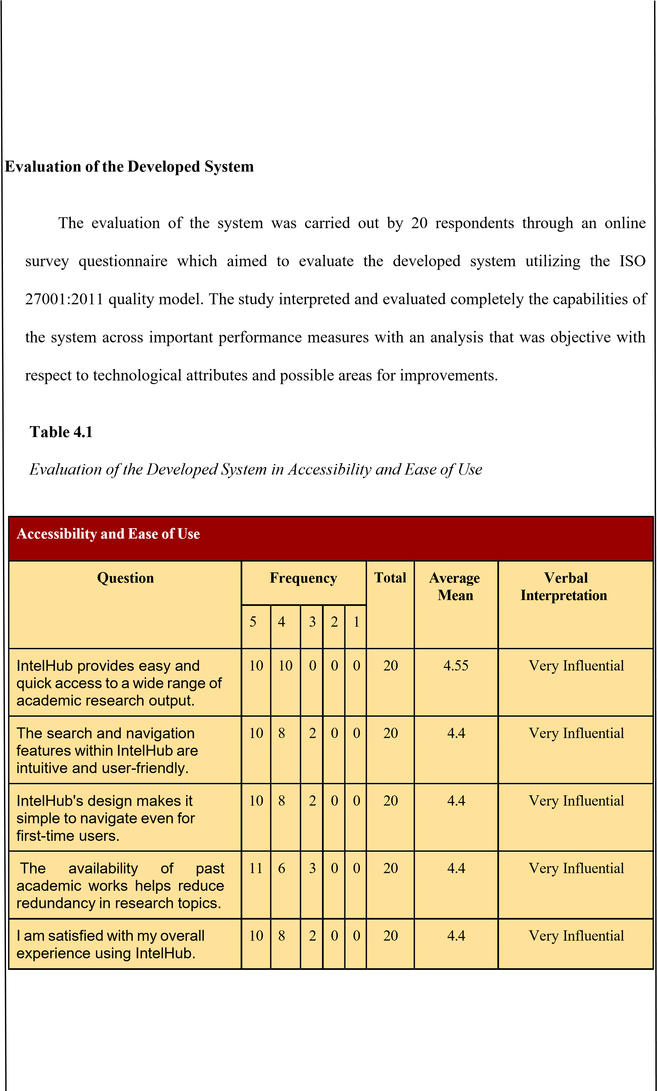
Table 4.1 presents a clear evaluation of IntelHub’s accessibility and ease of use. The system demonstrated consistently high performance across all indicators, with mean scores ranging from 4.40 to 4.55, all interpreted as Very Influential. These results show that IntelHub effectively supports users in navigating academic research outputs with ease and efficiency. The platform’s highest rating (4.55) highlights its ability to provide quick and convenient access to research materials, while its strong scores in navigation, design clarity, reduced topic redundancy, and overall satisfaction further affirm its usability.

ISO 27001:2011 defines usability and accessibility as the degree to which a system enables users to achieve goals effectively, efficiently, and satisfactorily under specific conditions. The positive feedback gathered from respondents indicates that IntelHub meets these expectations, showing its capability to support academic processes through intuitive design and dependable functionality. Overall, the findings confirm that IntelHub upholds a strong standard in accessibility and ease of use, validating its role as a student-centered research platform.

Table 4.2

Evaluation of the Developed System in Search, Organization & Retrieval

Search, Organization & Retrieval
Question |  | Frequency |  |  |  | Total | Average Mean | Verbal Interpretation
 | 5 | 4 | 3 | 2 | 1
I can easily find specific research documents using the categorization and metadata tagging features. | 11 | 9 | 0 | 0 | 0 | 20 | 4.55 | Very Influential
IntelHub supports academic excellence by providing organized research resources. | 12 | 7 | 1 | 0 | 0 | 20 | 4.55 | Very Influential
IntelHub's tagging features allow for efficient organization and retrieval of research documents. | 11 | 5 | 4 | 0 | 0 | 20 | 4.35 | Very Influential
The platform promotes visibility of research outputs from PUP Biñan Campus. | 10 | 8 | 2 | 0 | 0 | 20 | 4.40 | Very Influential
IntelHub contributes to effective institutional knowledge management. | 13 | 5 | 2 | 0 | 0 | 20 | 4.55 | Very Influential
Table 4.2 provides a comprehensive evaluation of IntelHub’s search, organization, and retrieval functions. All indicators received very high ratings, with mean scores ranging from 4.35 to 4.55, interpreted as Very Influential. These results demonstrate that IntelHub performs strongly in helping users locate, organize, and retrieve academic research outputs efficiently. The highest ratings (4.55) highlight the system’s effective categorization, metadata tagging, and its contribution to institutional knowledge management.
Meanwhile, scores between 4.35 and 4.40 confirm solid performance in visibility of research outputs and overall resource organization. ISO 27001:2011 defines information organization and retrieval as crucial components of functional suitability and information quality, ensuring that users can access needed resources accurately and efficiently. The consistently high results show that IntelHub meets these standards, supporting academic excellence by providing properly structured research resources and enhancing accessibility to institutional outputs. Overall, the findings affirm that IntelHub maintains a strong capability in organizing academic content and facilitating seamless research retrieval for its users.

Table 4.3

Evaluation of the Developed System in Contribution to Academic & Research Work
Contribution to Academic & Research Work
Question | Frequency |  |  |  |  | Total | Average Mean | Verbal Interpretation
 | 5 | 4 | 3 | 2 | 1
IntelHub has improved my ability to conduct literature reviews. | 7 | 12 | 1 | 0 | 0 | 20 | 4.30 | Very Influential
The platform motivates students by preserving their work academically. | 9 | 10 | 1 | 0 | 0 | 20 | 4.40 | Very Influential
IntelHub contributes to a stronger research culture within PUP Biñan Campus. | 12 | 7 | 1 | 0 | 0 | 20 | 4.55 | Very Influential
IntelHub effectively addresses challenges of research storage and accessibility. | 8 | 10 | 2 | 0 | 0 | 20 | 4.30 | Very Influential
I would recommend IntelHub to other students for research purposes. | 9 | 10 | 1 | 0 | 0 | 20 | 4.40 | Very Influential
Table 4.3 summarizes how IntelHub supports academic and research-related activities within PUP Biñan Campus. The results show consistently strong ratings, ranging from 4.30 to 4.55, all interpreted as Very Influential. These scores indicate that IntelHub significantly contributes to students’ research experience, particularly in improving literature review processes, motivating academic productivity, and strengthening the research culture of the institution. The highest mean (4.55) reflects IntelHub’s strong role in promoting a positive research environment, while the remaining high scores confirm its effectiveness in enhancing accessibility and recommending the system to future users.

According to ISO 27001:2011, a system’s capability to support user tasks and institutional goals is a key indicator of functional suitability. The responses affirm that IntelHub meets these expectations by providing reliable access to research outputs, supporting student engagement, and addressing challenges related to research storage and availability. Overall, the findings demonstrate that IntelHub serves as a valuable academic tool, contributing meaningfully to both student work and the broader research culture of PUP Biñan Campus.

Table 4.4

Evaluation of the Developed System in System Process, Security & Role Management

System Process, security & Role Management
Question | Frequency |  |  |  |  | Total | Average Mean | Verbal Interpretation
 | 5 | 4 | 3 | 2 | 1
Uploading and submitting documents is straightforward. | 11 | 8 | 1 | 0 | 0 | 20 | 4.50 | Very Influential
IntelHub ensures secure storage and preservation of academic outputs. | 10 | 8 | 2 | 0 | 0 | 20 | 4.40 | Very Influential
The system’s role-based access control (students, faculty, etc.) is appropriate. | 10 | 8 | 2 | 0 | 0 | 20 | 4.40 | Very Influential
The platform helps reduce reliance on paper-based archiving. | 12 | 6 | 2 | 0 | 0 | 20 | 4.50 | Very Influential
I would recommend IntelHub to students, faculty, or administrators at PUP Biñan Campus. | 12 | 8 | 0 | 0 | 0 | 20 | 4.60 | Very Influential
Table 4.4 presents the respondents’ assessment of IntelHub’s system process, security features, and role-based management. The results show high mean scores ranging from 4.40 to 4.60, all interpreted as Very Influential. These findings indicate that users consider the platform effective in facilitating easy document submission, ensuring secure storage of academic outputs, and implementing appropriate access controls for different user roles. The highest rating (4.60) highlights users’ strong confidence in recommending the system to various stakeholders within PUP Biñan Campus.
Aligned with ISO 27001:2011, these results reflect the system’s capability to support secure and efficient workflows, particularly in handling institutional research outputs. IntelHub’s contribution to reducing paper-based archiving further demonstrates its role in improving digital management practices across the campus. Overall, Section 4 confirms that IntelHub successfully meets user expectations for secure storage, streamlined processes, and proper access management, reinforcing its value as a reliable institutional research platform.
Accessibility & Ease of Use, Search & Retrieval, Academic Contribution, and System Process & Security—revealed consistently high user satisfaction, with mean scores ranging from 4.30 to 4.60, all interpreted as Very Influential. These results indicate that IntelHub effectively fulfills its core purpose as a digital research repository and clearance-support system for PUP Biñan Campus.

Section 1 showed that users find the platform highly accessible and easy to navigate, with clear interfaces and smooth interaction flow. Section 2 highlighted the strength of IntelHub’s organizational structure, particularly its metadata tagging and categorization features, which facilitated efficient retrieval of research documents. Section 3 emphasized the system’s academic impact, demonstrating how IntelHub supports literature review, strengthens research culture, and preserves institutional knowledge. Finally, Section 4 confirmed strong system performance in document submission processes, secure storage, and proper role- based access control, while also validating its capacity to reduce paper-based archiving.

Table 4.5

Summary of the Evaluation of the Developed System
Criteria | Mean | Verbal Interpretation
Accessibility and Ease of Use | 4.46 | Strongly Agree
Search, Organization & Retrieval | 4.48 | Strongly Agree
Contribution to Academic & Research Work | 4.39 | Strongly Agree
System Process, security & Role Management | 4.48 | Strongly Agree
Overall Mean | 4.45 | Strongly Agree
In the summary table, it can be inferred that the evaluation of the IntelHub system yielded highly encouraging results across all assessed criteria. Accessibility and Ease of Use achieved a mean score of 4.46, interpreted as Strongly Agree, indicating that users found the system easy to navigate, accessible, and efficient in supporting academic research submission and retrieval processes.

Search, Organization, and Retrieval obtained a mean score of 4.48, reflecting strong user agreement on IntelHub’s capability to structure, categorize, and retrieve research outputs effectively. This result highlights the system’s ability to manage academic data in an organized and secure manner, supporting efficient access to institutional research materials. Contribution to Academic and Research Work recorded a mean score of 4.39, confirming that IntelHub positively supports research activities, strengthens institutional research culture, and promotes academic continuity.
System Process, Security, and Role Management also achieved a mean score of 4.48, demonstrating strong confidence in the system’s secure operations, controlled access, and role-based management features. These findings align with the principles of ISO 27001, which emphasize information security, confidentiality, integrity, and availability. The overall evaluation of IntelHub resulted in an overall mean of 4.45, verbally interpreted as Strongly Agree.

Overall, IntelHub performed strongly across all evaluation criteria. The system is secure, reliable, and user-centered, effectively safeguarding academic research outputs while ensuring accessibility and efficient management. Most importantly, IntelHub meets institutional security standards and supports students and administrators by providing a trustworthy and compliant research repository platform aligned with ISO 27001 information security requirements.
Chapter 5

SUMMARY OF FINDINGS, CONCLUSIONS, AND RECOMMENDATIONS
This chapter contains the summary, findings, conclusions, and recommendations of the research. It assessed the overall success of the study concerning its objectives and goals.
Furthermore, it discussed the limitations and projections for future research.

Summary of Findings
The comprehensive evaluation of IntelHub demonstrated strong and consistent performance across all major dimensions of its design and purpose, yielding an overall weighted mean of 4.45, interpreted as Very Influential. The results highlight the system’s effectiveness in streamlining student research submission, organizing academic outputs, and supporting the clearance workflow for graduating students.

Findings from the four evaluation sections emphasize IntelHub’s reliability as a digital repository. Section 1 confirmed high accessibility and ease of use, with students reporting smooth navigation and satisfaction in using the system for academic purposes. Section 2 validated the platform’s structured organization, showing that categorization and metadata tagging contributed greatly to efficient document retrieval and visibility of institutional research. Section 3 reflected IntelHub’s academic impact, particularly its role in enhancing literature review processes and strengthening the research culture within PUP Biñan Campus.
Finally, Section 4 highlighted strong results in system processes and security, showing that users were confident in the platform’s document submission workflow, secure storage mechanisms, and proper role-based access controls.
Aligned with ISO 27001:2011 quality characteristics, the findings collectively affirm that IntelHub satisfies essential standards of usability, functional suitability, security, and reliability. With its high evaluation scores, IntelHub successfully demonstrates its capability to serve as a dependable academic repository and clearance support system, reinforcing its value to students and campus administrators.

Conclusion

The assessment of IntelHub revealed high user satisfaction across all criteria, with mean scores ranging from 4.30 to 4.60, reflecting consistently strong performance in accessibility, organization, academic support, security, and system processes. These findings indicate that IntelHub effectively supports its primary purpose: providing a structured, secure, and accessible platform for students to upload their research as part of their graduation clearance requirements. The study confirmed that research submission plays a critical role in academic operations, especially for students completing their degree requirements. The system’s organized repository allows students to store, access, and reference academic works efficiently, reducing challenges commonly associated with manual research archiving. Its contribution to the clearance process ensures proper documentation, minimizes errors, and promotes accountability among graduating students.
Furthermore, IntelHub aligns with ISO 27001 principles by delivering
strong usability, functional suitability, and security. The system's clear interface, secure storage, and well- defined user roles enable both students and administrators to perform tasks effectively and confidently. Overall, IntelHub fulfills its intended academic and institutional functions, demonstrating its value as a reliable digital platform that supports research preservation, institutional memory, and the overall academic workflow of PUP Biñan Campus.

Recommendation

The recommendations according to the obtained data and findings from the research were as follows:
Based on the findings and overall system evaluation, several recommendations are proposed to further enhance IntelHub’s performance. An automated status notification feature may also be added to inform students when their research submission has been reviewed or approved. These enhancements can improve usability, efficiency, and overall user experience of the system
IntelHub’s core purpose is to streamline the submission of student research and provide a well-organized platform for preserving academic outputs. Its structured repository, secure storage, and role-based workflows effectively support institutional documentation and verification procedures. Building on these strengths, the system may benefit from the integration of additional administrative tools and expanded filtering functionalities that would allow administrators to manage research records more efficiently. Such enhancements would improve workflow management, reduce processing time during clearance periods, and ensure smoother handling of academic submissions across departments.

In alignment with ISO 27001:2011 standards, it is strongly recommended that IntelHub undergo regular and systematic evaluations to ensure the continued quality of the system across critical attributes, including functional suitability, security, usability, performance efficiency, and maintainability. Regular assessments will enable the identification and resolution of potential issues before they impact the user experience, such as delays in system response, difficulties in document uploads, or challenges in navigating the repository interface. These evaluations will also help in maintaining the reliability and integrity of stored research outputs as the volu during the deployment phases of IntelHub.

References
Alvarez, M., & Brooks, L. (2020). Enhancing institutional repository engagement through user interface redesign: A case study. Canadian Journal of Library and Information Practice and Research, 15(1), 34-51.
Baker, D. J., & McMahon, T. (2022). Overcoming administrative challenges in universities: The role of AI-powered solutions. Higher Education Management & Policy, 34(2), 125-138.
Boiser, A. (2021). Developing research culture through centralized digital archives: The Philippine experience. Philippine Journal of Educational Research, 17(3), 89-105.
Chen, Y. (2021). Improving service delivery in academic libraries through AI-powered virtual assistants. Educational Technology & Society, 24(1), 59-71.

Claudia, F. (2021). Developmental research in educational technology: Frameworks and applications. International Journal of Instructional Design, 8(2), 45-60.
Cruz, R. D. (2021). Digitization and metadata standards in Philippine university repositories.
Journal of Philippine Librarianship, 38(2), 50-66.
CPrime. (2020). Agile Scrum Methodology Overview. Retrieved from
https://www.cprime.com/resources/what-is-agile-what-is-scrum/
De Guzman, A., Torres, E., & Lumibao, J. (2021). Implementation of digital thesis repositories in regional state universities. Asia-Pacific Journal of Multidisciplinary Research, 9(1), 70-80.
Del Rosario, J. (2020). Digitized archives and academic productivity: Case of University of the East. Journal of Academic Informatics, 12(2), 43-58.
European University Association. (2021). The Role of Institutional Repositories in Enhancing Research Visibility. EUA Publications.
Flores, M., & Javier, P. (2022). Evaluating academic originality through access to completed theses. Philippine Journal of Higher Education Research, 20(1), 31-44.
Gautam, A., & Sharma, P. (2021). The impact of AI-based systems in improving service delivery in educational institutions. Journal of Educational Administration, 59(4), 453-467.
Hassan, H., & Ahmed, R. (2021). The effectiveness of open-access repositories in higher education. Journal of Open Educational Resources, 13(3), 215-230.

Knight, T., & Watson, J. (2020). International standards in repository design: A global university survey. International Journal of Digital Library Systems, 11(4), 102-120.
McLeod, S. (2019). Likert Scale Definition, Examples and Analysis. Simply Psychology. https://www.simplypsychology.org/likert-scale.html
Mendoza, A. (2021). Supporting faculty research with digital archives. Educator's Technology Journal, 14(2), 20-35.
Mercado, L. (2021). Standardization in digital repositories: Enhancing institutional documentation. Philippine Information Management Journal, 8(2), 77-88.
Müller, H., & Schneider, R. (2020). Enhancing academic integrity with integrated repository features. Journal of Educational Technology Research, 45(3), 109-125.
Papageorgiou, A., & Georgiou, S. (2020). Automating administrative tasks in higher education: The case for AI-based solutions. International Journal of Educational Technology, 15(3), 210-225.
Podriquez, R. (2022). The value of context diagrams in system development: A case-based analysis. Systems Design Review, 7(1), 11-20.
QuestionPro. (2022). What is Descriptive Research?. Retrieved from
https://www.questionpro.com/blog/descriptive-research/

Reyes, A. (2022). Exploring student access behaviors toward digital research repositories.
Philippine Journal of Library and Information Studies, 21(2), 101-117.
Roberts, P., & Martin, L. (2022). Enhancing student support services in universities through artificial intelligence. Journal of Educational Technology Systems, 51(3), 321-335.
Salimi, M. (n.d.). Building user-centered research portals: A vision-based design approach.
Technology and Learning Journal, 29(4), 58-71.
Santos, G., & Villanueva, R. (2020). Centralized repositories for institutional efficiency.
Journal of Educational Administration in the Philippines, 6(1), 88-99.
Thompson, J., & Miller, D. (2021). Factors influencing repository usability in UK universities. Library Technology Reports, 57(4), 23-35.
Voxco. (2021). What is Descriptive Research?. https://www.voxco.com/blog/descriptive- research/
Wu, Y., & Zhang, J. (2022). Enhancing the efficiency of administrative services in higher education through intelligent systems. Higher Education Technology Trends, 16(2), 146-160.
Yamamoto, N., & Saito, H. (2018). Repository engagement through instructional support tools: A Japanese case study. Asian Journal of Digital Learning, 10(1), 88-102.
Zhang, Y., & Li, C. (2022). Institutional repositories and postgraduate research success:

Insights from Tsinghua University. Asian Journal of Educational Innovation, 19(2), 99-114.
Chavez, R. M., & Velasco, J. (2022). Developing metadata schemas for Philippine academic libraries. Philippine Information Science Review, 12(3), 61-75.
Tan, A. M., & Lopez, B. S. (2023). The role of centralized digital repositories in academic performance. Journal of Academic Technologies, 22(1), 110-126.
Garcia, P. E., & Rivas, M. C. (2020). Digital archiving practices in Southeast Asia: A comparative study. Archives and Data Science Quarterly, 6(4), 90-106.
Lee, M. K., & Stewart, C. A. (2023). The future of digital repositories: Blockchain, AI, and semantic web. Journal of Library Futures, 19(1), 45-68.
Singh, A., & Patel, N. (2022). AI-enhanced knowledge management in academic libraries.
International Journal of Library Science and Technology, 14(2), 115-129.
Navarro, D. C., & Perez, L. M. (2022). Enhancing academic research repositories with machine learning: Case studies from ASEAN universities. Asian Journal of Information Systems, 18(3), 202-218.
Ortega, R. A. (2021). Repository software comparison for higher education: DSpace, EPrints, and Greenstone. Software Tools in Higher Education, 27(2), 33-47.

Lopez, F., & Mendoza, K. (2023). Designing mobile-first digital archives for student research access. Technology in Education Journal, 20(1), 98-115.
Bautista, E. S. (2022). Evaluating user engagement in institutional repositories using analytics tools. Journal of Digital Learning and Technology Metrics, 11(2), 65-83.
Andrews, H. (2020). Creating inclusive repository platforms for persons with disabilities.
Inclusive Technology Review, 9(3), 122-139. me of submissions increases over time.

