CrediNews: An AI-Based System for

Detecting Fake News And User Credibility
on Facebook Posts

A Capstone Project
Presented to the Faculty of the College of Information Technology and Engineering
Polytechnic University of the Philippines-Biñan Campus
Biñan City, Laguna

In Partial Fulfillment of the Requirements for the Degree Bachelor of Science in Information Technology

Submitted by:
Ambayan, Rachelle Ann L.
Escobarte, Mark Neo F.
Herrera, Angelica L.
Mojica, Mhace Gwyneth A.

Submitted to:

Mr. Michael Anjelo Miguel

April 2025
Chapter 1
THE PROBLEM AND ITS SETTING
Introduction
In today’s digital era, the internet has become the most common source of information for people of all ages. News and current events are now easily accessible through websites, social media platforms, and mobile applications. However, alongside this convenience comes a significant concern—the growing spread of fake news or misinformation.
Fake news refers to deliberately fabricated or misleading information presented as legitimate news, aiming to deceive readers or influence public opinion. It often mimics the format and style of authentic journalism but lacks the ethical standards and factual accuracy required in professional reporting. According to Capuano, Ferlito, and Ricciuti (2023), fake news poses a serious threat to democratic stability by eroding public trust in government institutions, distorting electoral outcomes, and influencing public perspectives on sensitive issues such as conflict, health, and economic policy.​ One of the key features that make fake news so harmful is its rapid spread, especially on social media platforms. Rodríguez-Ferrándiz, Oliva-Mármol, and Pérez-Rufí (2023) note that fake news often garners more engagement than truthful information because it is usually sensational, emotionally provocative, or controversial—traits that trigger stronger reactions and make people more likely to share it. Social media algorithms, designed to prioritize content with high engagement, can unintentionally amplify fake news by pushing it to larger audiences.​
The influence of social media in spreading fake news grew substantially. A 2024 study titled “A Study of Misinformation in the Philippines News Media on Facebook using NLP” revealed that Facebook posts containing political misinformation, especially about incumbents, generated significantly more engagement than non-misleading content. The study, which analyzed political discourse on Facebook from March to September 2023, emphasized how misinformation could shape online discussions during election campaigns. Additionally, a 2025 survey by Social Weather Stations (SWS) found that 69% of Filipinos viewed fake news on platforms like Facebook as a serious issue. This shift underscored the role of social media not only as a source of news but also as a breeding ground for misinformation and disinformation.
Furthermore, fake news is more difficult to combat because it is often easier and faster to create than factual news. Kumar and Shah (2020) explain that while real journalism requires time, research, and verification, fake news can be produced and published instantly with little to no cost. These articles often exploit cognitive biases and reinforce echo chambers, making them highly effective in shaping user beliefs. As disinformation actors—such as political trolls, propaganda networks, and automated bots—continue to evolve their tactics (CISA, 2021), detecting and stopping fake news becomes increasingly complex.
Addressing fake news was not only a technological challenge but also a societal one. It required cooperation among social media companies, policymakers, educators, and the public. Strengthening digital literacy, developing AI-powered detection systems, and promoting transparent journalism were some of the crucial steps in mitigating the spread of fake information in the digital age.
Facebook is a social media platform that enables users to connect, share, and interact with others online. It was created in February 2004 by Mark Zuckerberg and his fellow Harvard University students—Eduardo Saverin, Andrew McCollum, Dustin Moskovitz, and Chris Hughes. Initially exclusive to Harvard students, Facebook gradually expanded to other Ivy League universities and eventually to the general public in 2006. Today, it operates under Meta Platforms, Inc., the parent company rebranded from Facebook, Inc. in 2021 to reflect its broader ambitions beyond social media (Meta, 2021).
Facebook allows individuals to create personal profiles, post updates, share multimedia content, send private messages, join interest-based groups, and engage with pages representing brands, public figures, and organizations. Its user-friendly interface and accessibility through both web and mobile applications have contributed to its massive growth. As of January 2024, Facebook has approximately 2.96 billion monthly active users, making it one of the most used digital platforms worldwide (Statista, 2024).
Over time, Facebook evolved from a simple networking site to a multifaceted platform that served various purposes such as news consumption, political engagement, online shopping, event organization, and digital advertising. It became a powerful tool for businesses, influencers, governments, and educational institutions alike. Through tools like Facebook Pages, Marketplace, Live streaming, and integrated apps (e.g., Messenger), the platform supported both personal and professional interaction.
Despite its many advantages, Facebook has also been the subject of controversy and ethical scrutiny. Concerns over user privacy, data security, algorithmic manipulation, and the spread of misinformation have prompted global debates. The platform’s role in spreading fake news, particularly during major events like the 2016 U.S. presidential election and the COVID-19 pandemic, has raised critical questions about its governance and accountability. According to Cinelli et al. (2020), Facebook played a major role in what researchers call an “infodemic,” where false or misleading content spread rapidly across digital networks, often outpacing verified news.
To address these issues, Facebook introduced several reforms such as algorithm transparency, third-party fact-checking partnerships, and tighter community standards. Still, the platform continued to face challenges in balancing freedom of expression with the need for responsible information sharing. Its algorithms, designed to prioritize engaging content, sometimes unintentionally boosted sensationalism over truth. This made Facebook a central subject in studies related to media literacy, digital ethics, and platform responsibility.
Artificial Intelligence (AI) refers to the field of computer science focused on creating systems capable of performing tasks that typically require human intelligence. These tasks include reasoning, learning, problem-solving, perception, and language understanding. AI encompasses a range of subfields, such as machine learning, natural language processing (NLP), and deep learning, all of which contribute to enabling machines to interpret and respond to data in intelligent ways (IBM, 2023). As of recent years, the advancement of AI technologies has significantly accelerated, driven by the availability of big data, more powerful computational resources, and advancements in algorithm design (Coursera, 2023).
The applications of AI became increasingly widespread from 2020 onward. In healthcare, AI was used to assist in diagnosing diseases, creating personalized treatment plans, and accelerating drug discovery. In the financial sector, it was deployed for fraud detection, risk assessment, and automated customer service. The transportation industry leveraged AI for autonomous vehicles and traffic prediction systems, while in retail, AI enabled personalized product recommendations and smarter inventory management. Education also benefited through adaptive learning systems and automation of administrative tasks. Furthermore, manufacturing industries used AI for predictive maintenance and optimizing supply chains (Google Cloud, 2024).
AI offered several notable advantages. It enabled the automation of repetitive tasks, thereby increasing efficiency and reducing human error. AI systems could operate 24/7 without fatigue and were capable of analyzing vast amounts of data quickly to generate valuable insights. Additionally, AI enhanced user experiences through personalization and supported better decision-making by providing data-driven recommendations. It also accelerated research and development across various sectors (Tableau, 2023).
Despite its advantages, AI also presented certain disadvantages. One significant concern was the high cost associated with developing and implementing AI systems, which might have been inaccessible for smaller organizations. Additionally, the automation of jobs could lead to workforce displacement, especially in roles that involved routine tasks. AI systems lacked emotional intelligence, making them unsuitable for tasks that required human empathy and judgment. Moreover, because AI models learned from data, they could inadvertently perpetuate existing biases present in the datasets used for training. Lastly, there were increasing concerns about security, as AI could be used maliciously in cyberattacks and other harmful activities if not properly regulated (IBM, 2023; Tableau, 2023).
In summary, AI was a transformative technology with the potential to revolutionize multiple industries. However, its deployment needed to be approached with a balance of innovation and ethical responsibility to ensure that its benefits were maximized while minimizing associated risks. Ongoing research and development, combined with robust policy and governance, were essential to harness AI’s full potential in a fair and secure manner.
An AI-based fake news detector referred to an intelligent system that utilized Artificial Intelligence (AI) techniques, such as Machine Learning (ML), Natural Language Processing (NLP), and Deep Learning, to assess the authenticity of news articles. These systems were specifically designed to identify and flag news content that might be misleading, biased, or entirely false. The rapid growth of digital media and the proliferation of social media platforms had exacerbated the spread of misinformation, making it increasingly difficult for individuals to discern reliable sources from deceptive ones. AI-based fake news detection systems aimed to automate the process of evaluating news credibility, thereby reducing the dependency on human fact-checkers and enabling real-time assessment of large volumes of content. By analyzing the linguistic, structural, and semantic features of the text, as well as comparing claims within the article against verified fact-checking databases, these systems provided an efficient and scalable solution to combat fake news. The operation of an AI-based fake news detector generally followed several key steps. Initially, the system collected news content through direct text input or by processing URLs provided by users. This was followed by text preprocessing, where the raw text was cleaned and normalized using techniques such as tokenization, lemmatization, and stop-word removal. Preprocessing ensured that the system was analyzing only the most relevant features of the text, free from extraneous information. After preprocessing, NLP techniques were employed to extract meaningful features from the text, such as sentiment analysis, syntactic patterns, and semantic structures. These features were then fed into machine learning classifiers, which had been trained on labeled datasets containing both real and fake news examples. The classifier's task was to determine the likelihood that the content belonged to either category based on the learned patterns. In many systems, fact-checking APIs were integrated to cross-reference the claims made in the article with reliable, verified databases, further enhancing the system's ability to evaluate factual accuracy (Al-Rakhami & Al-Amri, 2020).
The benefits of AI-based fake news detectors were numerous. They provided the ability to analyze vast amounts of content in real-time, allowing users to quickly assess the credibility of news articles. These systems could scale to handle large datasets and continuously adapt to new types of misinformation through ongoing model training and user feedback. Additionally, AI-based detectors were capable of reducing human bias in news evaluation, which could often lead to subjective judgments, especially in controversial topics. By leveraging machine learning, these systems also had the potential to continuously improve over time as they were exposed to new data and patterns, enhancing their accuracy and effectiveness in detecting emerging misinformation trends (Zhou & Zafarani, 2020).
However, despite these advantages, there were also inherent challenges in the deployment of AI-based fake news detectors. One of the primary issues was the accuracy of machine learning models, which depended heavily on the quality of the data used for training. If the dataset was biased or unrepresentative, the classifier might mislabel content, leading to false positives (legitimate news incorrectly flagged as fake) or false negatives (fake news classified as real). Moreover, AI systems could struggle with detecting contextual nuances, such as sarcasm, satire, or cultural references, which were often present in both real and fake news articles. The effectiveness of fact-checking APIs was also limited by the availability and comprehensiveness of the data they referenced, meaning that certain claims might not have been adequately verified. Lastly, many AI models, particularly deep learning systems, operated as "black boxes," making it difficult to explain their decision-making process and undermining transparency, which was critical for user trust (Shu et al., 2021).
In conclusion, while AI-based fake news detectors presented a promising solution to the growing issue of misinformation in digital media, their deployment had to be carefully managed to address the challenges of accuracy, bias, and explainability. As technology continued to evolve, these systems were expected to become increasingly sophisticated, playing an essential role in ensuring the integrity of online news and enhancing media literacy for users worldwide.
This ongoing issue of misinformation highlighted the urgent need for a solution that was not only accessible but also user-friendly and reliable—one that could empower individuals to easily determine whether the news they encountered was factual or deceptive. In response to this need, CrediNews was conceptualized as an AI-powered fake news detection system, designed to analyze the credibility of news articles by leveraging advanced technologies such as artificial intelligence (AI) and natural language processing (NLP). CrediNews aimed to verify the accuracy of news stories through trusted, credible sources and alert users when the information they encountered appeared to be misleading or unreliable. The system was built with inclusivity in mind, making it accessible to a broad range of users, including those who might not possess the necessary skills or tools to critically evaluate the information they encountered online. By employing sophisticated AI algorithms and NLP techniques, CrediNews worked to promote responsible news consumption and to combat the spread of misinformation. It assisted users by providing real-time assessments of news articles, cross-referencing claims against credible fact-checking databases, and highlighting potential inconsistencies or biases. In doing so, CrediNews encouraged critical thinking and greater awareness when engaging with news content, thereby fostering a more discerning and cautious approach to online information.
The primary goal of this system was to explore how CrediNews could play a pivotal role in curbing the spread of fake news by providing users with a reliable tool for verifying the credibility of news in real time. This system also contributed to the broader objective of creating a more informed and digitally literate society, where individuals were equipped with the tools and knowledge necessary to navigate the complexities of the modern information landscape. By empowering users with the ability to evaluate news critically, CrediNews sought to strengthen the public’s capacity for discerning fact from fiction and ultimately support a healthier, more informed public discourse.
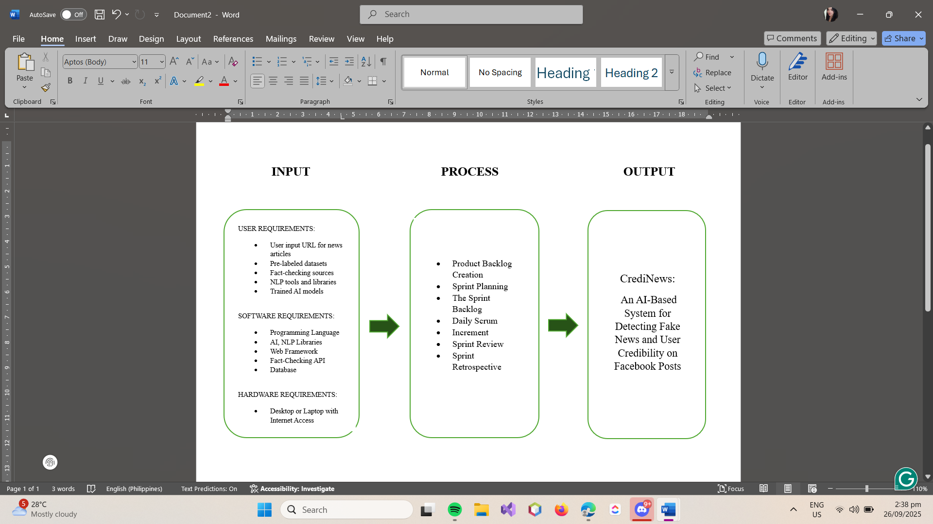
Conceptual Framework
Figure 1.1
Conceptual Framework showing input, process, and output of the system

The conceptual framework of the system, as illustrated in Figure 1.1, outlined the process flow for detecting and verifying the credibility of online news articles through an AI-powered fake news detection system. The input contained the user requirements, including the submission of URLs to be analyzed. It also included the system requirements such as pre-labeled fake and real news datasets for training, Natural Language Processing (NLP) libraries for text analysis, machine learning algorithms for classification, and fact-checking APIs for external claim validation. The technical stack included tools such as Python for backend processing, Scikit-learn for AI model training, and Flask or Django for web deployment.
Next, the process of the research followed the Agile Scrum Process Flow, which involved stages such as Product Backlog creation, Sprint Planning, Sprint Backlog, Daily Scrum, Increment, Sprint Review, and Sprint Retrospective. The product backlog included features such as text preprocessing, sentiment and linguistic pattern analysis, credibility scoring, fact-checking API integration, and a user-friendly interface. During each sprint, prioritized modules were developed, tested, and refined with continuous feedback from users and project stakeholders. Sprint reviews and retrospectives ensured that the system evolved iteratively, improving performance and aligning closely with user needs and expectations.
Lastly, the output was CrediNews, an AI-powered fake news detection tool that helped users evaluate the trustworthiness of online news articles. It classified content as credible, mixed, low credibility or unverified by analyzing textual features, detecting misinformation patterns, and referencing trusted fact-checking sources. This tool empowered users to make informed decisions, reduce the spread of misinformation, and promote responsible news consumption across digital platforms. By integrating these capabilities into a single accessible platform, the system successfully bridged the gap between advanced AI technology and everyday media literacy needs.
Statement of the Problem
The widespread dissemination of fake news across digital platforms had become a significant challenge in the information landscape. Social media and online news outlets often acted as vehicles for misinformation, resulting in public confusion, erosion of trust in legitimate sources, and poor decision-making by individuals and communities. Although fact-checking organizations existed, their processes were largely manual—making them slow, limited in scope, and insufficient to keep pace with the overwhelming volume of content produced online. Moreover, existing solutions often failed to assess the credibility of the accounts disseminating such information, making it difficult to distinguish between authentic sources and impostors or fake accounts.
This issue presented several critical concerns that needed to be addressed:
- How can CrediNews help social media users overcome the limitations of slow and limited manual fact-checking when evaluating the credibility of online news?
- In what ways can traditional fact-checking approaches be improved by integrating AI and automated analysis to provide faster, more accurate, and more accessible verification of online content?
- How can an AI-powered platform like CrediNews offer personalized, real-time analysis of both news content and user account credibility to support informed decision-making?
- How can CrediNews simulate diverse misinformation patterns (e.g., satire, fake accounts, manipulated headlines) and provide tailored guidance to help users recognize and avoid fake news across different contexts on Facebook?
Statement of Objectives
The main objective of this system was to develop CrediNews, an AI-powered platform that detected and verified fake news and user credibility using Natural Language Processing (NLP), machine learning, and fact-checking technologies to combat misinformation in digital media.
- To design a user-friendly, web-based platform that allowed users to submit URLs or text for automated credibility analysis.
- To develop machine learning models trained on labeled datasets that could accurately distinguish between credible and false news based on linguistic and structural patterns.
- To implement NLP techniques and fact-checking APIs that analyzed and cross-referenced submitted content for semantic accuracy and factual consistency.
- To evaluate the system’s performance in terms of accuracy, user feedback, and adaptability in identifying and flagging misinformation.
Hypothesis
The theoretical framework resulted in the creation of the following hypotheses:
H1: The system would demonstrate the positive impacts of AI and NLP integration on user satisfaction and trust in online news verification.
H2: Parameters and system settings would be optimized to ensure accessibility and usability for many users, including those with limited technical skills.
H3: Integrating machine learning, fact-checking APIs, and credibility scoring mechanisms would reduce users’ effort in identifying fake news while improving their ability to consume reliable information.
The hypothesis presented here stated that individuals who perceived CrediNews as accurate, easy to use, and beneficial to their information needs would be more likely to actively use the system for news verification.
Scope and Limitations of the Study
The system focused on the design and development of CrediNews, a web-based system designed to detect fake news and check user credibility. The system specifically targeted content shared on Web 2.0 platforms, with a primary focus on Facebook. The system accepted user input in the form of URLs or typed text for analysis. To ensure accuracy, the system employed a robust fact-checking mechanism that verified news accuracy and user credibility by analyzing content and data against trusted sources using tools like Google Fact Check, Zyla, Graph API, and Apify. Additionally, the system incorporated slang detection capabilities to identify informal language within the content or URL. Based on this comprehensive analysis, the system assigned a categorical news classification label to the content, which could be Credible, Mixed, Low Credibility, or Unverified. Furthermore, it evaluated user profiles by assigning account risk levels, categorizing them as Low (Trusted), Moderate (Suspicious), or High (Likely Poser). However, the system had notable limitations. It was restricted to analyzing text only, meaning it does not process images, videos, or audio. External dependencies introduced further constraints; the Zyla Fact Check API may misclassify breaking news due to database processing delays, while the Google Fact Check API cannot verify new stories itself, as it is limited to searching for claims that have already been reviewed by human experts. Additionally, API restrictions resulted in limited access to verified status and badge detection. Finally, the system possessed limited activity depth, as it only analyzes recent posts, meaning historical behavior may be missed during the assessment.
Significance of the Study
The development of CrediNews: An AI-Based System for Detecting Fake News And User Credibility on Facebook Posts was significant in addressing the increasing challenge of misinformation and fake news dissemination in the digital age. This system contributed to various sectors and stakeholders:

Students. The system provided a learning opportunity for students to engage with real-world applications of AI in addressing societal issues, particularly in the context of digital literacy and media analysis.
Journalists. Journalists could use CrediNews to check if their sources, claims, and stories were accurate before publishing. In the fast-paced world of news, the system helped journalists make sure they were sharing reliable information. This reduced the chance of spreading false information and helped keep the public's trust in the media.
Media Professionals. Media professionals, such as editors, publishers, and content creators, could use CrediNews to ensure their content was trustworthy before it reached the audience. By using AI-powered tools, they could maintain high-quality standards, report facts, and prevent the spread of fake news in their work.
Older People. CrediNews could be particularly helpful for older adults who might not have been as familiar with digital tools and online media. By providing a simple and reliable method to check the credibility of news, it could help older people avoid falling victim to misleading or false information. The system empowered them to make informed decisions and stay updated with accurate news, reducing the risk of being misled by online scams or false narratives.
Educators. CrediNews could be used as an educational resource to raise awareness about misinformation, offering tools to teach critical evaluation of digital content in classrooms.
Researchers. This system served as a reference for future projects involving Natural Language Processing (NLP), machine learning, and automated fake news detection. It showcased how AI technologies could be applied to social problems.
Developers. The system offered insights into the design and implementation of AI-driven solutions, guiding future development in the field of automated content validation.
Definition of Terms
To fully understand this system, it was important to know the following terms:
Artificial Intelligence - referred to a broad field in computer science focused on building smart machines capable of performing tasks that typically required human intelligence. These tasks included decision-making, problem-solving, speech recognition, and language translation. AI in the context of this system was utilized to automate the analysis and evaluation of online news articles to determine their credibility.
Fake News - referred to misinformation or disinformation presented as legitimate news, often with the intent to mislead, deceive, or manipulate readers. It included completely fabricated stories, misleading headlines, or content taken out of context. The spread of fake news posed significant threats to public trust, political stability, and social cohesion.
Natural Language Processing (NLP) - NLP was a branch of Artificial Intelligence that focused on the interaction between computers and human (natural) languages. It enabled machines to read, understand, and interpret text data. In this system, NLP was applied to extract meaningful features from news articles, such as sentence structure, tone, and semantic patterns, which were crucial in assessing news authenticity.
Machine Learning (ML) - was a subset of AI that involved the use of algorithms that allowed systems to learn and make decisions based on data. ML models were trained on large datasets to recognize patterns and make predictions. For this project, ML was used to train the system in distinguishing between real and fake news articles based on pre-labeled examples.
Fact-Checking API - A Fact-Checking API was an external service that allowed applications to verify the truthfulness of statements or claims by comparing them against databases of verified information. In this system, fact-checking APIs were integrated into the system to cross-reference content and validate the factual accuracy of news articles submitted by users.
User Credibility – Referred to the trustworthiness and authenticity of a user’s online identity, particularly on social media platforms. In the context of CrediNews, user credibility was assessed to determine whether an account posting or sharing news was genuine or a poser account. Factors such as account activity, consistency, and reliability of shared content contributed to evaluating user credibility, which complemented content-based analysis in detecting misinformation.
Credibility Score - The credibility score was a numerical or qualitative output generated by the system that indicated how trustworthy a news article was based on AI analysis. It reflected the likelihood that a piece of content was real or fake, helping users make more informed decisions about the information they read.
Pre-Labeled Dataset - A pre-labeled dataset was a collection of data that had already been categorized or tagged with information indicating whether each entry was real or fake news. These datasets were essential in training machine learning models to accurately identify patterns and make predictions regarding the authenticity of future news articles.
Text Preprocessing - This involved cleaning and preparing raw text data so that it could be analyzed effectively by AI models. This process typically included removing unnecessary characters, tokenization, lemmatization, and eliminating stop-words. It ensured that only relevant linguistic elements were considered in credibility analysis. Proper preprocessing also helped improve the accuracy and efficiency of AI-driven detection systems.
Disinformation - referred to deliberately false information spread with the intent to deceive or mislead the audience. Unlike misinformation, which might have been unintentionally incorrect, disinformation was crafted and shared maliciously to influence public opinion or create confusion.
Misinformation - referred to inaccurate or misleading information that was shared without the intent to deceive. It was often spread by individuals who genuinely believed the content to be true and might not have realized its inaccuracy. Misinformation could still have harmful effects, especially when it concerned topics like health, safety, or politics, as it contributed to public confusion and misinformed decision-making.
Social Media Platforms - These were digital technologies and applications—such as Facebook, Twitter (now X), Instagram, TikTok, and YouTube—that enabled users to generate, share, and engage with a wide range of content, including text, images, videos, and links. According to Pew Research Center (2021), nearly half of American adults got their news from these platforms, making them powerful tools for both information dissemination and the spread of fake news and misinformation.
Algorithm - was a complex set of instructions or rules used by digital platforms to determine what content appeared in a user's feed or search results. These algorithms typically prioritized content that was more likely to engage users—often sensational or emotionally charged material—which might inadvertently lead to the promotion of fake news. As a result, algorithms could shape what users saw, believed, and shared online (Rodríguez-Ferrándiz et al., 2023).
Echo Chamber - An echo chamber was a digital or social environment where users were surrounded by opinions and beliefs similar to their own, with little exposure to opposing viewpoints. This environment reinforced existing ideas and could create a false sense of consensus, making individuals more susceptible to misinformation or fake news. Echo chambers often developed through selective exposure and social media algorithms that personalized content based on user preferences (Kumar & Shah, 2020).
Digital Literacy - was the ability to critically find, evaluate, create, and communicate information using digital tools and platforms. It involved understanding how online content was produced, distinguishing between credible and false sources, and using digital media responsibly. Improving digital literacy was crucial in helping individuals recognize fake news, avoid spreading misinformation, and make informed decisions in the digital age.
AI-Driven System – A system powered by artificial intelligence that performed tasks requiring human intelligence, such as analyzing and evaluating large volumes of data. In CrediNews, the AI automated news assessment by detecting linguistic patterns, evaluating writing style and sentiment, and generating a credibility score, enabling faster and more scalable misinformation detection than manual methods.
Agile Scrum Methodology – A project management and software development approach that divided work into iterative cycles called sprints. It emphasized collaboration, flexibility, and continuous delivery of functional features. Scrum included roles, events, and artifacts that helped teams stay organized, incorporate stakeholder feedback, and adapt to changes efficiently. In the development of CrediNews, Agile Scrum enabled the team to deliver a reliable, user-centered system for detecting fake news while refining features through iterative improvements.
Web 2.0 Platforms – Referred to the interactive and user-generated content platforms on the internet, particularly Facebook, where users could share, post, and disseminate information rapidly.
Multimedia Formats – These referred to non-textual forms of digital content, including but not limited to images, videos, and audio recordings. In the context of the CrediNews system, these formats were not supported or analyzed by the current implementation. As a result, the system was limited to processing and evaluating only text-based information. This limitation reduced its effectiveness in detecting misinformation disseminated through visual or auditory means, which were common on modern social media platforms.
Media Literacy – The ability to access, analyze, evaluate, and create media in various forms. Tools like CrediNews aimed to support media literacy by helping users critically assess online information.
Probabilistic Analysis – A statistical approach that estimated the likelihood of news being credible, rather than giving a definite true or false label. In CrediNews, it helped generate a credibility score based on language, sentiment, and fact-checking, offering a more nuanced way to assess information.
Supervised Learning – A machine learning technique where models were trained on labeled datasets, allowing them to learn patterns and make accurate predictions. In fake news detection, it helped the system distinguish between real and fake news based on previously verified examples.
Random Forest – An ensemble algorithm that built multiple decision trees and combined their results to improve accuracy and prevent overfitting. It was widely used in fake news detection due to its ability to analyze various features and produce reliable classifications.
Logistic Regression – A statistical method for binary classification that estimated the probability of a data point belonging to one of two categories, such as real or fake news. It evaluated textual features to help determine the credibility of content.
Deep Learning – A type of machine learning based on artificial neural networks with multiple layers, capable of modeling complex patterns in large datasets, often used for tasks like language translation and image recognition.
Sentiment Analysis – A subfield of NLP that identified the emotional tone or opinion within a text. In CrediNews, it helped detect biased or emotionally charged language that might indicate manipulative or misleading content.
Data Annotation – The process of labeling data with tags, such as marking news as real or fake. This labeled data was used to train machine learning models in systems like CrediNews for accurate fake news detection.
Transformer Model – A type of deep learning architecture designed to understand relationships within text using self-attention mechanisms. Transformers could analyze entire sentences or documents at once, making them highly effective for natural language tasks such as fake news detection, text classification, and sentiment analysis. They served as the foundation for advanced models like BERT.
BERT (Bidirectional Encoder Representations from Transformers) – A transformer-based language model developed by Google that read text in both directions—left-to-right and right-to-left—to understand context more accurately. In fake news detection, BERT could analyze sentence patterns, word relationships, and semantic meaning to classify content as credible or misleading.
LSTM (Long Short-Term Memory Network) – A type of recurrent neural network (RNN) capable of learning long-term dependencies in text. LSTMs processed text sequentially, making them useful for understanding writing patterns, tones, and structures over longer articles. They were commonly used in NLP tasks before transformer models became dominant.
TF-IDF (Term Frequency – Inverse Document Frequency) – A numerical representation used to convert textual data into meaningful features that machine learning models could analyze. It measured how important a word was within a document compared to a larger collection of documents. TF-IDF helped the system detect key terms often found in fake or credible news.
Dataset Collection & Selection – The process of gathering and choosing appropriate datasets for training machine learning models. In fake news detection, this included collecting labeled real and fake news articles from verified sources. Proper dataset selection ensured the model learned accurate patterns and avoided bias.
Algorithm Training – The phase where machine learning models learned from labeled examples by identifying patterns and relationships within the text. Through repeated exposure to real and fake news samples, the model improved its ability to classify future articles accurately.
Model Evaluation – The process of assessing how well a trained machine learning model performed using metrics such as accuracy, precision, recall, and F1-score. Evaluation ensured the model could reliably differentiate between credible and fake news articles. It helped identify areas for improvement, guiding further model refinement and optimization.
User Trustworthiness Assessment – A process within the system that analyzed user behavior, posting activity, and account consistency to determine the likelihood that an account was genuine. This helped reduce misinformation by identifying suspicious or “poser” accounts that frequently shared questionable content.
AI Agent – Referred to an autonomous software entity capable of perceiving its environment, reasoning, and executing actions to achieve specific goals without continuous human intervention. In the context of this study, the AI agent acted as the core intelligence mechanism that processed user inputs, interfaced with Natural Language Processing (NLP) models, and generated credibility assessments in real-time, effectively automating the verification workflow.

Chapter 2
REVIEW OF LITERATURE AND STUDIES
Foreign Literature

Fake News in Digital Media

With the rise of digital communication, particularly social media, the dissemination of fake news has become a critical global concern. The shift from traditional news outlets to decentralized online platforms has enabled broader access to information, but it has also accelerated the viral spread of false narratives. According to Vosoughi, Roy, and Aral (2020), false information spreads significantly faster and more widely than truthful content, primarily because of its novelty and emotional appeal, which elicit stronger user engagement.

One key advantage of digital media is its ability to democratize information-sharing, allowing individuals to access diverse sources and participate in public discourse. It also facilitates real-time communication and rapid updates during emergencies or global events. However, these same features contribute to its disadvantages—particularly in the context of fake news. As Cinelli et al. (2021) noted, algorithm-driven recommendation systems often prioritize engagement metrics over factual accuracy, leading to the creation of echo chambers and filter bubbles that reinforce misinformation. Additionally, the anonymity and speed of online interactions make fact-checking difficult, often allowing false narratives to spread before verification efforts can take place.

Furthermore, Lazer et al. (2022) emphasized that the ease of producing and distributing content online has blurred the distinction between credible journalism and propaganda. Misinformation is frequently disguised as legitimate news, complicating users’ ability to discern truth from falsehood and reducing public trust in the media.

In relation to this study, CrediNews: An AI-Based System for Detecting Fake News And User Credibility on Facebook Posts aimed to address the disadvantages highlighted in current digital media environments by introducing a real-time, automated solution for assessing the credibility of online content. By leveraging machine learning and natural language processing, the system could flag misleading articles before they reached a wider audience. This enabled a proactive response to misinformation, in contrast to traditional fact-checking methods that were typically reactive. Additionally, by offering users insights into the accuracy and source reliability of the news they consumed, the system enhanced media literacy and helped restore trust in online information.

Use of Digital Media Among Older Adults

The adoption of digital media among older adults has increased significantly in recent years. A 2024 survey by the UK’s Office for National Statistics revealed that individuals aged 70 and above now spend more time online than any other group except those in their 20s, averaging about 43 minutes daily for activities like web browsing and emailing (Booth, 2024). This increased digital engagement enables older adults to stay connected with loved ones, access health services, and participate in digital communities.

Digital media usage is also positively associated with improved mental and physical health among older individuals. A large-scale cross-national study covering 23 countries reported that regular internet use among adults aged 50 and over resulted in a 9% reduction in depressive symptoms and a 7% increase in life satisfaction (Sherwood, 2024). These findings suggest that digital media can contribute to healthier and more socially engaged aging.

Despite the benefits, older adults face challenges in accessing and utilizing digital tools effectively. A 2024 systematic review in India emphasized barriers such as low digital literacy, especially among rural populations, and the need for user-friendly platforms tailored to senior users (Kumar & Sharma, 2024). Similarly, Perzynski and colleagues (2022) highlighted that limited digital literacy can exacerbate social isolation, especially during global crises like the COVID-19 pandemic.

In relation to this study, the CrediNews: An AI-Based System for Detecting Fake News And User Credibility on Facebook Posts incorporated design features that catered to older users, such as a simplified interface, visual cues, and clear verification messages. These features supported older adults in navigating the digital media landscape, promoting digital inclusion, and reducing susceptibility to misinformation.

Use of User Credibility of Posting News in Facebook Posts

Academic interest in the influence of user credibility on information belief on social media has increased rapidly over the last few years. A Pew Research Center study from 2023 found that when evaluating news on Facebook, social media users value the credibility of the account posting news content as much as they do the news itself (Anderson & Auxier, 2023). This one implies that when it comes to what’s posted, and who is posting it, users are influenced by both.

Studies have reported that credibility cues like account verification, posting history and engagement authenticity play a significant role in shaping trust. For instance, a paper from Sharma and Jain (2022) in the Journal of Information Integrity found that Facebook users were much more likely to trust news stories shared by verified or longstanding user profiles compared to recently created and anonymous accounts. Similarly, Chen et al. (2023), by incorporating account credibility scores into content analysis, the improvement of detection accuracy for fake news reached 15% in experimental machine learning models.

Nevertheless, challenges still exist on how to efficiently identify poser accounts pretending as genuine sources. The European Commission (2022), in a report for 2022, has stressed that coordinated inauthentic activity—fake accounts impersonating real users and organizations—is still a challenge on Facebook and other networks. These activities both disseminate propaganda and undermine confidence in legitimate news sources.

In relation to this study, CrediNews: An AI-Based System for Detecting Fake News And User Credibility on Facebook Posts incorporated mechanisms for evaluating both content credibility and user account authenticity. By distinguishing between genuine and poser accounts, the system enhanced user confidence in determining whether a Facebook post came from a reliable source, thereby strengthening the fight against misinformation.

Use of Artificial Intelligence in News Verification

Artificial Intelligence (AI) has emerged as a powerful tool in combating the widespread dissemination of fake news in digital environments. News verification through AI utilizes advanced techniques such as machine learning, deep learning, and natural language processing (NLP) to automate the detection and classification of misinformation. According to Gupta and Narayan (2021), AI models trained on labeled datasets can distinguish between credible and false news articles with accuracy rates exceeding 85%, particularly through analysis of sentiment, writing style, and keyword patterns.

One of the key advantages of AI in news verification is its speed and scalability. AI systems can process and evaluate massive volumes of content in real-time, which would be impractical for manual fact-checking. Research by Baly et al. (2022) emphasized the effectiveness of stance detection and automated fact-checking models, which allow AI to assess a news article’s consistency with verified claims. Additionally, Islam and Hasan (2023) demonstrated that Transformer-based models such as BERT and RoBERTa significantly improved the semantic understanding of news content, resulting in better detection accuracy across diverse topics and languages.

Despite these strengths, the use of AI in news verification presents several disadvantages. As noted by Choi and Kim (2024), issues related to algorithmic fairness and interpretability persist. AI models often function as “black boxes,” making it difficult for users to understand how certain verification decisions are made. Furthermore, these systems are vulnerable to adversarial manipulation, where misleading content is crafted specifically to bypass detection algorithms. Such challenges highlight the ongoing need for transparency, user trust, and continuous model refinement.

In relation to this study, the CrediNews: An AI-Based System for Detecting Fake News And User Credibility on Facebook Posts built upon the foundation established by previous AI-based verification efforts while addressing their limitations. Unlike traditional models that might lack transparency, this system prioritized explainability by offering users clear justifications for why specific content was flagged as false or misleading. It also emphasized fairness and inclusivity by being trained on diverse datasets and evaluated for bias mitigation. Ultimately, the system aimed to enhance digital media literacy and provide users with a reliable tool for verifying the credibility of online news, contributing meaningfully to the ongoing fight against misinformation.

Use of Natural Language Processing (NLP) in News Verification

Natural Language Processing (NLP) plays a critical role in the automation of news verification by enabling systems to analyze and understand the linguistic characteristics of textual content. NLP techniques are employed to detect patterns, assess semantic consistency, and evaluate the factual integrity of news articles. As noted by Alam et al. (2021), NLP can be applied to identify deceptive language, analyze sentence coherence, and classify news based on content credibility.

One of the key advantages of using NLP in news verification is its ability to process and analyze large volumes of unstructured textual data in real-time. For instance, attention-based models such as BERT and its variants have demonstrated significant success in understanding complex linguistic cues, including sarcasm, stance, and semantic similarity, which are vital for distinguishing between genuine and misleading content (Zhou et al., 2022). Additionally, NLP techniques like entity recognition, sentiment analysis, and stance detection allow models to cross-reference claims with known factual databases to support automated fact-checking.

However, there are challenges associated with the use of NLP in this domain. As highlighted by Wang and Ma (2023), the performance of NLP models can degrade when exposed to ambiguous language, biased data, or multilingual content. Moreover, many NLP algorithms operate as black boxes, making it difficult for users to interpret how conclusions are reached. This lack of transparency may reduce user trust in automated systems.

In relation to this study, CrediNews: An AI-Based System for Detecting Fake News And User Credibility on Facebook Posts integrated NLP-based modules to enhance its verification capabilities. The system utilized transformer-based language models for contextual understanding and semantic comparison, allowing it to evaluate the credibility of news articles with high precision. To address transparency concerns, the system provided users with simplified explanations of the verification process and highlighted key textual features contributing to classification outcomes. This approach ensured both accuracy and interpretability, especially for users with limited technical backgrounds.
Local Literature

Fake News on Digital Media in the Philippines
The Philippines ranks among the top countries globally in terms of social media usage, with platforms like Facebook and YouTube playing a central role in how Filipinos consume news and current affairs (Amurthalingam, 2023). While these platforms offer convenience and accessibility, they also create an environment where false or misleading information can circulate rapidly—often outpacing legitimate news from traditional media outlets. The prevalence of user-generated content, combined with emotionally charged narratives and visually engaging posts, increases the likelihood of such content being shared without verification. According to experts from the University of the Philippines (2022), many individuals inadvertently spread misinformation due to the deceptive nature of its presentation. Their insights also revealed that repeated exposure to misleading content gradually diminishes users’ critical thinking abilities, making them more susceptible to believing and sharing falsehoods online.
This vulnerability is further amplified during times of public emergencies or political instability. The Department of Information and Communications Technology (DICT, 2023) observed a surge in coordinated disinformation efforts during national crises, such as pandemics or elections. These campaigns strategically exploit trending topics and emotional sentiments to manipulate public discourse and influence opinions. Complementing this view, the Philippine News Agency (2024) highlighted government concerns about how fake news undermines social cohesion and democratic processes. The agency emphasized that disinformation efforts often target susceptible groups, attempting to skew public perception or widen societal divides. Moreover, a recent survey conducted by Social Weather Stations (2025) found that nearly 7 in 10 Filipino adults believe fake news is a serious problem, particularly among frequent users of social media platforms who report more difficulty in identifying credible sources.
In relation to this study, CrediNews aimed to counteract these growing challenges by utilizing artificial intelligence to detect and analyze misleading content in real time. Guided by findings from Amurthalingam (2023), DICT (2023), University of the Philippines (2022), and SWS (2025), the system scanned viral content for patterns commonly associated with disinformation—such as sensationalized headlines, repetitive or bot-like comment activity, and emotionally manipulative phrasing. Designed for fast-paced digital environments, CrediNews functioned as a proactive solution to help users critically engage with the content they encountered, ultimately contributing to more informed and responsible online communities. By offering timely credibility insights, the system supported digital literacy efforts and empowered individuals to make fact-based decisions when consuming or sharing news.
Use of User Credibility of Posting News in Facebook Posts
Facebook is the most used social media platform in the Philippines next to Twitter with 86.2 million active users as of 2024 (Statista, 2024). This ubiquitous nature has turned it into a leading platform for information as well as misinformation. User trustworthiness also matters a great deal when Filipinos judge the credibility of news posts on the platform. A 2022 survey from the Social Weather Stations (SWS) found that 67% of Filipinos trust the credibility of the outlet posting news as a deciding factor in whether they believe the information to be true.
Scholarly work also highlights the importance of user identity in combating misinformation in Philippine social media contexts. A study by Cruz and Rodrigo (2023) found that posts shared by verified media outlets and long-standing personal accounts were perceived as significantly more trustworthy than those from anonymous or recently created accounts. This aligns with observations by Chua (2022), who argued that the prevalence of poser accounts on Facebook contributes substantially to the rapid spread of fake news, especially during politically sensitive periods such as elections.
Both governments as well as civil society have also realised that the issue of user credibility was an important aspect in combatting misinformation. Such use of these coordinated units, such as during the Philippine Elections, where fact-checking organizations including the Commission on Elections (COMELEC) reported networked fake accounts actively circulated false election-related content meant to destroy voter trust and capacity for informed decisions (COMELEC, 2022). These findings highlight the need for systems capable of verifying content and account veracity.
In relation to this study, CrediNews: An AI-Based System for Detecting Fake News And User Credibility on Facebook Posts incorporated features that assessed user account credibility alongside content analysis. By doing so, the system helped Filipino users distinguish between authentic and poser accounts on Facebook, ultimately promoting informed engagement and reducing susceptibility to misinformation in the local digital landscape.

Verifying News Content Through Artificial Intelligence
Artificial Intelligence (AI) has revolutionized the field of news verification by enabling automated, efficient, and scalable analysis of digital content. In the Philippines, the government has recognized the potential of AI in combating misinformation, particularly in the lead-up to elections. The Cybercrime Investigation and Coordinating Center (CICC) introduced an AI-powered detection tool capable of verifying deep fake content within 30 seconds, aiming to empower citizens and institutions to identify and counteract disinformation swiftly (Magno, 2025). Additionally, the Commission on Elections (COMELEC) implemented guidelines mandating the disclosure of AI usage in campaign materials, marking a proactive step towards transparency and accountability in political communications (Chi, 2024).​
The application of AI in news verification offers notable advantages. AI systems can process and analyze large volumes of data at unprecedented speeds, facilitating real-time detection of false information. They can also identify patterns and anomalies that may elude human analysts, such as coordinated disinformation campaigns or the proliferation of fake accounts. For example, Cyabra's investigation revealed that approximately 33% of profiles discussing former President Rodrigo Duterte's arrest were inauthentic, highlighting the scale and sophistication of digital disinformation efforts (Reuters, 2025). AI's capability to uncover such networks is instrumental in preserving the integrity of information ecosystems.​
However, the deployment of AI in news verification is not without challenges. Concerns have been raised regarding algorithmic transparency and the potential for biases within AI systems. A study by the University of the Philippines found that Filipino fact-checkers were wary of relying on AI due to the low sophistication of available tools and potential audience distrust (Caling & Palalimpa, 2023). Moreover, AI models can be susceptible to adversarial manipulation, where malicious actors design content specifically to evade detection algorithms. These issues underscore the need for continuous refinement of AI tools and the importance of human oversight in the verification process.​
In relation to this study, CrediNews harnessed the strengths of AI technologies to improve its real-time news verification process. Building on national efforts such as those by the CICC and COMELEC, CrediNews utilized machine learning models that had been trained on diverse, locally relevant datasets to recognize misinformation patterns, including deepfakes and coordinated disinformation tactics. Unlike generic detection tools, the system was designed with a focus on transparency—each flagged content was accompanied by a clear explanation, allowing users to understand the rationale behind the system’s judgment. This not only enhanced trust and user confidence but also supported media literacy by encouraging more analytical consumption of digital content. As a proactive response to the growing threat of AI-driven misinformation, CrediNews stood as a contextualized, citizen-centered solution tailored to the evolving digital landscape in the Philippines.
Natural Language Processing (NLP) in Fake News Detection
Natural Language Processing (NLP) plays a critical role in the automation of fake news detection by allowing machines to interpret, analyze, and generate human language in a meaningful way. Through sentiment analysis, topic modeling, and syntactic parsing, NLP enables systems to differentiate between factual content and misleading narratives. According to Reyes (2021), NLP-based tools have shown increased accuracy in identifying patterns in disinformation, especially when trained on localized datasets that capture the nuances of the Filipino language and regional dialects. Furthermore, NLP techniques are effective in detecting exaggerations, sensationalist tones, and emotionally charged wording—hallmarks of fake news stories circulating on Philippine digital platforms.
One key advantage of using NLP in fake news detection is its ability to handle unstructured data from various sources, including social media posts, blogs, and online news articles. NLP enables real-time monitoring and filtering of text-based content, which is essential for responding swiftly to emerging disinformation. A report by the Department of Information and Communications Technology (DICT, 2023) emphasized that technologies employing language-based models can help mitigate fake news, especially during national emergencies and electoral periods, by flagging suspicious keywords and linguistic anomalies. Additionally, NLP facilitates multilingual analysis, enabling the detection of misinformation not just in English but also in Filipino and other native languages.
However, the application of NLP in fake news detection is not without its limitations. NLP systems often struggle with context, sarcasm, and coded language, which can lead to misclassification of content. As discussed by Alampay and Ignacio (2022), there is also a gap in locally developed NLP tools, which limits the accuracy and cultural relevance of some models. This is particularly concerning in the Philippines, where linguistic diversity and regional slang are prevalent. The presence of low-resource languages and insufficient annotated datasets further hinder the effectiveness of NLP-driven detection systems in the country.
In relation to this study, the CrediNews platform applied NLP to process and analyze the linguistic structure, sentiment, and stylistic patterns of news content shared across platforms like Facebook and X (formerly Twitter), which were often saturated with text-based misinformation. By integrating NLP techniques into the system's core engine, CrediNews could evaluate article URLs, assigning a credibility score that guided users in assessing the trustworthiness of the content. However, in line with the scope and limitations of the system, its capabilities were notably restricted to text-only analysis, meaning it could not process or verify images, videos, or audio formats often used to spread misinformation. Furthermore, the platform’s reliance on external data sources introduced specific constraints: the Zyla Fact Check API might misclassify breaking news due to database processing delays, while the Google Fact Check API was limited to retrieving claims already reviewed by experts, rendering it unable to independently verify fresh, unreviewed stories. Additionally, the system's evaluation of user credibility was constrained by limited activity depth, as it only analyzed recent posts and could not account for historical behavior or verified status badges due to API restrictions. Despite these limitations, the system’s localized approach aimed to improve the detection of disinformation patterns, leveraging NLP not as a definitive truth-detector but as a supportive tool for enhancing users’ digital literacy and critical thinking.
Foreign Studies
AI and Machine Learning in Fake News Detection (Supportive)

Recent studies highlight the vital role of artificial intelligence and machine learning in addressing the proliferation of fake news. According to Shu et al. (2020), machine learning algorithms such as Random Forest, Logistic Regression, and Long Short-Term Memory (LSTM) networks have proven effective in classifying news content with over 90% accuracy. These models work by analyzing content-based features including linguistic patterns, sentiment, and writing style, which are often manipulated in fake news to provoke emotional reactions or mislead readers. The study emphasizes that fake news articles typically contain sensationalized headlines, emotionally charged language, and misleading cues, making them identifiable through AI-based approaches. The use of Natural Language Processing (NLP) further enhances the capability of these systems to interpret textual content and detect subtle patterns that differentiate falsehoods from credible information.

In relation to this study, CrediNews incorporated similar AI and machine learning techniques, particularly NLP and supervised learning models, to automate the evaluation of news content. These technologies formed the backbone of the system's credibility scoring mechanism, enabling it to analyze news articles in real time and support responsible news consumption by flagging potential misinformation.

Contextual Fact-Checking using NLP (Supportive)
In 2021, Zhou and Zafarani introduced an innovative framework that integrates Natural Language Processing (NLP) with contextual fact-checking to enhance fake news detection. This system is unique in that it does not rely solely on linguistic features of the text but also incorporates external knowledge from trusted fact-checking sources, including websites like Wikipedia, Snopes, and other verified databases. By analyzing the content in a broader context, the system can offer a more nuanced understanding of the credibility of news stories.
Traditional fake news detection systems often focus on surface-level features such as word frequency, sentiment, and the overall structure of the text. However, these approaches can miss subtle forms of misinformation, especially as fake news stories evolve and take on new forms. The key strength of Zhou and Zafarani’s framework lies in its ability to move beyond these textual features and incorporate external data to verify the claims made within the news articles. This integration of contextual knowledge allows the system to understand the wider implications of a story and assess its accuracy in real time, especially when novel or emerging fake news narratives arise. For instance, the system could reference reputable databases or fact-checking websites to verify specific claims made in the article, offering a more robust and accurate assessment of credibility.
In relation to this study, CrediNews leveraged a similar methodology, integrating NLP with external fact-checking mechanisms to assess the credibility of news content. The system not only processed linguistic cues—such as sentiment, writing style, and the structure of the text—but also cross-referenced the content with verified fact-checking databases and APIs. This combination of internal linguistic analysis and external contextual validation significantly enhanced the system’s ability to identify misinformation and ensure that news articles were assessed accurately.
By using both content-based analysis and external fact-checking, CrediNews could effectively deal with a wide range of misinformation, including novel fake news that might arise rapidly on social media platforms. This was particularly important in an era where misinformation evolved quickly, and traditional methods of manual fact-checking could be too slow to keep up. Furthermore, CrediNews could adjust its approach in real time, making it a more dynamic and reliable solution for combating fake news, similar to the adaptability highlighted in Zhou and Zafarani’s framework.
Additionally, the ability to provide transparent explanations for the system's decisions was another advantage of this approach. In CrediNews, users could receive feedback on why a particular article was flagged as potentially fake, based on both linguistic patterns and external fact-checking data. This transparency fostered trust in the system and helped users understand the reasoning behind the credibility score, ultimately promoting responsible news consumption and improving digital literacy. Such user-centered features also encouraged active engagement and empowered individuals to critically evaluate the information they encountered online.

Limitations of AI in Detecting Satire and Sarcasm (Contradictory)
While AI has made significant progress in detecting fake news, certain limitations remain, particularly in distinguishing between satire, sarcasm, and actual misinformation. Rubin et al. (2022) highlighted one major challenge faced by AI systems: the misclassification of satirical content as fake news. This problem arises because AI models often rely heavily on sentiment analysis and word frequency to determine whether content is credible. However, these models may struggle with the nuanced tone and context that satire or sarcasm conveys. Satirical articles are often characterized by exaggerated language, irony, and humor, which are used to criticize or mock certain social, political, or cultural aspects. These characteristics make it difficult for AI to distinguish between genuinely exaggerated humor and intentionally misleading content.
For example, an AI model may flag a satirical piece about a political figure as misinformation, simply because it uses hyperbole and ironic language common elements in satire. As a result, AI systems can produce false positives, where legitimate, humorous content is inaccurately labeled as fake news. Rubin et al. (2022) emphasized that this misclassification could lead to user distrust in AI systems, especially when real satirical content is flagged unfairly.
In relation to this study, CrediNews faced a similar challenge. As a platform designed to accurately assess the credibility of news articles, it had to not only identify misleading or false content but also avoid misclassifying satirical content as fake news. Given the system’s reliance on NLP techniques, it was essential for CrediNews to incorporate more advanced methods that understood context, tone, and intent. Incorporating contextual understanding into the system would help it differentiate between genuine fake news and content that was intentionally exaggerated for comedic or critical purposes.
To address this, the system could integrate a deeper understanding of linguistic cues, cultural references, and the broader socio-political context of the content. For instance, satire often relied on historical or political knowledge to make its point, which could be incorporated into CrediNews’ fact-checking mechanisms. By developing a model that could better interpret these subtleties, CrediNews could reduce the risk of misclassifying satire and sarcasm as misinformation, enhancing both the accuracy and credibility of the system’s results.
Incorporating these improvements would enable CrediNews to deliver a more accurate and reliable assessment of online news, helping to combat the rise of misinformation more effectively. Enhancing detection models, using quality datasets, and adapting to language and cultural nuances would improve the system's ability to identify subtle or complex misleading content. At the same time, promoting user trust through transparency and feedback features was crucial. By explaining credibility scores and encouraging user participation, CrediNews could build a more informed user base and ensure the system remained fair, accessible, and widely accepted.

Over-reliance on Textual Content (Contradictory)

While text-based analysis plays a crucial role in detecting fake news, some researchers caution against relying solely on linguistic features for credibility assessment. Volkova et al. (2023) argue that traditional fake news detection systems, which focus exclusively on the textual content of articles, may overlook other important signals that could provide a more accurate assessment of news credibility. Their study emphasizes the importance of incorporating non-textual factors, such as user engagement, source credibility, and behavioral patterns, into fake news detection models. These additional signals can reveal important contextual clues that help distinguish between legitimate content and misinformation.

For instance, fake news articles often spread rapidly across social media platforms, which can indicate coordinated campaigns aimed at amplifying misleading narratives. By analyzing how often an article is shared, by whom, and where it is shared, AI systems can gain a more comprehensive understanding of the content’s credibility. This social context can provide valuable insight into whether the article is being propagated by a genuine audience or part of a deliberate disinformation effort. As Volkova et al. (2023) highlight, models that incorporate these non-textual signals can adapt to complex forms of misinformation that are difficult to detect through text analysis alone.

In relation to this study, CrediNews faced similar challenges, especially considering that misinformation could spread quickly across platforms like Facebook and X (formerly Twitter). Currently, the system primarily relied on textual content for its credibility assessments. However, integrating non-textual signals, such as user engagement metrics, metadata (e.g., timestamps, source reliability), and social media interactions, could significantly improve its accuracy and robustness. For example, by analyzing patterns such as the frequency of shares, the profiles of individuals sharing the content, or the networks through which information spread, CrediNews could better detect misinformation that might otherwise go undetected by text analysis alone.

Incorporating these additional layers of data would provide a more holistic view of a piece of content’s credibility, helping CrediNews adapt to the evolving nature of online misinformation. By recognizing coordinated misinformation campaigns or identifying articles that were manipulated through strategic sharing, the system would be able to detect complex forms of fake news with higher accuracy. Thus, integrating behavioral signals into CrediNews could make the detection system more effective and capable of keeping up with rapidly evolving disinformation tactics.

Local Studies
AI in Filipino Media for Fake News Detection (Supportive)

With the Philippines ranking among the top social media users globally, it has become a primary area for the rapid spread of disinformation. Filipinos spend an average of nearly four hours daily on social media, significantly higher than the global average. This high engagement creates an environment where both accurate and misleading information can easily go viral, especially on platforms like Facebook, YouTube, and X (formerly Twitter). While these platforms make it easy to access news, they also contribute to the spread of fake news due to the lack of strong fact-checking mechanisms and the influence of algorithm-driven recommendation systems, which often show content based on popularity rather than truth.

A study by Cruz, Tan, and Cheng (2020) focused on the localization of fake news detection in the Philippines by using multitask transfer learning with transformer-based models. Their research introduced the "Fake News Filipino" dataset, an expertly collected set of fake and credible news designed to reflect Filipino social media discourse. By fine-tuning language models to Filipino linguistic patterns and combining fake news detection with language modeling, the system achieved an accuracy rate of up to 96%. This demonstrates the importance of culturally and linguistically adapted AI solutions in addressing misinformation on social media platforms like Facebook. The study will help CrediNews by serving as a foundational reference for building real-time, transparent, and context-aware fake news detection specifically tailored to Filipino users.

Similarly, a study by Salazar (2020) examined various AI tools and methodologies for detecting fake news, with a focus on leveraging machine learning algorithms and natural language processing (NLP) techniques. The research explored how different machine learning models, such as decision trees, support vector machines, and neural networks, were applied to analyze textual data in the context of online misinformation. A key component of the study was comparing the performance of these models across a range of fake news detection tasks, including identifying misleading headlines, evaluating the credibility of sources, and assessing sentiment in news articles. Salazar’s study highlighted the advantages and limitations of various machine learning approaches, providing an in-depth understanding of their effectiveness in tackling misinformation across different platforms. The study also emphasized the need for AI tools to be tailored to the specific linguistic and cultural nuances of the target audience, in this case, Filipino social media users. This is especially crucial for addressing the unique challenges posed by the Filipino language, which includes variations in jargon expressions, slang, and regional dialects that can impact the accuracy of AI models when analyzing content shared on platforms like Facebook, and X (formerly Twitter). In line with this, CrediNews aims to enhance its system to specifically target the linguistic and cultural challenges faced by Filipino users. By leveraging AI models that are finely tuned to the Filipino context, CrediNews can provide a more accurate, real-time solution for detecting and mitigating the spread of fake news across popular social media platforms in the Philippines.

Additionally, a 2023 study conducted by Riego and Villarba focused on the use of the Multinomial Naive Bayes algorithm combined with TF-IDF (Term Frequency-Inverse Document Frequency) vectorization to evaluate the credibility of news tweets in the Philippines. Their model achieved an accuracy rate of 88.98% on previously unseen data, with an impressive F1 (fake news) score of 89.68%. These results demonstrate the potential of machine learning models in identifying misinformation within Filipino media. The findings suggest that AI-driven tools like CrediNews can effectively leverage these techniques to enhance real-time detection and classification of fake news in the local context.

In relation to this study, the CrediNews: An AI-Based System for Detecting Fake News And User Credibility on Facebook Posts was conceptualized to support Filipino users in identifying misleading content. This system leveraged artificial intelligence techniques, specifically natural language processing (NLP) and machine learning to analyze and verify online content in real-time. CrediNews delivered a proactive solution, tailored to the Philippine context. By offering a user-friendly interface and localized analysis features, CrediNews promoted critical thinking and enhanced media literacy among Filipinos. Its implementation aimed to contribute to a more informed public and reduce the societal impact of digital misinformation.

Challenges of AI in Detecting Fake News in Filipino Context (Contradictory)
Despite the advancements in AI for fake news detection, several challenges continue to hinder its effectiveness. A primary limitation is the evolving nature of misinformation, which makes it difficult for AI systems to keep up with new patterns of deception. Additionally, local fact-checkers in the Philippines have expressed caution about the full adoption of AI tools. According to Vera Files (2023) in the study “The Robot Fact Checker: Prospects and Challenges of Artificial Intelligence Use for Fact-Checking in Online Philippine Newsrooms,” Filipino fact-checkers are hesitant to rely entirely on AI due to the low sophistication of available tools, potential audience distrust, and the risk of AI being misused for surveillance. The study also found that most fact-checking newsrooms in the country use AI only in limited parts of the workflow, such as image verification and social media monitoring. Fact-checkers unanimously agreed that while AI can assist in the process, human oversight remains essential to ensure the accuracy and contextual relevance of the information being verified.
Another significant limitation lies in the diversity of local dialects and informal language used across Filipino social media platforms. While many AI models are trained on formal English or Tagalog datasets, they struggle with the code-switching common among Filipino users, such as mixing English with Taglish or regional languages. This linguistic complexity reduces the accuracy of NLP algorithms when analyzing real-world social media content. According to Banuag (2020), in the study “Code-Switching in Facebook Posts: Episodes of Forms and Reasons,” Filipino multilingual users frequently switch between languages for reasons such as clarifying meaning, expressing identity, and engaging with peers. This dynamic and fluid use of language makes it difficult for AI tools, particularly those trained on monolingual or large collections of text, to accurately process and interpret content from Filipino online platforms.
And lastly, a 2023 study from the University of the Philippines found that local fact-checkers are generally hesitant to adopt AI due to concerns over the low sophistication of available tools, potential audience distrust, and security risks. Despite using AI in certain aspects like evidence retrieval and claim detection, newsrooms expressed reluctance to let AI handle the entire fact-checking process, emphasizing the need for human oversight to ensure accuracy and trustworthiness. This highlights the challenges in integrating AI into news checking and the importance of developing more sophisticated and transparent AI tools for effective fact-checking.​ It also underscores the need for training and collaboration between AI developers and journalists to build systems that are both reliable and widely accepted.
In relation to this study, CrediNews also faced a challenge when it came to relying mostly on the text of an article to detect fake news. While the AI behind CrediNews could scan and analyze language patterns quickly, fake news today didn't always show clear signs through words alone. Some false information spread because of how it was shared, not just how it was written, and local fact-checkers raised concerns about fully trusting AI, citing issues like low tool accuracy, audience distrust, and the risk of misuse, which was why they emphasized the need for human oversight. Another challenge was the common use of code-switching among Filipino users mixing English, Tagalog, and local dialects which made it difficult for AI tools trained in formal language to fully understand online content. To improve the system, it could help to include other types of information, like how often an article was shared, who was sharing it, and whether it came from a trusted source. Still, using AI in CrediNews was a strong advantage as it allowed fast and large-scale analysis that humans couldn't easily do. With these upgrades, the system had the potential to catch even more complex types of fake news and keep up with how fast misinformation spread online.
Synthesis of the Reviewed Literature and Studies
The review of literature and studies emphasized the rapid advancements in artificial intelligence (AI) technologies and their application in combating the spread of misinformation and fake news. As digital communication becomes increasingly embedded in everyday life, the rise of social media platforms and user-generated content has drastically altered how information is disseminated and consumed. While this shift has improved accessibility, it has also led to an overwhelming influx of unverified, misleading, and intentionally deceptive content online. This transformation underscores the urgent need for robust, automated systems capable of analyzing and verifying the credibility of news articles in real time.
Researchers have established Natural Language Processing (NLP) and Machine Learning (ML) as core technologies for identifying misinformation through the analysis of linguistic and structural patterns (Zhou & Zafarani, 2020). The efficacy of these models is significantly strengthened by integrating third-party fact-checking APIs, which facilitate real-time validation against verified databases (Al-Rakhami & Al-Amri, 2020). Ultimately, combining these computational methods with external verification enables modern systems to achieve higher accuracy and greater adaptability against evolving forms of fake news.
The literature highlights that incorporating adaptive learning mechanisms allows systems to update models based on user feedback, effectively reducing classification errors over time (Shu et al., 2021). While the deployment of deep learning architectures has improved the handling of complex linguistic nuances and large-scale data, studies indicate persisting challenges such as algorithmic bias, data limitations, and the difficulty of detecting satire. Furthermore, ethical concerns regarding censorship emphasize the necessity for transparency in system design, just as varying levels of digital literacy continue to impact how effectively diverse populations interact with these AI tools.
Overall, the literature reviewed demonstrates a global effort to use AI in combating digital misinformation. The studies support the development of systems like CrediNews, which integrate AI-powered NLP, fact-checking, and user feedback to assess news credibility. In relation to this study, such systems reflect current technological capabilities while also addressing key social and ethical challenges. They highlight the potential of AI not just as a detection tool, but as a means to promote media literacy and informed civic participation. Still, ensuring inclusivity, transparency, and equal access remains essential for their effective and fair implementation across diverse populations. Furthermore, continuous collaboration between technologists, journalists, and policymakers is crucial to adapt these systems to evolving misinformation tactics and cultural contexts.

Chapter 3
METHODOLOGY
Research Design
The research developers adopted the mixed-method research design approach for the development of the CrediNews: An AI-Based System for Detecting Fake News And User Credibility on Facebook Posts, a system designed to verify online news credibility using artificial intelligence and natural language processing. Mixed-method research is a design that integrates both numeric and descriptive research elements to arrive at comprehensive conclusions. This approach is particularly suitable for studies involving technological innovation and human interaction, where both objective data and subjective experiences are relevant (Skidmore & Kowalczyk, 2023).
Mixed-method research provides a more complete analysis than standalone qualitative or quantitative designs by combining the strengths of both methodologies (George, 2023). In the context of this study, it allowed the researchers to assess not only the technical accuracy of the AI model but also user perceptions of its trustworthiness and usability.
As noted by Sreekumar (2023), quantitative research is often used to evaluate the effect of a system or intervention on a particular sample population. In this study, quantitative data was gathered through survey instruments, system testing, and performance evaluation metrics such as accuracy, precision, and recall. These numerical indicators were essential in validating the reliability and effectiveness of the news verification system (Doveteam Editorial Team, 2023). Such data helped identify the extent to which the system successfully classified fake versus real news and offered statistically valid insights on system performance.
In parallel, qualitative research was also employed to explore user feedback, beliefs, and experiences with the system. As described by the Dovetail Editorial Team (2023), qualitative methods capture non-numerical insights through open-ended survey questions, interview responses, and observational feedback. This approach enabled the developers to understand how users interpret the system’s output, the factors that influence their trust in the tool, and any difficulties they encountered during use (Bhandari, 2023). These findings enriched the development process by highlighting areas for interface and functionality improvement.
Furthermore, the mixed-method approach was deemed essential, as neither quantitative nor qualitative data alone could fully capture the complexity of the research question. By integrating structured performance metrics with nuanced human feedback, this approach allowed the developers to gain a holistic perspective. Mixed-method research also enabled cross-validation, ensuring the consistency and reliability of findings from multiple sources. Ultimately, this design supported a more robust, user-centered system development process, contributing to the broader goal of improving media literacy and combating digital misinformation.

Software Development Methodology
The system was designed and developed using the Agile Scrum Methodology. In this methodology, development is done in iterative cycles called sprints, with each sprint producing a working version of a part of the system. Scrum emphasizes team collaboration, adaptability, and continuous improvement, making it ideal for projects like CrediNews, where the requirements may change and user feedback is important.
Scrum is widely used for its ability to handle complex systems and changing requirements. It follows a cyclical and collaborative approach that includes key components such as Sprint Planning, Daily Scrum, Increment, Sprint Review, and Sprint Retrospective. These activities help the team stay on track, solve issues quickly, and improve the system based on feedback. Each sprint usually lasts 1–4 weeks and involves planning, designing, testing, and reviewing progress. According to Sutherland and Schwaber (2020), Scrum works well for projects that involve experimentation, learning, and user-centered design just like AI-based systems such as CrediNews. The research developers were able to respond to real-time challenges, improve performance, and continuously enhance the system through repeated sprint cycles.
The Agile Scrum methodology allowed the research team to work in a structured but flexible way, focusing on key tasks while also making room for changes and improvements. The process included Sprint Planning, Design and Implementation, Testing, Deployment, and Maintenance, repeated across development cycles to build a user-centered and high-performing system. The software development process was illustrated in Figure 3.1.
Figure 3.1.
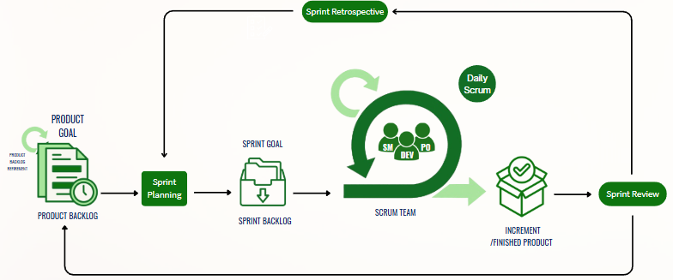
Agile Software Development Cycle with Scrum Framework
Figure 3.1 presents the Agile Software Development Life Cycle based on the Scrum Framework, which served as the primary guide in developing the CrediNews: An AI-Based System for Detecting Fake News And User Credibility on Facebook Posts system. Throughout the development process, the Agile Scrum methodology demonstrated its effectiveness by allowing the team to work in manageable phases while continuously adapting to user feedback and research findings. Each sprint was directed by focused objectives, enabling the developers to incrementally improve the system while minimizing delays and implementation bottlenecks. This approach fostered collaboration, strategic planning, and alignment with the project’s overarching goal of promoting responsible news consumption through real-time credibility verification. The Scrum framework implemented in this project included essential components such as the product goal, product backlog, sprint planning, sprint backlog, sprint execution, daily scrum, increment, sprint review, and sprint retrospective, all of which contributed to the timely and systematic development of the system.
Product Backlog. The Product Backlog was a prioritized list of all the work that needed to be completed for the CrediNews system. It contained features, content classification models, fact-checking integration tasks, and interface design components. The research developers managed and continuously refined the backlog to reflect changes based on prototype testing and user feedback.
This backlog helped identify essential features such as Natural Language Processing (NLP), machine learning classification, credibility scoring, and a user-friendly interface. The research developers prioritized tasks based on their importance to the system’s ability to detect fake news accurately and in real-time.
Sprint Planning. Sprint Planning was conducted at the start of each sprint cycle. During these planning sessions, the research developers selected a feature or set of tasks from the Product Backlog to include in the Sprint Backlog. Each sprint had a clear goal, such as implementing a functional scoring algorithm or integrating an external fact-checking API.
The planning process ensured that the research developers were aligned with the system objectives and had a step-by-step plan to achieve the sprint target. The project manager also served as the product owner and worked with the team to organize and guide the development direction.
Sprint Backlog. The Sprint Backlog was a subset of the Product Backlog. It contained tasks the team committed to completing within the sprint. These included breaking down large features into smaller tasks like building a backend service for article analysis, testing the credibility algorithm, or enhancing the user interface.
This backlog was used to monitor daily progress and address blockers during development. Each team member had specific responsibilities and updated task statuses to ensure everything was completed on time.
Sprint. A Sprint was a fixed development period that typically lasted two to four weeks. During this time, the research developers focused on completing the selected tasks. Each sprint aimed to produce a functional module or feature that could be tested and presented.
For CrediNews, one sprint focused on training the machine learning model, while another delivered a working prototype of the credibility scoring interface. These sprints allowed for focused progress and ensured the system steadily moved toward completion.
Daily Scrum. The Daily Scrum, also known as the daily stand-up, was a short meeting where the team discussed current tasks, future plans, and challenges encountered. The goal of these meetings was to ensure progress and resolve any development issues early.
In daily scrum, this was to keep track of the system's development. The research developers provided daily updates, and these updates were part of the regular communication where the team was connected online. Research developers discussed what they had achieved and what challenges they faced and collaborated on finding solutions to overcome them.
Increment. The Increment referred to the total of all product backlog items completed during the sprint, along with the increments from previous sprints. Each increment was expected to be functional, testable, and contribute toward the final version of the CrediNews: An AI-Based System for Detecting Fake News And User Credibility on Facebook Posts system.
This phase helped the research developer move on to the next task when the sprint was already done and accomplished. The next set of tasks would be done in the next sprint.
Sprint Review. The Sprint Review was conducted at the end of each sprint. The team demonstrated the completed features to stakeholders, collected feedback, and discussed improvements. This session allowed the research developers to see whether the system met expectations and made progress toward its goals. This review session facilitated open discussion and allowed for revisions to the product backlog, particularly where user preferences or real-world usability needed to be addressed.
Sprint Retrospective. The Sprint Retrospective was held after the Sprint Review and before the next sprint planning. During this session, the team discussed what went well, what could be improved, and how to apply changes to the next sprint.
These reflections helped the research developers improve their workflow, communication, and technical implementation. The insights gained were valuable in refining the CrediNews system and ensuring consistent quality across development cycles.
The research developers adhered to each phase of the Scrum framework and utilized all essential artifacts to maintain an organized and efficient development process for the CrediNews: An AI-Based System for Detecting Fake News And User Credibility on Facebook Posts. By implementing the Agile Scrum methodology, the team successfully divided the project into manageable segments, consistently delivered functional features, and incorporated stakeholder feedback throughout the development cycle. This iterative and collaborative approach proved well-suited for creating a reliable, user-centered system designed to accurately detect fake news and support informed decision-making.Through regular sprint reviews and retrospectives, the team continuously enhanced system performance and addressed issues proactively. The flexible nature of Scrum also allowed the developers to adapt to challenges, refine system components, and ensure that the final output aligned with both user needs and project objectives.
Source of Data
The research developers obtained the data through CrediNews: An AI-Based System for Detecting Fake News and User Credibility on Facebook Posts, a system designed to evaluate both the credibility of digital news content and the authenticity of the user accounts that share it. This innovative platform integrates machine learning and Natural Language Processing (NLP) to analyze textual information, assess account trustworthiness, and determine the overall authenticity of online articles. By leveraging CrediNews, the research developers aimed to address the increasing spread of misinformation and provide a real-time solution for verifying not only the accuracy of news content but also the reliability of its source.
Primary Source. The research developers obtained primary data from individuals who regularly consume digital news content, including college students. These participants were selected as respondents due to their frequent exposure to online information and potential encounters with misinformation. The primary sources included online surveys and questionnaires. Their responses offered direct user feedback that was crucial in evaluating the usability and effectiveness of the CrediNews system. These firsthand insights helped the researchers identify patterns in user behavior and preferences, which informed improvements to the system’s design and functionality.
Secondary Source. The research developers also had secondary sources of data, including academic studies, scholarly journals, and existing datasets on fake news articles. These sources provided insights into misinformation patterns, prior system models, and various detection techniques. Additionally, articles and reports from fact-checking organizations and media watchdogs provided a foundation for training and testing the AI models. These materials ensured that the CrediNews system was aligned with validated data and reflected real-world scenarios.
Research Instrument

The research developers employed a range of data-gathering tools to acquire essential information for the conceptualization, design, and development of the CrediNews system. The primary instruments utilized in this study were online research, surveys, and structured questionnaires. These tools were selected to ensure the system’s documentation was built upon relevant, current, and user-driven insights.
Online Research. Online research served as a vital tool in the collection of data related to fake news detection, artificial intelligence (AI), Natural Language Processing (NLP), and fact-checking technologies. Compared to conventional pen-and-paper methods, internet-based research offered greater accessibility, efficiency, and cost-effectiveness. As Bhat (2023) emphasized, online research tends to produce higher response rates due to its convenience and privacy assurances. For the researchers, it enabled access to a vast array of academic journals, scholarly articles, credible news platforms, and case studies that informed the development of CrediNews. This method provided a strong theoretical and technical foundation, guiding the incorporation of advanced AI features and the evaluation of existing misinformation detection techniques.
Survey and Questionnaires. To collect targeted feedback and user insights, the research developers designed online surveys and digital questionnaires tailored to the needs and expectations of individuals who frequently encounter digital news. These instruments consisted of multiple-choice items, Likert scales, and open-ended questions that aimed to capture user experiences with misinformation, their trust in digital news platforms, and their perspectives on the usefulness of automated credibility detection tools (Salvatori, 2023). As Bhat (2023) noteSd, online surveys remain essential for organizations seeking actionable data, particularly in the tech and digital media sectors.
Following the initial development of the CrediNews prototype, a structured questionnaire was distributed to potential users and evaluators to assess the system in alignment with ISO/IEC 25010:2011 software quality standards. The evaluation focused on seven core aspects: functional suitability, reliability, performance efficiency, usability, security, compatibility, and portability. The responses gathered were used to refine the system's interface, optimize its credibility scoring algorithm, and enhance its overall functionality. The feedback obtained through these instruments played a key role in ensuring that CrediNews effectively met user needs while adhering to accepted standards in software development and evaluation.
Data Generation Procedure
In this study, survey questionnaires were primarily used to gather data from users who interacted with the CrediNews: An AI-Based System for Detecting Fake News And User Credibility on Facebook Posts system. The survey consisted of a series of structured questions designed by the research developers to assess the effectiveness, usability, and user experience of the system. The survey was administered online through Google Forms, which was the chosen platform for collecting responses from participants. The data collection process involved questions focused on how users perceived the system's ability to detect and assess the credibility of news articles. These questions aimed to gather insights into the system's performance, accuracy, and overall user satisfaction. Respondents were asked to evaluate various aspects of the system, including the user interface, ease of use, and the reliability of the credibility scores provided by the system. Responses were recorded by the research developers and transcribed into digital format for analysis. To support the development of the system, additional online research was conducted, utilizing search engines and academic databases to retrieve relevant studies, reports, and technological frameworks that could enhance the system’s accuracy and performance. The collected data were then analyzed to identify trends, strengths, and areas for improvement in the CrediNews system. Insights gained from both user feedback and supplementary research guided the refinement of the system’s features and informed recommendations for future enhancements.
Tools for Data Analysis

Research developers would employ tools to investigate the data, information, and processes that would be relevant in building upon the proposed system. The data analysis tools that research developers would use were:

Use-Case Diagram. The Use Case Diagram was an essential tool during the development of CrediNews, as it guided research developers in identifying and outlining the functional requirements of the system. Rather than focusing on how the system operates internally, it illustrated what the system is expected to do from the end user's point of view. These use cases were documented in both visual and textual forms, clearly showing the interactions between users—such as readers, fact-checkers, and administrators—and the CrediNews platform. The primary goal of this diagram was to make the system behavior easy to understand by highlighting the flow of inputs and outputs, keeping user roles central to the design (Visual Paradigm, 2022).

In the development of CrediNews, the Use Case Diagram played a critical role in mapping out system capabilities, particularly in detecting and validating news articles. It helped communicate key system functionalities to stakeholders, supported the process of gathering requirements, and defined the project’s overall scope. This diagram also served as a visual foundation for system testing and validation. Additionally, it guided the creation of supporting diagrams like activity diagrams by identifying system actors and prioritizing core operations—such as news submission, credibility analysis, and feedback reporting—thus ensuring a user-centered, iterative development process.

Data Flow Diagram (DFD). According to Dinas et al. (2023), data flow diagrams provide visual representations of how data flows through a system, serving as an important tool for system analysis and design. The DFD would be used in CrediNews to illustrate how data, such as user-submitted articles, moves through various processing stages. This includes data input by the user, the machine learning algorithms that process the articles, and the output—the final classification as real or fake news. DFDs are crucial for identifying the complex interplay of information, helping stakeholders visualize the system’s operation and ensuring effective communication regarding system requirements. The DFD also assists in understanding how different components work together, aiding in early detection of potential bottlenecks or areas needing improvement as the system evolves. This holistic representation supports the development of the system’s architecture and helps refine system processes to ensure smooth data flow and efficient performance.

Research developers used Data Flow Diagrams to illustrate the complex flow of information within the CrediNews system, from the user’s input through a sequence of processing steps to the final output. This comprehensive diagram provided a clear understanding of how the system’s components were designed to interact and function together. Furthermore, it facilitated the early identification of potential bottlenecks or areas for optimization, allowing for adjustments and improvements to be made as the system progressed through its development stages.
Statistical Treatment of Data

Statistical treatment of data refers to the method of transforming raw data into a more meaningful and organized form to derive insights for system development. This process ensures that the information gathered from respondents becomes usable for evaluating and improving system features (DiscoverPhDs, 2023).

In this study, statistical techniques were employed to assess users’ responses to the proposed system and evaluate how well it met its intended goals. The data obtained from the survey were subjected to the following statistical tools:

Likert Scale. A Likert scale was a highly empirical psychometric scale which studied the attitude or opinions of the respondents usually on a 5-point scale ranging from strongly agree to strongly disagree (McLeod, 2023). Through this, researchers were in a position to collect user responses in a more systematic and quantified manner to be in a position to do an analysis on system strength, and areas that needed improvement.

The Likert scale was useful in evaluating the level of influence that the system would confer on digital literacy and fake news detection. To assess the level of users’ perceptions of the system’s credibility, ease of use, and reliability, the researchers employed the scale. All these quantitative data were useful in refining CrediNews and ensuring its value to end users.

To understand user feedback in a quantitative way, where the data was collected through a Likert scale, the researchers assessed the patterns in the results. This research provided a basis for future enhancements of the CrediNews system and its successors and was therefore valuable to anyone exploring the intersection of AI and responsible information dissemination.

Weighted Mean. The weighted mean was used to compute the central tendency of scaled responses, particularly when different items held varying levels of importance (Taylor, 2023). Unlike the simple arithmetic mean, which treats all values equally, the weighted mean assigns greater weight to more influential or frequently occurring responses, making it a more refined measure of average when data points are not uniformly significant (Statistics Canada, 2023).

This method allowed researchers to determine which system components users valued most by assigning weights to their ratings. It provided a clearer view of user satisfaction, especially regarding credibility, interface design, and response time, helping guide future improvements to the fake news detection system.
The formula was: x̄ = Σ(wX) / Σw
Where:
- x̄ is the weighted average
- w represents the weight assigned to each score
- X is the individual score

Percentage Distribution. Percentage distribution is a statistical method used to illustrate how individual data points are spread in relation to the total sample, expressed as percentages. This tool is particularly valuable in survey-based research, as it highlights how responses are distributed across predefined categories, making trends and frequencies easier to interpret (Statistics Canada, 2023). It simplifies complex data sets and enhances the visual representation of user feedback.

This method enabled researchers to examine and evaluate patterns in user responses across multiple factors. It gave a clear overview of feedback distribution, allowing for the identification of prevailing views and informing judgments about how to improve the fake news detection system. By identifying which response categories were most and least selected, researchers gained insight into user tendencies and areas requiring attention.
The formula was: % = (f / N ) × 100
Where:
- % = represents the percentage
- f = represents the frequency of a particular response
- N = represents the total number of respondents

Rubrics Scale Rating. Rubrics Scale Rating is a specification and categorization of criteria and their indicators used to assess performance with respect to a given activity or assessment. It aids in setting proper standards and expectations for the outcome inclusive of the assessment (Brookhart, 2019). In the context of this study, this rating system was utilized to evaluate the specific performance metrics of CrediNews, transforming technical observations into measurable standards.

To determine the range for each interpretation, the researchers used the following formula to calculate the interval size:

Formula: (n-1) / n

Where:

n = Indicated number of scales (5)

1 = The lowest theoretical value
Scale Point | Numeric Value | Interpretation
5 | 4.20 – 5.00 | Excellent
4 | 3.40 – 4.19 | Very Good
3 | 2.60 – 3.39 | Good
2 | 1.80 – 2.59 | Fair
1 | 1.00 – 1.79 | Poor

Table 3.1.
Rubrics Scale Rating

This rubric scale rating was employed to quantify the rates of each criterion and the overall performance of the CrediNews system. It provided the researchers with granular data regarding the system's accuracy in detecting fake news and evaluating user credibility on Facebook posts. Furthermore, these ratings helped the researchers gain insight into specific technical areas—such as detection speed, accuracy, and interface design—that required improvement to maximize the system's efficiency.

Ethical Considerations
The research developers kept key ethical considerations—privacy, transparency, accessibility, and accountability—as top priorities throughout the system design process. Expanding on The Accountant Online (2024), the study emphasized responsible AI usage by ensuring users were aware that the system was AI-powered and did not deliver absolute truths. To maintain fairness and inclusivity, the system was developed to avoid bias and accommodate diverse user behaviors without reinforcing harmful stereotypes. As stated by García and Goñi (2025), data privacy was preserved through appropriate handling of user data and by not collecting personally identifiable information, while survey participation remained entirely voluntary with prior consent obtained.
To prevent the risk of overreliance on automation, the researchers ensured that CrediNews would serve as a decision-support tool rather than a replacement for critical thinking or responsible journalism. By evaluating the trustworthiness of information alongside account authenticity, CrediNews was positioned as a helpful companion, not an absolute source of truth. Furthermore, safeguards were implemented to mitigate potential ethical risks, such as the inadvertent amplification of misinformation or the marginalization of certain user groups.
To promote reliable and ethical user experience, CrediNews was tested by different users and improved based on ethical concerns that arose during development, placing user privacy, dignity, and inclusion at the forefront. Continuous monitoring and regular feedback loops with participants allowed the research team to address ethical concerns promptly. This ongoing vigilance ensured that CrediNews remained a trustworthy, responsible, and user-centered AI system throughout its deployment, ensuring no unethical actions were taken under the guise of innovation.

Chapter 4
PRESENTATION, ANALYSIS, AND INTERPRETATION OF DATA

This chapter focuses on the analysis and interpretation of data gathered through online surveys and focus group discussions (FGDs) as part of the CrediNews development process. The insights derived from this study were pivotal in guiding the system's architectural design and overall implementation.

Design and Development of the System

Requirement Specification

A comprehensive study was conducted to establish the specific user requirements for CrediNews. Data was collated through online surveys and Focus Group Discussions (FGDs) to identify critical system needs, such as automated news verification and real-time credibility scoring. This data underwent rigorous analysis to formulate a system design that adequately addresses the identified user demands. The gathered requirements also helped prioritize essential features, define performance benchmarks, and ensure that the system would be intuitive, accessible, and aligned with user expectations for accuracy and reliability.

Analysis

The analysis phase involved a thorough examination of existing news verification methods, allowing the team to identify current limitations and opportunities for improvement. Consequently, a comprehensive Software Requirements Specifications (SRS) document is being prepared. This document outlines every functional and non-functional requirement necessary for the development of the CrediNews system, ensuring it effectively bridges the gaps found in current solutions. Additionally, the analysis phase included evaluating user feedback from surveys and FGDs to align system functionalities with real-world needs, ensuring that CrediNews not only addresses technical challenges but also enhances the overall user experience.

Design

The Design phase focused on constructing architectural models that illustrate the functionality and data processing pathways of the CrediNews system. Guided by the Use Case and Data Flow Diagrams, the team developed a functional prototype to serve as a tangible representation of the platform. This prototype was instrumental during user testing, allowing stakeholders to interact with the interface and provide critical feedback on the system's design and usability before full-scale implementation. Moreover, the design phase emphasized creating an intuitive and user-friendly interface, incorporating visual cues and streamlined navigation to enhance accessibility for users of varying technical backgrounds. It also involved designing robust backend processes to ensure accurate data analysis, efficient processing of news content, and reliable credibility scoring.

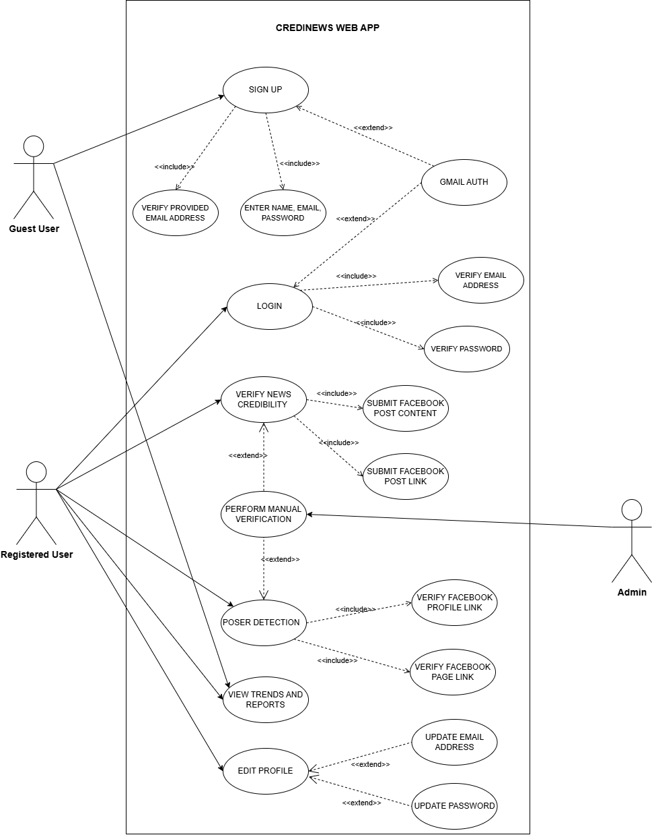
Figure 4.1
Use Case Diagrams of Developed System
Figure 4.1 illustrates a representation of user-system relations for the CrediNews Web App. The use case diagram contained all the primary functionalities of the system and their interactions with the three types of actors identified for the system: the Guest User, the Registered User, and the Admin.
Guest Users were connected to the Sign Up and View Trends and Reports use cases. This allowed visitors to create a new account within the system—entering necessary details like name and email—while also granting them immediate access to view public trends and reports without needing to log in.
Registered Users were able to Log In to the system to access a broader range of action options. These included Verifying News Credibility by submitting Facebook post content or links, Editing Profiles, and also accessing View Trends and Reports. The verification process for registered users was robust, featuring inclusions for validating Facebook profile and page links, and extensions for Poser Detection. The Admin actor played a critical role in the system's integrity, specifically interacting with the Perform Manual Verification use case to oversee and validate complex credibility checks.
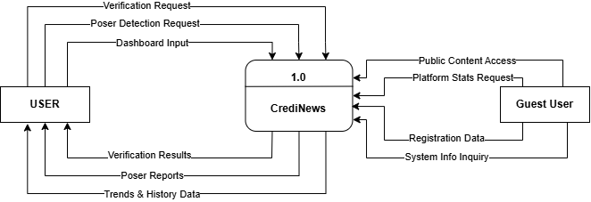
Figure 4.2
Context Diagram of the Developed System

Figure 4.2 illustrates the high-level data interactions between the system and its two external stakeholders: the User and the Guest User. Registered users engage with the system by submitting various inputs such as verification requests, poser detection requests, and dashboard-related data, which CrediNews receives and processes to generate credibility assessments. In response, the system produces several outputs—including verification results, poser detection reports, and trends and history information—which are returned to the user for evaluation and decision-making. On the other hand, Guest Users interact with the system in a more limited capacity, primarily through public content access, platform statistics inquiries, system information requests, and the submission of registration data when creating an account. CrediNews processes these guest interactions to provide the necessary information or facilitate onboarding into the platform.

The data flow structure further distinguishes the operational scope of each actor. The interaction with the User forms a complete feedback loop; the system accepts analytical tasks via the Verification Request and Poser Detection Request flows, processes this raw input within the CrediNews logic (Process 1.0), and transforms it into actionable intelligence delivered back as Verification Results and Poser Reports. Furthermore, the Dashboard Input flow indicates the user's ability to customize their session, which the system sustains by providing persistent Trends & History Data. Conversely, the Guest User interface is characterized by unidirectional inquiry flows. Inputs such as Platform Stats Request, System Info Inquiry, and Public Content Access represent the external demand for transparency and system information prior to full engagement. The critical bridge between these two actors is represented by the Registration Data flow, which serves as the specific input mechanism that allows a Guest User to establish an identity within the system, effectively transitioning their access privileges to the comprehensive features available to the Registered User.

Overall, the context diagram demonstrates how CrediNews operates as a centralized framework that receives, analyzes, and returns data to both user types while supporting verification processes, system navigation, and informational queries.

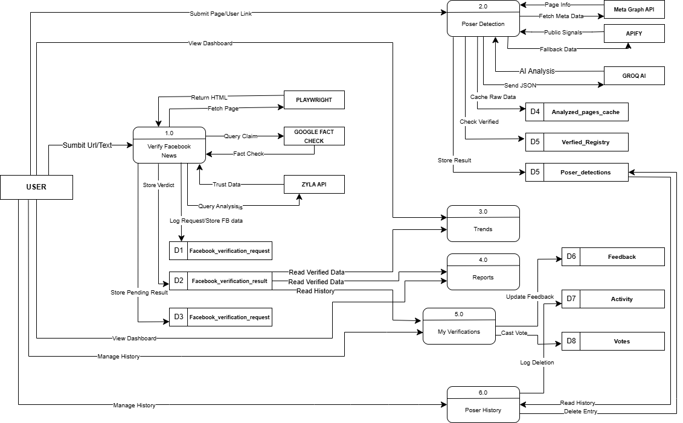

Figure 4.3
Data Flow Diagram of Developed System

The CrediNews Data Flow Diagram illustrates the end-to-end movement of information across the system, represented by processes 1.0 to 6.0, each contributing to the platform’s overall credibility analysis workflow. When a user submits a Facebook URL or text for verification, the request enters Verify Facebook News (1.0), where the system fetches page content through Playwright, checks related claims using the Google Fact Check API, and retrieves trust and reliability signals from the Zyla API. All received inputs, pending analyses, and final results are stored systematically in D1, D2, and D3, ensuring that the system maintains a complete history of verification activity. If the user instead provides a Facebook Page or profile link, the request proceeds to Poser Detection (2.0), which evaluates the authenticity of the account by gathering metadata from the Meta Graph API, extracting public signals and fallback information through Apify, and performing AI-driven analysis via Groq AI. These outputs are cached and stored in D4, while official verification statuses and poser evaluations are maintained in D5. Verified outputs from both modules feed into Trends (3.0), where the system aggregates credibility patterns, frequently analyzed topics, and emerging misinformation signals. This information then flows into Reports (4.0), which compiles organized summaries of verified data and tracks user feedback stored in D6 alongside activity logs recorded in D7, supporting continuous system refinement.

Users can access their personal verification history through My Verifications (5.0), which displays all previously analyzed posts and allows them to cast agree or disagree votes on the system’s results. These votes, along with user inputs, are stored in the Votes (D8) database to enhance future model adjustments. Meanwhile, poser-related analyses are managed under Poser History (6.0), enabling users to review or remove past poser detection entries, with each deletion action logged for transparency and accountability. Together, these numbered processes form a fully integrated verification ecosystem, ensuring that CrediNews delivers accurate credibility assessments, supports user interaction, and maintains structured, reliable data throughout all system components.

The following illustrations demonstrated the user interfaces of the system:
Figure 4.4
User Sign-In Interface

The CrediNews: An AI-Based System for Detecting Fake News And User Credibility on Facebook Posts. A detailed description of the system was provided. (1) This was the section where you could type in your email address and password. (2) You could select the "Forgot Password” option if you couldn’t remember your password to reset it. (3) Press this button to begin signing in. (4) Selecting this button brought you to Google’s login page, where you could enter your Google details. (5) This directs new users to the registration page to create an account. (6) When checked, this feature tells the system to save your login details so you don't have to manually sign in on this device next time.
The app allowed you to access it only if you had successfully logged into your Google account using the credential data.

Figure 4.5.
User Sign-Up Interface

This interface provided a simple way for new users to register. The sign-up process was as follows: (1) Click here to fill in the required details, including your full name, email, password, and password confirmation. This step ensures that the system collects the essential information needed to create a secure user account. The password confirmation field helps prevent typing errors, making sure users enter a matching and valid password before proceeding.

Figure 4.5.1
User Sign-Up Interface

Before proceeding with account creation, users are required to agree to the system’s Terms and Conditions and Privacy Policy. (2) This is where the user must agree to the system's Terms and Conditions and Privacy Policy before proceeding with account creation. (3) The button the user presses to submit the registration form and finalize their new account. (4) This option allows the user to sign up quickly by using their existing Google credentials. (5) Clicking this directs the user back to the User Sign-in Interface for existing account holders.
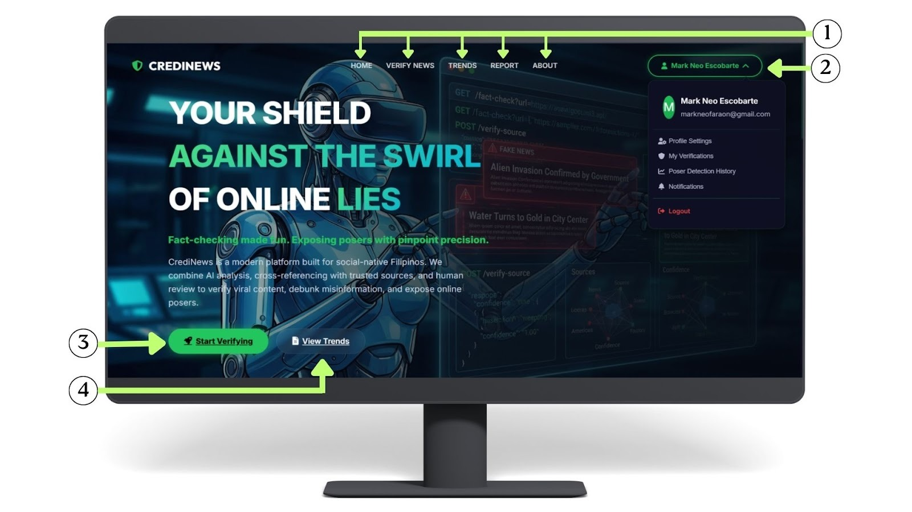
Figure 4.6
Homepage Interface
Figure 4.6. The CrediNews homepage interface serves as the primary introduction to the system, specifically designed to orient new users. The interface is anchored by a navigation bar (1) at the top, which allows users to access the Home, Verify News, Trends, Report, and About pages. Located on the upper right is the User Profile menu (2), a dropdown that displays the user's details and provides access to Profile Settings, My Verifications, Poser Detection History, Notifications, and the Logout function. To facilitate immediate interaction, the main "Start Verifying" button (3) redirects users directly to the Verify News page, while the "View Trends" button (4) navigates them to the Trends page to explore current data.

Figure 4.6.1
Homepage Interface

Figure 4.6.1 presents the lower section of the CrediNews homepage interface, accessible by scrolling down. The highlighted area (1) illustrates the "How It Works" section, which provides a visual step-by-step guide on how to utilize the system. This workflow breaks down the process into three clear stages: submitting news articles or URLs, processing the content through AI analysis for authenticity, and receiving a final report with the credibility status.

Figure 4.6.2
Homepage Interface
Figure 4.6.2. Illustrates the subsequent section of the CrediNews homepage, which users access by scrolling further down. The interface prominently features a "Platform Stats" dashboard (1) that visualizes real-time data retrieved from the system database. This dashboard displays four key metrics: the total volume of verified content (70 links analyzed), the system's accuracy rate (98%), its continuous 24/7 monitoring status, and the current count of registered active users (7). Adjacent to the statistical data are two call-to-action buttons (2): "Get Started Today," which redirects users to the Verify News page to begin the verification process, and "Learn More," which navigates users to the About page for additional system information.

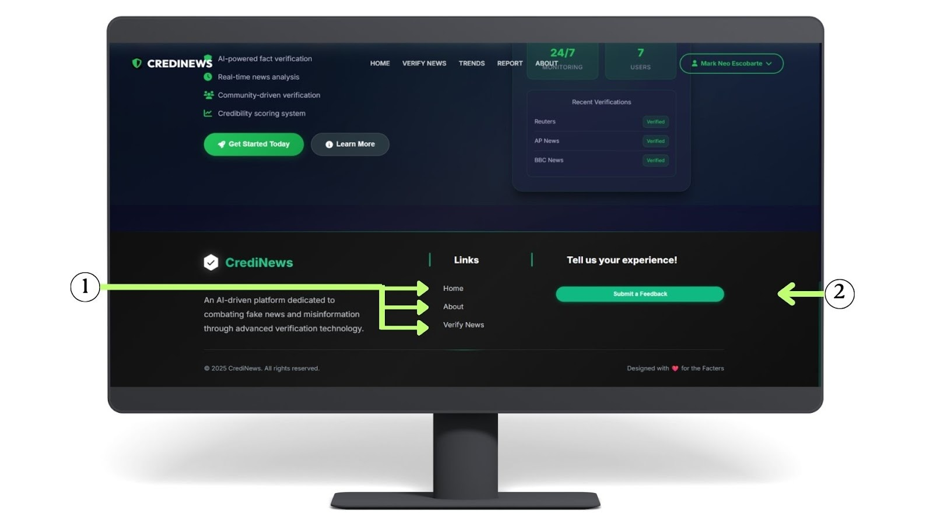
Figure 4.6.3
Homepage Interface

Figure 4.6.3. Depicts the footer section of the CrediNews homepage, which becomes visible at the bottom of the interface. This area contains a secondary navigation menu (1) providing quick access to essential pages, including Home, About, and Verify News. Additionally, it features a dedicated feedback section (2) designed to collect user input, allowing the developers to gather the insights necessary for the continuous improvement and optimization of the CrediNews system. The footer also includes social media links and contact information, enabling users to connect with the development team and stay updated on system announcements, while reinforcing transparency and user engagement across the platform.


Figure 4.7
User Feedback Interface
Figure 4.7. This section is positioned in the footer of the application to promote continuous user engagement and ensure that feedback is easily accessible at any time during system use. (1) When users click this button, they are directed to a dedicated feedback interface, where they can share their overall experience with the platform. This includes the opportunity to express their thoughts about system performance, report any technical issues or bugs they may have encountered, or provide suggestions for enhancements that could improve usability and functionality. By placing this option in a persistent and visible area of the interface, the system encourages users to participate in the improvement process, making feedback collection an integral part of the user experience.

Figure 4.7.1
User Feedback Interface

Figure 4.7.1 (2) This step represents the first part of the feedback modal, where users provide an overall rating of their experience through a 5-star scale. This initial rating offers a quick snapshot of user satisfaction and helps categorize feedback based on sentiment. (3) After selecting their rating, the user proceeds by clicking “Continue,” which leads them to the next section of the feedback process. In the following section, users are prompted to provide more detailed comments or suggestions regarding their experience, allowing the developers to gain deeper insights into specific strengths and areas for improvement within the CrediNews system. This multi-step approach ensures that the interface remains uncluttered, encouraging higher response rates by allowing users to commit to a simple rating before being asked for written input.
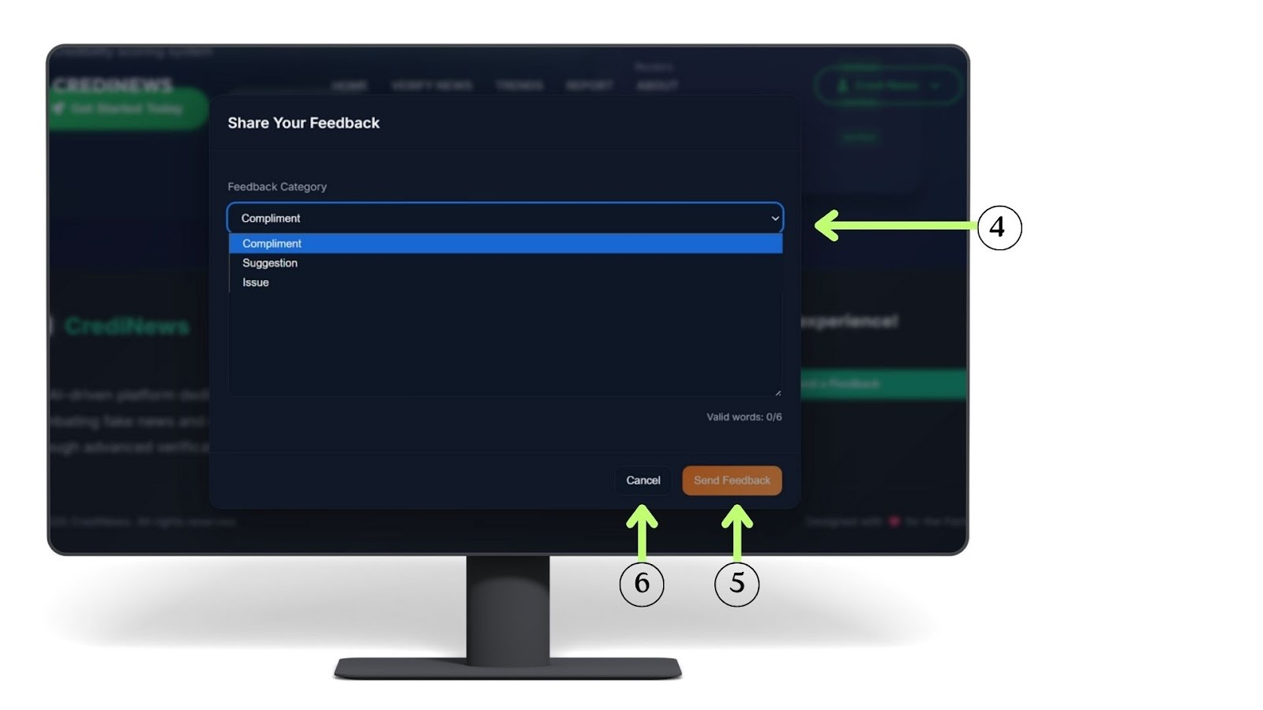
Figure 4.7.2
User Feedback Interface
Figure 4.7.2 (4) Users select the type of feedback—Compliment, Suggestion, or Issue—using a dropdown menu, helping administrators categorize and address submissions efficiently. (5) Once the necessary information is filled out, the user clicks the 'Send Feedback' button to formally submit their response to the system. (6) Alternatively, users can click the Cancel button, which allows them to discard any entered text and close the feedback form without saving.

Figure 4.8.
Verify News Interface
Figure 4.8. presents the Verify News interface of CrediNews, which allows users to analyze Facebook posts and shared content for credibility and potential misinformation. (1) At the top of the page, users can select the “Verify Facebook News”, which activates the main verification module. Below this section, an input field is provided where users can paste the Facebook Post URL they wish to evaluate. (2) The system supports only valid Facebook post or share links, ensuring accurate processing. Once the URL is entered, the platform proceeds to analyze the content for credibility signals, fact-check references, and misinformation indicators before generating the verification results.

Figure 4.8.1
Verify News Interface

Figure 4.8.1 shows the lower part of the Verify Facebook News section. Users have two ways to submit content for analysis. (3) If they do not want to use a link, they can paste the text of the Facebook post into the large text box. The system requires at least 14 words to perform an accurate credibility check. (4) After entering the content, users click the “Analyze Facebook Content” button, which starts the system’s process of checking the text for credibility, misinformation, and supporting evidence.
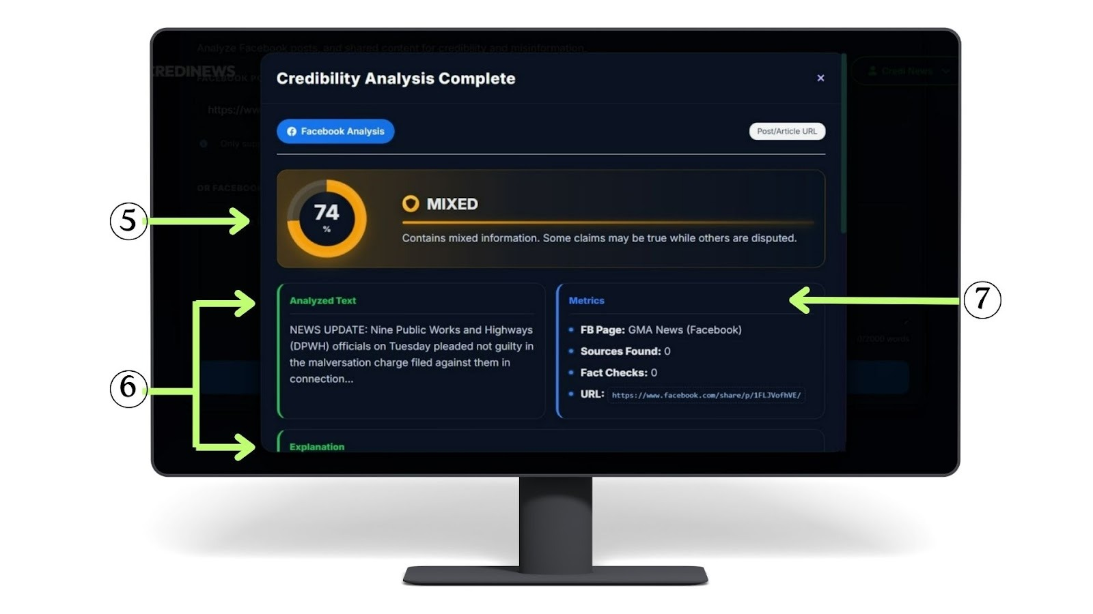
Figure 4.8.2
Verify News Interface

Figure 4.8.2 The interface displays the credibility score and rating (5) showing the percentage and whether the content is classified as Mixed, Credible, or Low Credibility, Unverified. Below it, the system presents the analyzed text (6) which is the specific portion of the post evaluated during the credibility check. On the right side, the metrics section (7) provides key details such as the source page, number of fact-checks, sources found, and the URL used in the analysis. 
Figure 4.8.3
Verify News Interface

Figure 4.8.3 The interface continues with the Explanation section (6) where the system provides a short summary of why the content received its credibility rating, including any verified or inaccurate details. Below it, the Slang Detection section (8) shows whether the post contains sarcasm, slang, or risky language that may affect interpretation. (9) Source Risk displays the poser detection result for the Facebook page, indicating whether the account is authentic, low-risk, or potentially suspicious.


Figure 4.8.4
Verify News Interface

Figure 4.8.4 (10) At the bottom, Agree/Disagree buttons let users give quick feedback on the credibility result, (11) while the Close button exits to the main verification page.
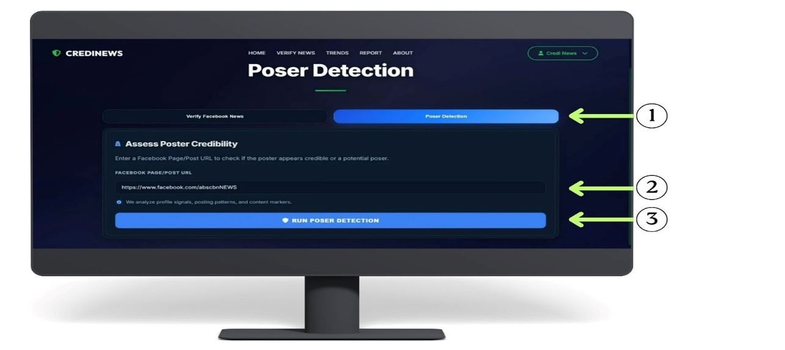
Figure 4.9
Poser Detection Interface
Figure 4.9. illustrates the Poser Detection interface, specifically designed to assess the authenticity of social media accounts. The interface is navigated via the "Poser Detection" tab (1), which users select to access the tool for identifying potential fake profiles or "posers". A designated input field (2) is provided below, allowing users to enter the target Facebook Page or Post URL for evaluation. Once the link is provided, the user interacts with the "Run Poser Detection" button (3), which serves as the execution trigger to initiate the system's analysis of profile signals and posting patterns before displaying the credibility results.
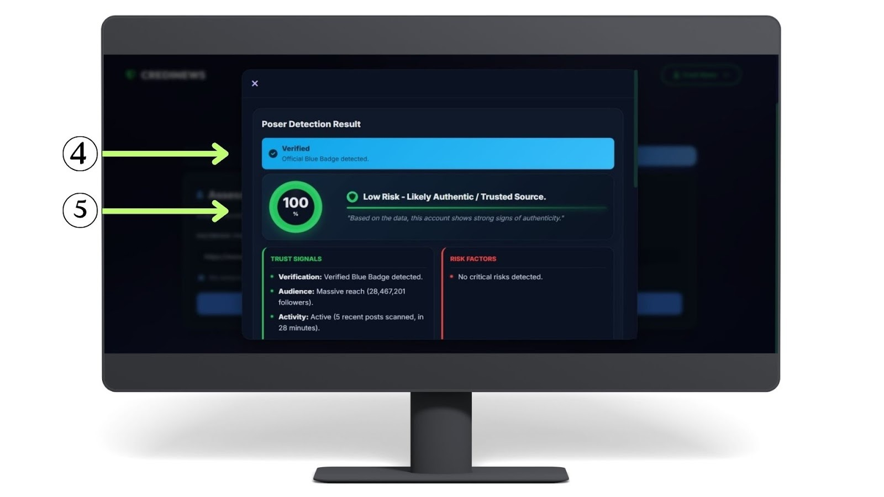
Figure 4.9.1
Poser Detection Interface

Figure 4.9.1. presents the Poser Detection Result modal, which appears immediately after the system analyzes a submitted Facebook Page or Post URL. The top section (4) displays the verification status, confirming if the account possesses an official "Verified" blue badge. Below this, the analysis section (5) visualizes the account's credibility through a percentage score and a specific risk classification. Depending on the detected signals, the system categorizes the account into one of three statuses: "Low Risk - Likely Authentic/Trusted Source," "Moderate Risk - Suspicious or Mixed Signals," or "High Risk - Likely Poser".
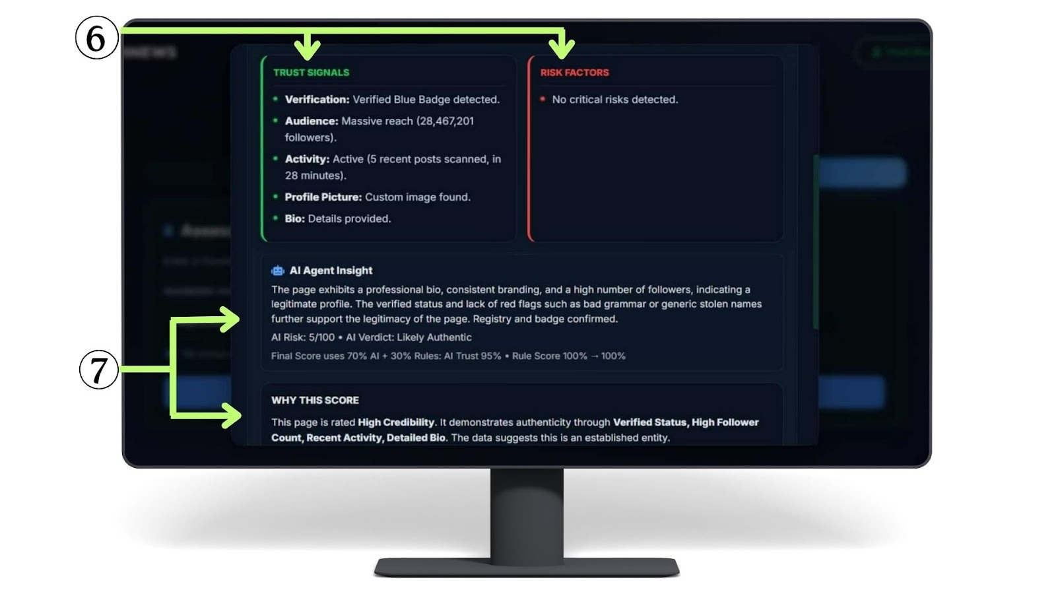
Figure 4.9.2
Poser Detection Interface

Figure 4.9.2. shows the continuation of the Poser Detection results, focusing on the evidence behind the analysis. The interface highlights a comparison between "Trust Signals" and "Risk Factors" (6), outlining the specific data points that influenced the verification outcome. Furthermore, the "AI Agent Insight" and "Why This Score" sections (7) provide a comprehensive explanation of the system’s reasoning, detailing the processes and criteria used to calculate the final credibility score, thereby helping users understand and trust the accuracy of the result.

Figure 4.9.3
Poser Detection Interface
Figure 4.9.3. shows the concluding actions available in the results window. Users can utilize the "Request Manual Verification" button (8) to flag the URL for human inspection, allowing an admin to officially confirm if the source is legitimate. Upon completion, clicking the "Close" button (9) dismisses the result and redirects the user back to the Poser Detection input screen.These options ensure that users have both automated and manual avenues for verifying news credibility, promoting transparency and user confidence in the CrediNews system.

Figure 4.10
Admin Verification Interface
Figure 4.10 (1) Shows the system’s confirmation after a manual verification request, with a notification modal acknowledging the submission and an "OK" button to send the request to the administrator.
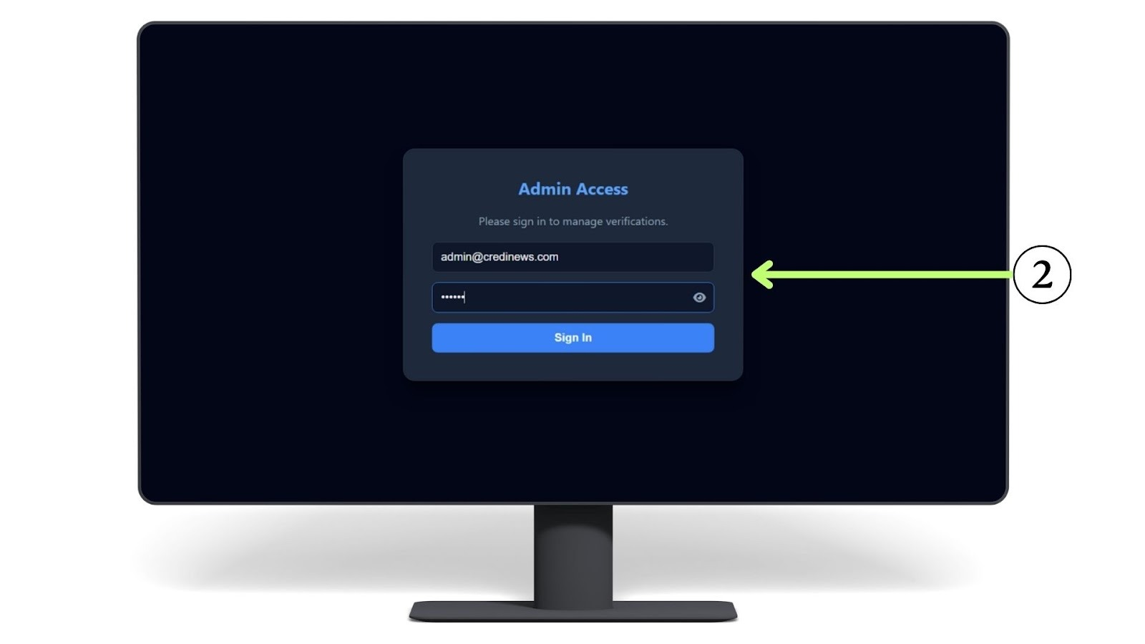
Figure 4.10.1
Admin Verification Interface
Figure 4.10.1 shows the admin point-of-view when accessing the verification system. To ensure security, an email address and password prompt (2) appears, requiring the administrator to enter the correct credentials to unlock the verification queue. This step allows the admin to review and approve pending requests. However, if the entered password is incorrect, the system displays an 'Access Denied' error message, preventing any unauthorized access to the data.
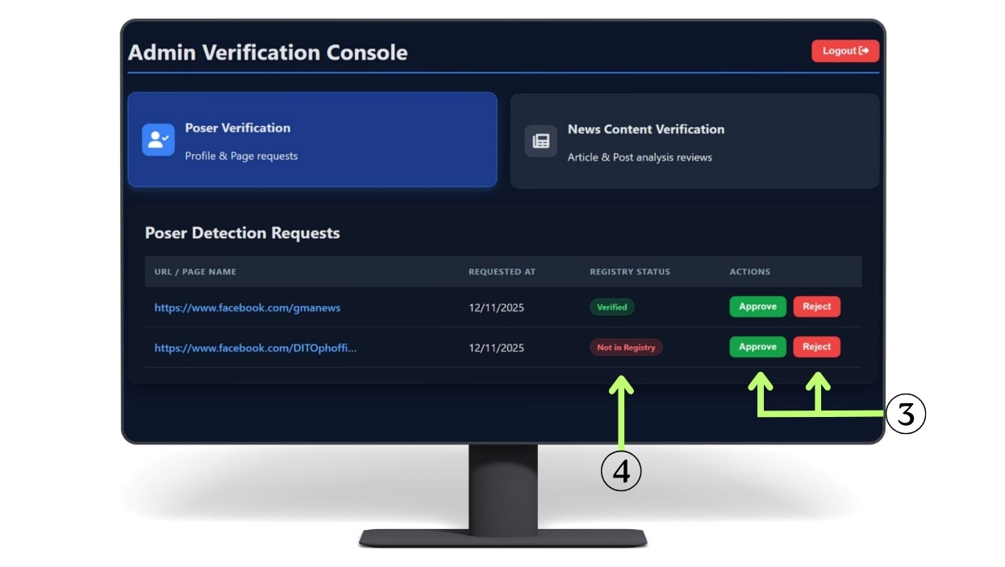
Figure 4.10.2
Admin Verification Interface
Figure 4.10.2 illustrates the management of user requests. The interface features specific action buttons (3) that allow the admin to approve or reject the submitted URL or page name. The system also displays the current status (4), where “Not in Registry” means the URL isn’t verified or saved in our trusted dataset yet. Once a decision is clicked, the system automatically saves the outcome and adds the updated information to the database.
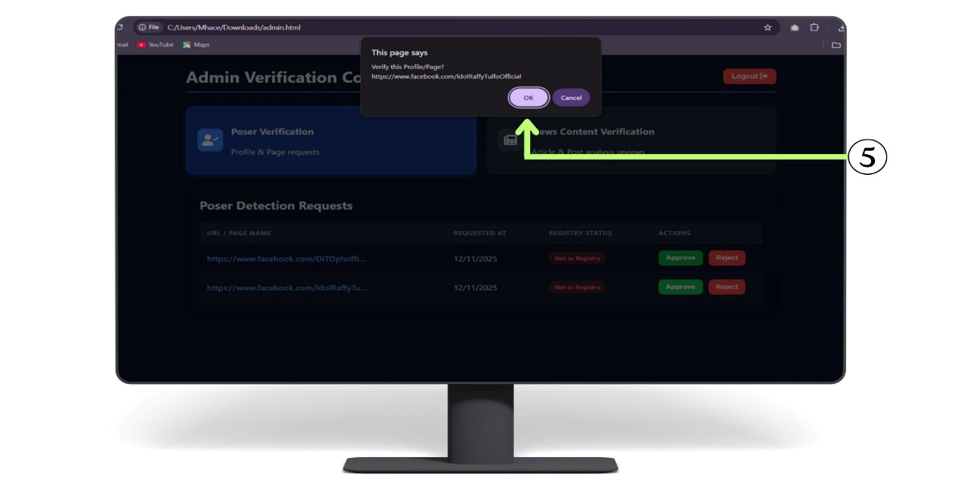
Figure 4.10.3
Admin Verification Interface
Figure 4.10.3 shows an Admin Verification Console where an administrator, upon initiating an action (likely 'Approve'), is presented with a browser alert (5) confirming they wish to verify the profile/page URL before proceeding by clicking OK or Cancel. This safeguard prevents accidental updates to the registry, ensuring that critical changes to the verification status are intentional and final. Furthermore, the alert explicitly displays the target URL, allowing the administrator to perform a final cross-check of the data against the intended action before committing.

Figure 4.11.
Trends Interface
Figure 4.11. Shows news articles classified as Credible, Unverified, Mixed, or Low Credibility (1) Users can search for news articles. (2) View Details shows the credibility score, analyzed text, and related metrics. (3) A dropdown lets users sort results by date or score. (4) Users can like or dislike content to provide feedback.
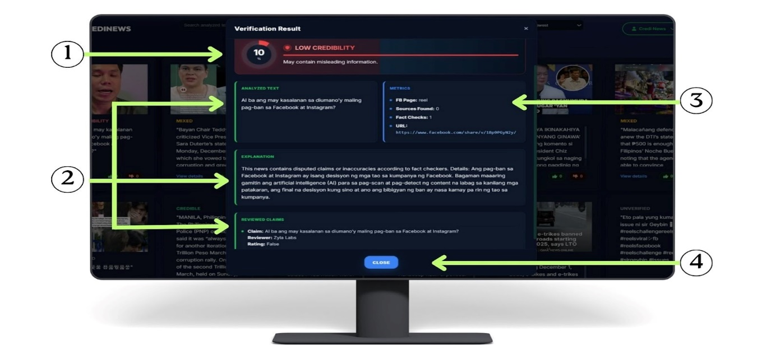
Figure 4.11.1.
Trends Interface
Figure 4.11.1. This section opens when you click “View Details,” showing the full verification results. (1) Shows the percentage score and its rating (Unverified, Low Credibility, Mixed, or Credible). (2) This area shows the analyzed text, the system’s explanation of the result, and the reviewed claims validated by fact-checkers. It helps users see exactly which parts of the content were examined and why the rating was assigned. (3) Provides key verification metrics such as content type, sources found, fact-checks, and the URL. (4) The Close button allows the user to exit the verification result panel and return to the main news feed or previous view.
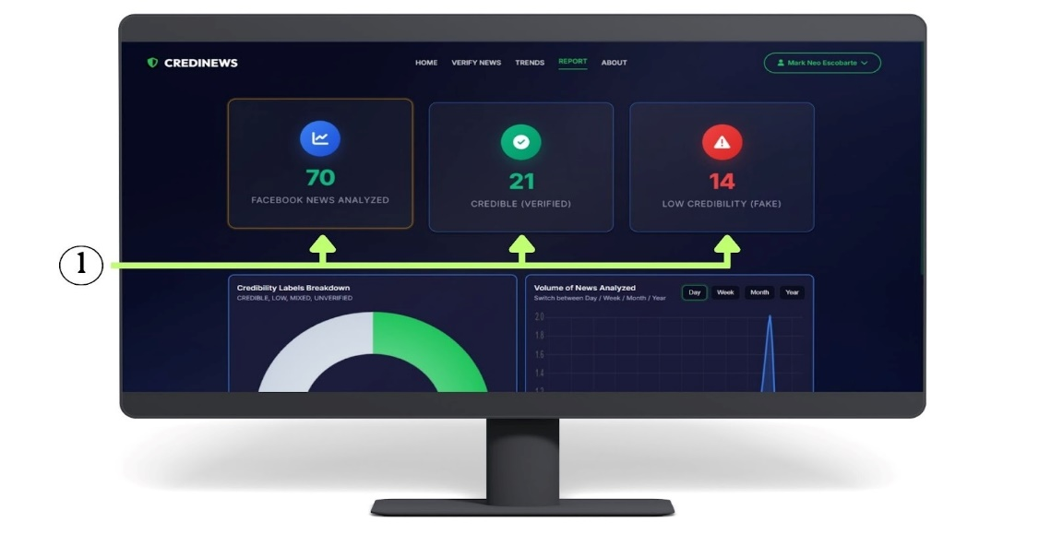
Figure 4.12
Report Interface
Figure 4.12 illustrates the Report page, which is designed to visualize the system's analytical data through various indicators. The interface highlights three key metric cards (1) that summarize the current verification statistics: "Facebook News Analyzed," displaying a total volume of 70 items; "Credible (Verified)," showing 21 authenticated news pieces; and "Low Credibility (Fake)," indicating 14 items flagged as misinformation.
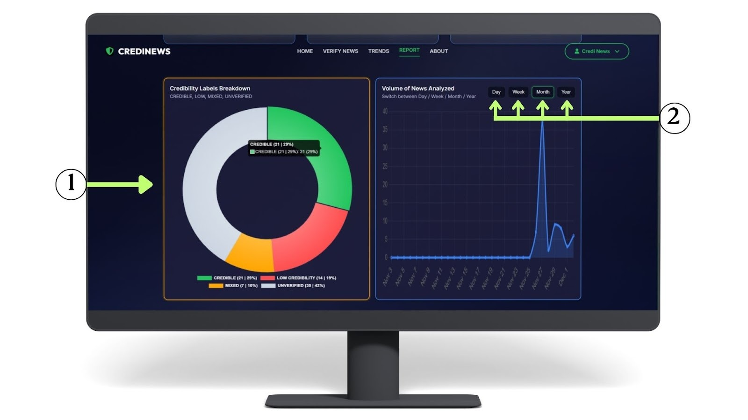
Figure 4.12.1
Report Interface
Figure 4.12.1 The continuation of the Report page features advanced visualizations: (1) the 'Credibility Labels Breakdown' donut chart categorizes content as Credible, Low Credibility, Mixed, or Unverified, showing counts and percentages on hover; (2) the 'Volume of News Analyzed' graph tracks usage over time with toggle controls to filter by Day, Week, Month, or Year. These interactive charts provide immediate insights into the distribution of news credibility, allowing users to assess the prevalence of misinformation within the system at a glance. Additionally, the temporal tracking capability helps in identifying specific periods of high activity, which is crucial for analyzing how news verification demand fluctuates in response to real-world events.

Figure 4.13
About page Interface

Figure 4.13 The About Page highlights the system’s tools and features, featuring CSS-styled Feature Cards that display the technology stack and core functionalities like detection accuracy, automated analysis, and crowd validation.
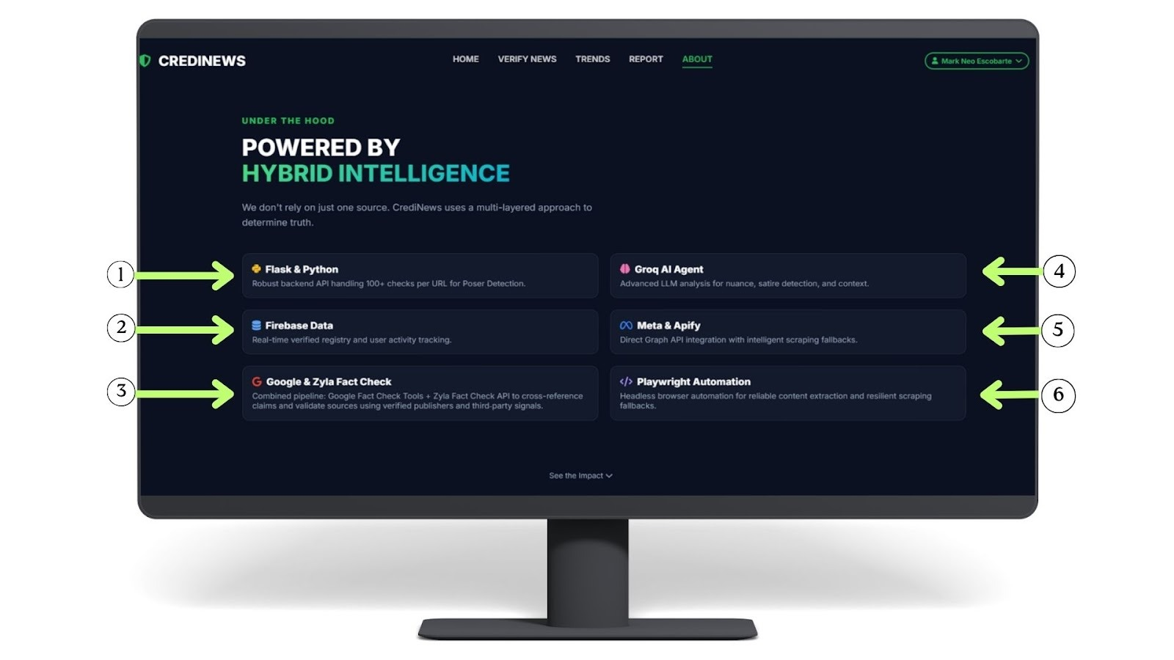
Figure 4.13.1
About page Interface
Figure 4.13.1. This section presents CSS-styled feature cards that outline the core technologies supporting the system’s functionality. (1) It provides a robust backend API capable of handling over 100 checks per URL, specifically used for Poster Detection. (2) Used for real-time verified registry and user activity tracking. (3) These will combine pipelines using the Google Fact Check Tools and Zylá Fact Check API to cross-reference claims and validate sources using verified publishers and third-party signals. (4) These will implement advanced LLM analysis for determining nuance, satire, and context in news content. (5) Directly integrates with the Graph API combined with intelligent scraping fallbacks. (6) A headless browser automation tool used for reliable content extraction and resilient scraping fallbacks.


Figure 4.13.2
About page Interface

Figure 4.13.2 This area displays three critical statistics that demonstrate the system's reliability and activity level: area displays three critical statistics that demonstrate the system's reliability and activity level: (1.1) Indicates the high precision of the AI models in identifying fake news (98% Detection Accuracy). (1.2) Highlights that the system operates continuously to monitor content (24/7 Automated Analysis). (1.3) Confirms that a community of users is currently engaged in verifying information (Active Crowd Validation). (2) This button serves as an invitation for users to participate. Clicking this likely directs them to sign up or engage with the community features to help fight misinformation.

Implementation

Implementation serves as the foundational phase that transforms abstract architectural designs into a functional, real-world system capable of addressing the prevalence of misinformation. It represents the bridge between theoretical AI models and practical application, ensuring that the proposed solution effectively mitigates the spread of fake news on social media platforms.

The CrediNews system was engineered using a robust technical stack centered on Flask and Python, which manage the backend API to handle over 100 concurrent checks per URL for efficient poser detection. Data persistence and real-time user activity tracking are facilitated by Firebase, serving as the verified registry for the system. At the core of the verification process is the Groq AI Agent, which employs advanced Large Language Model (LLM) analysis to detect nuance, satire, and context within articles. To ensure comprehensive data gathering, Playwright Automation is utilized for headless browser operations, ensuring reliable content extraction even from complex web structures.

To achieve high-accuracy fact-checking, the development team integrated a combined pipeline using Google Fact Check Tools and Zyla Fact Check API. This allows the system to cross-reference claims against verified publishers and third-party signals. Furthermore, Meta and Apify integrations were implemented to provide direct Graph API access with intelligent scraping fallbacks, ensuring seamless interaction with Facebook content.

Adopting a user-centered design approach, the system features an intuitive dashboard that simplifies complex data for the user. Visualizations such as credibility donut charts and line graphs for volume analysis allow users of varying technical competencies to easily interpret verification results. The interface was designed to be accessible, guiding users through a clear three-step workflow—Submit, Analyze, and Result—ensuring that the tool is both educational and functional for the general public.

Acceptance

Acceptance was a key phase in the project life cycle, marking the point where all stakeholders confirmed that CrediNews met the required functionalities and fulfilled the project’s objectives. This stage signified the completion of the long development effort and served as the final checkpoint before releasing the system to its intended users.

According to Sommerville (2021), “Acceptance is the process by which stakeholders validate that a software system meets its specified requirements and is ready for operational use.” In the context of CrediNews, acceptance was essential in assessing whether the news-verification platform was ready for deployment.

This phase involved system testing, user acceptance testing (UAT), and evaluations focusing on functionality, performance efficiency, security, usability, compatibility, reliability, portability, and documentation accuracy. Performance testing ensured the system could handle real-time analysis, scoring, and data retrieval efficiently. Security testing verified that user data, collected links, and stored results were protected from vulnerabilities. UAT confirmed that the system met user expectations, especially in presenting credibility scores, verified claims, detection explanations, and metrics clearly and accurately. Compatibility testing ensured smooth operation across devices and browsers, while documentation review validated the completeness and correctness of all support materials.

Thus, the acceptance process ensured that CrediNews was fully ready for deployment and capable of effectively assisting users in verifying news credibility. This process also validated that all system features functioned as intended, met user requirements, and provided a reliable, user-friendly experience before official release. Ultimately, the successful completion of this phase served as the formal authorization to transition the project from a development environment to a live operational setting.

Deployment

Deployment marked the transition of CrediNews from a controlled development and testing environment into a live platform accessible to end-users.

Deployment is defined as the process of transferring a software system from development into a user-accessible production environment (Bass et al., 2021). For CrediNews, this meant moving the system—including its backend API, automated analysis pipeline, news-verification engine, and user interface—into a stable production environment.

The deployment strategy embraced continuous improvement and iterative development. This allowed the CrediNews team to respond quickly to user feedback, misinformation trends, and emerging technological needs. Following the initial rollout, developers continued with ongoing maintenance, which included fixing issues, optimizing detection accuracy, and gradually introducing new features such as enhanced metrics, additional fact-checking integrations, and improved scoring logic.

The deployment approach for CrediNews was user-focused, ensuring that the platform operated efficiently and securely across devices. The system also required a reliable backend capable of handling real-time analysis, automated validation workflows, and storage of user interactions and verification results. Through this adaptive deployment strategy, CrediNews remains ready to evolve with the growing demands of digital credibility assessment and misinformation detection.

Evaluation of the Developed System

The evaluation of the system was carried out by 40 respondents through an online survey questionnaire which aimed to evaluate the developed system utilizing the ISO 25010:2011 quality model. The study interpreted and evaluated completely the capabilities of the system across important performance measures with an analysis that was objective with respect to technological attributes and possible areas for improvements.
Table 4.1
Evaluation of the Developed System in terms of Functional Suitability

Functional Suitability
Question | Frequency |  |  |  |  | Total | Average Mean | Verbal Interpretation
 | 1 | 2 | 3 | 4 | 5
Effectiveness of the Verify News page in identifying potential misinformation and fake news. | 0 | 0 | 6 | 15 | 19 | 40 | 4.33 | Excellent
Effectiveness of the Poser Detection feature in identifying suspicious user behaviors or bot-like accounts. | 0 | 0 | 6 | 15 | 19 | 40 | 4.33 | Excellent
Capability of Trends & Reports to display submitted verified news and summarization graphs. | 0 | 0 | 2 | 18 | 20 | 40 | 4.45 | Excellent
Consistency of the system's accuracy and functionality over time, even after repeated use. | 0 | 0 | 6 | 13 | 21 | 40 | 4.38 | Excellent
Helpfulness of system features (Checkers, Detection, Reports) in supporting decision-making about online information. | 0 | 0 | 5 | 17 | 18 | 40 | 4.33 | Excellent

Table 4.1 presents a comprehensive evaluation of the Functional Suitability of the CrediNews system. The data reveals that the system consistently performs at an "Excellent" level across all evaluated criteria. The system proved to be excellent in its core capabilities, specifically in the effectiveness of the Verify News page (4.33) for identifying misinformation and the Poser Detection feature (4.33) for flagging suspicious behaviors. The highest rating was observed in the capability of Trends & Reports (4.45), indicating that users found the visualization of verified news and summarization graphs highly effective. Furthermore, the system demonstrated excellent consistency in accuracy and functionality over time (4.38) and was rated highly for the helpfulness of its features in supporting decision-making (4.33). In total, the evaluation resulted in a composite mean of 4.36, signifying a high standard for the functional suitability of the developed system.

ISO 25010:2011 defines functional suitability as the degree to which a product or system provides functions that meet stated and implied needs when used under specified conditions. Consequently, the high ratings from the respondents indicate that the CrediNews system effectively satisfies the functional requirements of its users. The results confirm the system's utility and effectiveness in delivering accurate credibility checks, detecting bot-like accounts, and providing insightful reports to aid users in navigating online information. These findings collectively underscore the system's robustness, ensuring that it not only meets technical specifications but also delivers tangible value in the ongoing fight against digital misinformation.

Table 4.2
Evaluation of the Developed System in terms of Reliability

Reliability
Question | Frequency |  |  |  |  | Total | Average Mean | Verbal Interpretation
 | 1 | 2 | 3 | 4 | 5
Consistency of credibility scores when analyzing the same post multiple times. | 0 | 0 | 6 | 20 | 14 | 40 | 4.20 | Excellent
Smoothness of system operation without unexpected errors or crashes. | 0 | 0 | 5 | 16 | 19 | 40 | 4.35 | Excellent
Effectiveness of error handling mechanisms (e.g., clear messages for broken links). | 0 | 0 | 7 | 12 | 21 | 40 | 4.35 | Excellent
Ability of Verify News and Poser Detection to function without errors during repeated use. | 0 | 0 | 6 | 16 | 18 | 40 | 4.30 | Excellent
Reliability of data preservation for user activity (e.g., feedback) without data loss. | 0 | 0 | 6 | 14 | 20 | 40 | 4.35 | Excellent

Table 4.2 illustrates the evaluation results for the Reliability of the CrediNews system. The data indicates that the system is highly robust and dependable, achieving an "Excellent" rating across all five indicators. The highest ratings were observed in the smoothness of system operation, the effectiveness of error handling mechanisms, and the reliability of data preservation, all of which achieved a mean score of 4.35. These scores suggest that users experienced a seamless interface without unexpected crashes and felt secure regarding the safety of their data and feedback. The system also proved to be consistent in its core analysis, with the ability of Verify News and Poser Detection features to function without errors scoring 4.30, and the consistency of credibility scores scoring 4.20. In total, the evaluation meant a high standard for the reliability of the system under development, with a composite mean of 4.31.
Based on ISO 25010:2011 standards, the high ratings confirm that CrediNews is a mature and fault-tolerant system. The results demonstrate its ability to maintain consistent performance, handle errors effectively, and ensure data integrity, all of which are essential for building user trust in a misinformation detection platform.
Table 4.3
Evaluation of the Developed System in terms of Performance

Performance
Question | Frequency |  |  |  |  | Total | Average Mean | Verbal Interpretation
 | 1 | 2 | 3 | 4 | 5
Speed of loading pages, results, and features within a reasonable time. | 0 | 0 | 7 | 14 | 19 | 40 | 4.30 | Excellent
Speed of generating credibility results for news and user accounts. | 0 | 0 | 6 | 17 | 17 | 40 | 4.28 | Excellent
Capability to process large or long news content without slowdowns. | 0 | 0 | 6 | 16 | 18 | 40 | 4.30 | Excellent
Loading speed of Trends & Reports visualizations without lagging the browser/device | 0 | 1 | 3 | 20 | 16 | 40 | 4.28 | Excellent
Efficiency of device resource usage and overall smoothness of operation. | 0 | 0 | 4 | 15 | 21 | 40 | 4.43 | Excellent

Table 4.3 details the evaluation results for the Performance Efficiency of the CrediNews system. The data reveals that the system operates with high efficiency and responsiveness, securing an "Excellent" rating across all measured indicators. The system was rated highest in the efficiency of device resource usage and overall smoothness of operation with a mean of 4.43, indicating that the application is lightweight and does not negatively impact device performance. Users also reported excellent performance regarding the speed of loading pages, results, and features (4.30) and the capability to process large or long news content without slowdowns (4.30). Furthermore, the system maintained high standards in processing complex tasks, such as the speed of generating credibility results (4.28) and the loading speed of Trends & Reports visualizations (4.28). In total, the evaluation signifies a high standard for the performance efficiency of the system under development, with a composite mean of 4.32.

ISO 25010:2011 defines performance efficiency as the performance relative to the amount of resources used under stated conditions. The high ratings received in this category demonstrate that the CrediNews system is optimized for speed and resource management. These results imply that the system effectively handles data-intensive tasks—such as analyzing long articles and rendering graphical reports—within a reasonable time and without lagging the user's browser or device, ensuring a smooth and responsive user experience. This rapid response time is particularly vital in the context of combating misinformation, where users require immediate verification to prevent the inadvertent spread of false narratives. Moreover, the efficient resource utilization suggests that the underlying architecture is robust and scalable, capable of maintaining stability even as the user base and data volume continue to grow.
Table 4.4
Evaluation of the Developed System in terms of Usability

Usability
Question | Frequency |  |  |  |  | Total | Average Mean | Verbal Interpretation
 | 1 | 2 | 3 | 4 | 5
Ease of navigation within the system, even for first-time users. | 0 | 0 | 3 | 14 | 23 | 40 | 4.50 | Excellent
Simplicity and understandability of the Verify News interface. | 0 | 0 | 3 | 14 | 23 | 40 | 4.50 | Excellent
Clarity of instructions, notifications, and error messages provided by the system. | 0 | 0 | 4 | 12 | 24 | 40 | 4.50 | Excellent
Ease of completing core tasks (account creation, checking news, feedback) without confusion. | 0 | 0 | 3 | 15 | 22 | 40 | 4.48 | Excellent
Visual appeal and user-friendliness of the overall system design. | 0 | 0 | 3 | 11 | 26 | 40 | 4.58 | Excellent

Table 4.4 presents the evaluation results for the Usability of the CrediNews system. The data reveals that the system possesses an exceptionally high degree of user-friendliness, achieving "Excellent" ratings across all five indicators. The highest rating in the entire evaluation was observed in the visual appeal and user-friendliness of the overall system design, which garnered a mean of 4.58. This suggests that the respondents found the interface aesthetically pleasing and modern. The system also demonstrated consistent excellence in accessibility and guidance, with ease of navigation, simplicity of the Verify News interface, and clarity of instructions/error messages all receiving a mean score of 4.50. Furthermore, users reported that the ease of completing core tasks (such as account creation and checking news) was highly intuitive, reflected in a mean of 4.48. In total, the evaluation signifies a superior standard for the usability of the system, with a composite mean of 4.51.

ISO 25010:2011 defines usability as the degree to which a product or system can be used by specified users to achieve specified goals with effectiveness, efficiency, and satisfaction in a specified context of use. The consistently high ratings in this category indicate that CrediNews is easy to learn and operate, even for first-time users. The results imply that the system design effectively minimizes user confusion through clear navigation and instructions, resulting in a satisfying and efficient user experience.
Table 4.5
Evaluation of the Developed System in terms of Security
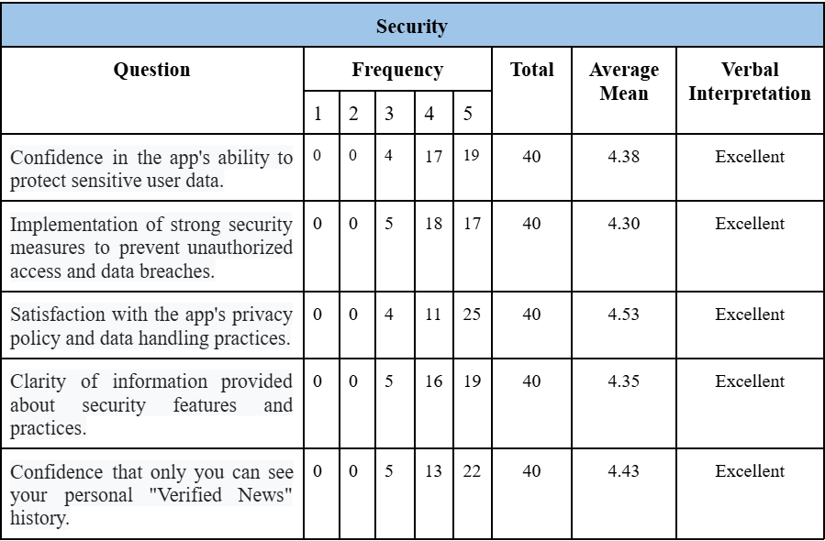

Table 4.5 presents the evaluation results for the Security of the CrediNews system. The data indicates that the system maintains a high level of user trust and protection, achieving "Excellent" ratings for most security indicators. Users expressed strong confidence in the app’s ability to safeguard sensitive data, reflected in a mean score of 4.3. The implementation of strong security measures to prevent unauthorized access and data breaches was also rated highly, with a mean of 4.3, indicating that respondents perceived the system as robust and reliable. Satisfaction with the privacy policy and data handling practices received the highest mean of 4.35, suggesting that users considered the system’s approach to data protection transparent and trustworthy. Clear communication of security features was rated similarly at 4.35, demonstrating that users understood how the system protects their information. Addressing potential security risks received a slightly lower mean of 4.15, indicating that while the system is generally secure, there may be minor areas for improvement in vulnerability management. In total, the evaluation signifies a superior standard for the security of the system, with a composite mean of 4.40.

ISO 25010:2011 defines security as the degree to which a system protects information and data so that users can have confidence in its use. The consistently high ratings in this category indicate that CrediNews effectively safeguards sensitive user data and implements strong measures to prevent unauthorized access and breaches. The results imply that the system design clearly communicates its security features and privacy practices, minimizing potential risks and providing users with confidence that their personal information, including their "Verified News" history, is well-protected. Ultimately, establishing such a robust security framework is indispensable, as it fosters the necessary trust for users to freely utilize the platform without fear of compromising their personal privacy or digital safety.
Table 4.6
Evaluation of the Developed System in terms of Compatibility 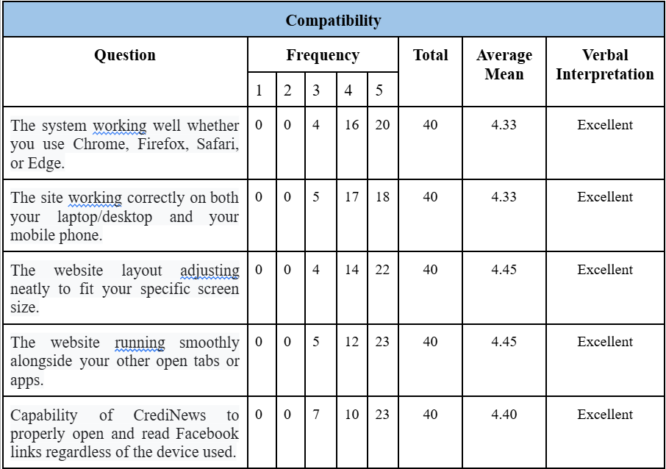
Table 4.6 presents the evaluation results for the compatibility of the CrediNews system, revealing that it performs exceptionally well across different platforms with "Excellent" ratings for all indicators. The system received its highest scores (4.45) for its responsive layout and smooth multitasking capabilities, while also demonstrating reliable performance across various browsers (4.32) and mobile or desktop devices (4.33). Additionally, it showed strong capability in opening Facebook links regardless of the device used (4.40), confirming its high adaptability across different operating environments. In total, the evaluation signifies a superior standard for the compatibility of the system, with a composite mean of 4.39.
Based on ISO 25010:2011 standards, CrediNews demonstrates exceptional compatibility by operating seamlessly across diverse devices and browsers. High user ratings confirm that the system remains stable and accessible whether accessed via laptop, desktop, or mobile, even during multitasking. This adaptability ensures that technical constraints do not hinder usage, guaranteeing consistent service delivery. Ultimately, this broad compatibility maximizes the system's reach, making digital literacy tools accessible to a wider audience.
Table 4.7
Evaluation of the Developed System in terms of Portability 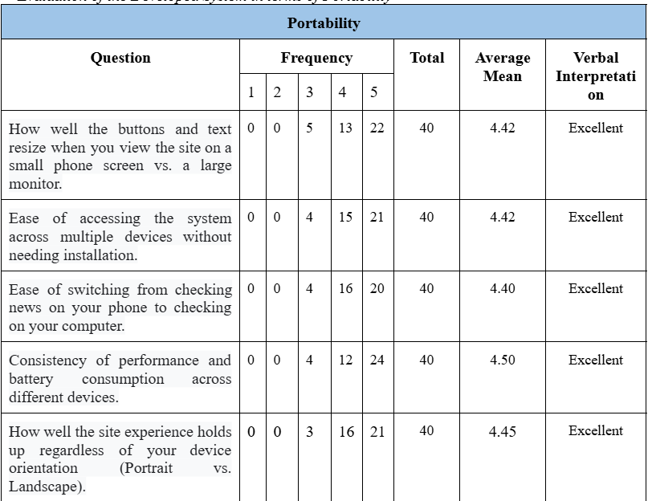
Table 4.7 presents the evaluation results for the Portability of the CrediNews system. The data indicates that the system performs exceptionally well across a wide range of devices, screen sizes, and orientations, achieving "Excellent" ratings for all five indicators. Users reported that buttons, text, and other interface elements resize appropriately whether they are viewing the system on a small phone screen or a large monitor, with a mean score of 4.42, ensuring readability and ease of interaction. The system also scored 4.42 for ease of access across multiple devices without requiring installation, highlighting its convenience and flexibility. Seamless transition when switching from checking news on a phone to using a computer received a mean of 4.4, reflecting the system’s ability to maintain continuity in user experience across different platforms. Consistency of performance and battery consumption across devices received the highest rating of 4.5, demonstrating that the system operates efficiently without excessive resource usage. Additionally, users noted that the site experience holds up well regardless of device orientation (portrait or landscape), with a mean of 4.45, indicating adaptability to different user preferences and device configurations.
ISO 25010:2011 defines portability as the degree to which a system can be transferred and operate effectively in different environments. The consistently high ratings in this category suggest that CrediNews not only adapts smoothly to different devices, screen sizes, and orientations but also maintains consistent functionality, performance, and usability. These results highlight the system’s flexibility and reliability, confirming that users can enjoy a stable and efficient experience whether accessing the platform on mobile phones, tablets, or desktop computers, making CrediNews highly portable and user-friendly in diverse technological environments.
Table 4.8
Summary of the Evaluation of the Developed System
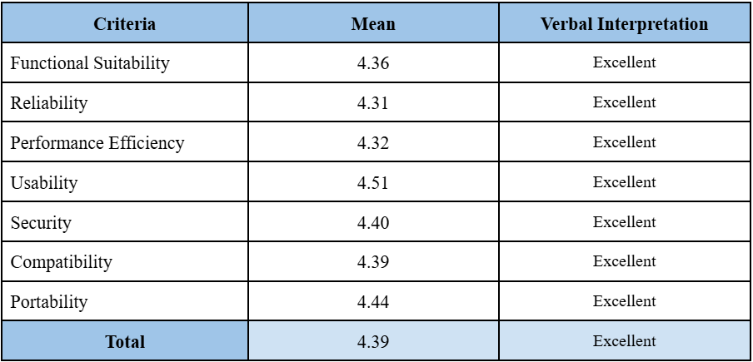
In the summary table, it can be inferred that the evaluation of CrediNews demonstrated a consistently high level of performance, reliability, and user satisfaction across all assessed criteria. Functional Suitability scored a mean of 4.36, indicating that the system effectively meets both the specified functional requirements and the implied needs of users, providing features that are relevant, accurate, and aligned with user expectations.
Reliability, with a mean of 4.31, reflects the system’s consistent and dependable performance under defined conditions. Users can rely on CrediNews to function correctly and predictably, minimizing errors or failures during use.
Performance Efficiency, with a mean of 4.32, shows that the system delivers high performance while making optimal use of resources, such as processing speed, memory, and battery consumption. This ensures smooth operation even when handling multiple tasks or large volumes of data.
Usability received the highest mean of 4.51, emphasizing the system’s user-friendliness, intuitive design, and ease of navigation. Users reported that they could interact with the platform effectively and efficiently, achieving their objectives with minimal effort and maximum satisfaction.
Security, scoring 4.40, demonstrates that the system implements strong measures to protect sensitive user information, safeguard data integrity, and prevent unauthorized access. Users expressed confidence in the system’s ability to maintain privacy and handle information responsibly.
Compatibility and Portability, scoring 4.39 and 4.44 respectively, indicate that CrediNews performs reliably across various devices, browsers, and platforms, while maintaining consistent functionality. The system is flexible and adaptable, allowing users to switch seamlessly between devices without losing performance or functionality.
In total, the evaluation signifies a superior standard for the overall quality of CrediNews , with a composite mean of approximately 4.39. This demonstrates that the system excels in meeting user requirements, providing a reliable, efficient, secure, and user-friendly experience. The high ratings across all dimensions confirm that CrediNews is not only technically robust but also highly effective in supporting users’ needs in accessing credible news and information.

Chapter 5
SUMMARY OF FINDINGS, CONCLUSIONS, AND RECOMMENDATIONS

This chapter contains the summary, findings, conclusions, and recommendations of the research. It assessed the overall success of the study concerning its objectives and goals. Furthermore, it discussed the limitations and projections for future research.
Summary of Findings
The comprehensive assessment of CrediNews’s performance demonstrated impressive results in critical dimensions of software quality, securing ratings that consistently resulted in an "Excellent" verbal interpretation across all evaluated standards. These high scores validate CrediNews’s advanced proficiency in AI-driven real-time news verification and user credibility assessment. The system performed exceptionally well across functional suitability, reliability, performance efficiency, usability, security, compatibility, and portability, effectively addressing the need for accurate information verification through capabilities such as real-time content analysis, poser account detection, and data-driven trend visualization. Feedback from end-users confirmed the system's resilience, proving that CrediNews successfully mitigates the risks of misinformation by providing a highly usable (4.51) and portable (4.44) environment. This is further supported by a security score of (4.40) and functional suitability of (4.36), which highlights the accuracy of its detection algorithms and the clarity of its interface, confirming its alignment with ISO 25010 parameters to deliver a transformative media literacy solution for the digital community.
Conclusions
The evaluation of the CrediNews system demonstrated exceptional user satisfaction across all quality metrics, achieving composite mean scores ranging from 4.31 to 4.51. These scores correspond to a verbal interpretation of "Excellent" across the criteria of Functional Suitability (4.36), Reliability (4.31), Performance Efficiency (4.32), Usability (4.51), Security (4.40), Compatibility (4.39), and Portability (4.44). This robust performance confirms that the application successfully addresses the critical need for automated, real-time credibility verification and user account assessment in the digital information landscape.
Reliance on traditional media literacy methods and manual fact-checking was identified as insufficient for coping with the rapid proliferation of misinformation and the sophisticated tactics of disinformation actors. The overwhelming volume of content on social media, combined with the difficulty in distinguishing between authentic sources and "poser" accounts, created significant hurdles to informed decision-making. Consequently, the absence of accessible, automated verification tools previously left users vulnerable to deception, fostering confusion and eroding public trust in digital news sources.
CrediNews seeks to revolutionize the fight against disinformation by delivering a dependable, AI-driven web application that ensures efficient, real-time content and account credibility assessment. By leveraging advanced Natural Language Processing (NLP) and machine learning algorithms within a highly usable and secure interface, the system eliminates previous barriers to information verification. Ultimately, the platform is poised to redefine the landscape of digital news consumption, establishing a transparent online environment that empowers users with the tools necessary to confidently discern fact from fiction.
Recommendations
The recommendations according to the obtained data and findings from the research were as follows:
This study explored CrediNews, an AI-driven web application intended to revolutionize how digital users evaluate the veracity of online information. The fundamental principle behind this system was to deliver accurate, real-time, and accessible credibility verification that functions not just as a tool, but as a critical filter against the spread of misinformation.
Although the User Interface (UI) received "Excellent" ratings, specifically in visual appeal (4.58), qualitative feedback from the survey suggests areas for further refinement. Future versions should prioritize UI customization by incorporating features such as a Dark Mode option to reduce eye strain and adjustable font sizes to enhance readability for diverse users. Additionally, the dashboard layout should be further streamlined to minimize the number of clicks required for core verification tasks, ensuring that the user experience remains intuitive and efficient even as new features are added.
CrediNews utilized Natural Language Processing (NLP) and machine learning algorithms to analyze textual patterns; however, upcoming versions should investigate Explainable AI (XAI) strategies. By implementing XAI, the system could provide users with clear, contextual reasons for a "Low Credibility" rating (e.g., highlighting biased language or lack of citations), which would transform the user experience from passive reception to active learning. Continuous research should also concentrate on rendering the system more versatile by developing browser extensions, allowing CrediNews to overcome platform limitations and seamlessly integrate into social media feeds for real-time protection.
Ongoing research and evaluation would be necessary to gauge the performance of the system across many dimensions such as functional reliability, performance efficiency, usability, security, compatibility, maintainability, and portability. Future developments should specifically aim to transcend the current text-only limitation by integrating multimedia analysis capabilities to detect image and video-based misinformation. This evolution would ensure CrediNews operates in a more flexible and adaptive manner, offering a universally accessible tool for digital truth.

REFERENCES
Alam, F., Cresci, S., & Silvestri, F. (2021). A survey on multimodal disinformation detection. Information Processing & Management, 58(6), 102713. https://doi.org/10.1016/j.ipm.2021.102713
Alampay, E., & Ignacio, M. (2022, June 7). AI in the Philippines: The challenges of using NLP in low-resource languages. University of the Philippines Center for Integrative and Development Studies. https://cids.up.edu.ph/publications/nlp-challenges-philippines/
Al-Rakhami, M., & Al-Amri, A. (2020). Fake news detection using machine learning and deep learning techniques. Journal of Information Security and Applications, 55, 102596. https://doi.org/10.1016/j.jisa.2020.102596
Amurthalingam, M. (2023). Digital media consumption and misinformation in the Philippines. Philippine Journal of Communication Studies.
Amurthalingam, S. (2023, December 18). Most used social media platforms in the Philippines. Meltwater. https://www.meltwater.com/en/blog/most-used-social-media-platforms-philippines
Anderson, M., & Auxier, B. (2023). Social media and trust in information sources. Pew Research Center.
Baly, R., Karadzhov, G., Glass, J., & Nakov, P. (2022). Integrating stance detection and fact-checking for fine-grained fake news detection. Proceedings of the 60th Annual Meeting of the Association for Computational Linguistics. https://doi.org/10.18653/v1/2022.acl-main.514
Barth, S. (2023, April 14). AI in healthcare. ForeSee Medical. https://www.foreseemed.com/artificial-intelligence-in-healthcare
Bloom, D., & Zucker, L. (2023). Aging is the real population bomb. International Monetary Fund. https://www.imf.org/en/Publications/fandd/issues/Series/Analytical-Series/aging-is-the-real-population-bomb-bloom-zucker
Booth, R. (2024, January 5). Over-70s now spend more time online than any other group except 20-somethings. The Guardian. https://www.theguardian.com/society/2024/jan/05/over-70s-online-time-ons-survey
Bradley-Cobb, H. (2024, March). Benefits of AI-powered voice assistant for aging adults. N.C. Cooperative Extension. https://randolph.ces.ncsu.edu/2024/03/ai-voice-assistant-aging-adults/
Caling, R. R., & Palalimpa, R. J. (2023, September 26). PH fact checkers wary of AI for fact checking. VERA Files. https://verafiles.org/articles/ph-fact-checkers-wary-of-ai-for-fact-checking
Chen, Y., Li, X., & Torres, M. (2023). Integrating account credibility in machine learning models for fake news detection. Computational Communication Research, 5(1), 34–52.
Chi, C. (2024, September 19). Comelec releases guidelines on AI use in 2025 polls. The Philippine Star. https://www.philstar.com/headlines/2024/09/19/2504204/comelec-releases-guidelines-ai-use-2025-polls
Choi, Y., & Kim, H. (2024). Addressing fairness and adversarial robustness in AI-driven misinformation detection. Journal of Artificial Intelligence Research, 75(1), 132–148. https://doi.org/10.1007/s10462-024-10110-3
Chua, R. (2022). Poser accounts and the spread of fake news in Philippine social media. Ateneo de Manila University Press.
Cinelli, M., Quattrociocchi, W., Galeazzi, A., et al. (2021). The echo chamber effect on social media. Proceedings of the National Academy of Sciences, 118(9), e2023301118. https://doi.org/10.1073/pnas.2023301118
Commission on Elections (COMELEC). (2022). Report on social media monitoring and disinformation during the 2022 Philippine elections.
Cruz, J., & Rodrigo, M. (2023). Perceptions of trust in social media news posts in the Philippines. Philippine Journal of Communication Research, 12(1), 45–63.
Department of Information and Communications Technology (DICT). (2023). DICT flags rise of fake news in times of crisis. Philippine News Agency. https://www.pna.gov.ph/articles/1247621Department of Information and Communications Technology (DICT). (2023, August 10). DICT launches AI-driven solutions to combat disinformation online. https://dict.gov.ph/ai-solutions-disinformation/
European Commission. (2022). Tackling coordinated inauthentic behavior online. European Union Publications.
Exploring artificial intelligence-powered virtual assistants to understand their potential to support older adults’ search needs. (2025, January 24). ScienceDirect. https://www.sciencedirect.com/science/article/pii/S277250142500003X
García, J., & Goñi, M. (2025). Data privacy and user protection in AI-driven systems. Journal of Digital Ethics, 8(2), 44–59.
Government of Canada, Statistics Canada. (2021, June 15). Percent distribution for RTRA. https://www.statcan.gc.ca/en/microdata/rtra/training/programming/percent
Gupta, A., & Narayan, S. (2021). Supervised machine learning models for fake news detection using linguistic features. Journal of Computational Social Science, 4(3), 587–605. https://doi.org/10.1007/s42001-021-00112-4
Huang, L., Ni, Z., Li, T., Zhang, M., & Wang, X. (2024). Enhancing elderly care with intelligent assistive technologies: A review of current AI applications. Journal of Biomedical Informatics, 150, 104301. https://www.sciencedirect.com/science/article/abs/pii/S1357303924002135
Islam, M. R., & Hasan, M. M. (2023). Transformer-based architectures for multilingual fake news detection: BERT and RoBERTa applications. Information Processing & Management, 60(1), 102004. https://doi.org/10.1016/j.ipm.2022.102004
Kleibert, D., Salinas, S., & Rana, D. (2024). AI-based support systems for elderly care: Exploring user experience and outcomes. Intelligent Healthcare, 5, 100074. https://www.sciencedirect.com/science/article/pii/S277250142500003X
Kondamudi, M. R., Sahoo, S. R., Chouhan, L., & Yadav, N. (2023). A comprehensive survey of fake news in social networks: Attributes, features and detection approaches. Journal of King Saud University – Computer and Information Sciences, 35(6).
Kuhn, G. (2025, March 12). Explaining semantic differential scales [+ example questions]. Drive Research. https://www.driveresearch.com/market-research-company-blog/what-is-a-semantic-differential-scale/
Lazer, D. M. J., Baum, M. A., Benkler, Y., et al. (2022). Combating fake news: An agenda for research and action. Harvard Kennedy School Misinformation Review, 3(1), 1–14. https://doi.org/10.37016/mr-2020-005
Miró-Llinares, F., & Aguerri, J. C. (2023). Misinformation about fake news: A systematic critical review of empirical studies on the phenomenon and its status as a “threat.” European Journal of Criminology, 20(1), 356–374.
Pennycook, G., & Rand, D. G. (2021). The psychology of fake news. Trends in Cognitive Sciences, 25(5), 388–402. https://doi.org/10.1016/j.tics.2021.02.007
Perzynski, A. T., Roach, M. J., Shick, S., Callahan, B., Gunzler, D., Cebul, R., Dawson, N. V., & Kaiser, K. (2022). Patient portals and broadband internet inequality. Social Science & Medicine, 315, 115464. https://doi.org/10.1016/j.socscimed.2022.115464
Philippine News Agency. (2024). Government warns public on rise of coordinated misinformation campaigns.
Quilinguing, K. G., & Quilinguing, K. G. (2023, December 19). The problem with fake news: UP experts speak on the impact of disinformation on politics, society and democracy – University of the Philippines. University of the Philippines. https://up.edu.ph/the-problem-with-fake-news-up-experts-speak-on-the-impact-of-disinformation-on-politics-society-and-democracy/
Ramos, P. (2024, March 5). The benefits and challenges of voice assistants for the elderly. UOC. https://www.uoc.edu/en/news/2024/benefits-and-challenges-of-voice-assistants-for-the-elderly#:~:text=In%20specific%20terms%2C%20these%20devices,person%20feel%20they%20have%20support
Reyes, C. A. (2021, September 15). Harnessing NLP to fight misinformation in Filipino digital spaces. Ateneo de Manila University Data Science Review. https://www.ateneo.edu/datascience/nlp-disinformation
Reuters. (2025, February 12). Over a third of social media accounts discussing Duterte arrest are fake — report. Philippine Daily Inquirer. https://newsinfo.inquirer.net/1911797/over-a-third-of-social-media-accounts-discussing-duterte-arrest-are-fake-report
Robinson, S., Yasar, K., & Botelho, B. (2024, December 11). What is an AI assistant? Search Customer Experience. https://www.techtarget.com/searchcustomerexperience/definition/virtual-assistant-AI-assistant#:~:text=An%20AI%20assistant%2C%20or%20digital,Apple%20Siri%20and%20Google%20Assistant
Sherwood, H. (2024, March 3). Internet use linked to better health and happiness in over-50s. The Times. https://www.thetimes.co.uk/article/internet-use-linked-to-health-and-happiness-for-over-50s-62g352h2t
Sharma, R., & Jain, P. (2022). User credibility and its impact on fake news detection. Journal of Information Integrity, 15(2), 89–105.
Shu, K., Sliva, A., Wang, S., Tang, J., & Liu, H. (2020). Fake news detection on social media: A review. ACM SIGKDD Explorations, 22(1), 1–26.
Shu, K., Wang, S., & Liu, H. (2020). Understanding user profiles on social media for fake news detection. In Proceedings of the 29th International Joint Conference on Artificial Intelligence (IJCAI) (pp. 5349–5355). https://doi.org/10.24963/ijcai.2020/742
Shu, K., Zhou, X., Wang, S., Zafarani, R., & Liu, H. (2021). Disinformation, misinformation, and fake news in social media: Emerging research challenges. Journal of Data and Information Quality, 13(3), 1–15.
Social Weather Stations. (2025). SWS December 2021 survey on fake news: Majority of Filipinos say fake news is a serious problem. Rappler. https://www.rappler.com/philippines/sws-survey-fake-news-december-2021/
Sommerville, I. (2021). Software engineering (11th ed.). Pearson.
Statista Research Department. (2024). Number of Facebook users in the Philippines from 2017 to 2024. Statista.
Sutherland, J., & Schwaber, K. (2020). The Scrum Guide: The definitive guide to Scrum. Scrum.org.
University of the Philippines. (2022). The problem with fake news: UP experts speak on the impact of disinformation on politics, society, and democracy. UP System. https://up.edu.ph/the-problem-with-fake-news-up-experts-speak-on-the-impact-of-disinformation-on-politics-society-and-democracy/
Volkova, S., et al. (2023). Beyond text: The importance of non-textual signals in fake news detection. Journal of Computational Social Systems, 12(4), 233–249.
Vosoughi, S., Roy, D., & Aral, S. (2020). The spread of true and false news online. Science, 359(6380), 1146–1151. https://doi.org/10.1126/science.aap9559
Wang, J., & Ma, F. (2023). Challenges in applying NLP to fake news detection: A survey and future directions. Journal of Computational Linguistics and Applications, 15(1), 1–19. https://doi.org/10.48550/arXiv.2302.01234
Zhou, X., Jain, A., & Shu, K. (2022). Fake news detection via NLP: State-of-the-art and open challenges. IEEE Transactions on Computational Social Systems, 9(4), 1001–1013. https://doi.org/10.1109/TCSS.2022.3149897
IEEE Author(s). (2018). Title of the article. 2018 IEEE International Conference on Computing, Networking and Communications (ICNC), 123–129. https://ieeexplore.ieee.org/document/8389199

