CrediNews: An AI-Based System for

Detection of Fake News and User Credibility

on Facebook Posts

Rachelle Ann L. Ambayan¹, Mark Neo F. Escobarte², Angelica L. Herrera³, Mhace Gwyneth A. Mojica ⁴,
and Indaleen P. Quinsayas⁵

Student, College of Information Technology, ^{1,2,3,4}
Faculty, College of Information Technology⁵
Polytechnic University of the Philippines Biñan Campus, Philippines

ABSTRACT
CrediNews: An AI-Based System for Detection Fake News and User Credibility on Facebook Posts is a web-based system developed to address the increasing spread of misinformation in today’s digital environment. As social media continues to grow as a primary news source, Facebook has become one of the most widely used platforms where people easily access updates, announcements, and trending issues. However, the same platform is also vulnerable to fake news, manipulated content, clickbait headlines, and misleading information that can confuse users and influence their opinions. Since information spreads rapidly online, false news can go viral within minutes and negatively affect public understanding, trust, and decision-making. For this reason, CrediNews was created to support users by providing a fast and accessible system that can help verify the credibility of online news content.
The system allows users to submit URLs or text from Facebook posts for evaluation, making it convenient for users who want immediate verification before believing or sharing the information. It uses Artificial Intelligence (AI) and Natural Language Processing (NLP) to analyze and interpret the text by identifying linguistic patterns, suspicious keywords, and misinformation indicators commonly present in fake or unreliable posts. CrediNews also integrates third-party fact-checking APIs to strengthen the verification process and provide more accurate results. After processing the information, the system generates a classification output such as Credible, Mixed, Low Credibility, or Unverified, which helps users easily understand whether a post is trustworthy or should be treated with caution.
Moreover, CrediNews enhances its verification process by evaluating user credibility to identify accounts that may contribute to misinformation spread. It analyzes posting behavior and account indicators to categorize users into Low (Trusted), Moderate (Suspicious), or High (Likely Poser), helping readers recognize sources that may be unreliable. This feature supports users in assessing not only the content itself but also the credibility of the person or account sharing it. Through the combination of news classification and user credibility analysis, the system promotes responsible news consumption, strengthens media literacy, and empowers users to make informed decisions when interacting with information on social media platforms.
Keywords: alternative communication, communication tools, customizable button, hand gesture support, machine learning

INTRODUCTION
Most technological innovations and digital advancements are greatly influenced by the cultural and social environments of every nation. As technology continues to evolve rapidly, it has become a major part of daily life, affecting how people communicate, study, work, and access information. Social media platforms have helped make information more accessible, allowing users to read and share news instantly. However, while these platforms provide convenience and fast communication, they also contribute to the rapid spread of misinformation and disinformation online (Amurthalingam, 2023) .¹
The widespread use of social media has transformed the way people consume and share news. Facebook, in particular, remains one of the most used platforms in the Philippines, with millions of active users engaging daily with current events and trending posts (Statista, 2024) .² While Facebook provides easy access to information, it is also vulnerable to fake news, manipulated narratives, and unreliable sources that can influence public opinion and lead to confusion. A key factor that affects whether people believe the information they read online is the credibility of the source posting it, which highlights the importance of evaluating both content credibility and the trustworthiness of the user behind the post (Social Weather Stations, 2022) .³
Fake news is often presented as legitimate information, even when it contains fabricated claims or misleading headlines. Due to the fast-paced nature of social media, users may share posts without verifying them, increasing the risk of misinformation spreading further. To solve this problem, Artificial Intelligence (AI) and Machine Learning (ML) have become effective approaches in detecting fake news by analyzing language patterns, sentiment, and writing style to classify whether a post is credible or misleading (Al-Rakhami & Al-Amri, 2020) .⁴ These automated systems can also support large-scale real-time analysis, which is difficult to achieve through manual fact-checking alone (Zhou & Zafarani, 2020) .⁵
The main goal of this study is to introduce CrediNews, an AI-powered system designed to detect fake news and evaluate user credibility on Facebook posts. CrediNews allows users to submit URLs or text content for verification, then generates credibility results such as Credible, Mixed, Low Credibility, or Unverified. It also strengthens verification by classifying account risk levels into Low (Trusted), Moderate (Suspicious), or High (Likely Poser) to help users recognize unreliable sources. The integration of AI-based verification tools helps increase user confidence and strengthens media literacy by providing clearer insights about why certain information may be false or questionable (Baly et al., 2022) .⁶
Advancements in Natural Language Processing (NLP) also support the effectiveness of news verification systems by enabling deeper understanding of sentence structure, tone, and deceptive language patterns found in misinformation (Alam et al., 2021) .⁷ However, challenges remain, especially in countries like the Philippines where linguistic diversity, slang, and low-resource languages may affect detection accuracy (Alampay & Ignacio, 2022) .⁸ Despite these challenges, the development of CrediNews aims to provide a practical solution that promotes responsible information sharing, reduces misinformation exposure, and helps users make informed decisions when consuming news on social media platforms.

EXPERIMENTAL METHOD/S

Research Design
The research developers adopted the mixed method research design approach for developing CrediNews, an AI-based system for detecting fake news and evaluating user credibility on Facebook posts. Mixed method research is a design that combines both numerical and descriptive data to produce accurate and well-supported conclusions. Primarily, data gathering involved an online survey and system evaluation to collect feedback from users regarding the effectiveness, accuracy, and usability of the system in identifying credible and misleading news content. This process focused on understanding how users verify information online and how the system influences their decision-making when engaging with news on social media. Thus, the proposed system aligned its objectives with the increasing need for accessible tools that support responsible news consumption and help reduce the spread of misinformation.

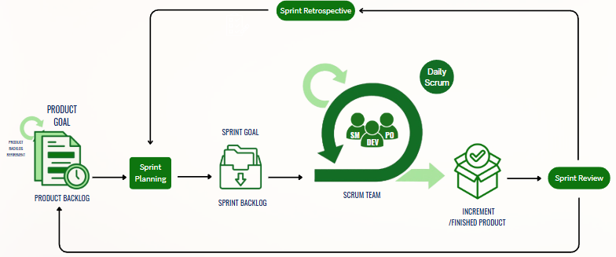
Software Development Methodology

Figure 2.1
Agile Software Development Cycle with Scrum Framework

The system was designed and developed using the Agile Scrum Methodology. In this approach, development is performed in iterative cycles known as sprints, where each sprint produces a working version of a system component. Scrum promotes team collaboration, flexibility, and continuous improvement, making it ideal for projects like CrediNews where requirements may change and user feedback is necessary. Scrum also includes key activities such as Sprint Planning, Daily Scrum, Increment, Sprint Review, and Sprint Retrospective, which help the developers stay aligned, address issues early, and enhance the system based on evaluation results. Each sprint usually lasts one to four weeks, involving planning, designing, testing, and reviewing progress. According to Sutherland and Schwaber (2020), Scrum is effective for projects that involve experimentation, learning, and user-centered development, which applies to AI-based systems such as CrediNews.

The Agile Scrum methodology helped the research team work in a structured yet adaptable manner by focusing on specific tasks while still allowing improvements throughout the process. This supported the continuous refinement of major features such as Natural Language Processing (NLP), machine learning classification, credibility scoring, API fact-checking integration, and user interface development, ensuring that the final output aligned with the goal of promoting responsible news consumption through real-time credibility verification.

Sources of Data and Research Instruments
The research developers gathered primary sources of data from the target respondents who regularly use social media platforms, particularly Facebook, and are exposed to online news content. These respondents were selected because they are potential users of CrediNews and can provide relevant feedback regarding the system’s effectiveness in detecting fake news and assessing user credibility. The primary data collection instruments included an online survey and structured questionnaires, which were used to evaluate the system’s performance, usability, and overall usefulness.
The research developers also utilized secondary sources of data such as related studies, journals, and online articles discussing fake news detection, Artificial Intelligence (AI), Natural Language Processing (NLP), and credibility evaluation. These secondary sources supported the development of the system by providing reference information and technical background needed in designing the proposed solution. The survey method was conducted exclusively online, where the research developers administered the questionnaires through Google Forms as the main platform for data gathering.
The collected data consisted of structured questions focused on the users’ experiences in identifying misinformation, their perceptions of credibility online, and the system’s ability to provide clear credibility results. Data and conclusions were analyzed based on the respondents’ feedback and assessment to ensure that CrediNews meets its objectives in promoting responsible news consumption and helping reduce the spread of misinformation.

Tools for Data Analysis
The research developers employed a Use Case Diagram as a major instrument for the development of CrediNews since it visually presents the interaction between the users and the system’s main functions. This tool was essential in identifying the system capabilities, gathering requirements, and defining the overall scope of the proposed system. It also served as a guide for system testing, validation, and iterative development by determining the key actors and prioritizing the important processes such as news submission, credibility checking, and result generation.
In addition, the research developers used Data Flow Diagrams (DFD) to illustrate how information moves within the system. The diagram shows the flow starting from user input, such as a Facebook post URL or text content, passing through the system’s analysis process using AI and NLP techniques, and ending with the final output results. These diagrams provide a clear overview of the system workflow, helping the developers identify possible bottlenecks, improve system performance, and ensure that CrediNews operates efficiently throughout its development and implementation.

Statistical Treatment of Data
In this study, the respondents were given a set of structured questions and their feedback was analyzed using various statistical methods based on the ISO/IEC 25010:2011 software quality requirements, including the use of the Likert Scale. The collected responses were analyzed, interpreted, and evaluated through the weighted mean and percentage distribution methods to determine the level of agreement of the respondents regarding the system’s performance.
In addition, a rubric scale rating was utilized to measure each of the objectives and the overall effectiveness of the developed CrediNews system. These statistical tools enabled the researchers to systematically and quantitatively assess the users’ perceptions of the system in terms of its quality attributes such as functionality, usability, reliability, security, and performance. Through these methods, the evaluation of CrediNews became more detailed and reliable, allowing the researchers to identify key strengths of the system as well as areas for improvement based on the respondents’ suggestions and assessments.

- RESULTS AND DISCUSSION
The evaluation results shown in the table below indicate the strong performance of the developed CrediNews system across different quality criteria.

Table 3.1
Summary of the Evaluation of the Developed System
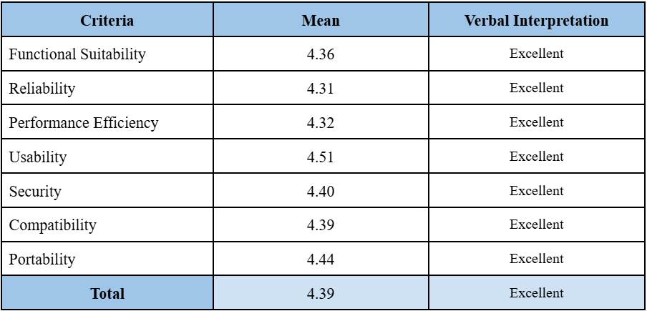

Functional Suitability obtained a mean score of 4.36, showing that the system successfully met both the required functions and user needs. Reliability earned a mean score of 4.31, indicating that the system performs consistently and can be depended on during repeated use. Performance Efficiency gained a mean score of 4.32, reflecting smooth responsiveness and efficient processing of credibility results.

Usability achieved the highest mean score of 4.51, proving that users found the system user-friendly, easy to navigate, and clear to understand. Security received a mean score of 4.40, demonstrating that the system effectively protects user data and ensures safe platform usage. Compatibility gained a mean score of 4.39, while Portability obtained a mean score of 4.44, confirming that CrediNews works well across different devices, browsers, and platforms.

In total, the evaluation signifies a superior standard for the overall quality of CrediNews, with a composite mean of approximately 4.39, which confirms that the system is reliable, efficient, secure, and effective in supporting users in accessing credible news and minimizing misinformation exposure.

CONCLUSION

The evaluation of CrediNews showed a high level of user satisfaction across all assessed criteria, with mean scores ranging from 4.31 to 4.51. These results indicate excellent system performance in Functional Suitability, Reliability, Performance Efficiency, Usability, Security, Compatibility, and Portability. Overall, the findings confirm that CrediNews effectively met its intended objectives of detecting fake news and assessing user credibility on Facebook posts while maintaining strong software quality based on ISO/IEC 25010 standards.

The rapid spread of misinformation on social media has become a major concern, as it can mislead users, influence public opinion, and reduce trust in digital information. Many users are exposed to misleading news posts that appear credible due to persuasive language, trending engagement, and unverified sources. This situation makes manual verification difficult for most users, especially when fake news spreads faster than fact-checking efforts. Because of this, there is a clear need for an accessible tool that can support users in evaluating both the credibility of content and the trustworthiness of the accounts posting it.

CrediNews aims to address this challenge by providing a reliable and user-friendly system that delivers real-time credibility analysis using AI and NLP techniques. Through its classification results such as Credible, Mixed, Low Credibility, or Unverified, along with user credibility categorization, the system helps users become more cautious and responsible when consuming and sharing online information. Overall, the study concludes that CrediNews is an effective solution that promotes informed decision-making, strengthens media literacy, and contributes to reducing the impact of misinformation on social media platforms.

REFERENCES

  - Alam, F., Cresci, S., & Silvestri, F. (2021). A survey on multimodal disinformation detection. Information Processing & Management, 58(6), 102713. https://doi.org/10.1016/j.ipm.2021.102713
  - Alampay, E., & Ignacio, M. (2022, June 7). AI in the Philippines: The challenges of using NLP in low-resource languages. University of the Philippines Center for Integrative and Development Studies. https://cids.up.edu.ph/publications/nlp-challenges-philippines/
  - Al-Rakhami, M., & Al-Amri, A. (2020). Fake news detection using machine learning and deep learning techniques. Journal of Information Security and Applications, 55, 102596. https://doi.org/10.1016/j.jisa.2020.102596
  - Sutherland, J., & Schwaber, K. (2020). The Scrum Guide: The definitive guide to Scrum. Scrum.org.
  - Statista Research Department. (2024). Number of Facebook users in the Philippines from 2017 to 2024. Statista.
  - University of the Philippines. (2022). The problem with fake news: UP experts speak on the impact of disinformation on politics, society, and democracy. UP System. https://up.edu.ph/the-problem-with-fake-news-up-experts-speak-on-the-impact-of-disinformation-on-politics-society-and-democracy/

ACKNOWLEDGMENTS
We would like to express our heartfelt gratitude to everyone who contributed to the successful completion of this study. Above all, we thank Almighty God for granting us strength, wisdom, and guidance throughout this journey.
We are sincerely thankful to the Polytechnic University of the Philippines – Biñan Campus for providing the resources, support, and learning environment that made this research possible. We also extend our appreciation to our professors for their knowledge and encouragement, which helped us improve our work.
We would like to give special recognition to Ms. Indaleen Quinsayas, our research adviser, for her patience, dedication, and valuable guidance. Her constructive feedback and continuous support played an important role in keeping us motivated and focused until the completion of this study.
We also express our gratitude to our Capstone Faculty, Mr. Michael Anjelo O. Miguel, for his direction, expertise, and consistent support. His insights and recommendations greatly helped us refine our research and complete the project with better quality and confidence.
We are also truly grateful to our Classmates and Friends for their encouragement, assistance, and understanding. Their companionship, cooperation, and support helped make the process lighter and kept us motivated throughout the development of this study.
Lastly, we would like to give our deepest appreciation to our Families, who have always been there to support, encourage, and provide everything we needed throughout this journey. Their love, sacrifices, and continuous motivation gave us the strength to keep going and successfully finish this research.

AUTHOR/S NOTE

LEADER:
Name : Herrera, Angelica L.
Email Address : angelicalherrera02@gmail.com
Permanent Address : 5288 Yatco Compound, Dela Paz Biñan, Laguna
School : Polytechnic University of the Philippines-Biñan Campus

MEMBERS:
Name : Ambayan, Rachelle Ann L.
Email Address : rachelleambayan@gmail.com
Permanent Address : Ambas St. Casile Biñan City, Laguna
School : Polytechnic University of the Philippines-Biñan Campus

Name : Escobarte, Mark Neo F.
Email Address : markneoescobarte@gmail.com
Permanent Address : 136 Bayabas St. Garcia Subd. San Antonio, Biñan City, Laguna
School : Polytechnic University of the Philippines-Biñan Campus

Name : Mojica, Mhace Gwyneth A.
Email Address : mhacemojica04@gmail.com
Permanent Address : Phase 1 Blk 7 lot Sitio Pulo Dela Paz Biñan Laguna
School : Polytechnic University of the Philippines-Biñan Campus

