Assignment 1: Startup and MSME Samples
Student-friendly sample images and a simple comparison essay
The images below are custom illustrative samples made to match each business type clearly. They are arranged to help you see the difference between a startup and an MSME in a simple way.

Startup Samples (10)

Image | Sample and short description
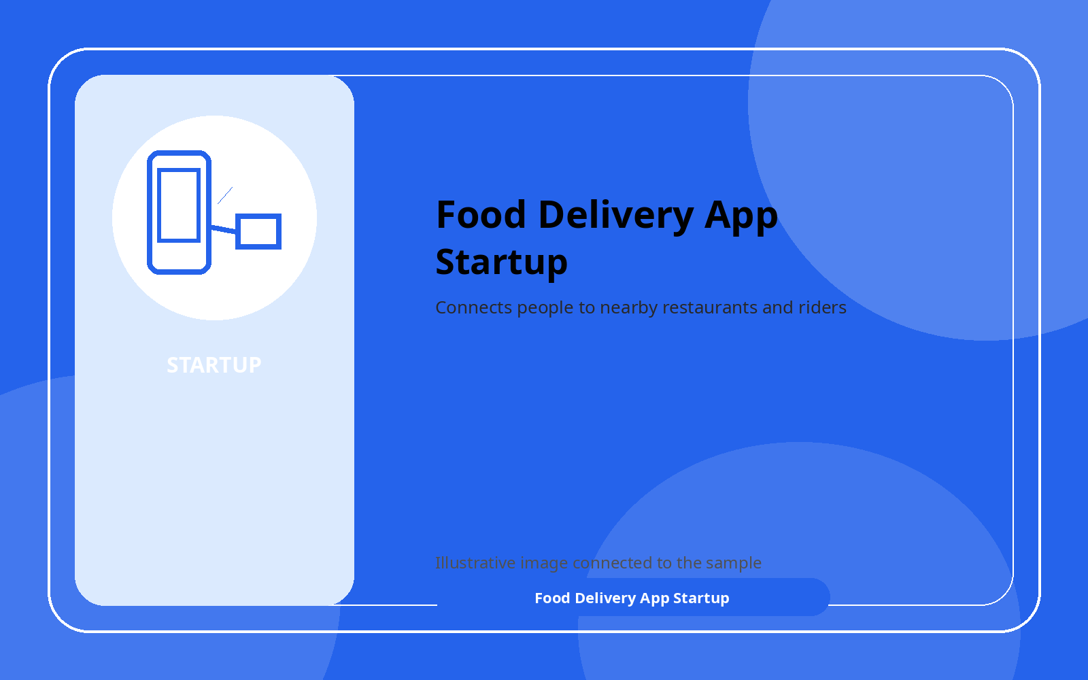 | Food Delivery App Startup  Connects people to nearby restaurants and riders
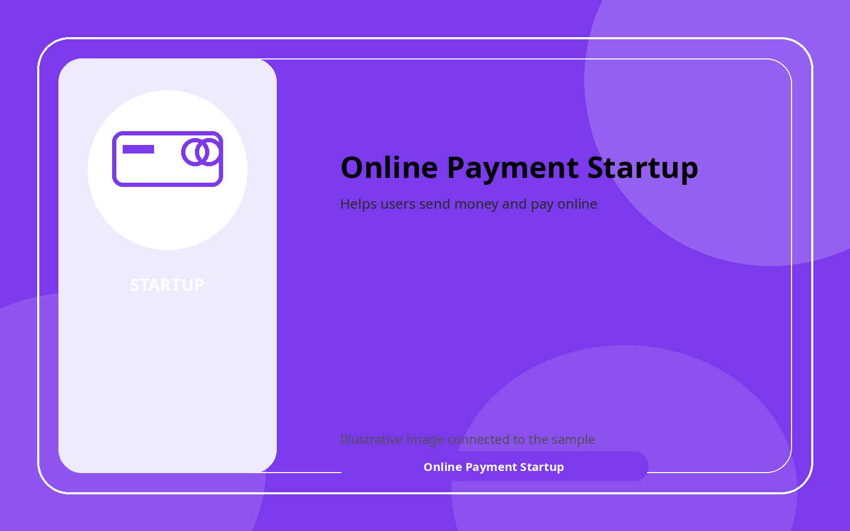 | Online Payment Startup  Helps users send money and pay online
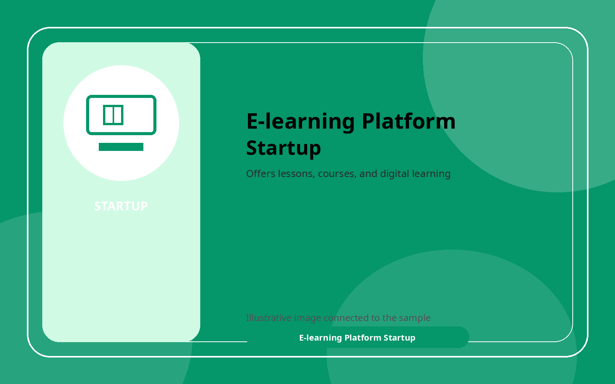 | E-learning Platform Startup  Offers lessons, courses, and digital learning
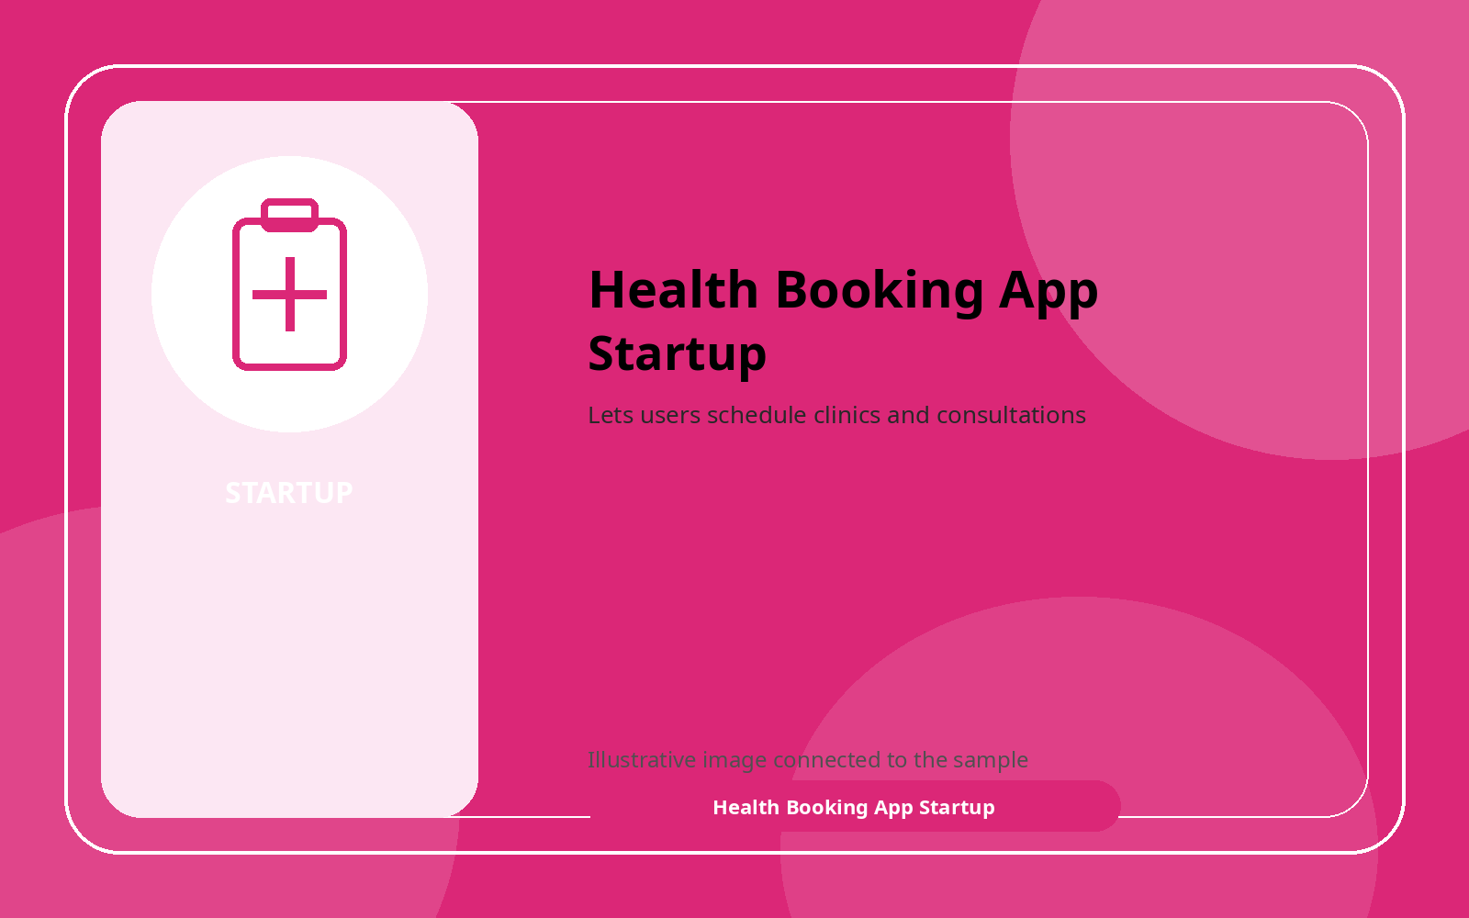 | Health Booking App Startup  Lets users schedule clinics and consultations

Image | Sample and short description
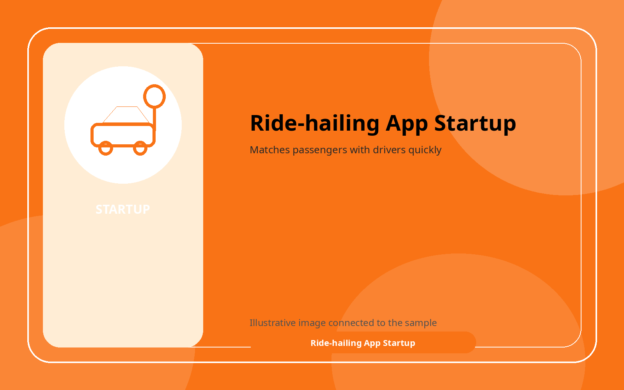 | Ride-hailing App Startup  Matches passengers with drivers quickly
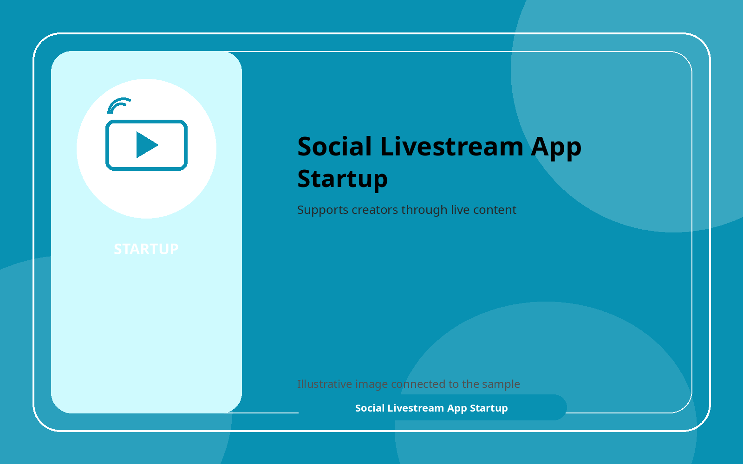 | Social Livestream App Startup  Supports creators through live content
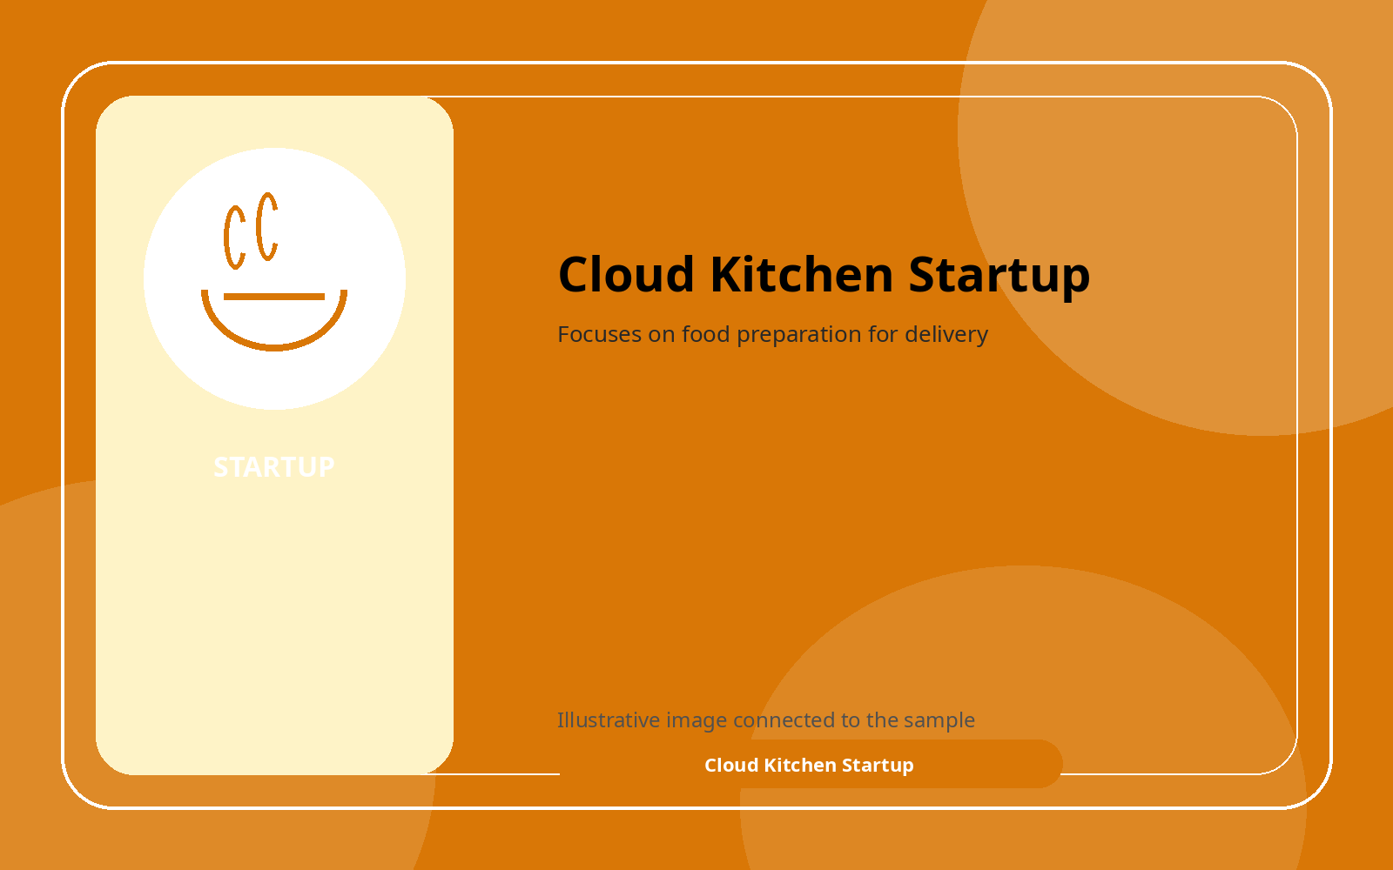 | Cloud Kitchen Startup  Focuses on food preparation for delivery
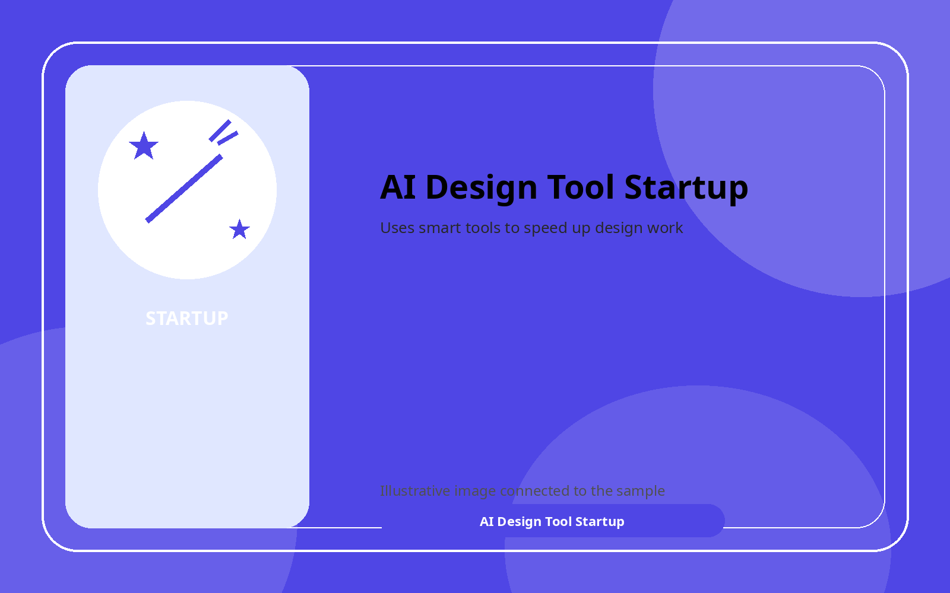 | AI Design Tool Startup  Uses smart tools to speed up design work
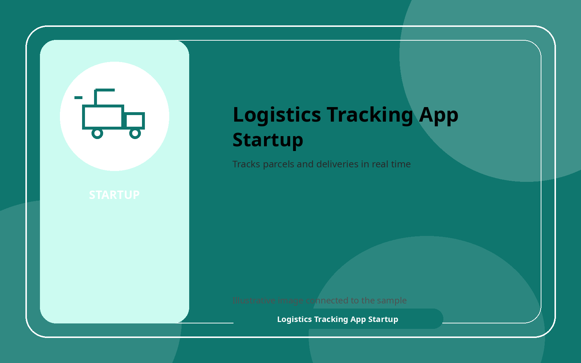 | Logistics Tracking App Startup  Tracks parcels and deliveries in real time
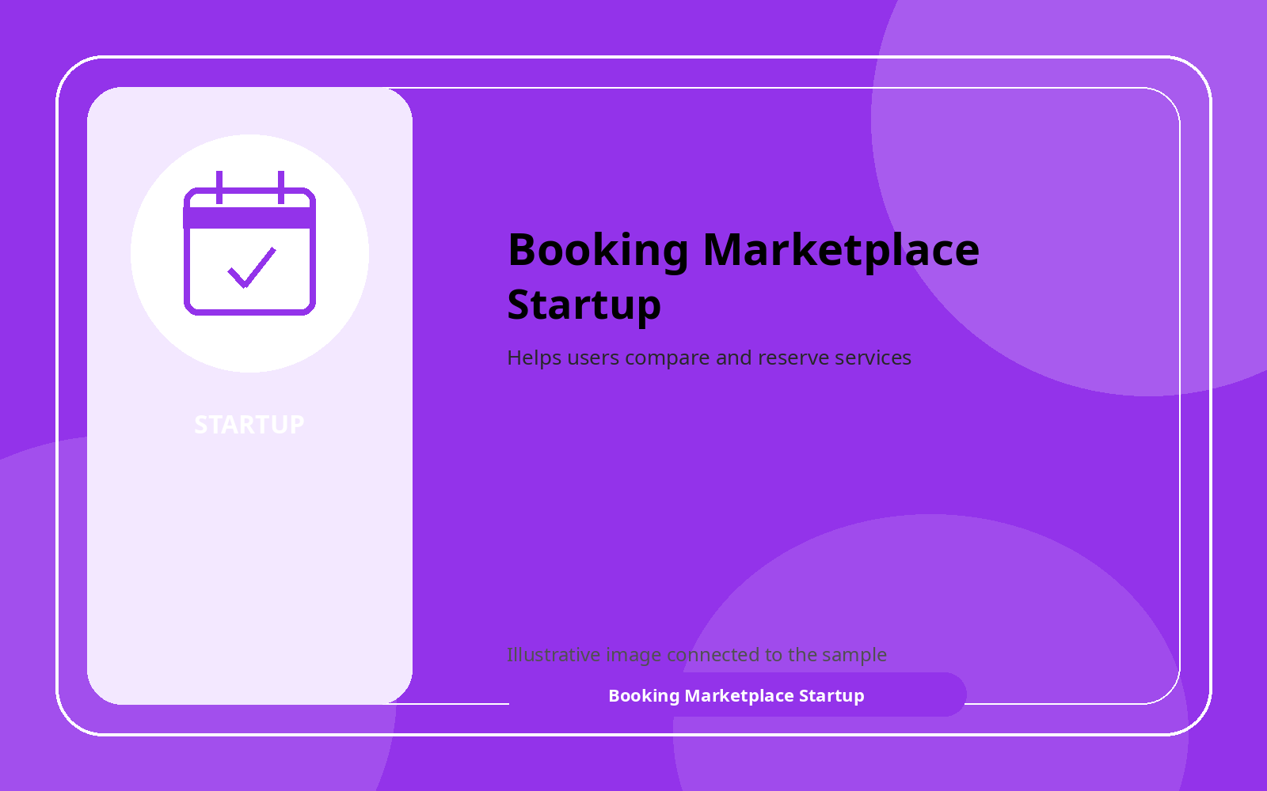 | Booking Marketplace Startup  Helps users compare and reserve services

MSME Samples (10)

Image | Sample and short description
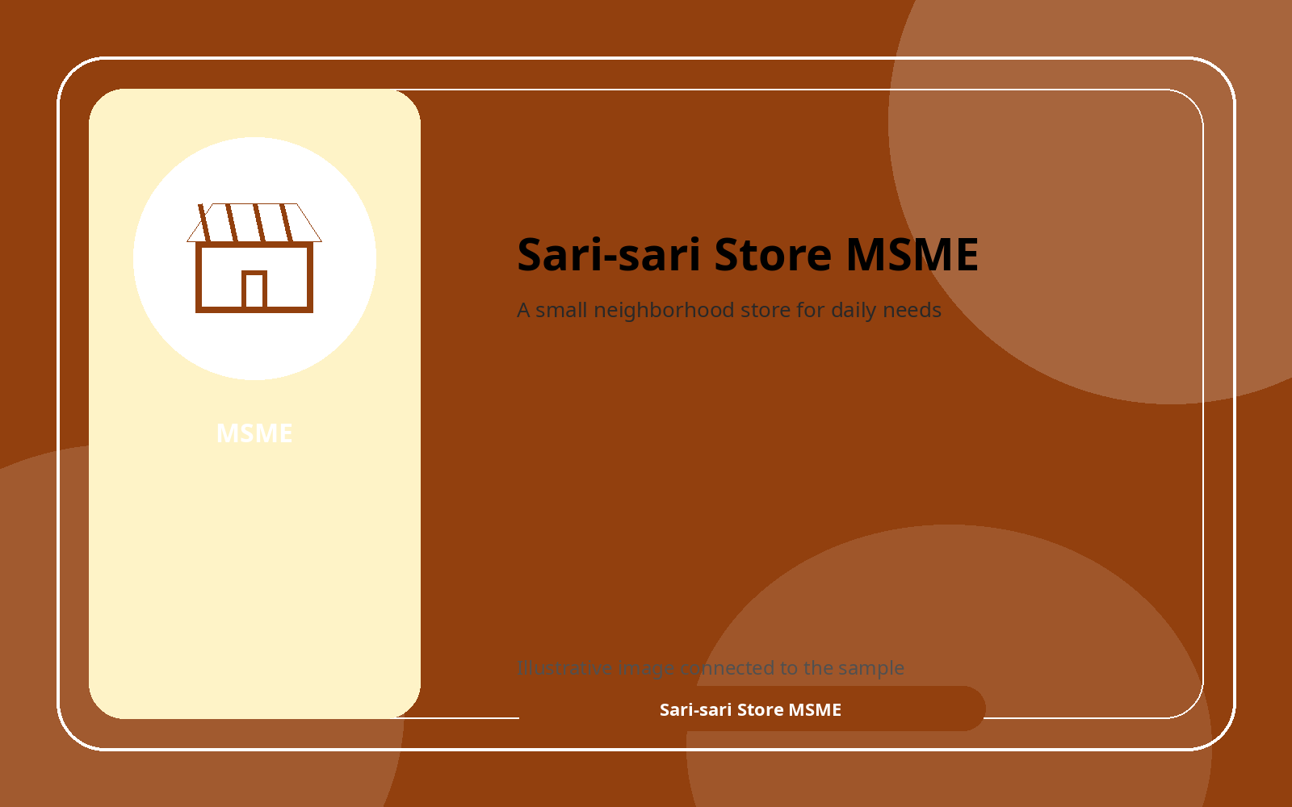 | Sari-sari Store MSME  A small neighborhood store for daily needs
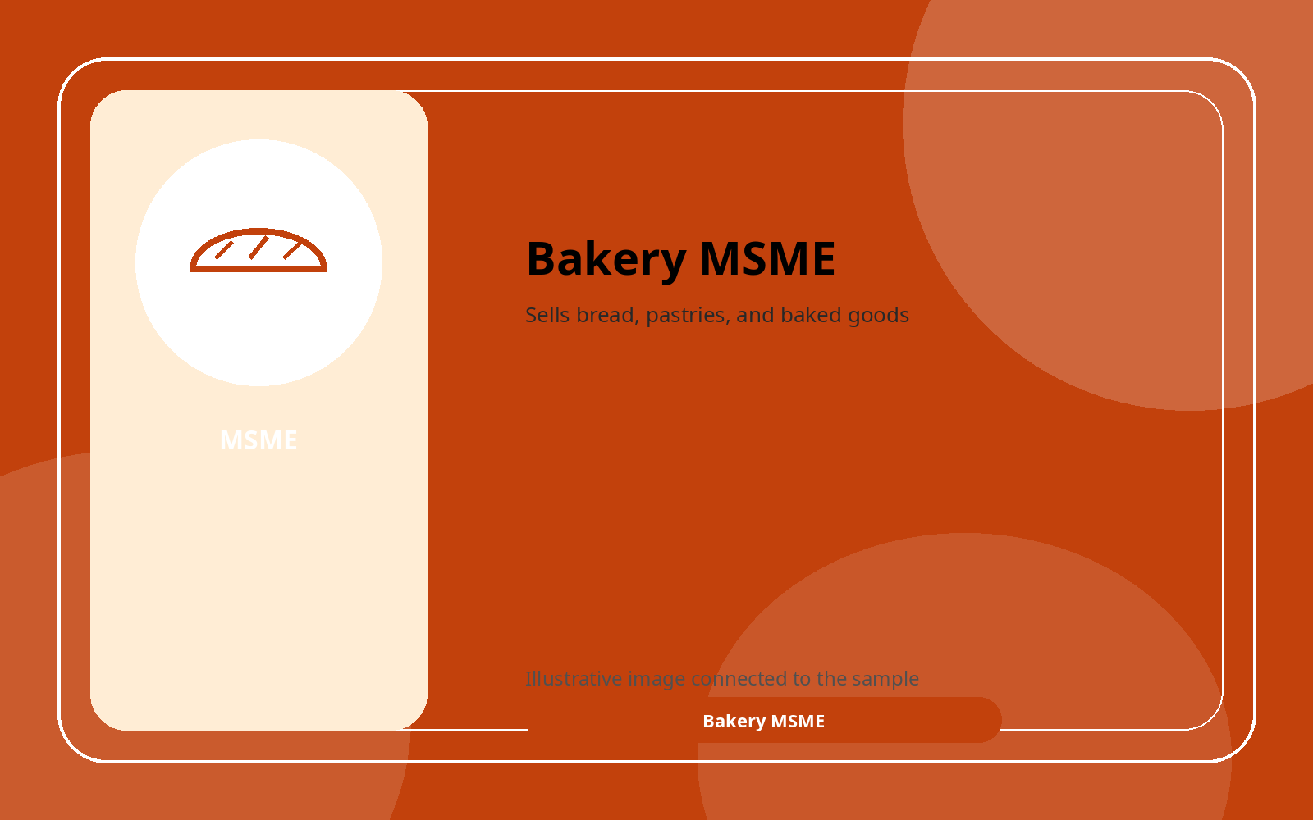 | Bakery MSME  Sells bread, pastries, and baked goods
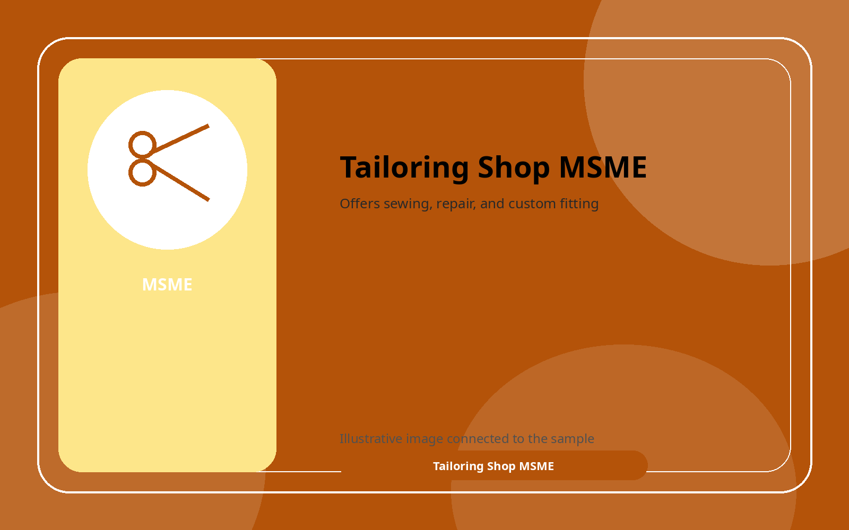 | Tailoring Shop MSME  Offers sewing, repair, and custom fitting
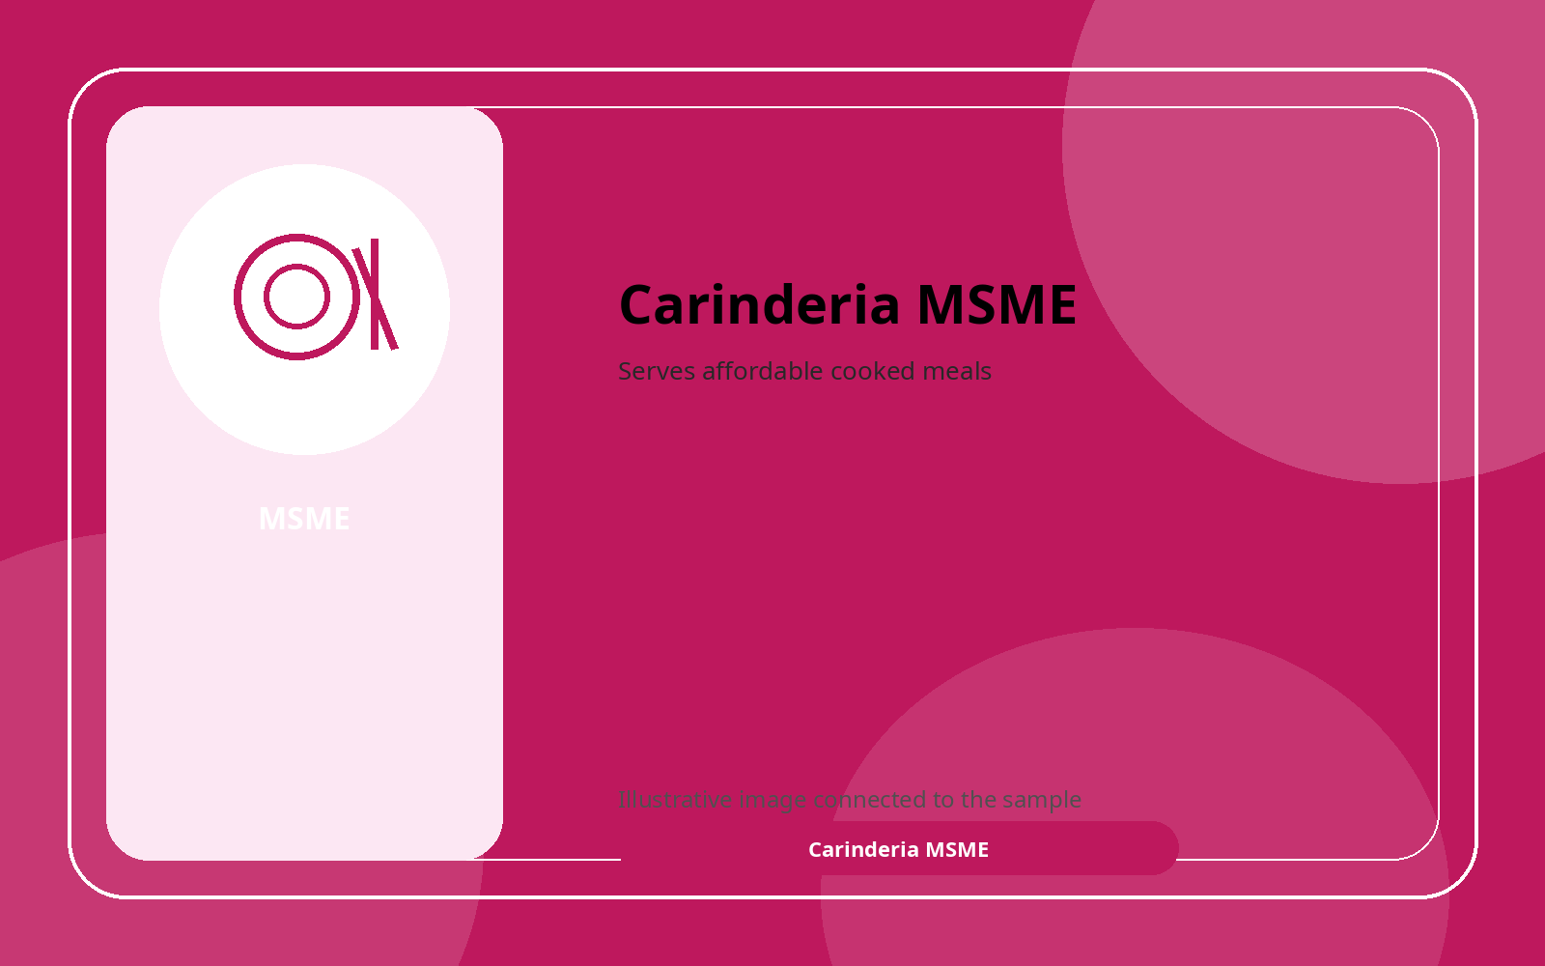 | Carinderia MSME  Serves affordable cooked meals
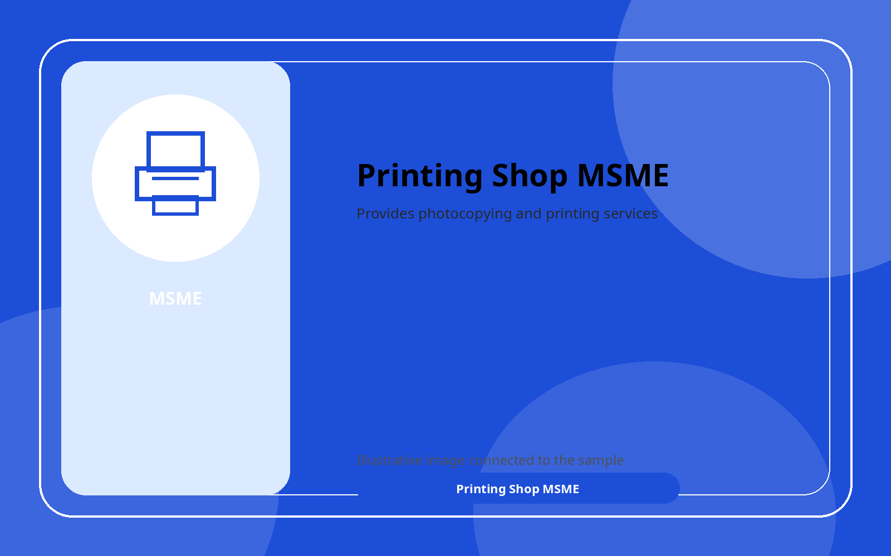 | Printing Shop MSME  Provides photocopying and printing services

Image | Sample and short description
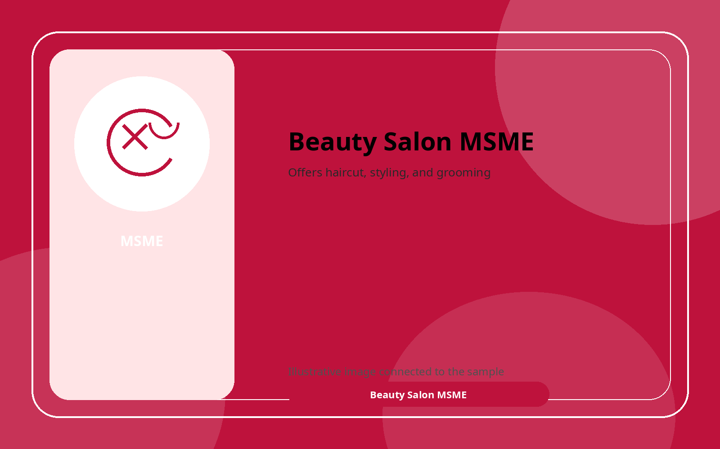 | Beauty Salon MSME  Offers haircut, styling, and grooming
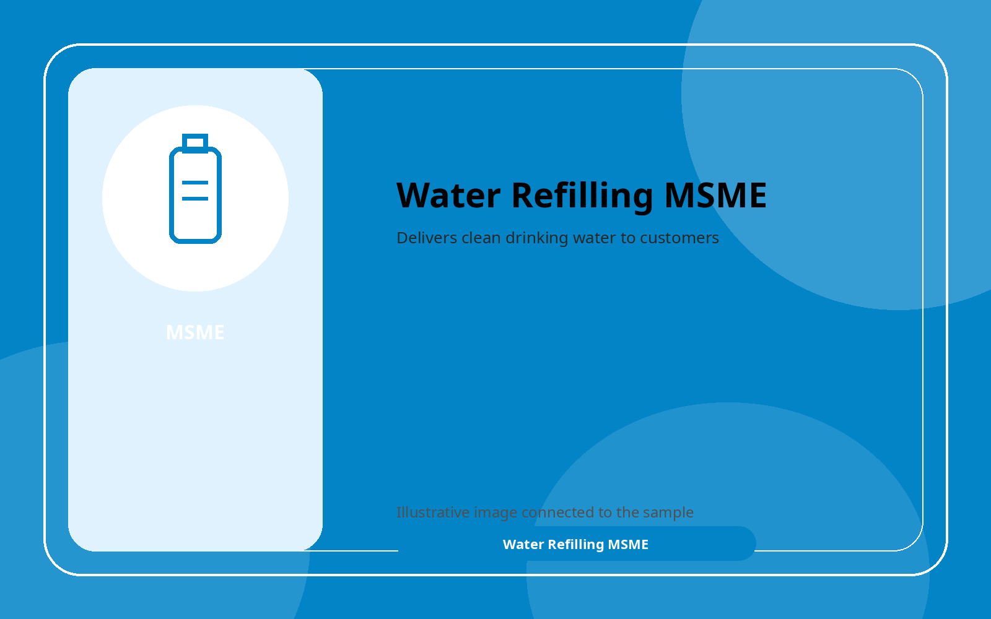 | Water Refilling MSME  Delivers clean drinking water to customers
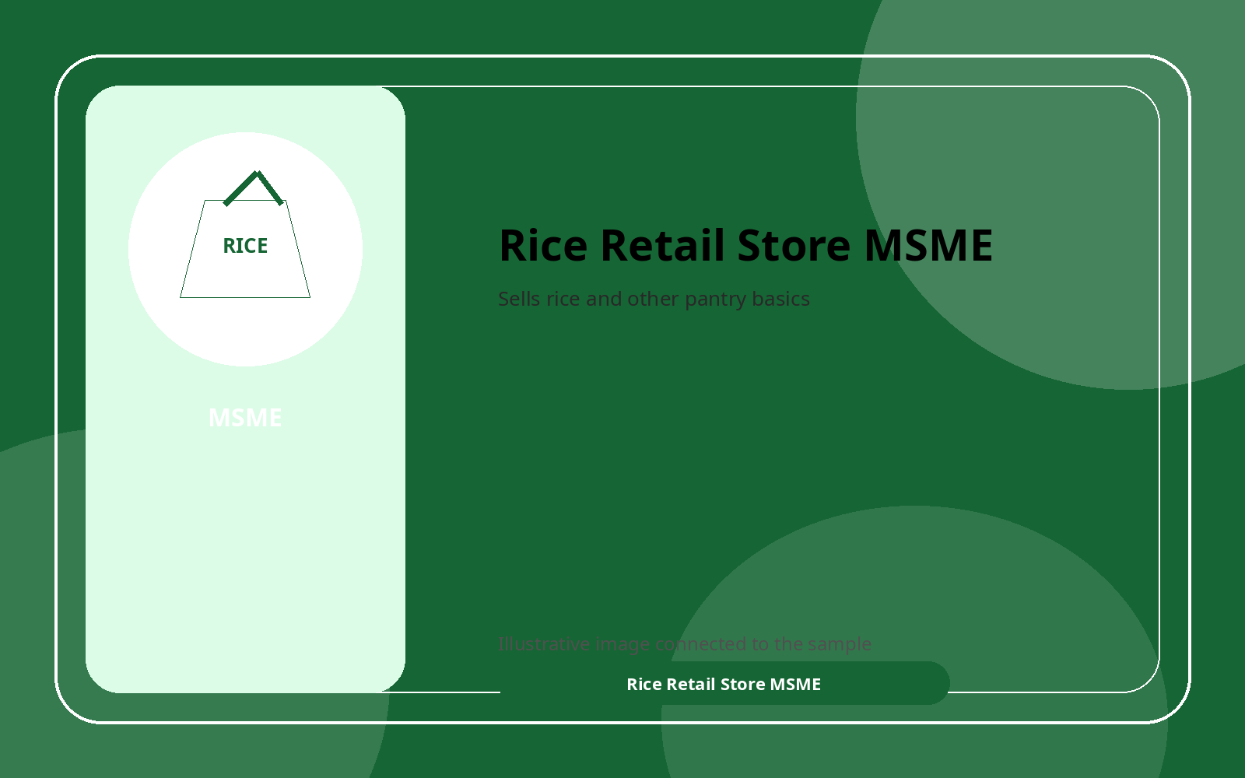 | Rice Retail Store MSME  Sells rice and other pantry basics
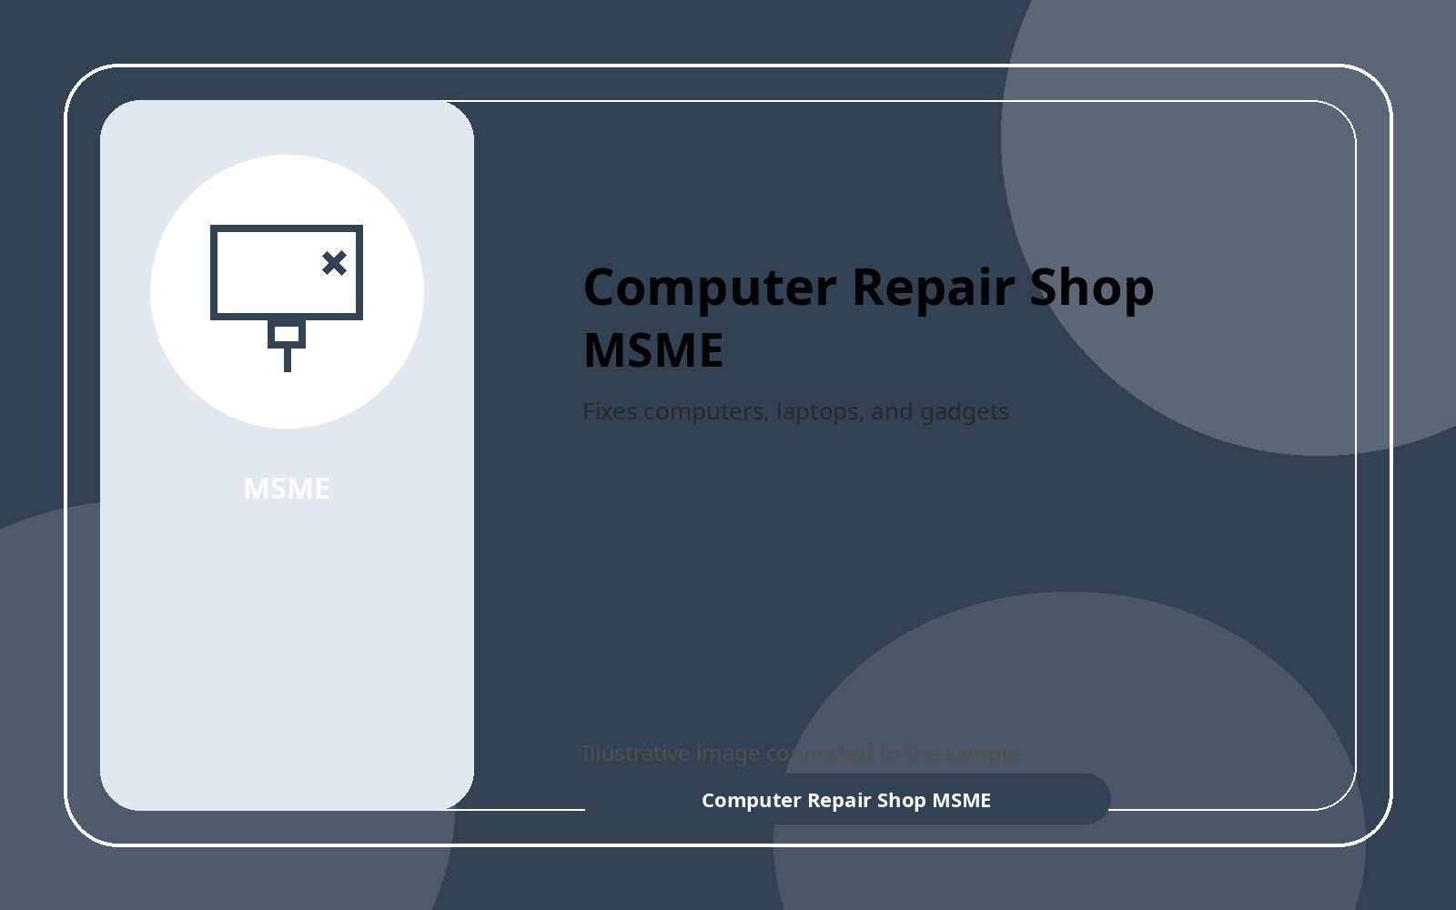 | Computer Repair Shop MSME  Fixes computers, laptops, and gadgets
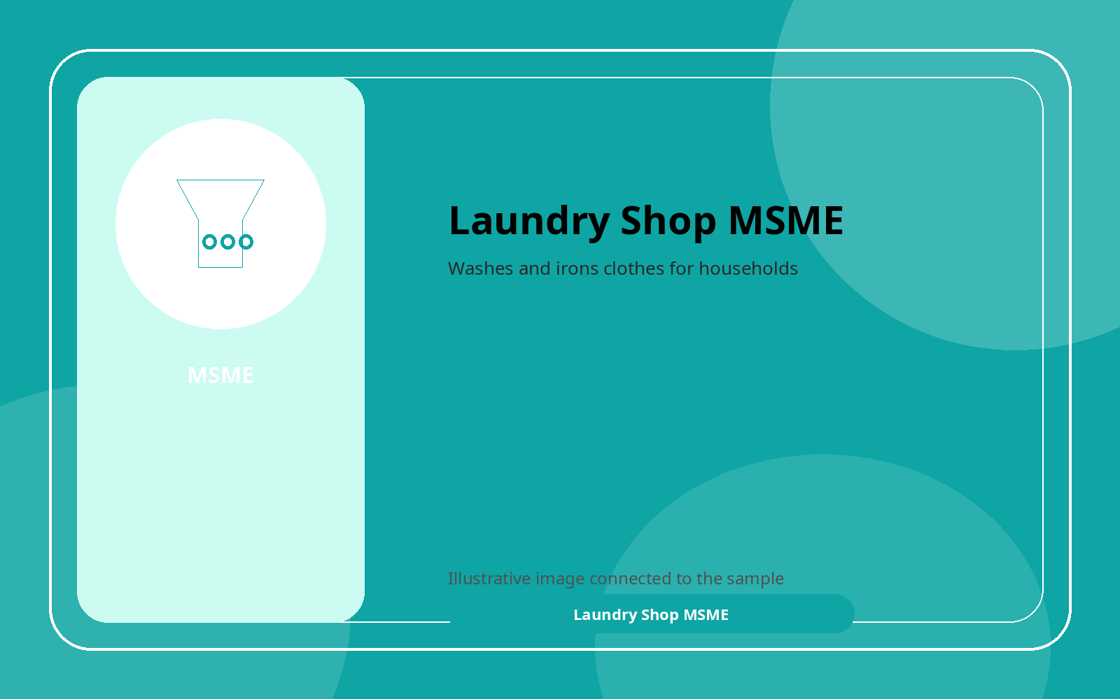 | Laundry Shop MSME  Washes and irons clothes for households

Key Difference Between Startup and MSME
Based on the samples above, the main difference between a startup and an MSME is their goal and way of growing. A startup usually begins with a new idea, a new system, or a technology-based solution. It is built to solve a problem in a fresh way and to grow fast. An MSME, on the other hand, is usually a small business that serves everyday needs in the community and grows step by step.
Aspect | Startup | MSME
Main goal | Solve a new problem and grow fast | Serve daily needs and stay steady
Common examples | Food delivery app, payment app, AI tool | Sari-sari store, bakery, laundry shop
Market focus | Can expand to many users or locations | Usually serves one community or nearby area
Source of growth | Often uses investors, funding, and scaling | Often uses savings, small loans, and daily sa
Business style | Technology-driven and innovative | Practical and service-focused

les

A startup is like a business that wants to create something new. In the samples above, the startup examples include a food delivery app, an online payment app, an e-learning platform, and an AI design tool. These businesses are not only trying to earn money. They are also trying to solve problems in a smarter and more modern way. Most of the time, startups use technology, and they are built with the idea that they can grow very quickly if people like their service.

An MSME is different because it is usually more focused on daily needs. The MSME samples above, such as a sari-sari store, bakery, tailoring shop, carinderia, and laundry shop, are the kinds of businesses that people see in their communities every day. They may be small, but they are very important because they provide jobs, convenience, and steady service to the neighborhood. MSMEs do not always need a big invention. What matters more is that they keep the business running well and serve customers properly.

Another important difference is the way they expand. Startups usually dream of becoming much bigger in a short time, sometimes by getting investors or launching in many places. MSMEs usually grow more slowly and carefully. The owner often starts with limited money and builds the business little by little. Because of this, startups are often described as innovation-driven businesses, while MSMEs are usually described as size-based businesses that support local communities.

Even though they are different, both are important. Startups bring fresh ideas and new technology, while MSMEs keep the economy active by serving everyday needs. Based on the samples, I can say that startups are about innovation and fast growth, while MSMEs are about stability, community service, and gradual improvement. Both of them help people in different ways, and both deserve support.

References
Republic Act No. 11337, also known as the Innovative Startup Act; Republic Act No. 9501, also known as the Magna Carta for MSMEs; Department of Trade and Industry materials on MSME development.

