

Republic of the Philippines
POLYTECHNIC UNIVERSITY OF THE PHILIPPINES
Office of the Vice President for Campuses
BIÑAN CAMPUS

ON-THE-JOB TRAINING
PORTFOLIO

In Partial Fulfillment of the Requirements of the Diploma In Information Technology

Submitted by:
Cardeño, Raven S.

Submitted to:
Miguel, Michael Anjelo O., MIT

May 2026
TABLE OF CONTENTS

PUP PROFILE
Vision
Mission
Philisophy
The Executive Officials
Rationale of the On-The-Job Training
COMPANY PROFILE
SECTOR COMPANY REGISTRATION
ON-SITE TRAINING
Reflection
Documentation
CERTIFICATE OF COMPLETION
APPENDICES
APPENDIX A: MEDICAL CERTIFICATE
APPENDIX B: INSURANCE
APPENDIX C: PARENT’S CONSENT
APPENDIX D: ENDORSEMENT LETTER
APPENDIX E: DAILY TIME REPORT

PUP PROFILE
History
The Polytechnic University of the Philippines (PUP) is a government educational institution governed by Republic Act Number 8292 known as the Higher Education Modernization Act of 1997, and its Implementing Rules and Regulations contained in the Commission on Higher Education Memorandum Circular No. 4, series 1997. PUP is one of the country's highly competent educational institutions. The PUP Community is composed of the Board of Regents, University Officials, Administrative and Academic Personnel, Students, various Organizations, and the Alumni.
Governance of PUP is vested upon the Board of Regents, which exercises policy-making functions to carry out the mission and programs of the University by virtue of RA 8292 granted by the Commission on Higher Education. The University is administered by an appointed President by virtue of RA 8292 and is assisted by an Executive Vice President and the Vice Presidents for Academic Affairs, Student Services, Administration, Research, Extension and Development, and Finance.
This institution started as the Manila Business School (MBS), founded in October 19, 1904 as part of the city school system under the superintendence of C.A. O'Reilley, which responds to the demand for training personnel for government service and the felt need to provide skills essential for private employment. In 1908, it was renamed as Philippine School of Commerce (PSC) and merged with the Philippine Normal School (PNS) in 1933 to 1946. By virtue of Republic Act 778, the PSC was again changed to Philippine College of Commerce (PCC) in 1952. Subsequently, the Philippine College of Commerce (PCC) was converted into a chartered state university, now known as the Polytechnic University of the Philippines by virtue of Presidential Decree Number 1341 issued by the President of the Philippines on April 1, 1978.
PUP is a public, non-sectarian, non-profit institution of higher learning primarily tasked with harnessing the tremendous human resources potential of the nation by improving the physical, intellectual and material well-being of the individual through higher occupational, technical and professional instruction and training in the applied arts and sciences related to the fields of commerce, business administration, and technology.
With more than twenty campuses serving more than 80,000 students, the Polytechnic University of the Philippines is the largest university in terms of student population. The main campus is named after a national hero, Apolinario Mabini, and is located in Sta. Mesa, Manila - in the middle of a busy metropolitan. But despite of this, the environment within its perimeter is a place conducive of learning.
Majority of the students belong to the economically challenged level of society. It is the University's commitment to give qualified and talented students access to quality and responsive education to aid them in the achievement of their dreams and improve their lives. Being a well-educated and skilled individual, they will not only become job seekers but job creators as well, a force of knowledge workers and entrepreneurs.
Scholars of the Nation (Iskolar ng Bayan), that is what we call our students because the Philippine Government and other non-government institutions subsidize their tuition and other fees. More than a hundred of the student population are foreigners from China, Singapore, Indonesia, Cambodia, Myanmar, Tanzania, Nigeria, and Ghana. They are enrolled in business, language, statistics, communication, and education courses in the undergraduate and graduate levels. Students from Korea regularly visit PUP in summer to take up Intensive English courses.
The Polytechnic University of the Philippines takes pride in its capability to accommodate the student needs because it:
- Has more than 20 campuses to make education accessible to everyone;
- Offers a wide range of courses: doctorate, master's, and bachelor's degrees as well as technology courses available through traditional and open, flexible or distance learning;
- Pioneered the ladderized system and the accreditation and equivalency system through the Expanded Tertiary Education Equivalency and Accreditation Program (ETEEAP) and the Nontraditional System Program (NTSP);
- Maintains an average size of 45-50 students per class;
- Offers an extensive selection of educational choices through more than 60 undergraduate and graduate programs;
- Schedules weekend and evening classes;
- Brings the resources and programs of PUP not only to full-time students but also to part-time and adult learners; and
- Provides a long list of extension services for the community and the country.
The commitment of its leaders, faculty, staff, students, alumni and friends has formed the cornerstone of this University that has exceeded expectations with every generation of the graduates it has produced since its establishment.
Today, PUP is relishing its successes and its students are enjoying unprecedented academic opportunities, an enhanced campus environment, upgraded colleges, state-of-the-art technology, and nationally and internationally recognized programs.
PUP celebrated its centenary last October 2004. It has gone far from what it was more than a century ago. This is mainly due to the support given by the government and the PUP Community and its benefactors. With the combined effort, PUP will continue to be a partner in nation-building and in poverty alleviation for the marginalized sector of society with quality, responsive, and relevant education as a tool.
Vision
Clearing the paths while laying new foundations to transform the Polytechnic University of the Philippines into an epistemic community.

Mission
Ensuring inclusive and equitable quality education and promoting lifelong learning opportunities through a re-engineered polytechnic university by committing to:
- provide democratized access to educational opportunities for the holistic development of individuals with global perspective.
- offer industry-oriented curricula that produce highly-skilled professionals with managerial and technical capabilities and a strong sense of public service for nation building.
- embed a culture of research and innovation.
- continuously develop faculty and employees with the highest level of professionalism.
- engage public and private institutions and other stakeholders for the attainment of social development goal.
- establish a strong presence and impact in the international academic community.
Philosophy
As a state university, the Polytechnic University of the Philippines believes that:
- Education is an instrument for the development of the citizenry and for the enhancement of nation building; and
- That meaningful growth and transformation of the country are best achieved in an atmosphere of brotherhood, peace, freedom, justice and nationalist-oriented education imbued with the spirit of humanist internationalism.

The Executive Officials


Manuel M. Muhi, D.Tech., ASEAN Engr.
University President

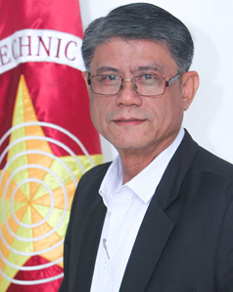
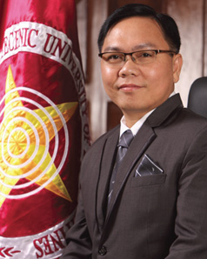
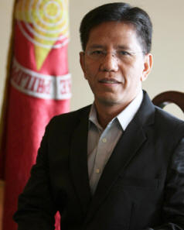

Tomas O. Testor, MPA
Vice President for Student Affairs
and Services
Alberto C. Guillo, MS (Stat) MA (Econ)
Executive Vice President
Vice President for Finance (concurrent)
Emanuel C. De Guzman, Ph.D
Vice President for Academic Affairs

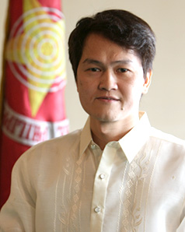

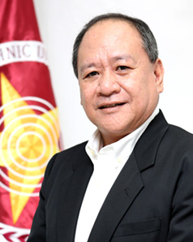

Adam V. Ramilo, MIR
Vice President for Administration
Pascualito B. Gatan, MBA
Vice President for Branches and
Satellite Campuses
Anna Ruby P. Gapasin, DEM
Vice President for Research, Extension,
Planning and Development
Polytechnic University of the Philippines – Biñan Campus
Polytechnic University of the Philippines – Biñan Laguna Campus consistent to its mission of making city of Biñan into premier city with a tagline of ‘Unlad Biñan!’, former Mayor Marlyn B. Alonte-Naguiat now a Congresswoman of Lone District of Biñan City entered into agreement with Polytechnic University of the Philippines (PUP) through a Memorandum of Agreement (MoA) dated September 15, 2009 to establish a PUP campus in the city of Biñan. Through this partnership, quality education become eccessible to every Biñanense, thus, respond to the needs of the largest estates and export processing zones located in the city. Equipped with (13) classrooms, (3) laboratory rooms, an audio-visual room, a student-center, an air-conditioned library and an elevator, PUP-Biñan Campus presently offers (8) Bachelor Degree and (2) Diploma Courses.
(Source: PUP-Biñan)
Rationale of the On-The-Job Training
On-The-Job Training also called practicum of internship depending on the nature of the academic program, is a course requirement for baccalaureate degree which provides as opportunity among students to apply the theories, principles and ideas learned in the academic environment to actual work settings under the guidance and supervision of their skills and prepare them for the “world of work” after collage. Attainment of the On-The-Job Training program objectives ensures the readiness of the graduates to face the challenges of the industry. Hence, vital as it is, OJT should be dynamic, technical, and managerial skill-centered for the students to effectively grasp the practical learning in the workplace.
(Source: MEMORAN ORDER NO.01 SERIES 2017)

METS Cold Storage Services Inc.
COMPANY
PROFILE


On a significant day marking the beginning of a vision-driven enterprise, METS Cold Storage Services Inc. (MCSSI) was established as a provider of reliable and efficient cold storage solutions in the Philippines. Rooted in its commitment to support the growing demand for temperature-controlled storage, the company began its operations with a clear purpose: to serve industries such as food processing, agriculture, and distribution that rely heavily on cold chain systems.
From its founding origins, the company started as a modest operation focused on delivering dependable storage services while maintaining product quality and safety. Through time, the organization steadily grew, guided by industry expertise, operational discipline, and a strong dedication to customer satisfaction. Its early years were marked by continuous improvement in facilities, processes, and workforce capability.
As the company evolved, a significant milestone was achieved through its rebranding into METS Cold Storage Services Inc. (MCSSI). This transformation symbolized not only growth in scale but also a renewed commitment to modernization, innovation, and excellence in service delivery. The rebranding reflected the company’s vision of becoming a more competitive and recognizable name in the cold storage and logistics industry.
With the integration of advanced refrigeration technologies and improved warehouse management systems, MCSSI strengthened its position as a reliable partner for businesses requiring secure and efficient storage solutions. The company has since built strong relationships with its clients and stakeholders, consistently ensuring that goods are preserved under optimal conditions and handled with utmost care.
As time progresses in shaping METS Cold Storage Services Inc., more opportunities continue to emerge. The company remains adaptive to industry trends and technological advancements, while continuously expanding its capabilities and services. Through its dedicated workforce and customer-centered approach, MCSSI sustains its role in supporting the supply chain industry and contributing to business growth across various sectors.
The MCSSI Vision
To be a leading provider of reliable and innovative cold storage solutions, ensuring quality preservation and customer satisfaction across industries.
The MCSSI Mission
To deliver efficient, safe, and high-quality cold storage services through advanced technology, skilled personnel, and strong client partnerships.
Company Tagline
“Preserving Quality, Delivering Excellence”
Core Values (TIES)
T – Teamwork and Trust
I – Integrity in Service
E – Excellence in Operations
S – Safety and Sustainability

WEEKLY
JOURNAL

Republic of the Philippines
POLYTECHNIC UNIVERSITY OF THE PHILIPPINES
Office of the Vice President for Campuses
BIÑAN CAMPUS
On-The-Job Training Program
Second Semester 2026
Internship: INTE 404
WEEKLY JOURNAL ACTIVITIES

INCLUSIVE DATE/S | NATURE OF ACTIVITY | CONTRIBUTION OF THE TRAINEE | NUMBER  OF  HOURS
WEEK 1
February 16 | – | – | –
February 17 | – | – | –
February 18 | - Familiarization of the System | - Examine the system's functionality and overview.  - Simulate ICN manual on the client side (creating ICN, update, and cancel submission) | 8 Hours
February 19 | - Simulation of the System | - Testing in Gears Portal inbound(Assign warehouse checker, and Truck transaction). | 8 Hours
February 20 | - Familiarization and Simulation | - Continue testing in Gears portal inbound(Assign warehouse checker, Truck transaction, RR process, and Manual Putaway).  - Simulate inbound of RF portal(Manual Receiver, and Putaway Queue). | 8Hours
WEEK 2
February 23 | - WMS Familiarization and Inbound Process Simulation | - Continue testing in Gears portal inbound(Assign warehouse checker, Truck transaction, RR process, and Manual Putaway).  - Continue simulate Inbound of RF portal(Manual Receiver, and Putaway Queue).  - Started testing Truck Monitoring in Client Portal. | 8 Hours
February 24 | - Continue simulation of the system and create a Documentation | - Continue simulate Truck Monitoring in Client Portal.  - Started simulation on Inbound Transactions on RF Device (Manual Receiving, Manual Putaway).  - Continued developing the PowerPoint presentation for the New Inbound Process. | 8 Hours
February 25 | - Company Orientation | - Attended a company orientation session, which covered key topics including organizational background, employee benefits, and other relevant policies and procedures. | 8 Hours
February 26 | - TMS Website Research Compilation | - Create a research documentation and ppt for websites that use the Transportation Management System (TMS). | 8 Hours
February 27 | - Create powerpoint in ICN | - Completed creating a powerpoint about Incoming Cargo Notice (ICN). | 8 Hours
WEEK 3
March 2 | - Simulation in Inbound Transaction | - Started role-based simulation of an Inbound transaction on the client portal, GEARS, and RF device. | 8 Hours
March 3 | - Inbound Backend Documentation Familiarization | - Started familiarization with inbound backend documentation using SQL Server Management Studio (SSMS). | 8 Hours
March 4 | - Database Documentation Review | - Continued familiarization with inbound backend documentation in SQL Server Management Studio (SSMS). | 8 Hours
March 5 | - Familiarization in MySQL server / Create Documentation about MySQL | - Continuing the documentation of the Truck Monitoring module in the Client Portal Inbound Backend using MySQL Server Management Studio. | 8 Hours
March 6 | - Simulation of ICN / Complete the Documentation in MySQL Server | - Simulation of ICN and Putaway Processes in the Client Portal, RF device, and GEARS system.  - Finish the documentation of the Truck Monitoring module in the Client Portal Inbound Backend using MySQL Server Management Studio. | 8 Hours
WEEK 4
March 9 | - Inbound Transaction Completion and Outbound Familiarization | - Started familiarization with outbound transactions using the Warehouse Management System (WMS), Client Portal, and RF Device. | 8 Hours
March 10 | - Absent |  | 8 Hours
March 11 | - QA Testing for Truck Monitoring Process | - Started Quality Assurance (QA) testing for the new Truck Monitoring process in the Client Portal. | 8 Hours
March 12 | - QA Testing Continuation | - Continued Quality Assurance testing of the new Truck Monitoring process in both the Client Portal and GEARS Portal.  - Reviewed and verified the system integration and overall functionality between the modules. | 8 Hours
March 13 | - Inbound Transaction Status Testing | - Conducted Quality Assurance testing on all inbound transaction statuses in the Warehouse Management System (WMS).  - Monitored and validated the full workflow, starting from the receipt of a new Incoming Cargo Notice (ICN) up to truck departure, using the Truck Monitoring module in the Client Portal and GEARS. | 8 Hours
WEEK 5
March 16 | - Inbound Transaction Status Testing (Multiple Transaction – ICN) | - We made a document about websites that are used for data analytics  - Conducted QA testing on all inbound transaction statuses using the Multiple Transaction feature in ICN. | 8 Hours
March 17 | - Inbound Transaction Status Testing and Completion (ICN – Multiple Transaction, WMS) | - Continued QA testing on all inbound transaction statuses using the Multiple Transaction feature in ICN.  - Completed ICN with different transaction statuses in WMS. | 8 Hours
March 18 | - System QA testing for functionality and compliance | - Conducted QA testing in ICN and OCN E-Sign to ensure system functionality, accuracy, and compliance with requirements. | 8 Hours
March 19 | - QA testing for transaction validation and tagging | - Continued QA test for inbound and outbound transactions in E-Sign validations and tagging ( Including Normal, Internal, Blast, and Distribution. | 8 Hours

ON-SITE
TRAINING
REFLECTION

Date : Feb 18 - Feb 20, 2026

WEEK 1
My first week of OJT was focused on familiarizing myself with the system and conducting testing activities. I started by examining the system’s overall functionality and understanding how each module works. I also simulated the ICN Manual on the client side, including creating, updating, and cancelling submissions, which helped me understand how transactions are processed. After that, I performed testing in the Gears Portal, particularly in the inbound module. I tested assigning warehouse checkers, truck transactions, the RR process, manual putaway, and also simulated inbound processes in the RF Portal such as manual receiver and putaway queue.

Date: Feb 23 – Feb 27, 2026*
WEEK 2
During my second week of OJT, I continued practicing and simulating different processes in the system to better understand how the operations work. I tested inbound transactions in the Gears Portal such as assigning warehouse checkers, truck transactions, the RR process, and manual putaway. I also simulated inbound processes in the RF Portal, including manual receiving and the putaway queue, and started testing the truck monitoring feature in the client portal. Aside from system testing, I worked on documentation tasks with my co-interns. We created documentation and conducted research about the Transportation Management System (TMS) and prepared a PowerPoint. I also attended a company orientation about the organization, benefits, and policies, and completed a presentation about the Incoming Cargo Notice (ICN).
Date: March 2 – March 6, 2026
WEEK 3
During my third week of OJT, I continued learning more about the system by doing simulations and exploring its backend. I started a role-based simulation of inbound transactions using the client portal, the Gears Portal, and the RF device. This helped me understand how different users perform their tasks during the inbound process. I also became familiar with the inbound backend using MySQL Server. I observed how the system stores and manages data in the database. During this week, I also worked on documentation for the Truck Monitoring module in the Client Portal Inbound Backend and completed it. Additionally, I simulated the ICN and putaway processes using the client portal, RF device, and the Gears system.

Date: March 9 – March 13, 2026
WEEK 4
The fourth week of my OJT, I focused on completing inbound transactions and started learning about outbound processes. I began familiarizing myself with outbound transactions using the Warehouse Management System (WMS), client portal, and RF device. This helped me understand how outbound operations are handled in the system. I also performed Quality Assurance (QA) testing for the new Truck Monitoring process in the client portal and the Gears Portal. I continued testing and checked the integration and functionality between the modules. In addition, I conducted QA testing on all inbound transaction statuses in the WMS, where I monitored and validated the full process from receiving an Incoming Cargo Notice (ICN) up to truck departure. This week helped me better understand both inbound and outbound workflows and improved my testing skills.
Date: March 16 – March 19, 2026
WEEK 5
During my fifth week of OJT, my tasks mainly focused on Quality Assurance (QA) testing and system validation. I started by documenting various websites used for data analytics to support our understanding of system-related processes. Alongside this, I conducted QA testing on inbound transaction statuses using the Multiple Transaction feature in ICN, ensuring that each status was functioning correctly. As the week progressed, I continued testing inbound transactions and successfully completed ICN processes with different transaction statuses in the Warehouse Management System (WMS). This helped me better understand the full transaction flow and how different statuses affect system operations. I also performed QA testing for both ICN and OCN E-Sign systems to ensure functionality, accuracy, and compliance with system requirements. Additionally, I worked on validating and tagging inbound and outbound transactions, including Normal, Internal, Blast, and Distribution types. These activities enhanced my attention to detail and strengthened my understanding of system validation processes.

ON-SITE
TRAINING
DOCUMENTATION

CERTIFICATE OF
COMPLETION

APPENDICES

APPENDIX A
(MEDICAL CERTIFICATION)

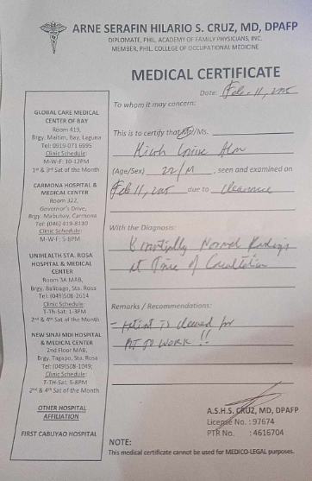

APPENDIX B
(CONFIRMATION OF INSURANCE)
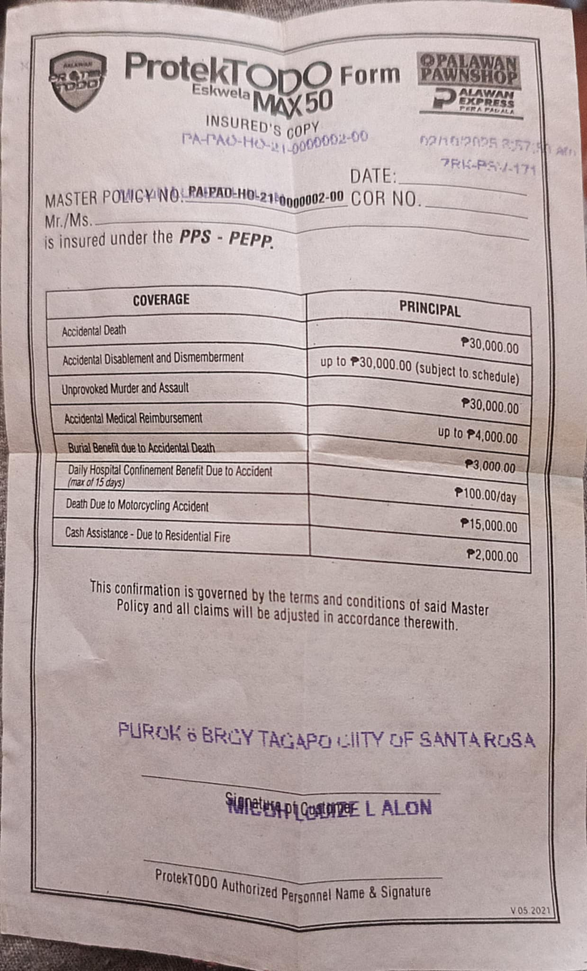

APPENDIX C
(PARENT CONSENT)

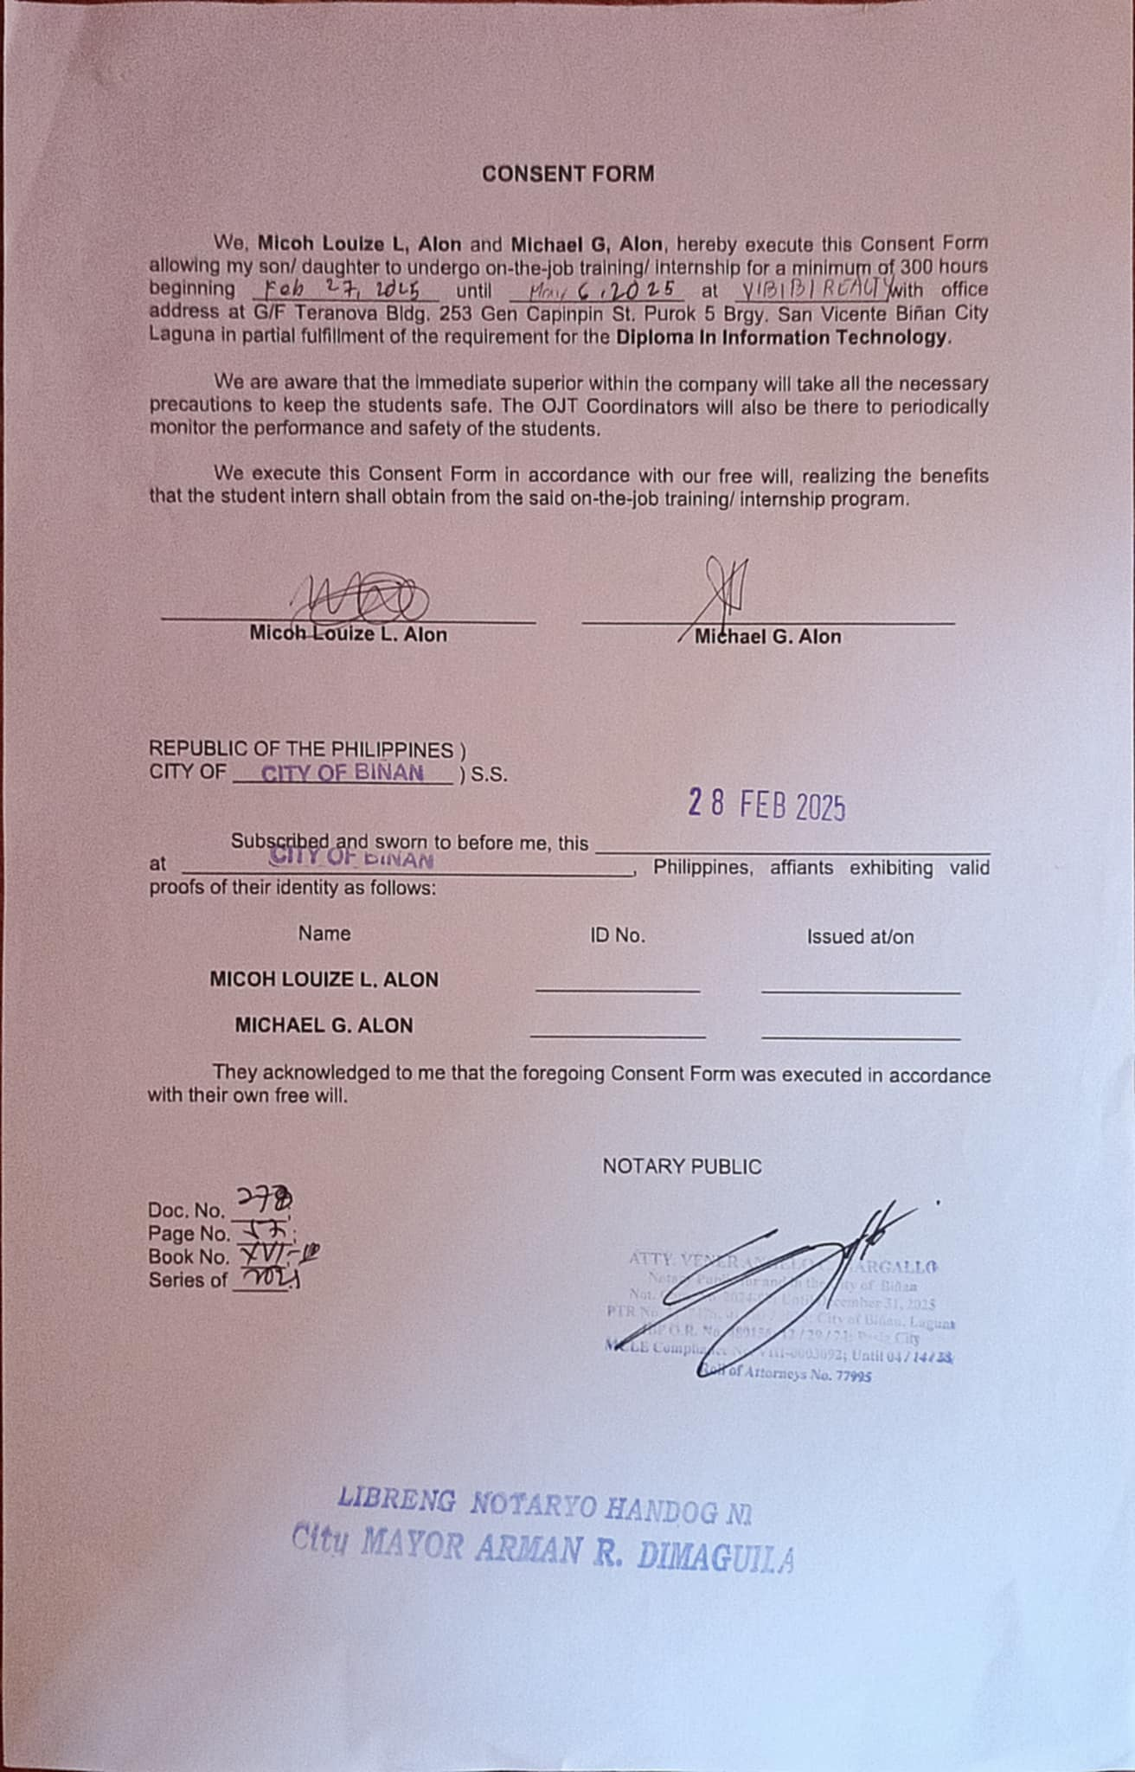

APPENDIX D
(ENDORSEMENT LETTER)
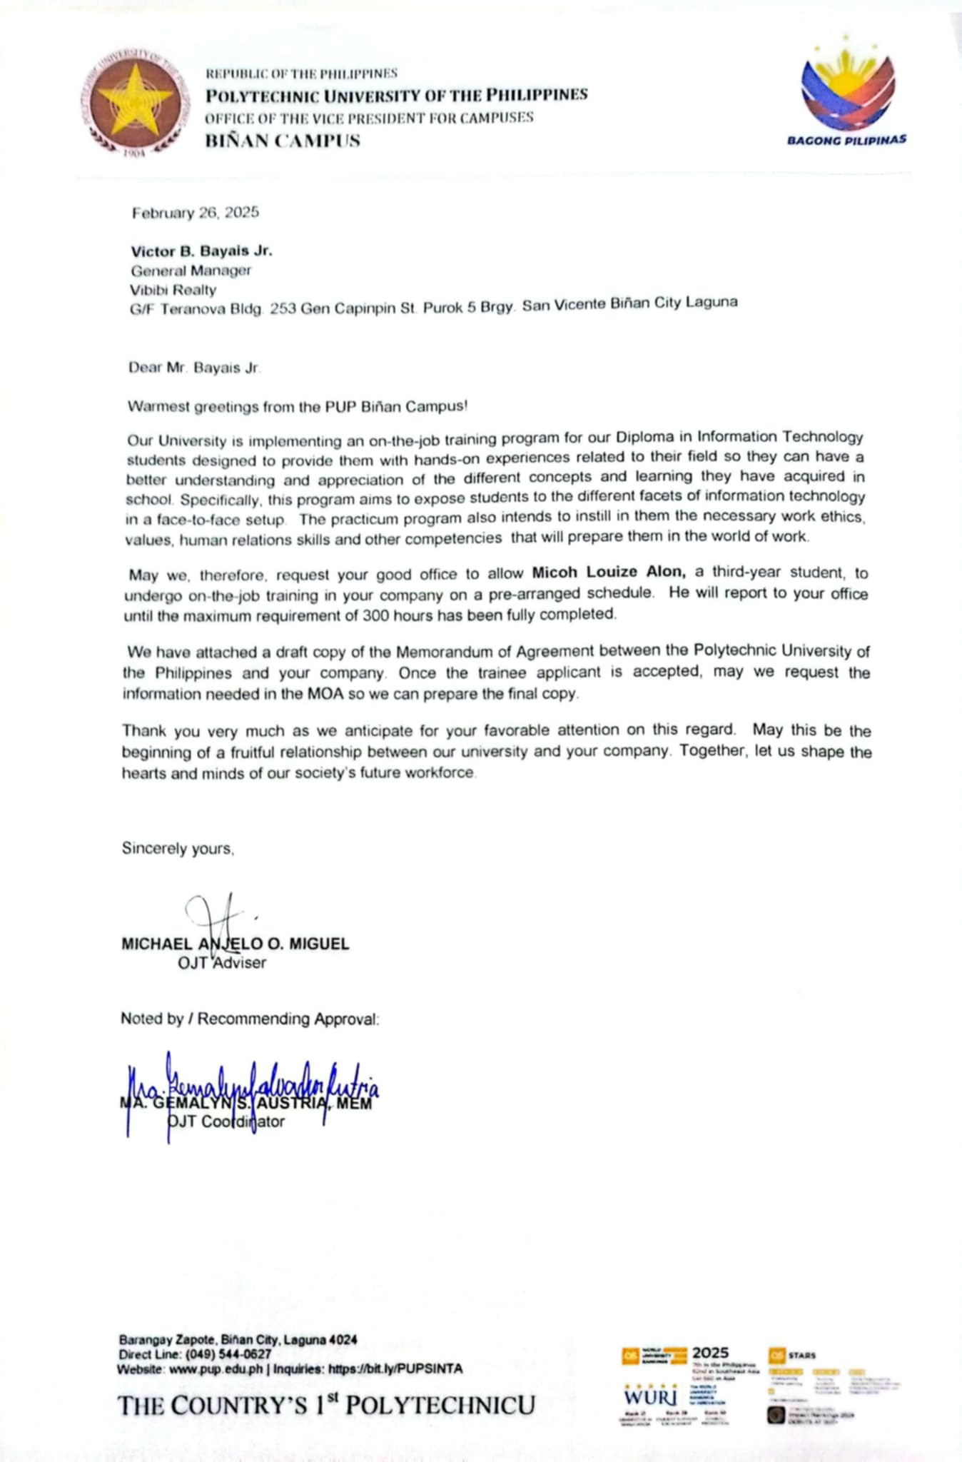

APPENDIX E
(DAILY TIME REPORT)

