Business Environment and SWOT Analysis

Business - Is a human activity carried out by the unified efforts of different categories of people, to produce wealth through production and distribution of the goods and services.
Environment - The birth, growth and continuous development of organization are influenced by a wide range of variables like employees, customers, suppliers, producers, competition, etc.
Business Environment - Includes the actors and forces that affect management’s ability to build and maintain successful relationships with customers.
Internal Environment - It includes forces affecting operations that are within the control of the company, that is the company is able to manipulate these forces towards the firm advantage.
The internal environment consists of five(5) equally powerful forces namely:
- Management - pertains to the organizational setup, including goals and objectives, organizational structure, managerial composition, company philosophy, vision, mission, policies, programs, plans, strategies, tactics etc.
- Marketing - includes the marketing program of the company covering the basic marketing mix (product, price, place and promotion). Specific forces falling under this force are product quality, packaging, pricing strategies, intermediaries used, advertising efforts, public relations, company image and reputation, distribution channels, warehousing, discounts and other sales promotion tools, market segmentation.
- Finance - includes the company’s resources. Items covered under this force are profitability indices, financial performance, balance sheet and income statement, assets, liabilities, net worth, investments, capital expenditures and operating expenses.
- Production and Operations - include all aspects of manufacturing or operations. Specific items falling under this force are quality and sources of raw materials, machinery and equipment, production efficiency, service reliability, technical expertise, production credo, scheduling, delivery, sales service, maintenance, factory location.
- Human Resources - pertains to the people in the organization. Specifically it include motivation ,compensation, training development, promotion, recruitment, selection, placement, hiring policies and procedures, fringe benefits, performance appraisal, grievance handling mechanisms, management labor relations.
External Environment - consisting of forces that are beyond a company’s control.
- Micro Environment- which is close to business and affects its capacity to work is known as Micro Environment
Suppliers - Are those who supply the inputs like raw material and components to the company.
Customers - Success of a business depends upon identifying customers, their needs, likes, etc. Enhancing the level of customer satisfaction.
Competitors - Mans other business units which are marketing and other producing similar products or a very close substitutes of a product. Business has to adjust its various activities according to the action and reactions of competitors.
- Macro Environment – factors that create opportunities and threats to business units.
The external environment consists of the powerful forces namely:
- Economic Environment - includes such forces as balance of trade, balance of payments, foreign exchange, import-export situations, competitive situation, taxation, energy and oil prices, employment, GNP, GDP, per capita income and other measures of economic performance.
- Socio Cultural Environment - pertains to people and their culture. Examples of forces under this type of external environment are education, customs and traditions, religious affiliations, perception ,cultural values, demography, ethnic and racial diversity.
- Politico-legal Environment - Politico pertains to government while legal pertains to law. This environment includes legislation regulating business, legal restrictions, elections, political stability, presidency, peace and order situations, armed forces etc.
- Technological Environment - refers to the advancement of science and technology and includes new inventions or discoveries, technological breakthroughs, research and development, information technology, scientific experiments.
- Natural Environment - includes typhoon, earthquakes, the El Nino, La Nina phenomena, climate change, global warming, Ozone depletion, deforestation, preservation and extinction of animal species.
SWOT
Strength - Something that a company is good at doing. It is a quality that produces a competitive advantage for the company. A characteristics is said to be a strength if its belongs to the internal environment is expected to affect company operations in a positive manner.
- Cheap and abundant raw materials
- Sufficient funds
- Availability of technology
- Presence of skilled workers
- Management and technical expertise of the entrepreneur
- Good quality/service
Weaknesses - The opposite of strength. Something that a c company lacks. It is a quality that puts the company at a disadvantage. A quality is said to be a weakness if it belongs to the internal environment and has a detrimental effect on company operations.
- High price
- Poor quality/service
- Weak management
- Lack of skilled workers
- Irregular supply
- Unattractive design
- High costs of production
Opportunity - A factor in the external environment that is expected to work favorably towards company operations.
- Big demand for the product/service
- Favorable government policy/support
- Scarcity of the product/service
- Poor quality of existing product
- Absence of product or service
- Possibilities of good profits
Threat - A factor in the external environment that is expected to have a negative effect on company operations.
- Shortage of raw materials at a given time
- Entry of many competitors
- Increasing costs of production
- Expectation of unfavorable government laws such as taxes
- Deteriorating peace and order
- Emergence of unfair demands of workers through labor union activities
The System Approach: Business Cluster.Value Chain.4Ms

Business cluster - is a geographic concentration of interconnected businesses, suppliers, and associated institutions in a particular field. Clusters are considered to increase the productivity with which companies can compete, nationally and globally.
The clustering concept was popularized by Harvard School professor Michael Porter. His techniques teach communities to analyze their existing business and industrial bases and build their economic development on those strengths.
What is a business cluster for?
It’s no secret that today’s marketplace is much faster, more complex and global than it used to be. The best way to stay up to date on innovations and product cycles and, moreover, to be able to face the competition is to share knowledge within a business cluster.
Types of business clusters
Making it clear that a business cluster is a grouping of companies in a given territory, we can continue by adding that these can be of a different nature.
Although several types of business clusters can be identified, the most common are the ones listed below:
Vertical cluster - They are designed to group companies or industries that have a relationship with sales and purchases. This type of cluster is for companies that are also linked through their product and supply chains. An example of a vertical cluster is the relationship between companies that assemble vehicles and those that manufacture auto parts.
Horizontal cluster - In horizontal clusters there are interconnections between companies at the same level, in order to be able to share common resources and tools. They seek to pool their knowledge and feedback in order to be able, for example, to advance in terms of innovation and technology.
Two other clusters start from the horizontal clusters:
1. High technology cluster - Clusters of this type have institutions, well-known universities and research centers at their core and are very well adapted to the knowledge economy. In addition, their main focus is the development of technology, as their name implies.
2. Industrial cluster - This is a group of companies related to the distribution of goods and services and production, such as suppliers, engineering and technology companies and research and design centers.
Does clustering really matter?
Yes…cluster do matter a lot…
- Companies in strong clusters are more innovative than other companies.
- Strong clusters creates a higher level of entrepreneurship
Value Chain
- Value is the total amount that buyers are willing to pay for a firms product.
- Value chain refers to the various business activities and processes involved in creating a product or performing a service.
- Value chain is concentrating on the activities started with a raw materials till the conversion into final goods and services.
Activities are categorized into:
- Primary activities – Operations, Distributions, Sales, etc
- Secondary activities – R&D, Human Resource, etc
4Ms of Operations
Over time, additional M’s have sometimes been added to the traditional 4Ms. Whether to direct more industry specific thinking, to demonstrate evolution or improvement of the tool, or to simply make it more complex as part of rebranding. However, the big 4 are still the same:
- huMan (Skill, Technology, Organization, Resources)
  - Do our associates have the skill (and the will) to do what is expected of them safely, consistently and effectively?
- Machine (Equipment)
  - Are our machines capable of safe and reliable output at the desired quality and rate? Do breakdowns, defects or unplanned stoppages inhibit their ability to meet that goal?
- Method (Process, Schedule, Procedure)
  - Do we have standard work methods in place which ensure and support consistent, safe production?
- Material (Information, Raw Materials, Consumables, Quality)
  - Do they meet the required specifications – are there no defects and shortages? Is excess handling or movement reduced or eliminated? Are they stored appropriately?

The Manager

“The conventional definition of management is getting work done through people, but real management is developing people through work” - Agha Hasan Abedi
The Problem-solving Manager focuses on providing solutions to every problem of the company. This manager also concentrates on achieving the company's goals. However, managers of this type sometimes tend to overdo the task of solving every problem which affects his or her overall performance.
The Pitchfork Manager threatens employees to work towards a goal. This manager employs fear tactics and uses an "iron hand" to push employees for results to avoid consequences. He or she is characterized as tough and rude.
The Pontificating Manager neither follows any strategy nor prepares for any situation or task and usually ends up with inconsistent results. The strength of this manager is his or her ability to make people feel at ease when he or she is around since listening to others is second nature to him or her.
The Presumptuous Manager thinks only of himself. This type of manager is not a team player and usually works for personal gain or interest. He or she breeds unhealthy competition instead of cooperation and teamwork. This type of manager is characterized as being too proud and overconfident and has the tendency to compete with the members of the team.
The Perfect Manager is open to change and personal growth. However, he or she can be very mechanical and may lack the interpersonal skills to interact more closely with his or her team members. He or she just concentrates on facts and figures, for example, about the product or service being offered.
The Passive Manager wants to please everyone and make the team members happy. However, being a crowd pleaser becomes a hindrance because of his or her lack of drive and assertiveness to manage the team. This type of manager is described as very timid in his or her approach to avoid any confrontation with anyone especially from the members of his or her team.
The Proactive Manager possesses the good qualities of the other types of managers. He or she has the drive of the problem-solving manager to spearhead solutions, the persistence of the pitchfork manager, the enthusiasm of the pontificating manager, the confidence of the presumptuous manager, the passion of the perfect manager for continued growth, and the desire of the passive manager to serve.

Main Management Functions
The main management functions are planning, organizing leading, and controlling. They can be summarized in the model below.
Functions of management
Planning and decision making -Determining courses of action
Organizing - Coordination of activities and resources
Leading - Managing and motivating people
Controlling - Monitoring and evaluating activities
Planning is the management function wherein managers identify and select the company’s goals and determine the corresponding courses of action in order to achieve them. As planners, managers aim to improve the company’s overall performance by formulating strategies to be implemented.
Organizing refers to structuring the business organization in such a way that employees are grouped together to perform jobs or tasks. The organization ensures that the employees are able to perform efficiently and coordinate effectively to achieve the company’s goals. Each group of employees is assigned a manager who oversees the employees as they perform their assigned tasks.
In leading, managers help the company achieve its objectives by motivating their subordinates to perform the tasks assigned to them. Managers encourage the employees to live up to the company’s vision in their job performance. They also ensure the employee’s commitment to the organization.
Controlling requires managers to identify any deviations from the strategies and methods used in attaining the company’s objectives. The manager, then, implements corrective actions to maintain or improve performance.
Top-level Management
Middle-level Managers
Lower-level Managers
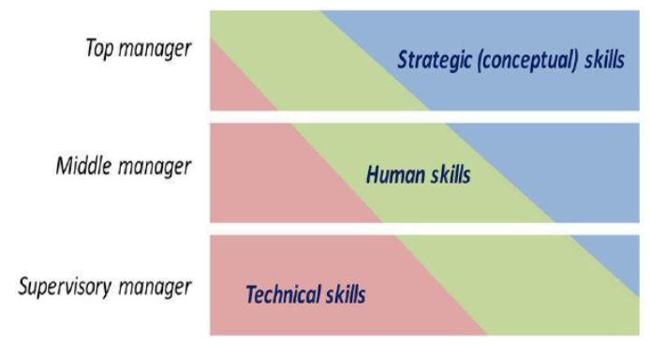

Corporate Responsibility Towards Employees

Work - activity in which one exerts strength or faculties to do or perform something: a specific task, duty, function, or assignment often being a part or phase of some larger activity.

Work is both a personal and social activity. As a personal activity, it is aimed at developing a person and as a social activity, its purpose is the preservation of human society.
Tenure - the amount of time that a person holds a job, office, or title.
Wage - an amount of money that a worker is paid based on the number of hours, days, etc., that are worked.
Salary is the compensation usually quoted annually or monthly for an employee.
Wage - is compensation quoted in an hourly or daily rate for an employee.
Compensation - payment given for doing a job; the money received by an employee from an employer as a salary or wages.
Service - the work performed by one that serves.
The right to work is part and parcel of the right to life and the duty to sustain it. The right to work is fundamental because it flows from nature, as it is in born in every person.
Why is the right to work fundamental at all?
- People work to survive
- Natural obligation to support our dependents.
- Psychological reason.
What is the Right to Equal Employment Opportunities?
- Equality in employment embraces all without discrimination:
- women, the aged, and racial minorities. Employers should not discriminate in job application procedures;
- The hiring, advancement, or discharge employees; employee compensation;
- job training and any other terms, conditions and privileges of employment.
What is the Basic Employee Right to Security of Tenure?
Security is a basic right of both public and private employees. Security of tenure means that in case of regular employment, the services of any one of the workers cannot just be terminated except for just cause or after a due process.
Just Cause refers to any wrongdoing committed by an employee including:
- serious misconduct
- willful disobedience of employers' lawful orders connected with work
- gross and habitual neglect of duty
- fraud or willful breach of trust
- commission of crime or offense against the employer, employer's family member/s or representative
Authorized Cause refers to an economic circumstance not due to the employee's fault, including:
- the introduction of labor-saving devices
- redundancy
- retrenchment to prevent losses
- closure or cessation of business
Work Days and Work Hours
- Work Day refers to any day during which an employee is regularly required to work.
- Hours of Work refer to all the time an employee renders actual work, or is required to be on duty or to be at a prescribed workplace.
- The normal hours of work in a day is 8 hours. This includes breaks or rest period of less than one hour, but excludes meal periods, which shall not be less than one hour.
- An employee must be paid his or her wages for all hours worked.
- If all or any part of his or her regular work hours falls between 10:00 p.m. to 6:00 a.m., a covered employee shall be entitled to a night shift pay in addition to his or her pay for regular work hours.
- If he or she works for more than 8 hours in one day, he or she shall be entitled to overtime pay
Weekly Rest Day
A day-off of 24 consecutive hours after 6 days of work should be scheduled by the employer upon consultation with the workers.
Wage and Wage Related Benefits
Wage is the amount paid to an employee in exchange for a task, piece of work, or service rendered to an employer. This includes:
- Overtime
- night differential
- rest day
- holiday pay
- 13th month pay
What is the right to Just Wage and Compensation?
The just wage is the minimum wage that will only enable the worker to meet the bare cost of living, but will also provide a means of desirable improvements in the quality of life.
Types of Wages
- Family Wage- the amount of money that the worker needs to provide for the needs of the family.
- Living Wage- minimum hourly wage necessary for a person to achieve some specific standard of living
- Minimum Wage-minimum rate a worker can legally be paid as set by the state or government.
- Just Wage- remuneration which is enough to support the wage earner in reasonable and frugal comfort.
- Real Wage- measured in terms of actual purchasing power ( inflation). wages that have been adjusted for inflation, or, equivalently, wages in terms of the amount of goods and services that can be bought.
- Nominal Wage- measured in terms of money paid, not in purchasing power.
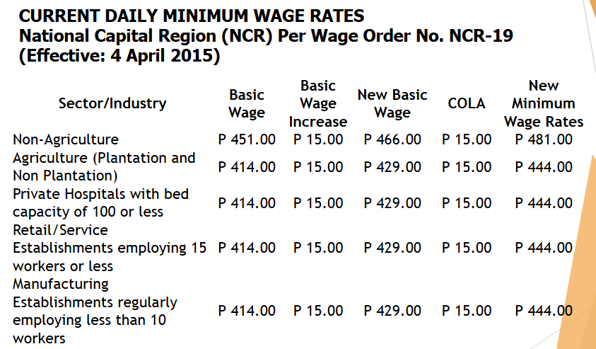
Working conditions refers to the safety and healthfulness of the workplace, particularly the physical work environment and the procedures followed in performing the work.
Factory vs. Sweatshop
- Factory generally refers to a large establishment employing scores of people involved in mass production of industrial or consumer goods.
- Sweatshop on the other hand is usually a small manufacturing establishment such as garment factory where tired employees work long hours under substandard conditions and for low wages.
What are the different dimensions of working conditions?
Working conditions comprise the multiple aspects of the workplace such as the: structure of the workforce
- physical environment
- working time issues
- organizational environment
- social environment and psychosocial risks work related outcomes.
Good Working Conditions a Factor of Success
- Reduced Operating Costs
- Enhanced Financial Performance
- Increased Stock Value
- Increased Productivity
- Enhanced Employee Commitment and Loyalty
- Ability to attract and retain talented employees
- Reduced absenteeism
- Protection and enhancement of company reputation

