A Stepwise Fitting Procedure plug-in for automated fitting of Ecopath with Ecosim models

Erin Scott ^{a, 1,*}, Natalia Serpetti ª, Jeroen Steenbeek ^{b}, Johanna Jacomina Heymans ª
ª Scottish Association for Marine Science, Oban, Argyll, PA37 1QA, UK
^{b} Ecopath International Initiative Research Association, Barcelona, Spain

Abstract
The Ecosim Stepwise Fitting Procedure plug-in automates testing of alternative hypotheses used for fitting Ecopath with Ecosim (EwE) models to observation reference data [1]. The calibration of EwE model predictions to observation reference data is important to evaluate any model that will be used for ecosystem based management. Thus far, the model fitting procedure in EwE has been carried out manually: a repetitive task involving setting > 1000 specific individual searches to find the ‘best fit’ model. The novel plug-in automates the manual procedure therefore producing accurate results and lets the modeller concentrate on investigating the ‘best fit’ model.

Keywords:
Stepwise Model Fitting Procedure; Ecopath with Ecosim; Ecological Modelling; Model Fitting

- Motivation and Significance
Ecopath with Ecosim (EwE) is an ecological modelling software suite that is freely accessible with over 6000 registered users from 164 countries [2,3]. It is used to build models of marine and freshwater ecosystems. Ecopath describes energy flows through a trophic web of functional groups. Ecosim provides a time-dynamic simulation of the ecosystem, with key initial parameters inherited from the base Ecopath model [2].

The calibration of Ecosim models by fitting model predictions to time series reference data (observations) is important, as it evaluates the input data in the Ecopath model [1]. The model fitting procedure tests a combination of hypotheses, to assess the top-down and bottom-up controls on the time series dynamics. Top-down controls include the trophic cascade resulting from changes of the top predators (including fishing activity), while bottom-up controls affect lower trophic levels such as primary producers and detritus. Vulnerability parameters, indicating the strength of the interaction between predators and prey, and/or an anomaly primary production (PP) function that represent an unknown function that can play a bottom-up control on the ecosystem. Vulnerability parameters and PP function are estimated using an optimisation search routine in Ecosim which reduces the sum of squares difference between the predicted and observed data. The effects of top-down controls (e.g. fishing) and bottom-up controls (e.g. primary productivity) depend on how the various model ecosystem components interact [1].

The Ecosim fitting procedure has previously been a manual process using the ‘fit to time series’ search interface within EwE [2]. This involves setting up individual searches where specific conditions apply, including selecting specific time series to be enabled or disabled (e.g., no forcing with forced fishing mortality), thus searching for best fits with and without fishing. It further involves selecting which search to carry out; vulnerability, PP anomaly or both. The number of parameters to be estimated in the search also needs to be set, and a sensitivity search is needed to determine which vulnerability parameters must be estimated. The set-up of one search therefore needs to be repeated depending on the number of parameters that can be estimated and hypotheses being tested. This repetitive task increases the chances of human error. In a large model such as the model of the West Coast of Scotland [4], which contains 48 time series of catch or biomass that can be used to estimate fitting parameters, either through vulnerability, PP anomaly or vulnerability plus PP anomaly searches, the number of searches to be run becomes substantial. With 48 time series, we can estimate 47 (n-1) parameters: thus 2-23 PP spline points (for smoothing the primary production anomaly over the 23 years of the time series) or 47 vulnerabilities, which leads to 1,658 possible combinations to be tested. Previously, manual fitting of the West Coast of Scotland model varied only each 5th combination (i.e. 5, 10, 15 vulnerabilities, 5, 10, 15 spline points etc.) in [4] to reduce the repetitive nature of the task. The novel plug-in developed here gives ecosystem modellers the opportunity to test all fitting combinations with accuracy and speed, and thus allows focus on the analyses of results.

- Software Description
The novel Stepwise Fitting plug-in presented here adheres to and automates the Ecosim model fitting procedure described in [1] and used by [4], [5]. As [1] states it is convention and good practice to explore different search strategies for parameterisations that best explain the observation data to find the best-fit model. The automated procedure focuses on the impact of fishing, changes in the predator-prey dynamics (predation vulnerability settings), changes in primary production (PP), and all of the above [1]. A high level view of the stepwise fitting procedure is shown in Figure 1. Eight alternative hypotheses are parameterized and compared. A more detailed description of the eight types of hypotheses can be found in [4] and are outlined here for convenience as follows:
Figure 1 Activity diagram of the workflow of the Stepwise Fitting Plug-in.
- Baseline: no environmental or fishery data are used to drive the model.
- Baseline and trophic effects (vulnerabilities): no environmental or fishery data are used to drive the model. The optimal numbers of vulnerabilities (for predator–prey interactions) are identified and estimated.
- Baseline and environmentally driven changes in PP anomaly: no environmental or fishery data were used to drive the model. Time-series values are estimated of annual relative primary productivity that may represent historical productivity trends impacting biomasses.
- Baseline and trophic effects (vulnerabilities) and environmentally driven changes in PP anomaly: no environmental or fishery data are used to drive the model. Vulnerabilities and a PP anomaly are estimated.
- Fishing: fishing is included as a model driver.
- Fishing and trophic effects (vulnerabilities): catch, biomass, and fishing mortality are included in the model and the optimal vulnerabilities are identified and estimated.
- Fishing and environmentally driven changes in PP anomaly: catch, biomass, and fishing mortality are included in the model. A PP anomaly is estimated.
- Fishing, trophic effects (vulnerabilities) and environmentally driven changes in PP anomaly: catch, biomass, and fishing mortality are included in the model. Vulnerabilities and a PP anomaly are estimated.

The fitting procedure determines all the alternative hypotheses that may describe the observation data in equal measure and finds the ‘best-fit’ model. The alternative hypotheses are calculated from the loaded available time series observation data which gives the number of parameters that can be estimated (n). The hypotheses are listed as fitting iterations in the user interface of the plug-in (Figure 2). The total number of estimated parameters is calculated from the number of relative biomass, total mortality, catch and average weight time series. The total number of parameters that can be estimated is thus n-1 [6].

The fitting procedure calculates and lists all the possible fitting iterations for the model for both baseline and fishing which include searches of vulnerability, PP anomaly (up to the number of years in the time series) and vulnerability plus PP anomaly. Absolute biomass, forced biomass, time forcing data, effort data by gear type, fishing mortality, forced total mortality and forced catch time series are disabled in baseline iterations [6]. There is the option to include and enable absolute biomass time series to the calculation of n and to include these time series in baseline iterations. If a forcing function is applied to the PP in the model, anomaly and vulnerability plus anomaly iteration searches will be calculated and shown in the iteration list of the plug-in. The spline point step size can also be set, the default value is 1. Before each iteration search is started the vulnerabilities and PP anomaly are reset by the procedure.
The plug-in was created to automate and assist in finding a ‘best-fit’ model. The ‘best-fit’ model is found and determined by the minimum difference between model predictions to time series observations using the weighted sum of squared differences (SS) and the Akaike Information Criterion (AIC) [7], which penalises for fitting too many parameters based on the number of time series available for estimating the SS. The formula used for the AIC is defined as:

$AIC=n∙\log\left({minSS}/n\right)+2K$ (1)
Where n is the number of observations, or time series values, i.e. the number of series used multiplied by the number of years for each parameter, minSS is the minimum sum of squares calculated by the algorithm, and K is the number of parameters estimated.
In addition the procedure also calculates the AICc [8], to address small sample size. The AICc is defined as:
$AICc=AIC+ {2K∙\left(K-1\right)}/{\left(n-K-1\right)}$ (2)
The procedure calculates all of these values for each iteration and identifies the best-fit by the iteration which has the lowest AICc value.

The choice in ‘best-fit’ model is still subjective therefore the user should take care in selecting the best model on the basis of its fit to data, supporting ecological knowledge and reasoned justification [1]. There are other parameters within an Ecosim model that could also be estimated to find the ‘best-fit’ model such as the diet matrix [9] which the plug-in does not deal with and the user should also consider.

The number of possible vulnerabilities that can be estimated are often significantly more than that of the data available to constrain the model, thus it is imperative to test the vulnerabilities that affect the most detectable change [1]. Before each iteration search is started a sensitivity search of sum of squares (SS) to the vulnerability parameters is carried out to find which of the vulnerability parameters creates the largest change on the SS, and therefore the most sensitive vulnerability parameters are used in the iteration search. The plug-in gives the choice to search by predator or predator/prey for all iterations.

A variety of output results for further analysis can be chosen from the plug-in: these are; no results, Ecosim results (similar to all the output results obtained from a usual Ecosim run), aggregated results (a smaller sub group of Ecosim results which include biomass, yield, mortality, vulnerabilities and anomaly shape) and both Ecosim and aggregated. Once all iteration searches are completed a csv file of these runs and fitting results is produced. Ecosim results are stored in separately named iteration folders. Aggregated results are stored in one folder and the file names identify which iteration the results are from. Anomaly shape results for all iteration searches are also stored in one csv file when Ecosim or aggregated result output is selected.

The plug-in can be used in three ways: command line, stand-alone and as an integrated plug-in within the EwE software suite. Iteration searches in the stand-alone version are faster than that of the integrated version. The stand-alone plug-in has a user interface (see Figure 2 for an example) and has all the functionality of the integrated version. The integrated version will be available in the next release of the EwE software suite.

- Example of the Automated Model Fitting Procedure
3.1 Iteration numbers and run times
The West Coast of Scotland model [4] is used as an example to demonstrate the fitting procedure of the novel plug-in. As stated previously there are 48 time series of catch or biomass, and therefore the plug-in calculates 47 parameters can be estimated. These parameters can be either vulnerabilities or PP spline points (up to the number of years in the time series). Thus 2-23 spline points (as there are 23 years in the time series, and one cannot have less than 2 spline points) or 47 vulnerabilities and a combination of these are possible. The plug-in calculates the number of observations (n in the AIC formula) in the time series as 1,063 and that there is in total 1,658 iteration searches. There is 829 iteration runs for both Baseline and Fishing. The time taken for the plug-in to complete all iteration runs was approximately 3.5 days. The number of different search iterations and the time taken for the plug-in to complete each are shown in Table 1.

Hypothesis | No. of Iterations | Time (minutes)
Baseline | 1 | 1
Baseline and trophic effects (vulnerabilities) | 47 | 82
Baseline and environmentally driven changes in PP anomaly | 22 | 9
Baseline and trophic effects (vulnerabilities) and environmentally driven changes in PP anomaly | 759 | 2333
Fishing | 1 | 2
Fishing and trophic effects (vulnerabilities) | 47 | 139
Fishing and environmentally driven changes in PP anomaly | 22 | 31
Fishing, trophic effects (vulnerabilities) and environmentally driven changes in PP anomaly | 759 | 2672
Table 1 The number of iterations and time taken to complete for each of the 8 alternative hypotheses of the West Coast of Scotland model. The stand-alone version of the fitting procedure was run on a PC running Windows 7 with an i7 core and 8GB RAM.

3.2 Results
The plug-in highlights the best fit model (the iteration with the lowest AICc value) which in this case is fishing and 39 vulnerabilities and 7 PP anomaly spline points as shown in Figure 2. Figure 3 presents the AICc result output for all iteration searches. This shows a comparison between the baseline and fishing iterations. Baseline (without fishing) iterations have higher AICc values than fishing iterations which indicates that fishing is the main driver in this ecosystem.

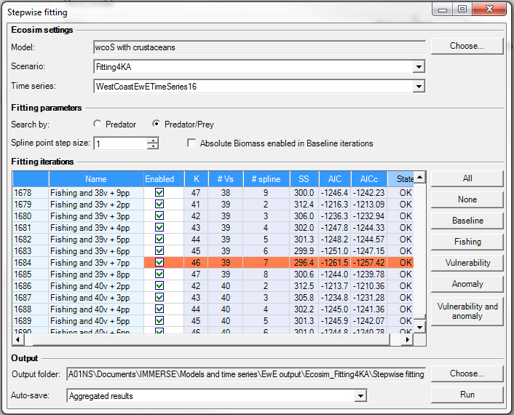
Although the plug-in can produce various output results, in the case of the West Coast of Scotland model, aggregated result output was selected. This allowed the analysis of anomaly shape and vulnerability adjustments results. The plug-in can assist in the analysis of results by providing output that can be easily converted into different visualisations.
Figure 2 The Stepwise Fitting Plug-in user interface highlights the best fit iteration of the West of Scotland model.
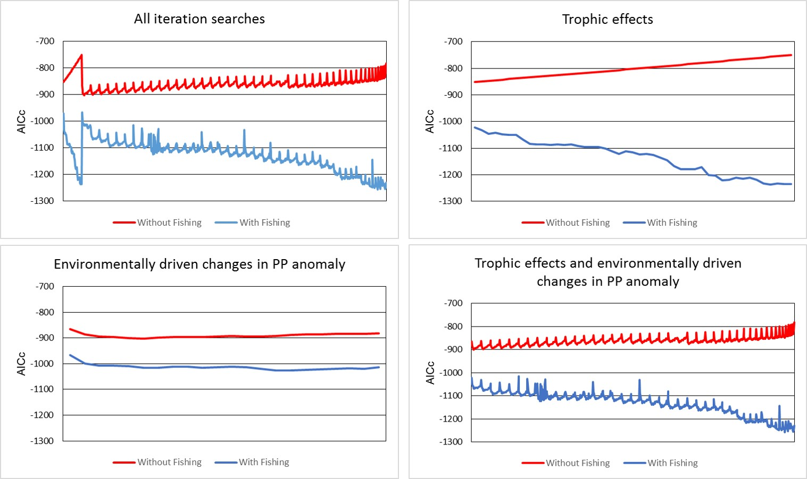
- Impact
Figure 3 The AICc values for all iteration searches is shown in top left graph. The red line indicates baseline values and the blue line indicates fishing iteration values. The x-axis is the order in which the plug-in carried out the iterations, which was the same for both baseline and fishing.
This plug-in will aid in the analysis of a variety of EwE models implemented by the high number of worldwide EwE registered users and encourage new users to the EwE software. The plug-in automates the Ecosim model fitting procedure described by calculating all alternative hypotheses and suggests the ‘best-fit’ model. As stated by [1] the key strength of the procedure is that it allows users to explore a range of possible ecological mechanisms that may contribute to ecosystem changes on decadal scales. Automating what was before a manual ad-hoc procedure reduces human error and accelerates the fitting process. Reducing the occurrences for human error will give more confidence in the results produced. Speeding up this repetitive process will give more time for explorative analysis of results and choosing the best model. This will help produce better models that will help guide policy makers.

The plug-in reduces the occurrence of human error and this is shown in the comparison with [4] when calculating the number of observations. The plug-in automatically calculates this for the user by adding up the number of data points from time series that are of type: relative biomass, total mortality, catch and average weight. In [4] forced catch data points were also added to the calculation leading to the wrong value being used in the AIC calculation. By automating the stepwise fitting procedure the plug-in reduces the chances of errors such as this.

- Conclusion
The Ecosim Stepwise Fitting Procedure plug-in automates testing of alternative hypotheses used for fitting EwE models to observation data [1]. The plug-in allows users to easily explore a range of possible ecological mechanisms that may contribute to ecosystem changes. It will assist in the knowledge of empirical investigations and help confront data issues [1]. The main benefit the plug-in provides is reducing the occurrences of human error and aids in finding the ‘best-fit’ model. This allows the user to concentrate on the justification of the ‘best fit’ model rather than on the model fitting procedure.

Acknowledgements
Erin Scott was funded by the Scottish Informatics and Computer Science Alliance (SICSA) Postgraduate Industry Internship Programme. Johanna J Heymans and Natalia Serpetti were supported by the Natural Environment Research Council and Department for Environment, Food and Rural Affairs under the project MERP: grant number NE/L003279/1, Marine Ecosystems Research Programme.
References
[1] S. Mackinson, G. Daskalov, J. J. Heymans, S. Neira, H. Arancibia, M. Zetina-Rejón, H. Jiang, H. Q. Cheng, M. Coll, F. Arreguin-Sanchez, K. Keeble, and L. Shannon, “Which forcing factors fit? Using ecosystem models to investigate the relative influence of fishing and changes in primary productivity on the dynamics of marine ecosystems,” Ecol. Modell., vol. 220, no. 21, pp. 2972–2987, 2009.
[2] V. Christensen and C. J. Walters, “Ecopath with Ecosim: Methods, capabilities and limitations,” Ecol. Modell., vol. 172, no. 2–4, pp. 109–139, 2004.
[3] M. Coll, E. Akoglu, F. Arreguín-Sánchez, E. a. Fulton, D. Gascuel, J. J. Heymans, S. Libralato, S. Mackinson, I. Palomera, C. Piroddi, L. J. Shannon, J. Steenbeek, S. Villasante, and V. Christensen, “Modelling dynamic ecosystems: venturing beyond boundaries with the Ecopath approach,” Rev. Fish Biol. Fish., pp. 413–424, 2015.
[4] K. Alexander, S. Heymans, S. Magill, M. Tomczak, and S. Holmes, “Investigating the recent decline in gadoid stocks in the west of Scotland shelf ecosystem using a food-web model,” ICES J. Mar. Sci., vol. 72, pp. 436–449, 2015.
[5] M. T. Tomczak, S. Niiranen, O. Hjerne, and T. Blenckner, “Ecosystem flow dynamics in the Baltic Proper-Using a multi-trophic dataset as a basis for food-web modelling,” Ecol. Modell., vol. 230, pp. 123–147, 2012.
[6] V. Christensen, C. J. Walters, D. Pauly, and R. Forrest, “Ecopath with Ecosim version 6 User Guide,” Fish. Centre, Univ. Br. Columbia, Vancouver, Canada, vol. 281, no. November, pp. 1–235, 2008.
[7] H. Akaike, “A new look at the statistical model identification,” IEEE Trans. Automat. Contr., vol. 19, no. 6, pp. 716–723, 1974.
[8] K. P. Burnham and D. R. Anderson, “Multimodel Inference: Understanding AIC and BIC in Model Selection,” Sociol. Methods Res., vol. 33, no. 2, pp. 261–304, 2004.
[9] C. H. Ainsworth and C. J. Walters, “Ten common mistakes made in Ecopath with Ecosim modelling,” Ecol. Modell., vol. 308, no. 8, pp. 14–17, 2015.

Code Metadata
Nr | Code metadata description | Please fill in this column
C1 | Current code version | V1
C2 | Permanent link to code/repository used of this code version | http://sources.ecopath.org/svn/Ecopath/trunk/Ecopath6
C3 | Legal Code License | GNU General Public License
C4 | Code versioning system used | svn
C5 | Software code languages, tools, and services used | Visual Basic.Net
C6 | Compilation requirements, operating environments & dependencies | OS needs to be Microsoft Windows XP service pack 3, Windows Vista, Windows 7, Windows 8.X, or Windwos 10 or newer with .NET Framework 4 Full installed. If the computer does not run Microsoft Office 2007 or newer will need to install Microsoft Access 2007 database drivers.
C7 | If available Link to developer documentation/manual | http://sources.ecopath.org/trac/Ecopath/
C8 | Support email for questions | egs@cs.stir.ac.uk

