Multi-Agent Software Factory
Complete architecture documentation

Undergraduate Final Project · Enzo Consulo · August 2026
WHAT THIS SYSTEM IS A system that takes the description of a project in natural language and builds it end to end. It is not an assistant that answers questions about code: it is a production line in which specialised agents plan, implement, verify, review and document — each with a defined role and limited authority. Mandatory human intervention happens exactly once, in the initial request.

HOW TO READ THIS DOCUMENT It was written to be read from beginning to end by someone who knows none of the technologies involved. Each part uses only what the previous ones have already explained: the vocabulary comes before the pieces, the pieces come before the platform, and the subjects usually treated as advanced — cost, semantic memory, concurrency — only appear once everything they presuppose has been introduced. Anyone in a hurry can read just the coloured band that opens each part and the figures: together they tell the whole story.

Roadmap
Part | What it answers | Where it lands
I — The problem | why long work with a language model breaks down | the idea of treating construction as a production line
II — The vocabulary | what an agent, a tool, a loop, context and a token are | how an agent works, from first step to last
III — The pieces | what a task is, what the gates are, what happens on failure | the full life of a task, from backlog to delivery
IV — The platform | why Elixir, which tools, and what each one does | the process tree and what the database keeps
V — The economics | where the money is spent and how the design cuts the bill | the five cost levers and per-role context
VI — The memory | how an agent that starts blank knows what was already decided | the two indexes, and when not to use each
VII — Operation | what happens outside software, and how all of it is watched | a whole project, from request to delivery
VIII — The project | in what order to build, what is out of scope, what can go wrong | the six phases, the scope and the known limits

PART I The problem, and the idea that answers it
Before any technology: what exactly breaks when you ask a language model to build a whole system.

1. Where a language model breaks down
A language model writes code well when the request is short and everything it needs to know fits in one conversation. Ask for a function, a query fragment, a fix for an error — the result is usually good.
Asking it to “build this system” is a different matter. The work runs for hours, spans dozens of files and depends on decisions made at the start that must still hold at the end. That is the regime in which it fails — and the point that matters is this:
the failures are not failures of writing, they are failures of process. The model keeps writing each isolated fragment well; what is lost is the coherence of the whole. Four failure modes show up every time, and none of them is solved by a better model:
- Context loss. The conversation grows, the beginning drifts out of view, and the model starts contradicting what it itself decided two hours earlier: the start of the conversation competes for room with everything that came after it.
- Decisions without a trace. The reason behind a choice — “we use this because that does not work here” — stayed in the dialogue, and goes with it when the session ends. A week later the same decision is made again, sometimes the opposite way.
- Self-approval. Whoever wrote the code is the one declaring it finished. And whoever wrote it rarely rejects it: the same reasoning that produced the mistake is the one sent to look for it.
- Unbounded retrying. One hard point consumes attempt after attempt. With no explicit limit it blocks everything queued behind it — and the cost grows while nothing advances.

2. The proposal: construction as a production line
The answer taken by this work is not to ask for the whole system at once. Instead: split the request into small, named tasks, give each an explicit state that is recorded outside the conversation, and put every delivery through reviewers that did not build it.
The model remains the worker — it is the one writing the code. The system around it decides what it does, when it does it, with what information and with what authority.
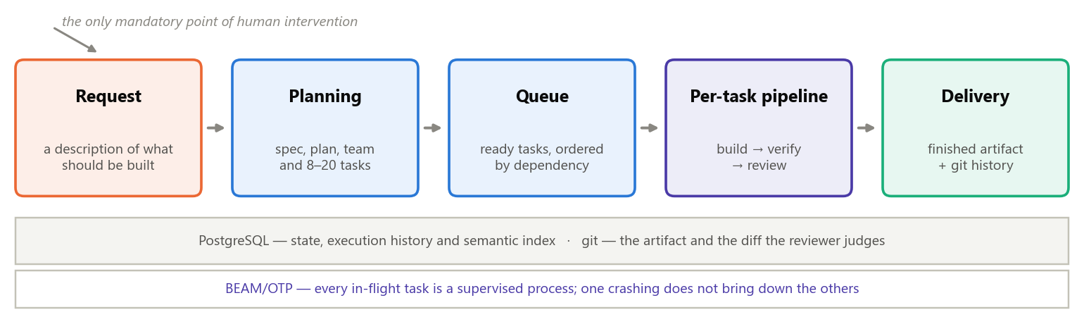
Figure 1 — From request to delivery. The only mandatory human intervention is the first box; from there on the system decides on its own. The two grey bands at the bottom are what holds it all up, and they appear in detail in Part IV.
1 Request  The user describes what they want, once, in natural language. | 2 Planning  An agent produces the specification, a phased plan and 8 to 20 tasks with declared dependencies. | 3 Building  Each task is implemented by an agent specialised in that area of the project. | 4 Two gates  One verifies that it works; the other reviews whether it is what was asked. Neither may fix anything. | 5 Delivery  A finished task becomes its own commit, and the system moves to the next.

3. The three rules that govern everything
All the rest of this document follows from three decisions. They reappear in every part, applied to a different problem each time.
- Whoever implements is never whoever approves. Verifier and reviewer have no permission to fix: they reject and send back. This is not a recommendation about conduct — in Part II we will see that the tool to write does not even exist for them.
- State outside the conversation. Every decision, every result and every cost is recorded the moment it happens. If everything crashes now, the next run rebuilds the world by reading the database and the version history — never by rereading a dialogue.
- Bounded failure. Three cycles per task. Beyond that, the system tries to resize the task once; if it still fails, the task is blocked and reported, and the queue moves on. A hard task never blocks the whole line.
THE THESIS, IN ONE SENTENCE The bottleneck of a system like this is not text generation, it is governance. A capable model produces good code; what decides whether the whole thing works is who commands it, within what limits, and what happens when something goes wrong. This work is about that layer.

PART II The vocabulary, and how an agent works
Six terms and one mechanism. After this part you can follow every technical decision in the rest of the document.

4. The terms the rest of this document uses
None of this is jargon for its own sake: every term below comes back, and three of them decide the cost of the entire system.
Term | What it means in this document
Language model | the worker: it takes text and returns text or requests for action. It keeps no memory between one run and the next
Tool | an action the model can ask to have performed: read a file, run a test, write code, search the web
Agent | a role: the text defining what it does, the list of tools it may use and the model that runs it
Tool-use loop | the cycle question → tool request → result, repeated until the model says it is done
Context | everything that goes into one request to the model. It is resent in full on every turn of the loop
Token | the unit the model is billed in, for input and output alike. Roughly a piece of a word
Prefix | the beginning of the request — the part that repeats identically from turn to turn (Part V)
Reuse | a provider feature: storing the already-processed prefix and charging a tenth to reuse it (Part V)
Vector (embedding) | a list of numbers representing the meaning of a text: similar texts get similar numbers (Part VI)

5. What an agent is
An agent is neither a program nor a service. It is a role written in plain text, plus two things that bound it: the tools that exist for it and the model that runs it.
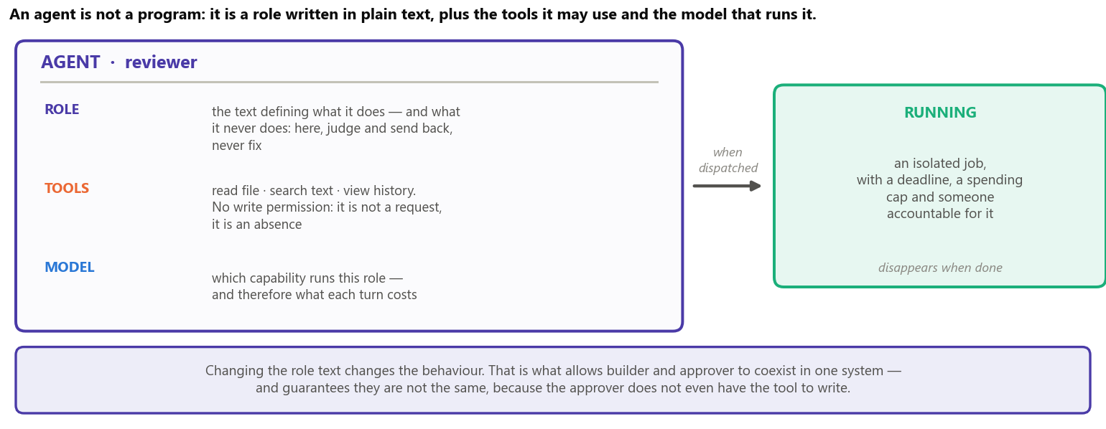
Figure 2 — The anatomy of an agent. Changing the role text changes the behaviour; removing a tool removes the capability, not merely the permission.
The third line of the figure is the one that usually goes unnoticed and matters most: the reviewer is not given the tool to write. The rule “the reviewer does not fix what it finds” stops being an instruction the model might misread and becomes an impossibility — it has no way to write, because the action is not on its list. It is the principle of least privilege applied to agents.
The generic roles — planner, builder, verifier, reviewer — serve any project. There is also a second kind of agent, tailored to each project; it appears in section 10.

6. How an agent works: the loop
A running agent is a loop, and understanding that loop is understanding the whole system — including the cost side of it. The cycle is always the same:
- The system assembles the request and sends it: the available tools, the permanent instructions and the entire conversation history so far.
- The model answers in one of two ways: asking for one or more tools to be used, or saying it is done.
- If it asked for tools, the system actually runs them — reads the file, runs the test — and returns the results in a single message.
- The loop starts again, now with one more turn of history. It ends only when the model says it is done, or when it hits a cap imposed from outside.
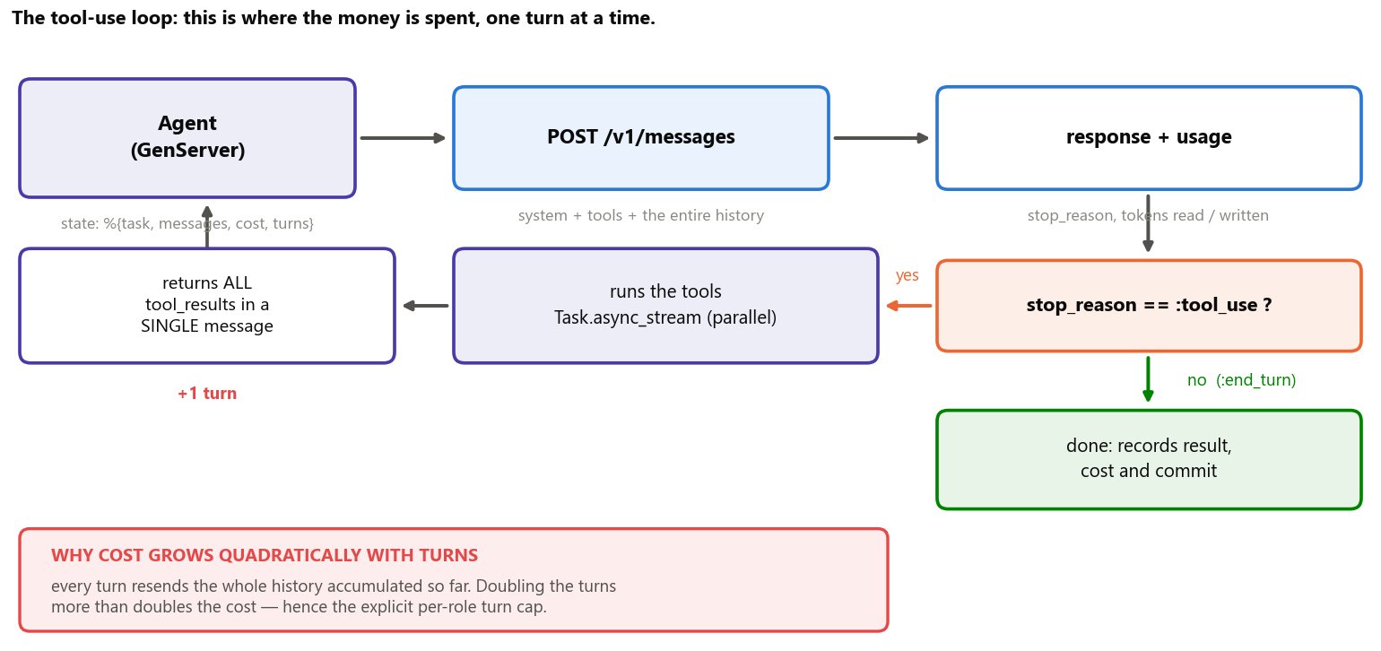
Figure 3 — The tool-use loop. The tools requested in the same turn run in parallel, and the results always return in a single message — splitting them teaches the model to stop requesting tools in parallel.
One property of this loop drives the entire design of the system: cost is not proportional to the amount of code, but to the number of round trips to the model. Because every turn resends the whole accumulated history, a late turn costs more than an early one. An agent that solves the task in eight turns costs far less than one that takes twenty — even writing exactly the same file at the end.
That is why the system invests so much in giving the agent a good starting point instead of letting it discover the project on its own, opening file after file. Part VI is entirely about that; Part V shows the arithmetic.

PART III The pieces of the system
The task, the two gates, what happens when something fails, and the team that is born with each project.

7. The task: the unit of work
If the whole request were handed to one agent we would be back at the problem of Part I. That is why planning breaks the request into tasks — and the task is the central piece of the system, because it is what carries the state.
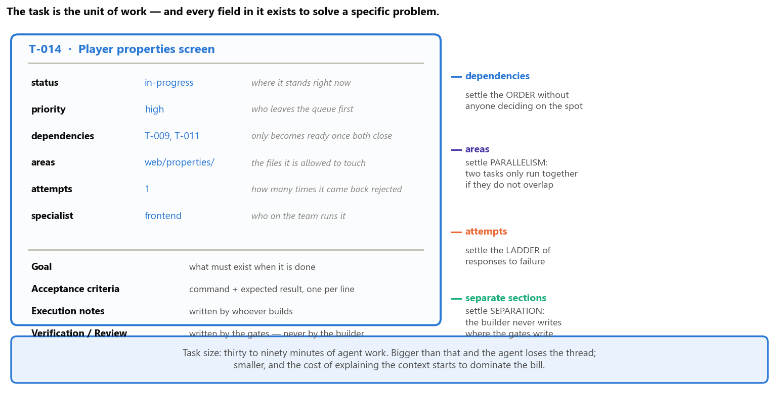
Figure 4 — The anatomy of a task. On the right, the problem each field solves: none of them is there as bureaucracy.
It is worth noting what the figure shows on the right. The fields do not describe the task for the sake of describing it — each one exists to make automatic a decision someone would otherwise have to make on the spot:
- Dependencies settle the order. A task becomes available only when all of its dependencies are done. Nobody has to decide “what comes next”: the queue orders itself.
- Areas settle parallelism. Two tasks in the same project may only run at the same time if the areas they declare do not overlap. That is what prevents two agents from editing the same file without knowing about each other.
- Attempts settle the response to failure. How many times the task came back rejected is what decides the next step — and that is the subject of section 9.
- Separate sections settle the separation of roles. The builder writes in the execution notes; the gates write in the verification and review sections. Nobody writes in anyone else’s section.
WHY TASKS OF THIRTY TO NINETY MINUTES It is the range where the two wastes balance out. Too large a task makes the agent lose the thread — and when it fails, it throws away a lot of work at once. Too small a task makes the cost of explaining the context (paid in full on every dispatch) dominate the cost of doing the work. The planner is instructed to split anything beyond that.

8. The two gates
Every delivery goes through two independent judgements, made by agents that did not build it. They are not two levels of care: they are two different questions.
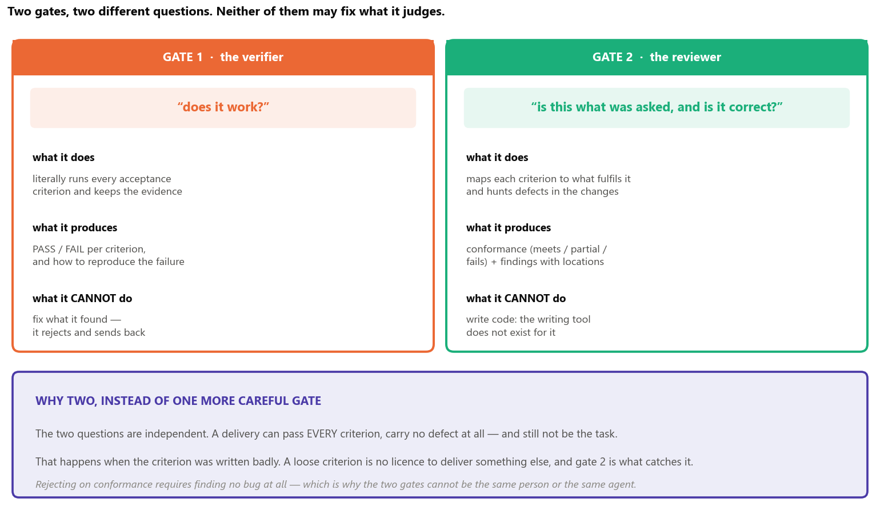
Figure 5 — The two gates. The purple band explains why one more careful gate would not be enough.
The subtle point of the design is in the bottom band of the figure, and it bears repeating: a delivery can pass every criterion, carry no defect at all and still not be the task. That happens when the criterion was written badly — and a loose criterion is no licence to deliver something else. Rejecting for non-conformance requires finding no bug at all.
Hence the requirement about how acceptance criteria are written: they take the form “command + expected result”, never the form of an evaluative sentence. “The API works” is not a criterion; “calling /users returns 200 with a JSON list” is. The difference shows up in Part VII, when the system has to do this outside software.

9. What happens when a task fails
Rejection is not the end of the line. The system answers failure in steps, and each step is only used after the previous one has genuinely failed — the trigger is always a recorded fact, never a guess about difficulty.
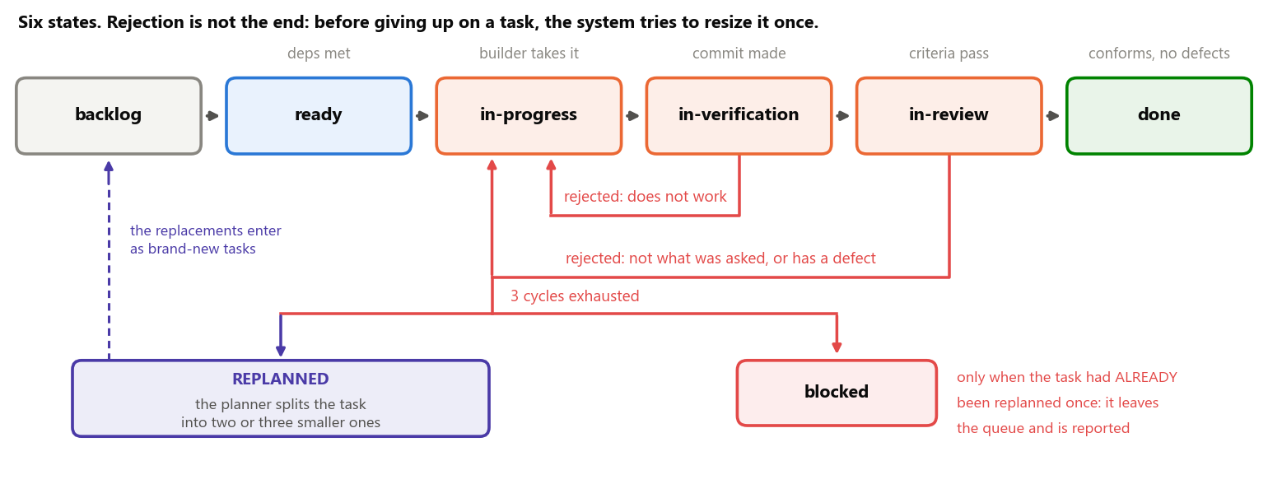
Figure 6 — The six states of a task. The two red arrows going back are the gates rejecting. Once the three cycles are exhausted there are two exits — and the first one is not giving up.
- 1st rejection — escalate the model. The task goes back to the builder, now run by a more capable model. Insisting on the same model after a rejection pays for the whole cycle again and burns one of the three attempts.
- 2nd rejection under the same specialist — swap the specialist. It was chosen during planning, before anyone knew where the task would fail; repeating is betting twice on the same guess.
- 3 cycles exhausted — replanning. The planner re-examines the task and splits it into two or three smaller ones, which enter the queue as brand-new tasks. The original is cancelled, with a reference to its replacements. It is the acknowledgement that the problem may not be one of execution, but of sizing.
- Exhausted again — now it blocks. A task already born from a replanning that fails once more is reported to the user. The system does not replan a replanning: if the problem survived two different readings, it needs a human decision.
Every state transition is a transaction: the new state, the stage report and the cost of that dispatch enter together, or not at all. There is no task that changed state without recording why, nor money spent that is not tied to a result.

10. The team born with the project
Here lies what is probably the system’s most distinctive piece. The factory has no generic programmer waiting for tasks in the queue: while planning, it synthesises a team from the request itself.
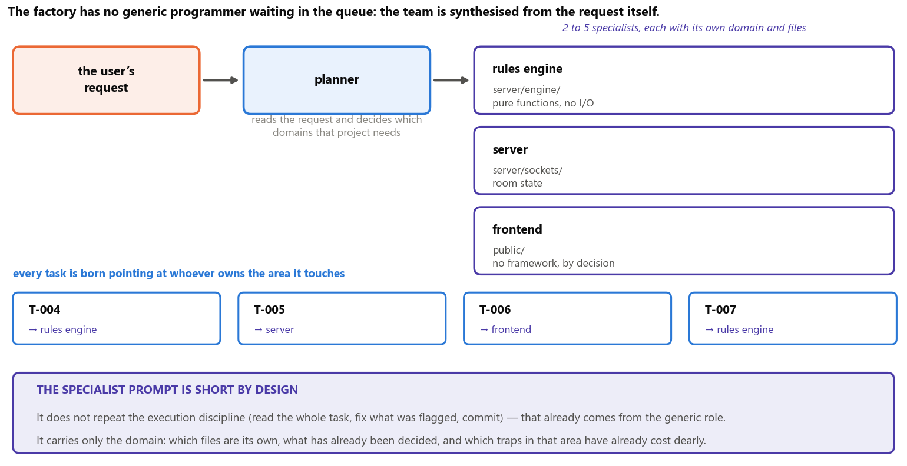
Figure 7 — From request to team. Every task is born pointing at the specialist for the area it touches.
Each specialist’s prompt is deliberately short. It does not repeat the execution discipline — read the whole task, fix first what was flagged, record what you did, commit — because that already comes from the generic builder role. It carries only the domain: which files are its own, which decisions are already settled, and which traps in that area have already cost dearly.
THE ONE DELIBERATE RENUNCIATION Specialisation is abandoned in exactly one case, and it is planned: when the same task is rejected twice under the same specialist, the system switches to a more capable generic builder and records the switch. The specialist was chosen during planning, before anyone knew where the task would fail — two consecutive rejections under the same domain prompt are evidence that the specialisation is biasing the attack on the problem.

PART IV The platform
Why Elixir, which tools make up the system, what each one does here, and how all of it is organised at run time.

11. Why Elixir
The choice of language is not an aesthetic preference: it is the answer to a list of demands the problem imposes. And the first thing to notice is that
the bottleneck of this system is not computation — it is waiting. Each agent spends most of its time awaiting the response of a remote service that may take minutes, fail midway, or need to be interrupted for exceeding a spending cap. There is no heavy local computation to do; there are many slow jobs to keep standing at once.
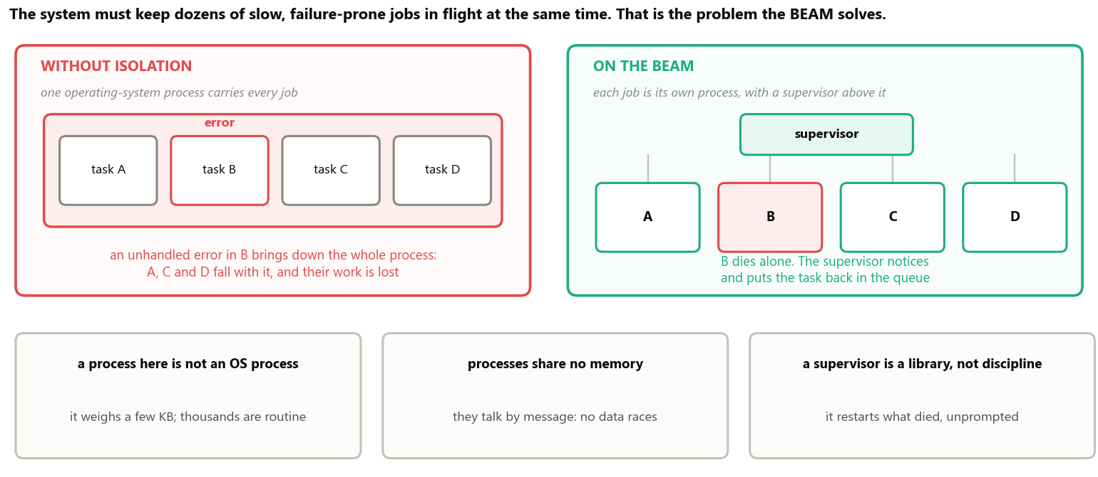
Figure 8 — The BEAM is the virtual machine Elixir runs on. Isolation between processes is the property this system exploits, not an implementation detail.
The figure shows the difference that settles the choice. In an application without isolation the jobs share one operating-system process: an unhandled error in any of them brings down all of them. On the BEAM each job is its own process — and “process” here is not the operating system’s: it weighs a few kilobytes, and keeping thousands of them is routine.
What the system demands | What the BEAM delivers
dozens of slow jobs at the same time | lightweight processes: keeping thousands of them is routine, not a feat
one job failing must not bring down the others | memory isolation: each process falls on its own
someone has to notice the failure and react | a supervisor: restarts or returns the task to the queue, unprompted
cutting a job off midway, safely | ending a process is a normal operation, not an emergency measure
watching all of it live on a screen | the dashboard runs on the same runtime, with no second application

The decisive argument is a mapping, not a benchmark: an agent becomes a supervised process. An agent stops being a loose run that nobody watches and gains an identifier, an owner, someone who can terminate it and — most importantly — someone who notices when it dies. Rules that previously had to be requested in writing become properties of the structure.
WHAT THE CHOICE DOES NOT SOLVE Elixir does not make the model cheaper: the price per token belongs to the provider, and no supervision tree changes that. And the language’s AI ecosystem is smaller than Python’s — which weighs little here, because the heavy part of the system is waiting on the network, and the only genuinely numerical step (turning text into vectors) has a mature library, described in the next section. Claiming otherwise would be selling the choice for more than it is worth.

12. The tools, and what each one does
The system is organised in five layers, and the rule separating them is simple: each one knows only the layer immediately below. Whoever triggers does not know which agent will run; whoever decides the order does not write code; whoever writes code does not decide what comes next.
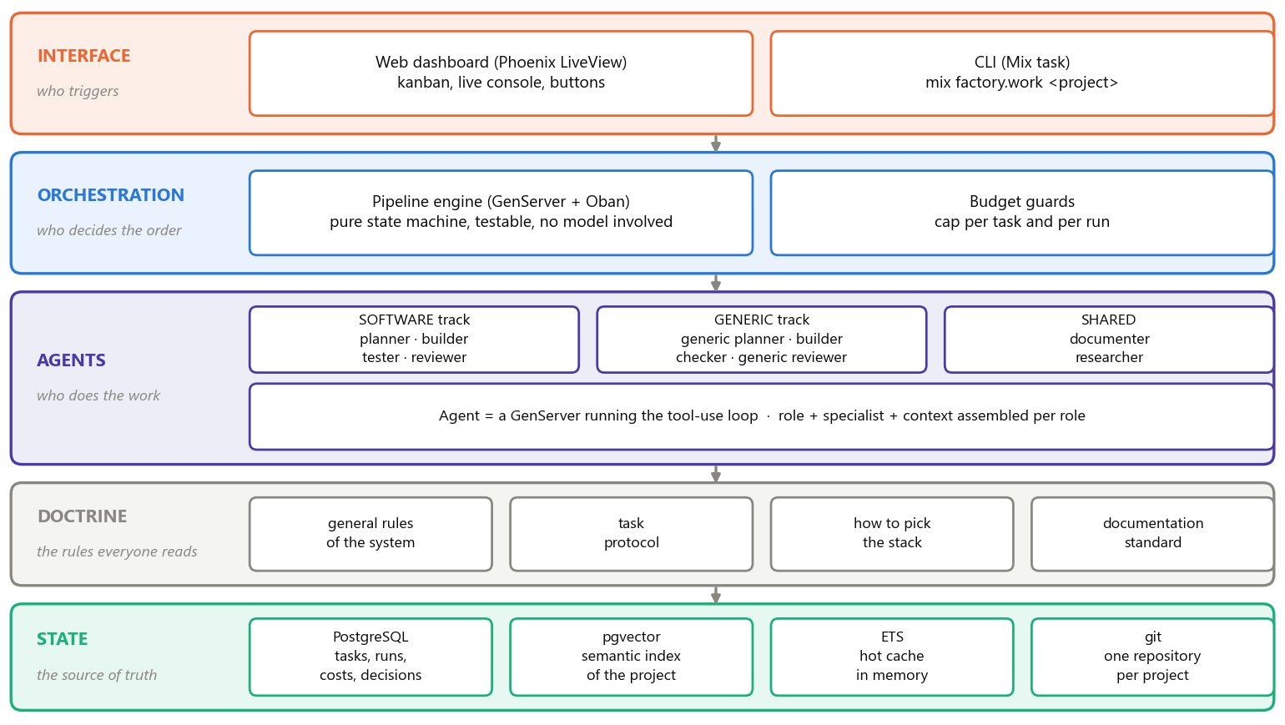
Figure 9 — The five layers and the technology behind each. The state layer at the bottom is the single source of truth: everything above it can be restarted from scratch with nothing lost.
Tool | What it is | What it does in this application
Elixir / BEAM | a functional language and the virtual machine that runs it | runs everything; each in-flight agent is one of its processes
OTP | the supervised-process library that ships with the language | provides the supervisor, the process registry and each agent’s lifetime cap
Phoenix / LiveView | a web framework where the screen is updated by the server | the dashboard: task board and live console, with no JavaScript to write
PostgreSQL / Ecto | a relational database and the library that talks to it | stores tasks, cycles, costs and decisions; every transition is a transaction
Oban | a job queue that lives inside the database itself | queues what must be done and returns whatever was interrupted
Req | an HTTP client | talks to the model API, with full control over the request body
Nx / Bumblebee | numerical computing and ready-made models running on this machine | turns text into vectors, in batches, without calling a paid service
pgvector | a PostgreSQL extension that stores and compares vectors | the meaning-based search over the project history (Part VI)
ExUnit / Mox | the testing library and its mocking companion | the suite runs against a fake API client: no network and no cost

The four choices that need justification
For the others, the obvious alternative is the one that was chosen. For these four it is not — so it is worth stating why.
- Oban, and not an in-memory queue. A job held in memory disappears when the program restarts. Because the queue lives in the same database as the tasks, enqueuing a job and changing the task state happen in the same transaction: either both hold, or neither does. That is what prevents the classic state “the task says in progress, but nobody is running it”.
- Req, and not a ready-made agent library. High-level libraries for talking to models do exist, including in Elixir. The core does not use them because it needs to decide, request by request, exactly which spans of text the provider may reuse — the subject of Part V. Convenience layers tend to hide precisely that control, and without it the design’s biggest saving is out of reach.
- Bumblebee locally, and not an embedding service. Turning text into vectors happens on every commit, over the project’s entire history. Running on this machine it is CPU work — which is abundant. Bought per call it would be a recurring cost, and it would send the project’s content outside.
- A fake API client in the tests. If the suite calls the real model, every run costs money and depends on the network. Such a suite stops being run within weeks — and a system whose suite is not run cannot be changed safely. That is why the double is delivered in the first phase of the project, not later.

13. The architecture at run time
With the vocabulary and the tools in place, the architecture fits in one sentence: every in-flight task is a supervised process, and its state does not live inside that process — it lives in the database. The process may die at any instant with nothing lost.
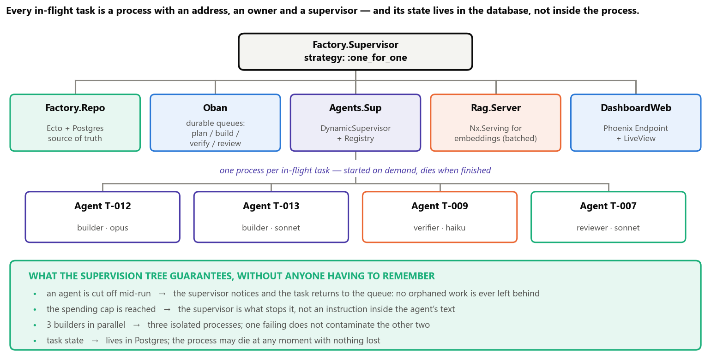
Figure 10 — The application’s supervision tree. Each box in the bottom row is a task being worked on right now; the green band lists what the structure guarantees without relying on anyone’s discipline.
The loop from figure 3 — the tool-use loop — is what runs inside each of those boxes in the bottom row. Written as an Elixir process, it looks like this:
def handle_info(:work, state) do
case Factory.Claude.messages(state.body) do
{:ok, %{stop_reason: "tool_use"} = r} ->
# tools requested in the same turn are independent: they run in parallel,
# each in its own process, with its own deadline
results =
r.content
|> Enum.filter(&(&1.type == "tool_use"))
|> Task.async_stream(&Tools.run(&1, state.sandbox),
max_concurrency: 4, timeout: :timer.minutes(2), on_timeout: :kill_task)
|> Enum.map(&result_or_error/1)

state
|> append_turn(r.content, results) # ALL results in a single turn
|> account_for(r.usage) # cost and tokens recorded per turn
|> continue_or_stop() # turn cap and spending cap

{:ok, %{stop_reason: "end_turn"} = r} ->
{:stop, :normal, finish(state, r)}
end
end
The core of the system. Notice what is NOT here: the turn cap, the spending cap, the deadline and the restart are not asked of the model — they are the supervisor’s and the process state’s responsibility. The agent has no way to ignore them.

14. What the system records
State has to survive everything: an agent crashing, a session ending, the machine restarting. And it has to answer questions nobody wants to answer by rereading a conversation.
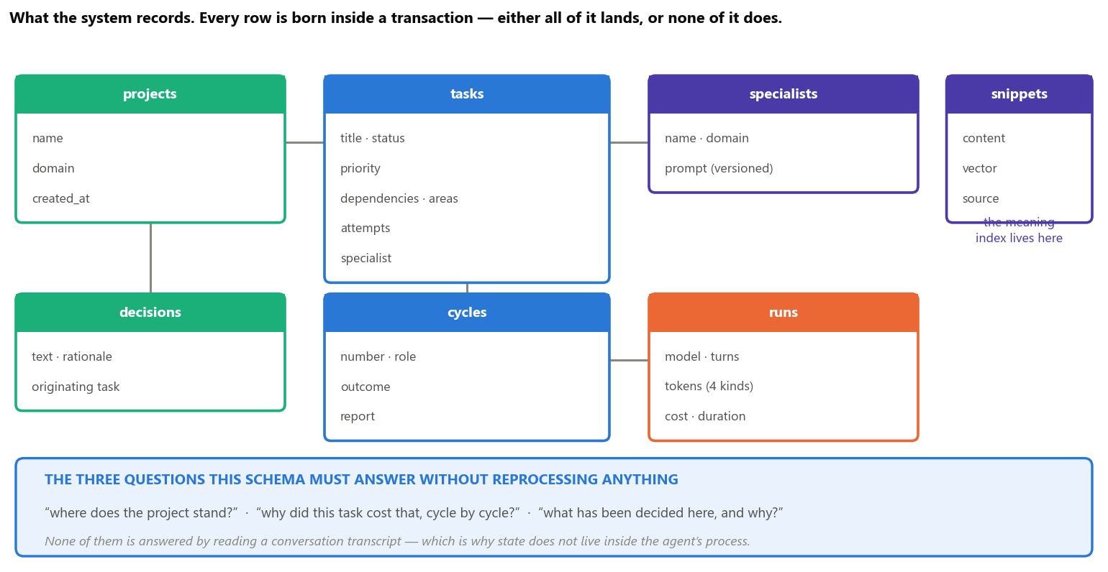
Figure 11 — The main tables. Every row is born inside a transaction: either all of it lands, or none of it does.
Two modelling choices deserve highlighting, because they are not obvious:
- Cycles are new rows, not overwrites. When a task is reworked, the previous cycle stays in the database. That makes it possible to ask afterwards how much each cycle cost separately — and that is how one discovers, in practice, that the cost of a hard task is concentrated in the rework, not in the first attempt.
- Cost is recorded per run, not per task. Every turn of the loop records the model, input tokens, stored tokens, reused tokens, output tokens, cost and duration. A per-task total is a sum; the other way round — deriving the detail from the total — would be impossible.

15. Concurrency: three tasks at once
With isolated processes and state in the database, running several tasks in parallel stops being risky. The limit is not technical but about the safety of the work: two tasks in the same project only run together if the areas they declare do not overlap.
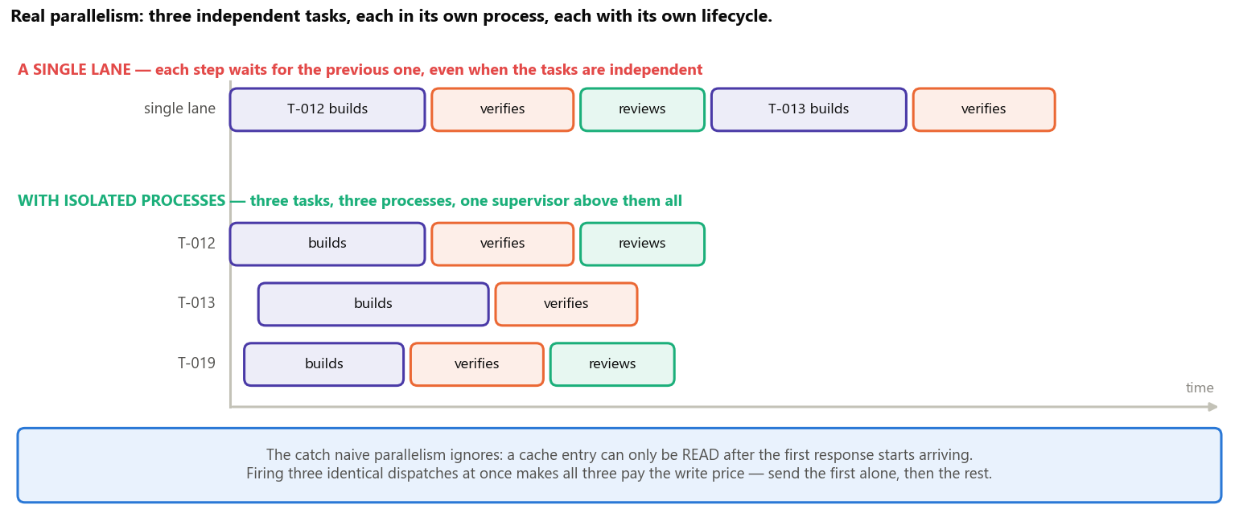
Figure 12 — Three independent tasks running at the same time, each in its own process and at its own pace. The blue band records a catch that naive parallelism ignores — explained in the next part.
A PARALLELISM RULE THAT LOOKS LIKE A DETAIL AND IS NOT The verifier needs a quiet project: the full test suite is never run while another agent is editing the same file tree. The reason is economic, not aesthetic — a false rejection caused by interference burns one of the three cycles, and makes the system answer failure with a more expensive model to fix a problem that never existed.

PART V The economics of the system
Where the money is actually spent, why intuition gets this wrong, and the five levers the design uses.

16. How the money is spent
Three linked facts explain the cost — and the third is what provides the lever.
- The API has no memory. Every request is independent. If the agent has already exchanged ten messages, the eleventh has to resend all ten — otherwise the model has no idea what this is about.
- So the opening text is re-charged on every turn. The permanent instructions and the project index always travel with it. In a fifteen-turn dispatch the same text is paid for fifteen times, without a single comma having changed.
- The provider lets you store that beginning. If the next request starts with exactly the same characters, it reuses what it already processed and charges roughly a tenth for that span.
For the third fact to be usable, the request has to be assembled in a specific order: from the content that never changes towards the content that always changes.
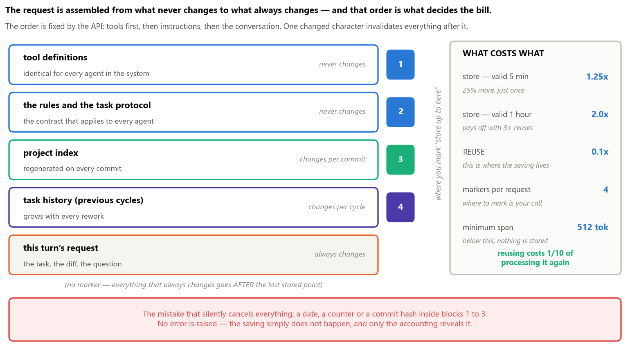
Figure 13 — The first four blocks can be stored and reused; the last one cannot, because it changes on every turn. One altered character in a block invalidates every block that follows it.
THE ARITHMETIC, IN ROUND NUMBERS Suppose a fixed opening of 20 thousand tokens (the instructions plus the project index) and a fifteen-turn dispatch. Without reuse that is 15 × 20 thousand = 300 thousand tokens charged at full price. With reuse: 20 thousand paid once with a 25% surcharge, plus fourteen turns at a tenth of the price — the equivalent of about 53 thousand. Roughly one sixth of the bill, for the same work and with no loss of quality.

17. The five levers
Cost lever | What it is | Effect
The request always starts identically | instructions, tools and project index identical across dispatches | the repeated span drops to a tenth of the price
Each role gets only what it uses | the builder gets the task’s files; the reviewer gets only the changes | unused context is worse than missing: it is reread every turn
Command checks before the model | criteria that are executable commands run for free, before the dispatch | what fails goes back without paying an agent to confirm the obvious
Model matched to the role | verifying is mechanical and uses the cheap model; rework escalates | the gap between tiers is fivefold on the input price
Batch work | reindexing and documentation do not need an immediate answer | the provider’s asynchronous path charges half for the same work

THE TRAP THAT SILENTLY CANCELS ALL OF THIS Reuse requires the beginning of the request to be identical character by character from one time to the next. A date, a counter or a commit hash inside it invalidates everything that follows — with no error and no warning, only with the saving that never materialises. That is why the system ships a test that assembles that beginning twice, at different moments, and fails if the two results diverge.

18. The context each role receives
The second lever deserves its own section, because it is the one that most contradicts intuition. The natural impulse is to give each agent as much information as possible — after all, extra information does not hurt. Here it does, and the reason is the loop.
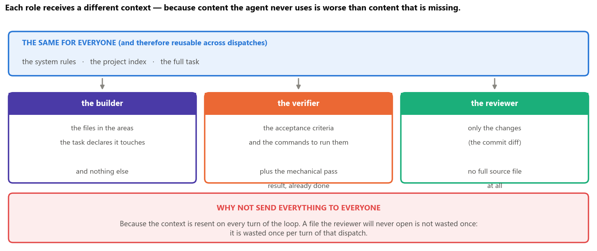
Figure 14 — The same beginning for everyone, and after that only what each role actually uses.
A file the reviewer will never open is not wasted once: it is wasted once for every turn of that dispatch. Since the reviewer judges what changed, it receives the changes and not the whole codebase; since the verifier has to run commands, it receives the criteria and the result of the mechanical pass already prepared. The information that is surplus in one role is precisely what is missing in another.

PART VI The project’s memory
How an agent that starts knowing nothing finds out what already exists — and what was decided, months ago.

19. The problem of starting blank
Every agent starts with no memory of what happened before. That is a property of the tool, not a limitation to be worked around: each dispatch opens a fresh run.
Letting it discover the project by opening file after file would be the worst possible path, because every read is a turn of the loop — and turns are exactly what costs. So the system hands the knowledge over ready-made, in layers.
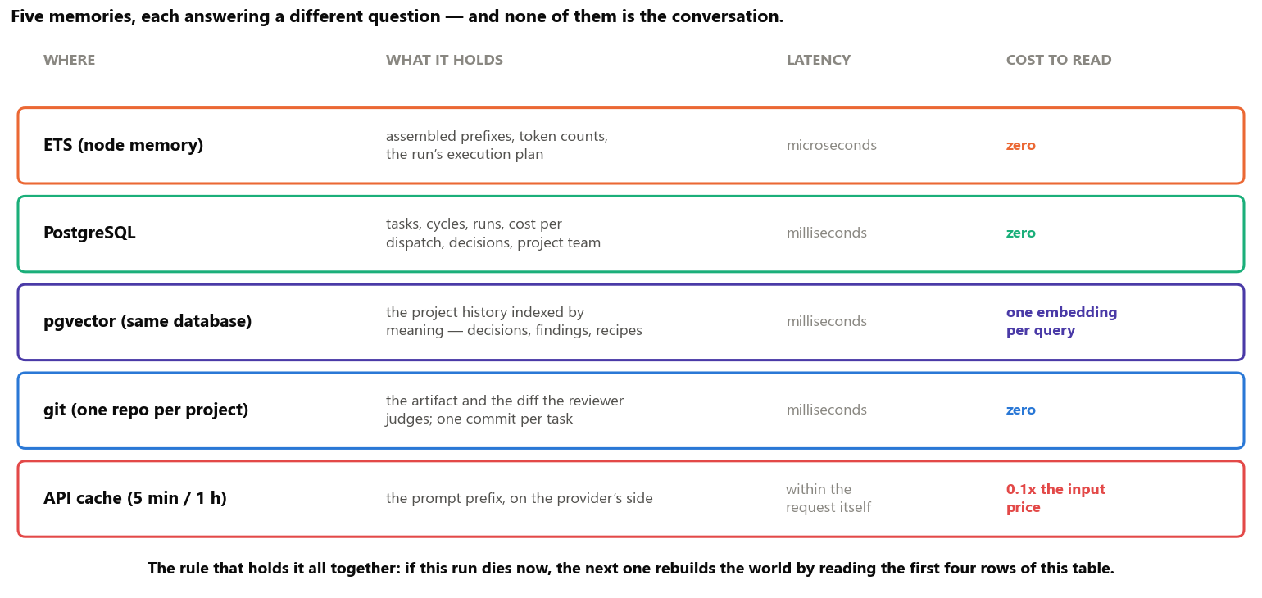
Figure 15 — The system’s five memories, what each one holds and what it costs to read. None of them is the conversation.

20. The two indexes
The first two rows of that table deserve detail, because they answer different questions — and confusing them is the most common mistake when people talk about memory for agents.
- “What exists and what is it called?” Answered by a script-generated index: the file tree with the signature of every function and one line saying what it is for. No model involved, zero cost, always up to date. It is the project’s table of contents, and it goes into the prompt in full.
- “Has this been solved here before, and what was decided then?” That one is not answered by function name — it is answered by meaning. And that is what the vectors are for.
WHAT A VECTOR IS, IN ONE SENTENCE A list of numbers representing the meaning of a text, such that texts with close meanings get close numbers. That is what allows searching by sense instead of by word: searching for “how do we handle a declined payment” finds a decision written as “when the card network refuses the transaction”, without a single word in common. The indexed material is not the code — the generated index already covers that — but the project’s history: decisions with their recorded rationale, review findings and finished tasks.

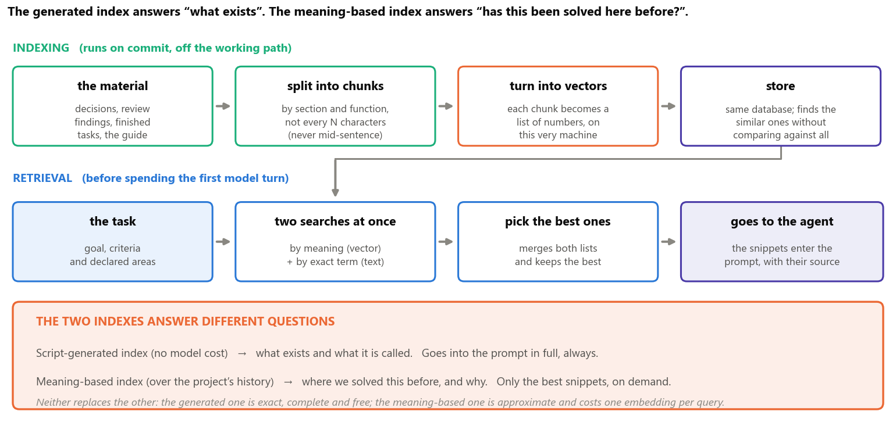
Figure 16 — Indexing runs on commit, off the working path; retrieval runs at the start of the dispatch, before spending the first model turn.
Why two searches at once, and not just the meaning-based one? Because the vector loses proper nouns: if the question mentions a flag called --require, it has no way of knowing what that is — the exact-term search finds it. And the exact-term search loses synonyms, which the vector finds. Each covers the other’s blind spot; the next step merges both lists and keeps the best snippets, which enter the prompt with their source cited.
The concrete gain is that the agent starts the work already knowing “this was decided this way, for this reason” — instead of deciding again, possibly the opposite of what is already in the code. It is the direct answer to the second failure mode of Part I: decisions without a trace.
WHEN NOT TO USE IT Meaning-based search is approximate and returns snippets, not truths. It does not replace the generated index, which is exact, complete and free, nor does it answer what an ordinary query answers better: “which tasks are blocked” is a database query, not a natural-language question. It comes in when the question is about precedent and the exact vocabulary is unknown. Outside that, it is cost wearing the face of sophistication.

PART VII Beyond software, and operating it
The same system building artefacts that are not code — and how an operator watches all of this happen.

21. The two tracks
The factory builds any artefact: a presentation, a manual, an analysis of numbers. The axis separating the two cases is not “is it code?”, but
how you prove it is finished. In software the proof comes for free: the program runs, and it either passes or breaks. Outside software it does not — and that is where the design could degenerate. A verifier with nothing to execute becomes a second reviewer, and two subjective judgements of the same artefact are not two gates: they are double the cost.
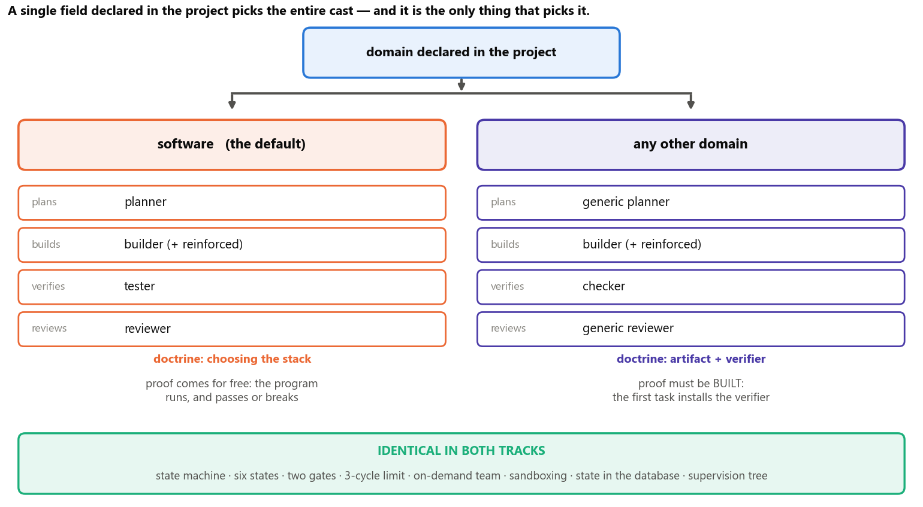
Figure 17 — A single field declared in the project picks the entire cast. Everything in the green band is identical across both tracks.

22. The proof ladder
The non-software track solves the gate problem with three pieces. The first is the ladder below: every acceptance criterion sits on one of three rungs, and whoever verifies is required to declare which rung it landed on.
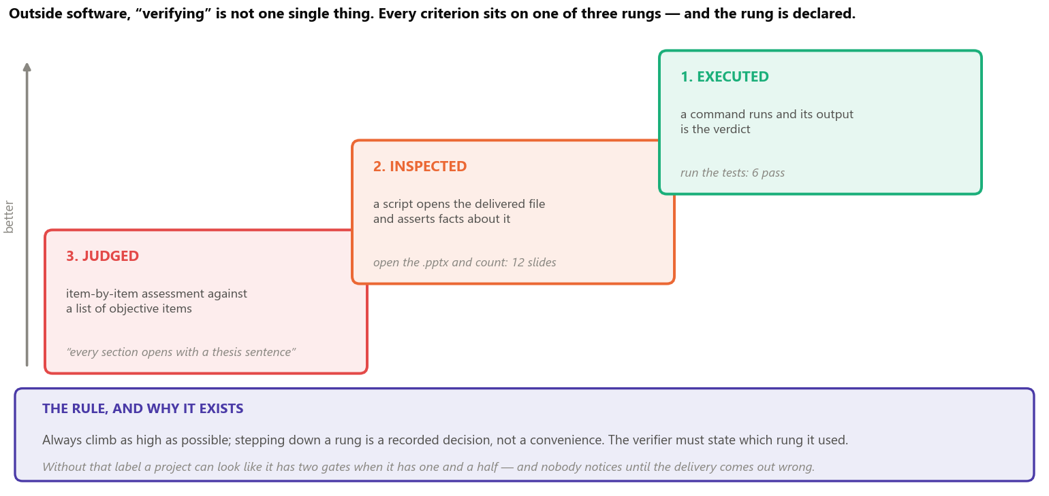
Figure 18 — The three rungs. Climbing is always preferable; stepping down is a recorded decision, not a convenience.
The other two pieces complete the design:
- The first task installs the verifier. Before producing any part of the artefact, the project delivers a program that knows how to open the generated file and assert facts about it. Without that, every criterion collapses onto the third rung and the middle gate stops being worth what it costs.
- The artefact is generated; the source is versioned. A binary file — presentation, spreadsheet, image — is never the source of truth. The source is versioned text, and the binary comes out of a command. Committing the binary as the source would erase the review gate, because nobody can review the changes inside a binary file.
THE LABEL IS WHAT STOPS THE FACTORY FROM LYING TO ITSELF When many of a project’s criteria fall on the judgement rung, the system is running with one and a half gates, not two. The mandatory label makes that visible — and visible early, on the dashboard, instead of discovered late, in a wrong delivery. But it fixes nothing on its own: an excess of judgement is a sign that planning has to be redone, not that the agent was careless.

23. The dashboard
The dashboard is not decoration: it is the instrument that makes cost visible while it is happening, rather than afterwards. It runs on the same database and the same event bus the engine uses — it is not a separate application reading log files.
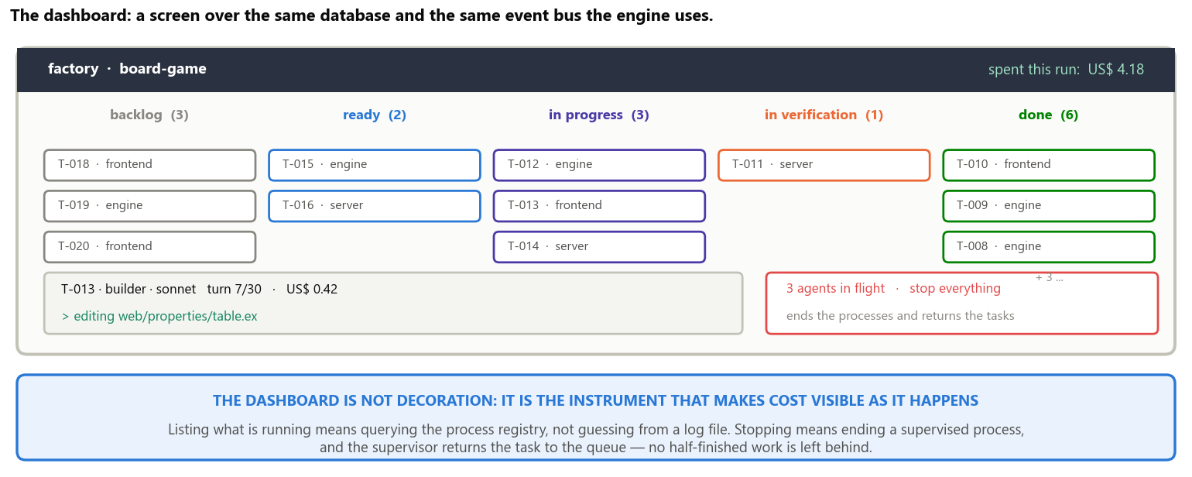
Figure 19 — The dashboard in operation: a task board by state, the agent’s live console, and the spend for the round.
- Every dispatch emits events. Start, end, model, turns, stored and reused tokens, cost and outcome. The dashboard subscribes to the bus and draws; the accounting does not depend on anyone remembering to write it down.
- The screen shows what is still in flight. Because each agent is a process with an address, listing what is running is a query against the process registry — not an inference from a log file.
- Stopping costs one button. Cutting an agent off is terminating a supervised process, and the supervisor returns the task to the queue. No half-finished work is left behind, and no file is left edited without an owner.
- Cost appears per task, not only per run. A cap calibrated on the cost of a single step underestimates the whole task — and underestimating always pushes the system into starting work that does not fit the budget.

24. A project end to end
It is worth putting everything together in a single pass. The figure below is a real project from beginning to end: the request, the planning, the first tasks, the parallelism, one rejection and the rework.
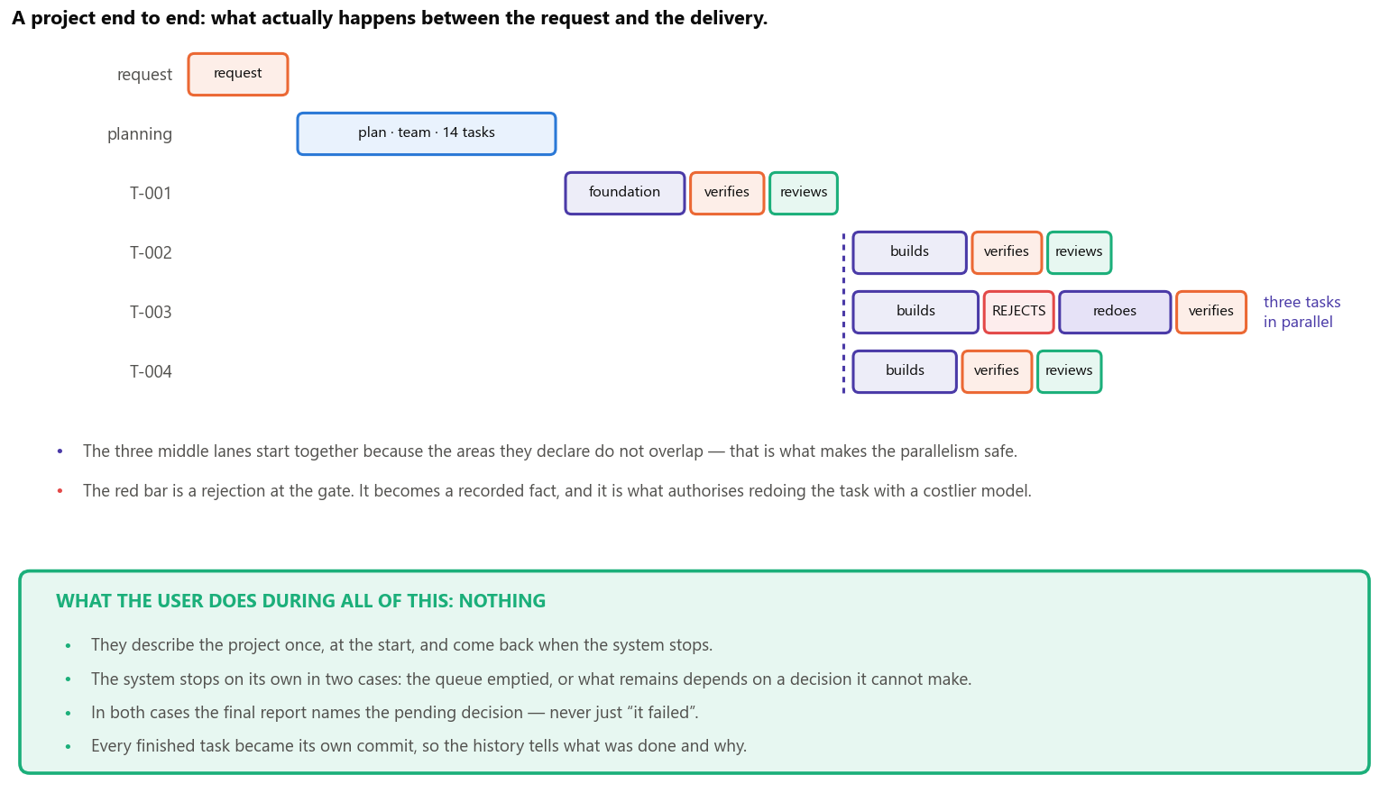
Figure 20 — A project end to end. The green band answers the question that always comes up: what the user does during all that time.

PART VIII The execution plan
In what order to build, what is deliberately left out, what could go wrong, and what all of this sets out to demonstrate.

25. The six phases
The order is not arbitrary: each phase delivers something verifiable and unlocks the next. And the milestone that closes each one is always an observable behaviour — never a completion percentage.
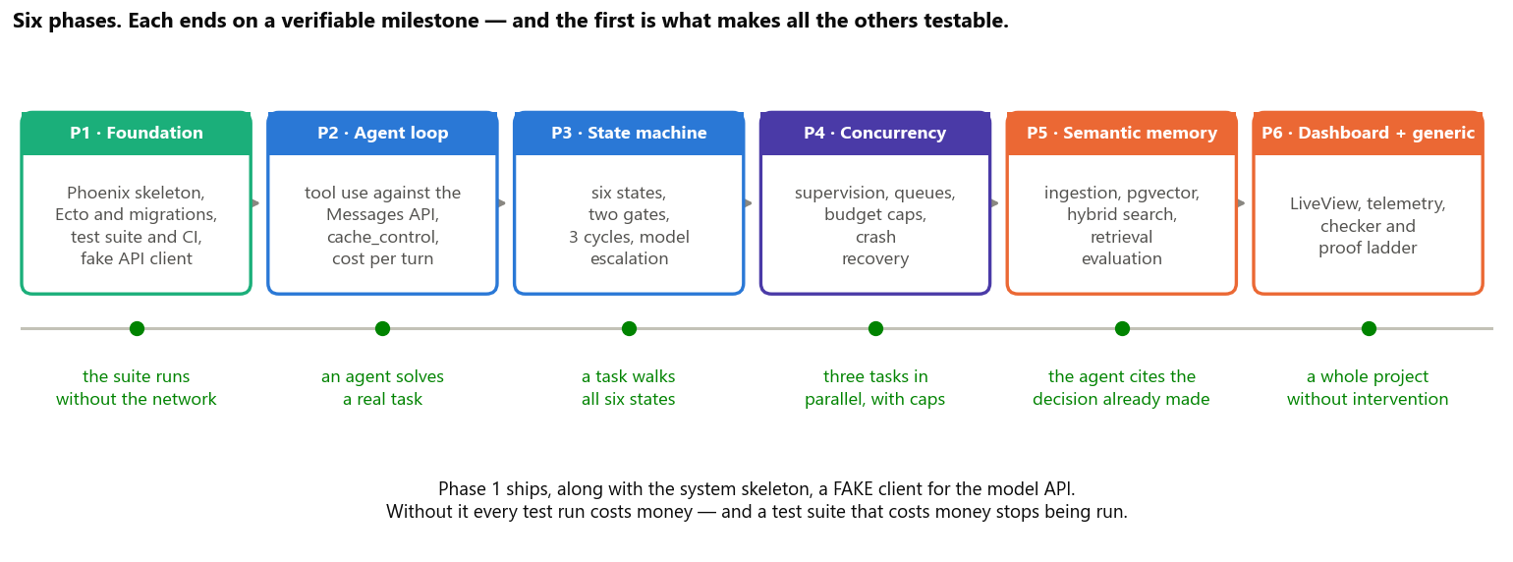
Figure 21 — The six phases and the milestones that close them.
Phase | What it delivers | Milestone — only passes when
P1 Foundation | project skeleton, database schema, test suite, continuous checks and the fake API client | the whole suite runs without touching the network and without spending a cent
P2 Agent loop | the tool-use loop, sandboxed tool execution, prompt assembly and per-turn accounting | an agent solves a real task, and its cost shows up broken down by turn
P3 State machine | the six states, the two gates, the cycle limit, the failure ladder | a task walks the six states, is rejected on purpose, is reworked and completes
P4 Concurrency | supervision tree, durable queues, spending cap, recovery after a crash | three tasks run in parallel; killing one midway does not affect the others, and it returns to the queue
P5 Semantic memory | indexing on commit, hybrid search and the context block with its source cited | in a project with history, the agent cites the earlier decision instead of deciding again
P6 Dashboard and generic track | live screen, telemetry, the non-software track and the proof ladder with its mandatory label | an entire project is planned, built and delivered without intervention

The first phase is the one you feel tempted to skip, and it is the most important. Without the fake API client, every run of the test suite costs money and depends on the network. A suite like that stops being run within weeks — and a system whose suite is not run cannot be changed safely. All the confidence of the next five phases depends on the first one having been done properly.

26. Scope
Delimiting what is left out is part of the project, and it is what keeps a final-year work from turning into a list of intentions.
In scope | Out of scope, and why
Planning, building, verifying, reviewing and documenting projects, with durable state and accounted cost | publishing what was generated to production: it involves external cost and third-party credentials; it stays a manual action
Execution on a single computer, with real concurrency and supervision | distributing across several computers: possible on the platform, but nothing in the problem demands it — the bottleneck is waiting on the model
A semantic index over the project history, with an evaluation of search quality | training or fine-tuning models: the system is model-independent by design, and that would destroy the property
Accounting per dispatch, task, project and day, with caps that prevent starting what does not fit | cutting an in-flight agent off for exceeding cost: interrupting midway pays the same and delivers nothing
A local dashboard to follow and trigger the work live | multiple users, authentication and permissions: it is an operating tool for one operator

27. Known risks and limits
Risk or limit | Why it exists | How the design answers
The reuse saving failing to materialise | it depends on the beginning of the request being identical character by character, and a single volatile character cancels it with no visible error | a test that assembles that beginning twice and compares; the accounting separates what was stored from what was reused, so an absent saving shows up on day one
Meaning-based search returning a useless snippet | approximate search returns snippets, and a snippet out of context makes the answer worse rather than better | a set of questions with known answers, measured on every change to the indexing; if it does not match the baseline, retrieval does not enter the prompt
A single file tree per project | parallel agents in the same project see each other’s uncommitted edits | the declared areas act as mutual exclusion, checked by the system before dispatching — not entrusted to the text of the dispatch
The middle gate being fragile outside software | with no program to execute, verifying tends to turn into opinion | a mandatory proof-degree label, with the proportion visible on the dashboard; an excess of judgement is treated as a signal to replan
Elixir’s AI ecosystem being smaller | fewer ready-made libraries and fewer published examples than in Python | the core depends on HTTP and JSON, not on an AI library; the only point that needs the ecosystem is the embedding, which has a mature path and a service-based alternative

28. What this work sets out to demonstrate
That the difference between a programming assistant and a production line lies entirely in the governance layer: roles with explicit authority, externalised and transactional state, gates operated by whoever did not build the thing, failure bounded by design, and deterministic routing. None of these mechanisms depends on a specific model or on any single vendor’s exclusive feature — they are all software-architecture decisions applied to a new kind of worker.
And, above all, that those decisions have to live somewhere other than a request written in plain prose inside a prompt. A rule the system asks for is an optional rule; a rule the structure guarantees is a property. Every chapter of this document is a version of that same trade: the separation between building and approving becomes an absent tool; the spending limit becomes a supervisor; the order of tasks becomes a database column; the project’s memory becomes a searchable index.
WHAT REMAINS IF EVERYTHING ELSE CHANGES Models will get better, get cheaper and change names. The part of this work that does not depend on that is the structure: small tasks with explicit state, two independent judgements made by whoever did not build the thing, bounded failure with one attempt at resizing before giving up, and everything recorded the instant it happens. If tomorrow’s model is ten times better, that structure remains what turns capability into reliable delivery.

