Multi-Agent Software Factory
Architecture of a system that builds software using language agents

Undergraduate Final Project · Enzo Consulo · August 2026
WHAT THIS DOCUMENT PRESENTS The architecture of a system that takes the description of a project in natural language and builds it end to end, coordinating specialised agents that plan, implement, verify, review and document — with human intervention only in the initial request. The text starts from the minimum vocabulary, explains why the chosen language is Elixir, details the tools involved and ends with the execution plan. A prototype of this architecture has already been built and has run real projects; what is described here is the system itself, and every section can be read with no prior knowledge of it.

1. The problem
A language model writes code well when the request is short and everything it needs to know fits in one conversation. Asking it to “build this system” is a different matter: the work runs for hours, spans dozens of files and depends on decisions made at the start that must still hold at the end. That is the regime in which it fails — and the failures are not failures of writing, they are failures of process.
- Context loss. The conversation grows, the beginning drifts out of view, and the model starts contradicting what it decided itself.
- Decisions without a trace. The reason behind a choice stayed in the middle of the dialogue; when the session ends, it vanishes with it.
- Self-approval. Whoever wrote the code is the one declaring it finished — and rarely rejects their own work.
- Unbounded retrying. One hard point consumes attempt after attempt and blocks everything queued behind it.
The proposal of this work is to treat software construction as a production line: split the request into small, named tasks, give each an explicit state, and put every delivery through reviewers that did not build it. The model remains the worker; the system decides what it does, when, and with what authority.
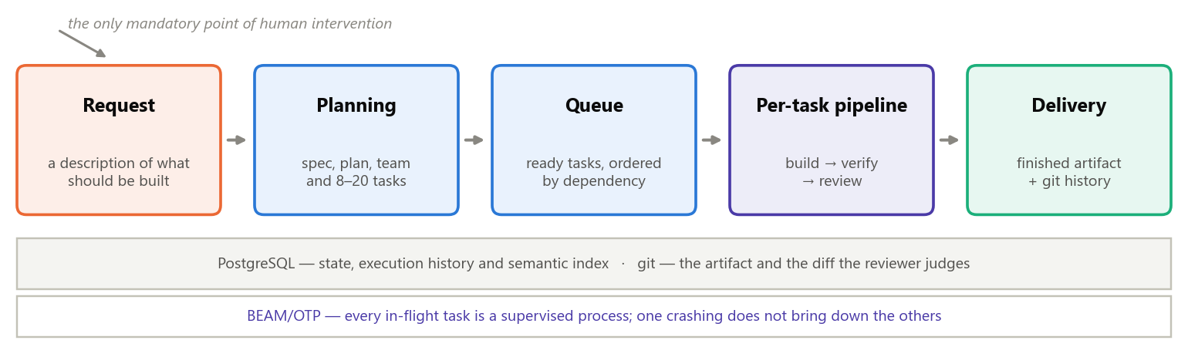
Figure 1 — From request to delivery. The only mandatory human intervention is the first box; from there on the system decides on its own.
1 Request  The user describes what they want, once, in natural language. | 2 Planning  An agent produces the specification, a phased plan and 8 to 20 tasks with dependencies. | 3 Building  Each task is implemented by an agent specialised in that area. | 4 Two gates  One verifies that it works; the other reviews whether it is what was asked. Neither may fix anything. | 5 Delivery  A finished task becomes its own commit, and the system moves to the next.

2. The minimum vocabulary
Nine terms carry the rest of this document: the first three say who works, the next three explain how the work is billed, and the last three only reappear in sections 8 and 9 — but they are defined here so that those pages depend on no new word.
Term | What it means here
Language model | the worker: it takes text and returns text or requests for action; it remembers nothing between one run and the next
Tool | an action the model can ask to have performed: read a file, run a test, write code
Agent | a role — the text defining what it does, the tools it may use and the model that runs it
Tool-use loop | the cycle question → tool request → result, repeated until the model says it is done
Context | everything that goes into one request to the model; it is resent in full on every turn of the loop
Token | the unit the model is billed in, both for what goes in and for what comes out
Prefix | the beginning of the request — the part that repeats identically from one turn to the next
Reuse | a provider feature: storing the already-processed prefix and charging a tenth to reuse it (section 8)
Vector (embedding) | a list of numbers representing the meaning of a text: similar texts get similar numbers (section 9)

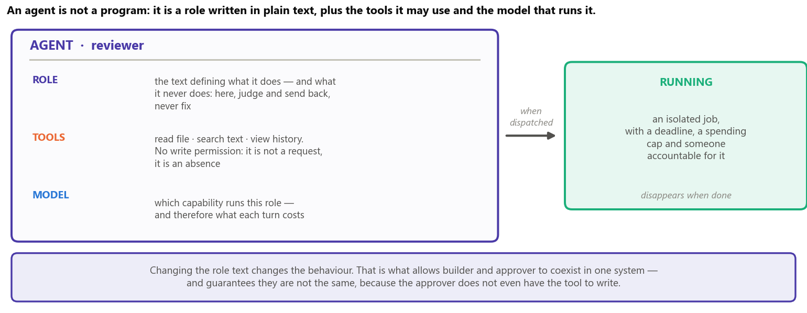
Figure 2 — The anatomy of an agent. Changing the role text changes the behaviour; removing a tool removes the capability.
The roles above are generic — the planner, the builder, the verifier, the reviewer — and serve any project. There is a second kind of agent, and it is probably the system’s most distinctive part: while planning, the system synthesises two to five specialists from the request itself — one for the database, one for the interface, one for the business rules —, each with its own domain, its own files and the decisions it may not reinvent. Every task is born pointing at the specialist for the area it touches, so execution is guided from the start rather than improvised the moment work begins.

3. How an agent works
A running agent is a loop. It assembles the request, calls the model API and looks at why it stopped: if the model asked for tools, the system runs them and returns the results; if it finished, the loop ends. Every turn is a paid request — and since the context is resent in full, a late turn costs more than an early one.
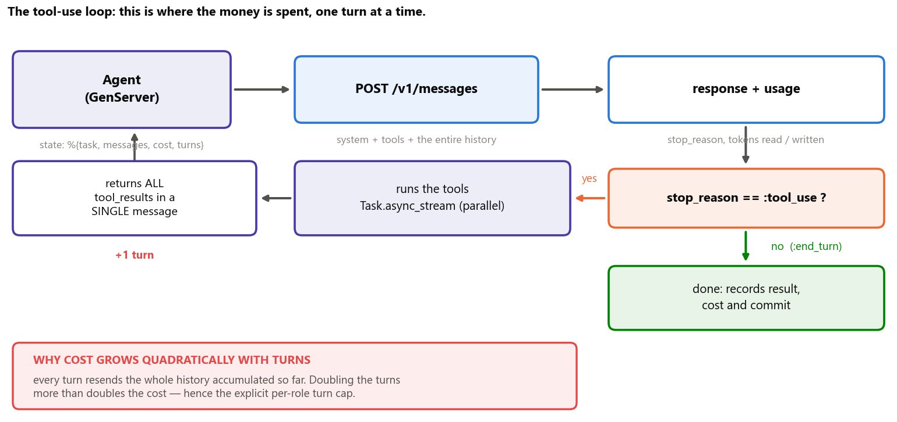
Figure 3 — The tool-use loop. Results always come back in a single message, and the tools requested in the same turn are executed in parallel.
From that comes a property that drives the entire design: cost is not proportional to the amount of code, but to the number of round trips to the model. An agent that solves the task in eight turns costs far less than one that takes twenty — even if it writes exactly the same file at the end. That is why the system invests in giving the agent a good starting point instead of letting it discover the project on its own.

4. Why Elixir
The bottleneck of this system is not computation: it is waiting. Each agent spends most of its time awaiting the response of a remote service that may take minutes, fail midway, or need to be cut off for exceeding a spending cap. The language therefore has to keep dozens of such jobs in flight at once, isolate the failure of each, and allow any of them to be terminated safely.
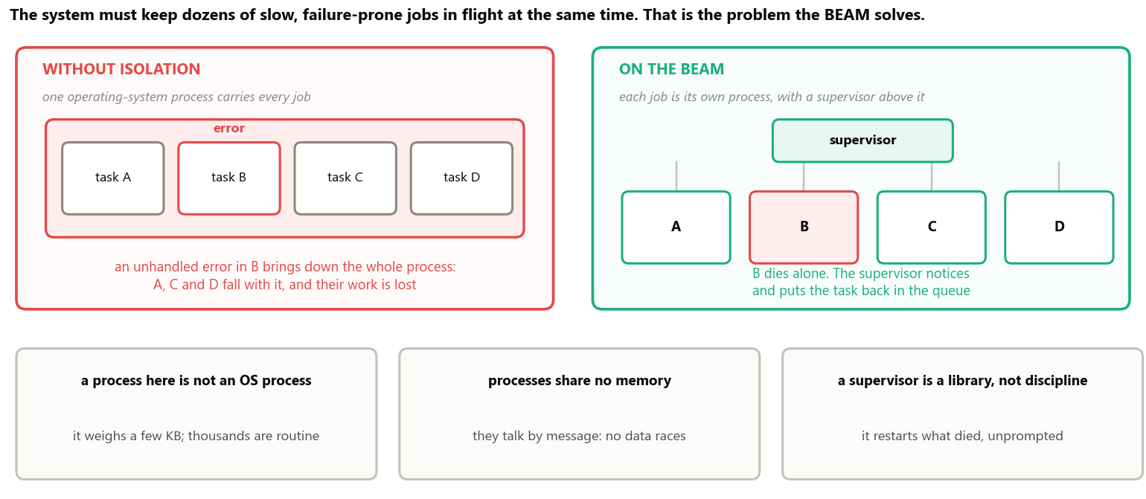
Figure 4 — The BEAM is the virtual machine Elixir runs on. Isolation between processes is the property this system exploits, not an implementation detail.
What the system demands | What the BEAM delivers
dozens of slow jobs at the same time | lightweight processes: keeping thousands of them is routine
one job failing must not bring down the others | memory isolation: each process falls on its own
someone has to notice the failure and react | a supervisor: restarts or returns the task to the queue, unprompted
cutting a job off midway, safely | ending a process is a normal operation, not an emergency measure
watching all of it live on a screen | the dashboard runs on the same runtime, with no second application

WHAT THE CHOICE DOES NOT SOLVE Elixir does not make the model cheaper: the price per token belongs to the provider, and no supervision tree changes that. And the language’s AI ecosystem is smaller than Python’s — which weighs little here, because the heavy part of the system is waiting on the network, and the only genuinely numerical step (turning text into vectors) has a mature library, described in section 5.

5. The tools, and what each one does
The system is organised in five layers, and each one knows only the layer immediately below: whoever triggers does not know which agent will run; whoever decides the order does not write code; whoever writes code does not decide what comes next.
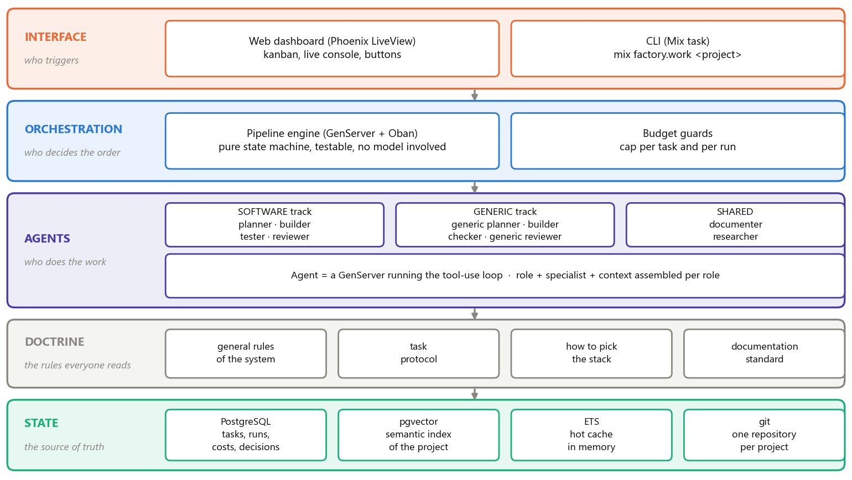
Figure 5 — The five layers and the technology behind each. The state layer at the bottom is the single source of truth: everything above it can be restarted with nothing lost.
Tool | What it is | What it does in this application
Elixir / BEAM | a functional language and the virtual machine that runs it | runs everything; each in-flight agent is one of its processes
OTP | the supervised-process library that ships with the language | provides the supervisor, the process registry and each agent’s lifetime cap
Phoenix / LiveView | a web framework where the screen is updated by the server | the dashboard: task board and live console, with no JavaScript to write
PostgreSQL / Ecto | a relational database and the library that talks to it | stores tasks, cycles, costs and decisions; every transition is a transaction
Oban | a job queue that lives inside the database itself | queues what must be done and returns whatever was interrupted
Req | an HTTP client | talks to the model API, with full control over the request body
Nx / Bumblebee | numerical computing and ready-made models running on this machine | turns text into vectors, in batches, without calling a paid service
pgvector | a PostgreSQL extension that stores and compares vectors | the meaning-based search over the project history (section 9)
ExUnit / Mox | the testing library and its mocking companion | the suite runs against a fake API client: no network and no cost

Four of these choices deserve justification, because the obvious alternative would be a different one:
- Oban, and not an in-memory queue. A job held in memory disappears when the program restarts. Because the queue lives in the same database as the tasks, enqueuing a job and changing the task state happen in the same transaction — either both hold, or neither does.
- Req, and not a ready-made agent library. The system needs to decide, request by request, which spans of text the provider may reuse (section 8). Convenience layers tend to hide exactly that control.
- Bumblebee locally, and not an embedding service. Turning text into vectors happens on every commit, over the whole project. Running on this machine it is CPU work; bought per call it would be a recurring cost — and it would send the project’s content outside.
- A fake API client in the tests. If the suite calls the real model, every run costs money and depends on the network. Such a suite stops being run, and a system whose suite is not run cannot be changed safely.

6. The architecture at run time
With the vocabulary and the tools in place, the architecture fits in one sentence: every in-flight task is a supervised process, and its state does not live inside that process — it lives in the database. The process may die at any instant with nothing lost.
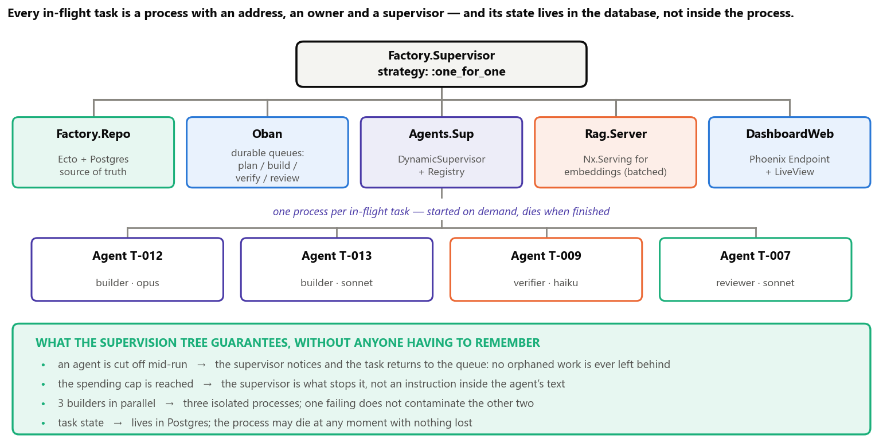
Figure 6 — The application’s supervision tree. Each box in the bottom row is a task being worked on right now; the green band lists what the structure guarantees without relying on anyone’s discipline.
def handle_info(:work, state) do
case Factory.Claude.messages(state.body) do
{:ok, %{stop_reason: "tool_use"} = r} ->
# tools requested in the same turn are independent: they run in parallel
results =
r.content
|> Enum.filter(&(&1.type == "tool_use"))
|> Task.async_stream(&Tools.run(&1, state.sandbox),
max_concurrency: 4, timeout: :timer.minutes(2), on_timeout: :kill_task)
|> Enum.map(&result_or_error/1)

state
|> append_turn(r.content, results) # ALL results in a single turn
|> account_for(r.usage) # cost and tokens recorded per turn
|> continue_or_stop() # turn cap and spending cap

{:ok, %{stop_reason: "end_turn"} = r} ->
{:stop, :normal, finish(state, r)}
end
end
The loop of figure 3, written as an Elixir process. What is not here — the turn cap, the spending cap, the deadline and the restart — is not asked of the model: it is the supervisor’s responsibility.

7. The life of a task
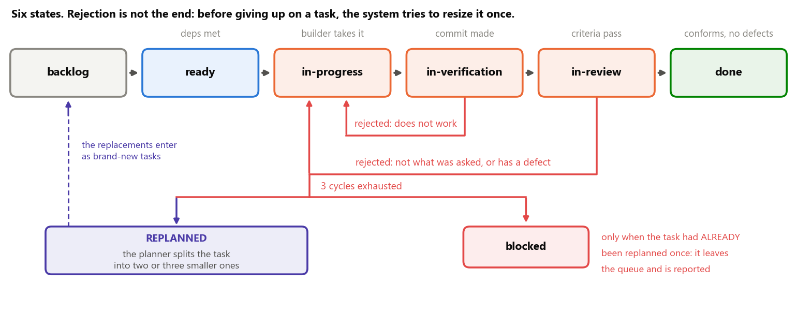
Figure 7 — The six states of a task. The two red arrows going back are the gates rejecting. Once the three cycles are exhausted there are two exits — and the first one is not giving up: the task is split into smaller ones and returns to the queue.
The verifier asks “does it work?” and literally runs every acceptance criterion, recording the evidence. That is why criteria are written as command plus expected result, never as an evaluative sentence.
The reviewer asks “is this what was asked, and is it correct?” — two distinct checks. And here is the subtle point of the design: a delivery can pass every criterion, carry no defect at all and still not be the task. A badly written criterion is no licence to deliver something else.
Rejection is not the end of the line. The system answers failure in steps, and each step is only used after the previous one has genuinely failed — the trigger is always a recorded fact, never a guess about difficulty:
- 1st rejection — escalate the model. The task returns to the builder, now run by a more capable model. Insisting on the same model after a rejection pays for the whole cycle again and burns one of the three attempts.
- 2nd rejection under the same specialist — swap the specialist. It was chosen during planning, before anyone knew where the task would fail; repeating is betting twice on the same guess.
- 3 cycles exhausted — replanning. The planner re-examines the task and splits it into two or three smaller ones, which enter the queue as brand-new tasks. The original is cancelled, with a reference to its replacements. It is the acknowledgement that the problem may not be one of execution, but of sizing.
- Exhausted again — now it blocks. A task that was already born from a replanning and fails once more is reported to the user. The system does not replan a replanning: if the problem survived two different readings, it needs a human decision.
Every transition is a transaction: the new state, the stage report and the cost enter together, or not at all. That is what makes it possible to ask afterwards how much each cycle cost separately.
The same structure builds presentations, documents and analyses. What separates the two cases is not “is it code?”, but how one proves it is finished: in software the proof comes for free — the program runs and passes or breaks. Outside it, the first task becomes installing a verifier, and each criterion is labelled with the level of proof that backed it: executed by a command, inspected by a script, or judged against objective items.

8. Cost, and how it is controlled
Three linked facts explain the system’s cost — and the third is what provides the lever.
- The API has no memory. Every request is independent. If the agent has already exchanged ten messages, the eleventh has to resend all ten — otherwise the model has no idea what this is about.
- So the opening text is re-charged on every turn. The system rules and the project index always travel with it. In a fifteen-turn dispatch, the same text is paid for fifteen times.
- The provider lets you store that beginning. If the next request starts with exactly the same characters, it reuses what it already processed and charges roughly a tenth for that span.
For that to work, the request is assembled from the content that never changes towards the content that always changes. That order is what the figure below shows.
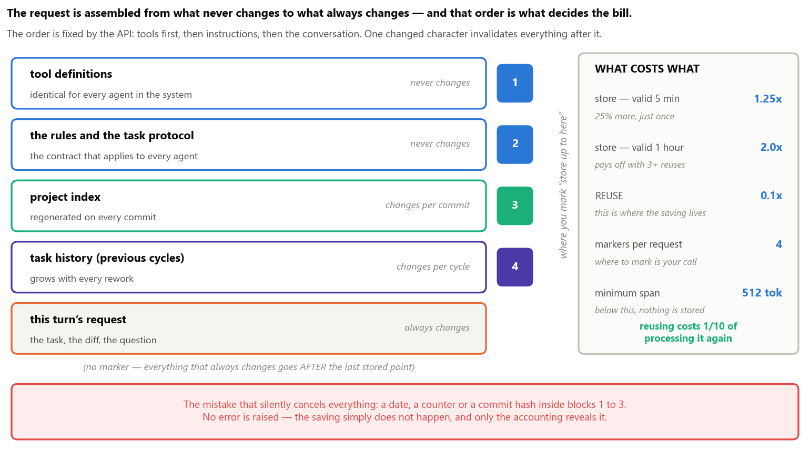
Figure 8 — The first four blocks can be stored and reused; the last one cannot, because it changes on every turn. One altered character in a block invalidates every block that follows it.
THE ARITHMETIC, IN ROUND NUMBERS Suppose a fixed opening of 20 thousand tokens (the rules plus the project index) and a fifteen-turn dispatch. Without reuse that is 15 × 20 thousand = 300 thousand tokens charged at full price. With reuse: 20 thousand paid once with a 25% surcharge, plus fourteen turns at a tenth of the price — the equivalent of about 53 thousand. Roughly one sixth of the bill, for the same work.

Cost lever | Effect
The request always starts identically | the repeated span drops to a tenth of the price
Each role gets only what it uses | the reviewer gets the changes, not the whole codebase
Command checks before the model | whatever fails goes back without spending an agent
Model matched to the role | verifying is mechanical and uses the cheapest model
Batch work | half price whenever the answer is not urgent

THE TRAP THAT SILENTLY CANCELS ALL OF THIS Reuse requires the beginning of the request to be identical character by character from one time to the next. A date, a counter or a commit hash inside it invalidates everything that follows — with no error and no warning, only with the saving that never materialises. That is why the system ships a test that assembles that beginning twice and fails if the two results diverge.

9. The project’s memory
An agent always starts knowing nothing about the project. Letting it open file after file until it understands would be the worst possible path, because every read is a turn — and turns are exactly what costs. So the system hands the knowledge over ready-made, in two layers, because there are two different questions.
- “What exists and what is it called?” Answered by a script-generated index: the file tree with the signature of every function and one line saying what it is for. No model involved, zero cost, always up to date. It is the project’s table of contents, and it goes into the prompt in full.
- “Has this been solved here before, and what was decided then?” That one is not answered by function name — it is answered by meaning. And that is what the vectors are for.
WHAT A VECTOR IS, IN ONE SENTENCE A list of numbers representing the meaning of a text, such that texts with close meanings get close numbers. That is what allows searching by sense instead of by word: searching for “how do we handle a declined payment” finds a decision written as “when the card network refuses the transaction”, without a single word in common. The indexed material is not the code — the generated index already covers that — but the project’s history: decisions with their recorded rationale, review findings and finished tasks.

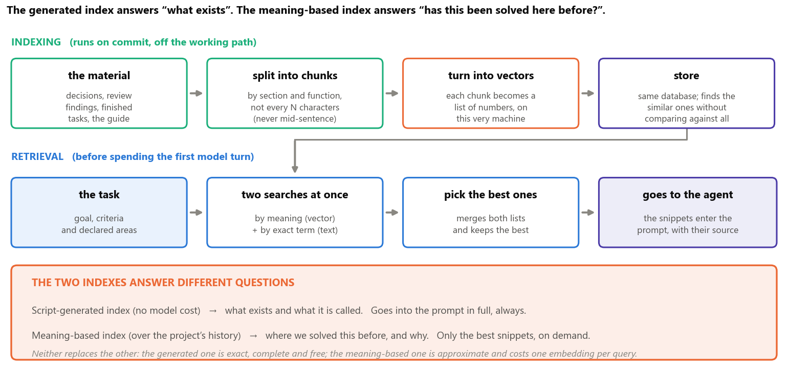
Figure 9 — Indexing runs on commit, off the working path; retrieval runs at the start of the dispatch, before spending the first model turn.
Why two searches at once, and not just the meaning-based one? Because the vector loses proper nouns: if the question mentions a flag called --require, it has no way of knowing what that is — the exact-term search finds it. And the exact-term search loses synonyms, which the vector finds. Each covers the other’s blind spot; the next step merges both lists and keeps the best snippets, which enter the prompt with their source cited.
WHEN NOT TO USE IT Meaning-based search is approximate and returns snippets, not truths. It does not replace the generated index, which is exact and free, nor does it answer what an ordinary query answers better: “which tasks are blocked” is a database query, not a natural-language question. It comes in when the question is about precedent and the exact vocabulary is unknown.

10. Execution plan, scope and limits
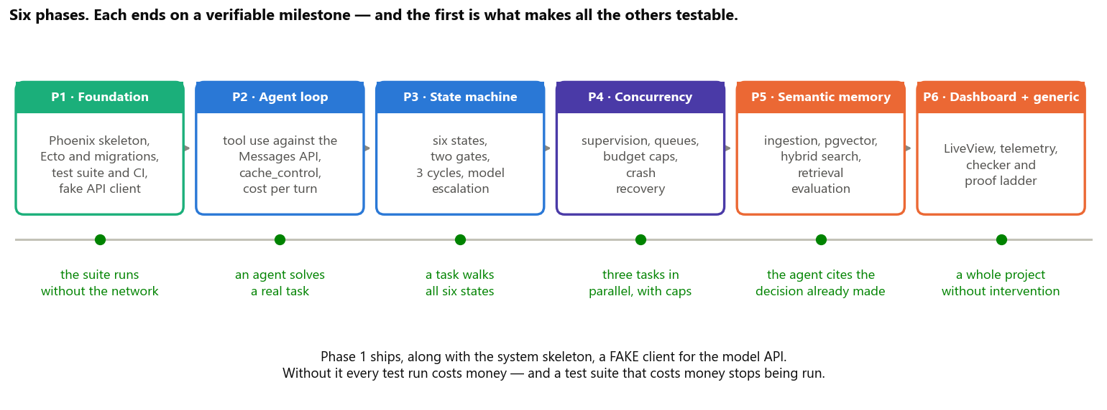
Figure 10 — The six phases and the milestones that close them. A milestone is always an observable behaviour, never a percentage of completion.
The order is not arbitrary: each phase delivers something verifiable and unlocks the next. The first is the one you feel like skipping, and it is the most important — it is what makes all the others testable.
In scope | Out of scope, and why
Planning, building, verifying, reviewing and documenting projects | deploying to production: external cost and third-party credentials
Running on a single machine, with concurrency and supervision | distributing across machines: the bottleneck is waiting on the model
Semantic index of the history, with retrieval evaluation | training models: it would destroy vendor independence
A local dashboard to follow and trigger the work | multiple users and authentication: this is a single operator’s tool

Known limits of the design
Limit | How the design answers it
The reuse gain may not materialise | a test that assembles the prefix twice and compares it byte by byte
Meaning-based search may return useless snippets | a set of questions with known answers, measured on every change
A single file tree per project | the areas each task declares become mutual exclusion checked by the system
The middle gate is fragile outside software | a mandatory proof level, with the proportion visible on the dashboard

What this work sets out to demonstrate: that the difference between a coding assistant and a production line lies entirely in the governance layer — roles with explicit authority, transactional state, gates operated by whoever did not build, and failure bounded by design. None of it depends on a specific model or a specific vendor.

