D

Experience

2021-2023

**Project 1**: BeadsWorld e-shop webpage

Learning React.js, HTML, CSS and JavaScript to design a website of Beads E-commerce store.

Including

Homepage: display the products and all related information.

Shop page: display the beads and products price, description and make

add to cart function correctly.

Cart page: show cart items, total price and checkout.

Signup Signin page: set up or login in account.

Contact page: display contact information and communication info.

DIYidea page: show DIY video embarced.

See link

**Project 2**: design my own portfolio page using react, HTML, CSS and JavaScript

See link

**Project 3**: make Fully Responsive Modern UI/UX Website in React JS according the

direction of YouTube channel

see link

**Project 4**: try to use Angular, DBmongo, Nodejs to create a food e-shop website

See link

Also create several onepage webpages to practice the HTML, CSS skills.

2018.9

*Georgia Institute of Technology, Atlanta, GA*

Major: Computer Science (OMSCS program)

Specialization: Machine Learning

Current GPA: 4.0

Courses taken:

1. Database Systems Concepts and Design

Assignment to make an image management system.

Summary

Seeking an intern or part time position as front end of web developer.

Skills:

HTML, CSS, JavaScript, React.js, SQL,

Visual Studio Code Editor, GitHub,

Bootstrap, PHP.

Now learning Angular

BIN LI

 enzymelab@Yahoo.com

 4698471689

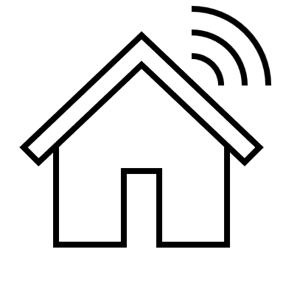 3948 Burnley Drive, Plano, TX, 75025

Project: The purpose is to analyze, specify, design, implement, document, and demonstrate an image management system called CorkBoardIt. CorkBoardIt is a simplified site with support for the most important features of an image organization and sharing site: users, CorkBoards, PushPins (to attach a picture to a CorkBoard), and the ability to follow other users, watch CorkBoards, and comment on the images on CorkBoards. The system is implemented using a fully relational, distinct Database Management System (DBMS) that utilizes tables and supports standard SQL queries. Please see the detail and SQL query we used in another attached file.

1. Introduction to Information Security
2. Software Development Process
3. Intro to Health Informatics
4. Data and Visual Analytics

Due to COVID pandemic, my husband lost the job and I have to drop off the program to work in full time.

But I am really interested in web design, I kept learning related knowledge from online resources.

And hope I could have an opportunity to get an intern or part time web developer position, then I might have a chance to go back OMSCS program and gain my certificate.

My long target is to be a healthcare cloud developer.

Many Healthcare operation system is quite poor and not good as many social media since I am currently working in a medical center and know some information about it. I hope I could solve or improve some feature one day.