EARTH OBSERVATION FOR SDG TARGETS AND INDICATORS, LOT-1

SDG 15.2.1 EO PATHFINDER: EO FOR SUSTAINABLE FOREST MANAGEMENT

D8.2 Policy Briefs (for SDG decision makers)

ESA Contract No: 4000139583/22/I-DT  
IABG Ref.: TA-B-006186

Date: 2025/04/24

Issue: v2.0

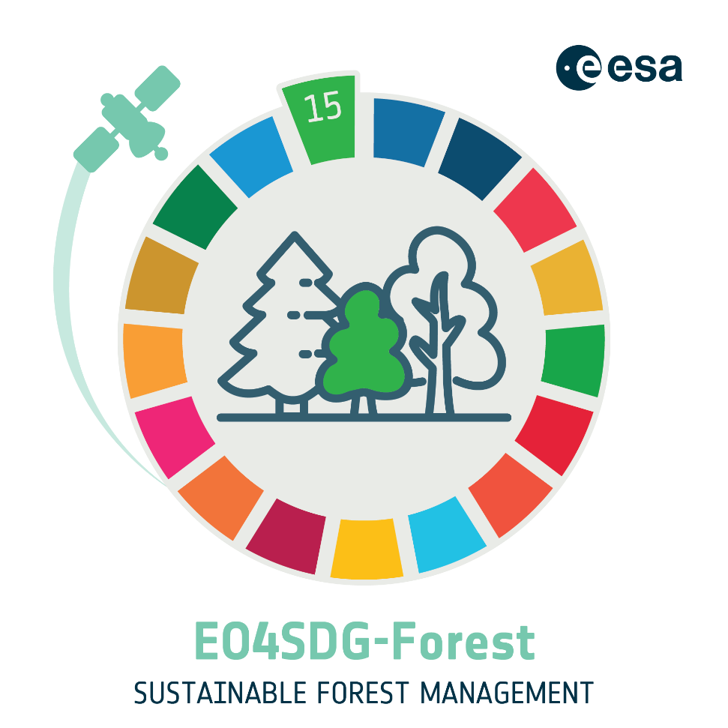

< PAGE INTENTIONALLY LEFT BLANK >

# Scope

The project aimed to support reporting and decision-making under UN Sustainable Development Goals (SDG) 15, specifically focusing on sustainable forest management bridging the gap between advanced EO technologies and the practical needs of national and international stakeholders involved in forest management and SDG reporting.

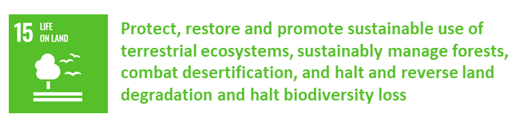

# Products



A robust and high-quality **indicator framework** was proposed based on a detailed review of global and regional SDG reporting frameworks and discussion with early adopters.

* + Forest Mask
  + Above Ground Biomass
  + Forest Condition Monitoring
  + Erosion and Landslide Risk
  + Landscape Metrics

The indicator framework offers forestry officials a streamlined approach to augment traditional reporting with additional spatial metrics. By incorporating these additional indicators, forestry departments can support national SDG commitments with a more comprehensive view of forest health and resilience. Through these steps, forestry officials can add valuable insights into forest sustainability assessments, informing more effective policies for sustainable forest management and conservation.

# In Detail

Possibility to **monitor historical development** of landscapes.

Forest Landscape Metrics (FLM)

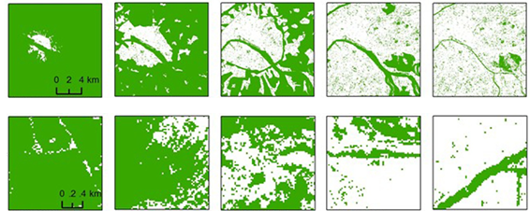

Results at **national scale**

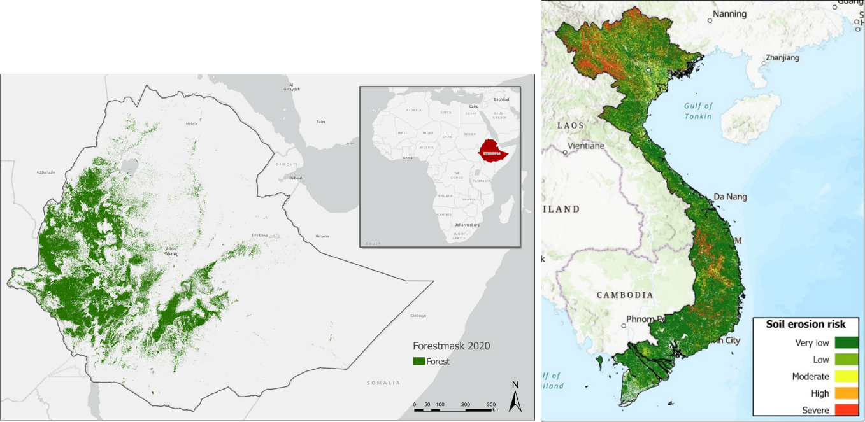

# Summary

Open Earth Observation satellite imagery, with its global coverage and high observation frequency, can prove essential in monitoring the environmental dimension of sustainable development.

The new indicator framework offers opportunities to modernise national statistical systems and improve capacities of countries to track sustainable development.

The indicator framework can aid in national forest **monitoring strategies.**

**Use Cases:**

* + Provide insight into SDG-relevant forest dynamics.
  + Cross-reference standard SDG-reporting
  + Share results in support of regional development and decision making.
  + Provide critical review on existing sustainability policy.

# Roadmap

Adoption requires robust institutional support and capacity building including targeted training programs to enhance technical expertise in using EO tools.

Integration of processing infrastructure and platforms with stakeholder operations.

Developing policy frameworks that integrate EO outputs into decision-making and reporting mechanisms.

< END OF DOCUMENT >