**Erosion Risk**

Soil erosion is a natural process defined as the accelerated removal of topsoil from the land surface mainly through water, wind and tillage. It occurs naturally under all climatic conditions and on all continents, but it is significantly increased and accelerated by unsustainable human activities through intensive agriculture, deforestation, overgrazing and improper land use changes. Soil erosion affects soil health and productivity by removing the highly fertile topsoil and exposing the remaining soil. It decreases agricultural productivity, degrades ecosystem functions, amplifies hydrogeological risk such as landslides or floods, causes significant losses in biodiversity, damage to urban infrastructure and, in severe cases, leads to displacement of human populations. It has implications for our environment and health including on water quality, the energy sector, urban infrastructure, and our landscapes.

Among the wide range of models developed to describe the soil erosion process, empirical models are a good compromise as they tend to be relatively simple, robust, less data demanding, and useable at a large or a global scale. This is why this product is based on the Revised Universal Soil Loss Equation (RUSLE), a well-known, universally accepted and implemented empirical soil erosion estimation model. It also has the benefit of a standardized approach (combining various input factors such as rainfall erosivity, soil erodibility, slope length and steepness, cover management) and allows calculating an average annual soil loss (in ton/ha/year).

**Landslide Risk**

Landslide susceptibility is the likelihood of a landslide occurring in an area on the basis of the local terrain and environmental conditions, and measures the degree to which a terrain can be affected by future slope movements. In other words, it is an estimate of “where” landslides are likely to occur, without considering the size (e.g., the length, width, depth, area or volume) of the land-slides.

Different approaches have been developed and tested, and current methodologies range from empirical to statistical concepts passing through models that qualitatively and/or quantitatively describe the root causes of landslides in a variety of environmental conditions and ecosystems.

Statistical approaches are based on the analysis of the functional relationships between known or inferred instability factors and the past and present distribution of landslides. Such approaches, widely used in the community, have been preferred for this product. The landslide risk assessment relies on the Landslide Susceptibility Index (LSI), calculated using the European Landslide Susceptibility (ELSUS) or the Analytical Hierarchical Process (AHP) multi-criteria approaches according to the territory considered.



Image: A. Vargas/International Atomic Energy Agency (IAEA) Available at: https://www.iaea.org/newscenter/news/what-is-soil-erosion-how-can-nuclear-techniques-help-to-identify-and-mitigate-it.

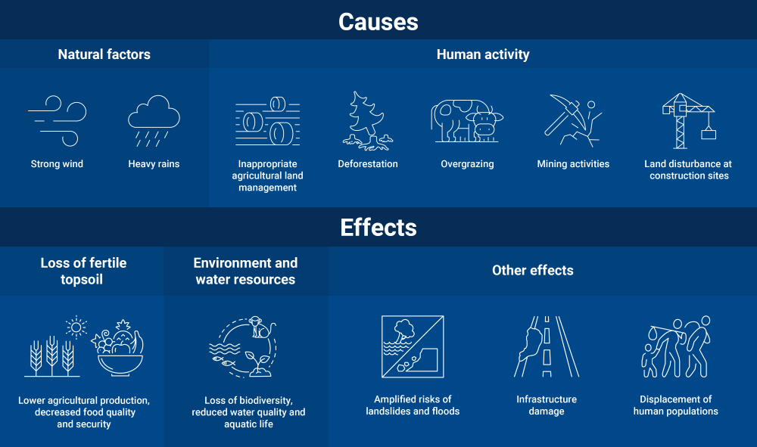

Image: A. Vargas/International Atomic Energy Agency (IAEA) Available at: https://www.iaea.org/newscenter/news/what-is-soil-erosion-how-can-nuclear-techniques-help-to-identify-and-mitigate-it.

**Solution**

The proposed solution provides an assessment of:

* The soil erosion susceptibility (mean annual soil loss, in ton/ha/year) and the soil erosion risk (classification into 5 classes, from “Very low” to “Severe”), through the FER/ER product,
* The landslide susceptibility (dimensionless) and the landslide risk (classification into 5 classes, from “Very low” to “Severe”), thanks to the FER/LR product.

Both classifications (soil erosion risk, landslide risk) have a minimum mapping unit (MMU) of 0.5 ha.

For visualization and analytics purposes both products include some statistics, consisting in the average value of either the soil erosion susceptibility, or the landslide susceptibility, calculated over various administrative levels (country, province and district levels) and compiled into vector files.

|  |  |
| --- | --- |
|  |  |

Soil erosion susceptibility (left) and landslide risk classification (right) values over the Son La province in northern Vietnam