Project Sprint #4

The Solitaire game is described in CS449HomeworkOverview.docx. You should read the description very carefully.

Your submission must include the GitHub link to your project and you must ensure that the instructor has the proper access to your project. You will receive no points otherwise.

GitHub link: https://github.com/eoagcf/CS449sprint4

This sprint assumes that all the features that support a human player to play a manual or automated Solitaire game is already implemented. The minimum features include choosing the game mode (manual or automated), choosing the board size, setting up a new game, making a move (in a manual or automated game), randomize the state of the board and determining if a manual or automated game is over.

The main task of this assignment is adding the feature of recording a game into a text file (or a lightweight database) and replaying from text file. The following is the complete GUI layout.

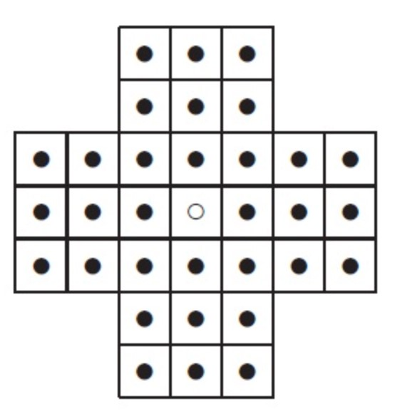

Sample GUI of Solitaire

Board size

Board Type

English

Hexagon

Diamond

Record game

New Game

7

Repla
y

Randomize

Autoplay

Figure 1: Sample GUI Layout of the Complete Solitaire Game

1

- Demonstration (10 points)

Submit a link to a video of approximately 5 minutes, clearly demonstrating that you have implemented all the features in the following table. In the video, you must explain what is being demonstrated. No points will be given without a video link.
YouTube/Panopto link: https://youtu.be/GyECLsDP3dI

 | Feature
1 | A complete manual game without using the “randomize” function is recorded
2 | A complete manual game without using the “randomize” function is replayed
3 | A complete manual game that sporadically uses the “randomize” function is recorded
4 | A complete manual game that sporadically uses the “randomize” function is replayed
5 | A complete automated game is recorded
6 | A complete automated game is replayed

- User Stories and Acceptance Criteria for the Record/Replay Requirements (5 points)

 User Story Template: As a <role>, I want <goal> [so that <benefit>] Add or delete rows as needed.
ID | User Story  Name | User Story Description | Priority | Estimated effort (hours)
20 | Record Manual Game | As a player, I want to record a manual game to a file so that I can replay it later | High | 2
21 | Replay Manual Game | As a player, I want to replay a recorded manual game so that I can review my moves | High | 2
22 | Record Manual Game with Randomize | As a player, I want to record a manual game that includes randomized board states so that the full game is captured | High | 1
23 | Replay Manual Game with Randomize | As a player, I want to replay a manual game that used randomize so that the board states are reproduced correctly | High | 1
24 | Record Automated Game | As a player, I want to record an automated game so that I can watch it replay later | High | 1
25 | Replay Automated Game | As a player, I want to replay a recorded automated game so that I can review how the computer played | High | 1

User Story ID and Name | AC ID | Description of Acceptance Criterion | Status (completed, toDo, inPprogress)
20 story - Record Manual Game | 20.1 | AC 20.1 Recording starts when checkbox is checked  Given: a manual game is active  When the player checks the "Record game" checkbox  Then: recording begins and the status bar shows "Recording started. Moves will be saved to game.txt." | ToDo
 | 20.2 | AC 20.2 Moves are saved to game.txt  Given: recording is active during a manual game  When the player makes a valid move  Then the move is written to game.txt as “MOVE r1 c1 r2 c2” | ToDo
 | 20.3 | AC 20.3 Recording stops when checkbox is unchecked  Given: recording is active  When: the player unchecks the "Record game" checkbox  Then: the file is closed and the status bar shows "Recording stopped. File saved as game.txt." | ToDo
21 story - Replay Manual Game | 21.1 | AC 21.1 Replay loads the correct board configuration  Given: a game.txt file exists with a recorded manual game  When: he player clicks the "Replay" button  Then: the board resets to the correct size and type from the recording | ToDo
 | 21.2 | AC 21.2 Moves are replayed in order  Given: a replay is in progress  When: each command is read from game.txt  Then: each move is applied to the board in the correct order with a visible delay between moves | ToDo
 | 21.3 | AC 21.3 Replay finishes with correct status message  Given: all commands in game.txt have been processed  When: the replay finishes  Then: the status bar shows "Replay finished." | ToDo
22 story -Record Manual Game with Randomize | 22.1 | AC 22.1 Randomize action is logged to file  Given: recording is active during a manual game  When: the player clicks the "Randomize" button  Then: RANDOMIZE_STATE followed by all board cell values is written to game.txt | ToDo
 | 22.2 | AC 22.2 Moves after randomize are also logged  Given: the player has randomized the board during a recorded game  When: the player continues making moves  Then: all subsequent moves are still logged correctly to game.txt after the RANDOMIZE line | ToDo
23 story - Replay Manual Game with Randomize | 23.1 | AC 23.1 Randomize is reproduced during replay  Given: game.txt contains a RANDOMIZE command  When: the replay reaches that command  Then: the exact board cell values from RANDOMIZE_STATE are restored directly so the board looks identical to the original recorded game | ToDo
 | 23.2 | AC 23.2 Moves after randomize replay correctly  Given: a RANDOMIZE command has been replayed  When: the replay continues  Then: all moves following the randomize are applied correctly in order | ToDo
24 story - Record Automated Game | 24.1 | AC 24.1 Automated game setup is logged  Given: the player selects Automated mode and checks "Record game"  When: he player clicks "New Game"  Then: NEW_GAME size boardtype Automated is written to game.txt | ToDo
 | 24.2 | AC 24.2 Every automated move is logged  Given: recording is active and the player clicks "Autoplay"  When: the computer makes each move  Then: every move is written to game.txt as MOVE r1 c1 r2 c2 | ToDo
 | 24.3 | AC 24.3 Recording ends cleanly after autoplay finishes  Given: autoplay has finished and the player unchecks "Record game"  When: the checkbox is unchecked  Then: RECORDING_STOPPED is written and the file closes cleanly | ToDo
25 story - Replay Automated Game | 25.1 | AC 25.1 Replay sets up the correct automated board  Given: game.txt contains a recorded automated game  When: the player clicks "Replay"  Then: the board resets to the correct size and type from the recording | ToDo
 | 25.2 | AC 25.2 All automated moves replay in order  Given: a replay of an automated game is in progress  When: each MOVE command is read  Then: each move is applied to the board visually with a delay so the player can follow along | ToDo
 | 25.3 | AC 25.3 RECORDING_STOPPED line is ignored during replay  Given: game.txt ends with RECORDING_STOPPED  When: the replay reaches that line  Then: it is silently ignored and the replay finishes normally with "Replay finished." in the status bar | ToDo

2

