**Guide**

Let’s use the website as a guide. The way they were able to combine the colors perfectly

<http://www.teletubbies.com/terms.php>

**Font type**

Change the font type on the page to the below

Subject: Berlin Sans

Body: Comic Sans

**Text Color**



Let’s change the color of the text to the blue on the brand manual (pg 18)

Lets make the font of the categories to Berlin Sans

**Logo**

Increase the size of the logo

**Icons**

Let’s change the icons of the Ask Sarah and E-Learning as discussed. Make the bar orange and the text color blue

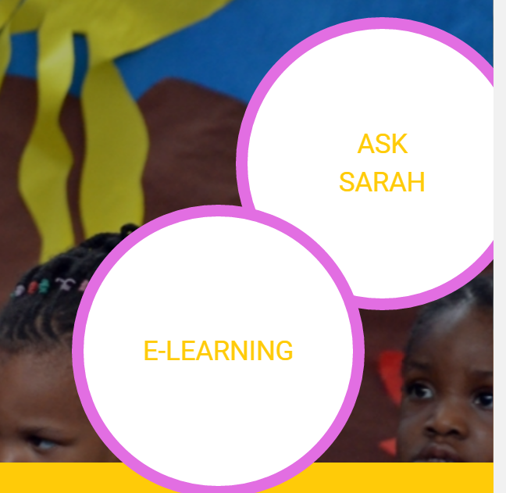

**Pop-up**

Let’s change the color of this pop-up to another the orange on the brand manual

Also, change the white icon to the blue on the brand manual



**Text Bars**

Make the text bars orange and when you hover the mouse on it let it change to blue.

Make the text turn to white

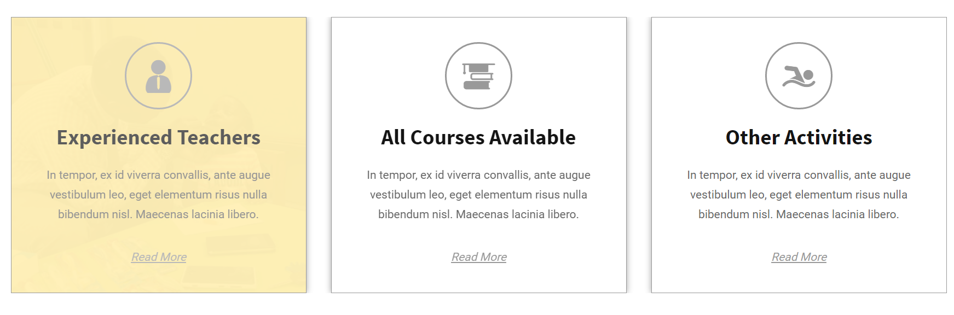

**Text Color**

Change the highlighted colors to Blue







**Text Box**

Change the text box to orange and the text to blue

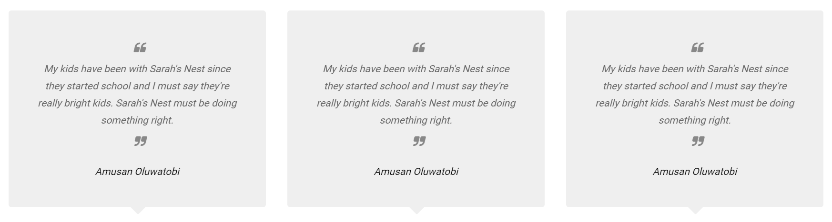

**Color change**

Change the color of this box to pink on the brand manual and the text to blue.

The box with the submit can be changed to blue while the text inside changes to white

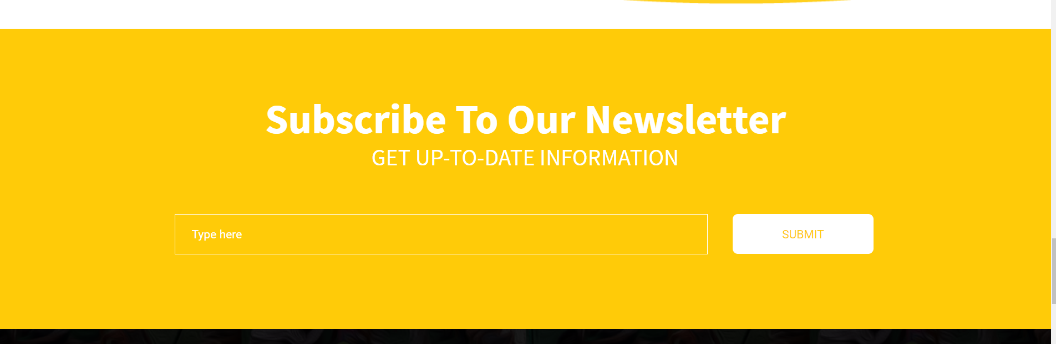

**Social Icons**

Change the color of the social icons to blue for facebook and Twitter and red for Google+

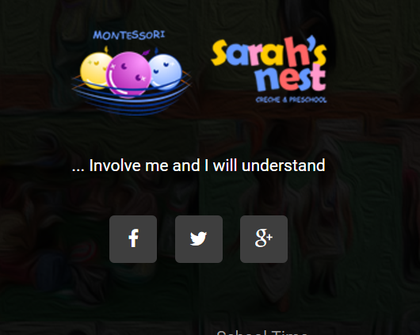

**Inner Pages**

Make the text box for the quote orange and the text blue

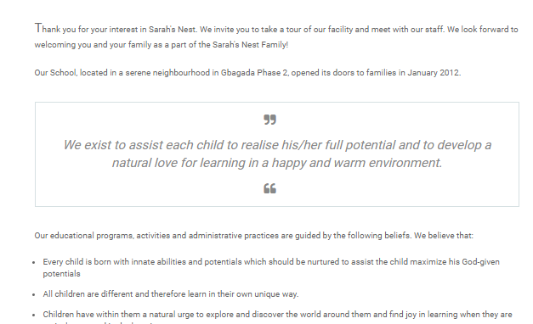

Change the highlighted text to blue

