***Eoan O’Dea***

***Dario Di Mambro***

***Gonçalo Correia***

*Assignment 3 MDE*

Our project is built based on this model:

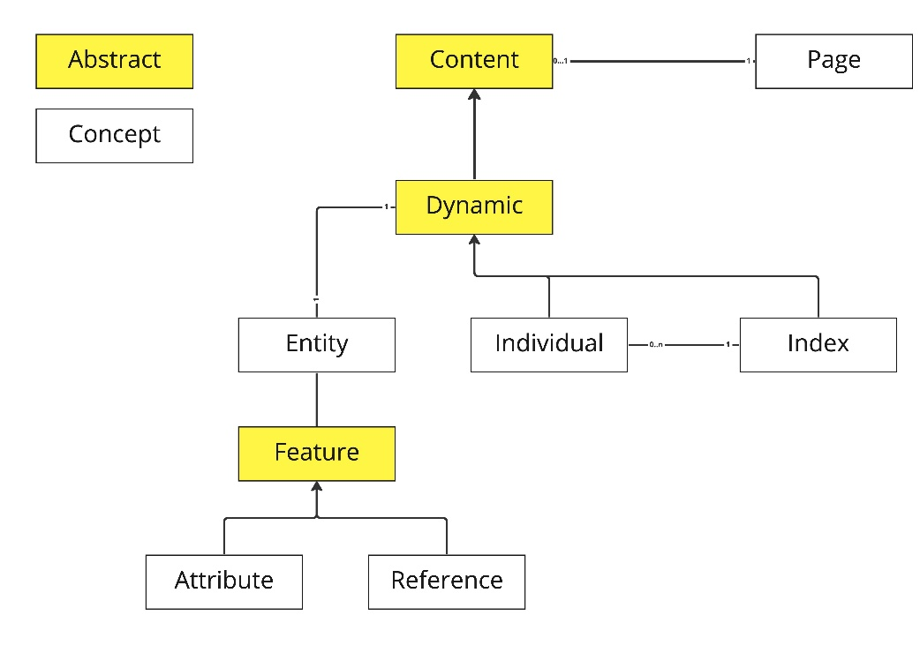

Structure:

We extended the DSL so that it is possible to distinguish between indexes and individual items. We created both individuals and indexes, the latter ones have various individuals as children. They are part of an abstract concept called Dynamic Content, that is itself of another abstract concept called Content.

TextGen:

We defined TextGen’s aspect rules to generate SQL queries capable of retrieving the content for indexes and individual items. We used the ID of the individuals to find the specific instances.