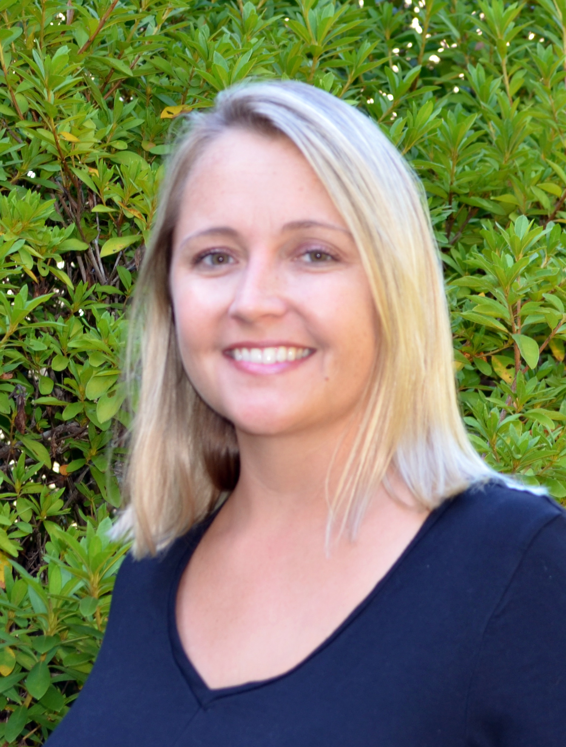

Sara E. Armstrong

Owner & Licensed Property Manager in Charge

I started learning about Property Management at an early age, working for my Dad’s real estate investment business in Central Illinois. Those experiences not only taught me the ins and outs of Property Management but, more importantly, about hard work, responsibility and perseverance. It didn’t hurt that I started out mowing some of the properties and painting porches and interior walls for my allowance growing up.

My passion has been to live on the beautiful coast of South Carolina, then eventually go into business for myself. I’ve called Charleston, SC home for nine years now, living on James Island, working in Property Management and also a couple years in the Mortgage business.

Most recently, I’ve become a very successful manager of multiple Airbnb listings. Continuously ranked, Five Star Super Host. Not only do I ensure guests have a clean and comfy retreat during their stay, I also like to give them local recommendations so they get the true Charleston experience, while our local businesses benefit in the process. I also believe good communication before and during their visit is key for success. You’re only as good as your last review!

Whether you have a second home retreat on Kiawah or Folly Beach, or a single-family rental property in West Ashley or James Island, you’ll be working with an experienced, personable, Charleston local that will always put you and your investment first!