August 28th 2020

Emeka Obianyor

PYCITY SCHOOLS REPORT

From the data provided on fifteen Pycity high schools and their math and reading scores, we see the following trend:

1. When you look at schools on a budget per student basis, PyCity schools range from $578 - $655 and we see a trend where schools with a lower per student budget have better math and reading scores and a higher passing percentage.

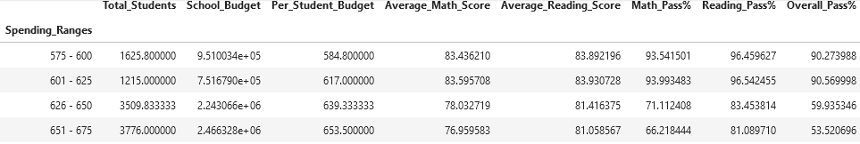

1. We also see a clear trend when we sort school by school size. Schools with fewer students (0 -1500) have better score than larger schools (4501 – 6000). This can be seen in the figure below.

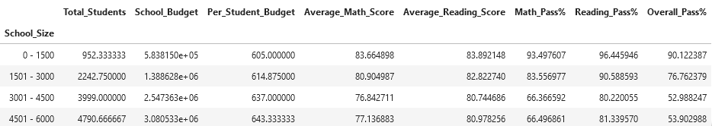

1. The final trend we see is the difference in scores when schools are sorted by school type. Charter school have higher score and better passing percentages than District school. This difference is more prominent in the Math scores than the Reading scores.

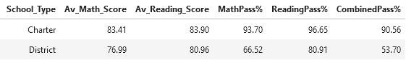

These are the trends we see in PyCity School data.