**HOLODECK etc. this isn’t the final cover.**

This version has a revised format for presentation of risks. We will be removing the table borders for the risks in the final copy.

**Table of Contents**

[Systems] Introduction (Using Heading 1) 3

[Systems] Mission Statement (Using Heading 1) 3

[Systems] Requirements (Using Heading 1) 3

Subsystem Name (Using Heading 1) 3

Current Subsystem Requirements (Using Heading 2) 3

Current Design Choice (Using Heading 2) 3

Justification for Design Choice (Using Heading 2) 4

Risks (This is a new table format) 4

Future Work (Using Heading 2) 5

[Systems] Summary and Conclusions 5

Appendix for larger drawings 5

**List of Tables and Figures**

Fig. ST-1: Smiley Faces (Use Heading 5 for title only) 3

# [Systems] Introduction (Using Heading 1)

Please use proper heading levels so the table of contents will update automatically. First lines should be indented ½ inch. Do not skip lines when beginning a new paragraph.

Normal text should be in font size 12. Heading 1 is bold and size 16, Heading 2 is bold and size 13, and Heading 5 is size 11. All text is black.

# [Systems] Mission Statement (Using Heading 1)

Note to all Subsystems: USE HEADING 5 TO LABEL FIGURES AND TABLES.

Label figures locally (within your subsystem) so the numbering won’t change around a lot. Don’t forget to refer to the image in the text. For example, Fig. ST-1 shows a smiley face.



##### Fig. ST-1: Smiley Faces (Use Heading 5 for title only)

These smiley faces serve as a sample figure. The text is left-justified with a modified left and right indent to stay under the image. Only the figure number and title are Heading 5. The rest is normal text of size 11.

# [Systems] Requirements (Using Heading 1)

# Power

## Current Subsystem Requirements

* For now, please update in the Google Doc here: <https://docs.google.com/spreadsheet/ccc?key=0Avv5ZCH0h428dExPdDZzQy1sMEJjLW1CbzlxTGVOSFE#gid=0>
* We may later ask you to reformat for inclusion in this doc.

- List and discuss the requirements (that were in your back up slides) here

-Provide a justification for why you arrived at these requirements

## Current Design Choice

The power requirements for each subsystem drove the design of the power subsystem. The following table shows the power required for each subsystem during each mode of operation. The highest power consumption occurs during data capture when the HOLODECK camera is in operation and the data is being processed and stored in real time by avionics. The lowest power consumption occurs while the satellite is waiting for commands in system maintenance and standby mode.

Figure PW-1: Power usage by system mode.

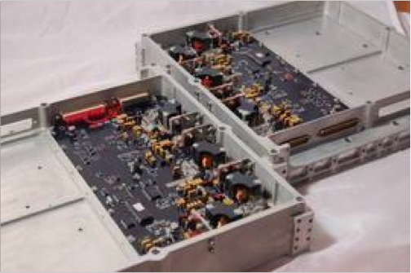The power subsystem uses a commercially available power distribution system made by Clyde-Space. This distribution system supports up to 300W average power per orbit, which is less than the largest power consumption required by the HOLODECK satellite design.

Figure PW-2: Clyde-Space SmallSat Electronic Power Subsystem. <http://www.clyde-space.com/products/electrical_power_systems/smallsat_power>.

Triple junction solar panels were selected because they provide the highest collection efficiency currently available (http://www.emcore.com/space-photovoltaics/space-solar-cells/). The large power consumption during data capture requires high efficiency arrays to keep the mass of the solar arrays low relative to the rest of the spacecraft. To minimize complexity in subsystem design, fixed solar panels were selected over sun-tracking solar panels. However, as the satellite will spend much of its time with opposite ends of the satellite bus pointing to the earth, it was determined that the solar panels will be coated with solar cells on both sides. 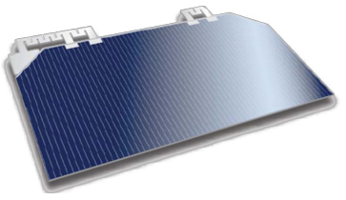

Figure PW-3: Emcore solar cell.

Lithium-Ion batteries were selected as the secondary batteries. These batteries have a high energy density and have been tested in spaceflight. The energy density of these batteries make them effective in minimizing the mass of the power subsystem. Primary batteries were not considered because the analysis of the satellite design did not consider the detumbling mode. It may be possible to power the satellite through solar array deployment using only secondary batteries, but a detailed analysis would need to be performed. Lithium-Ion batteries can be purchased through Clyde-Space (<http://www.clyde-space.com/products/spacecraft_batteries>)

## Justification for Design Choice

### Power Distribution System

The commercial Clyde-Space distribution system is being used because it is a tested and reliable off-the-shelf option. It eliminates the development cost of a custom distribution system. This system supports all the functions that were deemed necessary for the HOLODECK satellite. It includes a maximum power point tracking system, which is important because the satellite’s polar orbit results in large variations on the incident solar flux on the arrays.  It supports telemetry and telecommand, as required by PW-4. It directly supports between 16V and 35V from the bus and 5V regulated, meaning that it can power most of the satellite’s subsystems without transformers.

|  |  |  |  |  |
| --- | --- | --- | --- | --- |
|  | **Data Capture** | **Optical Downlink** | **System Maintenance & Standby** | **Orbit Transfer** |
| **Payload** | 90 | 0.0 | 0.0 | 0.0 |
| **Comm** | 25.5 | 115.5 | 25.5 | 25.5 |
| **Propulsion** | 1.5 | 1.5 | 1.5 | 35 |
| **ADCS** | 28 | 28 | 6 | 28 |
| **Avionics** | 105 | 50 | 50 | 50 |
| **Thermal** | 0 | 0 | 0 | 0 |
| **Total** | **250** | **195** | **84** | **139** |

Table PW-1: Power usage, broken down by subsystem in the nominal mission modes. All values in Watts.

### Material selection

Triple-junction solar panels were chosen because they have the highest energy collection efficiency available. The additional cost incurred in selecting a more expensive panel type is more than compensated for by savings in the mass budget; a lower collection efficiency would require larger solar panels. Lithium-Ion batteries were selected for their historic performance in space applications and their substantially higher energy density than other battery options. They have a 65% volume advantage and 50% mass advantage over Ni-Cd and Ni-H2. There is at least a 100% advantage in energy density.

### Solar Panel Orientation

The large energy requirements meant that body-mounted solar panels would not be large enough to power the satellite. For this reason, deployable solar panels were explored. An extensive analysis was performed to see if the solar panels needed to track the sun. Fixed solar arrays are advantageous in that they simplify the design, which reduces the cost of development.  The deployment mechanism for the solar arrays only has to work once and does not have to be monitored or controlled after deployment. A folding mechanism (as described by structures) can be used to avoid gimbaled arrays and simplify the structure.  Additionally, because the satellite will often be rotated 180 degrees about its x-axis, depending on whether it is in data capture mode or downlink mode, it is necessary to have double sided solar panels. Adding a second side of solar cells adds only 0.8 kg/m^2 of density, compared to the single-sided panel density of 3.2 kg/m^2. Most of the mass of solar arrays is the structure supporting the cells, not the cells themselves.

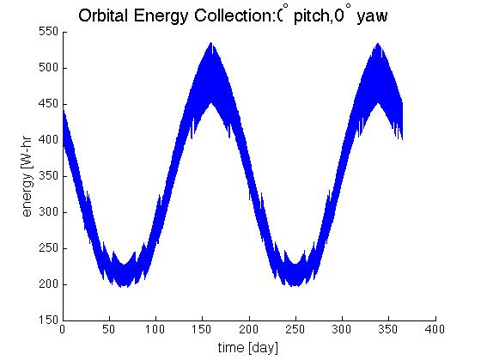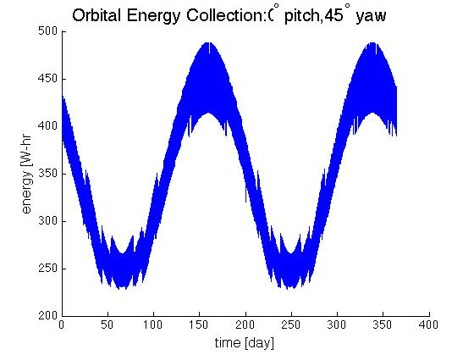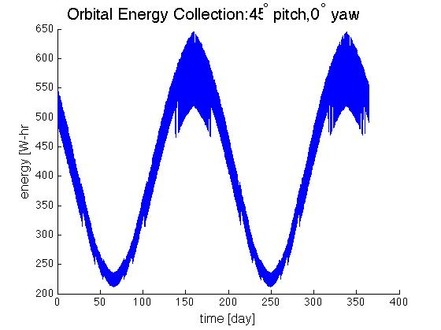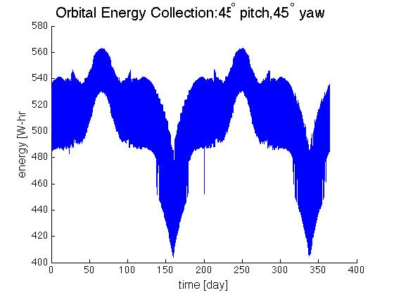

Figure PW-4: Energy collection during the year for different solar panel orientations. Plotted is the energy collected during an orbit that begins at the time on the horizontal axis. The orientation with 45˚ and 45˚ yaw collects the largest amount of energy and has the most consistent energy collection. The function appears to have some kind of bandwidth because the simulation time step (360 seconds) does not evenly divide into the orbital duration (94.62 minutes).

In order to determine the optimum placement of the solar panels, Systems Toolkit (STK) was used to analyze power collection during a polar orbit. The polar orbit causes variation in optimum solar collection position from the +y or -y side of the spacecraft in some months to the -z face in other months. These considerations suggested that the solar array configuration that would keep average energy collection per orbit as constant as possible throughout the year while making average energy collection per orbit as large as possible would be arrays at a pitch of 45 degrees and yaw of 45 degrees relative to the local satellite coordinate system. This logic was confirmed by STK solar collection analysis.  Power collection over the course of a year was simulated with the solar arrays at different configurations.  Figure PW-4 and Table PW-2 show the results of this analysis. In some portions of the year with low power collection due to the incidence angle of the sun’s rays on the solar panels, the satellite can be rotated 180 degrees about the z-axis to better align the solar panels.

|  |  |  |  |
| --- | --- | --- | --- |
| **Pitch** | **Yaw** | **Mean energy collected [W-hr]** | **Standard deviation of energy collected [W-hr]** |
| 0˚ | 0˚ | 339 | 97 |
| 45˚ | 0˚ | 347 | 73 |
| 0˚ | 45˚ | 408 | 125 |
| 45˚ | 45˚ | 507 | 27 |

Table PW-2: Mean energy collected per orbit and standard deviation of energy per orbit for different solar panel configurations. The configuration with a pitch of 45˚ and a yaw of 45˚ has the highest mean energy collection, and the most consistent collection (as it has the lowest standard deviation).

### Solar Array and Battery Sizing

The solar arrays were sized to accommodate the worst case power consumption mode with the least energy collection per orbit. The analysis determined that the solar array area is required to be 3 m2. This implies a solar array mass of 13.8 kg  This mass and size was deemed unacceptably large by structures and ADCS, as to overcome the drag induced by solar arrays of this size would have required more powerful reaction wheels and a reinforced structure.  It was determined a smaller solar array area of 2.25m2 was preferable, although this would limit what operations are possible in the worst case scenario. Through this analysis, it was also determined that batteries must have the capability to provide 372 W-hr of power, which results in a battery mass of 2.99 kg.

Initial STK-based array sizing considered the worst case scenario.  The worst case power usage orbit includes two downlinking ground station passes and as much data capture as can be handled by the avionics system. The worst case orbit for power collection orbit was determined using STK analysis. Orbital energy collection was calculated for every orbit throughout a year, for the satellite travelling in its nominal orientation and for the satellite travelling while rotated 180 degrees about the z-axis from the nominal orientation.  The orbital energy at each timestep was calculated by taking the maximum of these two orbital energies at that timestep, since the satellite can be rotated by 180 degrees about the z-axis to increase power collection.  Orbital energy collection is shown in Figure PW-4. From this new expression for orbital energy throughout the year, the minimum energy orbit was found.

Power collection and power usage over an orbit were overlaid graphically, as can be seen in Figure , for analysis.  Power usage was increased to account for the power distribution efficiency from the solar panels to the subsystem loads and from the batteries to the subsystem loads.  While power usage is less than power collection, the power usage is divided by Xsa = 0.8, increasing the usage to account for the pathway efficiency from the solar panels.  While power usage is greater than power collection, the power usage is divided by Xbatt  = 0.6, increasing the usage to account for the pathway efficiency from the batteries.  This process was performed iteratively to account for regions changing between the battery power usage and solar panel power usage. To account for lifetime degradation, the solar array area quoted is increased from the solar array area used to calculate collection in STK.  It is increased by dividing the area used in STK by Ld, the lifetime degradation.  Lifetime degradation is calculated by using the following expression:

Energy surplus for an orbit was calculated by subtracting power usage from power collected, and integrating over the course of the orbit.  Solar array area was chosen by simulating power collection for different areas until the energy surplus was near zero. Battery size was chosen by determining in the near zero energy surplus case the largest amount of charge that would be needed to be stored in the batteries.  In order to ensure that depth of discharge would never be greater than 70%, this size was increased by dividing by 0.7.

The array size required for this worst case scenario is near 3 m2 , which is unacceptably large for structures and ADCS.  It was decided that it would be more beneficial to place a limitation on ConOps for certain orbits and restrict solar array size to 2.25m2 .  Analysis was then performed to determine how much data capture could be performed for worst case solar energy collection and the nominal case solar energy collection.

Figure PW-5 shows the energy collection and usage for a nominal orbit.  This analysis shows that with 2.25 m2 solar arrays the satellite can support about 50 minutes of data capture per orbit.

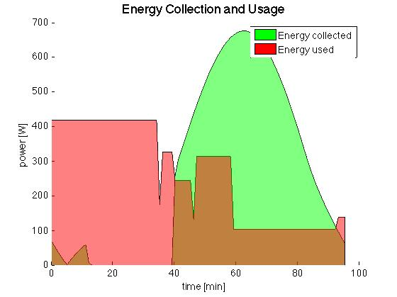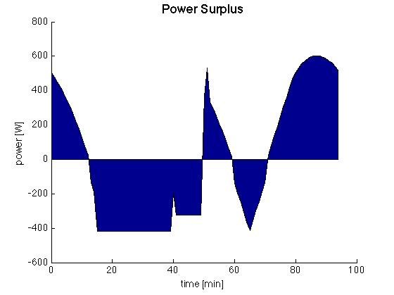

Figure PW-5: Nominal Case. The green area represents the energy collected by the solar arrays and the red area represents the energy consumed. In this case data is captured for 50 minutes and downlinked for 10 minutes. The remainder of the orbit is left in system standby and maintenance mode.

Though this is less than the maximum possible 70 minutes of data capture per orbit, it was determined that 50 minutes per orbit would be more than satisfactory to meet mission objectives.  Figure PW-6 shows the energy collection and usage for a worst case orbit.  This shows that the worst case orbit supports approximately 35 minutes of data capture.  This worst case will only be encountered during at most 2 months out of the year.  Because these limitations did not compromise the mission objectives, it was decided to limit the solar arrays to 2.25 m2 .

Figure PW-6: Worst Case. In this case data is only captured for 35 minutes and downlinked for 10 minutes. The rest of the orbit is system maintenance.

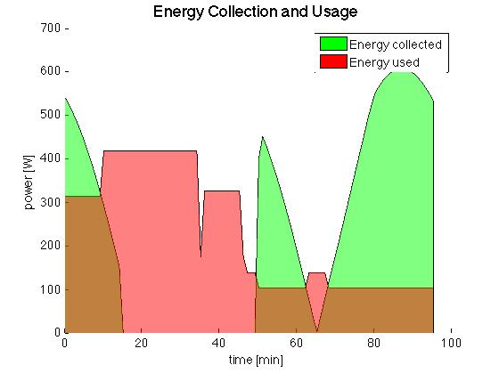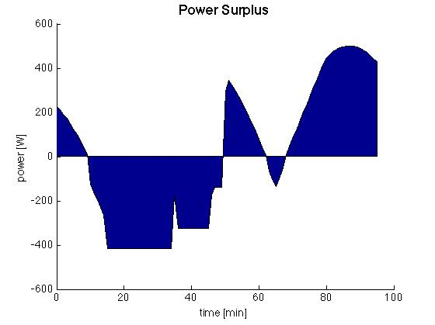

## Risks

|  |  |
| --- | --- |
| **PW-1**  (5,5) | If the satellite performs multiple power intensive operations during a low energy collection orbit the satellite could lose power.  **Mitigation Strategy:** We will set limitations on ConOps that monitors low energy consumption orbits |
| **EX-2**  ( , ) | If further analysis shows that the estimated efficiencies are higher than they actually are, the satellite might not have enough power budgeted.  **Mitigation Strategy:** Further restrict ConOps to limit data capture, and require a sun-pointing mode to maximize power collection. |
| **EX-3**  ( , ) | If other subsystems realize they have larger average power requirements than predicted, particularly Avionics or Comm, it could mean that the selected power distribution system could no longer handle the required power.  **Mitigation Strategy:** Select a different power distribution system that supports higher power usage, or develop a custom power distribution system. |

## Future Work

At this stage of the analysis it appears the solar arrays could increase in size to accommodate longer data capture times during the month that has low energy collection per orbit. Before increasing the size of the solar arrays a trade study would have to be conducted to ensure the change does not significantly affect the other subsystems. To make the power collection analysis more detailed the STK analysis needs to includes rotation of the satellite from data capture to optical communications downlink, which requires the spacecraft to rotate about the x or y axis 180 degrees. The power subsystem needs to determine the interfaces between each subsystem in order to provide power at the appropriate voltage. A secondary concern for moving the design forward is determining if the secondary rechargeable lithium ion batteries can store enough power to make it through orbital insertion. Harnessing and layout of the power subsystem will need to be developed.

# [Systems] Summary and Conclusions

# Appendix for larger drawings