**Executive Order Products and Services Overview**

An Overview of Executive Order Corporation Portfolio of Products, Projects, Training, Consulting, Technologies and Professional Services Offerings.

- By Steven Woodward

**Executive Order Corporation DAS www.eodas.com**

**Executive Order Development** - Executive Order builds complex systems for automated business management, business rules, business process management, natural language understanding, Ontology, real-time planning, and visualization. We provide Artificial Intelligence (AI), Business Rule Management Systems (BRMS), DROOLS, Business Process Management (jBPM) research development, and vision. We also offer a variety of books and training courses on AI Drools, IoT, jBPM and IT topics.

**Executive Order Professional Services** - We provide a complete enterprise software development solution for your business. By providing a full spectrum of consulting, training, and support services, we assist our customers with the development, integration, deployment, and management of their entire enterprise systems solution.

**IT SOFTWARE SOLUTIONS** - Executive Order is a software development company, providing all of your software development service needs. We design, develop, document, and deliver your custom software application. We assist our customers with the development, integration, deployment, and management of their entire enterprise software applications.



**Executive Order AI-IoT Internet of Things Drools-BPM www.iotbpm.com**

**Executive Order Corporation - We make Things Smart**

Executive Order Corporation provides custom software built by software professionals. We specialize in IoTBPM (Internet of Things), desktop and web-enabled IT solutions for small/large business enterprises. Our professional offerings span business and technology consulting, business application development, mobile messaging solutions, custom web design, e-commerce development, web maintenance, website re-engineering, website optimization for search engine submission, internet marketing hosting solutions for enterprises, GPS, IoTBPM (Internet of Things), remote sensing services and development program architecture of AI-Drools and jBPM (Business Process Management).

**IoT Definition**

IoT is the integration of computer-based systems into our physical world. – Steven Woodward

**IoTBPM.com**

IoTBPM an Executive Order Corporation

**AI-IoTBPM Book www.eodas.com/docs/AI-IoT_Artificial_Intelligent_Internet_of_Things.pdf**

**AI-IoTBPM Drools-BPM www.github.com/eodas/iotbpm**

The power of the IoT (Internet of Things) device increases greatly when business process (jBPM) can use them to provide information about our real-world as well as execute IoT devices action as part of our business process. The jBPM-BPMN modular allows us to define both the business processes and IoT devices behavior at the same time using one (BPM) diagram. With AI-IoTBPM adding Drools and jBPM to IoT, we make the IoT devices "**Smart**." Moving beyond just collecting IoT data and transitioning, to leveraging the new wealth of IoT data, to improving the SMART decision making is the key. The Executive Order Corp AI-IoTBPM will help these IoT devices, environments, and products to self-monitor, self-diagnose and eventually, self-direct. At Executive Order making **“Things Smart”** is our application of AI to IoT platform via Drools-Rules Inference Reasoning, jBPM, and ES-Expert Systems.

With the use of AI Drools-jBPM analysis and reasoning in IoT devices, we can orchestrate dissimilar devices that normally have no awareness of each other. This creates opportunities for direct integration of computer-based systems into the physical world that has never been available before. This results in greatly improved efficiency, accuracy, and economic benefits by increased automation - reduced intervention. This IoT orchestration of IoT devices gives us the ability for action after our AI decision.

**IoT Tiles – Control Panel www.github.com/eodas/PiIoTTiles**

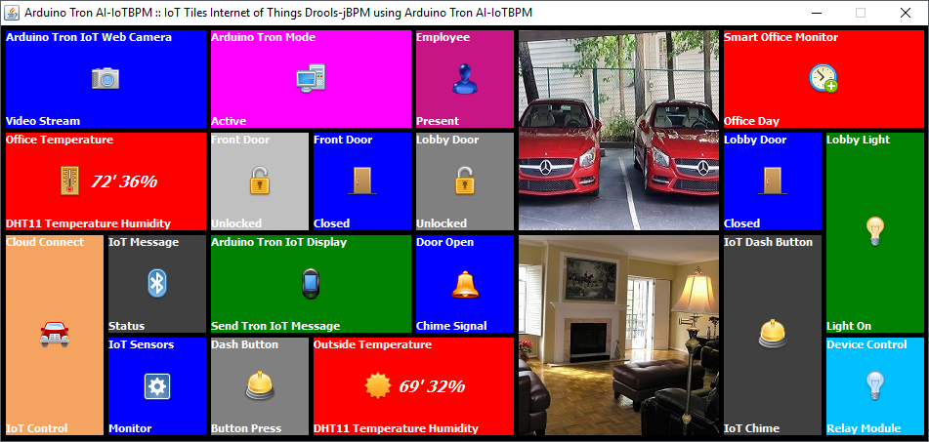

The Arduino Tron IoT tiles is a control panel (dashboard) for Arduino Tron IoT things, which controls IoT smart office automation and IoT monitoring from your desk. IoT tiles allows you to send IoT commands directly to your IoT devices and monitor all your IoT device sensors and alert messages.

This single dashboard gives you two-way communications with all your IoT devices and Arduino Tron IoT things. Also, it provides situational awareness, alerts, and notification messages from each of your IoT devices. Arduino Tron IoT things events and messages are updated “instantly” on the IoT tiles panel.

With Arduino Tron IoT tiles, you can view and control all your IoT devices from one dashboard panel

Motion sensors, water sensors, temperature, luminosity sensors, GPS (location), the weather outside, dimmable lights, control thermostats, door locks, entrance door access, music players, cameras (image capture), or any plant floor equipment from this one panel from IoT tiles panel.

**Executive Order AI-IoT Internet of Things Drools-BPM www.iotbpm.com**

**Executive Order Corporation - We make Things Smart**

Executive Order Corporation provides custom software built by software professionals. We specialize in IoTBPM (Internet of Things), desktop and web-enabled IT solutions for small/large business enterprises.

**IoT Definition**

IoT is the integration of computer-based systems into our physical world. – Steven Woodward

**IoT BPM Server**

IoT BPM Server is a Business Process Management engine for IoT Device Orchestration.

**IoTBPM Server Book www.eodas.com/docs/IoT_BPM_Server_Documentation.pdf**

**IoTBPM Server www.github.com/eodas/iotbpmserver**

* IoTBPM Server is a Business Process Management Engine for IoT Device Orchestration.

The IoT BPM server documentation will help you understand exactly what IoTBPM server is and how it is relevant to IoT device orchestration and IoT device ontology (AI-IoT device awareness, state of being, knowledge of real-world objects, events, situations, and abstract concepts).

In the context of IoT devices, when we say BPM, all we mean is “a sequence of tasks that allows us to achieve a goal.” In IoT BPM orchestrated each task-goal can be carried out by a different IoT device, enterprise RESTful server, human task, or any other integrated service.

The IoTBPM server ensures that once started, the BPM is carried out fully and retries any steps in case of failures. The IoTBPM server maintains an audit log so that the progress of BPM can be monitored. The IoTBPM server is fault tolerant and scales seamlessly to handle growing transaction volumes.

**The IoTBPM Server Orchestration**

A company’s end-to-end IoT BPM workflow will almost always span more than one IoT device or enterprise servers. These IoT device and enterprise services integration can be mission critical to the business and is rarely modeled and monitored. These cross-microservices workflows can be a company’s core operation drivers, often they are rarely modeled and monitored, and the flow of events through different IoT devices is usually expressed only in low-level Interface flow specifications and rarely depict business enterprise goals and workflow diagrams.

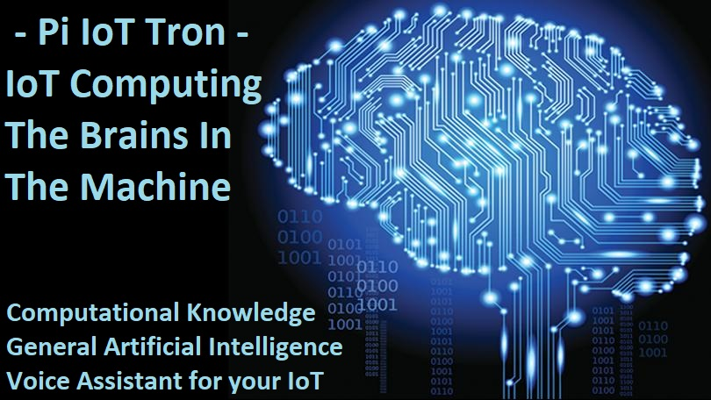

**Jarvis -** **Speech Recognition AI General Intelligence for your IoT Machines www.satellitetron.com**

Satellite Tron Voice Assistant give your IoT Devices AI General Intelligence. The Brains in the Machine, Computational Knowledge, and General Artificial Intelligence Voice Recognition for your IoT Devices.

**The Satellite Tron system known as Jarvis,** An artificial general intelligence and interactive voice assistant for your IoT devices, our powerful Raspberry Pi AI voice recognition software is a general intelligence computational knowledge engine. Your internet of things systems of interrelated computing devices, mechanical and digital machines, shop floor, office automation and field devices can now have the ability of AI natural human voice interaction. See [www.PiIoTTron.com](http://www.PiIoTTron.com)

With Satellite Tron artificial intelligent engine for your IoT devices, you can now ask general-knowledge questions from your IoT devices. Our artificial intelligent voice assistant is an intelligent piece of software for communicating with your IoT devices and machines. It gives you natural IoT device control and interaction. Combine this with the vast knowledge of the internet and you will be surprised by how much your business IoT devices can interact with you and the world.

Expanding on the information you now have available, you can ask Pi AI about things like “how the weather or traffic may affect your Satellite Tron Smart Connect IoT field devices.” The AI Pi revolutionary interface to your enterprise data and IoT devices allows your employees and customers to access, analyze, and interact with your business data like never before -– making information analysis and management broadly available – this kind of information you will need for your competitive advantage

**The new Jarvis integration with Satellite Tron – Smart Connect,** With the Satellite Tron – Smart Connect function. You can ask questions like: “Hey Jarvis, is everything ok back at the office?”

To learn more about Jarvis - Speech Recognition AI General Intelligence for your IoT Machines see **www.github.com/eodas/Pi_AI**



**Arduino Tron IoT Display www.github.com/eodas/ArduinoTron**

The Arduino Tron IoT display is a small and inexpensive display that can sit on your desk or be mounted to a wall. It provides situational awareness, alerts, and notification messages from your IoT LCD devices. The Arduino Tron IoT things events are displayed “instantly” on the IoT display. You can think of the IoT display as a single IoT tiles panel window, focused on displaying priority alerts from your Arduino Tron IoT things. The mini Arduino Tron IoT display can be integrated with any wireless security or IoT alert system, and display alerts for driveway alarms, motion sensor, and delivery detect alerts, wireless door entry chime, doorbell or panic button alarms.

This very small and inexpensive Arduino Tron IoT display uses an ESP-01 module receiver to connect via WiFi network, to accept IoT data and display the alerts and messages to you instantly. The Arduino Tron IoT display is a single point to display meaningful alerts form you from IoT Devices. This helps you know what is going on with your IoT network and devices.

**Arduino Tron Wireless Dash Button (iButton) www.iotbpm.com**

Arduino Tron ESP-01 Wireless Dash Button (iButton) can be used as a simple remote alert that will immediately send an alarm signal via the WiFi network back to the Arduino Tron AI-IoTBPM Drools-jBPM Server. The Arduino Tron wireless dash button can be integrated with any wireless security system, mailbox, garage door, driveway alarms, motion sensor, delivery detect alerts, wireless door entry chime, doorbell or panic button alarms. The Arduino Tron wireless dash button sensor provides an audio alert (door chime) or device activation (such as lamp or appliance).

The programmable Arduino Tron WiFi IoT dash button is a small device that can be mounted to a wall or button that sits on your desk or table. It provides situational awareness, alerts, and notification messages from your IoT devices. This adds audio functionality to the Arduino Tron wireless alert sensor, used for wireless door entry chime, doorbell, or panic button alarms. The Arduino Tron ESP-01 wireless dash button (iButton) can be used as a simple remote alert that will immediately send an alarm or notification signal via the WiFi network back to any IoT Device.

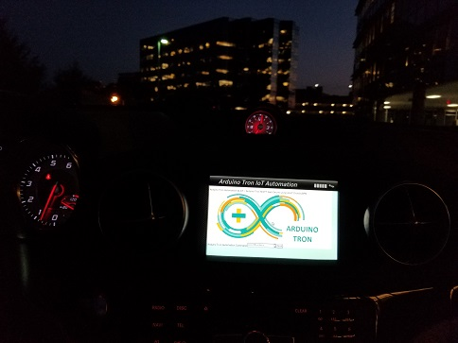

**Arduino Tron Web Server www.iotbpm.com**

The Arduino Tron Web Server Cloud interface for IoT device control is designed for IoT device management is the process of configuring, monitoring, and maintaining the device software that provides its functional capabilities. Effective IoT device management is critical to establishing and maintaining the health, connectivity, and security of all your IoT devices. The Arduino Tron web server provides device management to set IoT device parameters, activate and deactivate your devices, and grant access control of your IoT devices parameters from the Internet.

The Arduino Tron lightweight Web Server provides an IoT dashboard, management, and control for remote management of your Internet-Enabled IoT devices. With the Arduino Tron web server getting your IoT project working in the cloud is a fast-easy solution. The Arduino Tron lightweight web server is a cloud-connected complete SoC (System on a Chip) architecture that integrates all components of a computer, WiFi and web server application software on an ESP-01 or ESP8266 WiFi chip for complete control of Internet of Things (IoT) devices from the cloud.

**Arduino Tron ESP-01 Agent Expansion Module www.iotbpm.com**

The Arduino Tron IoT ESP-01 Agent WiFi relay expansion module board can be used to connect devices so that multiple devices or machines act in unison through the IoT BPM-Drools server. The Arduino Tron IoT ESP-01 Agent WiFi relay expansion module board can be used to connect to office door locks, activate security alarms, turn on office lights, control thermostats, answer the doorbell, open window shades, activate motion sensors, and to control any equipment on the shop floor machines.

The Arduino Tron Agent software interface allows you to send commands with the Arduino Tron AI-IoTBPM server software to control external Arduino connected devices. The Arduino Tron AI-IoTBPM server software uses a WiFi wireless transceiver interface to control and interact with module sensors and remote-control devices. Control any device from the Arduino Tron Agent software or stream any interface over the WiFi internet. With the Arduino Tron Agent software, you can automatically turn on lights, appliances, cameras, and lock/unlock doors from the Drools-jBPM expert system processing.

**Arduino Tron DHT11 Temperature and Humidity Sensor www.iotbpm.com**

The Arduino Tron DHT11 temperature and humidity sensor ESP-01 WiFi wireless module allows you to send information from the DHT11 digital temperature and humidity sensor directly to the Arduino Tron AI-IoTBPM Drools-jBPM server. This module uses the ESP-01 as the main controller, and the DHT11 as the temperature-humidity sensor.

With the Arduino Tron DHT11 temperature and humidity sensor ESP-01 WiFi wireless module, you can use DHT11 IoT information stream to decide what behavior and business process functions to execute based on temperature or humidity with the AI-IoTBPM Drools-jBPM server.

The Arduino Tron DHT11 can be configured to continuously transmit the temperature and humidity information to the Arduino Tron IoT Display for a constant display of temperature and humidity conditions from any location in the world.

**Arduino Tron ESP32-CAM IoT Web Camera www.iotbpm.com**

The Arduino Tron ESP32-CAM IoT wireless streaming video web camera is paramount for office security and monitoring for your property/rental space. Integrate surveillance systems with office automation audio today to take advantage of cutting-edge security features like sound-activated recording and motion detection. See who's approaching and leaving your office front door or other sensitive spaces, like your server room. The TensorFlow Lite Machine Learning (video) recognizes 1,000+ objects out of the box. The camera continuously detects the objects (bounding boxes and classes) in the frames seen by your Edge Device camera.

The Arduino Tron ESP32-CAM IoT wireless webcam is for automated remote monitoring and video notification. This IoT webcam device reduces the resources needed to manually monitor people, places, and things that could be self-monitored.

The streaming face recognition webcam offers an easy-to-use, wireless monitoring solution that uses existing WiFi networks and internet access to gather video sensor data and alert notifications instantly.

The ESP32 board is perfect for Edge computing, machine vision, and face recognition. The ESP32-CAM is designed for mobile, wearable electronics, and Internet-of-Things (IoT) applications. It features all the state-of-the-art characteristics of low-power chips, including fine-grained clock gating, multiple power modes, and dynamic power scaling.

The ESP32 camera has an image array capable of operating at up to 15 frames per second (fps) in UXGA resolution with complete user control of image quality, formatting, and output data transmitted or stored. All image processing functions, including exposure control, gamma, white balance, color saturation, hue control, white pixel canceling, noise canceling, and more, are all programmable through the SCCB webcam interface.

**Arduino Tron ESP-01 VOX-Audio Voice Alert www.iotbpm.com**

The Arduino Tron VOX-Audio voice alert system is a wireless WiFi internet connected, customizable security, and notification IoT device for homes and businesses. This cloud-based audio technology gives a voice to any of the items connected on the Internet of Things. Everything from your alarm clock to your dishwasher, and industrial appliances to medical devices, essentially can now talk.

IoT devices - everyday devices that are interconnected with one another and connect to the internet have enhanced day-to-day life for many people, audio capabilities and audio enhance these connected IoT devices themselves. Audio interactivity improves ease of use and allows users to utilize devices in a way that is most convenient for them.

IoT encompasses more and more devices that have an awareness of each other. This enhanced technology is about convenience and improving day-to-day life. The Arduino Tron VOX uses the latest technology in IoT wireless WiFi and digital voice alert systems. The Arduino Tron VOX-Audio voice alert system can be a stand-alone unit or intergraded into a local public-address (PA) system that audibly delivers a pre-programmed message.

Institutions and businesses can use the Arduino Tron VOX automatic audio alert system to deliver an audible message, alert, warning, or instruction. The Arduino Tron VOX System can be incorporated into hospitals, offices, engineering establishments, doctors or dentists waiting rooms or other internal environments where audible instructions are required.

**Arduino Tron IoT Devices (Sensors and Actuators) www.iotbpm.com**

Arduino Tron IoT devices allow you to send IoT sensor data and information directly to the AI-IoTBPM Drools-jBPM expert system from the Arduino device. This provides a very lite streamline IoT to Drools-jBPM (Business Process Management) application process with or without GPS LAT/LON, speed, bearing, and altitude positioning information. This makes for a very efficient IoT Drools-jBPM expert system.

The Arduino Tron MQTT sensor software allows you to interface and sends MQTT Telemetry Transport Information from your external connected Arduino devices to the Arduino Tron AI-IoT Drools-jBPM server. The AI-IoTBPM Arduino Tron Agent software uses a WiFi wireless transceiver interface to stream telemetry information to the Arduino Tron Agent from any control module sensors or remote device.

With Arduino Tron jBPM-BPMN modular it allows us to define both the business processes and IoT devices behavior at the same time using one diagram. With Arduino Tron adding just Drools-jBPM to IoT, we make the IoTBPM devices “smart.” This technique also helps Drools to process a large number of objects more efficiently and is designed for high volumes of data.

**SAC - Situational Awareness Component www.iotbpm.com**

SAC is the perception of environmental elements by our IoT devices and events with respect to time or space, the comprehension of their meaning, and the projection of their status after some variable has changed, such as time, or some other variable, such as a predetermined event.

In current IoT systems, sensing and actuation are mostly done at the bare bones data level, whereas many IoT applications demand higher level situation awareness of - and reasoning about - the systems’ states and the physical environment where they operate to perform intelligent decisions. This is what we have accomplished with our AI-IoT Drools-BPM implementation. Our Arduino Tron IoT devices are judging and making decisions after cognitive situational reasoning.

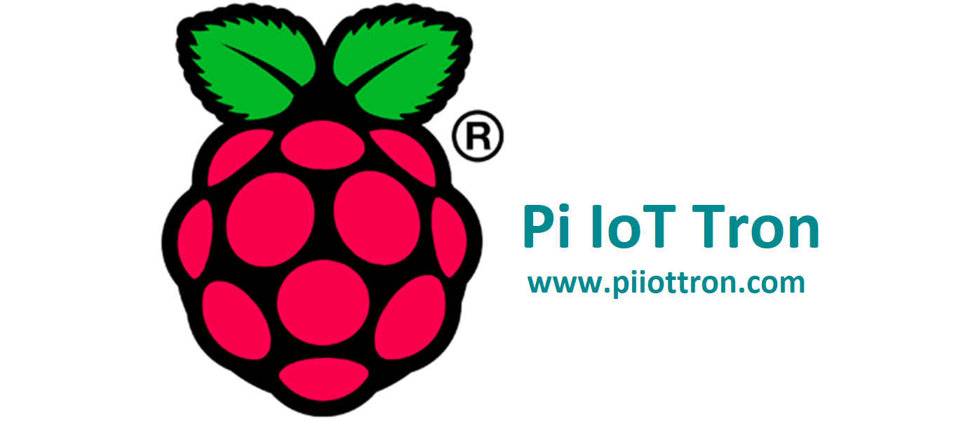

**Raspberry Pi IoT Kiosk www.github.com/eodas/kiosk**

**Pi IoT Kiosk (Pi IoT Tron)** - Executive Order provides our clients with custom IoT Kiosk development and end-to-end solution design services. We have successfully provided high-quality development services to our clients and have helped them gain core competitiveness and establish leading positions in their industries. Our unique IoT Kiosk wireless solution makes it easier for retailers to conduct business from anywhere and provide integration IoT device services to customers. Our IoT Kiosk operators help improve customer satisfaction while increasing the level of service and reduces overall costs.



Our AI-IoTBPM Internet of Things server makes it easier to deploy our IoT Kiosks and other mobile retail solutions to provide a higher level of customer services. By providing fast-reliable wireless connectivity, these IoT Kiosk retail solutions enable businesses to be both portable and flexible, allowing them to better meet their customer growing needs.

With IoT-enabled Kiosk retail solutions, your company can capitalize on new business opportunities and expand retail operations quickly and easily. Executive Order provides cloud-ready IoT Kiosks, with IoT devices, connectivity services, and web-based platforms that allows you to deploy your solutions faster and manage them effectively to support your business needs and growth.

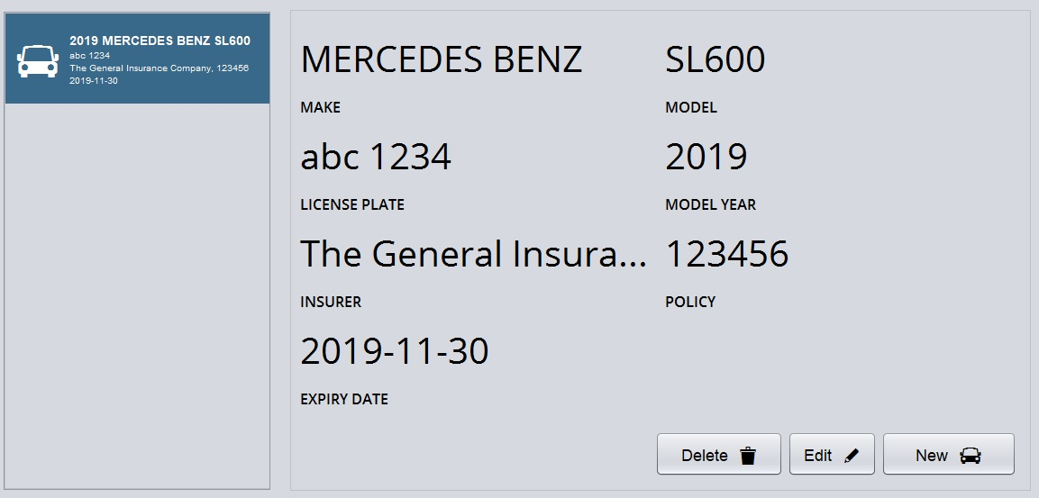

Executive Order Corp. builds complex systems for automated IoT Kiosk networks, business rules, business process management, natural language understanding, IoT ontology, real-time automation, and visualization. We provide Artificial Intelligence (AI), Business Rule Management Systems (BRMS) DROOLS and Business Process Management (jBPM) research, development, and vision to your solutions.

The Executive Order Corp. Internet of Things is helping vending machine, interactive Kiosks, touch screens, digital signs, set-top box (STB), and mobile devices operate more effectively, respond to consumer demand, and boost operational efficiency. Our IoT Kiosk and vending solutions help make machine management and IoT machine interaction simple and more effective.

The Executive Order **Raspberry Pi IoT Kiosk (Pi IoT Tron)** platform accommodates a variety of optional components common to most self-service applications from a swipe card reader, bar code scanner, bill acceptor, receipt printer, fingerprint reader, identity camera, RFID proximity sensor, biometric identity scanner, infrared scanner, parking gates, door locks, and WiFi capability.

The Executive Order **Raspberry Pi IoT Kiosk (Pi IoT Tron)** is built on a powerful platform that provides the capability for seamless hardware integration of new components, sensors, and wireless connectivity devices, that allows you to easily connect your IoT things and enterprise systems together, saving you time and allowing you to get your solution to market quickly.

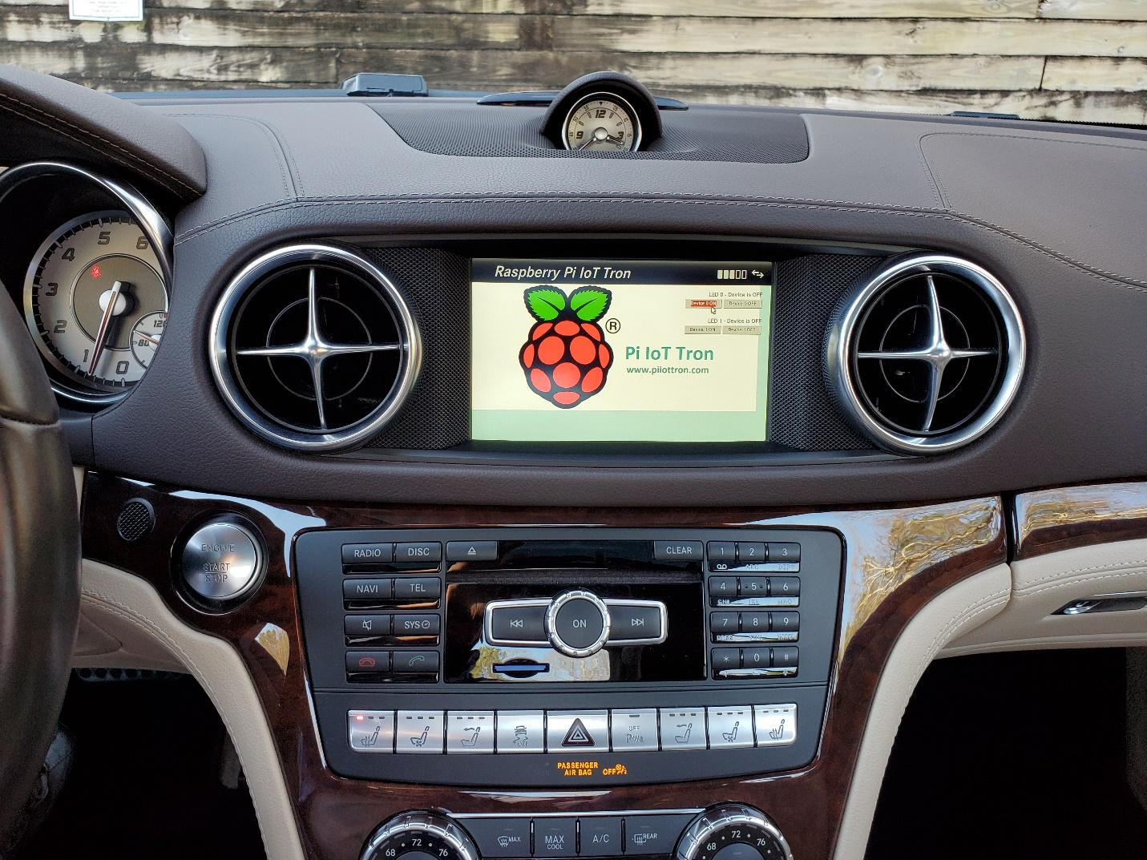

**Raspberry Pi IoT Tron Web Server www.github.com/eodas/PiIoTTron**

The Raspberry Pi IoT Tron Web Server Cloud interface for IoT device control is designed for IoT device management is the process of configuring, monitoring, and maintaining the device software that provides its functional capabilities. Effective IoT device management is critical to establishing and maintaining the health, connectivity, and security of all your IoT devices.

The Raspberry Pi IoT Tron web server provides device management to set IoT device parameters, activate and deactivate your devices, and grant access control of your IoT devices parameters from the Internet via the Raspberry Pi IoT Tron web server WiFi network.

The Raspberry Pi IoT Tron lightweight Web Server provides an IoT dashboard, management, and control for remote management of your Internet-Enabled IoT devices. With the Raspberry Pi IoT Tron web server getting your IoT project working in the cloud is a fast-easy solution. The Raspberry Pi IoT Tron lightweight web server is a cloud-connected architecture that integrates all components, and for complete control of Internet of Things (IoT) devices from the cloud.

I have developed an **AWS IoT Tron Edge Computing Architecture** for AI_ML Edge Computing technology that gives you the state of everything from all your devices and allows you to reason on top of the data so that you can truly solve your business problems. My AWS IoT Tron connects IoT devices with my open-source SDK including libraries, developer guides with samples, so that you can build innovative IoT products and solutions on your Raspberry Pi IoT Tron lightweight Web Server platform.

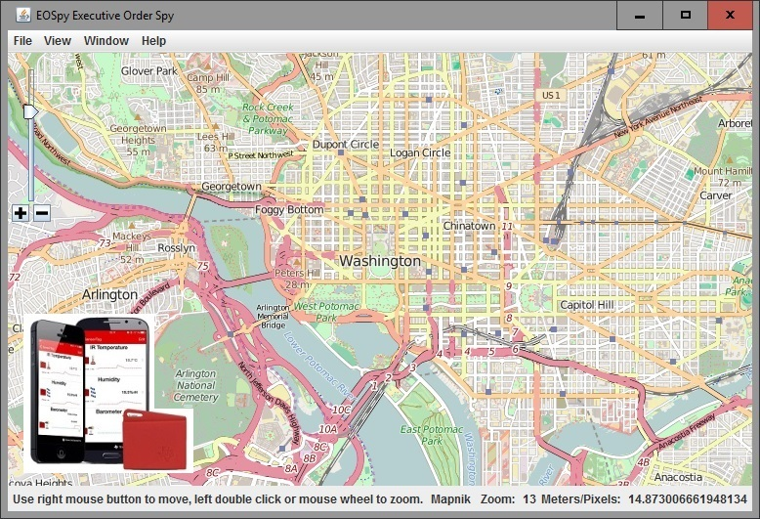

**Executive Order Sensor Processor System – EOSpy www.eospy.com**

The GPS Tracking automation and remote monitoring system ties all location and environment monitoring information on one live GPS Map Screen using IoT devices.

**Executive Order Sensor Processor System – EOSpy www.github.com/eodas/EOSpy**

Executive Order EOSpy (Sensor Processor System) Client and Server Applications is a GPS Tracking automation and remote monitoring system ties all location and environment monitoring information on one live GPS Map screen. The EOSpy wireless GPS tracking allows you to monitor your office, systems, personal property, fleet, and assets tracking, and employees from anywhere in the world.

Executive Order spy server is an application for viewing “Real Time” live GPS tracking information over the internet/mobile cell network that provides location, notification and telemetry information from your IoT devices and EOSpy works with many different GPS tracker manufacturers. The EOSpy system live map GPS tracking system supports more than 90 GPS communication protocols and more than 800 models of GPS tracking devices from popular GPS vendors. Our Android App Client and Java Client provide additional capabilities for environment and condition monitoring from your own IoT devices.

EOSPY-TI wireless GPS tracking allows you to monitor your office, systems, personal property, and fleet from anywhere in the world. Receive remote information from any number of events like when an employee arrives on-site to where a vehicle is located. The EOSPY-TI SensorTag Reader will read all sensors from the TI-SensorTag Bluetooth LE device. EOSPY-TI will send GPS position and remote TI-SenorTag data for the following: Ambient Temperature, IR Object temperature, Humidity Sensor, Pressure Sensor, Ambient Light, Accelerometer, Gyroscope, Magnetometer, and Digital Microphone.

**EOSpy Server www.eospy.com**

The web application is a server application that delivers EOSpy - Executive Order Sensor Processor System GPS information over the Internet through a web browser interface. The EOSpy server main control window ties all location and environment monitoring information on one GPS web browser map screen. EOSpy server is designed to support as many tracking devices as possible from popular GPS vendors. EOSpy server also works with many different browsers, including your mobile phone and tablet device browser. Use the EOSpy - Sensor Processor System Server mobile application for viewing “Real Time” live GPS Tracking information over Internet/Mobile Cell from your GPS GSM Tracking Devices.

**EOSpy GPS Mobile Tracking App play.google.com/store/apps/details?id=org.eospy.mobile**

EOSpy Mobile GPS Tracking System is an Android mobile version of EOSpy server. The EOSpy Mobile Android application allows you to use your mobile Android phone to monitor your GPS tracking device remotely. EOSpy mobile is easy-to-use and helps you stay connected in “Real-Time” with your EOSpy GPS devices and IoT telemetry information. EOSpy mobile provides seamless integration between your EOSpy server live-map GPS tracking devices and your mobile phone.

EOSpy mobile monitors buildings, vehicles, and people from anywhere in the world. Stay connected and informed to what’s important. EOSpy mobile show your GPS tracking devices on your Android phone map and receives ambient temperature, ambient light, and simple button press information from your GPS tracking devices. Additionally, the TensorFlow Lite Machine Learning (video) recognizes 1,000+ objects out of the box. The camera continuously detects the objects (bounding boxes and classes) in the frames seen by your Edge Device camera. This adds TensorFlow Lite object detection to EOSpy.

Executive Order EOSpy Mobile - The GPS tracking automation and remote monitoring system is a complete package for business or office. Its wireless GPS tracking allows you to monitor your office, systems, personal property, and business from anywhere in the world. Receive remote information from any number of events like when an employee arrives on-site or where a vehicle is located. The Executive Order EOSpy mobile unique product design allows live GPS tracking and surveillance all on your phone. Connect to your EOSpy server - Web application (Web app) is a server application that delivers EOSpy GPS information over the mobile interface. The EOSpy server main control window ties all location and environment monitoring information on one mobile GPS map screen.

**EOSpy GPS Client play.google.com/store/apps/details?id=org.eospy.client**

Executive Order Spy Client Android app allows you to use your mobile phone as a GPS tracking device. It reports location and additional information to EOSpy at selected time intervals. The EOSpy Client Android app also sends remote ambient light intensity, temperature, and humidity information to the EOSpy live map server. Using an internet-connected or mobile cell network connected Android phone, location, and environment information are at your fingertips. Remote streaming of additional information of the following is possible: Ambient temperature, IR object temperature, humidity sensor, pressure sensor, ambient light, accelerometer, gyroscope, magnetometer, digital microphone, magnetic sensor, and simple button press, and equipment status and condition.

**EOSpy- TI SensorTag play.google.com/store/apps/details?id=com.eospy.sensortag**

Executive Order EOSpy-TI - GPS - TI SensorTag is the GPS tracking automation and TI BLE SensorTag remote monitoring system is a complete package for business or office. Its wireless GPS tracking allows you to monitor your office, systems, personal property, and fleet from anywhere in the world. The EOSpy-TI SensorTag Android Client app also sends remote temperature sensor and humidity sensor.

Receive remote information from any number of events like when an employee arrives on-site to where a vehicle is located. The EOSpy-TI SensorTag reader reads all sensors from the TI-SensorTag Bluetooth LE device. The EOSpy-TI SensorTag sends GPS position and remote sensor data for temperature, IR temperature, humidity, pressure sensor, ambient light, accelerometer, gyroscope, magnetometer, digital microphone, magnetic sensor, and SensorTag simple button press.

Executive Order Spy TI SensorTag Android Client app allows you to use your mobile phone as a GPS tracking and TI BLE SensorTag sensor device. It reports location and additional TI BLE SensorTag information to EOSpy at selected intervals.

**EOSpy Windows www.eospy.com**

EOSpy Windows Desktop Application live map GPS tracking system supports more than 90 GPS communication protocols and more than 800 models of GPS tracking devices from popular GPS vendors. EOSpy is designed to support as many tracking devices as possible. Check the EOSpy device list for supported GPS tracking devices. With EOSpy software, set-up is a breeze. Just install the EOSpy windows desktop software on your computer, enter the new GPS device unique identifier and you’re ready to go.

**EOSpy Java Client App www.github.com/eodas/EOSpy**

Executive Order EOSpy Java is a Java version of the EOSpy Client - Executive Order Sensor Processor System Client. The EOSpy Java Client application allows you to transmit automation and remote monitoring system information directly to the EOSpy server from your own Java application. Monitor buildings, servers, vehicles, and people from anywhere in the world and post their status and condition directly to the EOSpy server from your own application.

The Executive Order EOSpy Java client live map GPS tracking application allows you to build your own GPS tracking and monitoring application. It reports location and additional information to EOSpy at selected time intervals. The EOSpy Java client application also sends custom remote ambient light intensity, temperature, and humidity information to the EOSpy live map server. Remote streaming of additional information is possible like the following; Accelerometer, magnetometer, gyroscope, IR temperature, barometer, and equipment status and condition. Monitor buildings, vehicles, and people from anywhere. The EOSpy Java application ties all location, environment monitoring and notification information together on one GPS map screen.

**OptaPlanner AI-IoTBPM Smart Automation Constraint Solver www.eospy.com**

OptaPlanner is a constraint solver. It optimizes business resource planning use cases, such as vehicle routing, employee rostering, cloud optimization, task assignment, job scheduling, bin packing, and many more. Every organization faces such scheduling obstacles: assign a limited set of constrained resources (employees, assets, time, and money) to provide products or services. OptaPlanner delivers more efficient plans to improve service quality and reduce costs. OptaPlanner is a lightweight, embeddable planning engine. It enables normal Java programmers to solve optimization problems efficiently. It is also compatible with other JVM languages (like Kotlin and Scala).

In our Drools EOSpy-AI example, you have a company that provides technicians with different skills to customers based on the skills, location, and availability of the technicians, and you want to automatically choose the best technician for every trouble ticket request. Additionally, you have customers with varying service charge rates. Also, we want to route your technicians to the customers with the highest revenue potential to maximize your business profits. This may mean passing a closer lower level customer to travel to a higher charge customer because we can bill the tech at a higher rate.

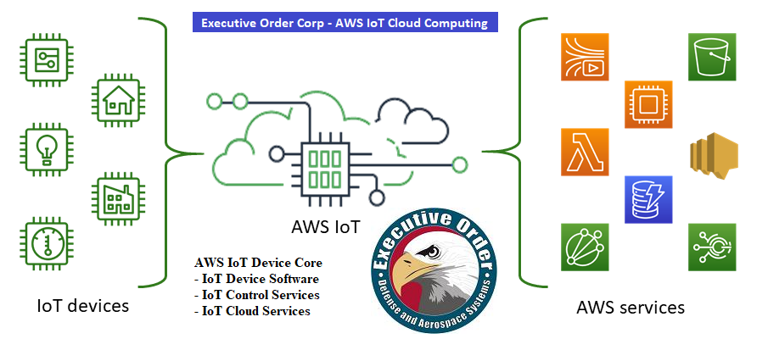

**AWS IoT Tron Cloud Computing**

***AWS IoT Tron Cloud Computing*** - I have developed an AWS IoT Tron Edge Computing Architecture for AI_ML Edge Computing technology that gives you the state of everything from all your devices and allows you to reason on top of the data so that you can truly solve your business problems. My AWS IoT Tron connects IoT devices with my open-source SDK including libraries, developer guides with samples, so that you can build innovative IoT products or solutions. **Device Software:** FreeRTOS, AWS IoT Greengrass. **Control Services:** AWS IoT Core, AWS IoT Device Management, AWS IoT Device Defender, AWS IoT 1-Click. **Analytics Services:** AWS IoT Analytics, AWS IoT Events, AWS IoT Things Graph.

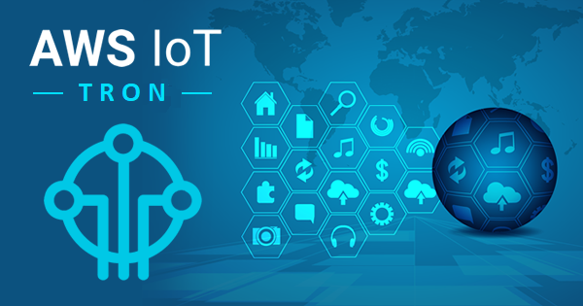

***AWS IoT Tron - Smart Micro-Device*** – This miniature smart AWS IoT MQTT telemetry transport device. The AWS IoT Tron smart micro-device can send alerts on equipment failures, faults or service conditions. It keeps you in constant contact with your equipment, employees, assets, and conditions. AWS IoT Tron AI-Artificial Intelligent Smart Things provides you with instant alerts and equipment status conditions.

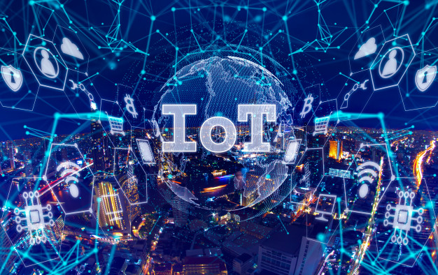

**Satellite Tron - Smart Connect www.satellitetron.com**

As merchandise travels between trading partners and logistics providers around the world, the Satellite Tron – Smart Connect IoT Solution helps to provide the global product and asset visibility that transport operators and fleet managers need to become more efficient, sustainable, compliant and competitive.

Smart IoT Asset Tracking solutions provide a seamless overview of the physical location and status of any vehicle and any asset throughout the supply chain. In fact, IoT Asset Tracking solutions provide details about the location and condition of containers, pallet or the actual goods in transit and can send out automatic alerts whenever an issue arises, such as unauthorized access to the goods or unwanted temperature fluctuations. This makes the supply chain more efficient and ensures a competitive edge.

Satellite Tron Smart Connect – Automation Alert Monitoring, with Command and Control is an Edge Computer version of the Satellite Tron Smart Connect software application. The Satellite Tron Smart Connect client application allows you to transmit automation and remote monitoring system information directly to the Satellite Tron Server from a Smart Connect Edge Computer.

Monitor buildings, servers, vehicles and people from anywhere in the world and post their status and condition directly to the Satellite Tron Server from your own application. Stay connected and informed to what’s important. The Satellite Tron Executive Order Satellite Tron Smart Connect Client is a GPS tracking automation and remote monitoring system that is a complete custom package for your business or office. Its wireless GPS tracking allows you to monitor your office, systems, personal property, and business from anywhere in the world. Receive information from any number of events like when an employee arrives on-site, where a vehicle is located and even receive remote ambient light intensity, temperature, humidity and other information.

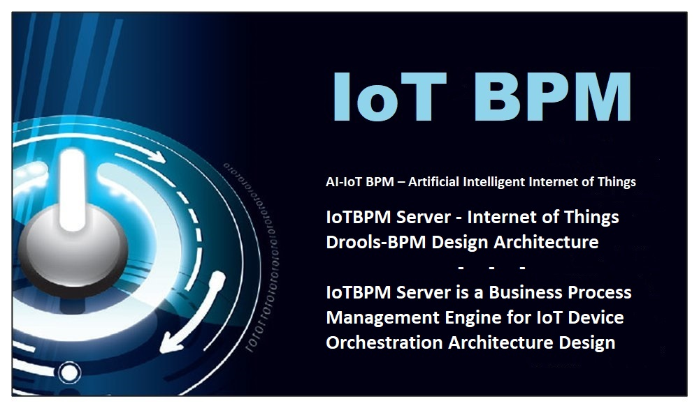

**Executive Order Cloud Computing AI IoT Edge Computing Consulting**

We start our Cloud Computing AI IoT Edge Computing custom engagements with one simple question.

**“If you knew the state of everything in your enterprise and you could reason over top of this data, what business case problems could you solve?”**

*Our mission is to make sure that you can know the state of everything of all your IoT devices in your enterprise and that you can reason on top of this data, so that you can truly solve your business problems and provide enhance customer service through AI IoT.* – Steven Woodward

**About Executive Order Corp Atlanta**

Founded in Atlanta, Georgia in 1978, Executive Order Corp was established to provide Project Consulting, Custom Applications, Professional Services, and Software Development to our corporate clients. We provide their clients with exemplary products and professional software consulting services.

Professional Consultant-Principal Architect and Software Engineer for Java, IoT Edge Computing, Senior Enterprise Architect for BPMN BRMS Drools, Arduino, Raspberry Pi and M2M AI-IoT Embedded Devices.

Executive Order Corp is a leading provider of technology that helps global companies design, develop, deploy, and integrate software applications. Delivering best-in-class solutions dedicated interoperability, we allow enterprises of all sizes to move toward IoT, Edge Computing and web-based computing, while continuing to leverage the benefits of legacy systems.

CONTACT: Executive Order Corporation - Atlanta

Steven Woodward

Telephone: (770) 998-3900

Email: swoodward@iotbpm.com

URL: http://www.eodas.com http://www.iotbpm.com http://www.satellitetron.com

###